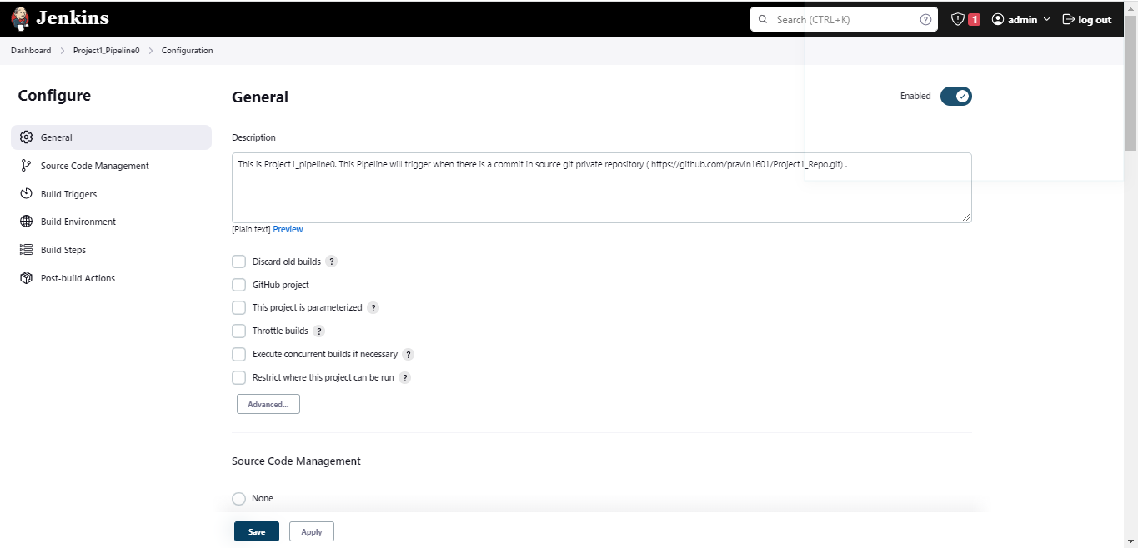

Here I have configured my git hub account credentials

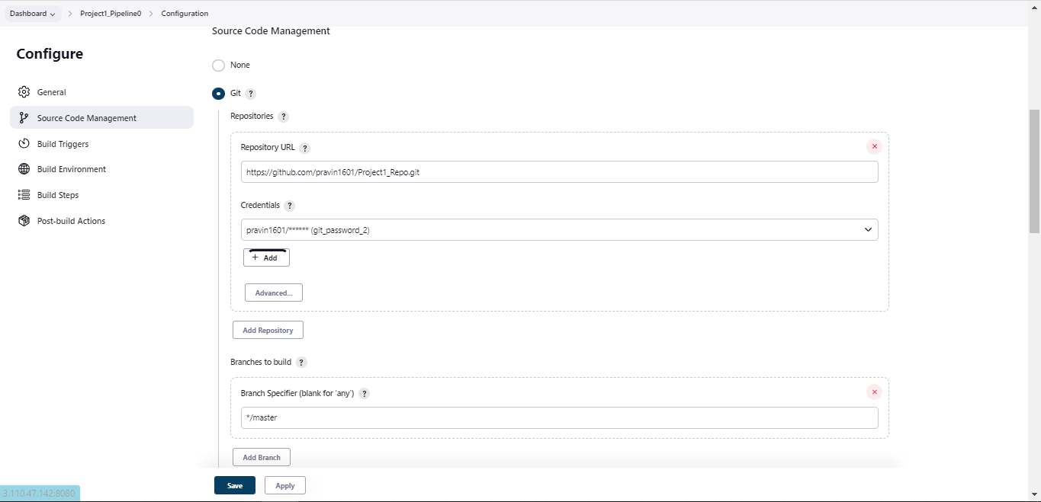

To trigger build for every commit I have selected “GitHub hook trigger for GITScm polling”

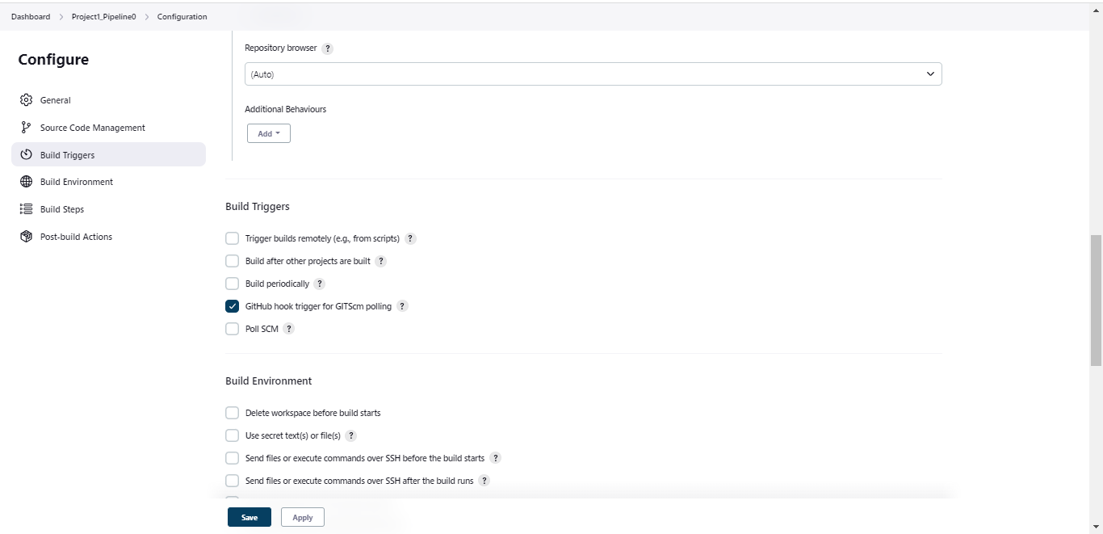

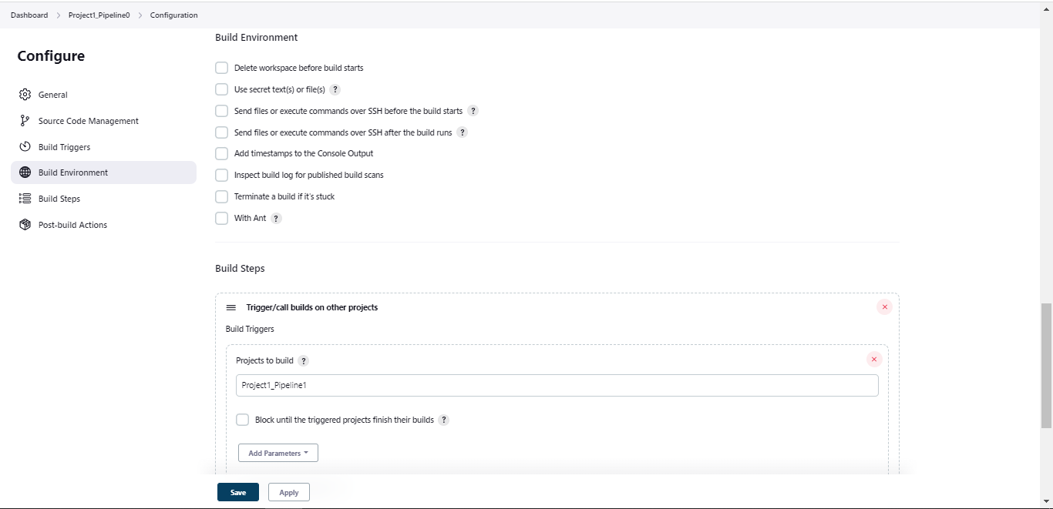

As a build step It will trigger 2nd pipeline “Project1_Pipeline1”

