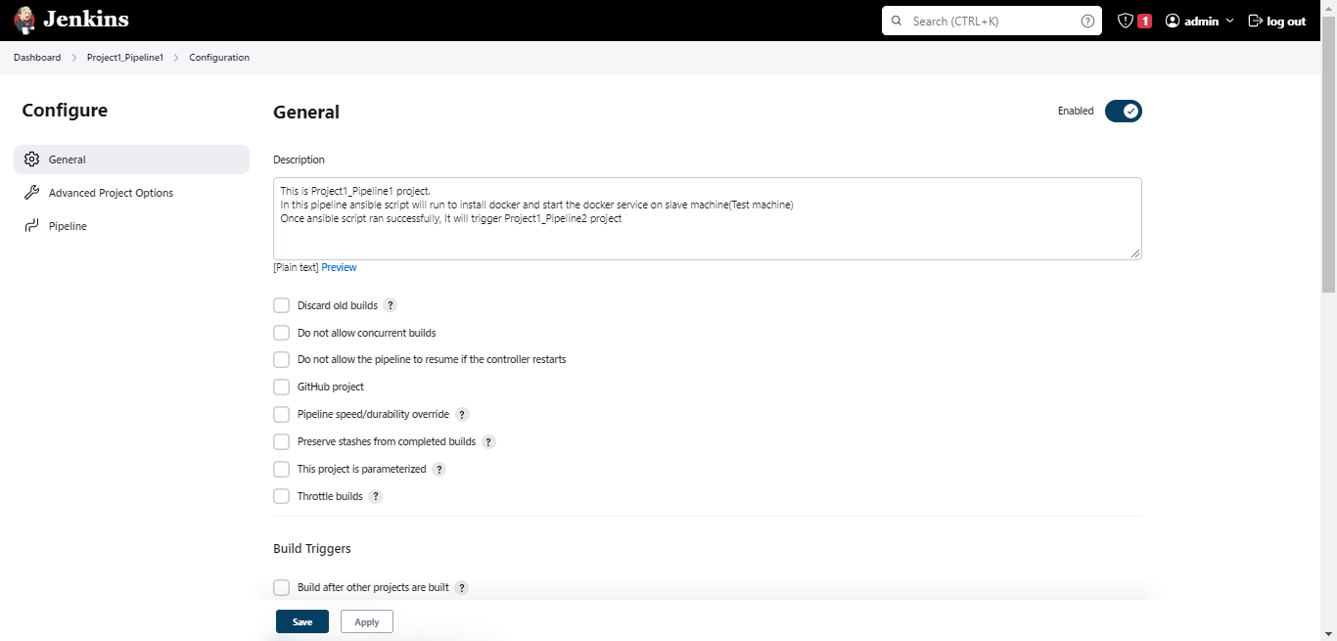

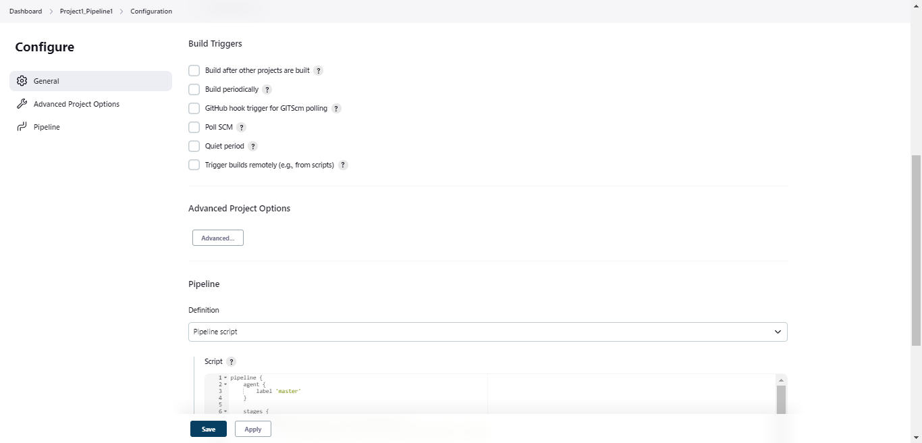

This job will run on master machine. It will run ansible script from master machine

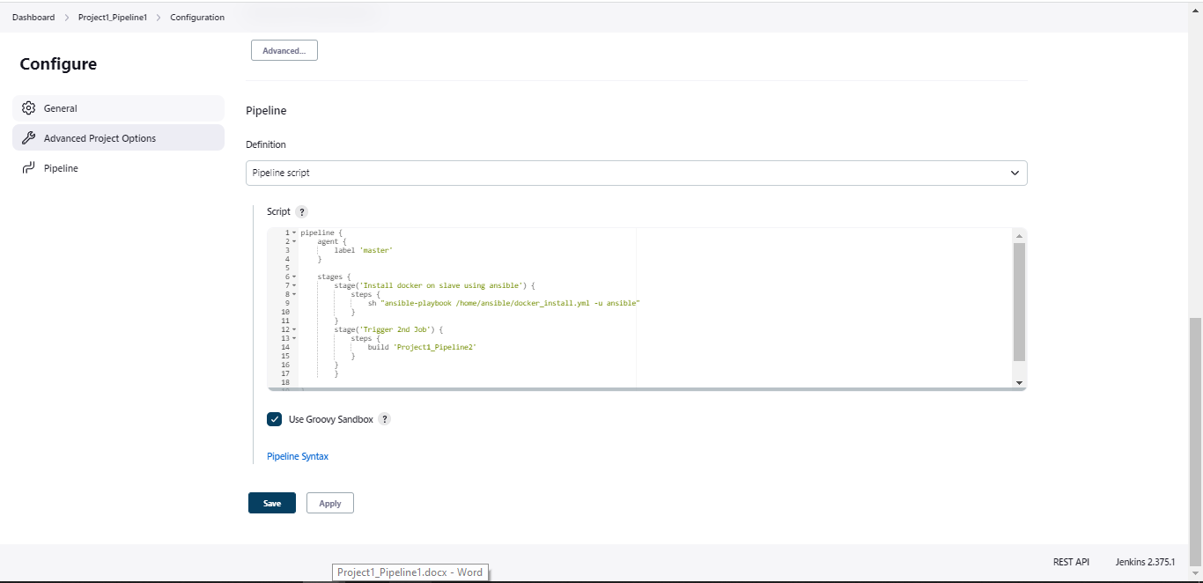

pipeline {

agent {

label 'master'

}

stages {

stage('Install docker on slave using ansible') {

steps {

sh "ansible-playbook /home/ansible/docker_install.yml -u ansible"

}

}

stage('Trigger 2nd Job') {

steps {

build 'Project1_Pipeline2'

}

}

}

}

Note: you can find ansible script in attached documents