- This is Project1_Pipeline2 project.

- This pipeline will pull code and Docker file from private git repo to slave machine (Test machine)

- Once code and Docker file is pulled, It will create Docker image from Docker File.

- Once Image is created It will try to run container with created image

- If container deployment step fails, It will trigger Project1_pipeline3 project where it will delete running container

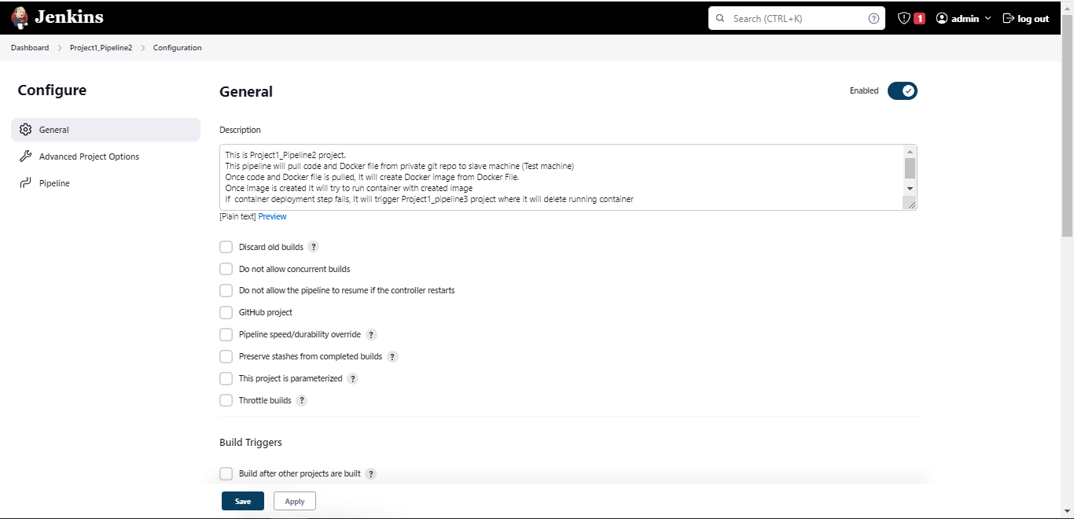

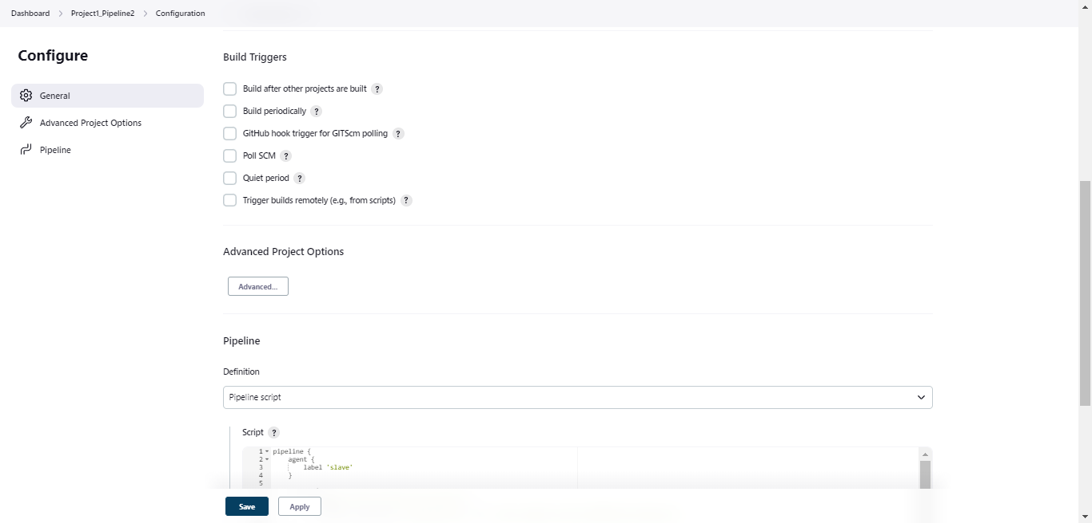

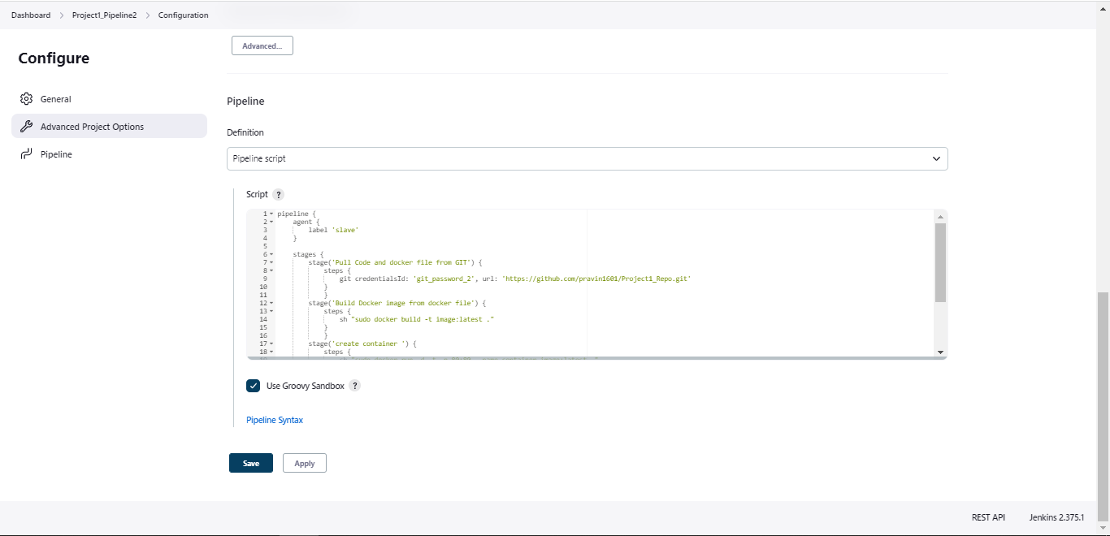

pipeline {

agent {

label 'slave'

}

stages {

stage('Pull Code and docker file from GIT') {

steps {

git credentialsId: 'git_password_2', url: 'https://github.com/pravin1601/Project1_Repo.git'

}

}

stage('Build Docker image from docker file') {

steps {

sh "sudo docker build -t image:latest ."

}

}

stage('create container ') {

steps {

sh "sudo docker run -d -t -p 80:80 --name container image:latest "

}

post{

failure{

build 'Project1_Pipeline3'

}

}

}

}

}