* This is Project3_Pipeline3project.
* This pipeline will delete/remove the running container.
* Once it is deleted, It will trigger the Project_pipeline2 to re-deploy container ## This step is not mentioned in requirement. This is additional step I have added ##

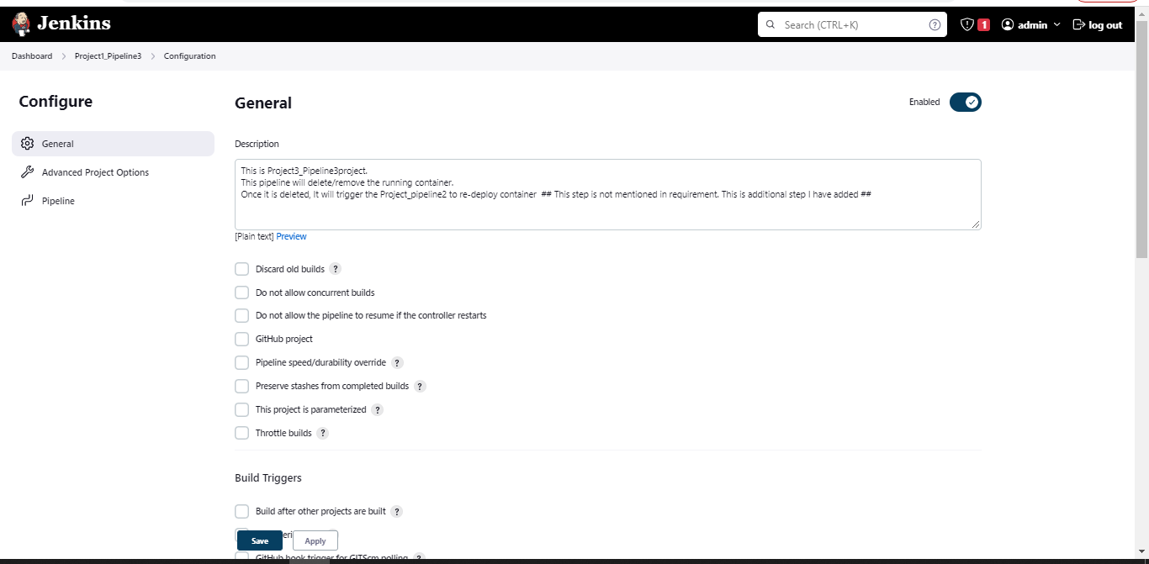

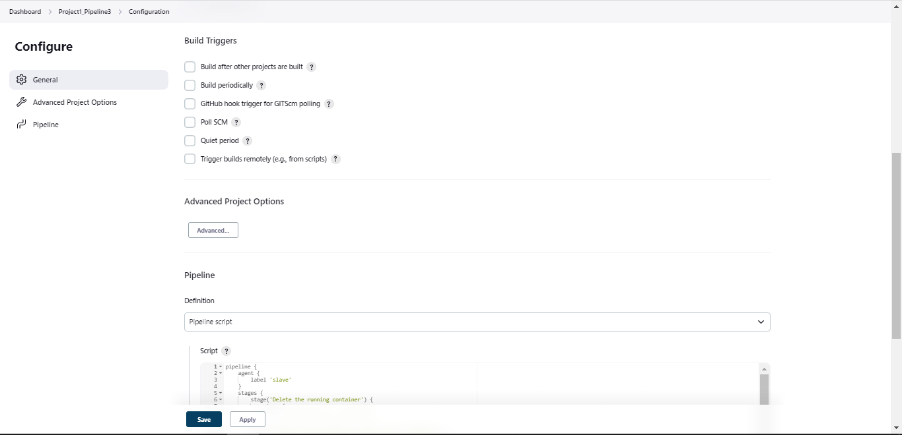

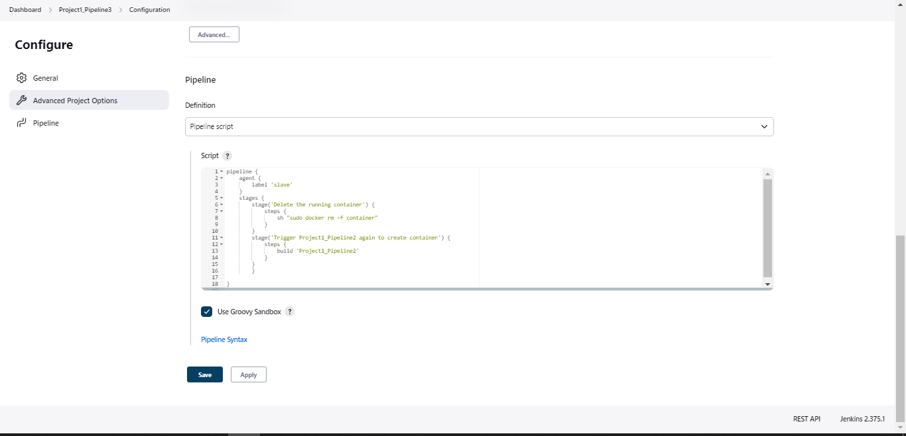

pipeline {

agent {

label 'slave'

}

stages {

stage('Delete the running container') {

steps {

sh "sudo docker rm -f container"

}

}

stage('Trigger Project1_Pipeline2 again to create container') {

steps {

build 'Project1_Pipeline2'

}

}

}

}