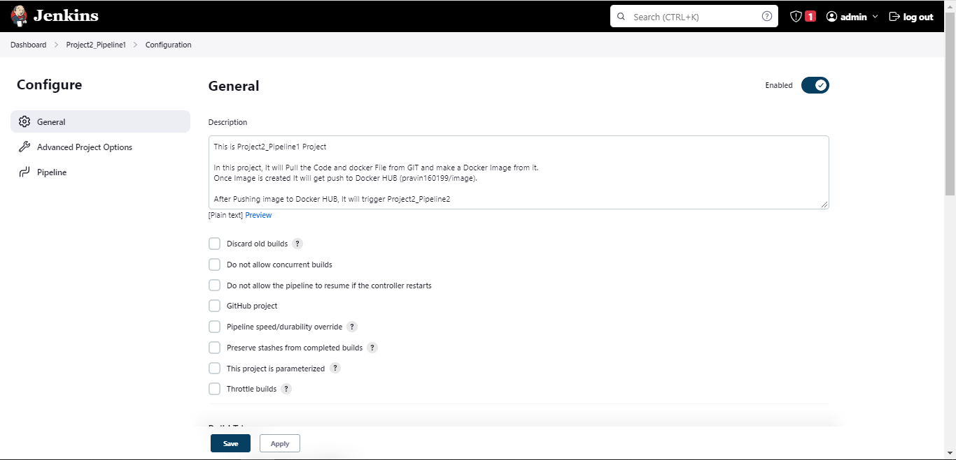

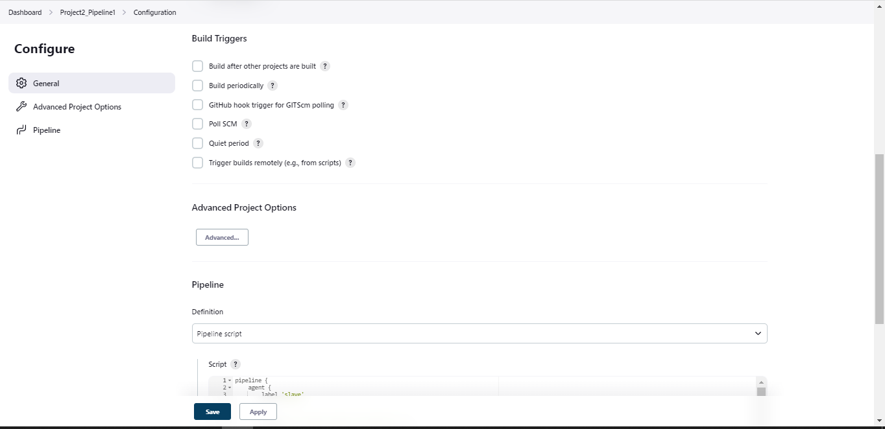

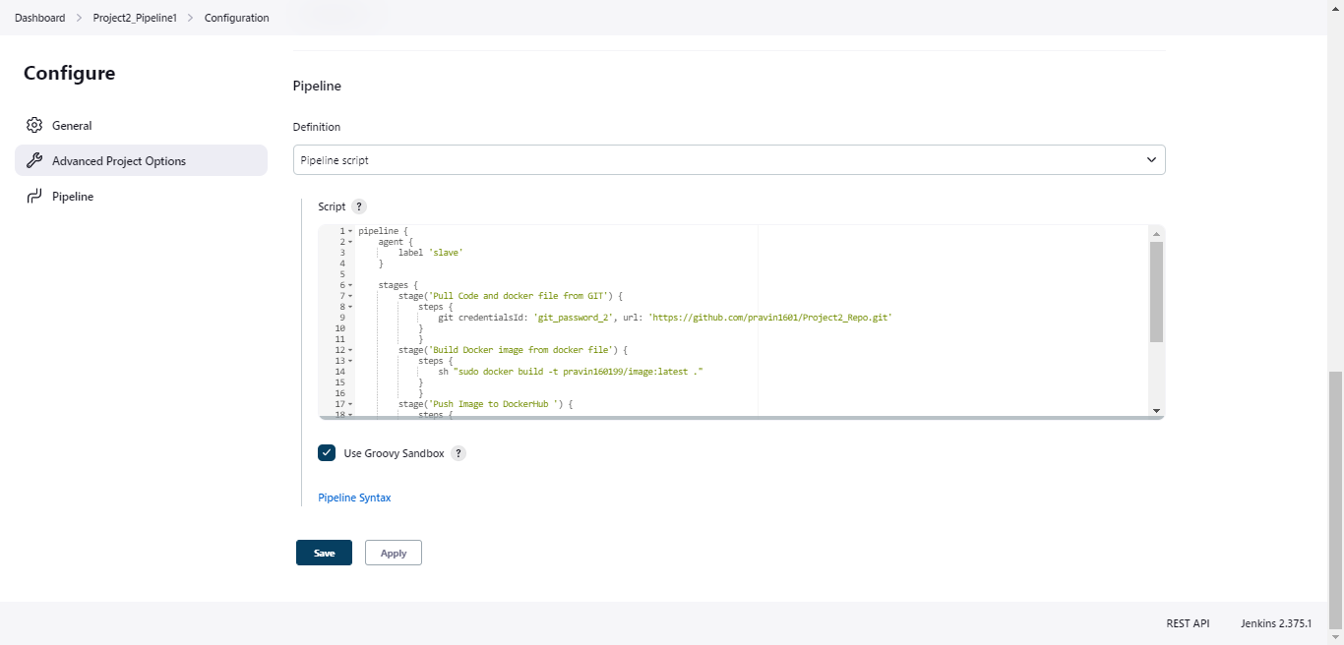

**Groovy Script USED:**

pipeline {

agent {

label 'slave'

}

stages {

stage('Pull Code and docker file from GIT') {

steps {

git credentialsId: 'git_password_2', url: 'https://github.com/pravin1601/Project2_Repo.git'

}

}

stage('Build Docker image from docker file') {

steps {

sh "sudo docker build -t pravin160199/image:latest ."

}

}

stage('Push Image to DockerHub ') {

steps {

sh "sudo docker push pravin160199/image:latest "

}

}

stage('Trigger Project2_Pipeline2'){

steps{

build 'Project2_Pipeline2'

}

}

}

}