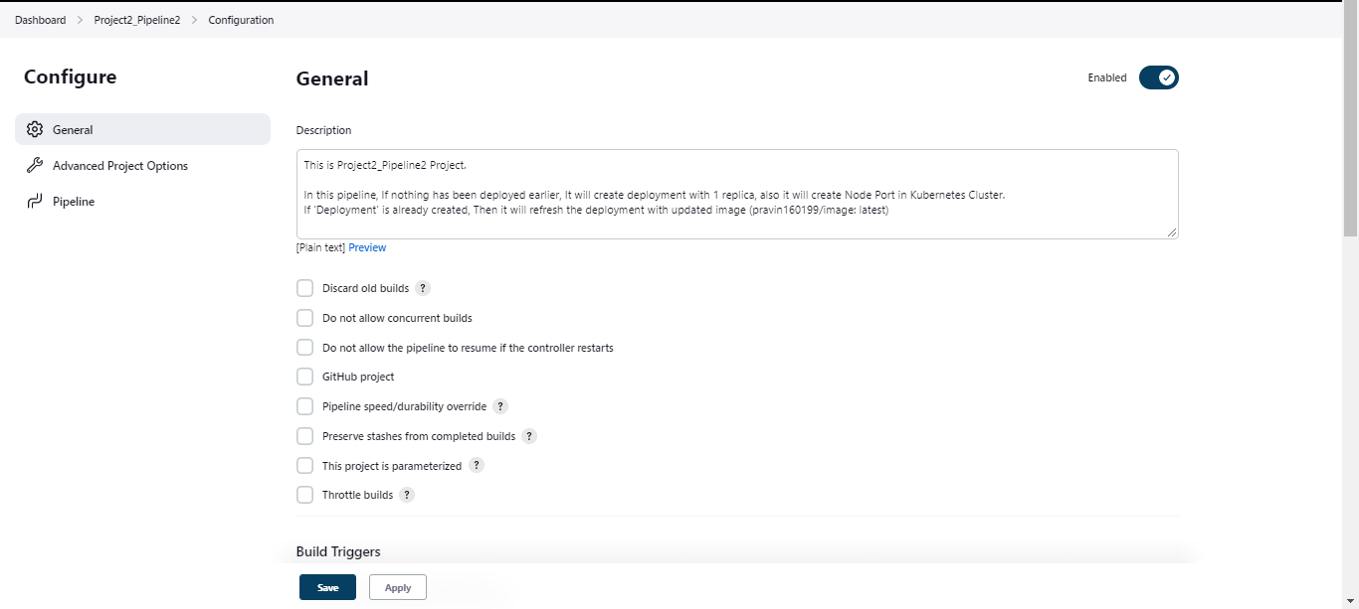

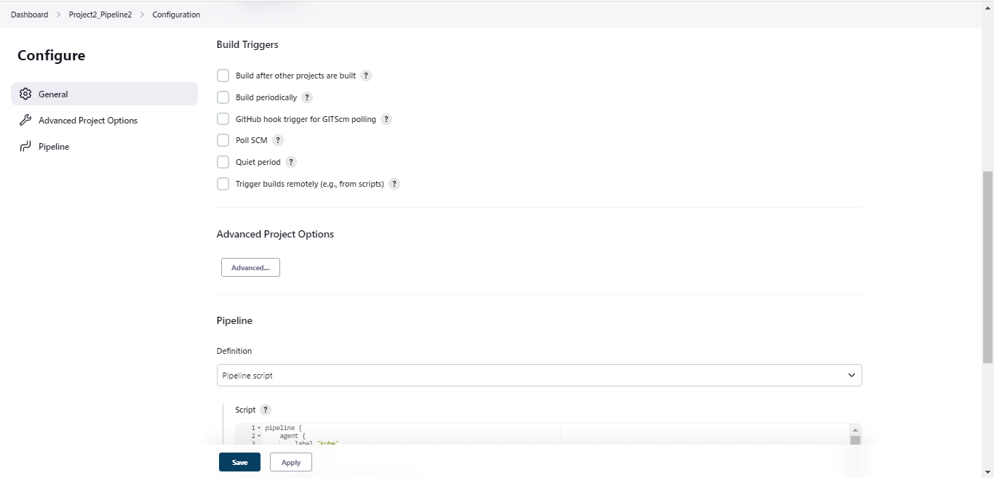

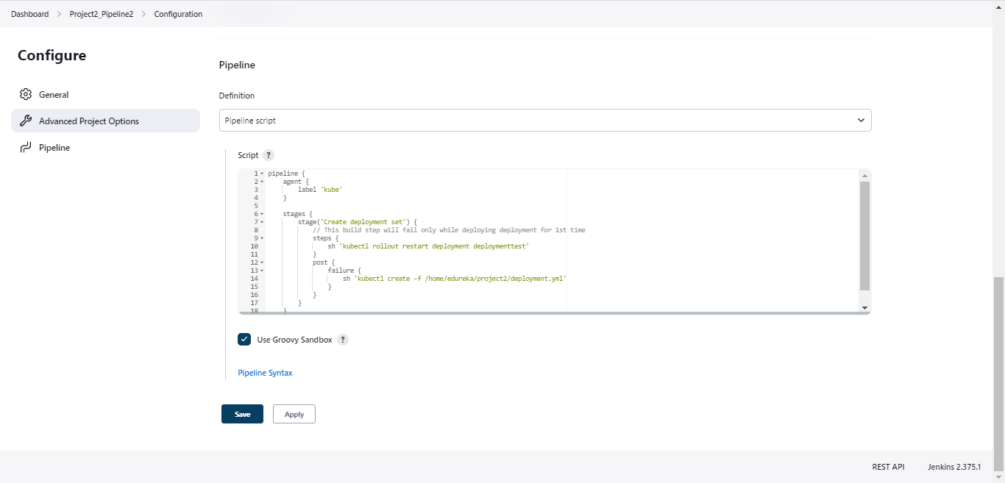

pipeline {

agent {

label 'kube'

}

stages {

stage('Create deployment set') {

// This build step will fail only while deploying deployment for 1st time

steps {

sh 'kubectl rollout restart deployment deploymenttest'

}

post {

failure {

sh 'kubectl create -f /home/edureka/project2/deployment.yml'

}

}

}

}

}