Chapter 1
Introduction

This chapter presents the objective of this paper and an in-depth theory on Wind Tunnels, their types, working and its applications in several different industries and importance in today’s time where CAD modelling and simulation software have taken over.
  - Objective
- An in-depth study on Wind Tunnels and its several aspects which will help to decide several crucial factors during the design process. The aspects include working, its types and applications in different industries.
- A Wind Tunnel must be designed taking into consideration all rules and factors found during the literature survey regarding the design of low-speed wind tunnels. Also create a three-dimensional Computer Aided Design (CAD) model of the Wind Tunnel using Dassault Systèmes SOLIDWORKS v23 software.
- Fabricate the Wind Tunnel according to the design made. Test the flow visualization for several scale models such as aerofoils, cars, aeroplanes and more. Also find lift and drag acting on these test models.
  - What are Wind Tunnels?
Wind tunnels are indispensable tools for understanding and optimizing the aerodynamic behaviour of a wide range of objects, playing a crucial role in engineering design, testing, and innovation. Their ability to simulate real-world airflow conditions provides valuable insights into performance, efficiency, and safety, making them essential for the development of advanced technologies. It is critical to enhance our understanding of airflow, optimizing vehicle and aircraft designs, and fostering breakthroughs in renewable energy. Wind tunnel testing serves as a critical bridge between simulations and real-world observations, enabling us to assess and validate the accuracy of our virtual CFD Simulation models by comparing them to data obtained in a controlled and replicable environment.^{[1]}
Wind tunnels work by creating a controlled flow of air around an object. The air is blown or sucked through the tunnel by a fan or other type of blower. The speed of the air can be controlled by adjusting the speed of the fan or by opening or closing valves in the tunnel. The object being tested is mounted in the test section of the tunnel, which is located in the middle of the tunnel. The air flowing around the object creates forces on the object. These forces can be measured by sensors located in the test section. The data from the sensors can be used to calculate the aerodynamic forces on the object.
  - Types of Wind Tunnels
There are various factors according to which Wind Tunnels are distinguished ^{[4]}
- On the basis of airflow speed
- Low-speed wind tunnel
A low-speed wind tunnel is a facility designed to test models or prototypes at relatively low airspeeds up to 450kmph. These wind tunnels are used for studying aerodynamic properties, such as lift, drag, and stability of objects such as aircraft, automobiles, and wind turbines.
- High speed wind tunnel
A high-speed wind tunnel is used to simulate air flow over objects at speeds greater than 450kmph. High-speed wind tunnels are typically used to study the aerodynamics of objects such as missiles, rockets, and spacecraft.
- Subsonic wind tunnel
A subsonic wind tunnel is a type of wind tunnel that is used to simulate air flow over objects at speeds less than the speed of sound (approximately 1235kmph).
- Transonic wind tunnel
A transonic wind tunnel is capable of testing models at speeds near and around the speed of sound. These wind tunnels are critical for understanding aerodynamic characteristics during the transition from subsonic to supersonic speeds, they are used to study the effects of compressibility on the aerodynamics of objects.
- Supersonic wind tunnel
A supersonic wind tunnel is a facility specifically designed for testing models at speeds greater than the speed of sound (>Mach1). These wind tunnels are essential for studying and understanding aerodynamics in the supersonic flight regime, where shock waves and other compressibility effects play a significant role.
- Hypersonic wind tunnel
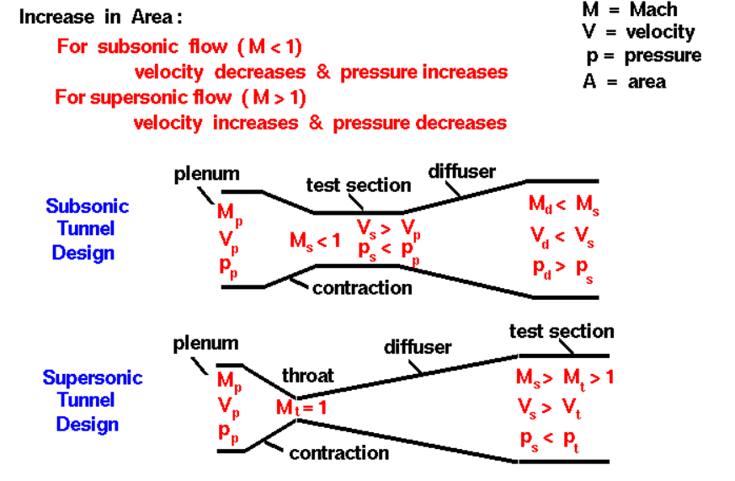
A hypersonic wind tunnel is a specialized facility that allows testing at speeds much higher than the speed of sound. Hypersonic speeds are typically defined as speeds greater than Mach 5. Hypersonic wind tunnels are typically used to study the aerodynamics of objects such as space re-entry vehicles and hypersonic missiles which operate at extremely high speeds where unique aerodynamic phenomena occur.
Fig. 1.1 Subsonic and Supersonic Tunnel Design ^{[8]}

- On the basis of construction
- Open-circuit wind tunnel
An open-circuit wind tunnel is a type of wind tunnel where the airflow is drawn from the environment, passes through the test section, and is then discharged back into the surroundings.
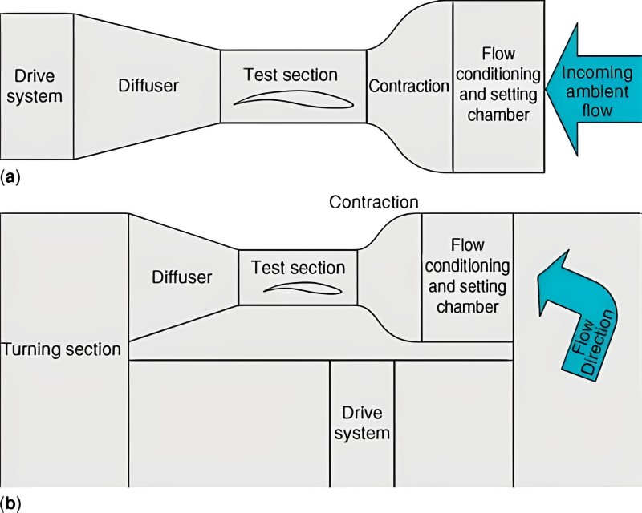
Fig. 1.2 Schematic of Open-circuit wind tunnel ^{[7]}
The primary characteristic of an open-circuit wind tunnel is that the air does not return to the tunnel for recirculation; instead, it is released into the atmosphere. Open-circuit wind tunnels are commonly used for testing large-scale models or for experiments where the test conditions can be easily replicated in the open environment.
- Closed-circuit wind tunnel
A closed-circuit wind tunnel is a type of wind tunnel where the air is recirculated within the system rather than being released into the environment. The airflow is drawn from the test section, then routed through a circuit that includes a fan or other means of generating the flow, and finally returned to the test section. Closed-circuit wind tunnels are advantageous for maintaining a controlled and consistent flow environment for aerodynamic testing. They allow for repeated testing under identical conditions, making them suitable for research and development purposes.
Fig. 1.3 Schematic of Closed-circuit wind tunnel ^{[7]}
- On the basis of method used for airflow propagation
- Suction type wind tunnel
A suction-type wind tunnel is a type of wind tunnel in which the air is drawn through the test section by a fan or blower located downstream. This creates a low-pressure area in the test section, which draws air from the surrounding environment. Suction-type wind tunnels are typically used for low-speed testing, as they are more efficient than blower-type wind tunnels at low speeds.

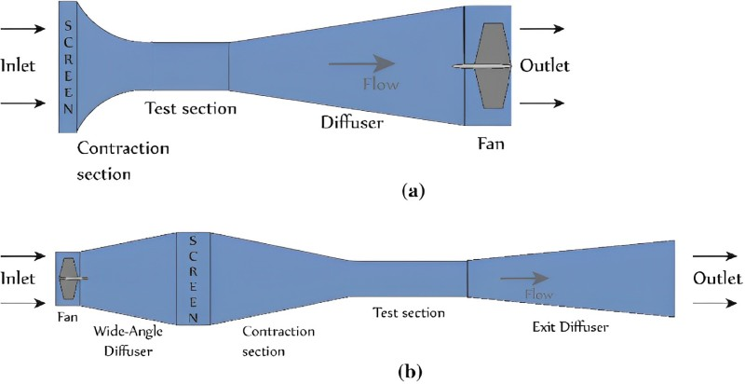
Fig. 1.4 Schematic of Suction type wind tunnel ^{[9]}
- Blower type wind tunnel
A blower-type wind tunnel is a type of wind tunnel in which the air is blown through the test section by a fan or blower located upstream. This creates a high-pressure area in the test section, which forces air through the test section. Blower-type wind tunnels are typically used for high-speed testing, as they are more efficient than suction-type wind tunnels at high speeds.
Fig. 1.5 Schematic of Blower type wind tunnel ^{[9]}

  - Uses of Wind Tunnels
Wind tunnels serve as a controlled environment thus are versatile tools used in various industries to study and optimize the aerodynamic behaviour of objects and structures.^{[3]} An overview of some of the diverse applications and industries where wind tunnels play a crucial role are:
1. Aerospace: Wind tunnels are at the heart of aircraft design and testing, enabling engineers to simulate flight conditions and evaluate aerodynamic performance. They are used for
- Testing aircraft models: Wind tunnels allow engineers to test scale models of aircraft to measure lift, drag, stability, and controllability.
- Optimizing wing designs: Wind tunnels are essential for refining wing designs, reducing drag, and improving aerodynamic efficiency.
- Evaluating engine performance: Wind tunnels can be used to assess the performance of aircraft engines and their impact on airflow.
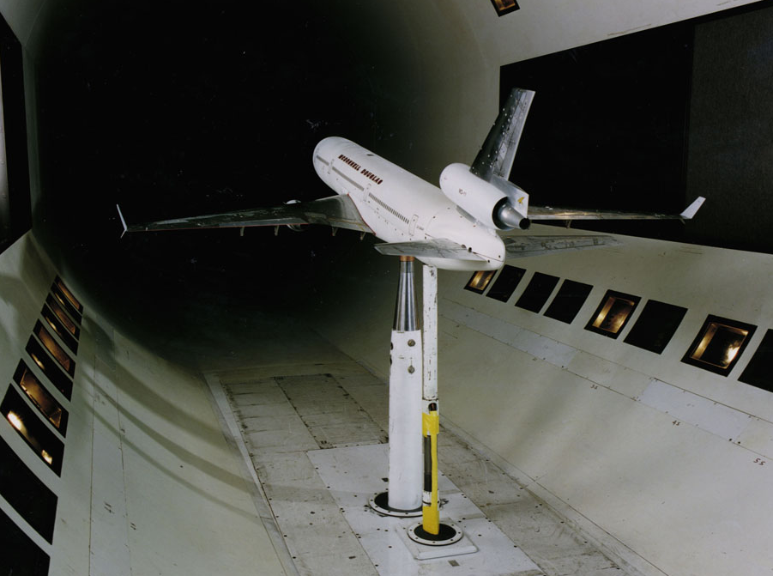
Fig. 1.6 Testing of aircraft model ^{[10]}
2. Automotive: Wind tunnels are crucial for improving the aerodynamic performance and fuel efficiency of automobiles.
- Testing vehicle models: Wind tunnels allow engineers to test scale models of cars to measure drag, stability, and noise generation.
- Optimizing body shapes: Wind tunnels are used to refine car body designs, reducing drag, and improving fuel economy.
- Evaluating air conditioning and ventilation systems: Wind tunnels can be used to test the effectiveness of car air conditioning and ventilation systems under various airflow conditions.
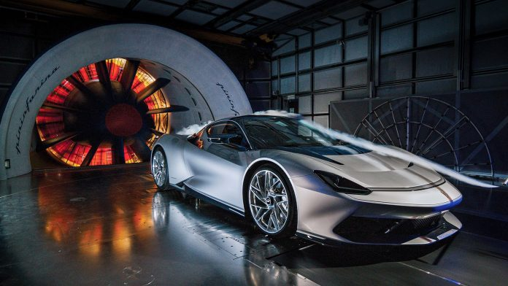
Fig. 1.7 Testing of Pinin farina Battista ^{[11]}
3. Civil Engineering: Wind tunnels play a vital role in ensuring the safety and stability of structures.
- Testing building models: Wind tunnels are used to test scale models of buildings to assess their structural integrity under various wind conditions.
- Evaluating wind loads on structures: Wind tunnels can be used to measure wind loads on bridges, skyscrapers, and other structures, ensuring their ability to withstand extreme weather events.
- Designing wind mitigation strategies: Wind tunnels can be used to study wind patterns around buildings and design wind mitigation strategies to reduce wind effects.
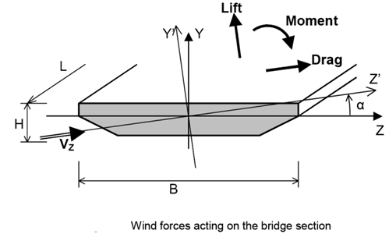
Fig. 1.8 Wind forces acting on Bridge section ^{[12]}
4. Sports Equipment: Wind tunnels are used to optimize the aerodynamic performance of sports equipment, such as:
- Testing bicycle designs: Wind tunnels can be used to test bicycle frames and wheels to reduce drag and improve speed.
- Optimizing ski and snowboarding designs: Wind tunnels are used to refine ski and snowboard designs for improved performance and stability.
- Evaluating helmet designs: Wind tunnels can be used to test the aerodynamic performance of helmets and reduce drag for cyclists, skiers, and other athletes.

Fig. 1.9 Testing of Helmet designs ^{[13]}

5. Industrial Applications: Wind tunnels are employed in various industrial applications, such as:
- Testing wind turbines: Wind tunnels can be used to test wind turbine blades for aerodynamic efficiency and structural integrity.
- Designing industrial fans and blowers: Wind tunnels are used to optimize the design of industrial fans and blowers for efficient airflow and noise reduction.
- Studying air pollution dispersion: Wind tunnels can be used to study the dispersion of air pollutants from industrial sources and develop mitigation strategies.
- Pharmaceutical Industry: Wind tunnels are employed in the pharmaceutical industry to investigate the dispersion of drug particles and aerosols, ensuring uniform drug delivery and optimizing inhalation devices.
- Chemical Engineering: Wind tunnels are utilized in chemical engineering to study the flow patterns and mixing behaviour of gases and liquids in various chemical processes, improving efficiency and safety.
- Electronics Cooling: Wind tunnels are used to evaluate the cooling performance of electronic devices, such as computer heat sinks and power electronics components, ensuring effective heat dissipation and preventing overheating.
- Fire Safety Research: Wind tunnels play a crucial role in fire safety research, simulating fire scenarios and studying the spread of smoke and flames to develop fire prevention and suppression strategies.
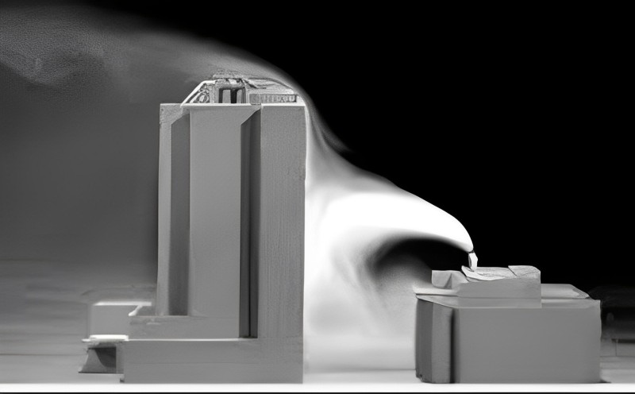
Fig. 1.10 Testing of Air pollution dispersion ^{[14]}
Wind tunnels continue to evolve with advancements in technology, enabling more precise measurements, sophisticated flow visualization techniques, and the ability to simulate increasingly complex aerodynamic environments. Their versatility and ability to provide real-world insights make them indispensable tools for innovation and progress in a wide range of industries.^{[4]}

Chapter 2
Literature Survey

This chapter presents the information that was found during the survey conducted. Several research papers and books were used as references and the information pertaining to this project was found and is presented.

J. B. Barlow, W. H. Rae, A. Pope – Low-Speed Wind Tunnel Testing (3rd edition)
The test section, which may be closed, open, partially open or convertible. The test-section length-to-hydraulic diameter ratio may typically be chosen to be 2 or more, in contrast to the shorter test sections of earlier era tunnels. A diffuser of at least three or four test-section lengths. The typical equivalent cone angle is in the range of 2-33" with the smaller angles being more desirable. The area ratio is typically 2-3, again with the smaller values being more desirable. Transition rectangular to circular cross section to take flow into the fan. Fan and straightener section. Other drive devices such as ejectors have also been used. Wide-angle diffuser with separation control screens. Typical properties are angles of about 45" and area ratios of 24. Contraction or node. Typical area ratings are in the range of 7-12, although lower and higher values are not uncommon.

J.H. Bell, R.D. Mehta - Contraction Design for Small Low-Speed Wind Tunnels
The procedure of installing a contraction chamber consists of first computing the potential flow field and hence the pressure distributions along the walls of a contraction of given size and shape using a three-dimensional numerical panel method. The pressure or velocity distributions are then fed into two-dimensional boundary layer codes to predict the behaviour of the boundary layers along the walls. For small, low-speed contractions it is shown that the assumption of a laminar boundary layer originating from stagnation conditions at the contraction entry and remaining laminar throughout passage through the successful designs if justified. The measured boundary layer momentum thicknesses at the exit of four existing contractions, two of which were 3-D, were found to lie within 10 percent of the predicted values, with the predicted values generally lower.

P. Bradshaw, R.C. Pankhurst - The Design of Low-Speed Wind Tunnels
Aerodynamic and structural design was studied from the viewpoint of the prospective tunnel designer, and details given of present-day practice. Comments, mostly cautionary, were made on the features of certain existing tunnels, and drawings and tabulated data were given for about thirty typical tunnels of various ages. The emphasis was on low-speed tunnels of wooden construction, but much of the discussion was applicable to the design of tunnels of larger size or higher speed.

D. Soni, S.K. Gupta, B. Singh - Wind Tunnel: A Research Tool
This paper covered the wind tunnel being used as a research tool, giving us an in-depth about wind tunnels and their history. It explained the several types of wind tunnels and the reason what made each of them unique. It showed where the wind tunnels are being used in todays time and their importance in several industries, especially in newer fields regarding environment safety and wellbeing. It also discussed about the components of the wind tunnel and the role they play.

N.K. Maurya, M. Manish, S.P. Dwivedi - Design & Fabrication of Low-Speed Wind Tunnel and Flow Analysis
In this research work, low velocity wind tunnel was designed. It was concluded that shape, size, material selection and manufacturing process is very important for designing of wind tunnel. Results depicts that velocity was increased and pressure was decreased when object height was gradually increases along the length up-to the maximum height and after the maximum height pressure was increased and velocity was decreases when height of object was decreases gradually along the length of object.

R.D. Mehta, P. Bradshaw - Design rules for small low speed wind tunnels
In this research paper, study of low-speed wind tunnels was done. Design process and methodology was discussed. Several designing factors for each component of the wind tunnel was done mathematically thus, setting some design rules for ideal measurements for small low speed wind tunnels.
C.J. Bahr, J. Mathew – Fundamentals of Wind Tunnel Design
This paper discusses the historical significance of wind tunnel testing in shaping aircraft design, optimizing wing profiles, and minimizing drag. The specific measurement requirements as well as the various space, budget, and power constraints that guide the tunnel design were also discussed. Ending the paper with how wind tunnels are being used in optimizing vehicle aerodynamics, with a focus on reducing drag and enhancing fuel efficiency.

Chapter 3
Design Methodology

This chapter presents reasoning behind the selection of design. It also provides the design criteria and standards followed during the design process. It helps understand the role of each component of a wind tunnel and why it is designed in a specific manner.

  - Design Selection
It was decided that Open Circuit Suction Type Wind tunnel would be used in this project. The Open Circuit design was selected as it is easier and cheaper to fabricate also requiring a much smaller area as compared to Closed Circuit design. For low-speed testing air taken from the air would not give a change in reading thus making the Open Circuit design the obvious choice.
In our study we found that Blower Type wind tunnel is suitable only for demonstration purposes, or for very approximate measurements. This is because the turbulence level is not low enough for any degree of precision. All the kinetic energy of the fast-moving air in the working section is wasted. The Suction Type wind tunnels are less expensive to build and operate, especially at low speeds while providing a streamlined flow of air. It has a simpler design and can be adapted for a wide range of applications. It has low power requirements and tends to be quitter and produce fewer vibrations compared to its counterparts.
  - Contraction
A contraction increases the mean velocity which allows the honeycomb and screens to be placed in a low-speed region, thus reducing pressure losses. It reduces both mean and fluctuating velocity variations to a smaller fraction of the average velocity.^{[2]} The design of a contraction centres on the production of a uniform and steady stream at its outlet, and requires the avoidance of flow separation. Two more desirable criteria include minimum exit boundary layer thickness and minimum contraction length. A design satisfying all criteria will be such that separation is just avoided and the exit non-uniformity is equal to the maximum tolerable level for a given application.^{[6]}

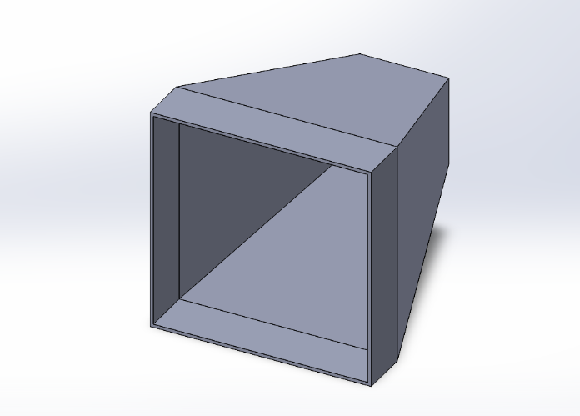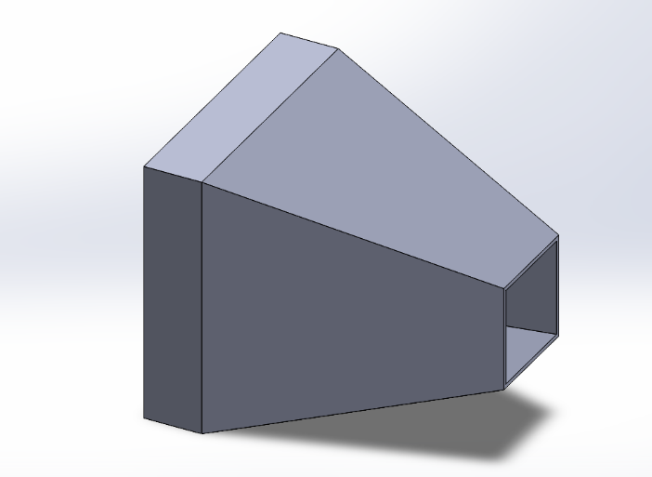
Fig. 3.1 3D Model of Contraction
Since the power factor contribution of screens in the settling chamber varies as 1/c², large contraction ratios are advantageous. But large contraction ratios mean higher construction and running costs besides possible problems of noise and separation near the ends. Therefore, contraction ratios between about 6 and 9 are normally used, at least for the smaller low speed tunnels.^{[6]}
Contraction ratio (c) = Inlet Area / Outlet Area
= A₁/A₂
= (720x720)/(250x250)
c = 8.29 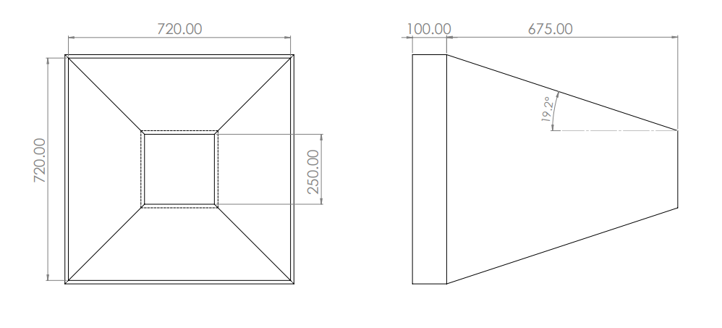
Fig. 3.2 Schematic of Contraction

  - Settling Chamber
The turbulence intensity tends to increase as the air enters the wind tunnel from the environment. A high turbulence intensity should be prevented therefore, the contraction is equipped with a settling chamber. The honeycomb aligns the flow with the axis of the tunnel and breaks up larger-scale flow unsteadiness. It removes swirl from the incoming flow and minimizes the lateral variations in both mean and fluctuating velocity.^{[6]} Honeycomb comes in different shapes such as circular, square, and hexagonal cross sections. Among these, hexagonal is usually the cross-sectional shape of choice, as it has the lowest pressure drop coefficient.^{[1]}
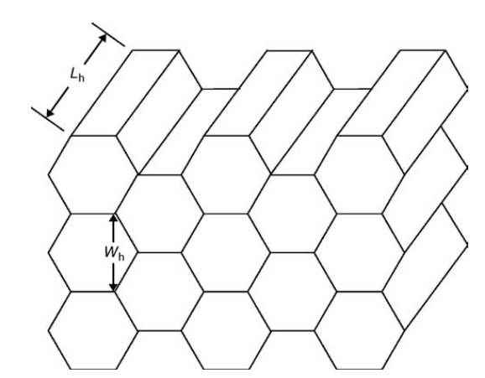
Fig. 3.3 Schematic of a Hexagonal Honeycomb Section ^{[7]}
  - Test Section
The test section functions as the area to locate the prototype or scaled model for the measurement. Test section design is totally dependent on the requirements of the individual experimenter. The advantage of the proposed test section is the use of transparent acrylic. Using transparent acrylic comes with two main objectives: the researcher can observe the prototype directly during the measurement, and easy to reassemble to place the prototype before the test. This also helps in flow visualization when combined with a smoke generator, this allows the researcher to see the air flow around the prototype in real-time and identify factors such as turbulence or vortices that may appear in the smoke.
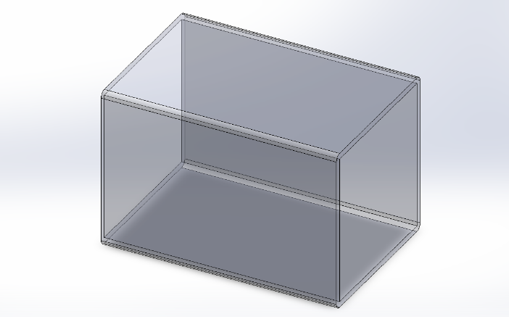
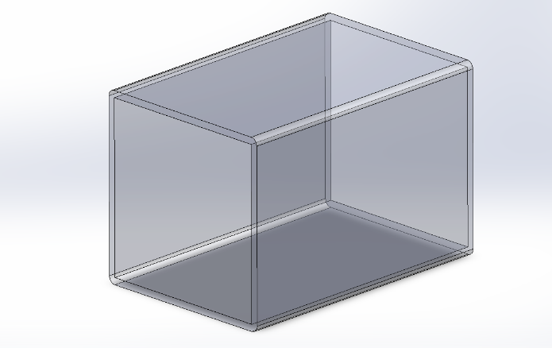
Fig. 3.4 3D Model of Test Section
The test section length must be in the range of 0.5-3 times its hydraulic diameter.^{[7]} The blockage ratio is (Projected area of test body/Cross sectional area of wind tunnel) and it must be less than 10%.^{[5]} The proposed test section is made of transparent acrylic
Test section length (L) = 400mm
Hydraulic diameter (D_{h}) = 4A/P
A₂ = cross sectional area = 250 x 250 = 62,500
P = Wetted perimeter = 250 x 4 = 1000
D_{h} = (4 x 62,500)/1000
D_{h} = 250mm
Ratio = L/D_{h} = 400/250
= 1.6 (which lies between 0.5 and 3)
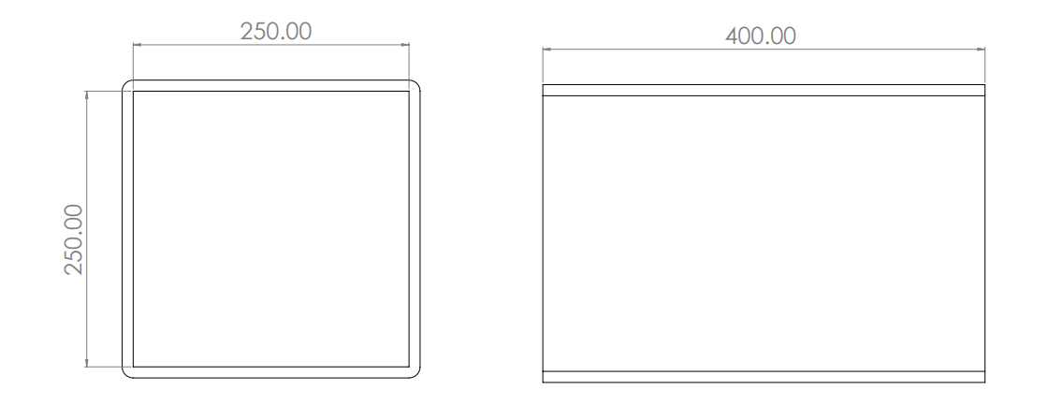
Fig. 3.5 Schematic of Test Section
  - Diffuser
The contraction chamber increases the air velocity that enters the wind tunnel, which is suitable for the test prototype, but it is dangerous for the surrounding area of the wind tunnel if the wind is released directly to the outside area. The diffuser section is placed after the test section to minimize the effect of jet velocity from the wind tunnel. In principle, a diffuser is a device to reduce the wind velocity before exiting the wind tunnel. The designed diffuser is made into two areas to help the wind tunnel’s manufacturing and assembly process.
Gentle expansions with a diffuser included angle usually not exceeding 5° (for best flow steadiness, although best pressure recovery is achieved at about 10°) and an area ratio of about 2-5.^{[6]}
Area ratio (AR) = Outlet Area / Inlet Area = A₃/A₂
= (410x410)/(250x250)
AR = 2.68
This diffuser is connected to the outlet of the test section.

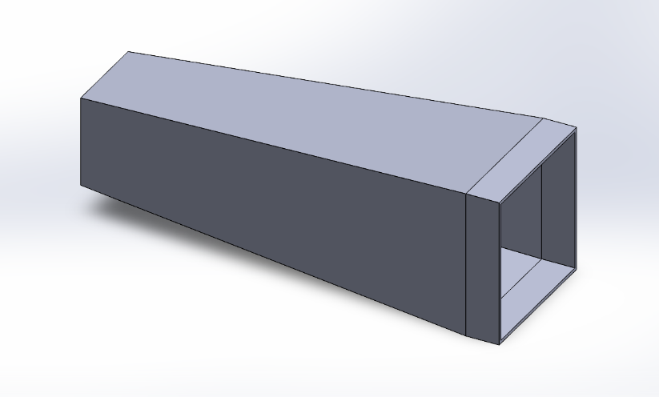
Fig. 3.6 3D Model of Diffuser-a
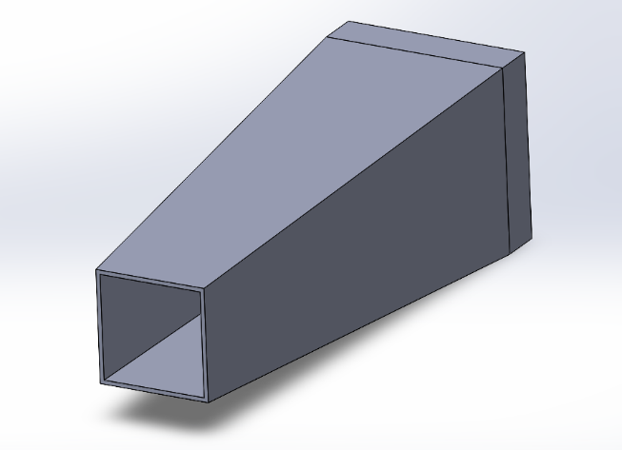
Fig. 3.7 3D Model of Diffuser-b

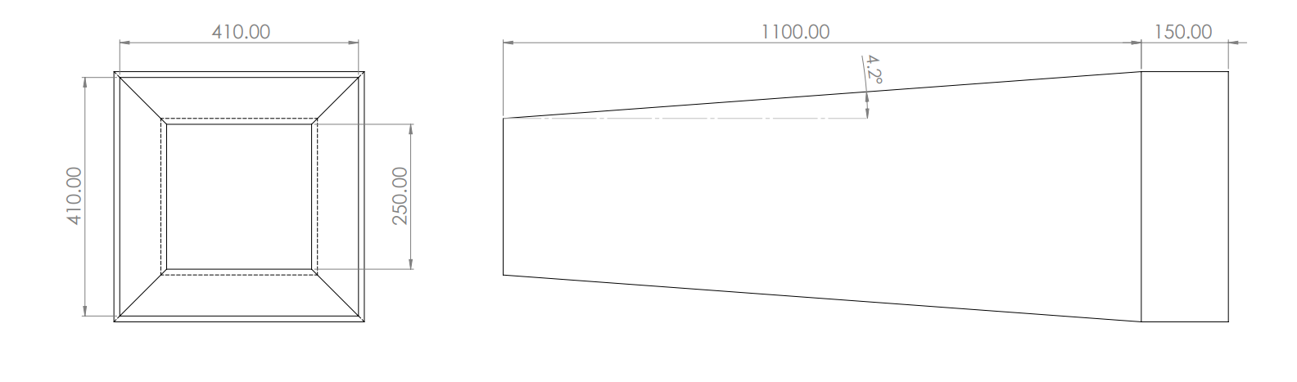
Fig. 3.8 Schematic of Diffuser

  - Fan
The axial fan is located at the end of the assembly and is designed to provide sufficient wind speed for measurement. The axial fan draws vacuum conditions within the wind tunnel to flow in the axial direction, parallel to the shaft about which blades rotate.
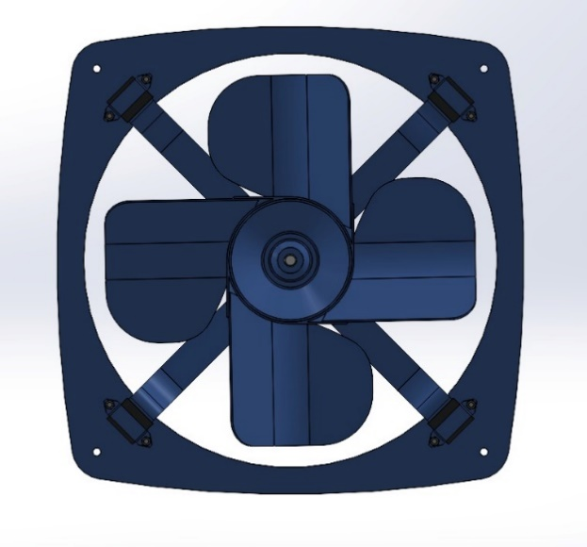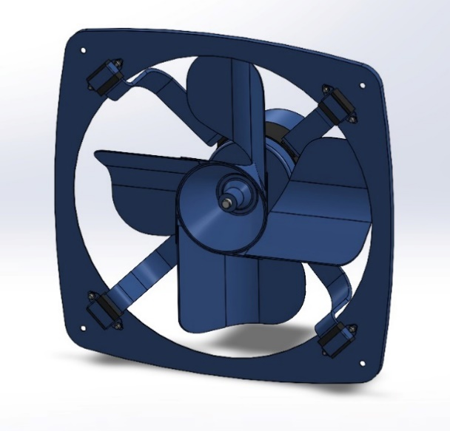
Fig. 3.9 3D Model of Fan

The rotation of the blade creates a pressure difference between the inside and outside area of the wind tunnel, making the air from the outside flow through the wind tunnel. The fan is set in suction mode, which means the air enters the wind tunnel from contraction chamber to the diffuser to minimize the turbulence intensity. A standard axial fan is used in this design which is widely available across the globe.

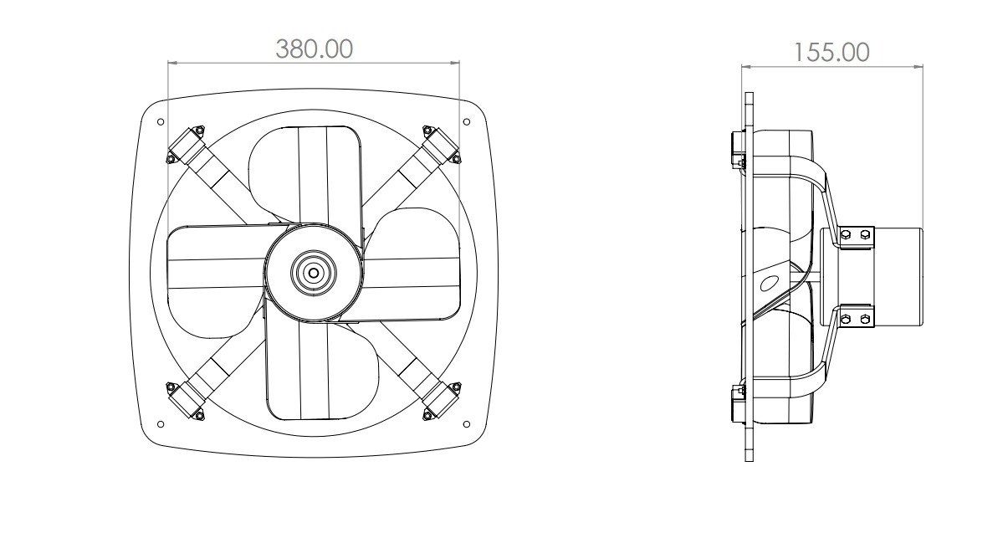
Fig. 3.10 Schematic of Fan

  - Assembly
Assembly of different parts of wind tunnel was complicated along the line of alignment. There were several parts of wind tunnel viz., fan, settling chamber, contraction cone, test section and diffuser.

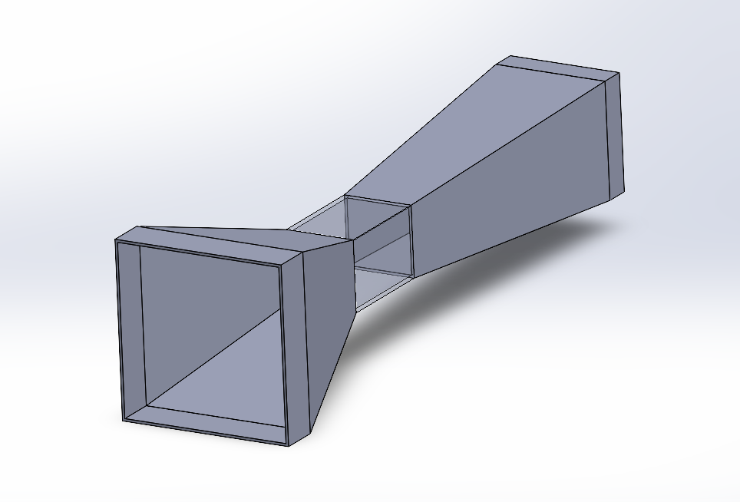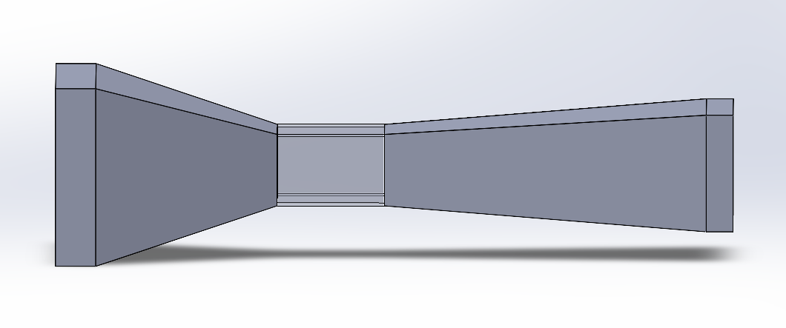
Fig. 3.11 3D Model of Assembly
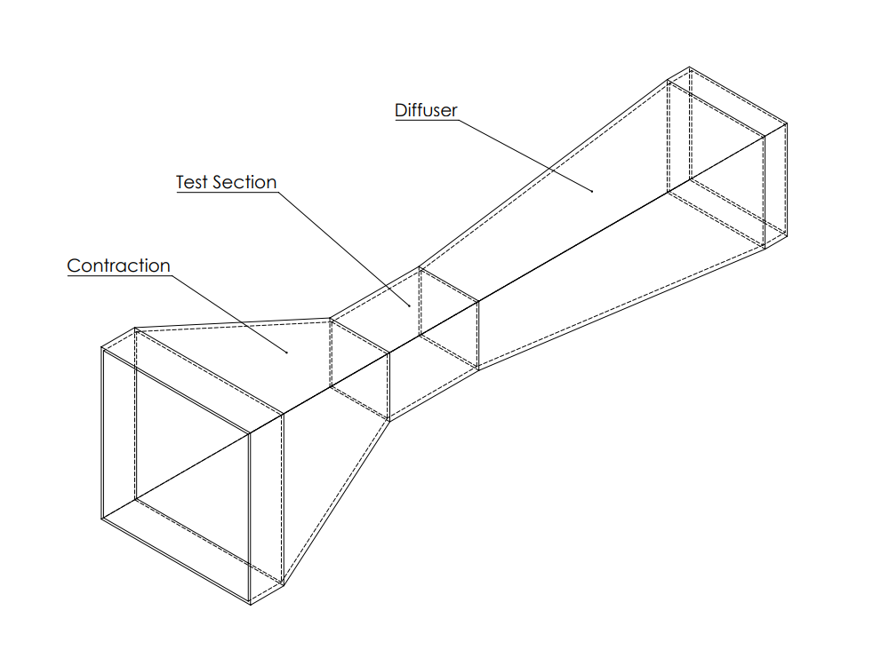
Fig. 3.12 Labelled Component Assembly

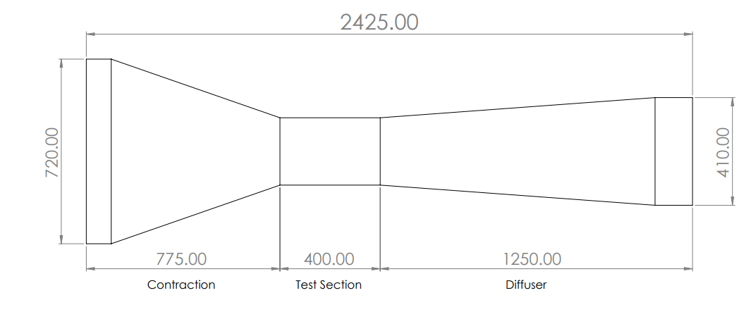
Fig. 3.13 Schematic of Assembly

Chapter 4
Simulation of Wind tunnel using ANSYS Fluent

This chapter presents the steps of the simulation in ANSYS Fluent and comparing the results of velocity, pressure and turbulence at different inlet velocities.
- Steps of Simulation
The computational domain was discretized using a mesh generated within ANSYS. The mesh elements were chosen to have a size of 10 millimetres. A total of 8,36,250 nodes and 7,53,723 elements are formed while the meshing was generated.

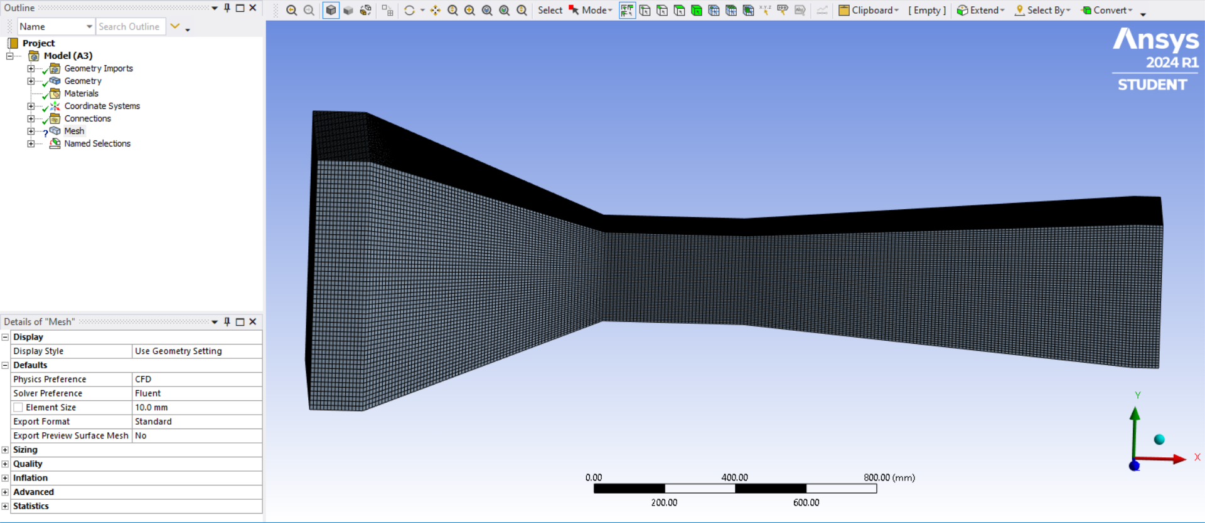
Fig. 4.1 Mesh
Mesh elements size was selected after performing mesh convergence which showed that 10mm element size was ideal and the student version of ANSYS has a limit of 10,00,000 nodes and elements, so we have to generate the mesh within these limits. The simulation was performed at 25⁰C.
The standard k-omega model was selected as the turbulence model. The k-omega model was selected because in ANSYS, the k-omega turbulence model is a valuable tool for simulating flows with complex characteristics. Due to its strength in capturing near-wall effects, it excels in analyzing adverse pressure gradient regions, a common scenario in internal flows.

Additionally, the k-omega model demonstrates robustness compared to other options, preventing the accumulation of excessive turbulent kinetic energy near stagnation points. This translates to a model that is well-suited for a wide range of applications, including internal flows, separated flows, jets, high-pressure gradients, and even flows through curved geometries.
The boundary conditions were set to be the same as the wall off the wind tunnel.
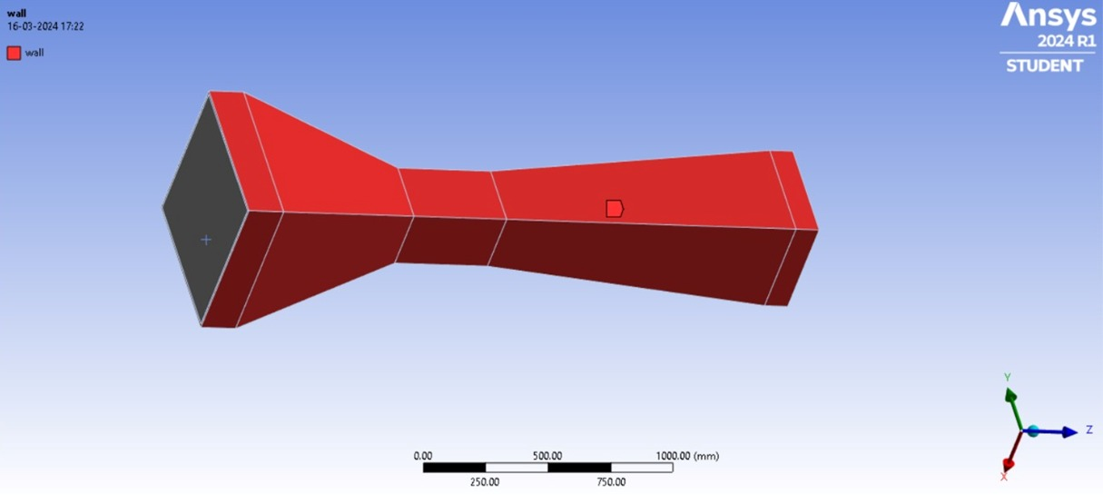
Fig. 4.2 Boundary Conditions

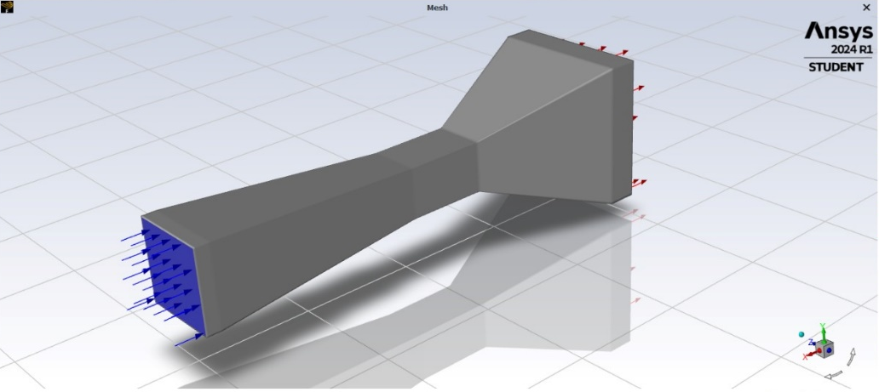
Fig. 4.3 Outlet of Wind tunnel

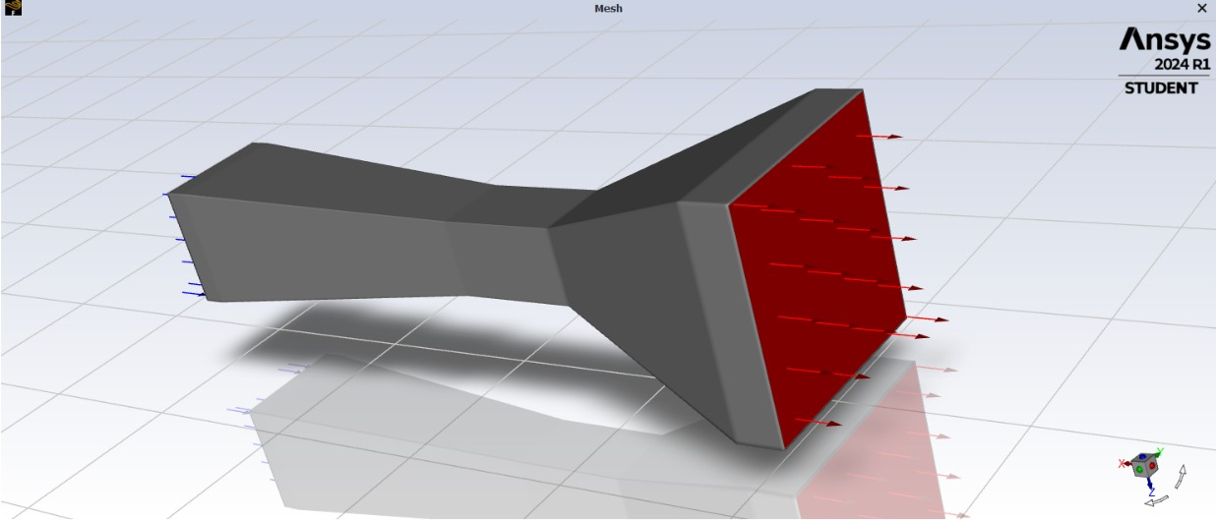
Fig. 4.4 Inlet of Wind tunnel
The simulation shows color-coded arrows to depict the flow direction and magnitude. Since we can only specify the inlet velocity magnitude. We consider it to be negative as we can not specify an inlet velocity at the contraction end, thus we assume the diffuser end to be the inlet and input the inlet velocity magnitude as negative.
This velocity magnitude is decided from the standard specifications of the fan provided by the manufacturer. Therefore, blue arrows represent the outward flow exiting the diffuser, while red arrows indicate the inward flow entering the contraction. The inlet velocities were set to -3 m/s, -2.8 m/s, -2.5 m/s and -1.8 m/s.
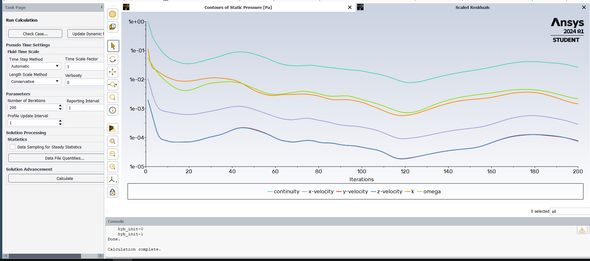
Fig. 4.5 Iterations solved
While running the calculation the parameter for the number of iterations was set to be 200 and Automatic Step Method was used.
  - Results for velocity -1.8 m/s
An analysis of the velocity magnitude contours reveals the variations of velocity across the wind tunnel. The maximum velocity is achieved in the test section. The maximum velocity for this case was found to be 5.61 m/s.
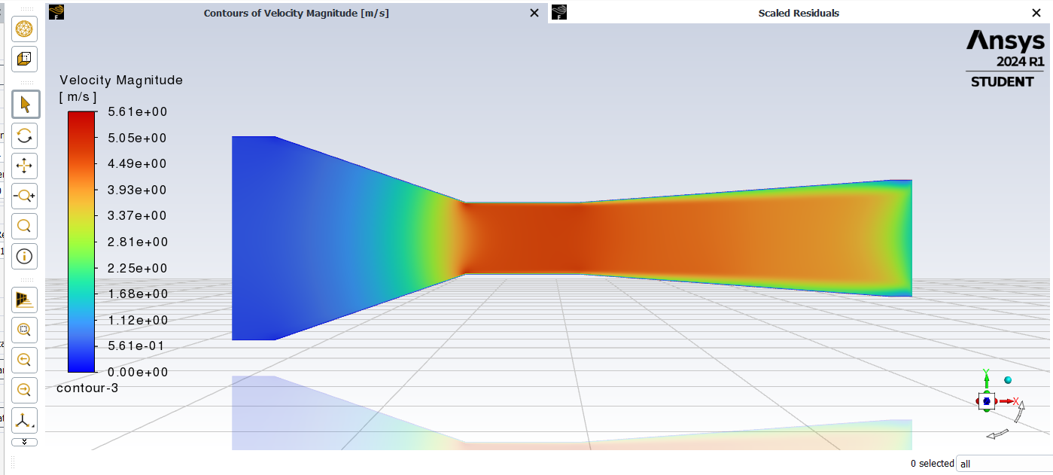
Fig. 4.6 Contours of Velocity Magnitude at velocity -1.8 m/s

An examination of the velocity component across the X axis reveals contour plots in the direction in which the air will flow from the contraction to the diffuser. The maximum value for velocity in X direction is 5.46 m/s.
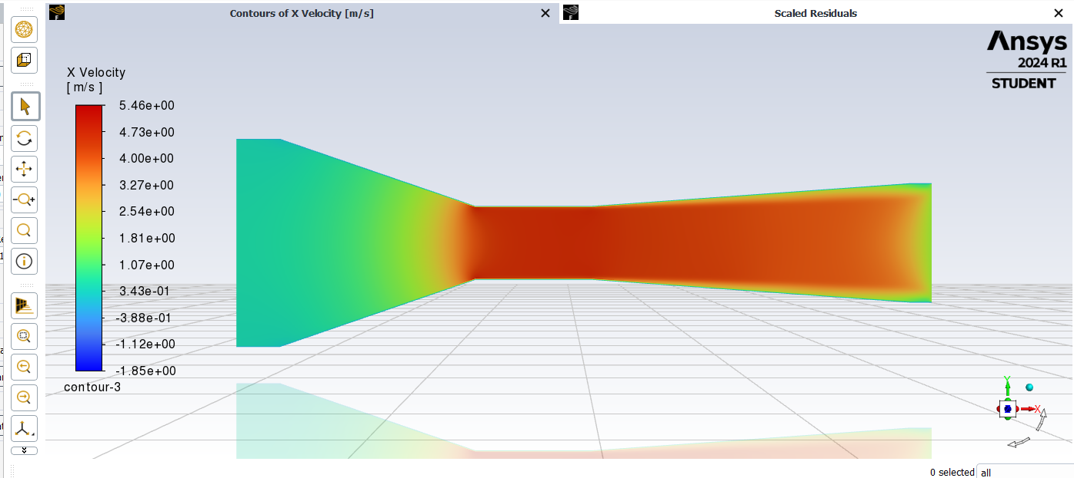
Fig. 4.7 Contours of X Velocity at velocity -1.8 m/s

The simulation of the static pressure contours shows a pressure distribution characterized by both positive and negative pressures. The minimum pressure observed is -24.18 Pa.
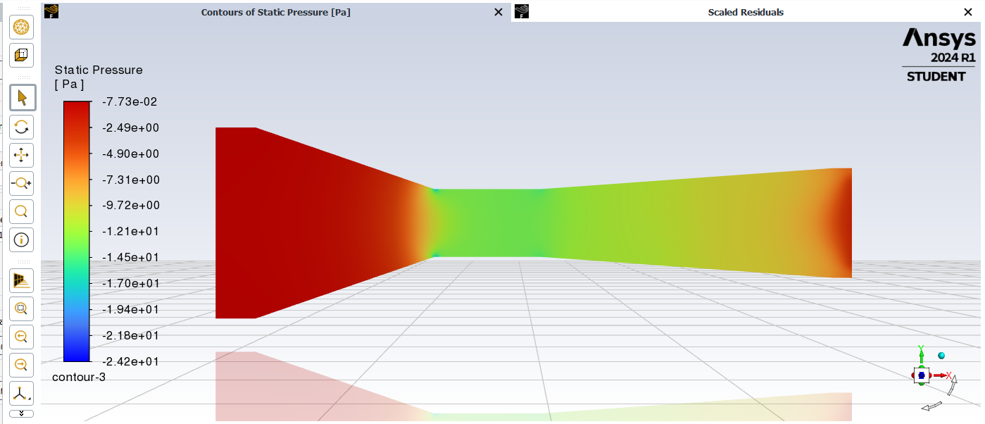
Fig. 4.8 Contours of Static Pressure at velocity -1.8 m/s

An inspection of the turbulent intensity reveals variance in turbulence levels across the wind tunnel. The minimum turbulence for this velocity is 0.42%
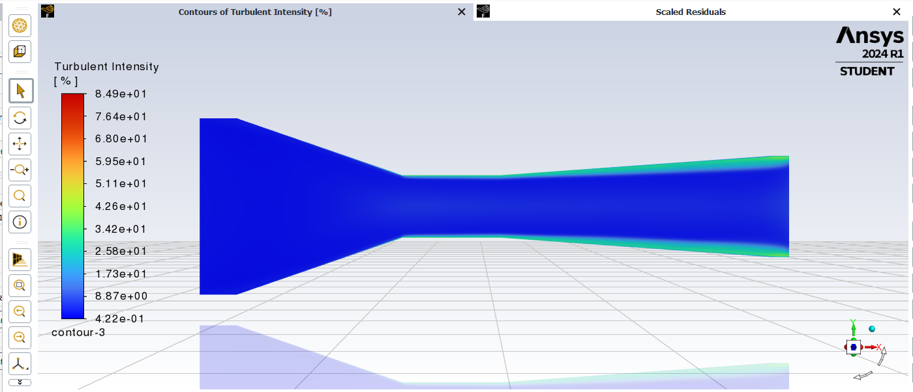
Fig. 4.9 Contours of Turbulent Intensity at velocity -1.8 m/s

  - Results for velocity -2.5 m/s
An analysis of the velocity magnitude contours reveals that the flow reaches a maximum speed of 7.82 m/s.
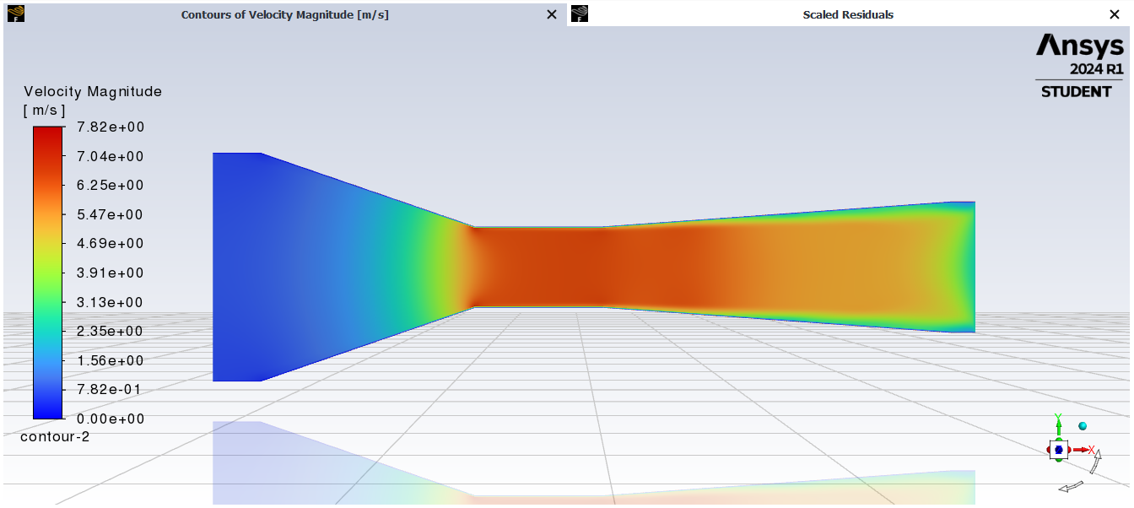
Fig. 4.10 Contours of Velocity Magnitude at velocity -2.5 m/s

The maximum velocity in the X direction reaches 7.61 m/s.
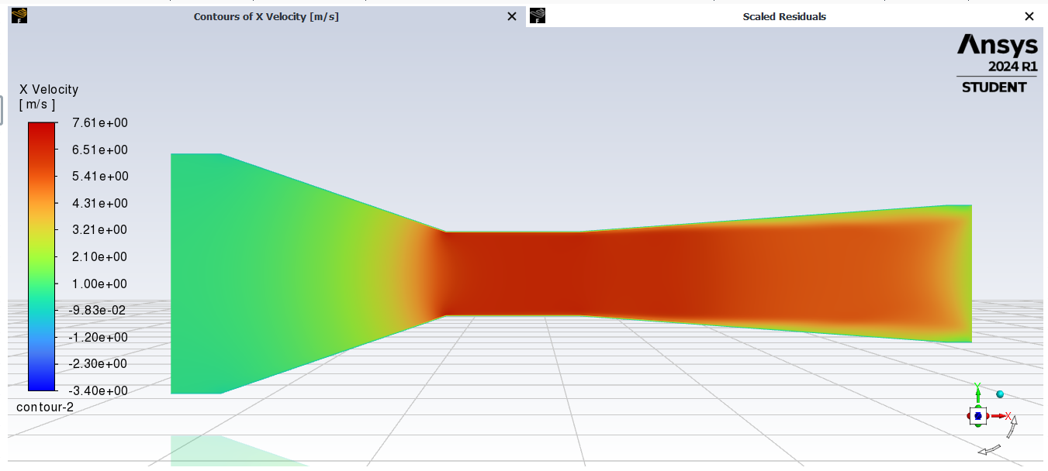
Fig. 4.11 Contours of X Velocity at velocity -2.5 m/s

The highest pressure measured within the domain reaches -1.51 Pa, while the lowest pressure recorded is -46.8 Pa.
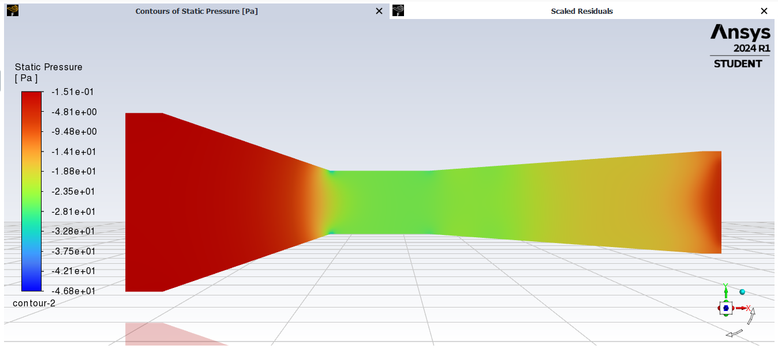
Fig. 4.12 Contours of Static Pressure at velocity -2.5 m/s

The minimum turbulence intensity value of 0.069% in the test section signifies region of comparatively low turbulence.
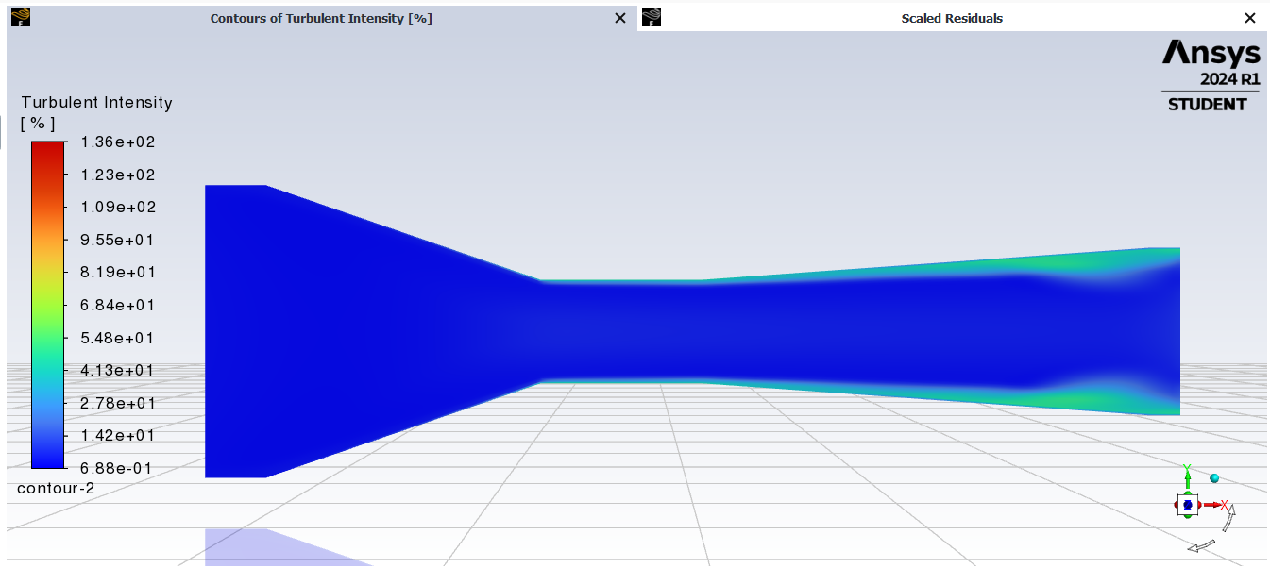
Fig. 4.13 Contours of Turbulent Intensity at velocity -2.5 m/s

  - Results for velocity -2.8 m/s
An analysis of the Velocity Magnitude contours reveals that the flow reaches a maximum speed of 8.77 m/s.
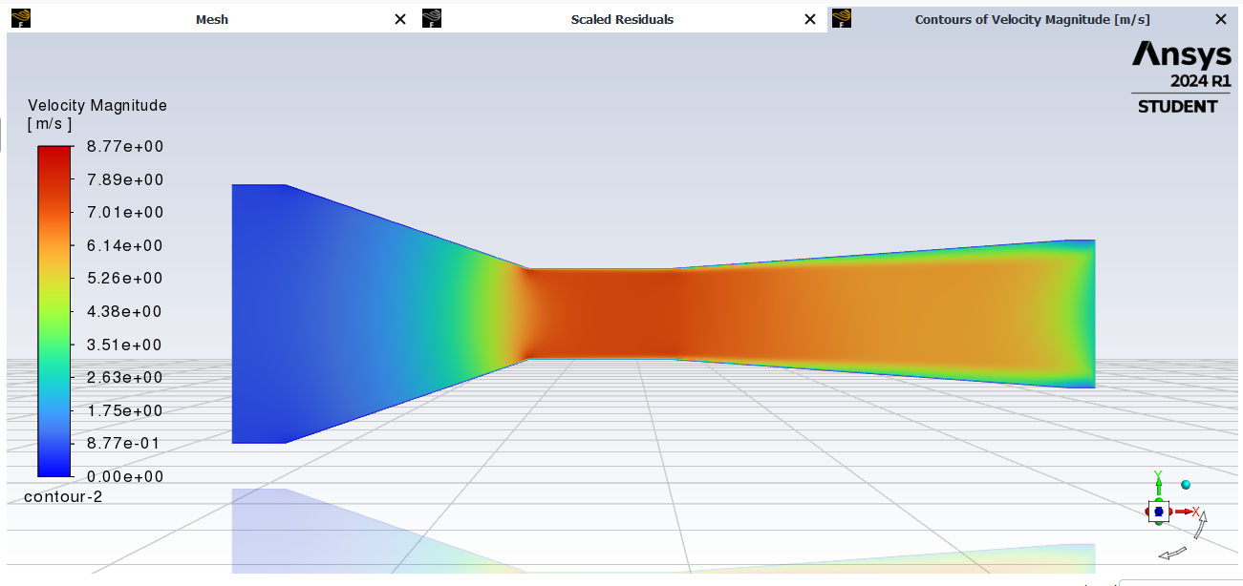
Fig. 4.14 Contours of Velocity Magnitude at velocity -2.8 m/s

An analysis of the velocity magnitude in X contours reveals that the flow reaches a maximum speed of 8.53 m/s.
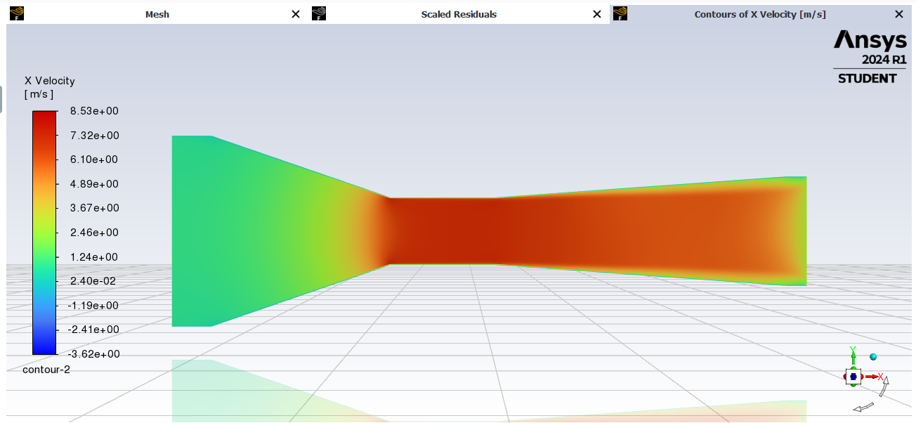
Fig. 4.15 Contours of X Velocity at velocity -2.8 m/s

The plot of the Static Pressure contours reveals that the minimum pressure generated in the test section was -58.75 Pa.

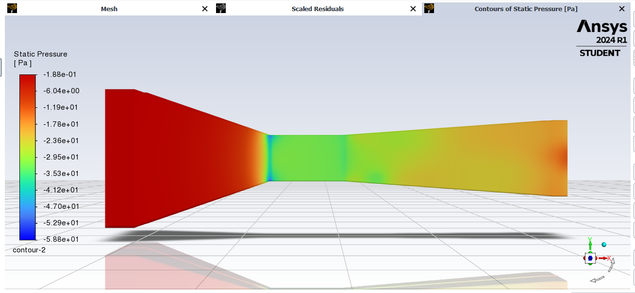
Fig. 4.16 Contours of Static Pressure at velocity -2.8 m/s

The minimum turbulence intensity value of 0.078% in the test section signifies region of comparatively low turbulence.
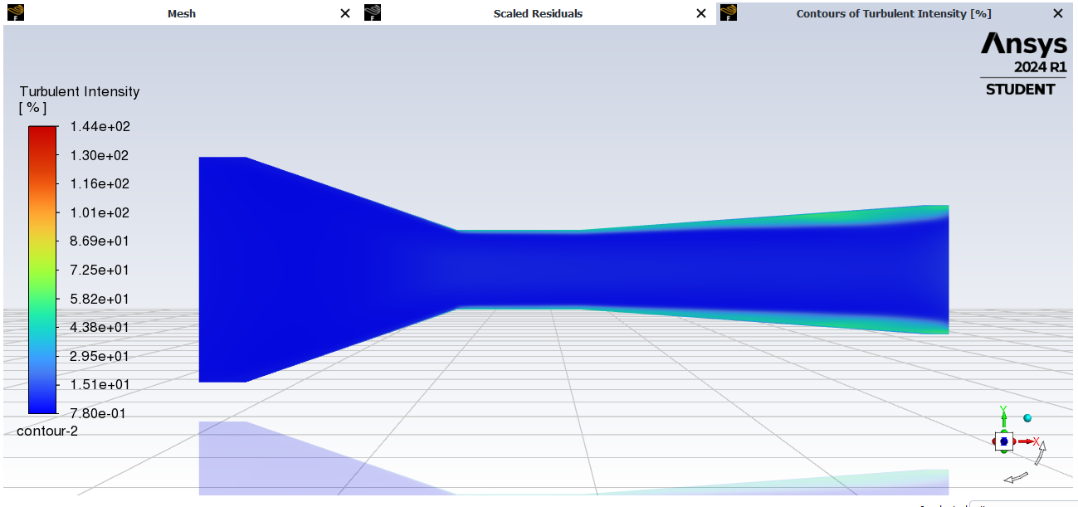
Fig. 4.17 Contours of Turbulent Intensity at velocity -2.8 m/s

  - Results for velocity -3.0 m/s
An analysis of the Velocity Magnitude contours reveals that the flow reaches a maximum speed of 9.40 m/s
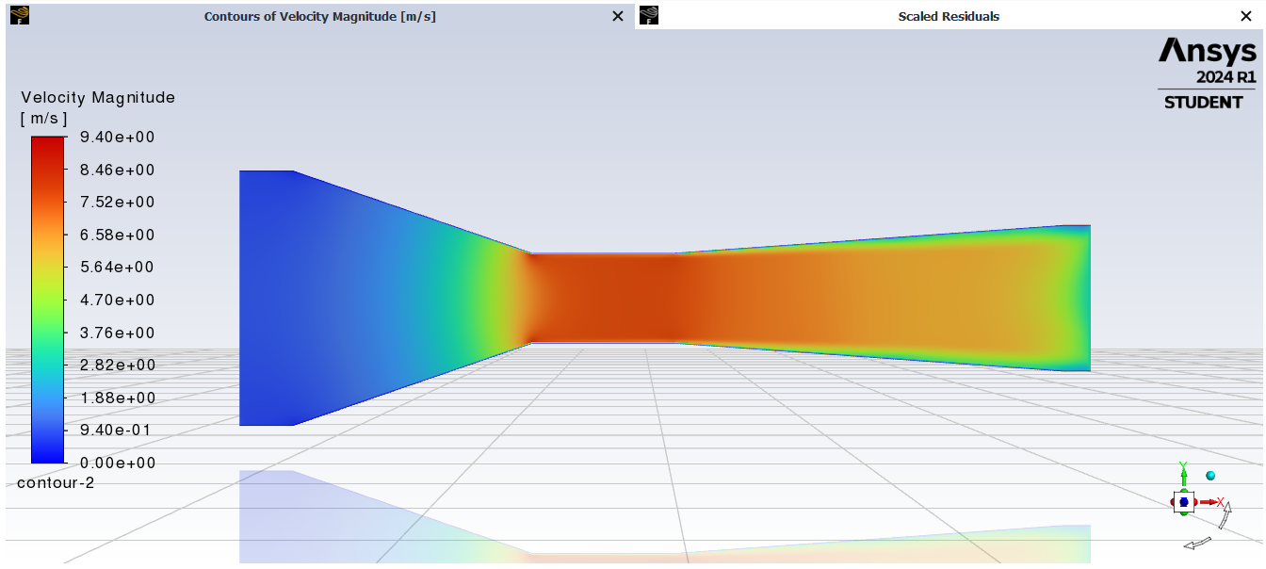
Fig. 4.18 Contours of Velocity Magnitude at velocity -3.0 m/s

An analysis of the velocity magnitude in X contours reveals that the flow reaches a maximum speed of 8.53 m/s.
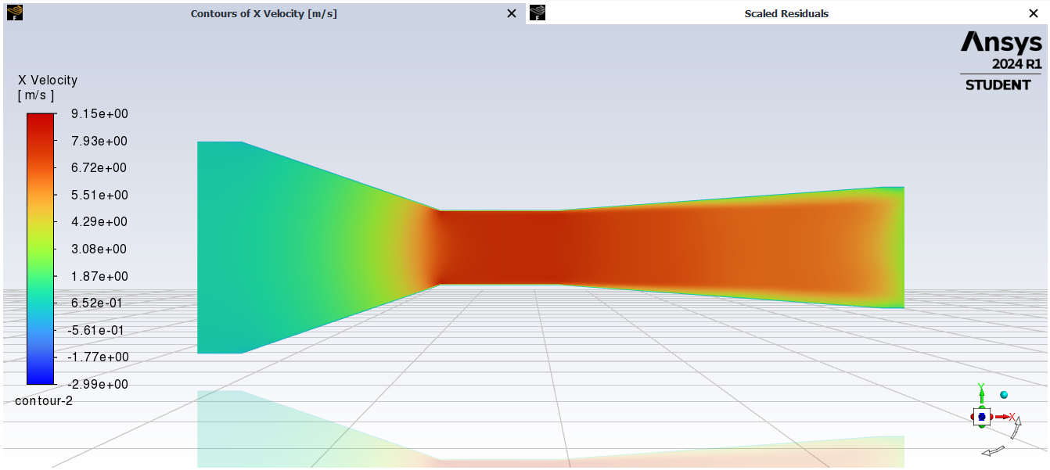
Fig. 4.19 Contours of X Velocity at velocity -3.0 m/s

The plot of the Static Pressure contours reveals that the minimum pressure generated in the test section was -58.75 Pa.

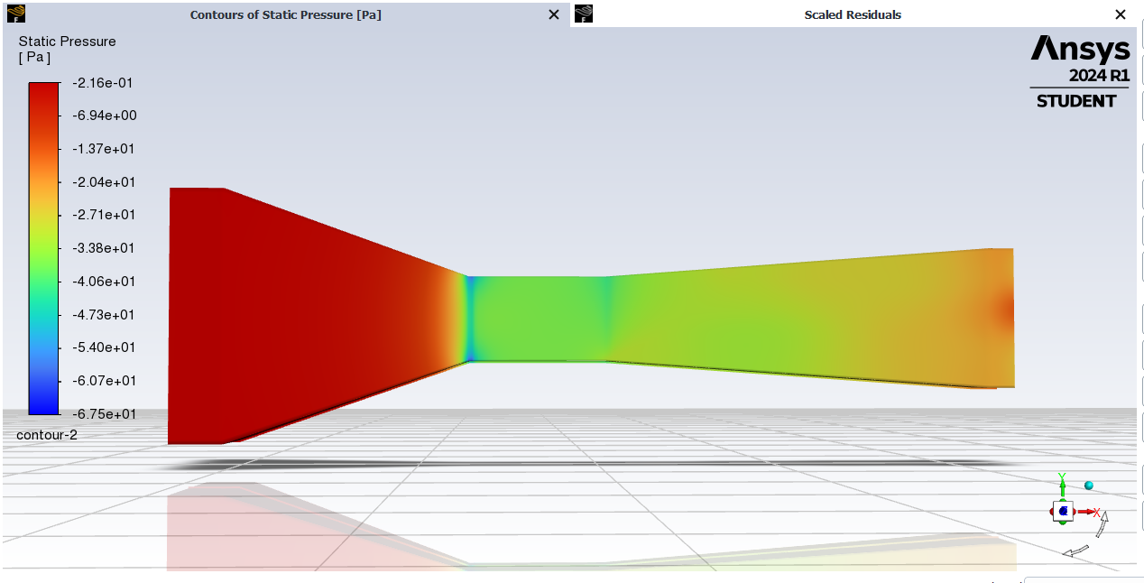
Fig. 4.20 Contours of Static Pressure at velocity -3.0 m/s

The minimum turbulence intensity value of 0.078% in the test section signifies region of comparatively low turbulence.
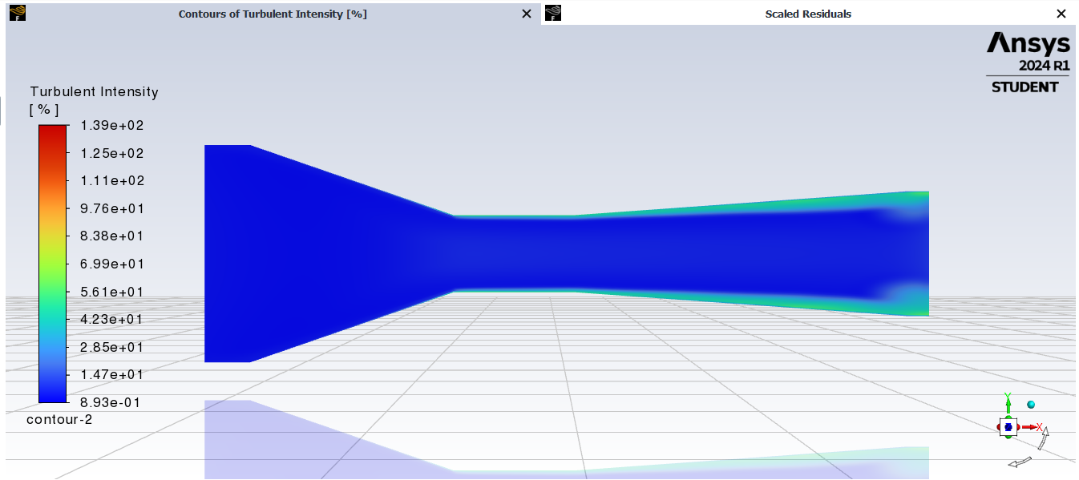
Fig. 4.21 Contours of Turbulent Intensity at velocity -3.0 m/s

  - Final Results of simulation
The figure below shows the path lines for velocity magnitude. From this we understand that there is a smooth flow in the wind tunnel test section. The 3D simulation depicts the spatial distribution of velocity magnitude.
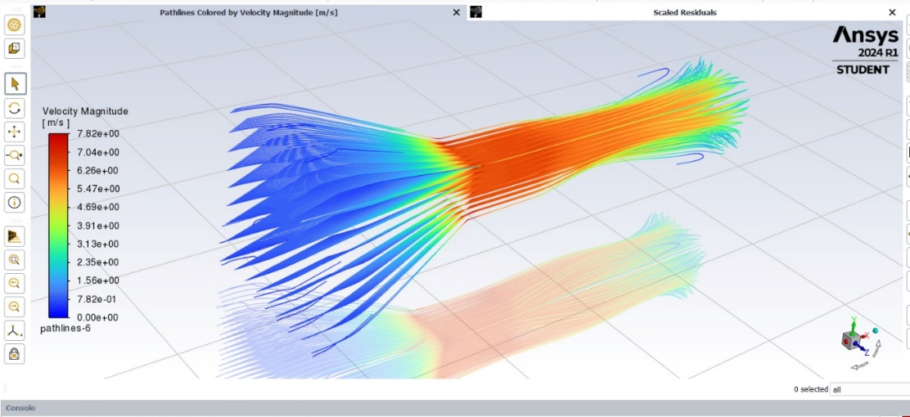
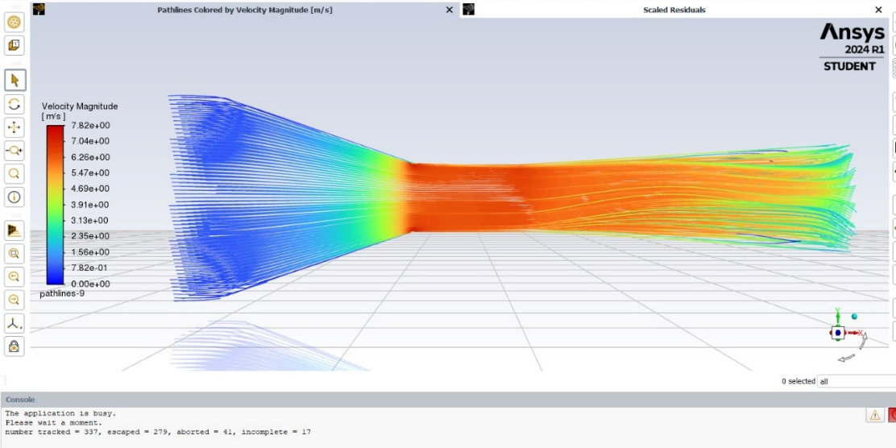 Fig. 4.22 Path lines coloured by -2.5 m/s velocity magnitude

All results have been compared below in a tabular format.
Table 4.1 Results of Simulation
Velocity at Outlet (m/s) | Max Velocity (m/s) | Max Velocity (X) (m/s) | Min Pressure (Pa) | Min Turbulent Intensity
1.8 | 5.61 | 5.46 | -24.18 | 0.42%
2.5 | 7.82 | 7.61 | -46.80 | 0.69%
2.8 | 8.77 | 8.53 | -58.75 | 0.78%
3.0 | 9.40 | 9.14 | -67.47 | 0.86%

Thus, we can conclude that as the Outlet Velocity increases subsequently the velocity in the test section also increase which also increases the turbulent intensity

Chapter 5
Fabrication of Wind Tunnel

This chapter presents the steps of the fabrication process of the Wind Tunnel and gives in depth detail of each component material and fabrication.
5.1 Fabrication methodology
For the fabrication process of wind tunnel, metal sheet of mild steel of thickness 1.5mm was selected. Hydraulic press was used to cut the sheets which were then welded together to form the diffuser section and contraction section. To make the parts completely air tight and leak proof all edges were covered with silicon sealant.
For the test section, transparent acrylic of thickness 6mm was selected. Laser cutting done to make holes for the nuts and bolts and a rectangular section was cut as a door where a hinge was attached. A door was made through which the test piece can be inserted. The fan used is a Crompton industrial exhaust fan with a blade sweep of 380mm. The test pieces including the aerofoil, car and aeroplane were 3D printed.
An anemometer is used for finding the velocity of air in the test section

5.2 Wind Tunnel Setup
Contraction
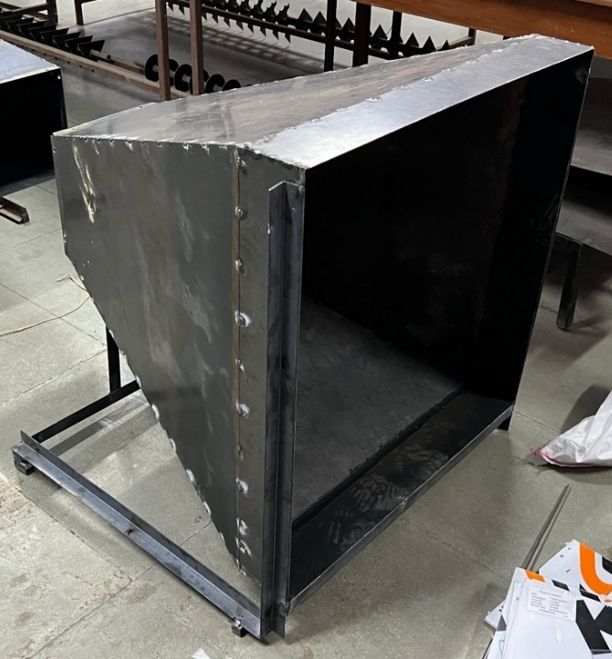
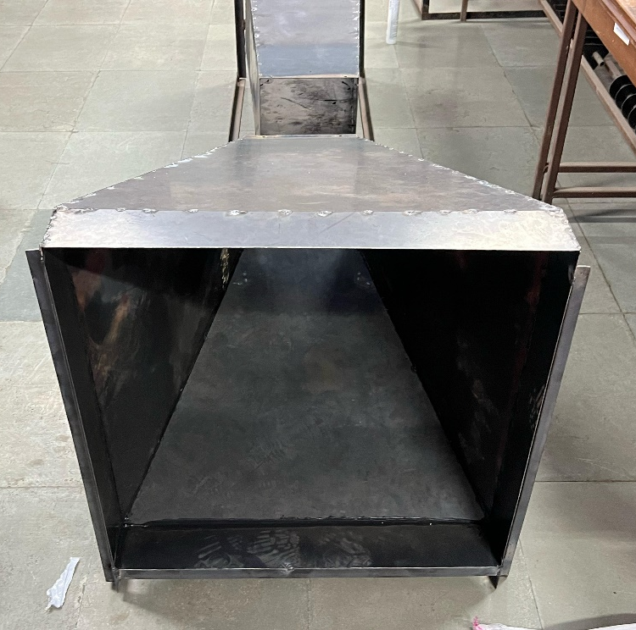
Fig. 5.1 Contraction

Honey Comb Mesh
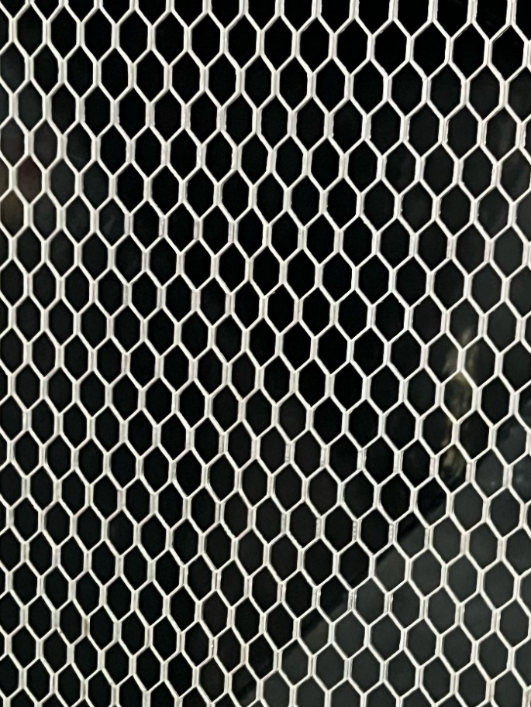
Fig. 5.2 Honeycomb mesh
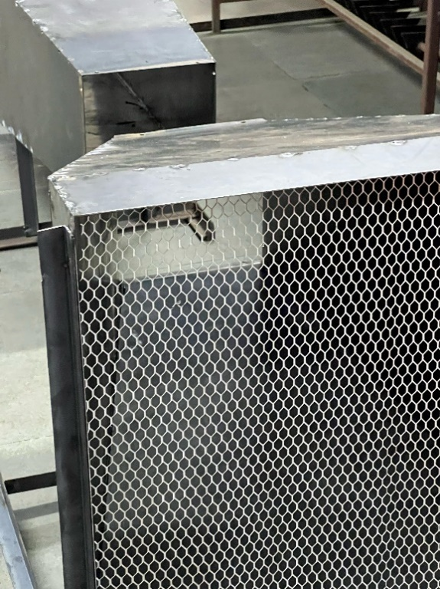
Fig. 5.3 Honeycomb mesh fitted
Diffuser
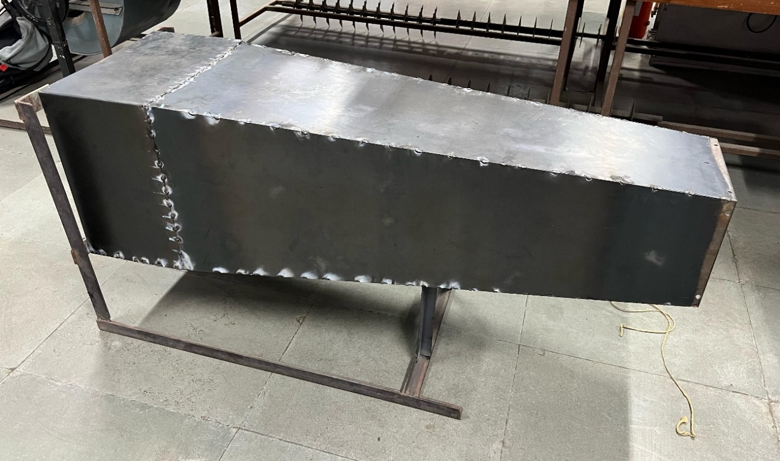
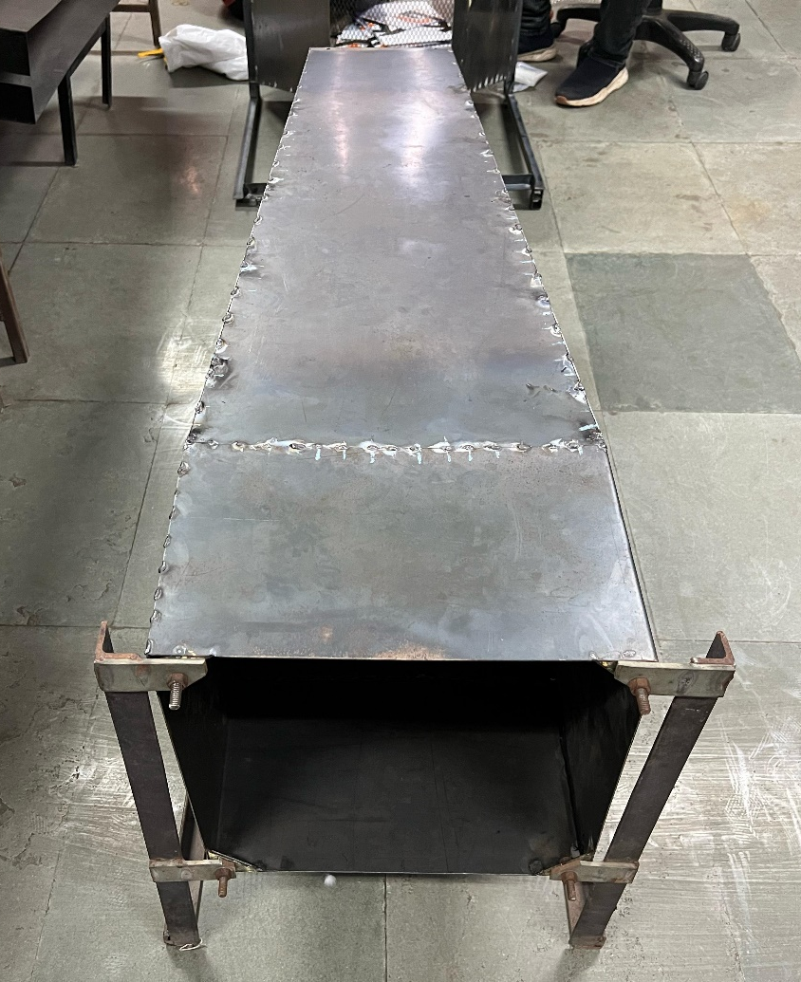
Fig. 5.4 Diffuser
Fan
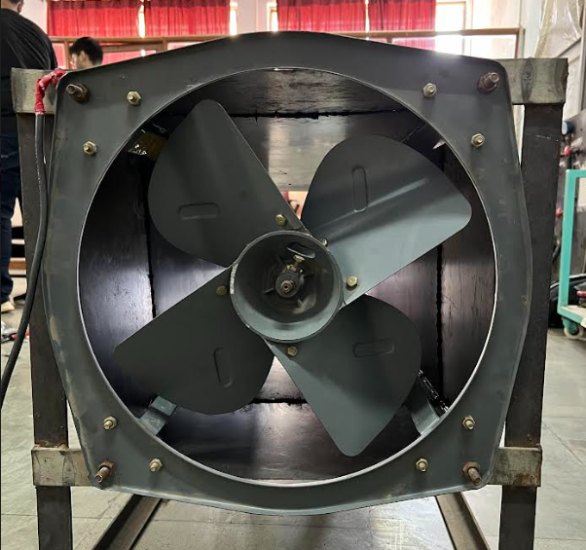
Fig. 5.5 Fan
Test section
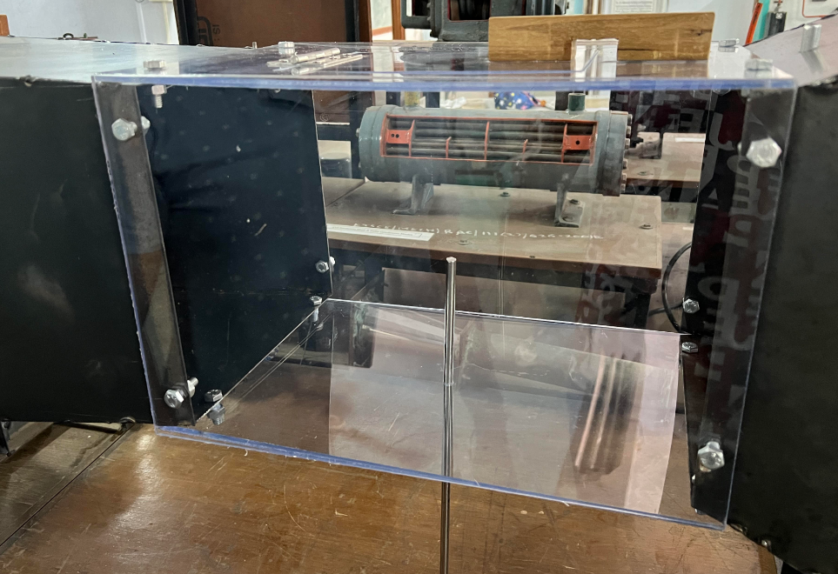
Fig. 5.6 Test Section

Test Pieces
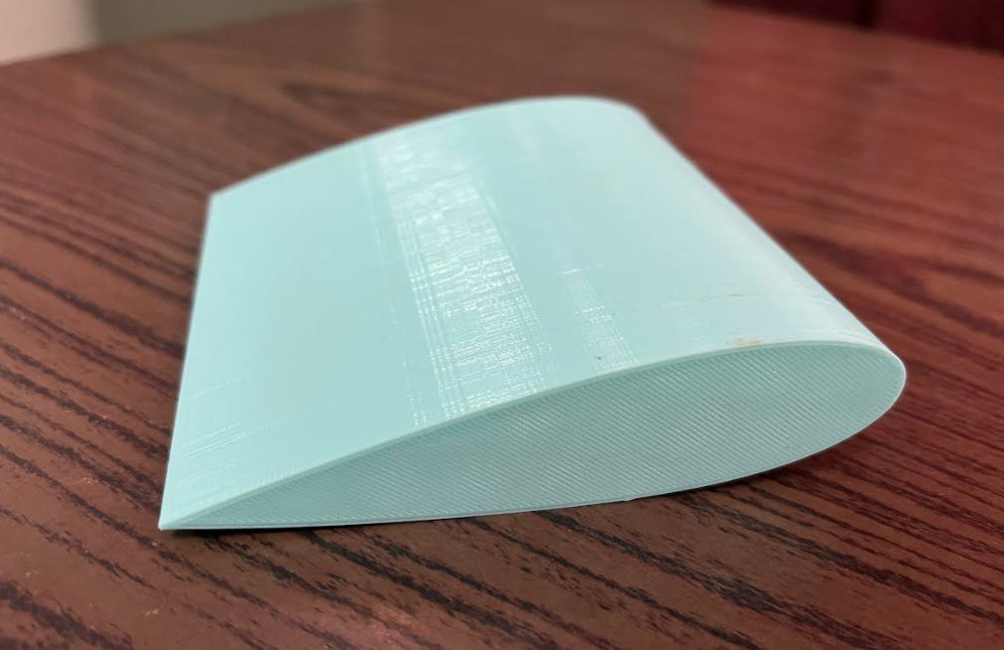
Fig. 5.7 Aerofoil
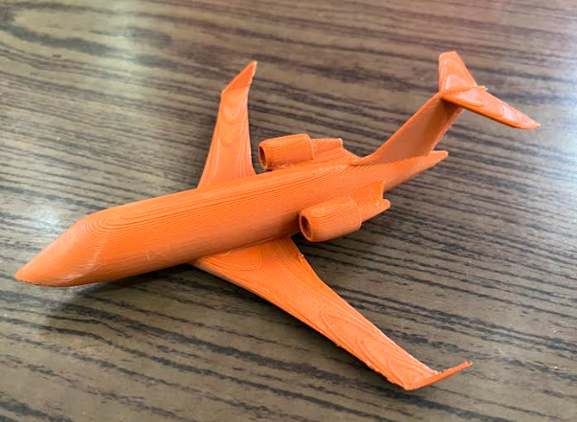
Fig. 5.8 Aeroplane
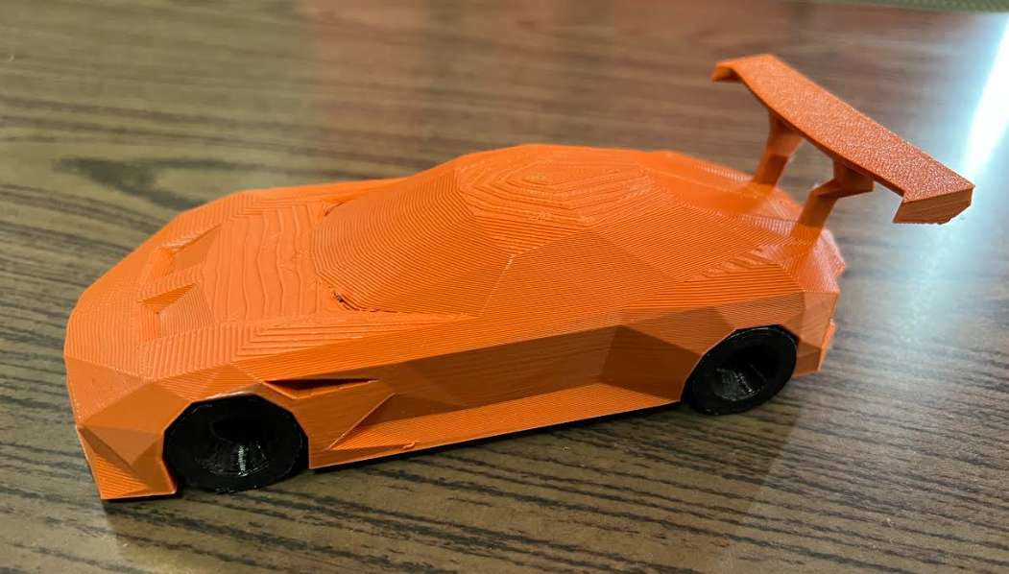
Fig. 5.9 Car
Test piece holder
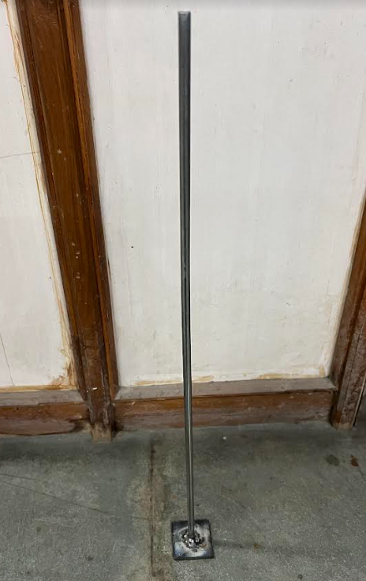
Fig 5.10 Test Piece Holder
Anemometer
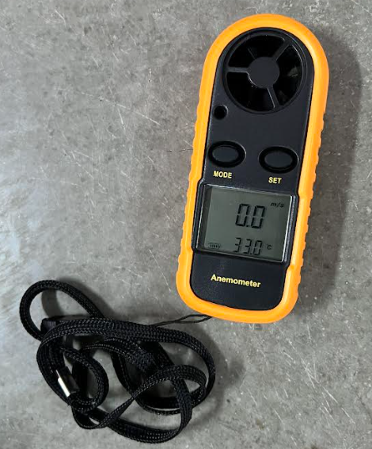
Fig. 5.11 Anemometer
Fully Assembled Wind Tunnel
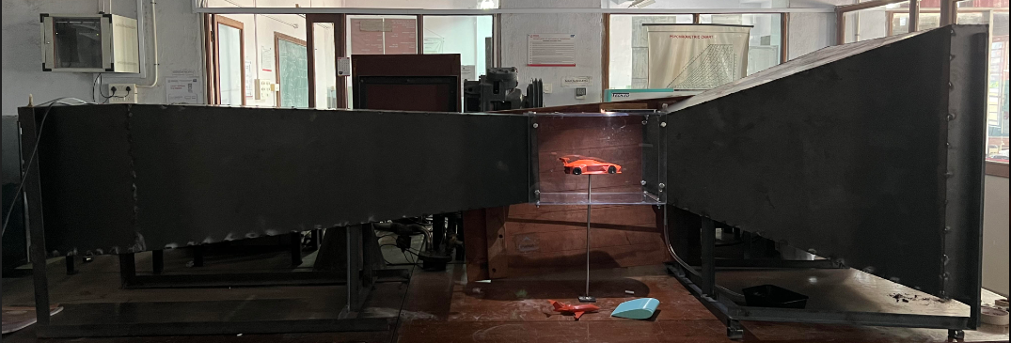
Fig. 5.12 Fully assembled Wind Tunnel

Air flow Visualization
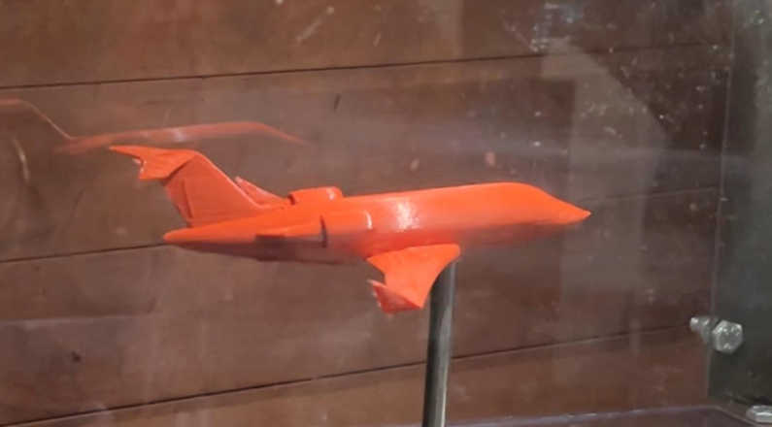
Fig. 5.13 Air flow Visualization

Table 5.1 Bill of Materials
Sr. No. | Material | Cost (Rs)
1 | MS sheet (1.5mm) x 2 | 8,500
2 | Fan | 4,300
3 | Acrylic Sheets | 1,000
4 | Honeycomb Mesh | 400
5 | Angle Rod (15m) | 530
6 | Anemometer | 1,100
7 | Fan Regulator | 180
8 | Test Pieces (3D printing) | 650
9 | Silicon Sealant | 600
10 | LED strip | 55
11 | Nuts and Bolts | 140
12 | Dhoop Sticks | 95
Total |  | 17,550

Chapter 6
Conclusion

This chapter presents the summary of all the objectives completed during this project and its future scope.

6.1 Summary
A thorough study and survey was done on Wind Tunnels. Their working, types and applications were studied in-depth. The study also included several rules and factors that should be taken into account while designing a wind tunnel. These findings governed the design process of the wind tunnel for this project. 3D CAD models of the various components of the wind tunnel were made using the SOLIDWORKS software. The simulations including the contours of velocity, pressure and turbulence were performed on the ANSYS software, where the highest and lowest values of the same were found out. Fabrication of the different parts of the wind tunnel was done and the fan was integrated and all the parts were assembled together.
Thus, we concluded that there is an increase in the turbulent intensity when the outlet velocity and the velocity in the test section increase.
6.2 Future Scope
The integration of electronics such as load cells and air velocity sensors will help to achieve accurate readings for parameters such as Drag, Lift, Downforce and real time velocity in the test section. Experiments can be performed after the electronics are integrated which would be very beneficial for the students of the college.

References
- J. B. Barlow, W. H. Rae, A. Pope – Low-Speed Wind Tunnel Testing (3rd edition)
- J.H. Bell, R.D. Mehta - Contraction Design for Small Low-Speed Wind Tunnels
- P. Bradshaw, R.C. Pankhurst - The Design of Low-Speed Wind Tunnels
- D. Soni, S.K. Gupta, B. Singh - Wind Tunnel: A Research Tool
- N.K. Maurya, M. Manish, S.P. Dwivedi - Design & Fabrication of Low-Speed Wind Tunnel and Flow Analysis
- R.D. Mehta, P. Bradshaw - Design rules for small low speed wind tunnels
- C.J. Bahr, J. Mathew – Fundamentals of Wind Tunnel Design
- https://www.grc.nasa.gov/www/k-12/airplane/tunnozd.html
- R. Natalia, A. Mittal - Design and study of mini wind tunnel for microsystems fluid interaction under low Reynolds number flows
- https://www.nasa.gov/learning-resources/what-are-wind-tunnels-grades-k-4/
- https://www.piston.my/2022/07/19/50th-anniversary-of-the-pininfarina-wind-tunnel-which-has-shaped-car-designs-by-air/
- https://communities.bentley.com/skans_blog/posts/bridge-aero-dynamics
- https://www.autoevolution.com/schuberth-opens-wind-tunnel-for-aerodynamic-and-aeroacoustic-helmet-development-98746.html
- https://www.delabcon.com/designing-safe-and-energy-efficient-laboratory-exhaust-systems/
- T. Chandler, J. Woods, T. Shaw – Wind Tunnel Design Report
- New Jersey Institute of Technology - Design, Construction and Characterization of a Wind Tunnel

