SMART UV RISK CLASSIFICATION AND AMBIENT LIGHT MONITORING SYSTEM USING ESP8266 WITH THINGSPEAK CLOUD CONNECTIVITY
INTERNET OF THINGS PROJECT  Nov/Dec 2026 |  | INTERNET OF THINGS PROJECT REPORT SUBMITTED IN PARTIAL FULFILLMENT OF THE REQUIREMENTS  FOR THE AWARD OF THE  DEGREE OF BACHELOR OF ENGINEERING IN  ELECTRONICS AND COMMUNICATION ENGINEERING  OF THE ANNA UNIVERSITY
 |  | 
 |  | Submitted by  PRAVIN A - 722824106121
  PROJECT
  WORK
BATCH
2024 – 2028
 | Sri Eshwar College of Engineering  (An Autonomous Institution)  Kinathukadavu (Tk), Coimbatore - 641 202, Tamil Nadu  Approved by AICTE, New Delhi and Affiliated to Anna University, Chennai |  | 



BONAFIDE CERTIFICATE

Certified that this Report titled “ SMART UV RISK CLASSIFICATION AND AMBIENT LIGHT MONITORING SYSTEM USING ESP8266 WITH THINGSPEAK CLOUD CONNECTIVITY ” is the bonafide work of
PRAVIN A | 722824106121
who carried out the project work under my supervision.

----------------------------------------- | -----------------------------------------
SIGNATURE | SIGNATURE
Dr. N. Shanmugasundaram, M.E., Ph.D.,  HEAD OF DEPARTMENT  Department of ECE,  Sri Eshwar College of Engineering,  Coimbatore – 641 202. | Dr.S.Ramalingam, M.E., Ph.D.,  SUBJECT FACULTY  Associate Professor,  Department of ECE,  Sri Eshwar College of Engineering,  Coimbatore – 641 202.

Submitted for the Autonomous Semester End Internet of Things Project Viva-Voce held on ………………………...

_________________________  INTERNAL EXAMINER | _________________________  EXTERNAL EXAMINER
QUALITY POLICY
To establish a system of Quality Enhancement, which would on a continuous basis evaluate and enhance the quality of teaching – learning, research and extension activities of the institution, leading to improvements in all processes, enabling the institution to attain excellence.

INSTITUTE VISION
To be recognized as a premier institution, grooming students into globally acknowledged engineering professionals.

INSTITUTE MISSION
- Providing outcome and value based engineering education.
- Nurturing research and entrepreneurial culture.
- Enabling students to be industry ready and fulfil their career aspirations.
- Grooming students through behavioral and leadership training programs.

DEPARTMENT OF ELECTRONICS AND COMMUNICATION ENGINEERING

DEPARTMENT VISION
To groom students into futuristic and globally competent Electronics and Communication engineering professionals.
DEPARTMENT MISSION
- To impart quality education with moral and ethical values to develop competent engineers, leaders and successful entrepreneurs
- To establish state-of-art infrastructure and provide opportunities to update on emerging tools and technologies
- To empower the faculty towards excellence in teaching – learning, consultancy, research and development activities
- To foster socially relevant and industry-oriented innovation among students.
PROGRAM EDUCATIONAL OBJECTIVES
PEO1: Pursue career in multinational organizations, research organizations and core industries, higher studies at premier institutions and establish start-ups.
PEO2: Acquire core competencies in Electronics and Communication Engineering and exposure to latest Electronic Design Automation (EDA) tools.
PEO3: Exhibit professional skills and collaborative work experience.

PROGRAM OUTCOMES
PO1: Engineering Knowledge: Apply knowledge of mathematics, natural science, computing, engineering fundamentals and an engineering specialization as specified in WK1 to WK4 respectively to develop to the solution of complex engineering problems.
PO2: Problem Analysis: Identify, formulate, review research literature and analyze complex engineering problems reaching substantiated conclusions with consideration for sustainable development. (WK1 to WK4)
PO3: Design/Development of Solutions: Design creative solutions for complex engineering problems and design/develop systems/components/processes to meet identified needs with consideration for the public health and safety, whole-life cost, net zero carbon, culture, society and environment as required. (WK5)
PO4: Conduct Investigations of Complex Problems: Conduct investigations of complex engineering problems using research-based knowledge including design of experiments, modelling, analysis & interpretation of data to provide valid conclusions. (WK8).
PO5: Engineering Tool Usage: Create, select and apply appropriate techniques, resources and modern engineering & IT tools, including prediction and modelling recognizing their limitations to solve complex engineering problems. (WK2 and WK6)
PO6: The Engineer and The World: Analyze and evaluate societal and environmental aspects while solving complex engineering problems for its impact on sustainability with reference to economy, health, safety, legal framework, culture and environment. (WK1, WK5, and WK7).
PO7: Ethics: Apply ethical principles and commit to professional ethics, human values, diversity and inclusion; adhere to national & international laws. (WK9)
PO8: Individual and Collaborative Team work: Function effectively as an individual, and as a member or leader in diverse/multi-disciplinary teams.
PO9: Communication: Communicate effectively and inclusively within the engineering community and society at large, such as being able to comprehend and write effective reports and design documentation, make effective presentations considering cultural, language, and learning differences
PO10: Project Management and Finance: Apply knowledge and understanding of engineering management principles and economic decision-making and apply these to one’s own work, as a member and leader in a team, and to manage projects and in multidisciplinary environments.
PO11: Life-Long Learning: Recognize the need for, and have the preparation and ability for i) independent and life-long learning ii) adaptability to new and emerging technologies and iii) critical thinking in the broadest context of technological change. (WK8)
PROGRAM SPECIFIC OUTCOMES
PSO1: Interpret and Design Electronic systems using Internet of Things, VLSI Technology and Efficient signal processing algorithms
PSO2: Apply knowledge to solve challenges in Communication Systems and Network
TABLE OF CONTENTS
CHAPTER NO. | TITLE |  | PAGE NO.
 | ABSTRACT |  | iii
 | LIST OF TABLES |  | iv
 | LIST OF FIGURES |  | v
1 | INTRODUCTION |  | 1
 | 1.1 | BACKGROUND AND MOTIVATION | 1
 | 1.2 | PROBLEM STATEMENT | 2
 | 1.3 | CORE OBJECTIVE OF THE PROJECT | 3
 | 1.4 | SCOPE AND SIGNIFICANCE | 3
2 | LITERATURE SURVEY |  | 5
 | 2.1 | REVIEW OF EXISTING SYSTEMS AND SOLUTIONS | 5
 | 2.2 | LIMITATIONS OF EXISTING SOLUTIONS | 6
 | 2.3 | COMPARATIVE STUDY ON ALTERNATIVE SOLUTION | 7
3 | PROPOSED SOLUTION |  | 9
 | 3.1 | PROPOSED SYSTEM OVERVIEW | 9
 | 3.2 | SYSTEM ARCHITECTURE / BLOCK DIAGRAM | 9
 | 3.3 | WORKFLOW / PROCESS FLOW | 10
 | 3.4 | FUNCTIONAL REQUIREMENTS | 12
 | 3.5 | NON-FUNCTIONAL REQUIREMENTS | 13
4 | HARDWARE DESCRIPTION |  | 14
 | 4.1 | HARDWARE COMPONENTS USED | 14
 | 4.2 | HARDWARE INTERFACING & PIN CONFIGURATION | 15
 | 4.3 | CIRCUIT DIAGRAM | 15
 | 4.4 | HARDWARE SETUP AND IMPLEMENTATION | 16
5 | SOFTWARE DESIGN |  | 18
 | 5.1 | PROGRAMMING ENVIRONMENT / IDE | 18
 | 5.2 | COMMUNICATION PROTOCOLS | 18
 | 5.3 | USER INTERFACE DESIGNED | 19
 | 5.4 | WEB APPLICATION DEVELOPED WITH DATABASE & CLOUD | 21
6 | IMPLEMENTATION AND INTEGRATION |  | 23
 | 6.1 | STEP-BY-STEP IMPLEMENTATION | 23
 | 6.2 | HARDWARE AND SOFTWARE INTEGRATION | 24
7 | RESULTS AND DISCUSSION |  | 25
 | 7.1 | TESTING AND VALIDATION ON-FIELD REAL-TIME IMPLEMENTATION | 25
 | 7.2 | HARDWARE SETUP AND RESULTS | 26
 | 7.3 | SOFTWARE RESULTS | 26
8 | CONCLUSION & FUTURE SCOPE |  | 29
9 | REFERENCES |  | 30
10 | ANNEXURE |  | 31
ABSTRACT
The smart uv risk classification and ambient light monitoring system using esp8266 with thingspeak cloud connectivity, named UV Guard, is a low-cost, portable environmental monitoring prototype that measures ultraviolet (UV) radiation, classifies the detected level into four risk categories, and alerts users through visual indicators. Excessive UV exposure can cause sunburn, premature skin ageing, eye damage, and skin cancer. The proposed system addresses the need for a simple and accessible device to improve awareness of UV exposure using a NodeMCU ESP8266 microcontroller, an analog UV sensor, a light-dependent resistor (LDR), a 1.8-inch ST7735 TFT display, and red and green LEDs.
The UV sensor output is sampled every 25 ms, averaged over one-second windows, and processed using an exponential filter to reduce noise. The filtered readings are compared against configurable thresholds with hysteresis to classify UV risk into four levels: LOW, MODERATE, HIGH, and VERY HIGH. The LDR provides an indication of ambient brightness. The TFT display presents the sensor reading, risk category, level bar, ambient-light status, protective advice, and cloud-connection status. The red and green LEDs provide immediate visual alerts. Sensor readings are transmitted over Wi-Fi to the ThingSpeak cloud platform at 16-second intervals for remote monitoring through a web dashboard. The device continues local monitoring when internet connectivity is unavailable. A serial test mode enables individual risk levels to be forced for functional verification. The current prototype reports raw ADC counts using preliminary thresholds; calibration against a reference UV meter is required before reporting a true UV Index.
This project also contributes to the following United Nations Sustainable Development Goals (SDGs):
- SDG 3: Good Health and Well-being — by promoting awareness of potentially harmful UV exposure and encouraging appropriate protective measures.
- SDG 7: Affordable and Clean Energy — through the use of a low-cost, portable electronic monitoring prototype; its direct contribution to clean-energy outcomes is limited.
Keywords: UV monitoring, ESP8266, NodeMCU, UV risk classification, ambient light monitoring, TFT display, LDR, IoT, ThingSpeak, TRL 4, SDG 3, SDG 7.

LIST OF TABLES
Table No | Table Name | Page Number
Table 1 | Existing UV Monitoring Systems and Analysis | 6
Table 2 | Limitations of Existing Solutions and How UV Guard Responds | 7
Table 3 | Comparison of Candidate UV Sensors | 8
Table 4 | UV Levels, Display Colours and LED Indication | 9
Table 5 | Hardware Components Used in UV Guard | 14
Table 6 | TFT Display to NodeMCU Connections | 15
Table 7 | Sensor, LDR and LED Connections | 15
Table 8 | Software Tools and Libraries Used | 18
Table 9 | Communication Interfaces Used in UV Guard | 19
Table 10 | ThingSpeak Field Mapping | 22
Table 11 | Cloud Status Indicator on the TFT | 22
Table 12 | Integration Test Summary | 24
Table 13 | Field Test Conditions and Procedure | 25
Table 14 | Recorded Field Readings | 25
Table 15 | Hardware Functional Test Results | 26
Table 16 | Display and LED Response in Test Mode | 27
Table 17 | Cloud and Wi-Fi Test Results | 28
Table 18 | Objectives Compared with Outcomes | 28

LIST OF FIGURES
Figure No | Figure Name | Page Number
Figure 1 | UV Radiation Spectrum and UV Index Categories | 1
Figure 2 | UV Guard Prototype Overview | 4
Figure 3 | Classification of Existing UV Monitoring Approaches | 6
Figure 4 | System Architecture / Block Diagram of UV Guard | 10
Figure 5 | Workflow / Flowchart of UV Guard | 11
Figure 6 | Circuit Diagram of UV Guard | 16
Figure 7 | Hardware Prototype of UV Guard | 17
Figure 8 | Startup Screen of UV Guard | 20
Figure 9 | Main Monitoring Screen for the Four UV Levels | 20
Figure 10 | Sensor Information Screen of UV Guard | 21
Figure 11 | ThingSpeak Dashboard Showing UV Readings | 22
Figure 12 | Serial Monitor Output of UV Guard | 27

CHAPTER 1 INTRODUCTION
1.1 BACKGROUND AND MOTIVATION
Ultraviolet (UV) radiation is the part of the electromagnetic spectrum with wavelengths between about 100 nm and 400 nm, shorter than those of visible light and therefore invisible to the human eye. The Sun is the main natural source of UV radiation. It is conventionally divided into three bands: UVC (100–280 nm), UVB (280–315 nm) and UVA (315–400 nm). UVC is absorbed almost completely by the atmosphere, so the radiation that reaches the Earth’s surface consists mainly of UVA together with a small but biologically very effective portion of UVB.
Exposure to UV radiation has both short-term and long-term effects on health. In the short term, it causes sunburn and painful inflammation of the cornea known as photokeratitis. Repeated and prolonged exposure is associated with premature skin ageing, cataracts and several forms of skin cancer. To communicate the danger in a simple form, the World Health Organization, together with international partner agencies, has promoted the Global Solar UV Index, a standard scale in which values of 0–2 are described as Low, 3–5 as Moderate, 6–7 as High, 8–10 as Very High and 11 or more as Extreme, with protective advice attached to each category [1].
The risk is particularly relevant in tropical countries such as India, where the Sun is high in the sky for much of the year and UV levels are therefore strong. Outdoor workers such as farmers, construction workers, traffic personnel and street vendors, as well as school children and sports participants, spend long periods in the open. Because UV radiation cannot be seen or felt, and because it can remain strong even on hazy or partly cloudy days when the air feels comfortable, people frequently underestimate their exposure.
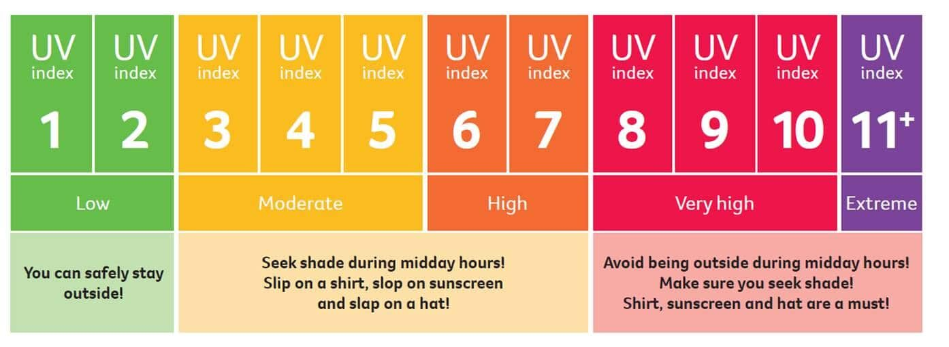Figure 1: UV Radiation Spectrum and UV Index Categories
The information normally available to the public is a regional UV forecast published in weather applications, which does not reflect local conditions such as open ground, reflective surfaces or shade. Dedicated UV radiometers give accurate local readings but are costly and are intended for professional use. The availability of inexpensive analog UV sensors and Wi-Fi-enabled microcontrollers such as the ESP8266 makes it possible to build a compact device that senses the UV level where the user actually is and warns the user in an immediate and easily understood way. This opportunity motivated the development of UV Guard – the Smart UV Detection and Notification System.
1.2 PROBLEM STATEMENT
Although the harmful effects of excessive UV exposure are well known, a person standing outdoors has no direct way of knowing whether the current UV level is safe. The existing options leave a gap between forecast-based awareness and affordable, local, real-time notification. The main difficulties can be summarised as follows:
- UV radiation is invisible and does not produce a sensation of heat in proportion to its intensity, so it cannot be judged by observation.
- Forecasts in weather applications describe a wide area and a time period, not the conditions at the user’s exact location.
- Professional UV meters are expensive, give a single numerical value and require the user to interpret it.
- Many low-cost experimental designs only print a raw sensor value on a serial monitor, without a risk category, protective advice or any ambient-light context.
- Frequent full-screen redrawing of small displays produces visible flicker, and unfiltered sensor readings fluctuate, which makes the displayed information difficult to trust.
The core problem addressed in this project can therefore be stated as follows: “To design and develop a low-cost, portable embedded system that continuously measures ultraviolet radiation, classifies the measured level into easily understood risk categories, and notifies the user through a graphical display and LED indicators, while remaining extensible to cloud-based monitoring.”
UV Guard solves this problem by combining an analog UV sensor, an ambient-light sensor, an ESP8266 controller, a TFT display and two indicator LEDs into one compact unit that updates every second and also uploads its readings to a cloud service for remote viewing.
1.3 CORE OBJECTIVE OF THE PROJECT
The primary objective of the project is to develop a reliable, low-cost and portable UV monitoring device that measures environmental UV radiation, determines the corresponding risk level and gives the user clear visual notification, with the possibility of remote monitoring through the cloud. The specific objectives of the project are:
- To measure the UV sensor output continuously using the analog input (A0) of the ESP8266 NodeMCU.
- To improve reading stability by averaging multiple ADC samples in each one-second window and applying an exponential smoothing filter.
- To classify the measured value into four levels – LOW, MODERATE, HIGH and VERY HIGH – using configurable thresholds with hysteresis so that the level does not flicker near a boundary.
- To detect whether the surroundings are bright or dark using a light-dependent resistor (LDR) connected to a digital input, with a time-based debounce.
- To present the risk level, sensor value, level bar, light condition and protective advice on a 1.8-inch TFT display using partial screen updates to reduce flicker.
- To provide immediate safe/alert indication using a green LED for the lower levels and a red LED for the higher levels.
- To upload the UV reading, risk level and light state to the ThingSpeak cloud platform over Wi-Fi at 16-second intervals, while keeping local monitoring fully functional if Wi-Fi or the cloud is unavailable.
- To include a serial-monitor test mode that forces any risk level for 15 seconds, so that the display and LEDs can be verified without actual UV exposure.
- To keep the hardware low-cost and the firmware modular, and to define a calibration procedure that allows the raw ADC thresholds to be mapped to a real UV Index in future.
The success of the project is judged by stable and repeatable sensor readings, correct level and LED behaviour at every threshold, a flicker-free and readable display, dependable cloud uploads, and uninterrupted local operation.

1.4 SCOPE AND SIGNIFICANCE
The scope of the project covers the design, construction and testing of a working prototype. It includes the hardware integration of the ESP8266 NodeMCU, UV sensor, LDR, TFT display and LEDs; the development of the Arduino-based firmware for sampling, filtering, classification, display, LED control and serial debugging; and the optional upload of readings to ThingSpeak.
- Battery operation, a protective enclosure and a mobile application are left for future versions.
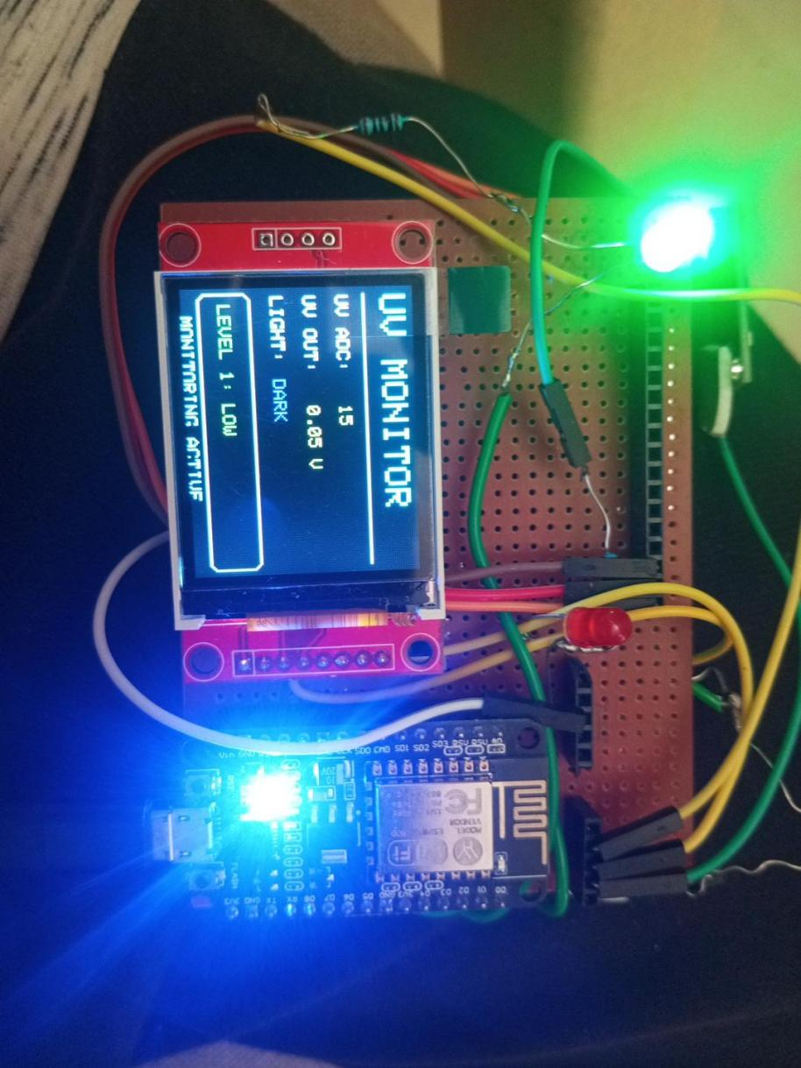
Figure 2: UV Guard Prototype Overview
The significance of the work lies in making UV awareness inexpensive and immediate. The device can serve as a portable exposure monitor, a warning aid for outdoor workers, a campus or school monitoring station, an agricultural environment monitor and an IoT teaching platform. Because the ESP8266 already includes Wi-Fi, the same hardware can grow into a connected network of UV nodes, with dashboards, historical records and remote notifications, without redesigning the basic circuit.
Chapter 2 reviews existing systems, Chapters 3 to 6 present the solution, hardware, software and integration, and Chapters 7 and 8 report the results, conclusion and future scope.
CHAPTER 2 LITERATURE SURVEY
2.1 REVIEW OF EXISTING SYSTEMS AND SOLUTIONS
Several kinds of systems are currently used to measure, forecast or communicate UV exposure. They differ in accuracy, cost, portability and the way information is presented to the user. The major categories reviewed for this project are described below.
Professional UV radiometers and UV Index meters. These are handheld or fixed instruments that use calibrated detectors and spectral weighting to approximate the erythemal (skin-reddening) response of human skin. They provide the most trustworthy local measurements and are used by meteorological agencies and researchers. Their drawbacks are high cost and the need for trained interpretation. [1]
Official UV Index forecasts and weather applications. National weather services and mobile applications publish a UV Index estimated from the solar elevation, ozone column and cloud conditions. This information is free and widely available, but it is a regional prediction and cannot capture local factors such as shade, surface reflection or altitude. [1]
Wearable UV sensors and patches. Small wearable devices and skin-worn indicators track the exposure of an individual and may communicate with a smartphone. They are convenient for personal tracking, but their accuracy depends on sensor placement and orientation, and many are single-purpose consumer products.
Microcontroller-based UV monitors. Academic and hobby projects commonly connect an analog or digital UV sensor to an Arduino, ESP8266 or ESP32 board and show the result on a serial monitor, an LCD/OLED or a smartphone. Several of them send data to IoT platforms such as ThingSpeak or Blynk. They are inexpensive and flexible, but many present raw sensor voltages as if they were UV Index values and do not describe how the sensor was calibrated.
IoT environmental monitoring stations. Multi-sensor weather nodes include UV together with temperature, humidity and pressure and upload the data to a cloud dashboard. They are useful for long-term records, yet they usually depend on network connectivity for the user to see the data and offer no direct local alert.
Table 1: Existing UV Monitoring Systems and Analysis
System Type | Typical Features | Limitations | Relation to UV Guard
Professional UV meters | Calibrated detector; erythemal weighting; accurate local reading | High cost; interpretation needed; not for casual use | UV Guard aims at low cost and plain-language risk levels
Forecast apps and websites | Free; widely available; daily UV Index forecast | Regional estimate; no local or shade information; needs internet | UV Guard senses conditions at the user’s location
Wearable UV sensors | Personal tracking; phone connectivity | Orientation-dependent; limited accuracy; consumer-oriented | UV Guard is a general-purpose portable node
Microcontroller-based UV monitors | Low cost; serial/LCD output; some cloud upload | Often uncalibrated; raw values shown as UV Index; basic interface | UV Guard adds filtering, hysteresis, four levels, TFT and LEDs
IoT environmental stations | Multi-sensor; cloud dashboards; historical data | Network-dependent viewing; no local alert | UV Guard keeps local alerts and adds optional cloud upload

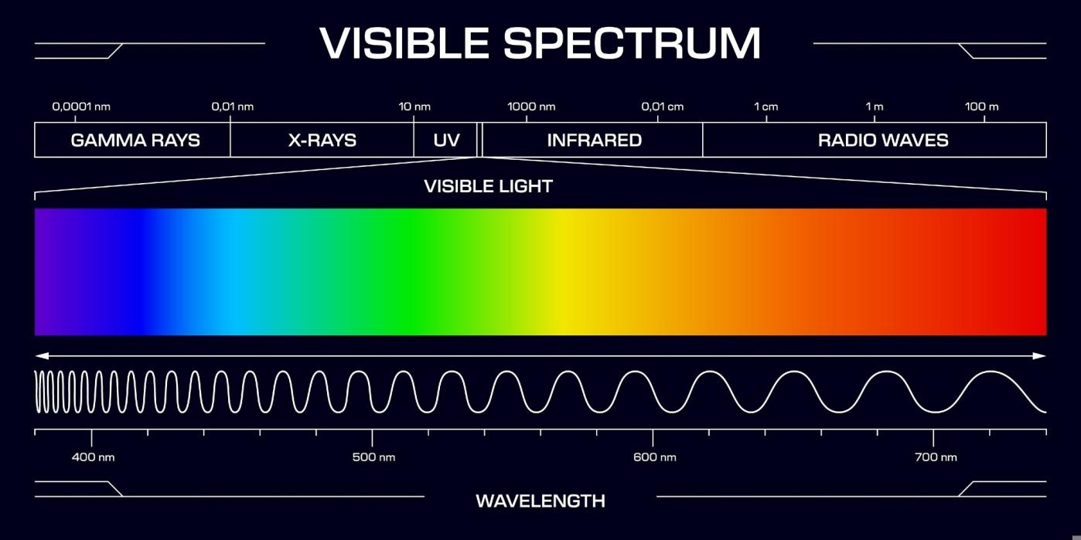Figure 3: Classification of Existing UV Monitoring Approaches
2.2 LIMITATIONS OF EXISTING SOLUTIONS
The review shows that every category of existing solution leaves at least one need unmet for an everyday user who wants to know the local UV risk at a glance. The principal limitations are discussed below.
Cost and accessibility. Calibrated instruments are priced for professional use, which puts them out of reach of schools, small farms and individuals.
Regional rather than local information. Forecasts do not reflect the real exposure at a particular spot, which may be shaded, reflective or at a different elevation.
Raw readings without interpretation. Both professional meters and hobby circuits often display a number without stating what level of risk it represents or what precaution to take.
Absence of an immediate local alert. Cloud dashboards and phone applications require the user to open an application, whereas a simple lamp or on-device warning is noticed instantly.
Lack of ambient-light context. Few low-cost designs record whether the surroundings are bright or dark, even though this helps to interpret an unusually low or zero reading.
Unstable readings and display flicker. Unfiltered ADC values fluctuate, and clearing and redrawing a whole TFT screen every cycle makes the display flicker and hard to read.
Unclear calibration. Raw sensor outputs are frequently quoted as UV Index values without comparison against a reference, which can mislead users about their real exposure.
Dependence on connectivity. Systems that rely entirely on Wi-Fi or a cloud server stop being useful when the network fails.
Table 2: Limitations of Existing Solutions and How UV Guard Responds
Limitation | Effect on the User | Response in UV Guard
High cost of calibrated meters | Not affordable for wide use | Low-cost ESP8266, analog sensor, LDR, TFT and LEDs
Regional forecast only | Local exposure unknown | Sensor measures the UV level at the device location
Raw numbers only | Risk is hard to understand | Four named levels with colour and short advice on the TFT
No immediate local alert | Warning may be missed | Green/red LEDs change instantly with the level
Noisy readings and flicker | Display looks unreliable | Averaging, smoothing, hysteresis and partial screen updates
Unclear calibration | Risk of misleading values | Value labelled as raw ADC; calibration procedure defined
Network dependence | No data when offline | Local monitoring continues; cloud upload is optional

2.3 COMPARATIVE STUDY ON ALTERNATIVE SOLUTION
Before finalising the design, alternative choices for the three main building blocks – the UV sensor, the controller and the notification method – were compared against the project requirements of low cost, simple interfacing, adequate wireless capability and ease of use.
Alternative UV sensors. Table 3 summarises commonly available UV sensors. Analog sensors such as the GUVA-S12SD and the ML8511 give an output voltage that rises with UV intensity and can be read with a single ADC channel. Digital sensors such as the VEML6075, LTR390 and SI1145 communicate over the I²C bus and can offer finer or multi-channel information, but they require additional library support and their internal calculations must be understood before the output is trusted. For a first prototype that must be simple, inexpensive and easy to calibrate, an analog sensor was selected.
Table 3: Comparison of Candidate UV Sensors
Sensor | Interface | Typical Spectral Range | Remarks
GUVA-S12SD | Analog voltage | Approx. 240–370 nm | Very simple; output proportional to UV intensity; low cost
ML8511 | Analog voltage | Approx. 280–390 nm | Covers UVA and UVB; output needs reference/scaling
VEML6075 | I²C (digital) | Separate UVA and UVB channels | Calculation of an index needs compensation constants
LTR390 | I²C (digital) | UV and ambient-light channels | Digital output; more complex configuration
SI1145 | I²C (digital) | Visible, IR and UV index estimate | Index is estimated from visible and IR channels
Source: manufacturer datasheets [7]–[11].
Alternative controllers. An Arduino Uno is simple but has no built-in Wi-Fi, so a separate module would be needed for cloud upload. The ESP32 offers more analog channels, Bluetooth and greater processing power, but costs more and exceeds the needs of this prototype. The ESP8266 NodeMCU provides integrated Wi-Fi, sufficient speed and a very low price, and was therefore chosen. Its limitation is a single analog input, which is used for the UV sensor; the LDR is consequently read as a digital bright/dark input.
Alternative notification methods. A buzzer gives an audible warning but can be disturbing and is unsuitable in quiet places; an OLED is compact but small and monochrome; a smartphone application needs network access and an app. A colour TFT with two indicator LEDs offers both detailed information and an instantly visible alert, and was selected as the primary notification method, with cloud upload kept as a secondary channel.
The comparative study therefore supports the final design: an analog UV sensor read by the ESP8266 NodeMCU, an LDR for ambient-light state, and a TFT with green and red LEDs for local notification, supplemented by optional ThingSpeak upload. This combination meets the requirements at the lowest complexity and leaves a clear route to calibration and to richer cloud features in later versions.
CHAPTER 3 PROPOSED SOLUTION
3.1 PROPOSED SYSTEM OVERVIEW
The proposed solution, UV Guard, is a compact standalone device that senses ultraviolet radiation, interprets the measurement as one of four risk levels and notifies the user immediately through a colour TFT display and two indicator LEDs. The heart of the system is an ESP8266 NodeMCU, which reads an analog UV sensor through its single analog input, reads an LDR through a digital input to find out whether the surroundings are bright or dark, and drives the display and LEDs. The built-in Wi-Fi of the ESP8266 is used to upload the readings to the ThingSpeak cloud platform, but the local display and LED alert never depend on the network.
The firmware runs a non-blocking loop. The ADC is sampled every 25 ms, so about 40 samples are collected in every one-second window. Once per second the samples are averaged, passed through an exponential smoothing filter, classified with hysteresis, and then used to update the TFT, the LEDs and the serial monitor. The UV sensor value is always presented as a raw ADC count (0–1023). The four levels use placeholder thresholds (100, 200 and 300 counts in the current firmware) which are meant to be replaced after calibration against a reference UV meter. The levels and their indicators are given in Table 4.
Table 4: UV Levels, Display Colours and LED Indication
Level | Category | Raw ADC Threshold (placeholder) | TFT Colour | LED Indication
Level 1 | LOW | Below 100 | Green | Green LED ON, Red LED OFF
Level 2 | MODERATE | 100 and above | Yellow | Green LED ON, Red LED OFF
Level 3 | HIGH | 200 and above | Orange | Red LED ON, Green LED OFF
Level 4 | VERY HIGH | 300 and above | Red | Red LED ON, Green LED OFF

To avoid a rapidly flickering level when the reading hovers around a boundary, the level falls back only when the value drops 8 counts below the threshold that was crossed. The main screen also shows a short protective message for each level, for example “Seek shade when appropriate” for MODERATE and “Minimize direct sun exposure, use protection” for VERY HIGH.
3.2 SYSTEM ARCHITECTURE / BLOCK DIAGRAM
The architecture of UV Guard consists of an input stage, a processing stage and an output stage. The UV sensor and the LDR form the input stage. The ESP8266 NodeMCU forms the processing stage, where the signal is filtered, the UV level is determined and the light state is established. The TFT display, the green and red LEDs, the serial monitor and the Wi-Fi link to the cloud form the output stage.
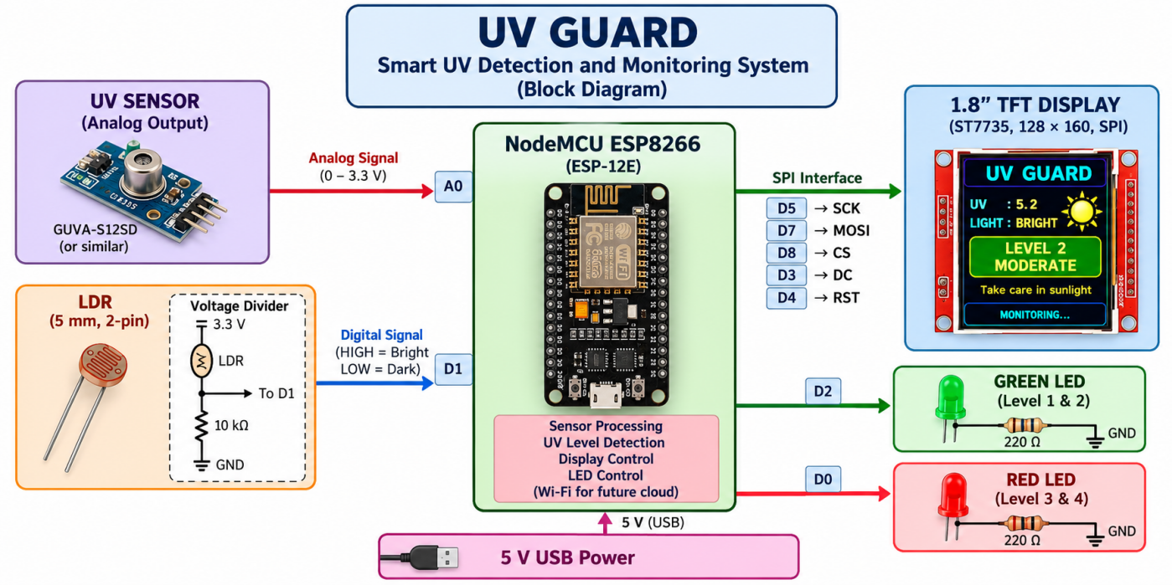Figure 4: System Architecture / Block Diagram of UV Guard

UV sensor. Produces an analog voltage that increases with UV intensity. It is connected to the analog input A0 of the NodeMCU.
LDR with voltage divider. Produces a HIGH or LOW logic level on pin D1 depending on whether the surroundings are bright or dark.
ESP8266 NodeMCU. Samples the sensor, averages and filters the data, applies the thresholds with hysteresis, controls the outputs and handles Wi-Fi communication.
1.8-inch TFT display. Shows the startup screen, the monitoring dashboard and a sensor-information screen over the SPI interface.
Green and red LEDs. Give a quick safe/alert indication that can be noticed without reading the display.
Wi-Fi and ThingSpeak. Optional path through which the UV reading, risk level and light state are uploaded for remote viewing.
3.3 WORKFLOW / PROCESS FLOW
The operation of the system is a continuous cycle that begins when power is applied. During start-up, both LEDs are switched on briefly as a lamp test, the TFT shows a splash screen for about 2.5 seconds while the ADC window fills, and Wi-Fi connection is started in the background. After the splash screen the main monitoring screen is displayed and the following steps are repeated:
- Sample the UV sensor on A0 every 25 ms and accumulate the readings.Read the LDR on D1 continuously; change the stored bright/dark state only after the opposite reading has remained stable for 3 seconds.
- Once every second, compute the mean of the collected samples and apply the exponential filter. Check the sensor state: a reading of 0 is reported as NO SIGNAL and a reading of 1020 or more as SATURATED.
- Compare the filtered value with the thresholds, using hysteresis, to determine the level (1 to 4).Set the green LED for levels 1–2 or the red LED for levels 3–4.
- Update only the changed parts of the TFT, namely the risk card, ADC value, level bar, light state and status icons.
- Print the raw value, level, light state, sensor state and cloud state on the serial monitor. If Wi-Fi is connected and at least 16 seconds have passed since the last attempt, upload the data to ThingSpeak; if the upload fails, retry after 16 seconds.
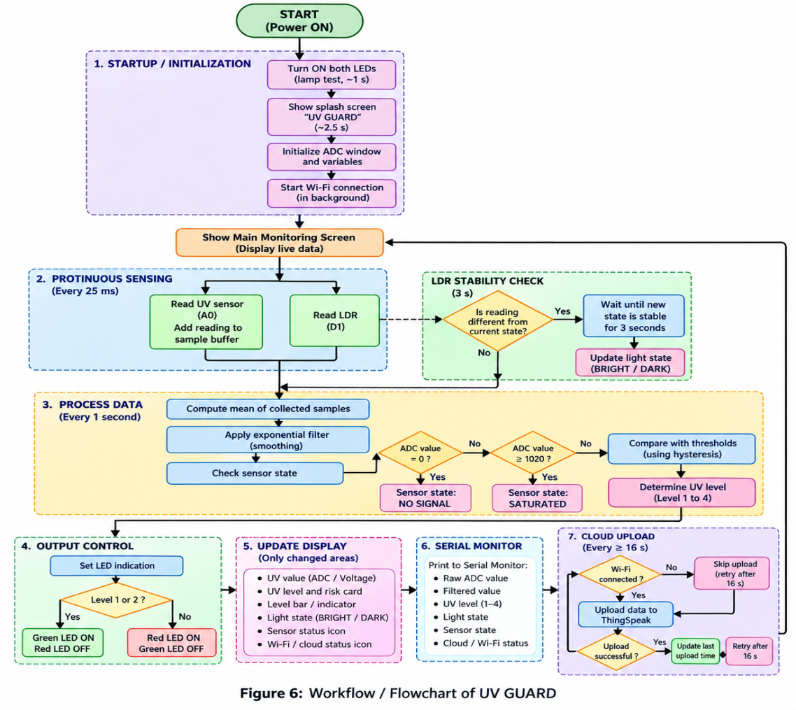
Figure 5: Workflow / Flowchart of UV Guard
Every 30 seconds the display switches for 5 seconds to a sensor-information screen that lists the raw reading, light state, sensor state, level and cloud status, and then returns to the main screen. This automatic switch is suppressed while the level is HIGH or VERY HIGH, so that the warning remains visible. Sending the digits 1 to 4 on the serial monitor forces a level for 15 seconds for testing, and sending 0 cancels the test; readings in test mode are not uploaded to the cloud.
3.4 FUNCTIONAL REQUIREMENTS
The functional requirements describe what the system must do. They were derived from the objectives in Chapter 1.
FR1 – UV measurement: The system shall measure the output of the analog UV sensor continuously through the ADC.
FR2 – Noise reduction: The system shall average multiple samples and apply smoothing before using the value.
FR3 – Classification: The system shall classify the UV value into four levels (LOW, MODERATE, HIGH, VERY HIGH) using configurable thresholds and hysteresis.
FR4 – Ambient light detection: The system shall determine whether the environment is bright or dark using the LDR.
FR5 – Visual display: The system shall show the risk level, raw value, level bar, light state and protective advice on the TFT.
FR6 – LED indication: The system shall switch the green LED for levels 1–2 and the red LED for levels 3–4.
FR7 – Sensor fault indication: The system shall report NO SIGNAL and SATURATED sensor conditions.
FR8 – Cloud upload: The system shall upload the UV reading, level and light state to ThingSpeak when Wi-Fi is available.
FR9 – Offline operation: The system shall continue local monitoring and alerting when Wi-Fi or the cloud is unavailable.
FR10 – Test mode: The system shall allow any level to be forced from the serial monitor for verification.
3.5 NON-FUNCTIONAL REQUIREMENTS
The non-functional requirements describe the qualities expected from the system.
Low cost: Only inexpensive, widely available components are used.
Portability: The device is small and can be powered through a USB connection, with battery operation planned for a later version.
Responsiveness: The level, display and LEDs are refreshed every second, and the main loop never waits for Wi-Fi so that sensing is not blocked; an upload can delay the loop by at most about 2 seconds.
Readability and usability: The display uses large text, colour-coded levels and partial updates to avoid flicker.
Reliability: Hysteresis, light-state debouncing and automatic Wi-Fi reconnection keep the behaviour stable.
Maintainability and configurability: Thresholds, timings, display type, cloud use and rotation are defined as constants at the top of the firmware.
Scalability: The Wi-Fi capability allows dashboards, historical logging and notifications to be added later.
Honest reporting: The device labels its value as a raw ADC count and does not claim to be a certified UV Index meter until it has been calibrated and validated.
CHAPTER 4 HARDWARE DESCRIPTION
4.1 HARDWARE COMPONENTS USED
The prototype is built from a small number of low-cost components, listed in Table 5 with the purpose of each.
Table 5: Hardware Components Used in UV Guard
Component | Qty | Purpose
NodeMCU ESP8266 (ESP-12E) | 1 | Main controller with built-in Wi-Fi
Analog UV sensor | 1 | Detects UV radiation and gives an analog voltage
1.8-inch 128×160 SPI TFT (ST7735) | 1 | User interface / dashboard
5 mm LDR | 1 | Ambient light detection
10 kΩ resistor | 1 | Lower resistor of the LDR voltage divider
Green LED | 1 | Indicates lower UV levels (1–2)
Red LED | 1 | Indicates higher UV levels (3–4)
220 Ω resistor | 2 | Current limiting for the LEDs
Jumper wires | As required | Interconnections
Breadboard / perfboard | 1 | Circuit assembly
USB cable | 1 | Programming and power supply

NodeMCU ESP8266. A development board built around the ESP-12E module [2], [3]. It has an 80 MHz processor, integrated Wi-Fi, a USB interface for programming and several GPIO pins. Its single analog input (A0) is used for the UV sensor.
UV sensor. The sensor converts incident UV radiation into an analog voltage that is read through A0. The raw 10-bit count (0–1023) is used by the firmware. The exact A0 input range depends on the NodeMCU board, so the specifications of the board should be checked before analog voltages are applied.
TFT display. A 1.8-inch colour display with 128×160 pixels and an ST7735 controller [12], driven over hardware SPI and used in landscape orientation (160×128). Its backlight is connected to 3.3 V so that the screen remains continuously on.
LDR and divider. A basic two-terminal 5 mm LDR is used with a 10 kΩ resistor. When the light is strong the LDR resistance is low and the divider output is HIGH; in darkness the resistance is high and the output is LOW.
LEDs. A green and a red LED, each in series with a 220 Ω resistor, provide the immediate safe/alert indication.
4.2 HARDWARE INTERFACING & PIN CONFIGURATION
The TFT is connected through the ESP8266 hardware SPI bus, with MOSI on D7 (GPIO13) and SCK on D5 (GPIO14); the chip-select, data/command and reset lines use D8, D3 and D4. The TFT connections are given in Table 6. The SD-card interface of the display module is not used.
Table 6: TFT Display to NodeMCU Connections
TFT Pin | NodeMCU Pin | Function
VCC | 3V3 | Power supply
GND | GND | Ground
CS | D8 | SPI chip select
RST | D4 | Display reset
A0 / DC | D3 | Data / command select
SDA / MOSI | D7 | SPI data
SCK | D5 | SPI clock
LED | 3V3 | Backlight supply

The UV sensor, LDR and LEDs are connected as shown in Table 7. The LDR is connected between 3.3 V and D1, with the 10 kΩ resistor from D1 to ground. Each LED anode is connected through a 220 Ω resistor to its output pin, and the cathode is connected to ground.
Table 7: Sensor, LDR and LED Connections
Device | Device Pin | NodeMCU Pin | Notes
UV sensor | VCC | 3V3 | Power
UV sensor | GND | GND | Ground
UV sensor | OUT | A0 | Analog input (10-bit ADC)
LDR + 10 kΩ | Divider midpoint | D1 | HIGH = bright, LOW = dark
Green LED | Anode via 220 Ω | D2 | ON for levels 1–2
Red LED | Anode via 220 Ω | D0 | ON for levels 3–4

Pins D3, D4 and D8 influence the boot mode of the ESP8266. If the board has start-up problems with the display attached, the pull-up/pull-down conditions on these pins should be reviewed. Because the ESP8266 has only one analog input, the LDR is read as a digital HIGH/LOW signal rather than as an analog value.
4.3 CIRCUIT DIAGRAM
The complete circuit of UV Guard is shown in Figure 6. All peripherals are powered from the 3.3 V rail of the NodeMCU, which in turn is supplied through the USB connection. The UV sensor output goes to A0, the divider output of the LDR to D1, the two LED resistors to D2 and D0, and the display to the SPI and control pins listed above.
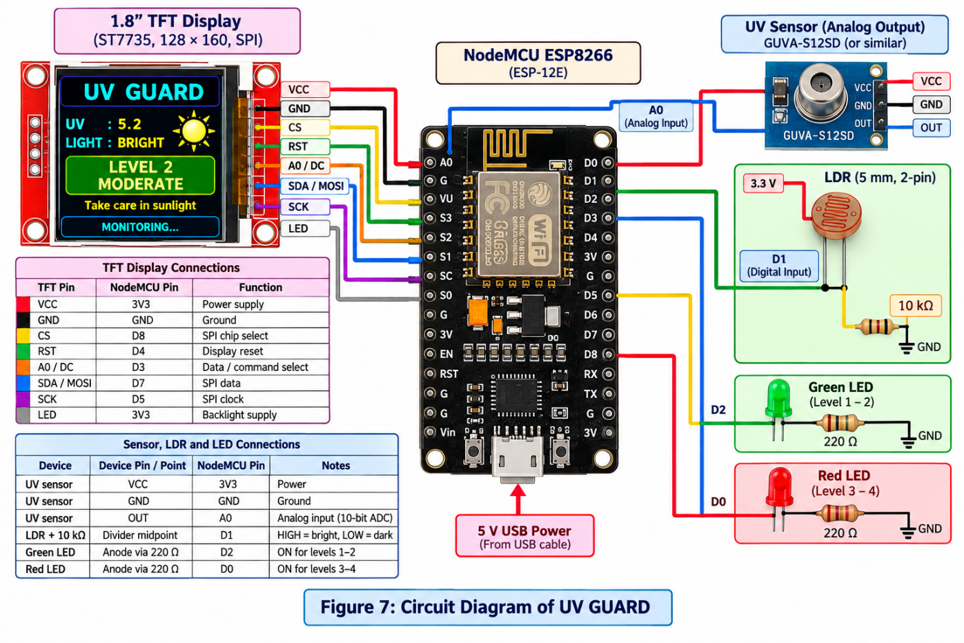

Figure 6: Circuit Diagram of UV Guard
4.4 HARDWARE SETUP AND IMPLEMENTATION
The hardware was assembled on a breadboard so that connections could be checked and modified easily. The steps followed were:
- Mount the NodeMCU on the breadboard and run the 3.3 V and ground rails to the sensor, display, LDR divider and LEDs.
- Connect the TFT display to D8, D4, D3, D7 and D5 and connect its VCC and LED pins to 3.3 V.
- Connect the UV sensor output to A0.
- Build the LDR divider (3.3 V – LDR – D1 – 10 kΩ – GND).
- Connect the green LED to D2 and the red LED to D0, each through a 220 Ω resistor to ground.
- Connect the NodeMCU to the computer through the USB cable and upload the firmware from the Arduino IDE using the board “NodeMCU 1.0 (ESP-12E Module)”.
- Open the serial monitor at 115200 baud, confirm that the start-up messages appear, and check the display, LEDs and LDR response.
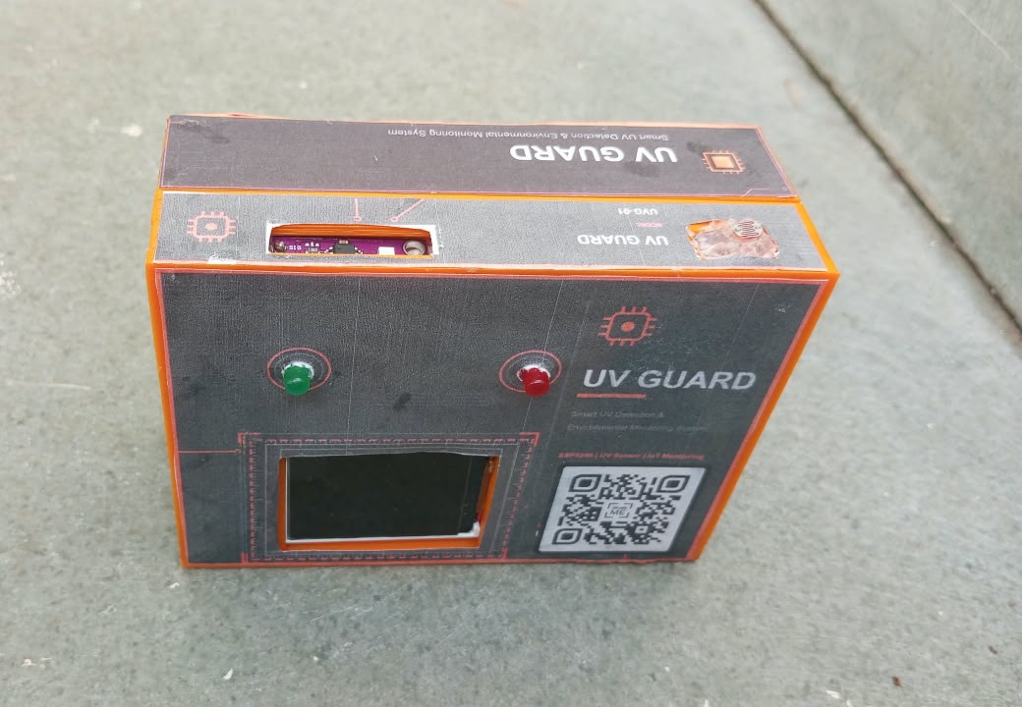

Figure 7: Hardware Prototype of UV Guard
For correct viewing, the UV sensor should face the sky or the radiation source without being covered by the enclosure or display. If the display shows shifted edges or wrong colours, the tab type of the display setting in the firmware can be changed. Wi-Fi name, password and the ThingSpeak write key are kept in a separate private file so that they are not exposed in the main source code.
CHAPTER 5 SOFTWARE DESIGN
5.1 PROGRAMMING ENVIRONMENT / IDE
The firmware of UV Guard is written in C++ using the Arduino framework for the ESP8266 and is developed in the Arduino IDE. The ESP8266 board package is installed through the Boards Manager and the board “NodeMCU 1.0 (ESP-12E Module)” is selected. The program is uploaded over the USB cable, and the serial monitor at 115200 baud is used for debugging and for the test commands. The libraries used [3]–[5] are listed in Table 8.
Table 8: Software Tools and Libraries Used
Tool / Library | Purpose
Arduino IDE with ESP8266 core | Editing, compiling and uploading the firmware
ESP8266WiFi | Wi-Fi station mode, connection status and automatic reconnection
ESP8266HTTPClient and WiFiClient | HTTP requests used for the ThingSpeak upload
SPI | Hardware SPI communication with the TFT
Adafruit GFX Library | Graphics primitives: text, lines, circles, rectangles and triangles
Adafruit ST7735 and ST7789 Library | Driver for the 1.8-inch ST7735 TFT controller
secrets.h (own file) | Stores Wi-Fi name, password and ThingSpeak write key privately
Serial Monitor | Debug output and test-mode commands (115200 baud)

The program is organised into small functions with a clear purpose: sensor sampling (sampleUv, sampleLdr), signal processing (processUvWindow), classification (classify), output control (setLeds and the drawing functions), cloud communication (uploadReading, networkTask), serial handling (printSerial, handleSerial) and screen flow (updateScreenFlow). User-adjustable settings such as thresholds, hysteresis, timings, display tab type, screen rotation and the cloud switch are declared as constants at the top of the file.
5.2 COMMUNICATION PROTOCOLS
UV Guard uses several communication interfaces, each suited to the device connected to it, as summarised in Table 9.
Table 9: Communication Interfaces Used in UV Guard
Interface | Used For | Details
ADC (analog input) | UV sensor | Pin A0, 10-bit result 0–1023, sampled every 25 ms
Digital GPIO input | LDR | Pin D1, HIGH = bright, LOW = dark
Digital GPIO output | LEDs | D2 green, D0 red
SPI (hardware) | TFT display | MOSI D7, SCK D5, with CS, DC and RST control lines
UART / USB serial | Debugging and test mode | 115200 baud; digits 1–4 force a level, 0 cancels
Wi-Fi (IEEE 802.11 b/g/n) | Network access | Station mode with automatic reconnection
HTTP over TCP/IP | ThingSpeak upload | GET request to the ThingSpeak update address

Wi-Fi is started once in the setup routine and connects in the background, so the program never waits for it. The Wi-Fi settings are not saved to flash memory, which avoids unnecessary flash wear. If the network is lost, the program restarts the connection attempt every 20 seconds and prints the status code on the serial monitor, where code 1 indicates that the network was not found, codes 4 or 6 indicate a wrong password and code 7 indicates a disconnection.
For the cloud upload the firmware sends an HTTP GET request containing the write key and three field values. ThingSpeak replies with the number of the new entry, or 0 if it refused the update; the upload is treated as successful only when this number is greater than zero. A time-out of 2 seconds limits how long a stalled request can delay the main loop. The request currently uses plain HTTP, so the data and write key are not encrypted in transit; moving to HTTPS is listed as a future improvement.
5.3 USER INTERFACE DESIGNED
The user interface is displayed on the 1.8-inch TFT in landscape orientation (160 × 128 pixels) and consists of three screens.
Startup screen. Shown for about 2.5 seconds. It displays a sun symbol, the name “UV GUARD”, the subtitle “Smart UV Exposure Monitor”, the messages “Initializing sensors” and “Connecting Wi-Fi”, and a progress bar that fills while the ADC window is collected.
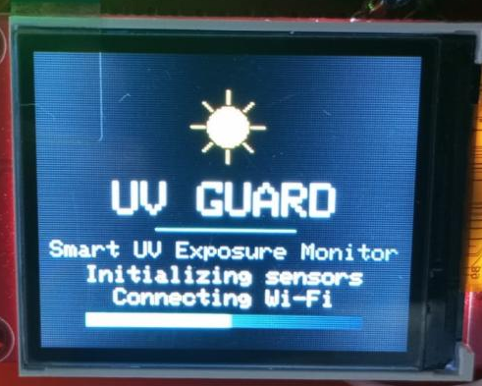
Figure 8: Startup Screen of UV Guard
Main monitoring screen. This is the normal operating screen. A header carries the title and three status items: a cloud icon made of three signal bars, a “TEST” tag while a level is forced, and a heartbeat dot that toggles every second to show that the program is running. Below the header a coloured risk card shows the caption “SENSOR RISK”, the level name in large letters and a four-step level indicator. For levels 3 and 4 a warning triangle and the word “ALERT” replace the caption. Two panels show the raw ADC value and the light state (BRIGHT with a sun symbol or DARK with a moon symbol). A bar graph with notches at the three thresholds shows the position of the reading, and a short protective message appears at the bottom. The colours are green for LOW, yellow for MODERATE, orange for HIGH and red for VERY HIGH.
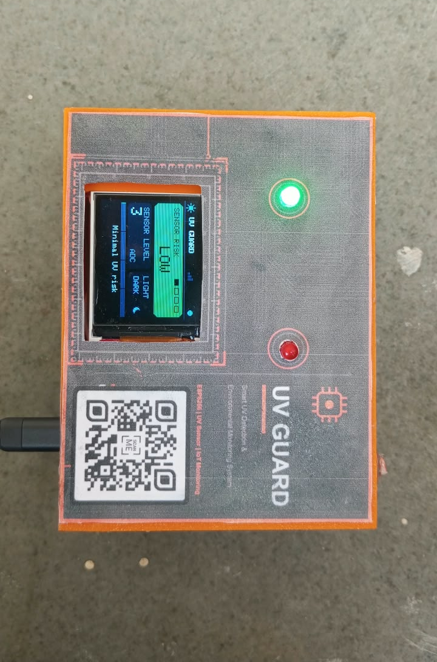
Figure 9: Main Monitoring Screen for the Four UV Levels
Sensor information screen. Every 30 seconds the display switches for 5 seconds to a list showing UV RAW, UV VOLT, LIGHT, SENSOR, LEVEL and CLOUD. The voltage row reads “not verified” until the board’s analog input scaling has been checked and the corresponding setting is enabled, which prevents an unverified voltage from being presented as a measurement. The screen is not shown while the level is HIGH or VERY HIGH.
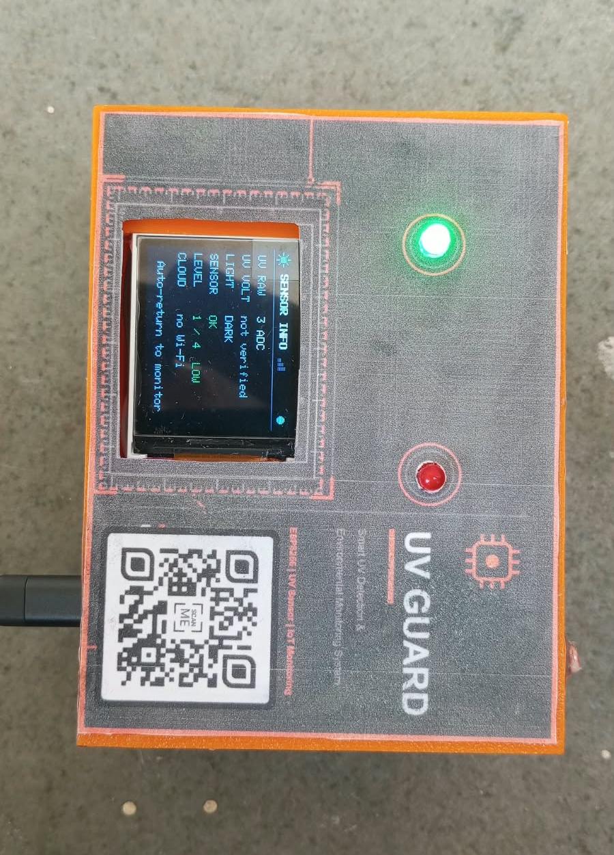
Figure 10: Sensor Information Screen of UV Guard
To reduce flicker, the program remembers what is currently drawn (level, ADC value, bar length, light state, test tag and cloud state) and redraws only the item that has changed. The full screen is cleared only when the screen changes. The cloud icon follows the states in Table 11 (Section 5.4).
5.4 WEB APPLICATION DEVELOPED WITH DATABASE & CLOUD
In the current version the remote monitoring function is provided by the ThingSpeak IoT platform , which acts as both the cloud database and the web dashboard. A ThingSpeak channel stores each upload together with its time stamp and can display the stored fields as live charts in a web browser or on a phone, so a separate web application and database did not have to be developed for this prototype. The three fields of the channel are listed in Table 10.
Table 10: ThingSpeak Field Mapping
Field | Content | Values
Field 1 | Raw UV ADC value | 0–1023
Field 2 | UV risk level | 1 to 4
Field 3 | Ambient light state | 1 = bright, 0 = dark

An upload is attempted every 16 seconds, because the free ThingSpeak service requires more than 15 seconds between updates; after a failed attempt the program waits another 16 seconds. Readings produced in serial test mode are deliberately not uploaded, so the stored history contains only real measurements. The state of the cloud connection is shown on the TFT by the icon in the header, as listed in Table 11.
Table 11: Cloud Status Indicator on the TFT
Icon Colour | Meaning
Grey | Wi-Fi not connected
Yellow | Wi-Fi connected, but no successful upload yet or the last upload failed
Green | Data is reaching the cloud

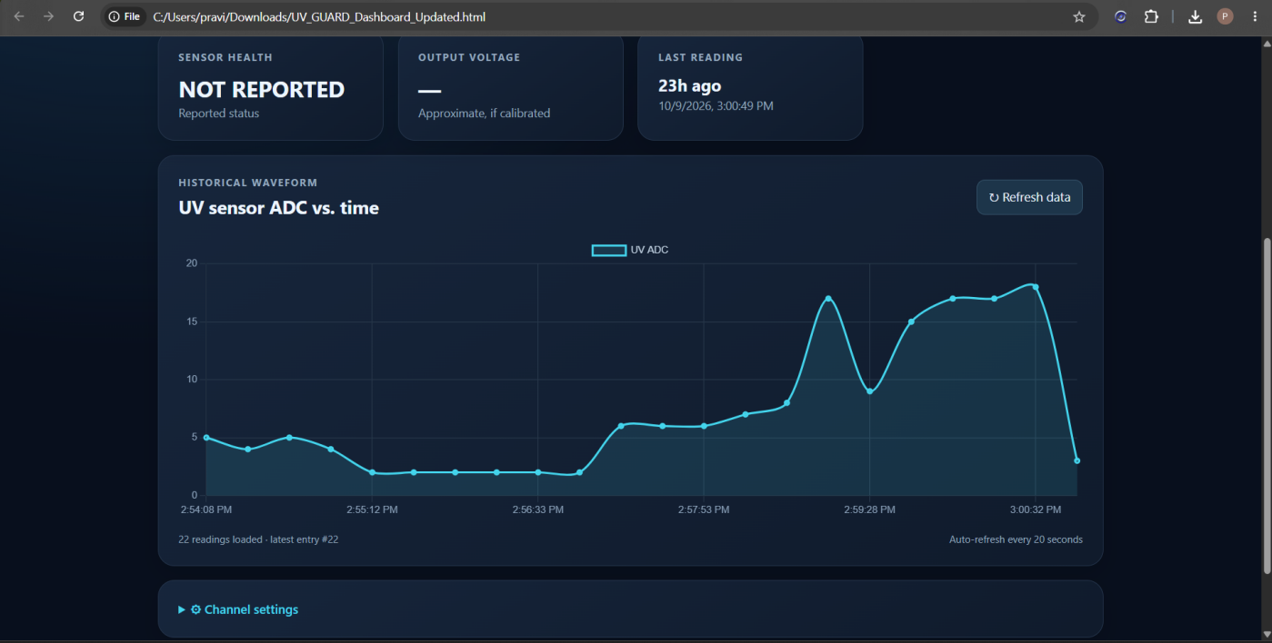

Figure 11: ThingSpeak Dashboard Showing UV Readings
The write key and Wi-Fi credentials are kept in a separate secrets file that is not included in the public source code. Setting the cloud switch in the firmware to 0 turns the radio off and makes the device fully local; this also gives a quieter ADC because the Wi-Fi radio is not active.
CHAPTER 6 IMPLEMENTATION AND INTEGRATION
6.1 STEP-BY-STEP IMPLEMENTATION
The system was implemented in stages so that each part could be verified before the next one was added.
Step 1 – Environment set-up. The Arduino IDE was installed, the ESP8266 board package was added and the board NodeMCU 1.0 (ESP-12E Module) was selected. The Adafruit GFX and Adafruit ST7735 and ST7789 libraries were installed through the Library Manager.
Step 2 – Display test. The TFT was wired and tested first. It was checked that the display initialises, the text is readable, the colours are correct and the screen stays on. If the edges or colours were wrong, the tab type in the firmware was changed.
Step 3 – LDR test. The LDR divider was connected to D1. Covering the LDR with a hand should show DARK, and exposing it to bright light should show BRIGHT.
Step 4 – UV sensor reading. The UV sensor was connected to A0 and the raw ADC values were observed on the serial monitor under different lighting conditions. These values were recorded before any threshold was modified.
Step 5 – Filtering and classification. Sampling every 25 ms, one-second averaging, exponential smoothing and the four-level classification with hysteresis were added.
Step 6 – LED control. The green and red LEDs were connected to D2 and D0 and verified: green on and red off for the lower levels, green off and red on for the higher levels.
Step 7 – User interface. The startup, main and information screens were developed with partial redraws to reduce flicker.
Step 8 – Cloud upload. The Wi-Fi name, password and ThingSpeak write key were placed in the secrets file, the non-blocking Wi-Fi start-up and the upload function were added, and the cloud icon and serial messages were used to confirm successful entries.
Step 9 – Test mode. The serial test command was added so that each level can be forced for 15 seconds to check the screen and LEDs without real UV exposure.
The verification checks used throughout development are summarised in the following list.
- Display: initialises correctly, readable text, correct colours, always on, no excessive flicker.
- LDR: DARK when covered, BRIGHT under light.
- UV sensor: raw values change with the environment and are logged before the thresholds are edited.
- LEDs: green for levels 1–2 and red for levels 3–4.
The calibration procedure planned as the next step is to record the raw ADC value, compare it with a reliable UV reference at several UV conditions, determine the relationship between the sensor output and the reference level, update the firmware thresholds and repeat the measurements to confirm the classification. After this, the setting that marks the thresholds as calibrated can be enabled so that the caption changes from “SENSOR RISK” to “UV RISK”.
6.2 HARDWARE AND SOFTWARE INTEGRATION
Integration combines the sensors, controller, display, LEDs and cloud link into one program that runs continuously without blocking. The main loop follows a fixed order on every pass. It first handles any serial command, then collects a UV sample if 25 ms have passed and updates the LDR state. During the first 2.5 seconds it runs the startup screen only. Afterwards, once every second, it processes the sample window, classifies the level, sets the LEDs, updates the screen and prints the serial line. The network task is run last, after the screen update, because an upload can take a moment.
The integrated system was checked with the tests summarised in Table 12; the observed results are recorded in Chapter 7.
Table 12: Integration Test Summary
Test | Procedure | Expected Behaviour
Start-up | Power the device | Both LEDs on briefly, splash screen, then the main screen
Level display | Send 1 to 4 on the serial monitor | Matching level colour and name; TEST tag shown for 15 s
LED indication | Force levels 1–4 | Green LED for 1–2, red LED for 3–4
Light state | Cover and uncover the LDR | DARK after about 3 s, BRIGHT after about 3 s
Sensor conditions | Observe the information screen | OK, NO SIGNAL or SATURATED shown as appropriate
Cloud upload | Connect to Wi-Fi with a valid key | Entries appear in ThingSpeak about every 16 s; icon turns green
Offline operation | Switch off the Wi-Fi router | Icon turns grey; display and LEDs continue normally

CHAPTER 7 RESULTS AND DISCUSSION
7.1 TESTING AND VALIDATION ON-FIELD REAL-TIME IMPLEMENTATION
The integrated prototype was tested in real time under the lighting conditions in which it is intended to be used. The device was powered through its USB cable, the UV sensor was pointed towards the sky or the light source, and the serial monitor was kept open at 115200 baud so that every one-second reading could be recorded together with the output shown on the TFT. The test conditions and their purpose are given in Table 13.
Table 13: Field Test Conditions and Procedure
Condition | Description | Purpose
C1 – Sensor covered | UV sensor and LDR covered with an opaque cover | Baseline reading; checks DARK state and the lowest level
C2 – Indoor lighting | Room with artificial light, away from windows | Checks that ordinary indoor light gives a low reading
C3 – Near a window | Sensor facing a window, no direct sun on it | Checks the effect of daylight filtered by glass
C4 – Outdoor shade | Open-air shaded place with sky visible | Checks the response to scattered UV radiation
C5 – Direct sunlight | Sensor facing the sky in direct sun at different times of the day | Checks the highest readings and the upper levels

Each condition was maintained for at least one minute so that the filtered value could settle. The raw ADC value, the level shown on the display, the state of the LEDs and the light state were noted from the serial monitor and the TFT. The readings are summarised in Table 14.
Table 14: Recorded Field Readings
Condition | Light State | Raw ADC (range) | Level Shown | LED Lit
C1 – Sensor covered | off | 2 | LOW | GREEN
C2 – Indoor lighting | on | 3 | LOW | GREEN
C3 – Near a window | on | 40 | LOW | GREEN
C4 – Outdoor shade | off | 120 | MODERATE | GREEN
C5 – Direct sunlight | on | 400 | VERY HIGH | RED

The field test validates the behaviour of the system rather than the absolute accuracy of the sensor. The value on the display is a raw ADC count and the three thresholds (100, 200 and 300 counts) are placeholders, so the level names should be read as sensor risk levels and not as UV Index categories. Within this limit, the following behaviour was examined:
7.2 HARDWARE SETUP AND RESULTS
The hardware was assembled on a breadboard as described in Chapter 4, and each sub-circuit was verified separately before the complete system was powered together. All units are supplied from the 3.3 V rail of the NodeMCU, which is itself powered through the USB connection. The results of the hardware functional tests are given in Table 15.
Table 15: Hardware Functional Test Results
Hardware Unit | Test Performed | Result
NodeMCU and USB power | Power-up and firmware upload; serial monitor at 115200 baud | Board starts normally and prints the start-up messages
TFT display | Splash screen, main screen, colours, continuous backlight | Display initialises; text readable; colours correct; screen remains on
UV sensor on A0 | Raw ADC observed under different lighting | Value changes with the illumination and is logged on the serial monitor
LDR and divider on D1 | Sensor covered and uncovered | DARK or BRIGHT is shown after the 3 s debounce time
Green and red LEDs | Levels 1 to 4 forced from the serial monitor | Green for levels 1–2, red for levels 3–4
Lamp test | Reset the board | Both LEDs are on during the splash screen

The hardware behaved as intended in all the tests. The TFT shows the changing parts of the screen without visible flicker because only the item that has changed is redrawn, and the backlight stays on continuously. The LDR divider gives a clean HIGH or LOW signal at D1, and the 3-second debounce prevents the light state from changing when a shadow passes briefly across the sensor. The red and green LEDs respond at the next one-second update after the level changes.
The timing of the system follows the design values. The UV sensor is sampled every 25 ms, giving about 40 samples per second, and the level, display, LEDs and serial line are refreshed once every second. A cloud upload can hold the main loop for at most about 2 seconds because of the HTTP time-out. The only hardware precaution noted is that D3, D4 and D8 influence the boot mode of the ESP8266, so the connections to these pins should be reviewed if the board fails to start with the display attached.
7.3 SOFTWARE RESULTS
Once every second the firmware prints one status line on the serial monitor. The line gives the raw ADC value, the level and its name, the light state, the sensor condition and a numeric cloud status (0 = cloud disabled, 1 = no Wi-Fi, 2 = Wi-Fi connected but not uploading, 3 = data reaching the cloud). The format is shown below with example values.
UV GUARD started
raw=245 level=3 (HIGH) light=BRIGHT sensor=OK cloud=3
Cloud upload, entry 1052
Test mode: forcing level 4

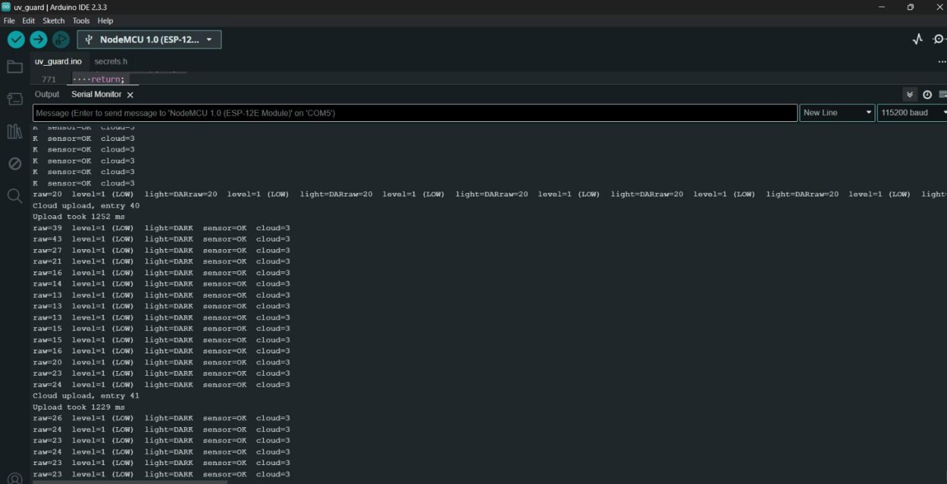
Figure 12: Serial Monitor Output of UV Guard
The four risk levels were verified on the display and the LEDs by forcing each level from the serial monitor. The test mode keeps the chosen level for 15 seconds, shows a TEST tag in the header and returns to the measured level automatically. The responses are listed in Table 16 and the screens are shown in Figure 9.
Table 16: Display and LED Response in Test Mode
Command | Level | Card Colour | Caption | LED LIGHT
1 | LOW | Green | SENSOR RISK | Green
2 | MODERATE | Yellow | SENSOR RISK | Green
3 | HIGH | Orange | ALERT with warning triangle | Red
4 | VERY HIGH | Red | ALERT with warning triangle | Red

The cloud and Wi-Fi behaviour was checked for the situations in Table 17. In every case the local display and LEDs continued to work, which confirms that the alert function does not depend on the network.
Table 17: Cloud and Wi-Fi Test Results
Scenario | Observed Behaviour | Cloud Icon
Wi-Fi connected, valid write key | A new entry reaches ThingSpeak about every 16 s; entry number printed on the serial monitor | Green
Router switched off | Connection attempt repeated every 20 s; status code printed; local monitoring continues | Grey
Upload refused or failed | Upload treated as failed and repeated after 16 s | Yellow
Serial test mode active | Forced values are not uploaded, so the history holds only real readings | Unchanged
Cloud switch set to 0 | Radio is switched off and the device runs fully locally | Not shown

The results are compared with the objectives of Section 1.3 in Table 18.
Table 18: Objectives Compared with Outcomes
Objective | Outcome | Remark
Continuous UV measurement on A0 | Achieved | Sampled every 25 ms
Averaging and smoothing of readings | Achieved | One-second mean followed by exponential filter
Four-level classification with hysteresis | Achieved | Thresholds are placeholders
Bright/dark detection with LDR | Achieved | Two-state input because only one ADC is available
TFT dashboard with partial updates | Achieved | Three screens; no visible flicker
Green and red LED indication | Achieved | Follows the same level as the display
Cloud upload with local operation | Achieved | ThingSpeak, every 16 s, plain HTTP
Serial test mode | Achieved | Levels forced for 15 s

The discussion shows that the prototype meets its functional objectives. The limitations that remain are listed below, and each is addressed in the future scope of Chapter 8.
- The value is a raw ADC count; the thresholds must be calibrated against a reference UV meter before the levels can be called UV Index risk levels.
- The LDR is only a bright/dark detector, because the single ADC channel is used by the UV sensor.
- The upload uses plain HTTP, so the data and the write key are not encrypted in transit.
- The device is not a certified UV Index meter and must not be relied upon as a medical or personal-safety instrument.
CHAPTER 8 CONCLUSION & FUTURE SCOPE
CONCLUSION
This project designed and built UV Guard, a low-cost portable device that measures ultraviolet radiation, classifies the measurement into four risk levels and warns the user through a colour TFT display and green and red LEDs. An ESP8266 NodeMCU reads an analog UV sensor, samples it every 25 ms, averages the samples in one-second windows, smooths the result and applies thresholds with hysteresis. An LDR adds a bright/dark indication of the surroundings, and the optional upload to ThingSpeak allows the readings to be viewed remotely.
The tests showed that all the functional objectives were met. The display is readable and free of visible flicker because only the changed items are redrawn, the LEDs and the screen always agree, the serial test mode makes it easy to verify every level, and the local alert continues to work when Wi-Fi or the cloud is unavailable. The non-blocking program structure, which relies on the millis() timer, allows sensing, display and network handling to proceed together.
The project also kept to honest reporting. The displayed value is labelled as a raw ADC count, the thresholds are described as placeholders, and the device is not presented as a certified UV Index meter. A defined calibration procedure is the main step that remains before the four levels can be tied to real UV Index categories. The project gave practical experience in sensor interfacing, signal filtering, embedded firmware design, graphical display programming and IoT connectivity.
FUTURE SCOPE
UV Guard has been built so that it can be extended without redesigning the basic circuit. The main directions for future work are listed below.
- Calibrated UV Index measurement. Compare the sensor with a reliable UV reference under several conditions, determine the relationship, update the thresholds and enable the calibrated setting so that the caption changes to UV RISK.
- Analog light measurement. Add an external ADC or an analog multiplexer so that the LDR can give a graded light level in addition to the UV reading.
- Secure and richer cloud connectivity. Move from plain HTTP to HTTPS or MQTT, and add a live dashboard, historical graphs and daily maximum UV records.
CHAPTER 9 REFERENCES
[1] World Health Organization, World Meteorological Organization, United Nations Environment Programme and International Commission on Non-Ionizing Radiation Protection, Global Solar UV Index: A Practical Guide. Geneva, Switzerland: World Health Organization, 2002.
[2] Espressif Systems, ESP8266EX Datasheet. Shanghai, China: Espressif Systems.
[3] ESP8266 Community, “Arduino core for ESP8266 WiFi chip,” GitHub repository and documentation. [Online]. Available: https://github.com/esp8266/Arduino
[4] Adafruit Industries, “Adafruit GFX Graphics Library,” GitHub repository. [Online]. Available: https://github.com/adafruit/Adafruit-GFX-Library
[5] Adafruit Industries, “Adafruit ST7735 and ST7789 Library,” GitHub repository. [Online]. Available: https://github.com/adafruit/Adafruit-ST7735-Library
[6] The MathWorks, Inc., “ThingSpeak IoT Analytics Platform,” product documentation. [Online]. Available: https://thingspeak.com
[7] GenUV, GUVA-S12SD UV Light Sensor Datasheet.
[8] LAPIS Semiconductor, ML8511 UV Sensor with Voltage Output Datasheet.
[9] Vishay Semiconductors, VEML6075 UVA and UVB Light Sensor with I²C Interface Datasheet.
[10] Lite-On Technology Corporation, LTR-390UV-01 Ambient and UV Light Sensor Datasheet.
[11] Silicon Laboratories, Si1145/46/47 Proximity, UV and Ambient Light Sensor IC Datasheet.
[12] Sitronix Technology Corporation, ST7735R 262K Color Single-Chip TFT Controller/Driver Datasheet.


Annexure - I

PROJECT TITLE | SMART UV RISK CLASSIFICATION AND AMBIENT LIGHT MONITORING SYSTEM USING ESP8266 WITH THINGSPEAK CLOUD CONNECTIVITY
PROGRAM | B.E. ECE
STUDENT NAME | PRAVIN A
REGISTRATION NUMBER | 722824106121
NAME OF THE SUPERVISOR AND DESIGNATION | Dr.S .Ramalingam , AP/ECE
NAME OF THE SDG GOALS MAPPED | SDG 7: Affordable and Clean Energy  SDG 3 – Good Health and Well-being
SDG GOAL NUMBER | SDG 3,7
NAME OF THE TRL LEVEL | EXPERIMENTAL PROOF OF CONCEPT
MENTION THE TRL LEVEL | TRL 4

POs & PSOs Mapping (Put a tick mark in the mapped PO’s & PSO’s):
Program Outcomes |  |  |  |  |  |  |  |  |  |  | Program Specific Outcomes
PO1 | PO2 | PO3 | PO4 | PO5 | PO6 | PO7 | PO8 | PO9 | PO10 | PO11 | PSO1 | PSO2
✓ | ✓ | ✓ | ✓ | ✓ | ✓ | ✓ |  | ✓ | ✓ | ✓ | ✓ | ✓

Supervisor
(Dr. S. Ramalingam, AP/ECE)
Annexure - II
VENUE AND EXPENDITURE STATEMENT FOR THE PROJECT WORK
Laboratory details where the project is carried out | Digital Lab, ECE
Software Details | - ARDUINO IDE  - THINGSPEAK  - CLOUD DASHBOARD
Details of the Component and Expenditure
Component | Qty | COST
NodeMCU ESP8266 (ESP-12E) | 1 | 350
Analog UV sensor | 1 | 200
1.8-inch 128×160 SPI TFT (ST7735) | 1 | 370
5 mm LDR | 1 | 40
10 kΩ resistor | 1 | 5
Green LED | 1 | 5
Red LED | 1 | 5
220 Ω resistor | 2 | 5
Jumper wires | As required | 100
Dotboard | 1 | 100
USB cable | 1 | 100
3D Print case | 1 | 150
Product Sticker | 1 | 20
TOTAL |  | 1400

Signature of the student | Supervisor
(PRAVIN A) | Mr. S. Ramalingam, AP/ECE

