PERSONALIZED T2D PATIENT STATE
AND TRAJECTORY FORECASTING
Using MIMIC-IV Demo Data

PROJECT REPORT
Submitted in fulfilment for the Course Project of ISWE410L - Machine Learning

in
M.Tech (Software Engineering)
by
[Student Name] ([Registration Number])

Under the guidance of
Dr. Ushapreethi.P


School of Computer Science Engineering and Information Systems
October 2026


School of Computer Science Engineering and Information Systems
Fall Semester 2026-27
TABLE OF CONTENTS
CHAPTER NO. | TITLE | PAGE NO.
 | ABSTRACT | 1
1. | Problem Statement | 1
2. | System Design | 2
3. | Software Requirement Specifications | 3
4. | Implementation | 4
 | 4.1 Source Code | 4
 | 4.2 Dashboard Views and Results | 5
5. | Special Work Conference Readiness | 7
 | References | 8

ABSTRACT
This project implements a research-only personalized patient-state prototype for type 2 diabetes using the bundled MIMIC-IV demo data. The system separates longitudinal feasibility assessment from acute-care trajectory monitoring. It first audits whether repeated HbA1c measurements support the intended long-horizon endpoint, then builds a distinct exploratory task that forecasts the next observed in-hospital laboratory glucose value from information available at the prediction time.
The demo cohort contains 35 T2D-coded patients, 1038 valid glucose measurements, and 639 eligible next-glucose prediction points from 28 evaluated patients. Whole patients are held out during five-fold validation. Persistence, snapshot, fixed-history, and adaptive-state models are evaluated on identical out-of-fold prediction points. The best observed subject-macro mean absolute error is 42.48 mg/dL for adaptive ridge regression, compared with 44.41 mg/dL for persistence; the patient-bootstrap confidence intervals overlap. The report therefore presents the implementation as a reproducible exploratory prototype, not evidence of clinical superiority or a deployable digital twin.
1. PROBLEM STATEMENT
1.1 Motivation
Type 2 diabetes requires repeated assessment because glucose values, clinical status, and the timing of laboratory measurements vary between people and across admissions. A useful machine-learning prototype should make its inputs, update mechanism, and evaluation boundary visible. The project addresses this need by representing each participant with a state computed from current and historical laboratory glucose observations and by evaluating predictions against a later observed value.
1.2 Objective and scope
The objective is to build an understandable pipeline and dashboard for personalized state monitoring and short-horizon trajectory forecasting. The main implementation goal is not to prescribe therapy. It is to determine whether explicit time-aware state features can be evaluated fairly against simpler baselines when only past information is available. The project uses the MIMIC-IV demo CSV bundle directly; no database server is required.
1.3 Feasibility decision
The preferred longitudinal endpoint from the research proposal is the next HbA1c. The audit identified 74 HbA1c measurements from 20 T2D-coded participants, but only 6 participants with an eligible repeat pair over 30-730 days. This does not meet the pre-specified minimum of 50 participants. The next-HbA1c analysis is therefore a NO_GO for this demo, rather than an unsupported model result.
1.4 Exploratory research question
For the available demo data, the exploratory question is: can a patient-specific, time-decayed state representation predict the next valid in-hospital glucose laboratory result, measured one to twenty-four hours after the prediction time, more accurately than persistence and non-longitudinal baselines? This narrower endpoint is appropriate for a pipeline demonstration but does not describe outpatient disease progression.
2. SYSTEM DESIGN
2.1 End-to-end workflow
The system has five stages: cohort construction, measurement validation, past-only state updating, grouped model evaluation, and dashboard presentation. A T2D cohort is created from qualifying ICD-10 E11 or ICD-9 250.x0/250.x2 inpatient diagnoses. Valid blood glucose laboratory records are retained, duplicate timestamps are aggregated by median, and each admissible index observation is paired with the next measurement in the same admission.
Module | Input | Output and safeguard
Cohort builder | Diagnosis and admission tables | T2D-coded patients and admissions using explicit ICD families.
Measurement processor | Laboratory glucose events | Plausible 20-1000 mg/dL values; same-time values aggregated before modelling.
State updater | Current and prior 48-hour glucose history | Snapshot, fixed-history, and time-decayed adaptive features; no later value is used.
Evaluator | Eligible prediction points | Five patient-held-out folds, saved out-of-fold predictions, patient-bootstrap intervals.
Dashboard | Saved research outputs | Patient state, trajectory, forecast, evidence, and safeguards; not a live monitor.

Table 1. System modules and their research safeguards.
2.2 Personalized patient-state representation
At each laboratory observation, the adaptive state stores a time-decayed mean, standard deviation, linear trend, effective observation count, and state age over a 48-hour lookback. Recent observations receive greater weight through a twelve-hour decay half-life. The representation is intentionally transparent: it is a feature-engineering approach for a patient-specific state, not a physiological simulation or causal treatment model.
2.3 Model and validation design
Model | Inputs | Role
Persistence | Latest glucose | Carry-forward baseline that must be beaten.
Snapshot ridge | Latest glucose, age, sex, time from admission | Non-longitudinal reference.
Fixed-history ridge | Snapshot inputs plus 48-hour summary statistics | Tests conventional temporal context.
Adaptive-state ridge | Snapshot inputs plus time-decayed state | Tests the transparent state representation.
Adaptive-state HGB | Adaptive-state inputs | Nonlinear comparison with fixed pre-specified settings.

Table 2. Pre-specified model comparisons on identical prediction points.
3. SOFTWARE REQUIREMENT SPECIFICATIONS
3.1 Functional requirements
ID | Requirement | Verification
FR-01 | Read the compressed MIMIC-IV demo CSV files without a database service. | Runner completes from the project folder.
FR-02 | Build a transparent T2D cohort and write feasibility counts. | feasibility_audit.json records cohort flow and HbA1c decision.
FR-03 | Construct next-glucose points from past-only observations. | Unit test changes a future value without changing earlier features.
FR-04 | Evaluate models without patient overlap between train and test. | fold_audit.csv records zero subject overlap in every fold.
FR-05 | Present separate state, monitoring, forecasting, evidence, and safeguard views. | Streamlit smoke test confirms five dashboard tabs.

Table 3. Functional requirements and verification evidence.
3.2 Non-functional requirements
• Reproducibility: frozen JSON configuration, deterministic seed, stored run environment, and saved out-of-fold predictions.
• Interpretability: state features and model roles are documented; a persistence baseline is retained.
• Safety: dashboard text states that the project is research-only and must not guide patient care.
• Usability: one command creates all evidence artifacts; the web interface reads only the saved results.
• Data governance: the project uses the supplied de-identified demo files and must follow MIMIC-IV access and data-use requirements when scaled.
4. IMPLEMENTATION
4.1 Source code
The implementation is organized as a small Python package. The cohort module defines the diagnosis rule and laboratory filters. The feature module creates the fixed-history and adaptive-state values. The evaluation module performs GroupKFold validation and patient-level bootstrap confidence intervals. The pipeline module writes a compact, reviewable set of outputs, while the Streamlit application displays only saved held-out predictions.
Path | Purpose
configs/study.json | Pre-specified study settings, time windows, model list, and random seed.
src/mimic_t2d/data.py | T2D cohort construction and glucose/HbA1c measurement processing.
src/mimic_t2d/features.py | Past-only feature construction and adaptive state calculation.
src/mimic_t2d/evaluation.py | Grouped cross-validation, metrics, and bootstrap intervals.
scripts/run_study.py | One-command study runner.
app.py | Interactive research dashboard.
tests/ | Cohort-code, leakage, and group-split tests.

Table 4. Source-code organization.
Three automated tests provide basic scientific guardrails. The cohort test checks the ICD-9 and ICD-10 T2D rule. The feature test confirms that changing a future glucose value does not alter already constructed features. The evaluation test confirms that each model produces one out-of-fold prediction per point and that no patient appears in both train and test partitions.
4.2 Dashboard views and result visualizations
The dashboard is organized into separate patient-state, trajectory-monitoring, held-out-forecasting, study-evidence, and methodological-safeguard views. This separation avoids presenting a later observed measurement as if it were available at prediction time. The figures below reproduce the result visualizations generated from the saved out-of-fold study outputs.
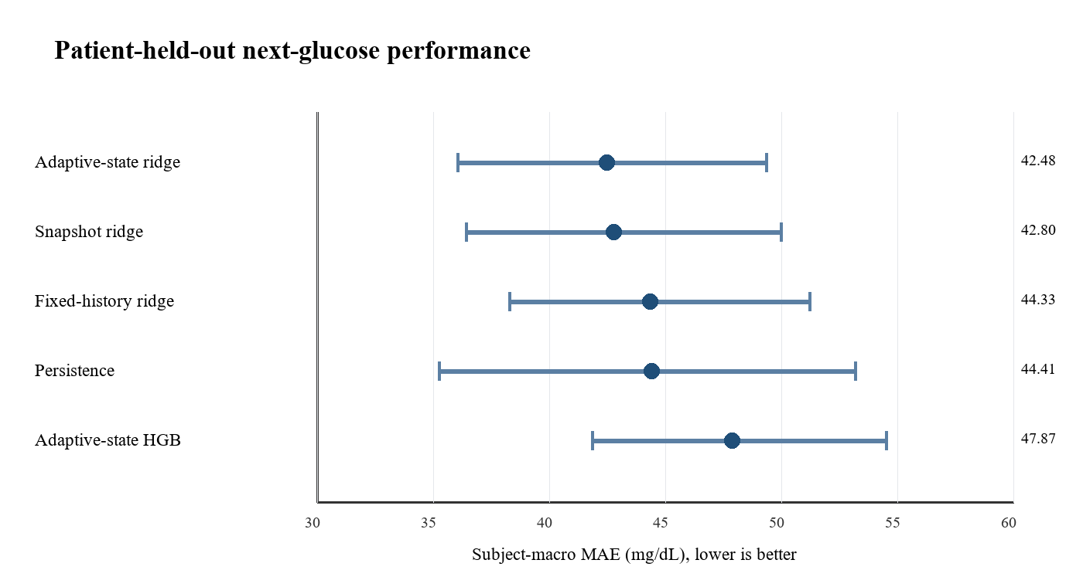
Figure 1. Subject-macro MAE and patient-bootstrap 95% intervals. Lower MAE is better.
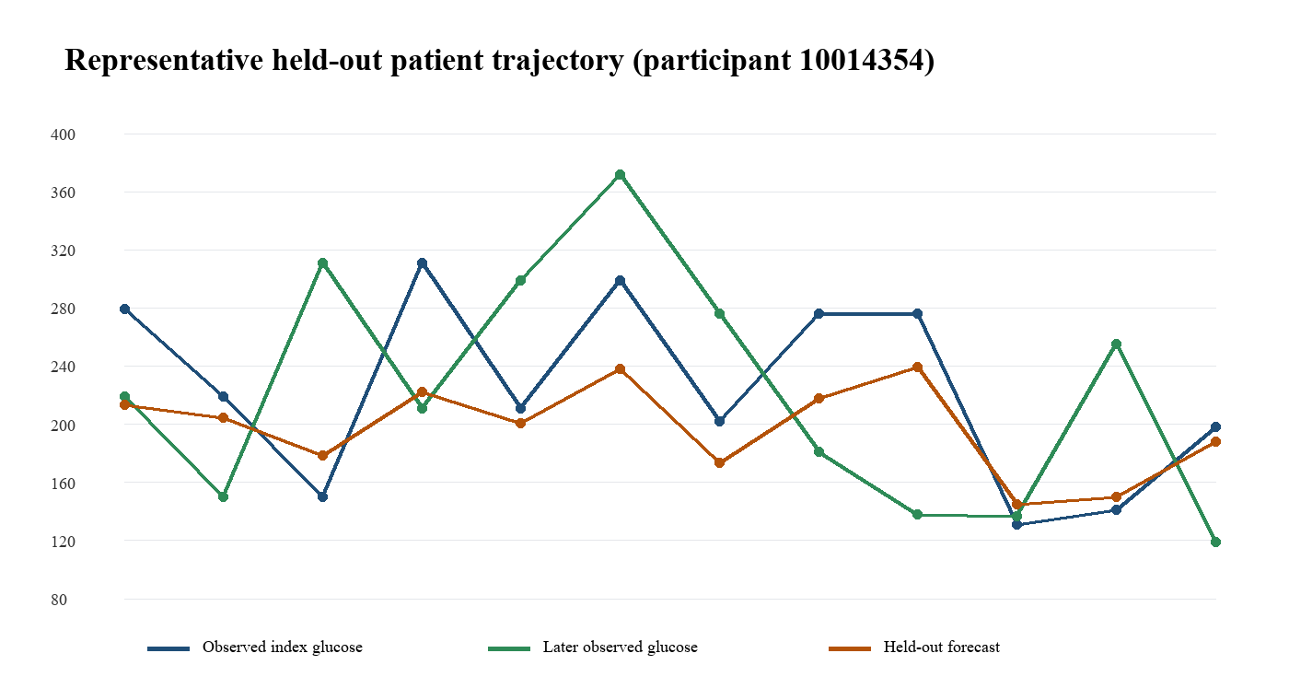
Figure 2. Representative held-out trajectory for research participant 10014354; not a live dashboard or clinical display.
4.3 Observed demo results
Model | Subject-macro MAE mg/dL | 95% CI | Patients
Adaptive-state ridge | 42.48 | 36.06 to 49.36 | 28
Snapshot ridge | 42.80 | 36.43 to 49.97 | 28
Fixed-history ridge | 44.33 | 38.30 to 51.23 | 28
Persistence | 44.41 | 35.24 to 53.20 | 28
Adaptive-state HGB | 47.87 | 41.84 to 54.51 | 28

Table 5. Held-out exploratory next-glucose performance in the MIMIC-IV demo cohort.
Adaptive ridge regression had the lowest observed subject-macro MAE, 42.48 mg/dL. However, the confidence interval overlaps the persistence baseline, and the data are small, irregular, and drawn from an acute-care setting. These results demonstrate the evaluation workflow; they do not establish that adaptive state modelling is superior or clinically useful.
5. SPECIAL WORK CONFERENCE READINESS
5.1 Contribution boundary
The defensible contribution is a transparent, leakage-safe implementation for evaluating a time-aware patient-state representation against simpler alternatives. The dashboard makes the distinction between observed state, trajectory monitoring, and later-outcome forecasting visible. The project does not claim novelty for the phrase digital twin itself, and it does not claim a complete physiological or clinical twin.
5.2 Next steps for a conference or research-paper study
• Use an approved full MIMIC-IV extract or another longitudinal diabetes cohort and freeze the outcome, eligibility rules, and modelling plan before test-set review.
• Restore the next-HbA1c question only if the full cohort passes the repeated-measurement feasibility gate.
• Add temporal validation, external validation where feasible, subgroup analysis, calibration/uncertainty analysis, and a complete exclusion-flow diagram.
• Treat medication-response modelling as exploratory unless exposure timing, treatment selection, baseline state, and appropriate causal methods are available.
• Report the final study with TRIPOD+AI and align all claims with the evaluated population and endpoint.
REFERENCES
1. Johnson AEW, Pollard TJ, Shen L, et al. MIMIC-IV, a freely accessible electronic health record dataset. Scientific Data. 2023;10:1.
2. Collins GS, Dhiman P, Andaur Navarro CL, et al. TRIPOD+AI statement: updated guidance for reporting clinical prediction models that use regression or machine learning methods. BMJ. 2024;385:e078378.
3. Pedregosa F, Varoquaux G, Gramfort A, et al. Scikit-learn: machine learning in Python. Journal of Machine Learning Research. 2011;12:2825-2830.
4. MIMIC-IV Clinical Database Demo. PhysioNet. Accessed for the bundled project data; use is subject to the applicable credentialing and data-use requirements.

