CGM FORECASTING FOR TYPE 2 DIABETES

Project Report
Submitted in fulfillment of the Course Project of ISWE410L Machine Learning

in
M.Tech Software Engineering
by
Padmanathan K

Under the guidance of
Dr. Ushapreethi.P


School of Computer Science Engineering and Information Systems
October 2026


School of Computer Science Engineering and Information Systems
Fall Semester 2026-27
TABLE OF CONTENTS
CHAPTER NO. | TITLE | PAGE NO.
 | ABSTRACT | iii
1 | Problem Statement | iii
2 | Dataset and Method | iv
3 | Implementation | iv
4 | Results and Accuracy | v
5 | Conclusion and Limitations | vii
 | References | viii

ABSTRACT
This project evaluates simple machine-learning models for short-horizon continuous glucose monitoring forecasting in people with type 2 diabetes. The ShanghaiT2DM dataset contains 100 people and 109 CGM episodes. The task is to predict glucose concentration 15, 30, and 60 minutes ahead using only the previous six hours of CGM observations. Three standard models are compared: persistence, Ridge regression, and Histogram Gradient Boosting regression from scikit-learn. The evaluation keeps every person entirely in either training or testing data through five patient-held-out folds. The main metric is subject-macro mean absolute error, which gives every patient equal weight. At 60 minutes, Histogram Gradient Boosting achieved the best result with a mean absolute error of 16.54 mg/dL and a 95% patient-bootstrap interval of 15.89 to 17.22 mg/dL. Both learned models improve on persistence, but accuracy decreases as the forecast horizon becomes longer. The project provides a reproducible Python implementation, clear accuracy figures, and a small Streamlit viewer for understanding saved results. The system is for retrospective research and education only; it is not a clinical decision-support tool.
1. Problem Statement
People with type 2 diabetes can experience rapid changes in glucose. A useful research task is to estimate the next CGM value from recent CGM history. The project asks whether standard regression models can improve on a simple carry-forward baseline when forecasting 15, 30, and 60 minutes ahead.
Objective
• Build a reproducible, patient-held-out CGM forecasting pipeline.
• Compare three standard scikit-learn approaches using the same input history.
• Report understandable accuracy results with graphs and confidence intervals.
Scope
The dataset supports short-term glucose forecasting only. It does not contain sufficient longitudinal clinical follow-up for reliable long-term disease progression, next-HbA1c, medication-response, or treatment recommendation claims.
2. Dataset and Method
2.1 Dataset
The ShanghaiT2DM release contains 100 de-identified people and 109 CGM episodes. Measurements are processed as 15-minute observations. Invalid values outside 20 to 600 mg/dL are treated as missing. The timeline is split at missing values and non-15-minute gaps so no feature window crosses a discontinuity.
2.2 Input Features
Each prediction uses the current glucose value, 24 past CGM lags, recent changes, rolling mean and variability, and time-of-day terms. This represents six hours of history. Features at time t are computed only from observations available at or before time t, preventing future information from entering a prediction.
2.3 Models
Model | Role | Implementation
Persistence | Baseline | Predicts that the next value equals the latest CGM value.
Ridge regression | Linear model | Median imputation, standardisation, and L2-regularised linear regression.
Histogram gradient boosting | Non-linear model | scikit-learn HistGradientBoostingRegressor using the same history features.

2.4 Evaluation
Five outer folds are created at patient level. All recordings from one patient remain in one fold, preventing the model from training and testing on the same person. The primary metric is subject-macro MAE in mg/dL. RMSE, R-squared, and percentage of predictions within 15 mg/dL are secondary descriptive metrics. The 95% confidence intervals are calculated by resampling patients, not individual time points.
3. Implementation
The implementation is deliberately small and uses standard Python tools. Pandas reads and cleans the data. scikit-learn trains the Ridge and Histogram Gradient Boosting models. Matplotlib and Seaborn create the final figures. Streamlit provides a read-only result viewer with an accuracy screen and a patient-level held-out prediction screen.
Folder or file | Purpose
src/shanghai_t2d | Data loading, feature construction, standard models, and evaluation.
scripts/run_basic.py | Runs the three-model patient-held-out workflow.
scripts/create_presentation_results.py | Creates the concise accuracy table and two report figures.
outputs/presentation | Presentation-ready accuracy summary and figures.
app.py | Simple Streamlit viewer for accuracy and one patient at a time.

Execution Steps
• Load CGM episodes and remove invalid or discontinuous intervals.
• Construct six-hour past-only feature windows for each forecast horizon.
• Split patients into five held-out folds.
• Fit persistence, Ridge, and Histogram Gradient Boosting models.
• Save out-of-fold predictions, calculate patient-level metrics, and draw final figures.
4. Results and Accuracy
Lower MAE is better. The table reports the subject-macro MAE in mg/dL, followed by a 95% patient-bootstrap confidence interval. All three models are evaluated on the same held-out patients and prediction points.
Model | 15 min MAE | 30 min MAE | 60 min MAE
Persistence | 6.57 (6.26-6.88) | 12.09 (11.49-12.67) | 20.36 (19.32-21.46)
Ridge regression | 4.26 (4.12-4.40) | 9.65 (9.29-10.02) | 17.45 (16.77-18.16)
Histogram gradient boosting | 4.39 (4.22-4.57) | 9.42 (9.04-9.80) | 16.54 (15.89-17.22)

At 15 minutes, Ridge regression is the best model with MAE 4.26 mg/dL. At 30 and 60 minutes, Histogram Gradient Boosting is best with MAE 9.42 and 16.54 mg/dL. At the primary 60-minute horizon, gradient boosting reduces MAE by 3.81 mg/dL compared with persistence, an improvement of 18.7%.
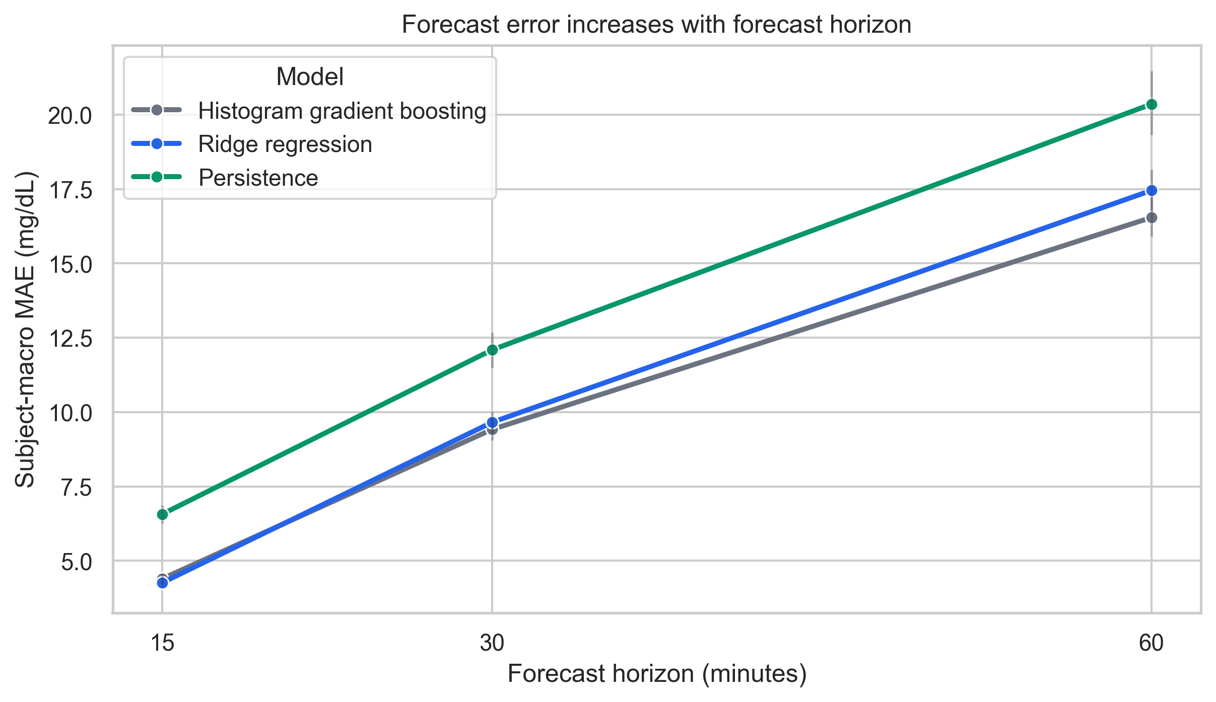
Figure 1. Subject-macro MAE by forecast horizon. Error bars show 95% patient-bootstrap intervals.
The increase in error from 15 to 60 minutes is expected because longer forecasts are more uncertain. The learned models remain better than persistence at every horizon, showing that recent CGM history contains useful information beyond the latest value alone.
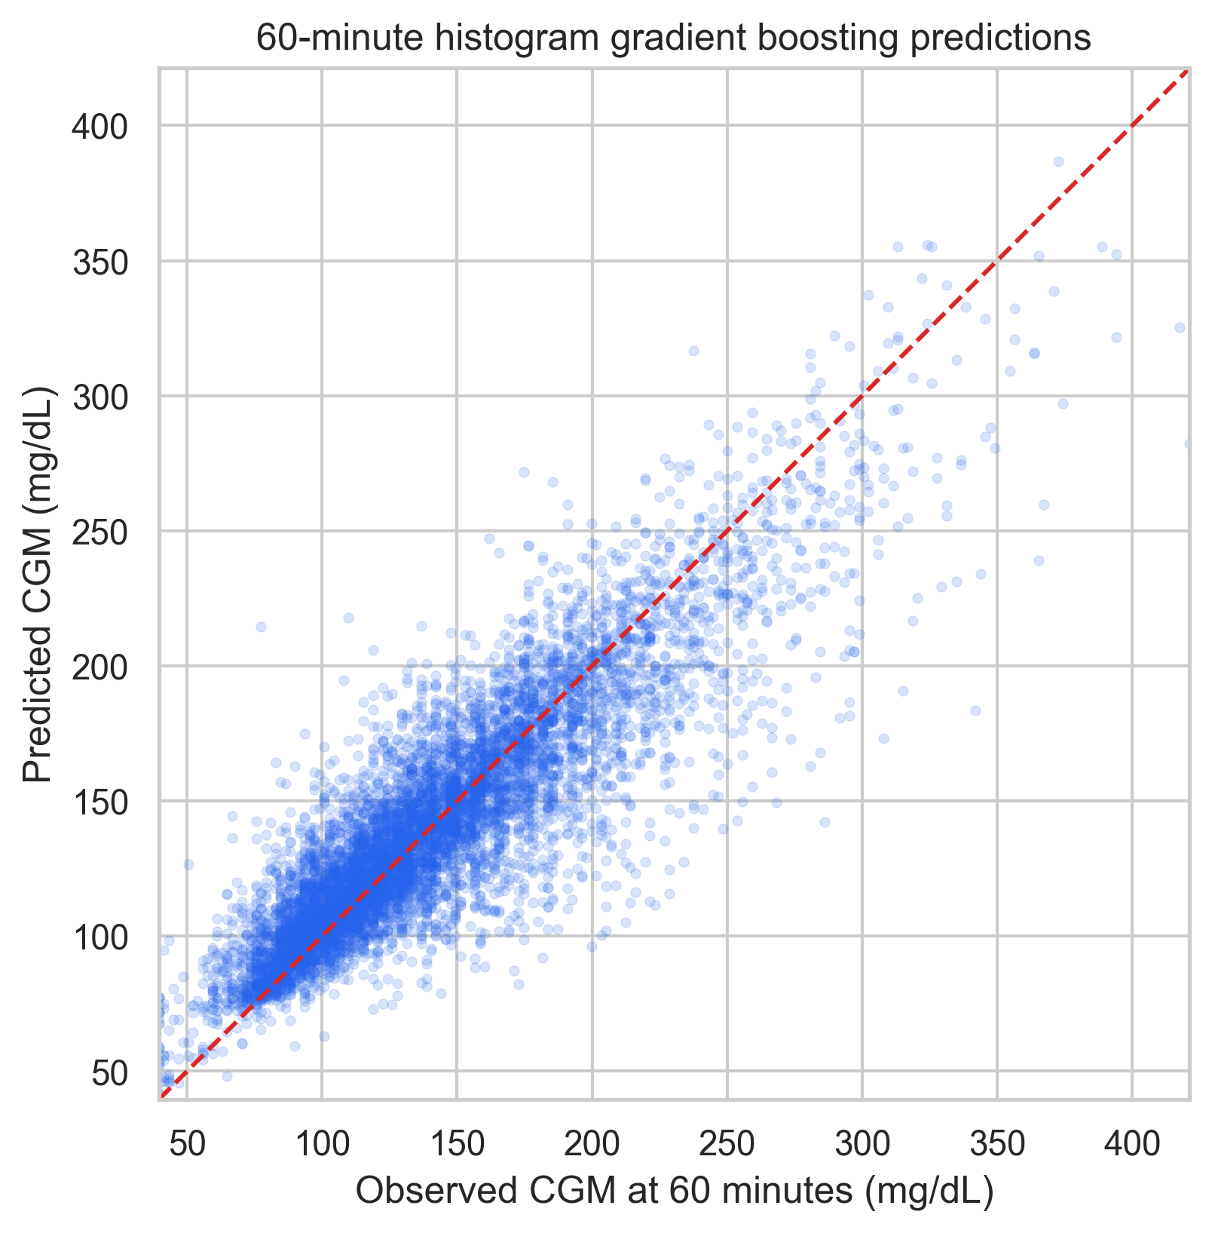
Figure 2. Observed versus held-out 60-minute predictions for Histogram Gradient Boosting. The dashed line indicates perfect agreement.
For the 60-minute gradient-boosting model, R-squared is 0.611 and 60.7% of predictions are within 15 mg/dL of the observed value. The scatter plot follows the diagonal overall, while wider spread at higher glucose values shows that individual forecasts still have meaningful error.
5. Conclusion and Limitations
The project demonstrates a clear and reliable comparison of standard forecasting models. Ridge regression provides the best 15-minute accuracy, while Histogram Gradient Boosting performs best at 30 and 60 minutes. Both models outperform the persistence baseline. The patient-held-out design, past-only features, saved predictions, and patient-level confidence intervals make the result reproducible and easier to explain.
The main limitations are the single retrospective dataset, short CGM episodes, and absence of long-term clinical outcomes. Therefore, the findings should not be interpreted as evidence for clinical deployment, disease-progression prediction, insulin dosing, or treatment recommendations. External and prospective validation would be required before any clinical use.
References
1. Zhao Q, Zhu J, Wang C, Rao W. Chinese diabetes datasets for data-driven machine learning. Scientific Data. 2023;10:35. doi:10.1038/s41597-023-01940-7.
2. ShanghaiT1DM and ShanghaiT2DM dataset repository. Figshare. https://figshare.com/articles/dataset/diabetes_datasets_zip/21600933.
3. Pedregosa F, et al. Scikit-learn: Machine Learning in Python. Journal of Machine Learning Research. 2011;12:2825-2830.

