Core Java
===========================================

Apr-23-2021
===============================
Standalone Application:-
Any prog runs in the context of local disk, whose results are not sharable.

Distributed Application:-
Those applications which runs in the context of browerand whose results are sharable across the globe.

Client-Server Architecture:-
Tier 1:-
-> set of client programs
-> Set of server programs
Tier 2:-
-> Set of client programs
-> Set of server programs
-> DB layer
Tier 3:-
-> Set of client programs
-> Set of server programs
-> DB layer
-> Cluster Setup Node
N Tier:-
-> Set of client programs
-> Set of firewall programs
-> Set of server programs
-> DB layer
-> Cluster Setup Node

e.g
Server S/w :-
Tom Cat - Apache
Weblogic - BEA Corporation
Websphere - IBM
glassfish - Sun Microsystem
Oracle 10g - Oracle Corporation

Java Release Types:-
J2SE -> Java 2 Standard Edition -> Desktop Applicaiton
J2EE -> Java 2 Enterprise Edition -> Web Application/Entrerprise Application
J2ME -> Java 2 Mobile Edition -> Mobile Applications.

Protocol:-

HTTP:-
-> HTTP comes under TCP (Transmission Control Protocol).
-> HTTP is one of the acknowledgement oriented protocol.
-> HTTP is one of the stateless protocol.
FTP:-
-> FTP comes under UDP(User Datagram Protocol).
-> FTP is one of the non-acknowledgement oriented protocol.
-> FTP is one of the stateful protocol.

Features/Busswords of Java:-
=========================================================
1. Simple
2. Platform Independent
3. Architectural Neutral
4. Portable
5. Multithreaded
6. networked
7. Distributed
8. High Performance
9. Robust
10. Dynamic
11. Interpreted
12. Secured
13. OOPL (Object Oriented Prog. Lang.)

1. Simple:-
Java is one of the simple programming language because of the following points:-
a. Java Programming does not support a complex concept called pointers.
b. Memory Allocation :- Java programming execution environment containes inbuilt "garbage collection" program for automatic memory management for strengthaning the performance of Java applications.
GC -> internal algorithm (mark and sweep)

* Define a Garbage Collector:-
Garbage collector is one of the background system java program which s running internally along with regular Java program for collecting unused/unreferenced memory space for improving the performance our Java applications.
Note:- Java Programming does not support destructor concept is place of destructors we have GC program.
24-Apr-2021
===================

2. Platform Independent:-
a. The language must have data types & they must have take same amount of memory space on every platform.
b. The language must contain some special internal programs which will convert from one format of one OS to another format of another OS.

3. Architectureal Neutral:-
- An application is said to be architectural neutral if an only if the application runs on every processor without considering their architectures and vendors(provider).
- A language is said to be architectural neutral, it has to satisfy the following property.
- The s/w must have the special internal programs which will convert the factors of one processor to factors of another processor.
- The language like c, c++ etc. are considered architectureal dependent because the above property is not satisfied.

4. Portable:-
- A portable application is one which will run on every operating system and on every processor without considering their vendors and architectures.
- The applications of c, c++, pascal etc. are treated as non portable applications.
- All the Java applications are treated as portable applications.
According Sun Microsystem.
Portability = Platform Independent + Architectural Neutral

5. Multithreaded:-
- Multithreading is one of the distinct facility of Java Programming.
- The basic aim of multithreading is that to achieve concurrent excution.
- A flow of control is konwn as thread.
- The basic usage of thread is to execute user/programmer defined functions.

- In Java programming multithreading applications are deveoped by following Packages.
a. java.lang.Thread(class)
b. java.lang.Runnable (Interface)

e.g:- thread/execution flow main method

public static void main(String [] args {
jflasjflasjf
}

6.Networked:-
- Java has introduced the capability to develope networked applications, web applications.
- Java has J2SE and it has capability or API or pacakges to develope network applicaionts.
e.g - java.net.*; ServerSocket ss=new ServerSocket(6666);

26-Apr-2021
=====================
7. Distributed :-
According to the industry standards, in Java realtime applications are classified into two types they are
1. Centralized Applications
2. Distributed Applications

When we run the Java Program, for executing the logic of our Java program there exist one thread known as foreground thread. To monito the status of foreground thread, there exist one more background Java Program known as Garbage Collector.
For executing garbage collector there exist on thread know as background thread hence in Java programming execution environment there exist above two threads.

8. High Performance:-
Java is one of the high performance programming language because of the following reasons
1. Because of magic of bytecode.(We know that bytecode is the set of optimized instructions generated by the Java compiler during compilation phase and it is more faster than ordinary pointer code.)
2. Because of magic of GC , automatic memory mangement is taken care.(We know that GC is the one of the system background Java program runs along with our regular Java program for collecting unused memroy space for improving the performance of Java applications.)
3. Java programming is free from pointers so that a Java program can develop an application as early.

9. Robust(Strong) :-
When we write any program in any programming lang. we come across various types of errors.Broadly errors are classified into two types they are:
1. Compile time errors:-
2. Runtime errors.

10. Dynamic :-
Types of memory allocation
1. Static memory allocation.
2. Dynamic memory allocation.

- Java only supports dynamic memory allocation.

11. Interpreted :-
:> javac Test.java -> compilation
:> java Test -> interpretion

Java supports both compilation as well as interpretation.

JIT(Just In Time) is the set of programs developed by Sun Microsystem and added into JVM to speed up the interpretation phase by reading the entire section of the bytecode and converting it into native understanding form of OS.

12. Secured:-
- No pointers
- Class file and robust bytecode.
- Automatic memory management.
- "java.security"

13. OOPL (Object Oriented Prog. Lang.):-
Class
Object
Interface
OOPS concepts(Polymorphism, Abstraction, Encapsulation, Inheritance)

27-Apr-2021
===========================================
Datatypes in Java:-
1. Integer category datatypes
2. Float
3. Character.
4. boolean.

1. Integer Category:
Datatype Size Range
----------------------------------------------------------
byte 1 byte +127 to -128 e.g byte a;
short 2 byte +32767 to -32768 e.g short a;
int 4 byte +2147483647 to -2147483647 e.g int a;
long 8 byte +9,223,372,036,854,775,808 to -9,223,372,036,854,775,807 e.g long a;

2. Float:
Datatype Size Range
----------------------------------------------------------
float 4 byte Sufficient for storing 6 to 7 decimal digits e.g float a; 10.10
double 8 byte Sufficient for storing 15 decimal digits e.g double a; 10.20

3. Character:
Datatype Size Range
----------------------------------------------------------
char 2 byte Stores a single characeter/letter or ASCII values e.g char a; 'A'

4. boolean:
Datatype Size Range
----------------------------------------------------------
boolean 1 bit Stores true/false values e.g boolean a; true/false

Identifiers:
String empName; (here empName is identifier)
int empId; (here empId is identifier)

Variables:
If we enter any input to the program then the input must be stored in the main memory of the computer in terms of variables.
Definition:- Variable is an identifier whose value is changing during execution of the program.

Rules for writing variables:-
- First letter of the variable must an alphabet. e.g int empId;
- length of the variable in java can be allowed upto 32 characters.
- No special symbols are allowed except underscore(_) e.g String emp_Name
- No reserved words used while declaring variable names. e.g String if/else/private/public; invalid

Variable declaration:-
syntax: datatype variableName1, variableName2;

int a;
int b;
int a, b;
char c1, c2;
String s1, s2;

Initialization of Variables:-
syntax:- datatype v1=val1, v2=val2;
eg. int a=10, b=20;

28-Apr-2021
===========================================
*JDK
The Java Development Kit (JDK) is a software development environment used for developing Java applications and applets.
It includes the Java Runtime Environment (JRE), an interpreter/loader (Java), a compiler (javac), an archiver (jar), a documentation generator (Javadoc) and other tools needed in Java development.

*JRE
JRE stands for “Java Runtime Environment” and may also be written as “Java RTE.” The Java Runtime Environment provides the minimum requirements for executing a Java application; it consists of the Java Virtual Machine (JVM), core classes, and supporting files.

*JVM
Java Virtual machine(JVM) is a very important part of both JDK and JRE because it is contained or inbuilt in both. Whatever Java program you run using JRE or JDK goes into JVM and JVM is responsible for executing the java program line by line hence it is also known as interpreter.

Class Loader Subsystem:-

It is mainly responsible for three activities.
- Loading
- Linking
- Initialization

JVM Memory

-Method area:
In the method area, all class level information like class name, immediate parent class name, methods and variables information etc. are stored, including static variables. There is only one method area per JVM, and it is a shared resource.
-Heap area:
Information of all objects is stored in the heap area. There is also one Heap Area per JVM. It is also a shared resource.
-Stack area:
For every thread, JVM creates one run-time stack which is stored here. Every block of this stack is called activation record/stack frame which stores methods calls. All local variables of that method are stored in their corresponding frame. After a thread terminates, its run-time stack will be destroyed by JVM. It is not a shared resource.
-PC Registers:
Store address of current execution instruction of a thread. Obviously, each thread has separate PC Registers.
-Native method stacks:
For every thread, a separate native stack is created. It stores native method information.

Java Program Structure:-
-> Comment statement
-> package statement
-> import statement
-> Interface declaration
-> abstract classes declaration
-> other concrete classes
-> main class
-> methods (predefined/user defined)

*Comments:-
A comment is a statement which explains what the program does or explains the narations of the programs.

1. Single line comment:
// Single line comment -> C++ style
/*single line comment*/ -> C style

2.Multiline Comment/paragram:

/*
....
multiple line comment
...
*/

3. document/html comment:
/**
*
*
*...*/

javadoc Addnum.java -> java documentation generation from document comment.
javap Addnum -> java profiler

29-Apr-2021
============================================
*Keywords :- predifined words by programming language and it has some special meaning.
----------
1.abstract 2.assert 3.byte 4.break 5.boolean 6.class 7.const 8.catch
9.case 10.continue 11.char 12.do 13.double 14.default 15.else 16.extends
17.enum 18.for 19.float 20.final 21.finally 22.false 23.goto 24.if 25.int
26.interface 27.implements 28.instanceof 29.long 30.new 31.native 32.package
33.private 34.protected 35.public 36.return 37.super 38.switch 39.static
40.synchronized 41.try 42.this 43.throw 44.throws 45.transient 46.void 47.volatile 48.while

Operators in Java:-
========================
1. Unary Operators -> one operator & one operand
e.g. -y, +x
2. Binary operator -> one operator, two operands
e.g. x-y, x+y
3. Ternary Operator -. Two Operators & three operands
a>b?c:b;

Types Operators:-

1. Assigment operator =
e.g int a = 10;

2. Arithmetic Operator: -,+,*,/,%,++,--
e.g int a = b+c;

3. Relational Operator/Comparison operator: >, <, >=, <=, ==, !=

e.g. if(a>b){}

4. boolean/logical operator: &&, ||, !
if(a>b && c>d){}

5. bitwise operator: &, |, ^, <<, >>, ~
e.g int a = a&b;

6. Compound Assignment operator: +=, -=, *=, /=, %=
e.g int a = 10, b = 5;
a+=b;
7. conditional/ternary operator: ?:
e.g a>b?c:b;

9. Type operator: instanceof

A -> B -> C e.g if(c instanceof a)

A a = new C();

30-Apr-2021
==========================================
*Constants In Java

final:-

- If we don't want to change the value of the variable then those variable values must be made as constant.
- Definition:-
A constant is an identifier whos values can't be changed during execution of the program.

1. Final Variable level :-
e.g. final datatype v1=val1,..vn = valn;

e.g. final float PI = 3.14f;

2. Final Method level:-
e.g final returnType methodName(list of formal parameteres){
//block of statement;
}

- If we don't want to change the definition of the method then the method definition must be made as constant by using final keyword.
- In another words whenever we develop another method which is common for many number of java programmers then such methods are highly recommended to make them as final.
Bike bike = new Honda(); // -> CTTI (Compile Time Type Identificatin) RTTI (Runtime Type Identification)

* Define method overriding and method overloading?
-> Method overriding :- The process of redefining the original method for performing multiple operations is know as method overriding.

Method overriding = Method heading is same + method body is different

-> Method overloading:- The method is said to be overloaded method if and only if method name is same but its signature is different.
Signature represents the following.
-> No. of parameters.
-> Type of parameter
-> Order of parameters

e.g :-
addition(10,20,30); -> number parameters 3
addition(100,200); -> number paramerters 2
addition(100,10.75f); -> type of parameters
addition(10.75f, 100); -> order or parameters

8-May-2021
========================================

3. Final at class level:-
- If we don't want to give the feature of base/parent class to the derived/child class then the base class definition must be made as final.

Syntax:-

final class <class_name>
{
//class body
}

- Once the class is final whose properties can't be inherited from base class to derived class.
- Final class is never participate in inheritance process.

Note:-
- final variable values can't be modified.
- final methods can't be overriden.
- final class can't be inheritable/reusable/extendable.

OOPS Feature:-
=====================================================
1. Procedure Oriented Programming Language.
-> C, pascal, COBOL, ADA

2. Object Oriented Programming Language.
-> Small Talk, Lisp, Object Pascal, Object COBOL, C++, Java, .net.

C++ is partial object oriented.
1. Every c++ program can be written like c prog.
2. 50% of OOPs principles not satisfied.
3. Friend Function.

OOPS Features:-
1. class
2. object
3. Data Abstraction
4. Data Encapsulation
5. Inheritance
6. Polymorphism
7. Dynamic Binding.
8. message passing.

1. class:-
Definition:- The process of binding the data members and associated methods in a single unit. This single unit is known as class.

- The data members of the class are also known as attributes or properties.
- The mehtods of the class are also known as behaviors or accessories.

- We have 2 categories of methods:
1. member method
-> A member method is one which is available within the scope of the class and it can access the data of the class.

2. non member method
-> A non member method is one which is not available within the scope of the class and it can not access the data members of the class.

10-May-2021
==========================================================
Syntax:-

class <class_name>
{
data_member declaration;
method definition;
}

e.g
class Student{
int id;
String name;
float m1, m2,m3;
String collegeName;

public int getNoOfHoursStudy(){
return n;
}
}

2. Object:-
1. Instance of a class is know as an object (Instance is nothing but allocating sufficient amount of memory space for the data members of the class).

Student s = new Student();

2. Each and every class variable is known as an object.
3. Grouped item is known as an object (Grouped item is a variable or identifier which allows us to store multiple values either of same type or different type or both).
4. value form of class is object.
5. Blue print of a class is known as an object.
6. Real world entities are known as object.
7. Logical runtime entity is known as object.

Datatype Default Value
-------------------------------------------------
boolean false
char '\u0000'
byte 0
short 0
int 0
long 0L
float 0.0f
double 0.0d

The operator new internally performs two types of operations:
1. allocating sufficient amount of memory space for the data member of the class.
2. instantiation of the data member for which memory is allocated.

Syntax:-
1.
<class_name> objectName = new <class_name>;
2.
<class_name> objectName;
objectName = new <class_name>;

e.g:
Student s = new Student;

Student s;
s = new Student();

11-May-2021
=======================================================
Types of Data Members:-

1. Instance/non-static data members :-
-> Instance data members are those whose memory space is created each and every time whenever an obect is created.
-> If our class is containing collection of data members and we are placing specific values then those data members are recommended to take as instance data members.
-> Programatically to make any data member as instance data member whose declaration should not be preceded by a keyword "static".
-> syntax :- data_typa v1,v2,...vn;
e.g int a; float b;
-> Each and every instance data member must be accessed with respect to object name.
objname.IDM(Instance Data Member).
-> The values of instance data members are not sharable.
-> Instance data members are also known as object level data members because they depends on object and independent from class name.

2. static data members:-
-> Static data members are those whose memory space is created only once when the class is loaded in the main memory irrespective of number of objects are created.
-> If our class is containing collection of data members which are containing common values or fixed values then the data members of the class are recommended to take as static data members.
-> Programatically to make any data member as static data member whose declaration must be preceded by keyword "static".
-> syntax:
static data_type v1, v2,..., vn;
e.g static int a; static float b;
-> Each and every static data member must be accessed with respect to class name.
Class_Name.SDM(Static Data Member);
-> The values of static data members are always sharable.
-> Static data members are also known as class level data members becuase they depends on class and independent from object name.

12-May-2021
=========================================================
Types of Methods:-

1. Intance/non-static methods:-
-> Instance methods are those which are recommended to perform repeated operations such as reading records from the file, reading records from the DB>
-> Programatically instance methods definition should not be preceded by a keyword static.
Syntax:-
return_type method_name(list of formal parameters if any){
//block of statements
}
-> Each and every instance method must be accessed with respect to object name.
e.g;-
object_name.instanceMethodName();

-> The result of instance method is not sharable.
-> Instance methods aer know as object level methods because they depends on object & independent from class.
e.g:-
void getTotal(){
//body of methoduntitled:Untitled-1
}
2. static methods:-
-> Static methods are those which are recommended to perform one time operations such as opening a file, obtaining DB connection.
-> programatically static methods definitions must be preceded by a keyword static.
Syntax:-
static return_type methodName(list of formal paramters){
//body of the method
}
-> All the static methods in java must be accessed with respect to class name.
e.g:-
Class_Name.staticMethodName();
-> The results of static methods are always sharable.
-> static methods are also know as class level methods because they depends on class name and independent from object.
e.g:-
public static void main(String [] args){
//method body
}

14-May-2021
=============================================
Rules for instance and static methods:-

Rule 1:
One static method can call another static method directly provided both static methods belongs to same class.

Rule 2:
One instance method can call another instance method directly provided both the methods must belong to same class.

Rule 3:
One static method can call another instance/non-static method with respect to an object provided wheather they belongs to same class or different class.

Rule 4:
One instance method can call another static method with respect to class name provided wheather they belongs to same class or different class.

Note:- As a part of the class what are all the methods defined by the programmer are known as business logic methods and the block of statements auntitled:Untitled-1vailable in the business logic methods is known as business logic.

20-May-2021
=====================================================
length:-
========
Lenght is one of the implicit variable created automatically by the JVM and supplied to every java program for two purposes.
1. To find the number of element or size of the array.
2. To treat the fundamental arrays as objects because java is one of the pure object oriented programming language.

Syntax:-
Arrayname.length.

e.g
1. int a[] ={10,20,30};
System.out.println("No. of elements = "+a.length);

2. String s[] = {"abc","pqr","Java"};
System.out.println("No. of Names = "+s.length)

for(int i = 0, i< s.lenght; i++){
System.out.println(s[i]);
}

Accessing the Data Dynamically:-
===============================

Accessing the data dynamically is nothing but entering the values to the java program at runtime.
In Java programming to access the values dynamically we have three approaches they are:
1} By using command line arguments
2} By using keyboard
3} By using properties file (Resource bundle file)

1) By using Command Line arguments:-
Q. Why Java main method takes array of objects of String class as a parameters?
=> Every main method takes array of objects of String class because to accept command line arguments.
The number of values which we are passing to the Java Program from the command prompt are know as command line arguments.

e.g :> java SumDemo 60 70
----- ------- ---------
command Java Prog. Command Line arguments

-> When we enter any command line arguments to the Java program then they are by default treated as String data.
-> All the command line arguments are by default passing to main method.
-> All the command line arguments must be holding main method by taking a String parameter.
-> Since command line arguements are unlimited/dynamic main method is holding all the command line arguments in an array variable in a String type.
-> While we are using array variable of String type in the main method one can't specify the size of the array.
-> Since Java is pure object oriented programming String data which is available in main method must be represented by using predefined class called String.
-> Therefore every main method must take array of objects of String clas for holding command line arguments.

21-May-2021
===================
Converting String data into fundamental or numerical data:-
- When we pass any command line arguments to the java program, by default the command line arguments are treated as String data.
- We know that on String data one can't perform numerical manipulations hence it is highly desirable to convert String data into numerical or fundamental data.
- The following table gives fundamental datatype corresponding wrapper class and conversion method from String data to fundamental data.

Datatype Wrapper Class Name Conversion method from String to fundamental data_type
-----------------------------------------------------------------------------------------------------------------------------
byte Byte public static byte parseByte(String)
short Short public static byte parseShort(String)
int Integer public static byte parseInt(String)
long Long public static byte parseLong(String)
float Float public static byte parseFloat(String)
double Double public static byte parseDouble(String)
char Character public static byte parseChar(String)
boolean Boolean public static byte parseBoolean(String)

In general each & every wrapper class is containing the following generalized predefined method for converting string data into fundamental data.

e.g :
public static XXX parseXXX(String)
------------------------------------
Here XXX represents any fundamental datatype.

e.g
String s[] = {"10","20"};
SOP(s[0]+s[1]);

int x = Integer.parseInt(s[0]);
int y = Integer.parseInt(s[1]);

int z = x + y;
sop("Sum = "+z);
sop("Sum = "+x+y);

29-May-2021
=====================================
-> Write a Java Program which will perform interchanging(Swap) of two values.
-> Write a Java Program to print the multiplication table of given number.
-> Write a Java Program to calculate factorial of a given number. // 5 5 * 4 * 3 * 2 * 1 = 120
-> Write a Java Program to decide whether given number is prime or not. // a number which is divided by 1 or itself. e.g. 2,3,5, 11 , 13 , 17,19

31st May 2021
=====================================

Constructors in Java:-

-> A constructor is a special member method which is automatically calling by the JVM for placing our own values whenever an object is created without placing the default values.
-> The basic purpose of constructor in Java is to initialize an object.

* Advantages of Constructors:-
1. Constructors eliminates placing of default values.
2. Constructors eliminates calling ordinary methods explicitly

* Rules/properties/characteristics of Constructors:-
1. When we use the constructors as a part of our Java program we need to follow rules.
2. Constructor will be called automatically whenever an object is created, the name of the constructor must be similar to class name.
3. Constructors should not return an value even void also(If we write void as a return type of the construcotr then it is treated as ordinary method.)
4. Constructor should not be static because constructors must be called each and every time as and even obejct is created.
5. Contructors will not be inherited from one class to another class because every constructor of a class must be used for initializing data members of the same class but not other class data members.
6. A constructor can be private provided an object of that class can not be created in the context of some other classes.

* Types of Constructor:-
In Java programming we have two types of constructors they are:
1. Default/parameter less / zero argument constructor
2. Parameterized constructor.

1. Default Constructor:-
Test t1 = new Test();

- A default constructor is one which never takes any parameter.
- Default constructor is highly recommended to take place same values in different obejct of same class.

Syntax:-

class <class_name>{
//statments

<class_name>(){ // default constructor.
//block of statments
}
}

2nd June 2021
==============================

Rule 1:
- Whenever we create an object only with default constructor defining the default constructor is optional.
- If we are not defining default constructor then JVM will call it's own constructor called System Defined default constructor and it is placing default value depends on data members of class.
- If we define our own default constructor then JVM will call user/programmer defined default constructor for placing our own values.

2. Parameterised Constructor:-
- A parameterised constructor is one which always takes parameters.
- If we want to place different values for different objects of same class then we must use parameterized constructor.

Syntax:-
class <class_name>
{
<classname> (list of formal parameters)
{
}
}

Rule 2:-
- Whenever we create an object with parameterised constructor, defining the parameterised constructor is mandatory.

Rule 3:-
- Whenever we create multiple objects with both default & parameterised constructor it is mandatory for the Java programmer to define both the constructors otherwise we get compile time error.

* Overloaded Constructors:-
- A constructor is said to be overloaded if an only if constructor name is same but its signature is different.

Signature represents:
-> No. of parameters
-> Type of parameters
-> order of parameters

e.g.
Test t1 = new Test(10,20);
Test t2 = new Test(100);
Test t3 = new Test(10.25f, 20.75f);
Test t4 = new Test(100, 10.75f);
Test t5 = new Test(10.75f, 200);

In the above example the constructor Test() is known as overloaded constructor.

* Object Paramterised constructor:-
- An object parameterised costructor is one which always takes objects as parameter.
- Object parameterised constructor is used for copying the content of one object into another object provided both the obejects must belongs to same type.

- Let us consider the following:-

Test t2 = new Test(10,20); -> (1)
Test t4 = new Test (t2); -> (2)

- The statement (2) represents object parameterised constructor i.e. it copies the content of t2 into an object t4.
- The object t2 and t4 belongs to same type i.e. Test.
- Therefore in Java programming to copy the content of one object into another object, we use the concept of object paramterised constructor which is exactly funtioning like copy constructor of C++.

3-June-2021
==============================================

* this keyword:-
- This is one of the implicit keyword/object created by the JVM and supplied every Java program for two purposes they are :
1. It points to current class object.
2. Whenever formal parameters and data memebers of the class are similar then JVM gets and ambiguity (not having clarity to identify which are data member of the class and which are formal parameteres.)
- In order to differenciate between formal parameters and datamembers of the class, as a Java programmer data members of the class must be preceeded by a keyword "this ".

Syntax:
this.currentclass data member;

- In Java programming operator overloading facility is not avaibale but we can solve all the problems with a simple concept of methods.
- A method is not only returning fundmental values and predefined classes but alos returns user defined class name as return type.

* this(), this(...):-
- We know that one method can call another method either with respect to object or with respect to class i.e. we can esatblish the communication between multiple methods.
- Similarly, in order to establish the communication between constructors of the current class we must use two types of functions. They are:
1. this()
2. this(...)

1. this():-
It is used for calling current class default constructor from current class parameterised constructors.
2. this(...):-
It is used for calling the current class parameterised constructors from other category constructors of same class.

Rules:-
1) When we ae using either this() or this(...) in the current class constructors they must be used always as a first executable statement otherwise we get compile time errors.
2) No cycle to be formed but recommend to form only path when we are using either this() or this(...) in the current class constructors.
3) No consecutive this(), this(...) to be used in the current class constructors because every this(), this(...) want ot have as a first executable statement in the current class constructors.

e.g. :-

class ThisObjectMethod{
int a,b;

ThisObjectMethod(){ // ----- (2)
this(1000); // control goes to (3)

System.out.println("Default Constructor");

a = 1;
b = 2;

System.out.println("Val of a = "+ a);
System.out.println("Val of b = "+ b);
}

ThisObjectMethod(int x){ // ----- (3)
System.out.println("Single param Constructor");

a = x;
b = x;

System.out.println("Val of a = "+ a);
System.out.println("Val of b = "+ b);
}

ThisObjectMethod(int x){ // ----- (3)
System.out.println("Single param Constructor");

a = x;
b = x;

System.out.println("Val of a = "+ a);
System.out.println("Val of b = "+ b);
}

ThisObjectMethod(int x, int y){ // ----- (1)
this(); // control goes to (1)

System.out.println("Two param Constructor");

a = x;
b = y;

System.out.println("Val of a = "+ a);
System.out.println("Val of b = "+ b);
}
}

class ThisObjectMethodExec{

public static void main(String [] args){ ThisObjectMethod(int x){ // ----- (3) single paramerterised constructor x =100

System.out.println("Single param Constructor");

a = x; // a = 1000
b = x; // b = 1000

ThisObjectMethod tom = new ThisObjectMethod(100, 200); // control goes to (1)
}
}

TOP TOP
E | (3) Default Constructor (3) /\
x | (2) Single param Constructor (2) |
e | (1) Two param Constructor (1) | Calling
c \/ |
u Botton Bottom
tion ThisObjectMethod(int x){ // ----- (3) single paramerterised constructor x =100

System.out.println("Single param Constructor");

a = x; // a = 1000
b = x; // b = 1000

In the above program, constructors are calling in the order of 1,2,3 (increasing order and executing in the order of 3,2,1 (decreasing order)).
In general, in any Java program constructors are calling from bottom to top and executing from top to bottom.

Note:- Whenever we use two consecutive this() and this(...) in the current classs constructor syntacticall which is wrong but it can be solved programmatically by using above rule.

Note:- Whenever we want to have multiple values in the same object, it is recommended to establish the communication between multiple construcotrs of the same class by making use of this() and this(...).

04-May-2021
====================================================
- Inheritance:-
- Inheritance is one of the distinct feature of Object Oriented programming language.
- If we use Inheritance concept as a part of our Java programming we get various advantages.

- Definition:-
1) The process of obtaining the data members and methods from one class to another class is known as inheritance.
2) The process of creating a new class from the old class is know as Inheritance.

- The class which is giving data members and methods to some other class is know as base or super or parent class.
- The class which is getting data members and methods from some other class is know as derived or sub or child, derived class.
- The concept of Inheritance is also know as sub-classing or extendable classes or derivation or re-usability.

- Advantages:-
When we use Inheritance concept as a part of our Java program, we get the following advantages.
- Application Development time is less.
- Application memory space is less.
- The execution time of an application is less.
- The redundancy(repeatation) of the code is reduced. So, that we get less memory cost and consistent result.
- An overall we can achieve the slogan of Java i.e WORA(Write Once Reuse Anywhere).

Faculty
← Base/Super/Parent class
Data Member
← Inheritance/subclassing Student ← Derived/sub/child class.
Methods
Data Member
Methods
- Types of Inheritance:-
The number of ways we inherit the features of various classes into derived classes are know as re-usable techniques or inheritance types.
In Java programming we have five inheritances types. They are:

1) Single Inheritance:-
Single base class and single derived class.
C1

*Inheritance Path:-
C2
C1 → C2

2) Multilevel Inheritance:-
Multilevel Inheritance is one in which there exist single base class, single derived class and multiple intermediate base classes. → Intermediate base class. * Inheritance Path:-
C1
C2
C3
C4
C1 → C2 → C3 → C4

* Define Intermediate base class:-
An intermediate base class is one, in one context if access base classes and in another context it access derived class.

3) Hierarchical Inheritance:-
Hierarchical Inheritance is one in which there exist single base class and multiple derived classes.
C1

C2
C3
C4

* Inheritance Path:-
C1 → C2
C1 → C3
…
- C1 → C4

4) Multiple Inheritance:
Multiple Inheritance is one which there exist multiple base classes and single derived class.
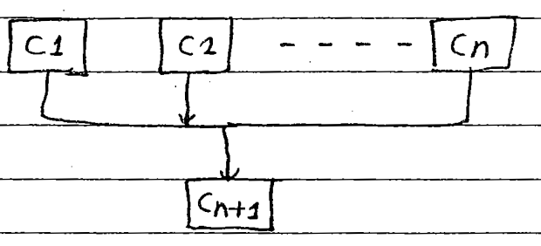
* Inheritance path:- C1 → Cn+1, C2 – cn+1, ---, cn → cn+1
* Note: Java programming never support the concept of multiple inheritance with respect to classes. But it can be supported by Java with a concept of an Interface.

5) Hybrid Inheritance:-
Hybrid Inheritane = combination of any available inheritance types.
In the combination if one of the combination is multiple Inheritance then the entire combination is not supported by the concept of classes. But it can be supported by the concept of Interfaces.
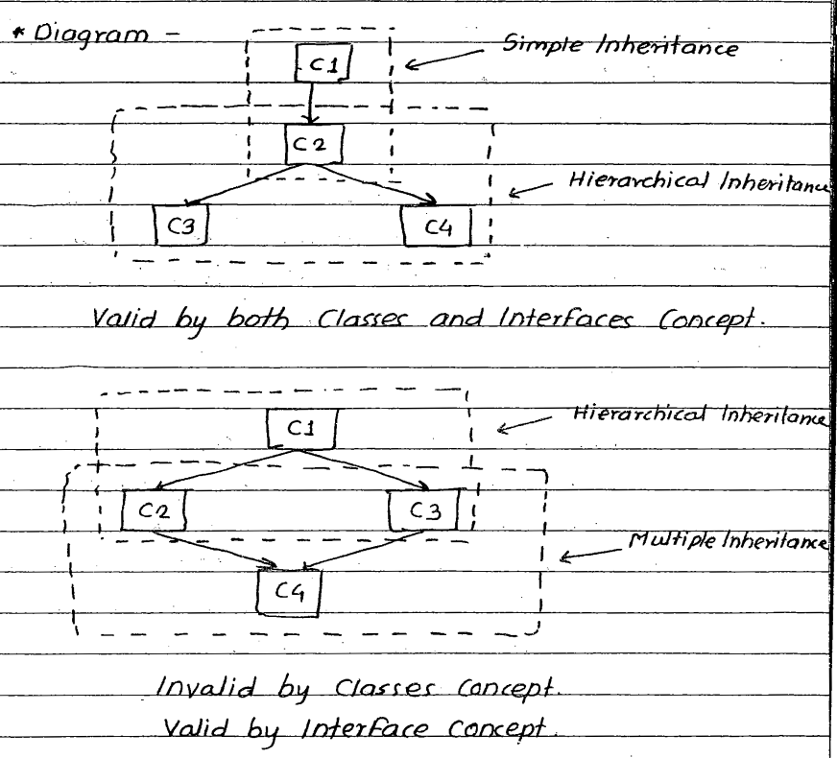
* Syntax for Inheriting features of Base class to derived class:- class <classname2> extends <classname1>{
variable declaration.
}
*e.g.
class Student extends Faculty{ // Student is child class and Faculty is Parent Class
}
5-May-2021
=========================================================================
Syntax Explanation:-
In the above syntax:-
1) <classname1> & <classname2> represents the name of the Base and Derived classes respectively.

2) extends is a keyword used for inheriting the features of base class into derived class plus it is improving the functionality of derived classes.

3)one derived class can always extends only one base class.

4) Whenever we develop any inheritance applications, it is highly recommended for the Java programmer to create an object of bottom most derived class because it contains all the features of top most super class and multiple intermediate base classes.

5) Whenever we create an object of bottom most derived class, first we get the memory space for data members of top most base class, second we get the memory space for data members of intermediate base classes and the last we get the memroy space for data members of bottom most derived class.

6) If we dont want to give the features of base class to the derived classes, then the definition of the base class must be made final. Hence final base classes never participates in inheritance process.

7) If we dont want to give some of the features of base class to the derived class then those features of the base class mus be made as private. Hence, private features of the base class never participates in the inheritance. In other words, the private features of base class can’t be accessed in derived class context.

8) The constructors of the base class will not be inherited into derived class, because constructors are meant for initializing its own class data members and not other class data members.

9) An object of base class always contains details about its own class but an object of base class never contains details about special features of derived class.

10) For each & every class in Java, there exist an implicit predefined super class know as java.lang.Object class. Because java.lang.Object provides garbage collector program to its subclasses for collecting unused memory space for improving the performance of Java applications.

- Types of Relationship In Java:-
Types of relationships always makes us to understand how to get the features of one class into another class. In other words, types of relationships allows us to share the data between multiple classes.
In Java programming we have three tyes of relationships. They are:-
1) Is-a relationships
2) has-a/ A part of relationships
3) uses-a relationships

1) Is-a relationship:-
Is-a relationship is one in which the features of one class is obtained from another class with the concept of Inheritance by using extends keyword.

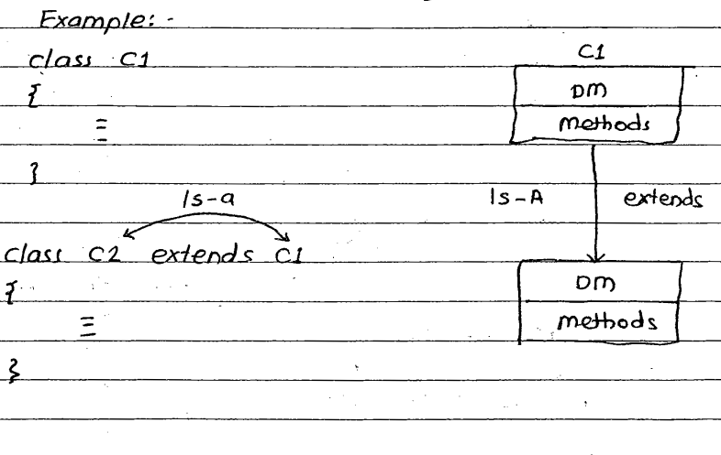

2) Has-a relationship:-
Has-a relationship is one in which one class object is created in another class as a datamember of that class.

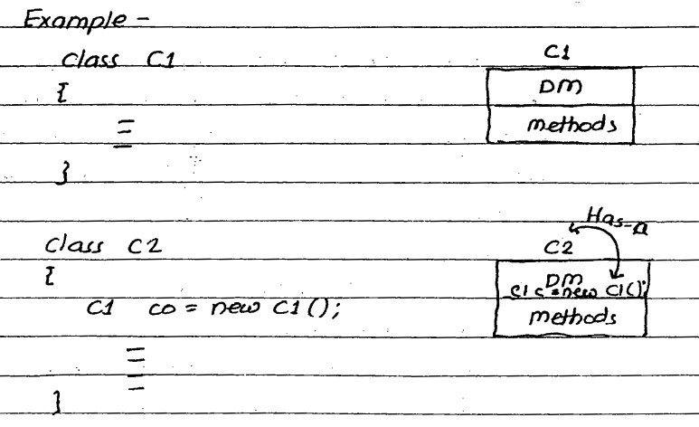

3) Uses-a relationship:-
Uses-a a relationship is one in which a method of one class is using an object of another class.

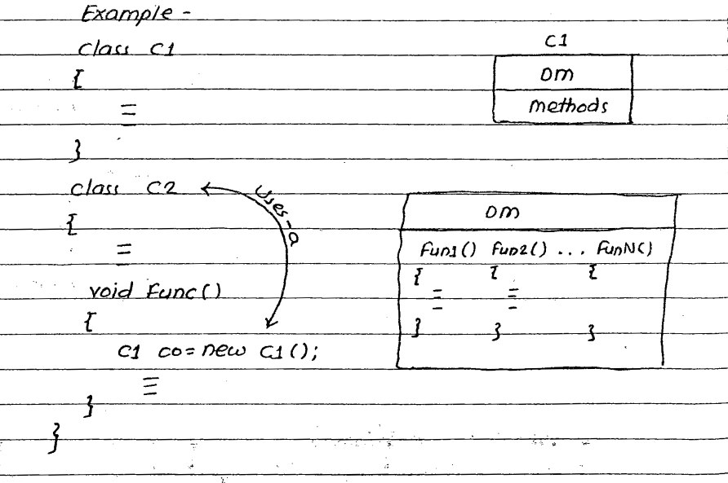

8-June-2021
===========================

- Super Keyword:-

1) Super At variable Level:-
Whenever we inherit the data members of base class into derived class, there is a possibility that those class members are similar to derived class data members. JVM is unable to differentiate between base class data members and derived class data members.
In order to differentiate between base class data members and derived class data members in the context of derived class, base class data members must be preceded by a keyword ‘super’.

Syntax:-
super.<Base class data member name>;

e.g:- SuperAtVariableLevel.java

2. Super at method level:-
Whenever we inherit the methods of base class into a derived class, there is possibility that base class methods are similar to derived class methods. So that JVM is unable to differentiate between base class methods and derived class methods, in the context of derived class, base class methods must be preceded by a keyword “super”.

Syntax:-
super.BaseClassMethodName();

e.g:- SuperAtMethodLevel.java

In the above program if we eliminate super keyword then display method of derived class called by infinately. Which leads to bad recurssion.
In Java programming if same function called by itself infinately then we get an error at runtime known as StackOverflowError.

3. Super at method overriding Level:-
Method overriding = Method Heading is same + method body is different.
The process of redefining the original method into various derived classes by inheriting the original method from base class for performing various operations.

e.g. :- SuperAtMethodOverridingLevel.java

4. Super at constructor level:-
1. Whenever we develop any inheritance application it is highly recommended for the Java programmer to create an object of bottom most deried class because it is getting features from intermediate base classes and it’s top most base classes.
2. When we create an object of bottom most derived class first we get the memory space for base class data memberss and second we get the memory space for intermediate base class and at last we get the mmory space for derived class.
3. In whichever the order memory space is created in the same order initialization process has to be taken.
4. We know that initialization of the data member must be done by constructor.

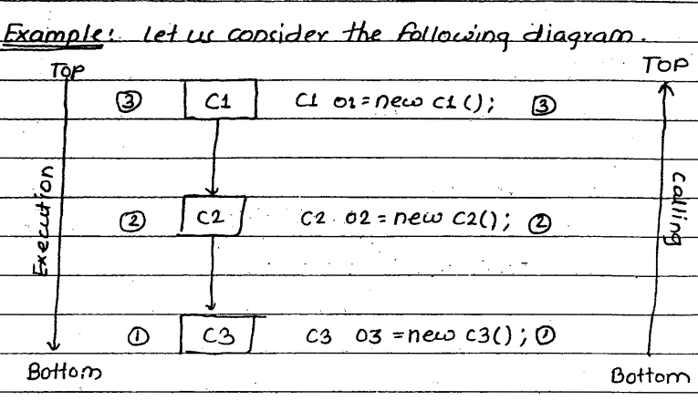
In the above diagram, the default constructor of C3 is automatically calling default constructor of C2 and default constructor of C2 and default constructor of C2 is automatically calling default constructor of C1. Constructor C1 will be executed first and C2 default constructor will execute second and at last default constructor of C3 will be executed.
In general in any inheritance application the way of calling the constructor is from bottom to top (increaing order) and they are executing in the order of top to bottom(decreasing order).

e.g. Write a Java program that will illustrate the concept of constructors are calling from Bottom to Top and executing from top to bottom.

SuperAtConstructorLevel.java

* In order to establish the communication between base class constructor with derived class constructors.
We have two functions. They are:-

10-June-2021
========================
1) super()
2) super(...)

1) Super():-
It is used for calling base class default constructor from derived class constructors.
When we call super() in the context of derived class, JVM will automatically call base class default constructor. The usage super() in the context of derived class constructor is optional. Because base class contains only one default constructor.

2) super(…):-
It is used for calling base class parameterized constructor from derived class constructors. The usage of super(…) is mandatory in the derived class constructors.

*Rules:-
Whenever we use super() and super(…) in our program then the programmer must follow the following rules:-
1) Whenever we use super() or super (…) in the derived class constructor then they must be used as first executable statement.
2) No two consecutive super() and super(…) will be used in the context of derived class constructors.

- Polymorpism:-
Polymorphism is one of the distinct facility of the object oriented programming.
Definition:-
“The process of representing one form in the multiple form” is know as polymorphism.
1) In Java programming the concept of polymorphism can be implemented programatically by one concept of method overloading.
2) We know that method overriding is nothing but method hiding and both are same.

In other words, the process of representing the Original method into multiple forms for performing multiple operations is known as method overriding.

According to OMG(Object Management Group) principle of polymorphism is classified into two types They are:-

1) Static or compile time polymorphism.
2) Dynamic or Runtime polymorphism.

1) Static Polymorphism:-
The process of binding the method with an object at compile time is known as static polymorphim.

Drawback of static polymorphism:-
- Utilization of resources(memory, cpu time) etc are very poor.
- To eliminate the above problem we use the concept of dynamic polymorphism.
By using function overloading & operator overloading that program satisfies static polymorphism principle.
In real world, c++ environment, c++ programming follows static polymorphism but Java never follows static polymorphism principle by only follows Dynamic polymorphism.

2) Dynamic Polymorphism:-
A dynamic polymorphism is one in which methods will binds with an object at runtime. Java programming never follows static polymorphism but it always follows dynamic polymorphism.
The basic advantage advantage of dynamic polymorphism is to utilize the resources efficiently.

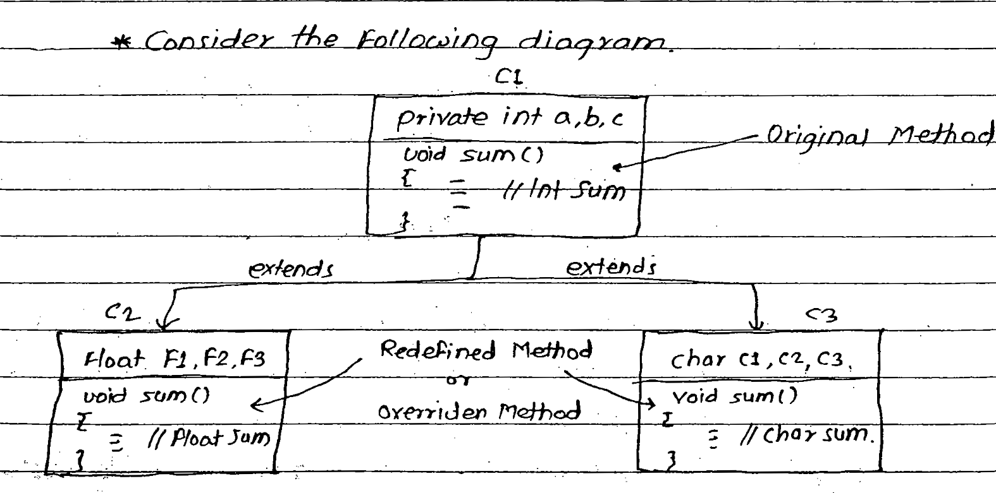
Most of the realtime applications will be developed with the concept of polymorphism along with the method overriding concept. To execute the polymorphism applications it is highly recommended to use dynamic binding concept.
- Dynamic Binding :-
Dynamic binding is one of the distinct feature of object oriented programming.
- Dynamic binding always says that don’t create the objects of derived classes but create the objects of base classes.
- Dynamic Binding is always used to execute polymorphism applications.
- The basic advantage of dynamic binding concept is that to minimize the application memory space. So, that performance of an application is improved.

Definition:-
“The process of binding appropriate versions (overriden methods) of the derived classes which are inherited from base class with base class object is known as dynamic binding.”
While we are executing polymorphism applications by making use of dynamic binding internally JVM consider two point.
1) What type of object is?
2) What type of address reference object contains?

Let us consider the following set of executable statements for executing the problem which is represented in the previous figure.

e.g:-
class DBDemo{
public static void main(String [] args){
1) C1 o1 = new C1();
2) o1.sum(); // Integer sum
3) o1 = new C2();
4) o1.sum(); // Float sum
5) o1 = new C3();
6) o1.sum(); // Char sum
}
}
In the above program -
In statement no. 1,3,5 the object o1 contains addresses of multiple classes(C1, C2 & C3). Hence the object o1 is known as polymorphic object.
Originally, the method is available in one form (original form) but it is represented in multiple for (overriden methods). Hence sum() method is know as polymorphic method.
In the statement no. 2,4,6 sum() method is actually a single statement but it gives different sums (int sum, float sum, char sum). Hence o1.sum() is known as polymorphic statement.
Hence in most of realtime application development applications must be executed with the concept of dynamic binding.

