**Binary Search Algorithm**

* It is a searching algorithm.
* For binary search we need sorted array.
* Binary search accept the four parameter.

1. Array
2. Element to search (x)
3. Lowest element in array(low)
4. Hight element in array(high)

* Find the mid value mid = [(high + low)/2]
* If search element greater than mid then update low with mid+1
* If search element in less than mid then update high with mid – 1





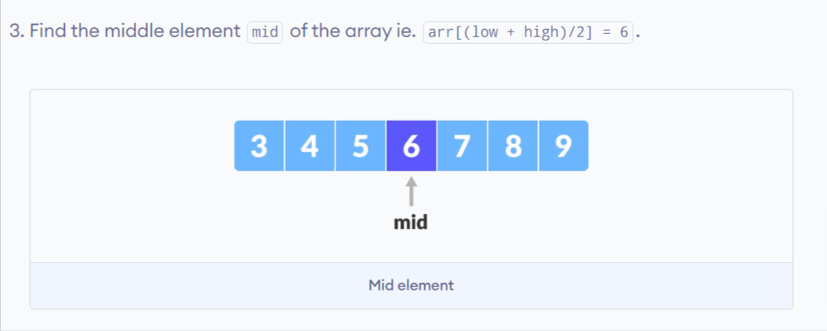



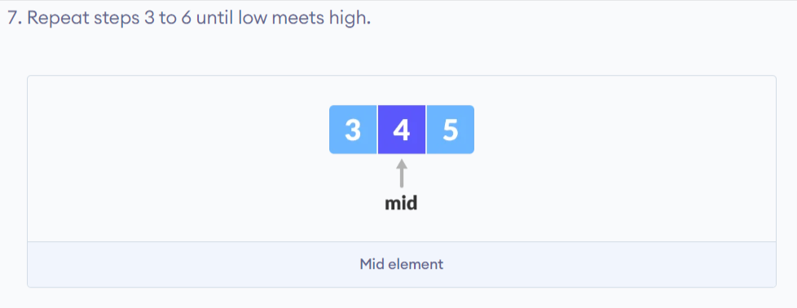

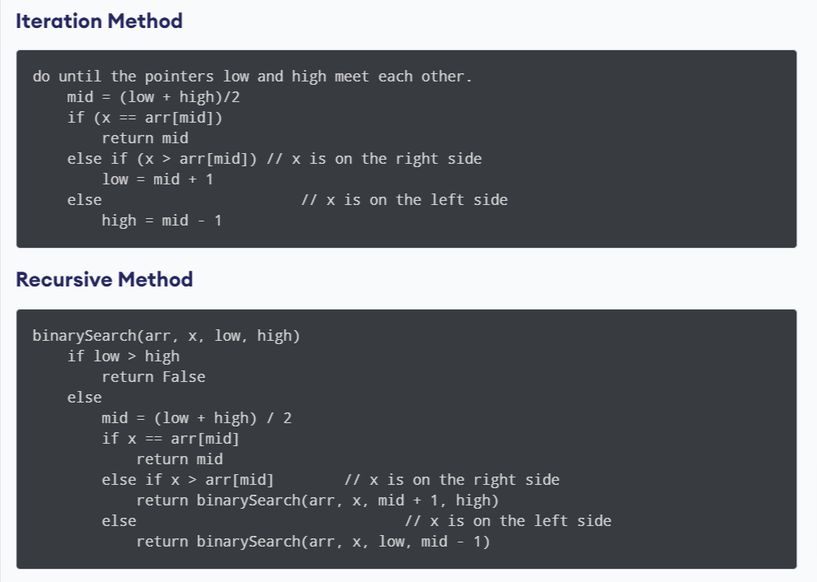

Time Complexities

* Best case complexity: O(1)
* Average case complexity: O(log n)
* Worst case complexity: O(log n)

Space Complexity

The space complexity of the binary search is O(1).