# Importing necessary libraries  
library(tidyverse)

## Warning: package 'tidyverse' was built under R version 4.4.1

## Warning: package 'ggplot2' was built under R version 4.4.1

## Warning: package 'tidyr' was built under R version 4.4.1

## Warning: package 'readr' was built under R version 4.4.1

## Warning: package 'purrr' was built under R version 4.4.1

## Warning: package 'stringr' was built under R version 4.4.1

## Warning: package 'forcats' was built under R version 4.4.1

## Warning: package 'lubridate' was built under R version 4.4.1

## ── Attaching core tidyverse packages ──────────────────────── tidyverse 2.0.0 ──  
## ✔ dplyr 1.1.4 ✔ readr 2.1.5  
## ✔ forcats 1.0.0 ✔ stringr 1.5.1  
## ✔ ggplot2 3.5.1 ✔ tibble 3.2.1  
## ✔ lubridate 1.9.3 ✔ tidyr 1.3.1  
## ✔ purrr 1.0.2   
## ── Conflicts ────────────────────────────────────────── tidyverse_conflicts() ──  
## ✖ dplyr::filter() masks stats::filter()  
## ✖ dplyr::lag() masks stats::lag()  
## ℹ Use the conflicted package (<http://conflicted.r-lib.org/>) to force all conflicts to become errors

library(ggplot2)  
library(lubridate)  
library(readr)

# Filepath of the dataset  
filepath <- "D:/Mini Project/DAT/spotify-2023.csv"  
  
# Load the spotify dataset  
spotify_df <- read_csv(filepath, locale = locale(encoding = "latin1"))

## Rows: 953 Columns: 24  
## ── Column specification ────────────────────────────────────────────────────────  
## Delimiter: ","  
## chr (5): track_name, artist(s)_name, streams, key, mode  
## dbl (17): artist_count, released_year, released_month, released_day, in_spot...  
## num (2): in_deezer_playlists, in_shazam_charts  
##   
## ℹ Use `spec()` to retrieve the full column specification for this data.  
## ℹ Specify the column types or set `show_col_types = FALSE` to quiet this message.

# View the first 5 rows of the data  
head(spotify_df)

## # A tibble: 6 × 24  
## track_name `artist(s)_name` artist_count released_year released_month  
## <chr> <chr> <dbl> <dbl> <dbl>  
## 1 Seven (feat. Latto… Latto, Jung Kook 2 2023 7  
## 2 LALA Myke Towers 1 2023 3  
## 3 vampire Olivia Rodrigo 1 2023 6  
## 4 Cruel Summer Taylor Swift 1 2019 8  
## 5 WHERE SHE GOES Bad Bunny 1 2023 5  
## 6 Sprinter Dave, Central C… 2 2023 6  
## # ℹ 19 more variables: released_day <dbl>, in_spotify_playlists <dbl>,  
## # in_spotify_charts <dbl>, streams <chr>, in_apple_playlists <dbl>,  
## # in_apple_charts <dbl>, in_deezer_playlists <dbl>, in_deezer_charts <dbl>,  
## # in_shazam_charts <dbl>, bpm <dbl>, key <chr>, mode <chr>,  
## # `danceability_%` <dbl>, `valence_%` <dbl>, `energy_%` <dbl>,  
## # `acousticness_%` <dbl>, `instrumentalness_%` <dbl>, `liveness_%` <dbl>,  
## # `speechiness_%` <dbl>

# Combine the columns into a single 'release_date' column  
spotify_df <- spotify_df %>%  
 mutate(release_date = make_date(released_year, released_month, released_day))

# Drop the original year, month, and day columns  
spotify_df <- spotify_df %>%  
 select(-released_year, -released_month, -released_day)

# Drop unnecessary columns  
spotify_df <- spotify_df %>%  
 select(-bpm, -key, -mode)

# Check for duplicates in the 'track_name' column and drop the row causing the issue  
spotify_df <- spotify_df %>%  
 filter(!duplicated(track_name))

# Convert 'streams' column to numeric format  
spotify_df <- spotify_df %>%  
 mutate(streams = as.numeric(streams))

## Warning: There was 1 warning in `mutate()`.  
## ℹ In argument: `streams = as.numeric(streams)`.  
## Caused by warning:  
## ! NAs introduced by coercion

# Sort the dataset by 'streams' in descending order  
spotify_df <- spotify_df %>%  
 arrange(desc(streams))

# Drop duplicates in 'track_name', keeping the first occurrence (highest streams)  
spotify_df <- spotify_df %>%  
 distinct(track_name, .keep_all = TRUE)  
  
# Check for null values and drop unnecessary columns  
spotify_df <- spotify_df %>%  
 select(-in_shazam_charts)

# Remove commas and convert 'in_deezer_playlists' column to numeric  
spotify_df <- spotify_df %>%  
 mutate(in_deezer_playlists = as.numeric(gsub(",", "", in_deezer_playlists)))  
  
# Display the structure of the dataframe  
str(spotify_df)

## tibble [943 × 18] (S3: tbl_df/tbl/data.frame)  
## $ track_name : chr [1:943] "Blinding Lights" "Shape of You" "Someone You Loved" "Dance Monkey" ...  
## $ artist(s)_name : chr [1:943] "The Weeknd" "Ed Sheeran" "Lewis Capaldi" "Tones and I" ...  
## $ artist_count : num [1:943] 1 1 1 1 2 3 2 1 2 2 ...  
## $ in_spotify_playlists: num [1:943] 43899 32181 17836 24529 24094 ...  
## $ in_spotify_charts : num [1:943] 69 10 53 0 78 24 36 23 0 79 ...  
## $ streams : num [1:943] 3.70e+09 3.56e+09 2.89e+09 2.86e+09 2.81e+09 ...  
## $ in_apple_playlists : num [1:943] 672 33 440 533 372 433 492 250 315 281 ...  
## $ in_apple_charts : num [1:943] 199 0 125 167 117 107 99 121 159 137 ...  
## $ in_deezer_playlists : num [1:943] 3421 6808 1800 3595 843 ...  
## $ in_deezer_charts : num [1:943] 20 7 0 6 4 0 31 10 0 1 ...  
## $ danceability_% : num [1:943] 50 83 50 82 76 77 59 77 75 68 ...  
## $ valence_% : num [1:943] 38 93 45 54 91 36 48 74 64 49 ...  
## $ energy_% : num [1:943] 80 65 41 59 50 63 76 78 52 59 ...  
## $ acousticness_% : num [1:943] 0 58 75 69 54 1 4 4 41 16 ...  
## $ instrumentalness_% : num [1:943] 0 0 0 0 0 0 0 0 0 0 ...  
## $ liveness_% : num [1:943] 9 9 11 18 7 36 10 23 11 13 ...  
## $ speechiness_% : num [1:943] 7 8 3 10 5 5 5 11 3 28 ...  
## $ release_date : Date[1:943], format: "2019-11-29" "2017-01-06" ...

# Top 10 Artists Have Most Streamed Songs in 2023  
top_artists <- spotify_df %>%  
 count(`artist(s)_name`, sort = TRUE) %>%  
 head(10)

# Plot the top 10 artists  
ggplot(top_artists, aes(x = reorder(`artist(s)_name`, n), y = n)) +  
 geom_bar(stat = "identity") +  
 coord_flip() +  
 labs(title = "Top 10 Artists Have Most Hits In 2023", x = "Artist", y = "Number of Hits") +  
 theme_minimal()

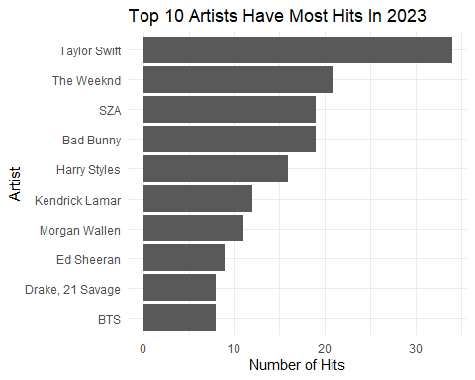

# Top 10 Streamed Songs in 2023  
top_10_songs <- spotify_df %>%  
 top_n(10, streams)

# Plot the top 10 streamed songs  
ggplot(top_10_songs, aes(x = reorder(track_name, streams), y = streams)) +  
 geom_bar(stat = "identity") +  
 coord_flip() +  
 labs(title = "Top 10 Streamed Songs in 2023", x = "Track Name", y = "Streams") +  
 theme_minimal()

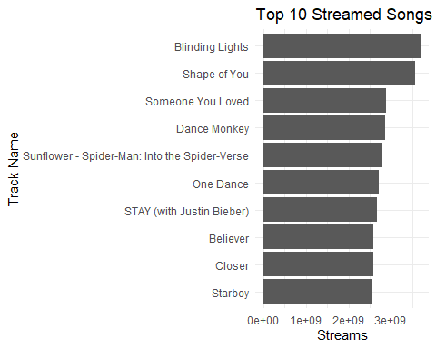

# Relationship Between Most Streamed Songs And Platforms In 2023  
# Spotify  
ggplot(spotify_df, aes(x = streams, y = in_spotify_playlists)) +  
 geom_point() +  
 geom_smooth(method = "lm") +  
 labs(title = "Relationship Between Most Streamed Songs And Spotify Playlists In 2023",  
 x = "Streams", y = "Number of Spotify Playlists") +  
 theme_minimal()

## `geom_smooth()` using formula = 'y ~ x'

## Warning: Removed 1 row containing non-finite outside the scale range  
## (`stat_smooth()`).

## Warning: Removed 1 row containing missing values or values outside the scale range  
## (`geom_point()`).

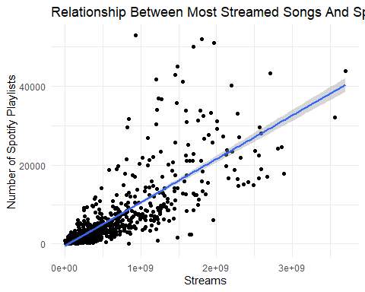

# Apple  
ggplot(spotify_df, aes(x = streams, y = in_apple_playlists)) +  
 geom_point() +  
 geom_smooth(method = "lm") +  
 labs(title = "Relationship Between Most Streamed Songs And Apple Playlists In 2023",  
 x = "Streams", y = "Number of Apple Playlists") +  
 theme_minimal()

## `geom_smooth()` using formula = 'y ~ x'

## Warning: Removed 1 row containing non-finite outside the scale range  
## (`stat_smooth()`).

## Warning: Removed 1 row containing missing values or values outside the scale range  
## (`geom_point()`).

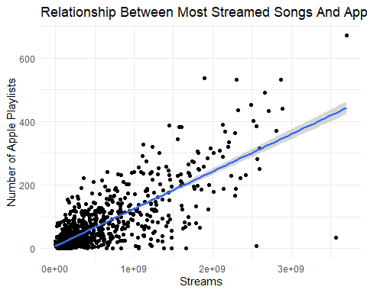

# Deezer  
ggplot(spotify_df, aes(x = streams, y = in_deezer_playlists)) +  
 geom_point() +  
 geom_smooth(method = "lm") +  
 labs(title = "Relationship Between Most Streamed Songs And Deezer Playlists In 2023",  
 x = "Streams", y = "Number of Deezer Playlists") +  
 theme_minimal()

## `geom_smooth()` using formula = 'y ~ x'

## Warning: Removed 1 row containing non-finite outside the scale range  
## (`stat_smooth()`).

## Warning: Removed 1 row containing missing values or values outside the scale range  
## (`geom_point()`).

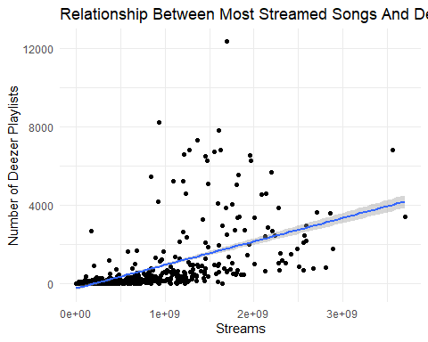

# Top 10 Songs vs. Danceability  
top_10_danceable_songs <- spotify_df %>%  
 arrange(desc(`danceability_%`)) %>%  
 head(10)

# Horizontal bar chart for danceability  
ggplot(top_10_danceable_songs, aes(x = `danceability_%`, y = reorder(track_name, `danceability_%`))) +  
 geom_bar(stat = "identity") +  
 labs(title = "Top 10 Songs vs. Danceability", x = "Danceability Score", y = "Song") +  
 theme_minimal()

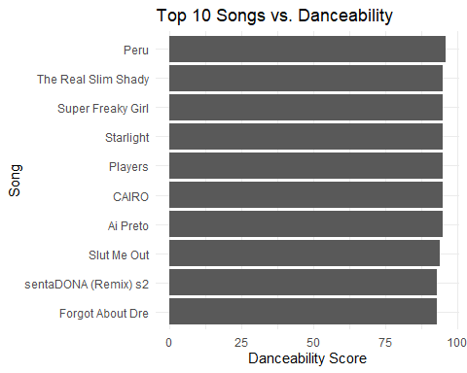

# Pie chart for danceability  
pie(top_10_danceable_songs$`danceability_%`, labels = top_10_danceable_songs$track_name, main = "Top 10 Songs Danceability Distribution", col = rainbow(10))

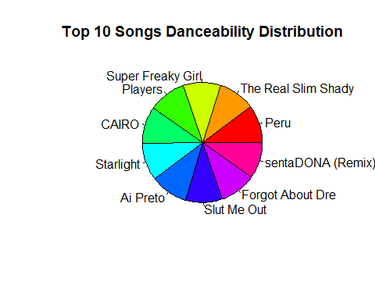

# Distribution of Songs in Playlists by Platform in 2023  
platform_totals <- spotify_df %>%  
 summarise(Spotify = sum(in_spotify_playlists, na.rm = TRUE),  
 Apple = sum(in_apple_playlists, na.rm = TRUE),  
 Deezer = sum(in_deezer_playlists, na.rm = TRUE))

# Pie chart for platform distribution  
pie(unlist(platform_totals), labels = names(platform_totals), main = "Distribution of Songs in Playlists by Platform in 2023", col = rainbow(3))

