How to do the Automate Deployment in Jenkins
Alternate tool : Ansible, Puppet, Chef, Salt stack

Application Deployment: For this we are using Tomcat APP Server…

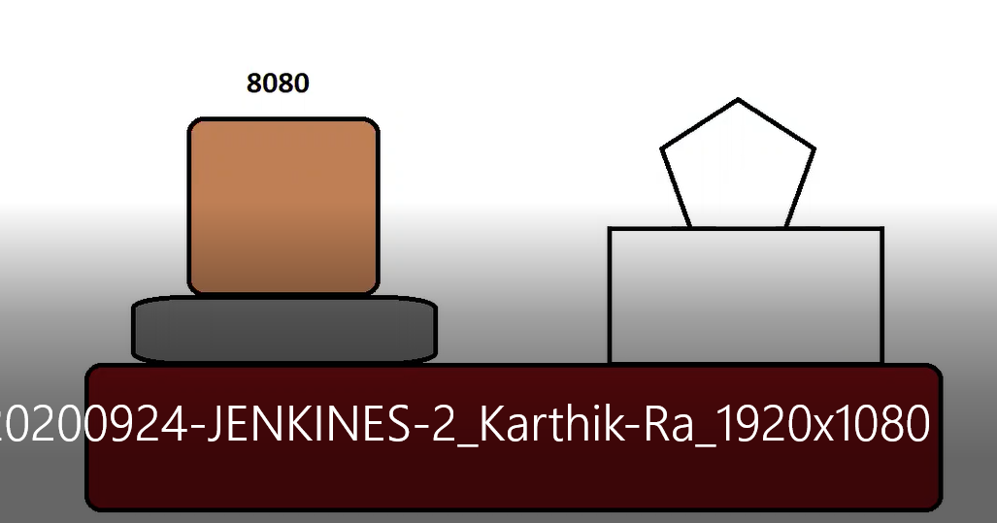

Step -1
1.Download the Tomcat server in local pc
https://tomcat.apache.org/download-80.cgi
Download tomcat
Step-2
2.Download Sample war file in local PC
https://tomcat.apache.org/tomcat-7.0-doc/appdev/sample/
Step-3
By using WINZP to transfer the file(sample. War, Apache) to Local System to /home/Ubuntu (EC2)
WinZip( we can easily transfer file one environment to another environment).
Step-4
Apache file Copy to /opt Path --------> (additional software should install in OPT Path)
cp /home/ubuntu/apache-tomcat-8.5.81.tar.gz .
ls -lrt
untar
tar -xvzf apache-tomcat-8.5.81.tar.gz
ls -lrt
cd apache-tomcat-8.5.81/
ls -lrt
we able to see multiple file system available
Below Mentioned fours files are very important:
logs It captures logs details belongs tomcat server
webapps Deployment details everything’s under in webapps (it is important for application relevant data)
conf Its relevant with tomcat Configuration
bin Every Script relevant file available in bin path ( example start , stop)

We need to change the Port number in Tomcat , because both Jenkins and tomcat are running in 8080 Port.
cd conf
ls
sever.xml
vi server.xml
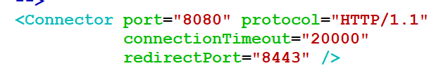
we need to restart the tomcat since we change the setup of configuration file.
cd bin (just view the file)
./shutdown.sh
./startup.sh

Then check the tomcat hosted:9090
Step-5
We are going to do Deployment Process in Jenkins
1. Create job in Auto deployment at Jenkins
In build we just mention sample script but (real time pre-request script )
2.Post Build
We need to plug in the Deployment – container (for reference Jenkins’s plugin page)
https://plugins.jenkins.io/ (plugin list for Jenkins we can check this site)

Manage JenkinsManage PluginAvailabledeployer-containerInstall without restart

Then go to check job configure post-build Action -> able to view Deploy/war to container.
Step-6
Check the Jenkins default path
cd /var/lib/Jenkins
ls
workspace
Autodeployment
Run the job
Then we able to see job details in workspace
Then Copy the Sample war file to workspace.
cp /home/ubuntu/sample.war .
ls-lrt
Then go to jenkins

job configure post-build Action-> Deploy/war to container.

Warfile - **/*.war
Context path – calling name
Tomcat URL – Hostname:portnumber (http://52.3.236.193:9090/)
Create Credential for tomcat ( because real time they create the credential)
cd /opt/apache-tomcat-8.5.81
ls -lrt
cd conf
vi tomcat-users.xml
Edit configure file Delete Ctrl+U
In between <tomcat user>
And past it below content

<role rolename="manager-gui"/>
<role rolename="manager-script"/>
<role rolename="manager-jmx"/>
<role rolename="manager-status"/>
<user username="admin" password="admin" roles="manager-gui,manager-script,manager-jmx,manager-status"/>
<user username="deployer" password="deployer" roles="manager-script"/>
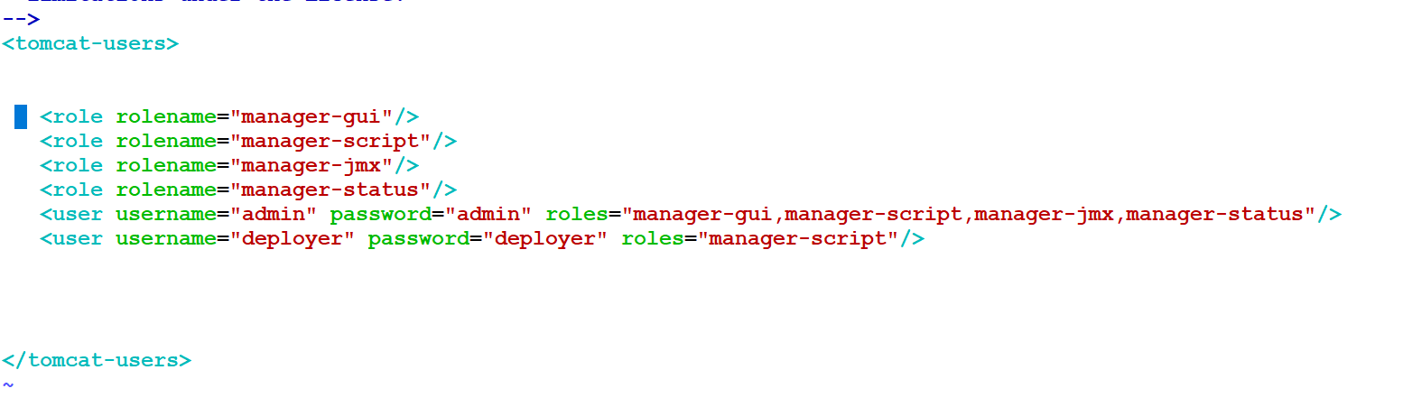
Then restart the tomcat since we modify the configuration.
Cd bin
./shutdown.sh
./startup.sh

Step-7
Then go to Jenkins
Add the credentials which we give in tomcat server
Credentials add username : deployer , password : deployer save

And run the job and check if facing error below steps should we follow
We need to modify the webpage file
/opt/apache-tomcat-8.5.81/webapps/manager/META-INF/context.xml
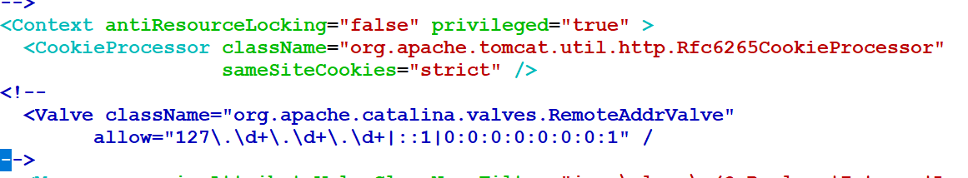

And run the job and check

User Management in Jenkins
Mostly we are using Admin level
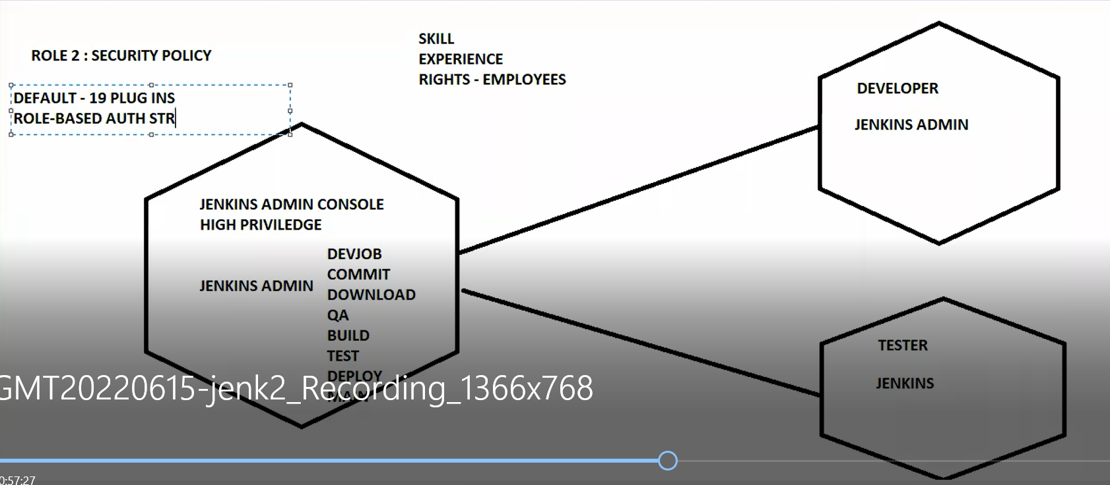

Manage Jenkins Configure Global SecurityAuthorizationLogged in user can do anything (this default setting)

We need to plugin in the Role Based Plugin

Role Based Strategy:
MangepulginAvaliableRole-based Authorization Strategy

Then go to security Group
Manage Jenkins Configure Global SecurityAuthorizationRole base strategy ( we able to view after plugin)

We create the two users (developer and test)
Security groupManage Userscreate User (create two user (user1,user2))
User1-Ramu
User2-Somu
Then we can assign the Roles for both users ( like Ramu-devloper,Somu-tester)
Create Roles
Manage and Assign Role (last to the Page)MangeRoles three types of roles Available(GlobalRoles,ItemRoles,Noderoles(its machine level access)
Global RolesRole add (example Employees)
For this only we give read only memory

Item Roles (Its depones upon on the project)
Item Roles Role to add ( here we are going to give two role)
Role to add Devloper
PatternDev.* (Ensure here give job name properly which we create in console)
ADD

Role to add Tester
PatternTest.*
ADD
Give full access for both project
NODE Rule: Machine level Privilege like we able to define which user can use the particular System. (System Level Restriction)(Mostly it will be defined by local system level people)
Now Assign the Role to each user
Manage and Assign RolesAssign Roles
user/groupadd user1add
user/groupadduser2add
Then Tick both Box of the user under employee role in Global role table
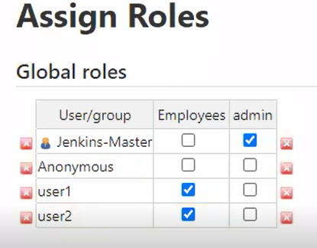
Items Roles
User/groupadd user1add
User/groupadd user2add
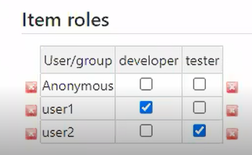
Then click the tick box in both who one has developer and tester
Then go and logout
Login admin user here able to do anything
Login user1(dev) here able to do only which one we give the access to do him.
Login User2(Tester) here able to do only which one we give the access to do him.

