Lab3 – Data Virtualization Data Cache

1. Open the Cache Management

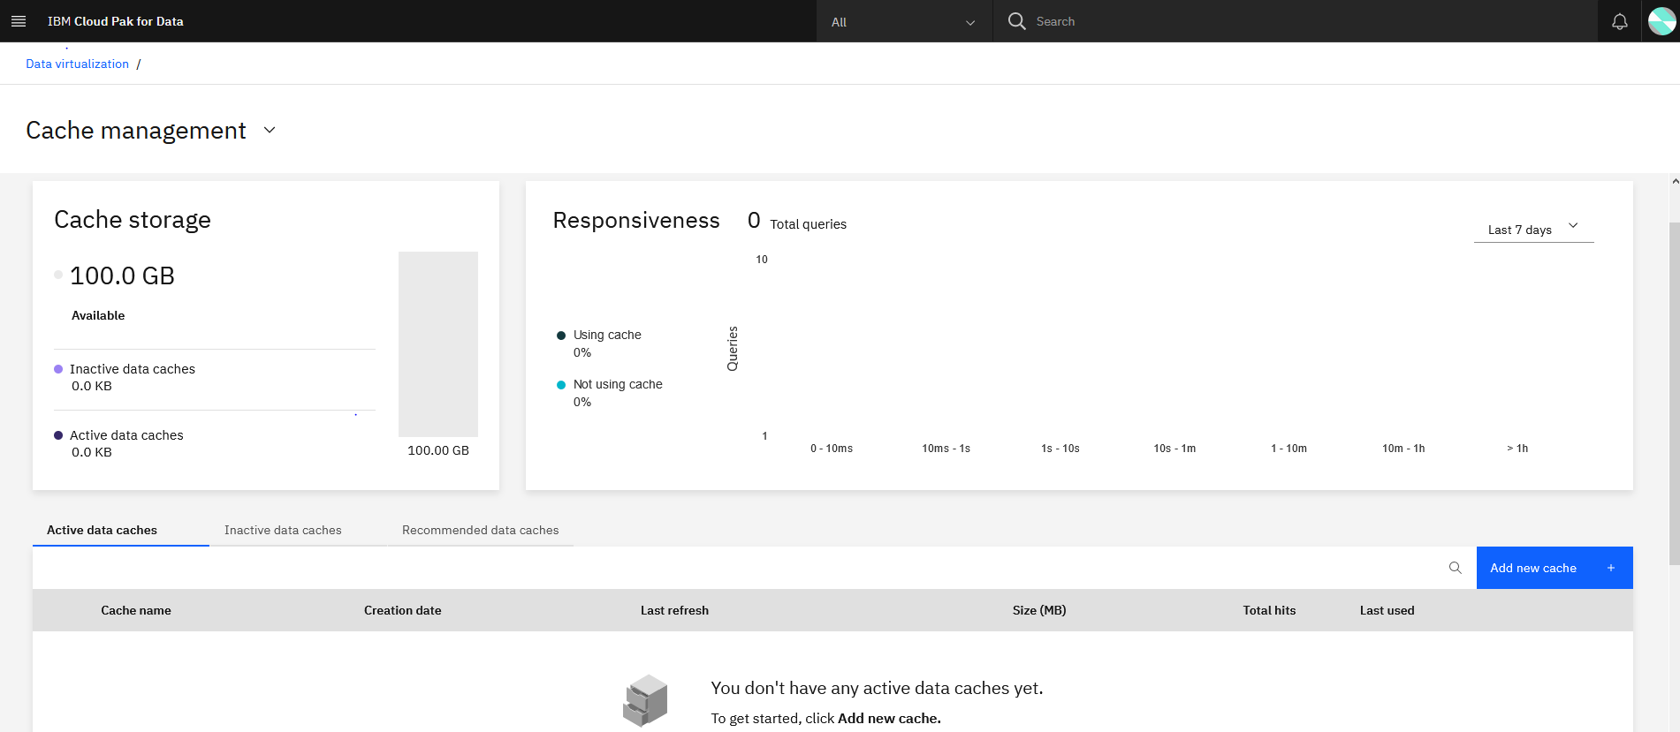

Check the Recommendations for the cache

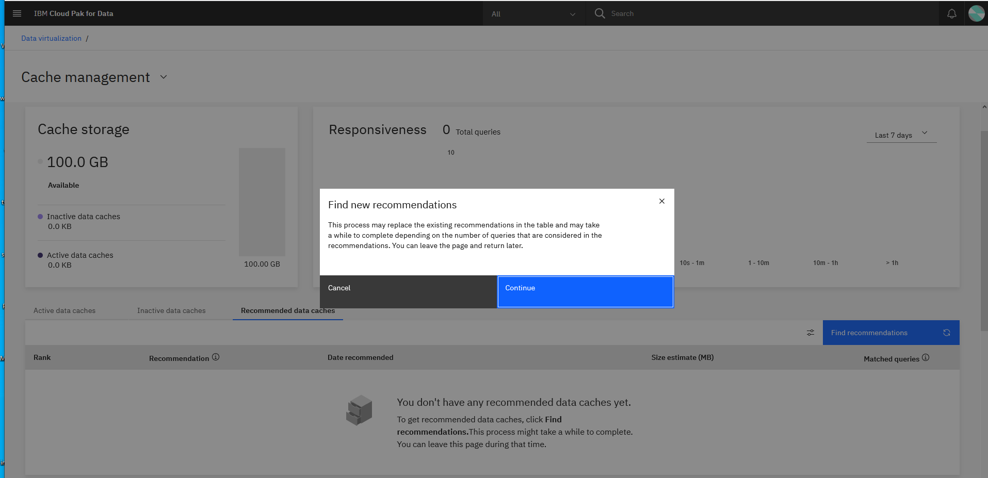

Add queries to the be cached as per the recommendations.

Add new queries to be cached.

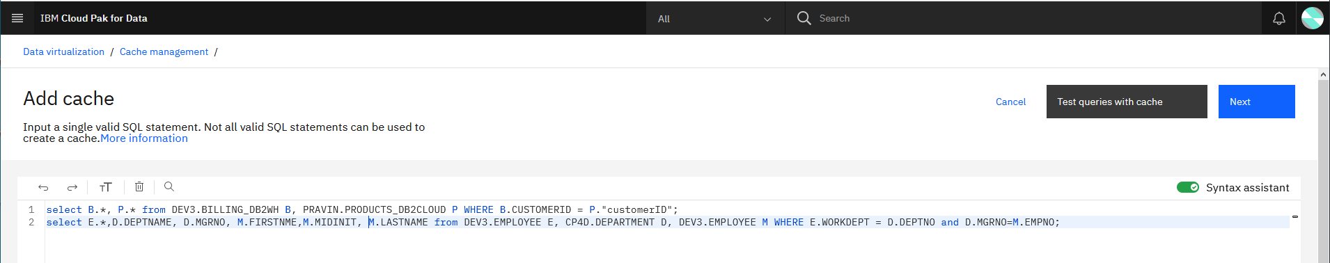

Click on Test Queries with Cache

Choose Either Select Existing Query or Choose Enter query in SQL

Choose Execution time > 1 minute and > 10 minute category. 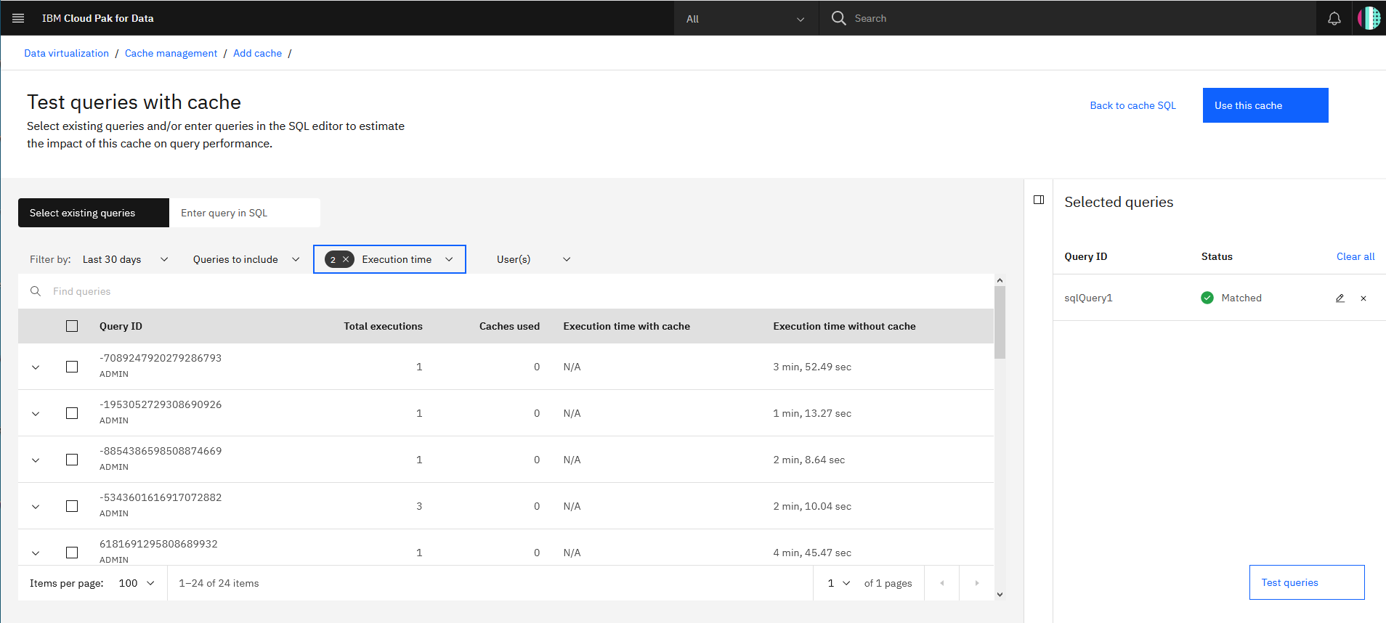

You can choose to include all queries to be cached. (24 queries)

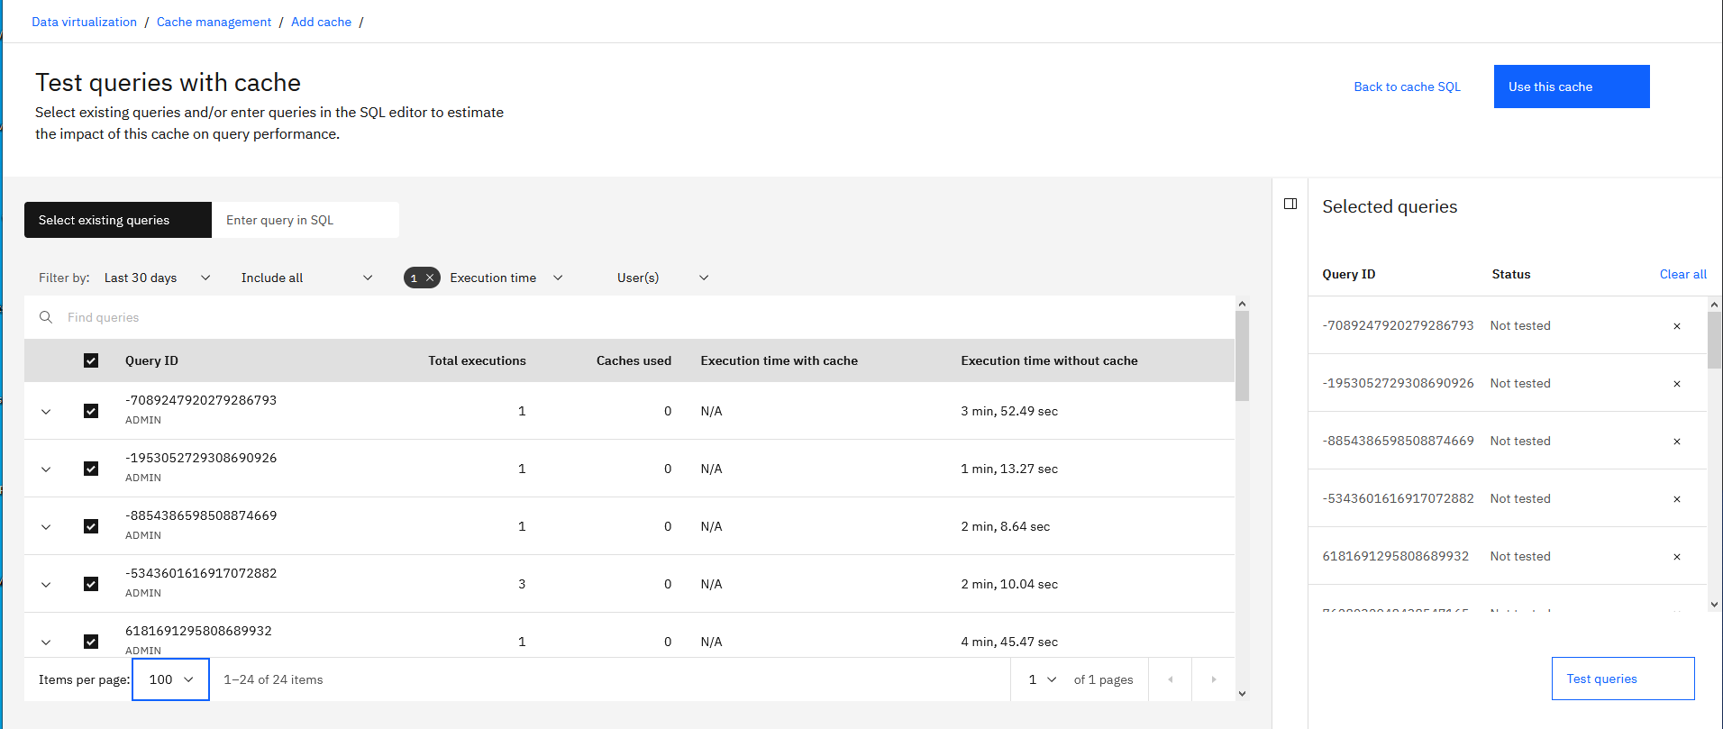

Choose include all and test.

Then remove the not matched queries.

Then process to Add to the cache option.

If We will choose Enter Query in SQL

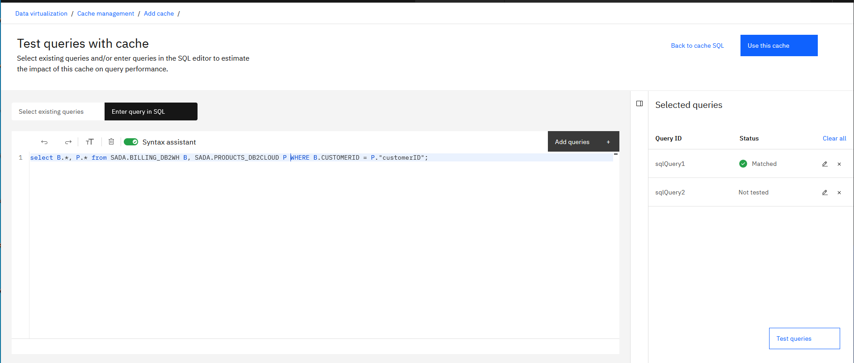

Add query to test and then test

Not tested will change to Matched. Then use Add to cache

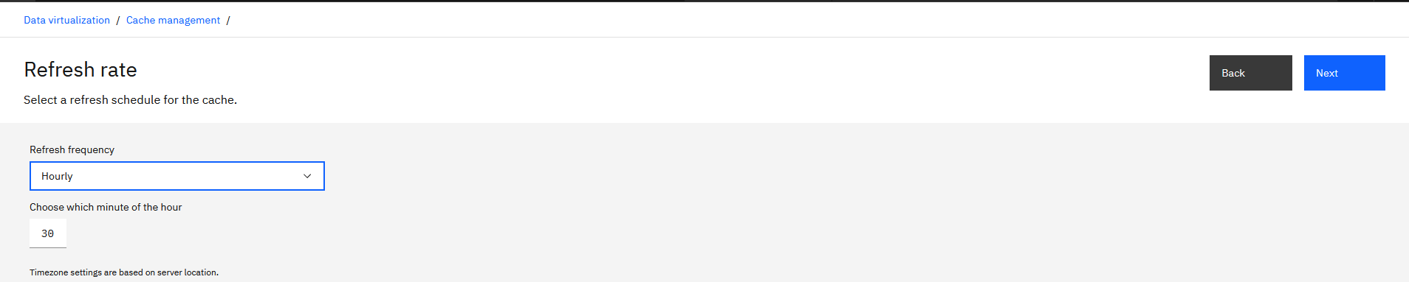

And then finalize the cache.

