**Data Virtualization LAB 2 – Data Virtualization of tables in DB2 WH on CP4D & DB2 WH on CLOUD**

Virtualize the Tables from DB2 WH on Cloud

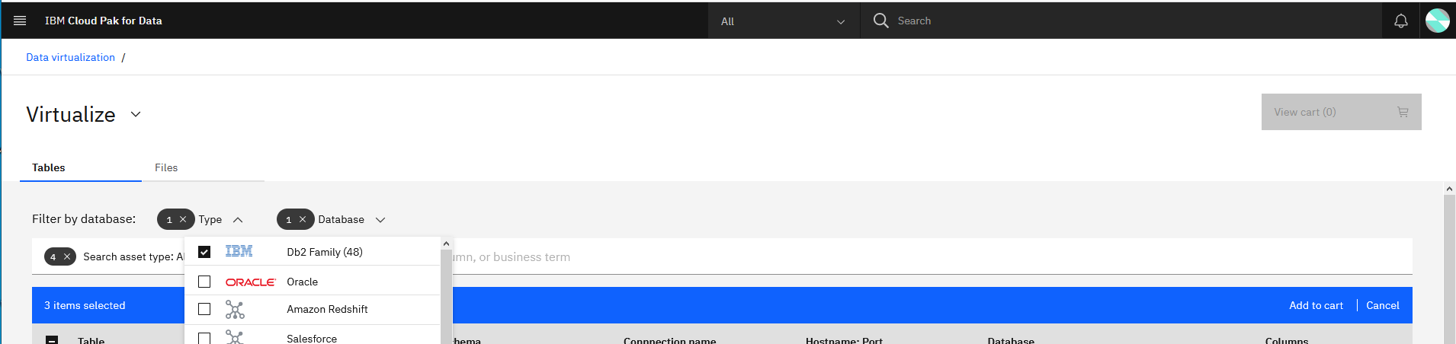

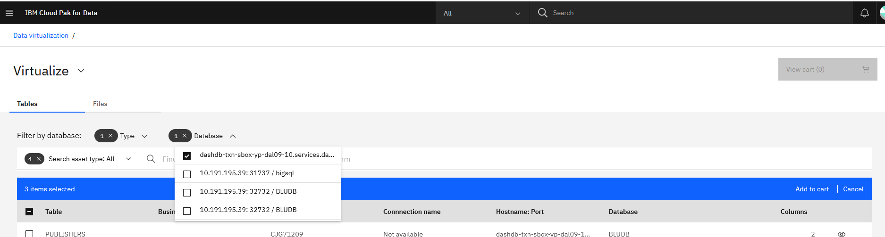

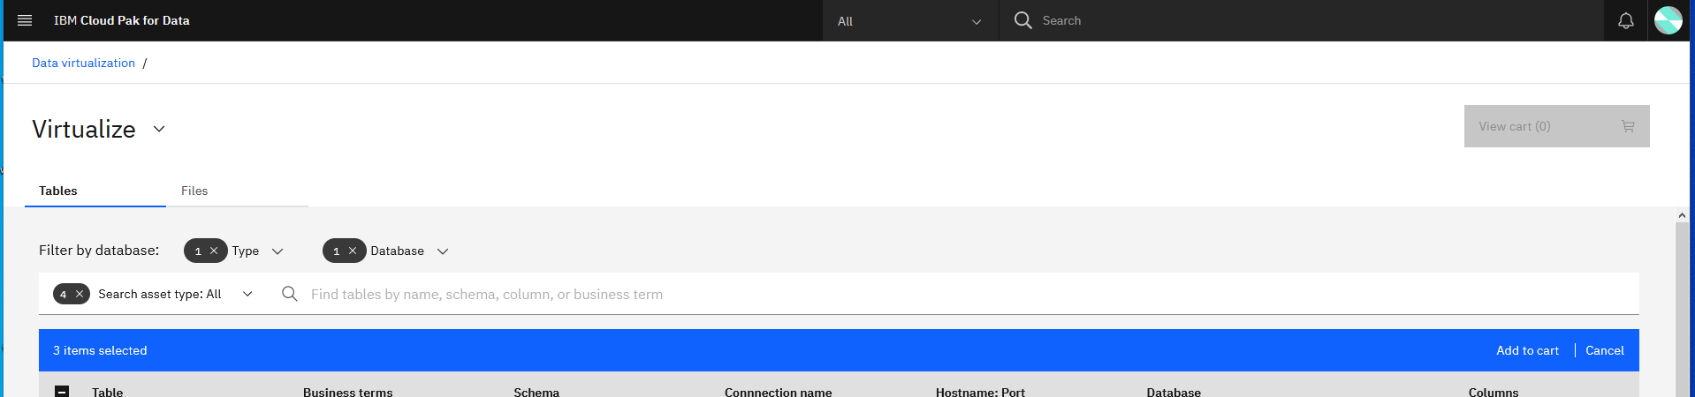

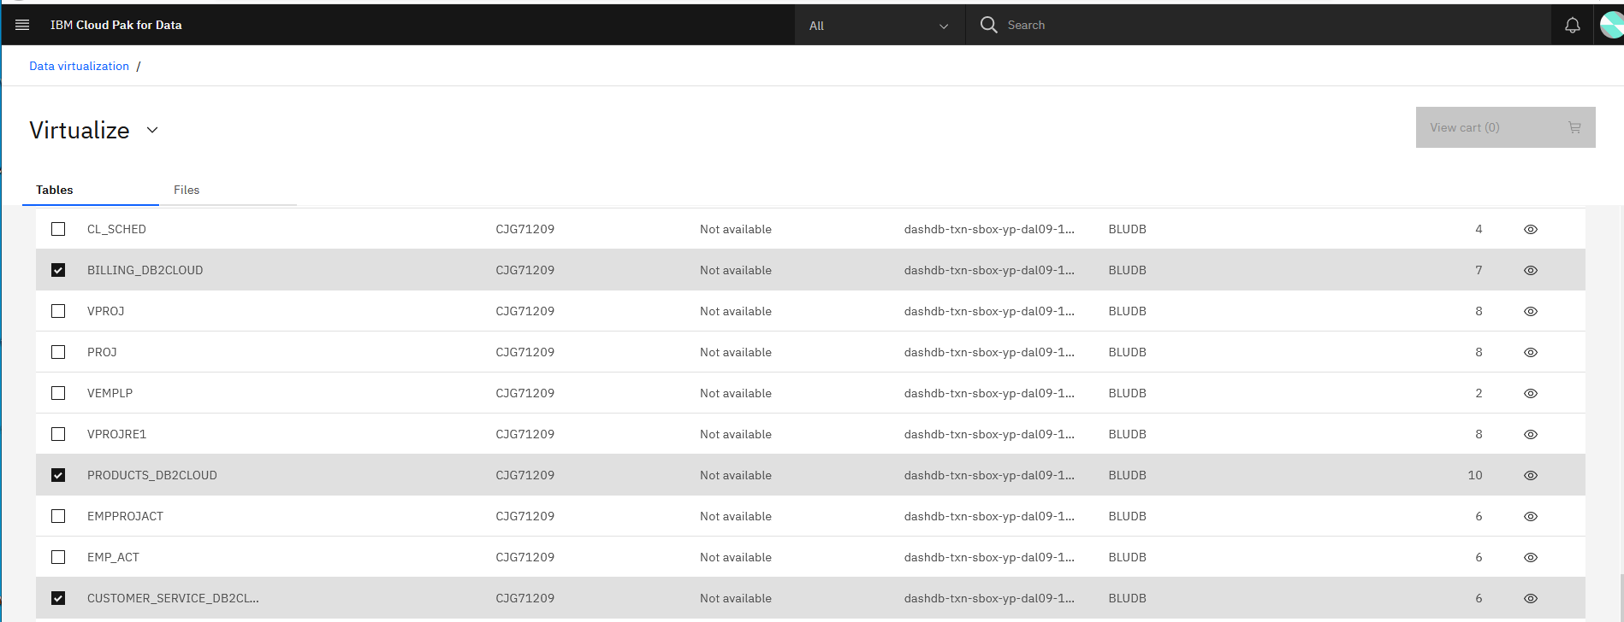

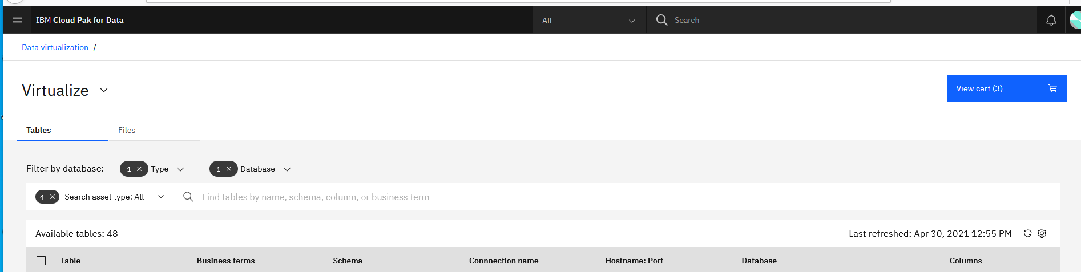

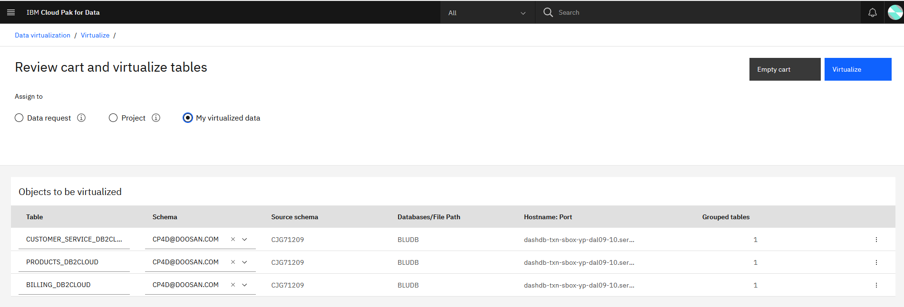

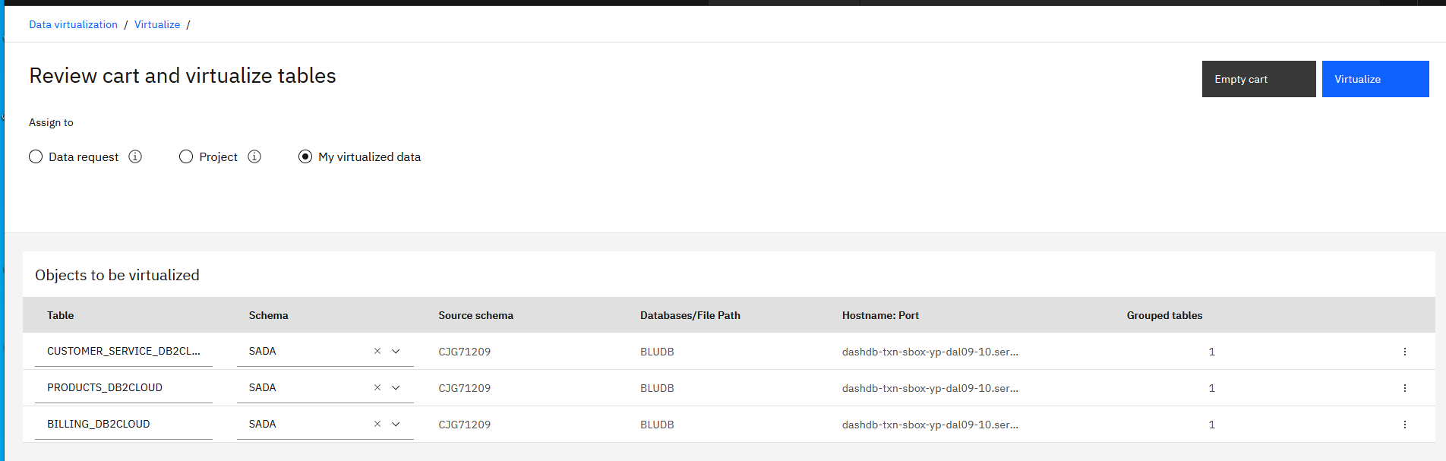

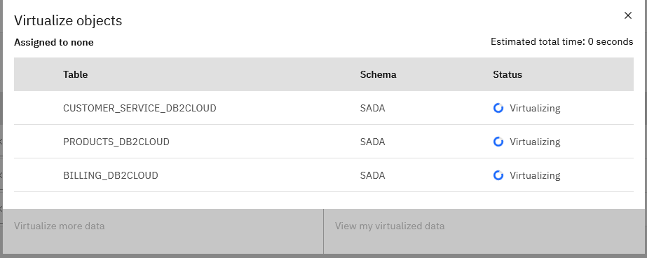



Virtualize the Tables from DB2 WH on CP4D

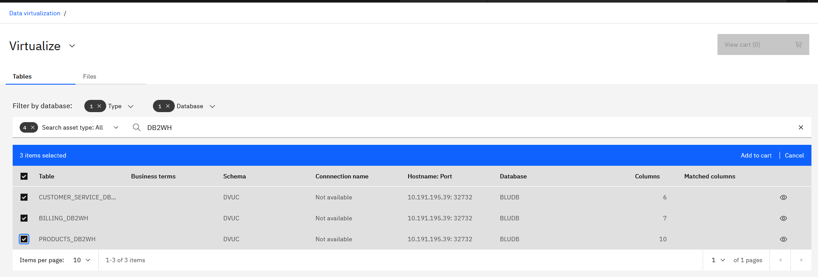

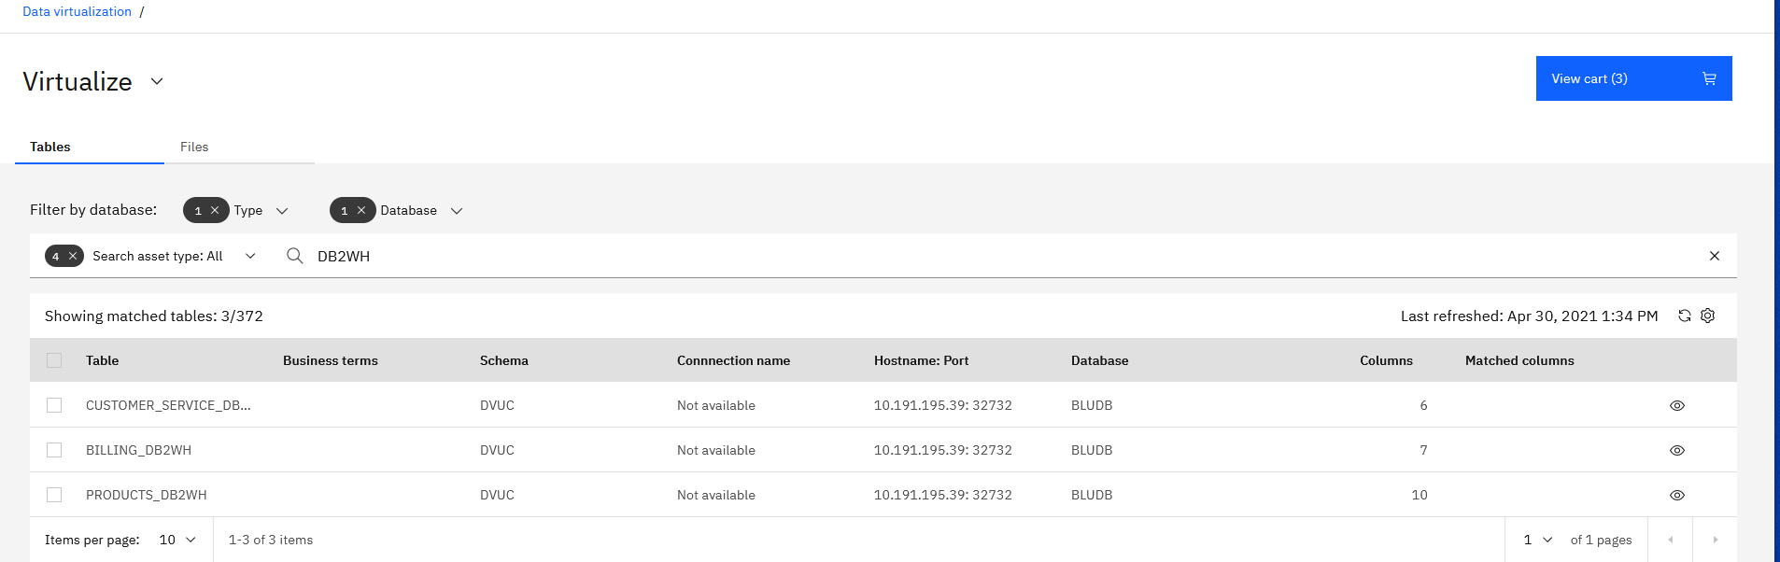

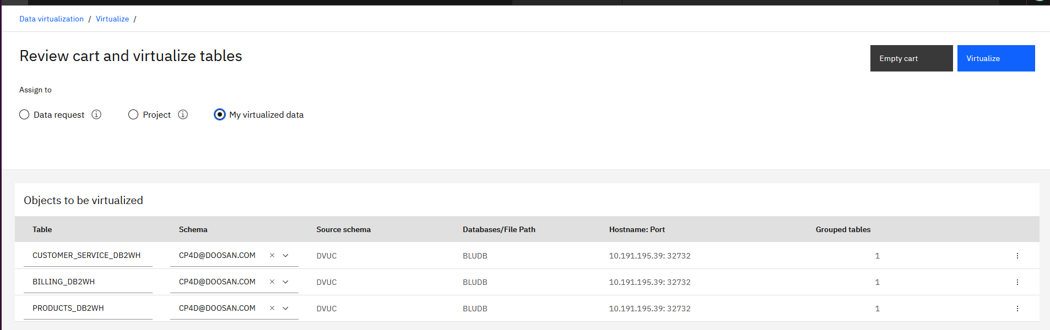

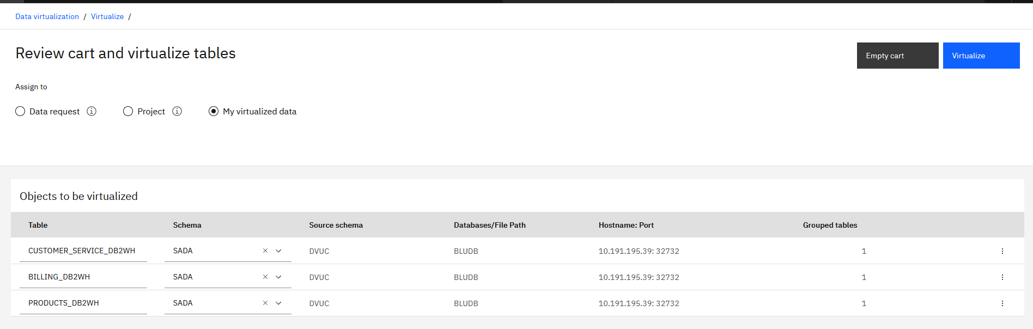

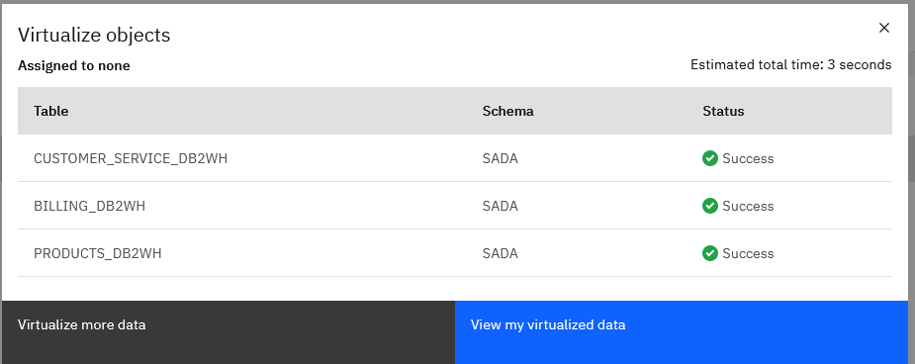



Now you will be able to see the tables in the My VIRTUALIZED tables

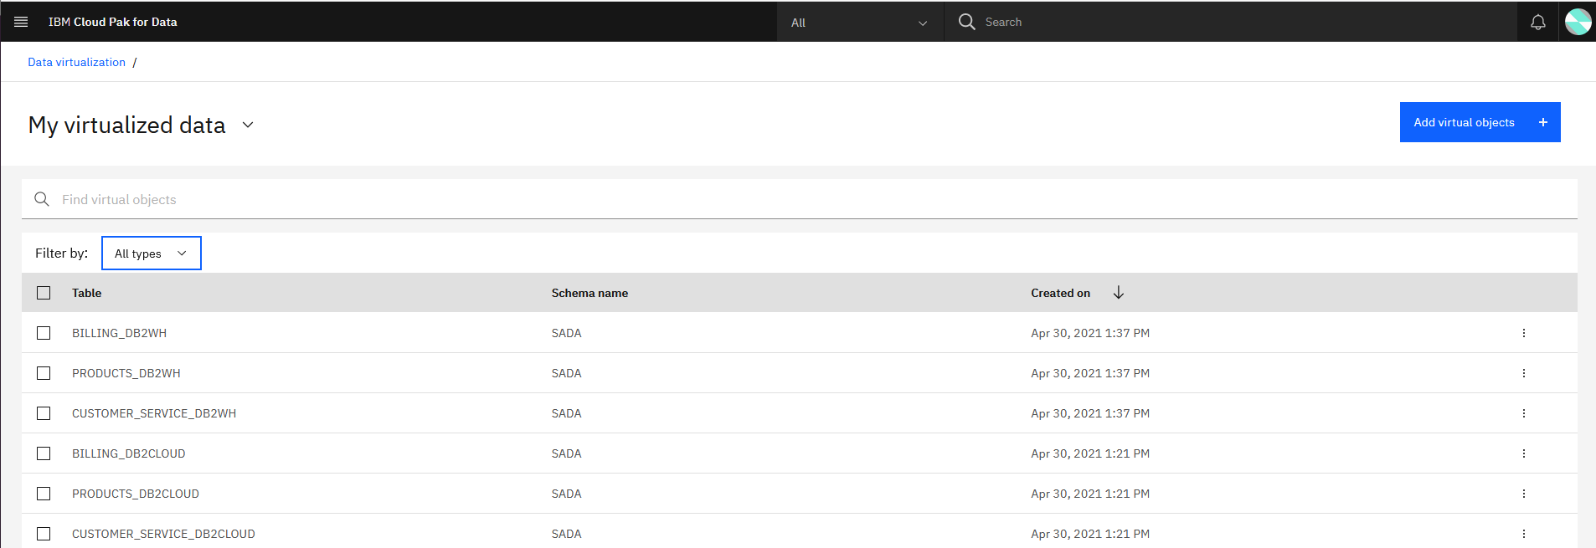

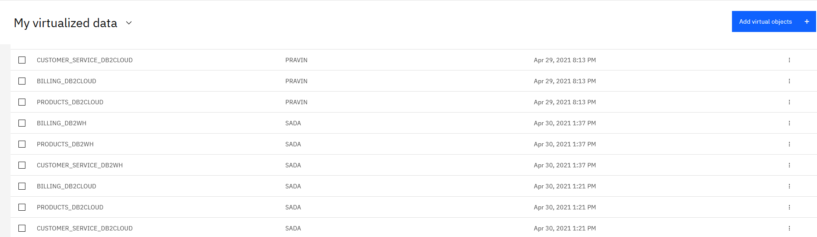

You can run the query on the virtual tables from the SQL Editor.

