**Data Virtualization LAB 1 – Data Loading in DB2 WH**

1. I have already loaded the same 3 tables on my DB2 WH on Cloud Database
   1. CJG71209.BILLING_DB2CLOUD
   2. CJG71209.PRODUCTS_DB2CLOUD
   3. CJG71209.CUSTOMER_SERVICE_DB2CLOUD

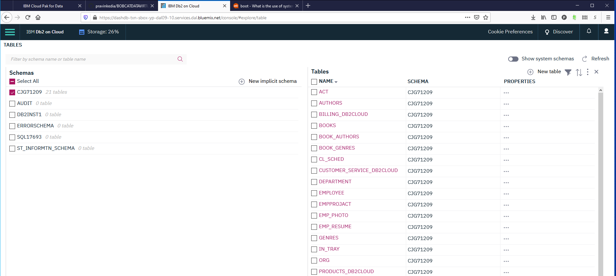

1. Load Data in DB2 WH for following 3 tables in <YOUR NAME> schema.
   1. PRAVIN.BILLING_DB2WH
   2. PRAVIN.PRODUCTS_DB2WH
   3. PRAVIN.CUSTOMER_SERVICE_DB2WH

Select the local file products.csv to Load into the DB2 WH database in your environment.

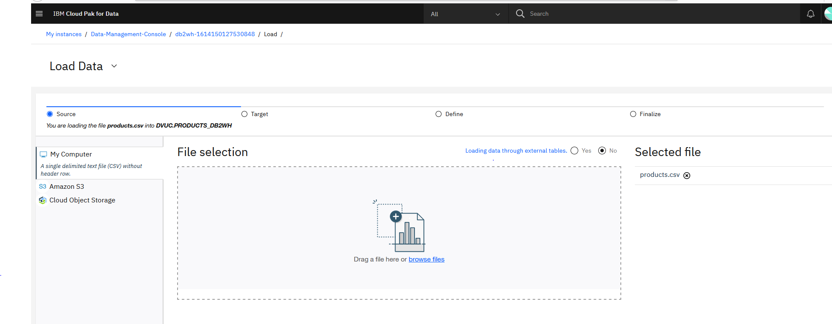

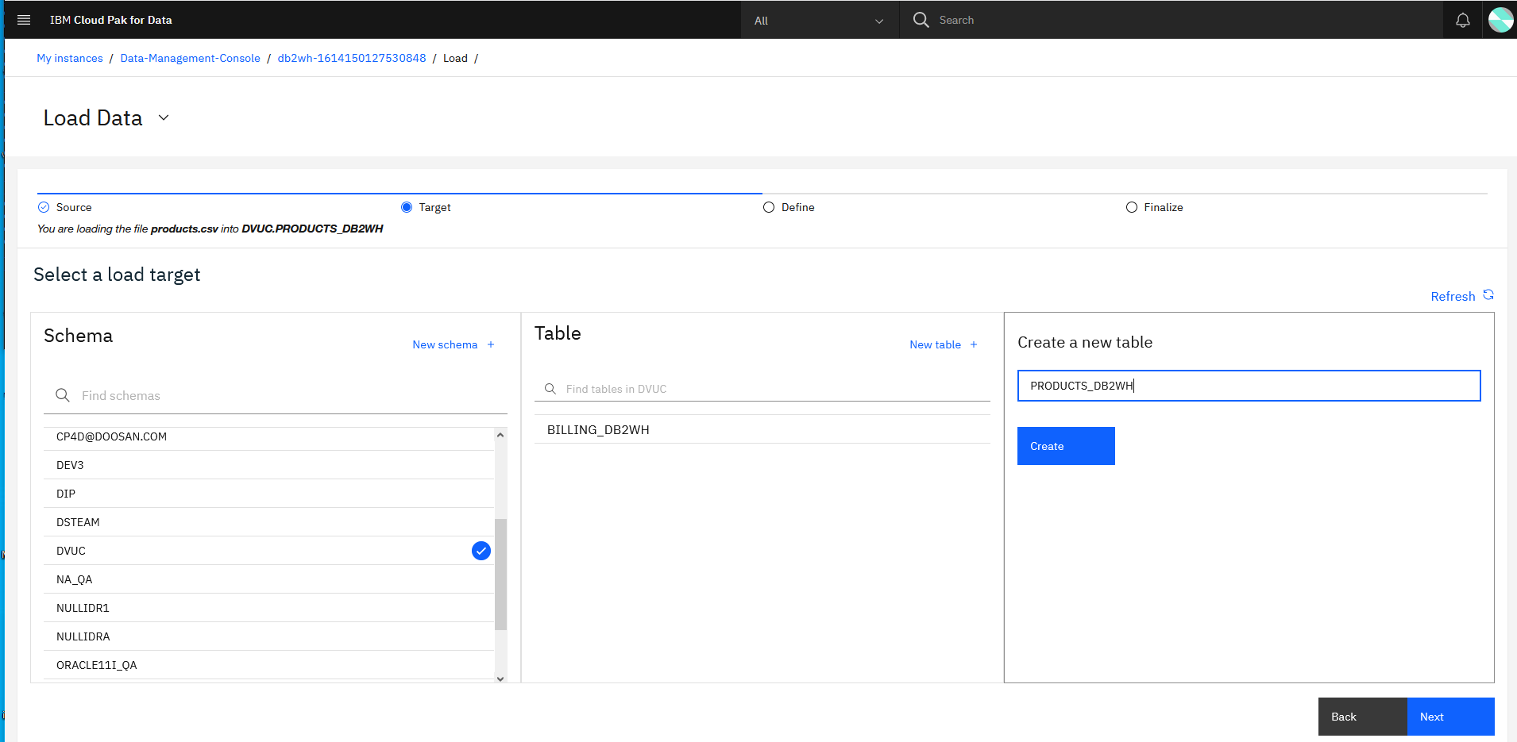

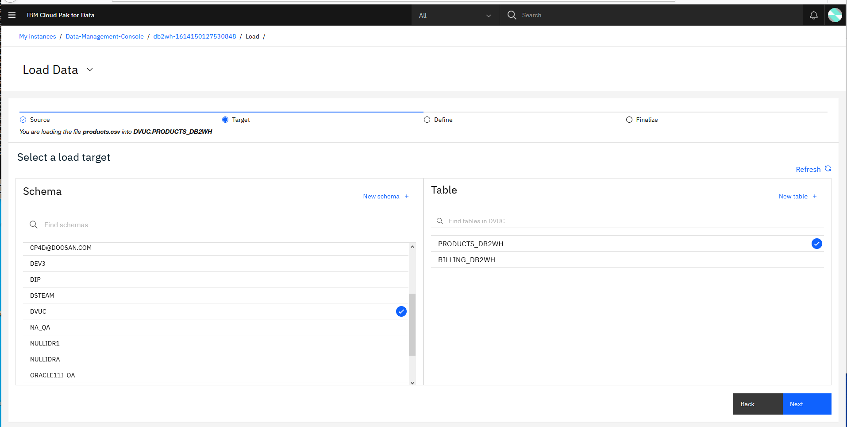

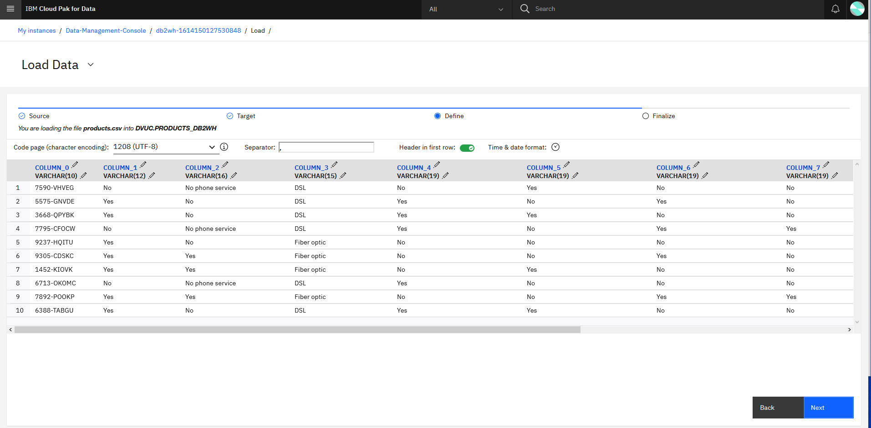

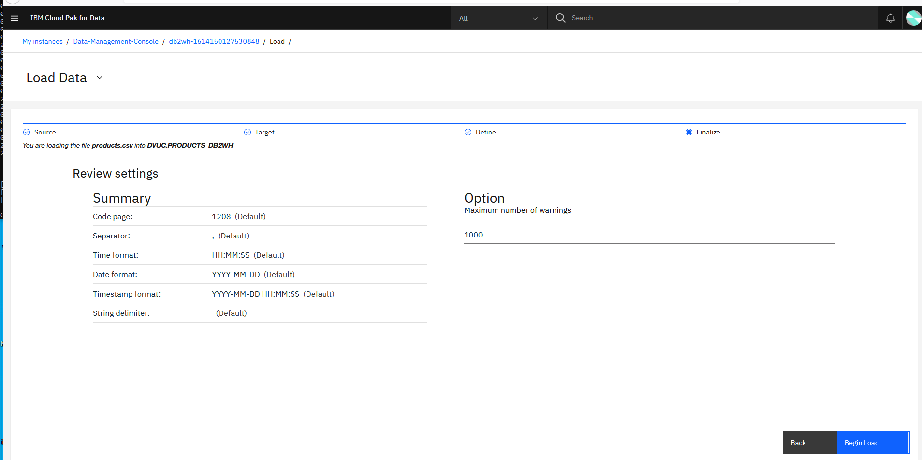

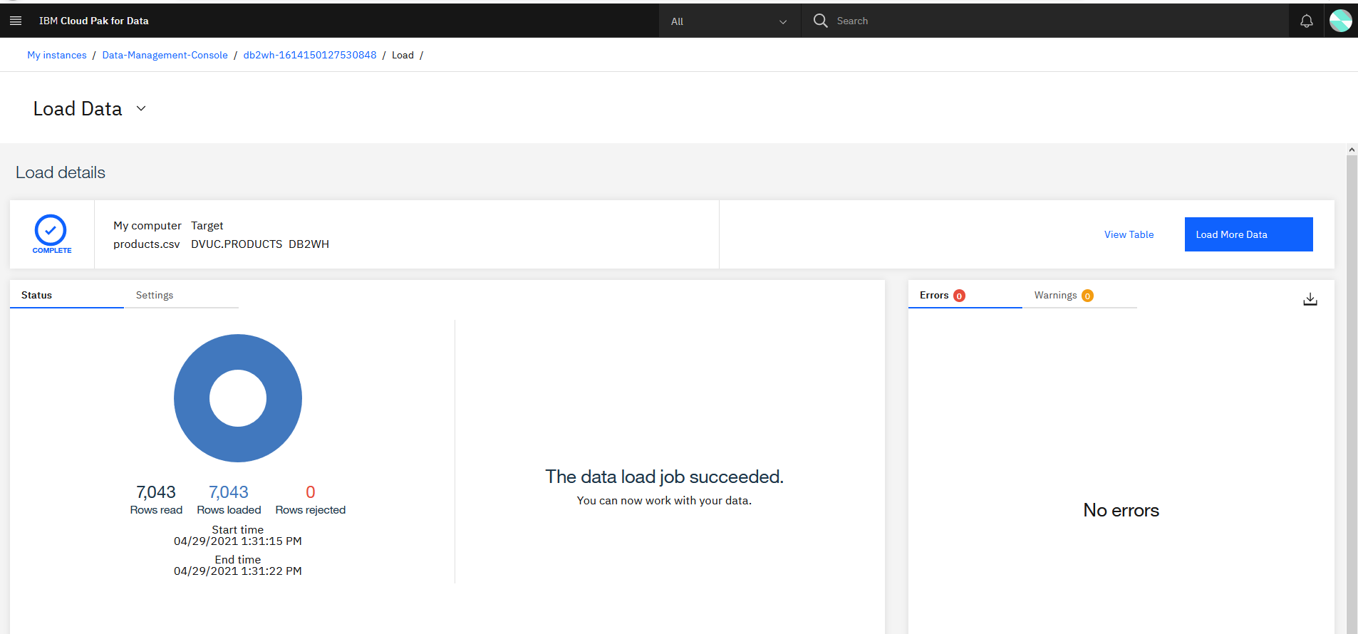

Repeat similarly for the local file customer-server.csv

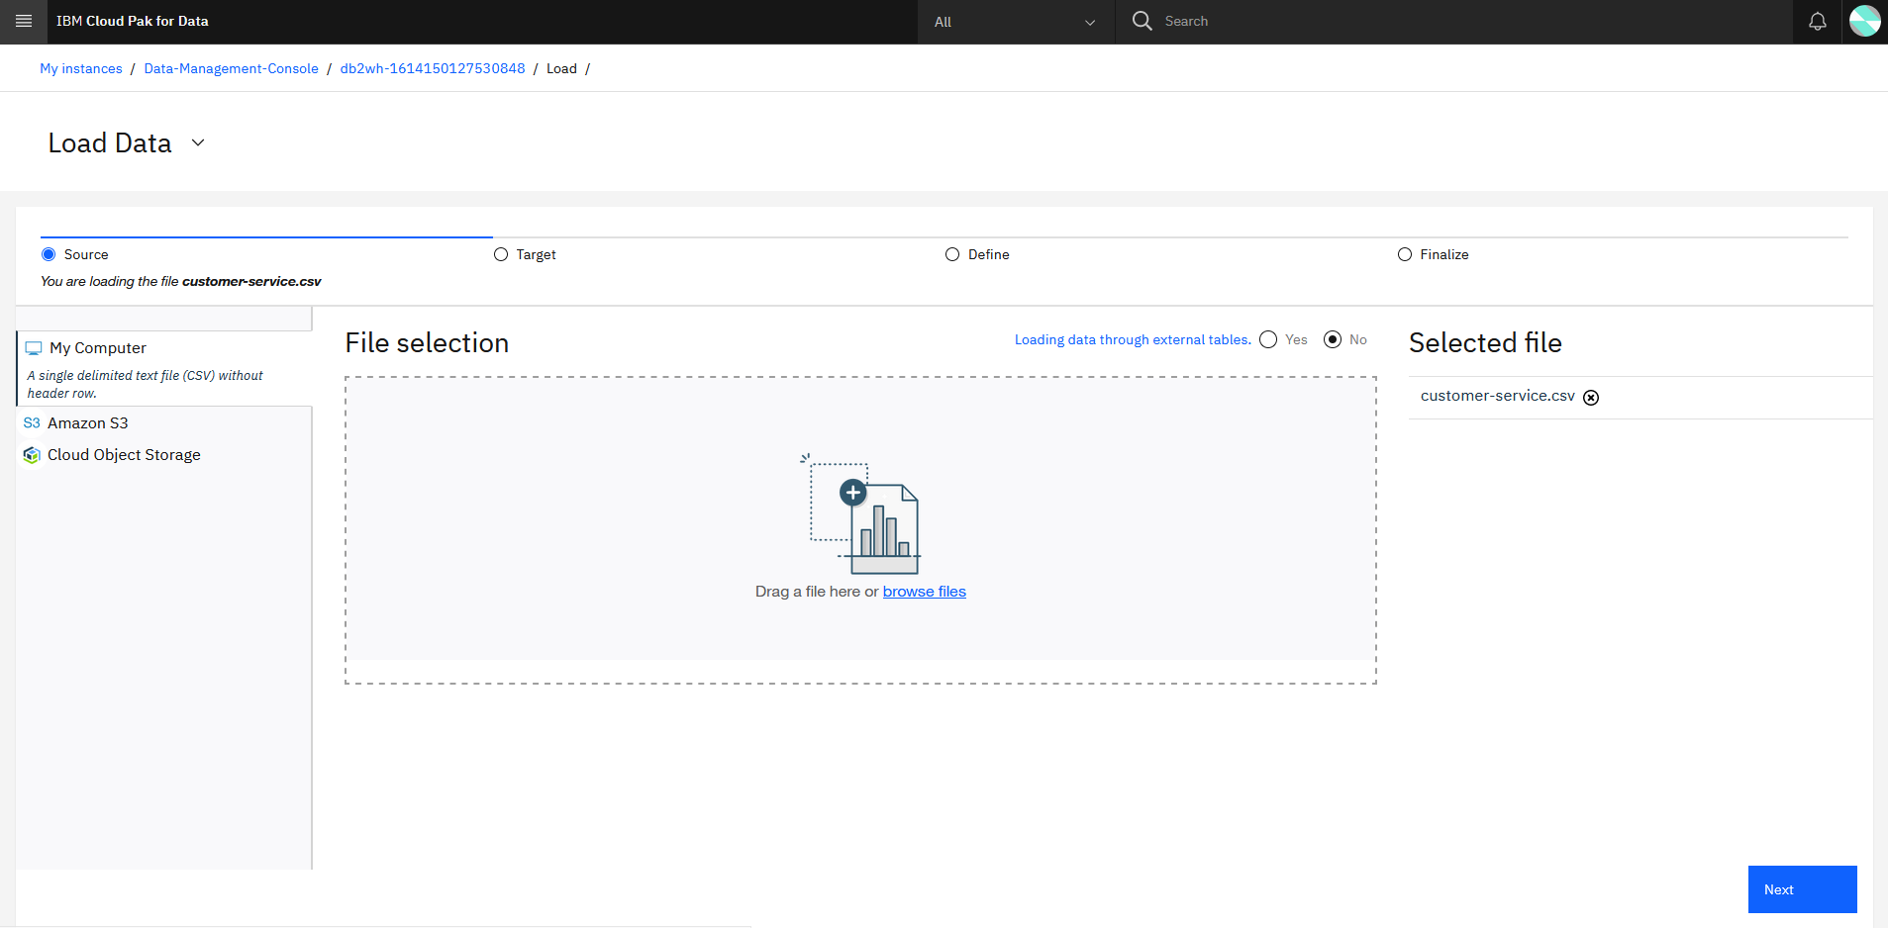

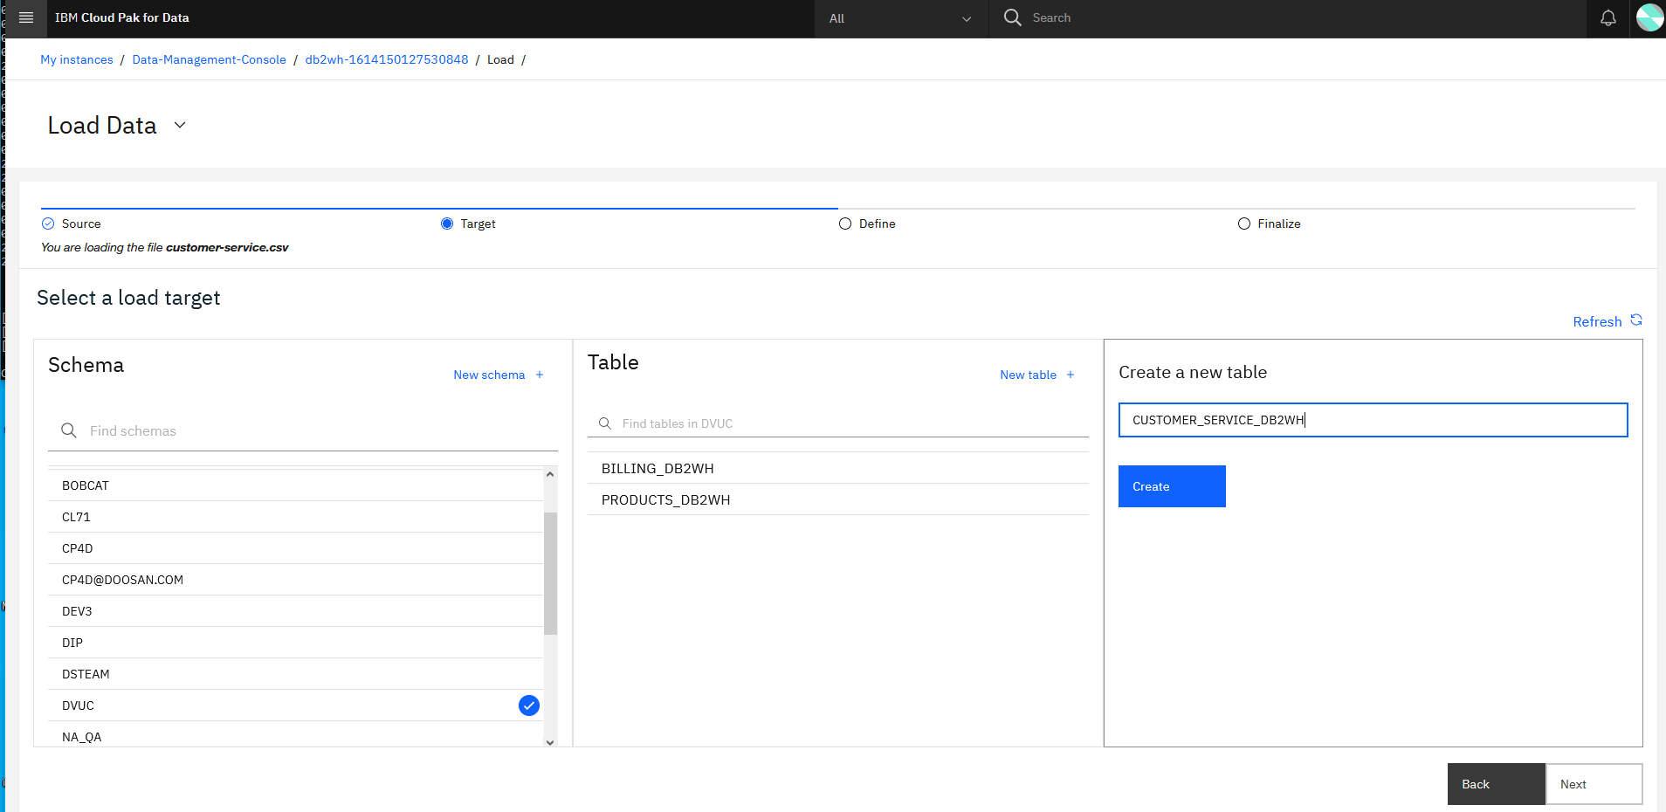

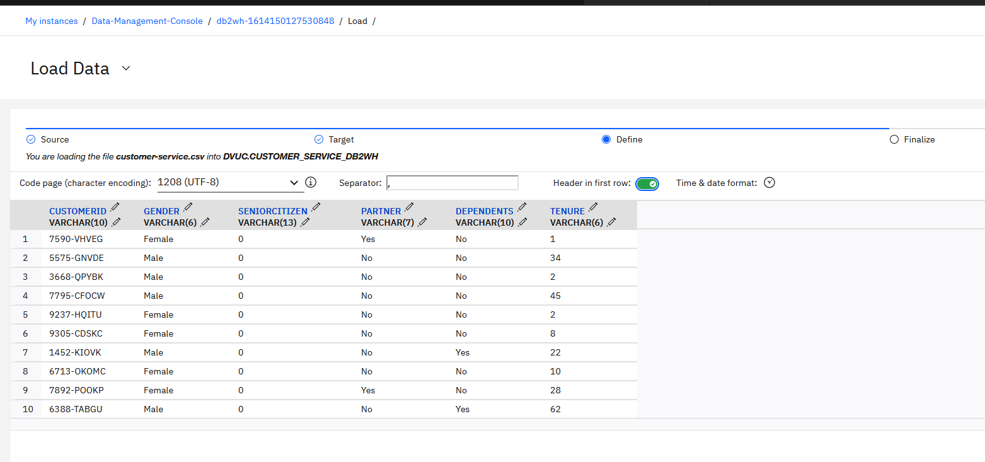

Change Data type to Integer/smallint for SENIORCITIZEN and TENOUR column

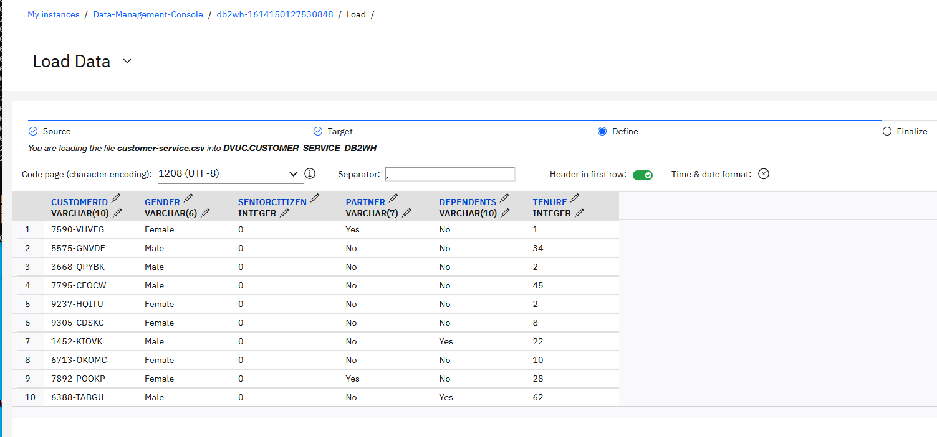

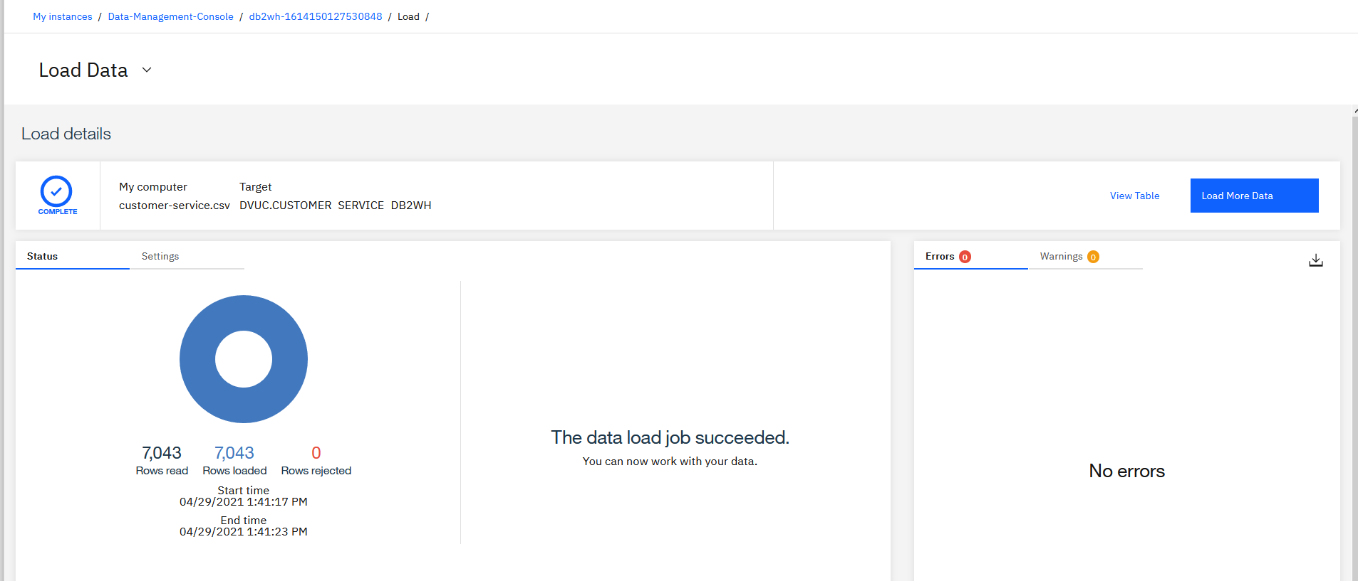

Repeat similarly for the local file billing.csv

Change data type for MONTHLYCHARGES and TOTALCHARGES to DECIMAL (31,2) while loading the data into the DB2 WH database on CP4D platform.

You can see the 3 tables in DB2 Warehouse.

