**Join the virtualized data.**

Now we are going to *join* the tables we created so we have a merged set of data. It will be easier to do it here rather than in a notebook where we would have to write code to handle three different datasets. Click on any two tables (PRODUCTS and BILLING, for instance), then click the **Join** button.

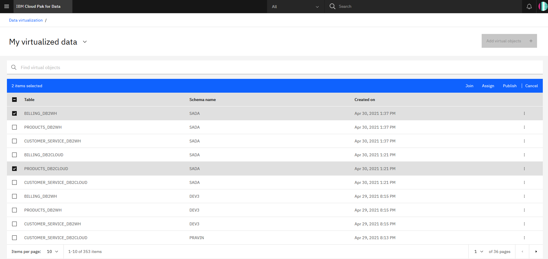

To join the tables, we need to pick a key that is common to both datasets. Here we choose to map customerID from the first table to customerID on the second table. Do this by clicking one and dragging it to the other. When the line is drawn, click **Next**.

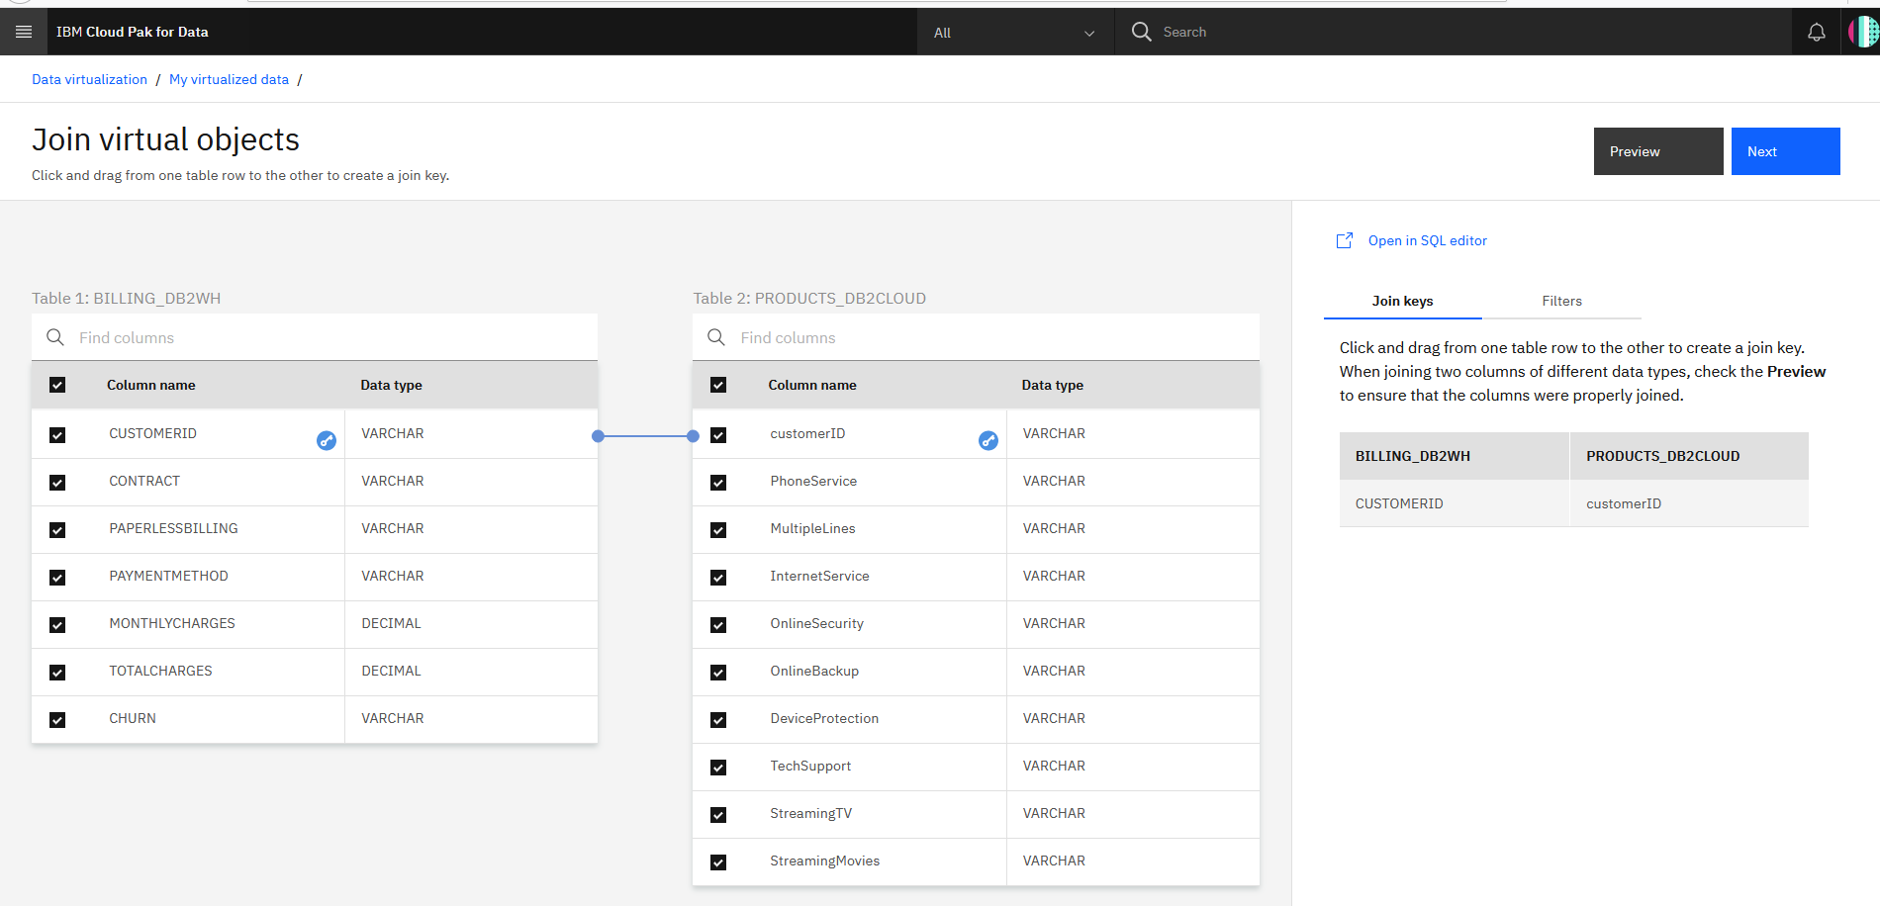

Next, you have a chance to edit column names, but we will keep them as-is. Click **Next**.

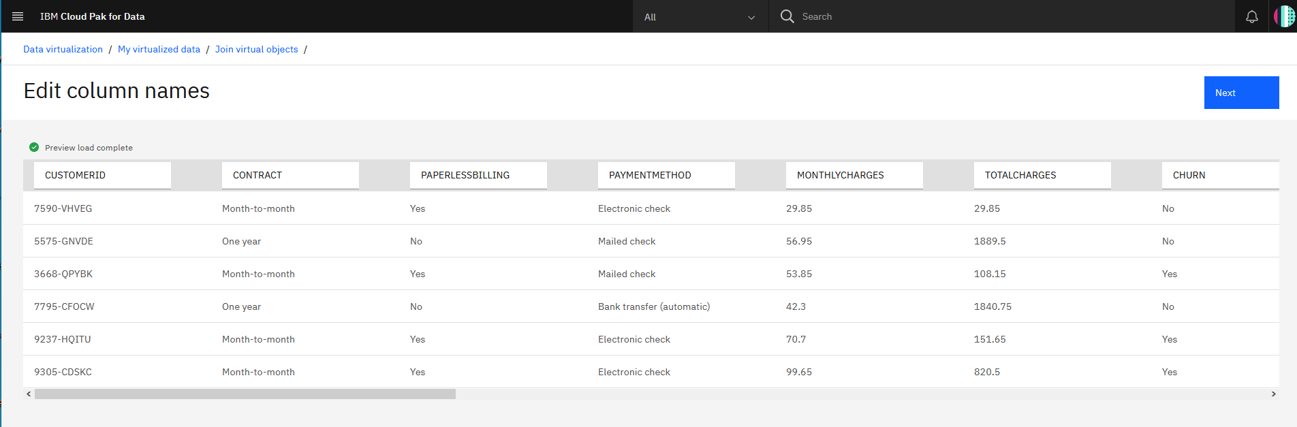

In the next panel, we’ll give our joined data a unique name such as BILLINGPRODUCTS (to be consistent with SQL standards, pick an uppercase name). Under **Assign to**, choose **My virtualized data** and uncheck the box that says Submit to catalog. Click **Create view** to start the process.

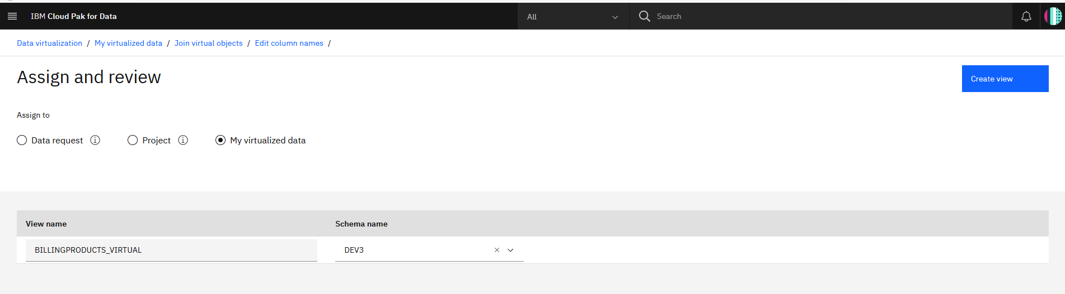

You’ll be notified that the join has succeeded. Click on **View my virtualized data** to go back and see all your virtualized data.

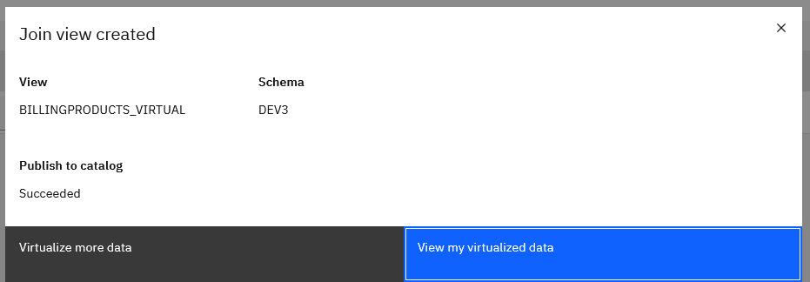

**IMPORTANT** Now join the new joined view (BILLINGPRODUCTS) and the last virtualized table (CUSTOMERS) to create a new joined view that has all three tables; let’s call it BILLINGPRODUCTSCUSTOMERS. Switching back to the **My virtualized data** screen should show all three virtualized tables and two joined tables. Do not go to the next section until this step is performed.

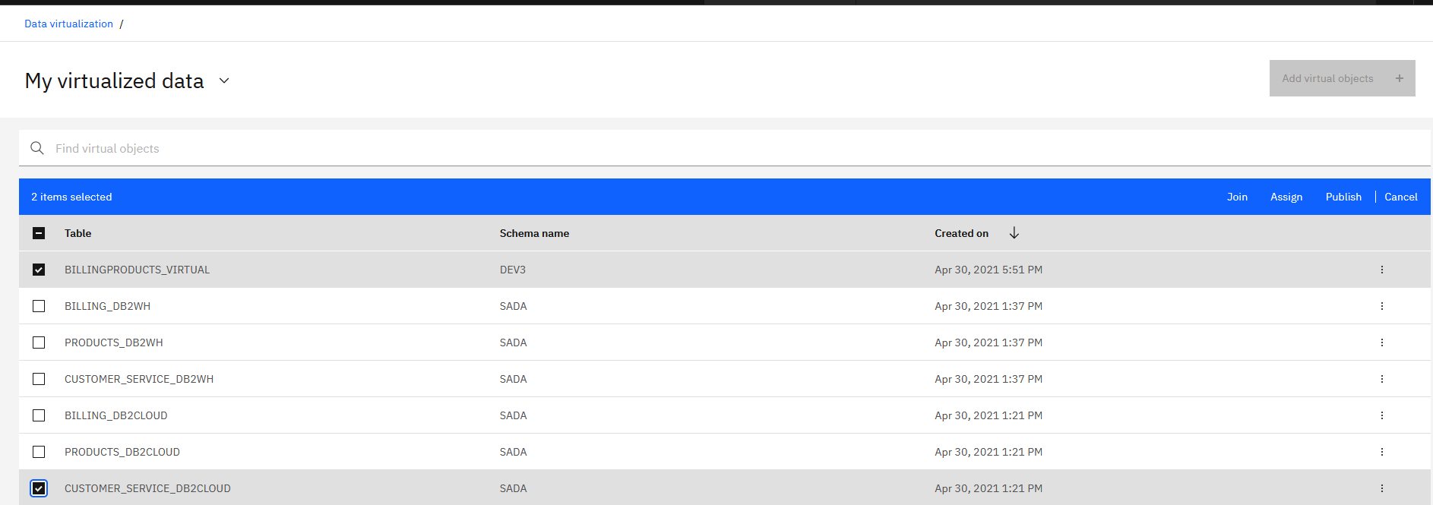

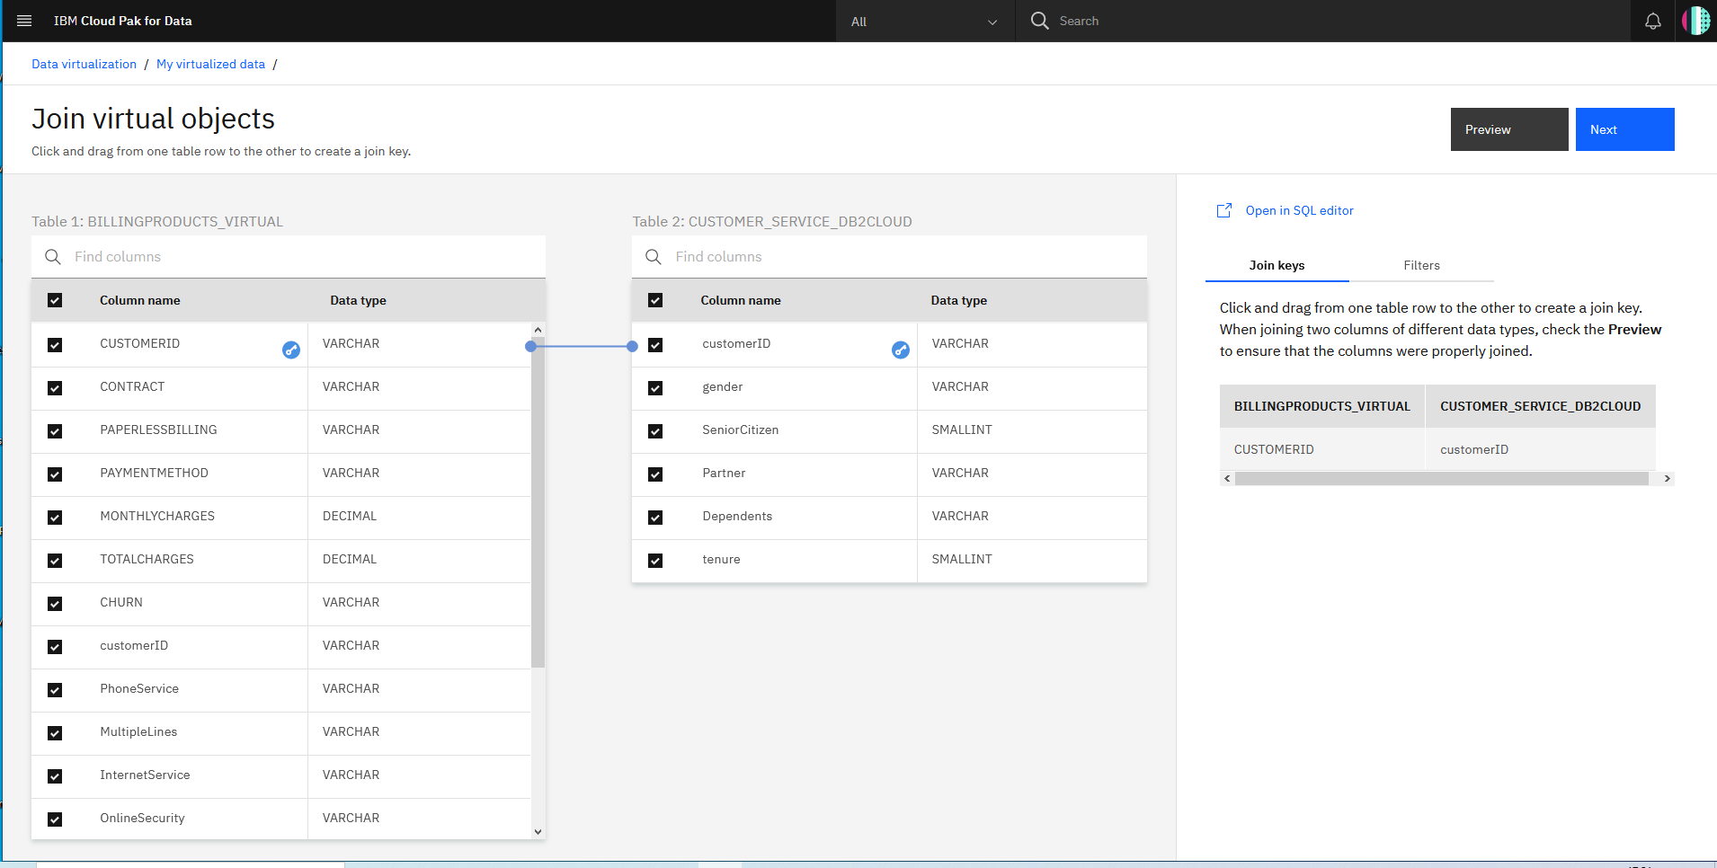

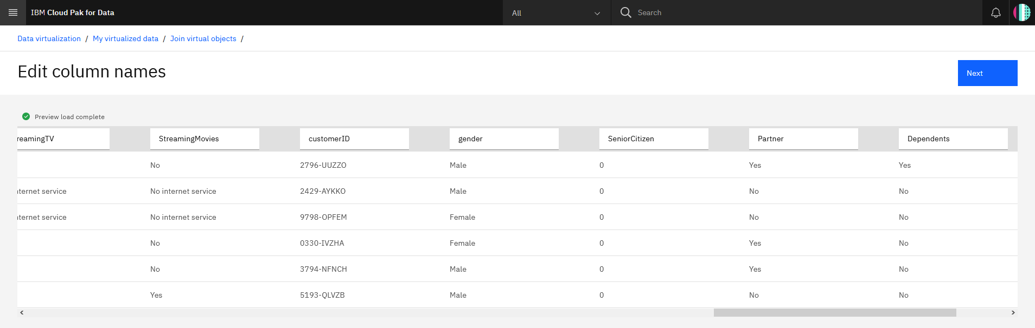

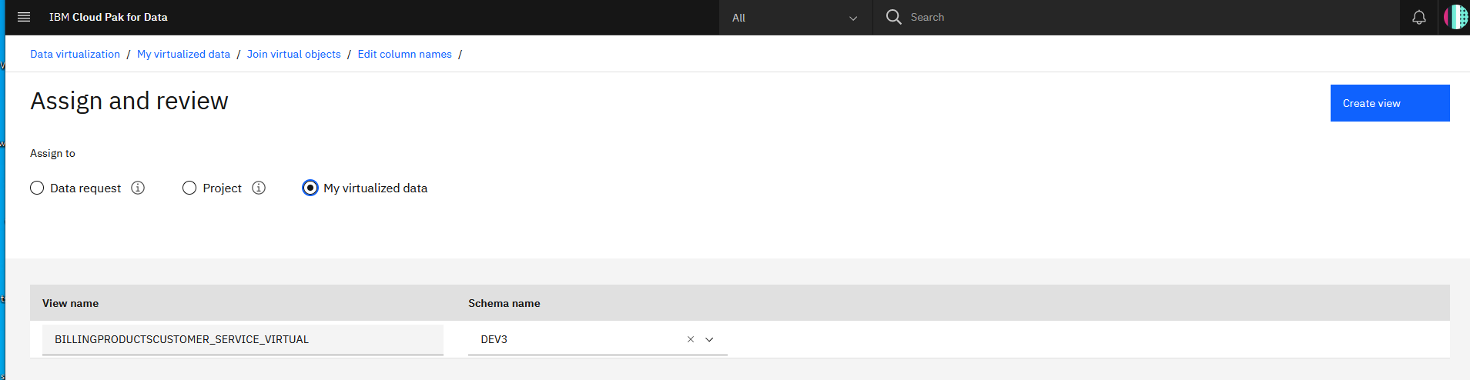

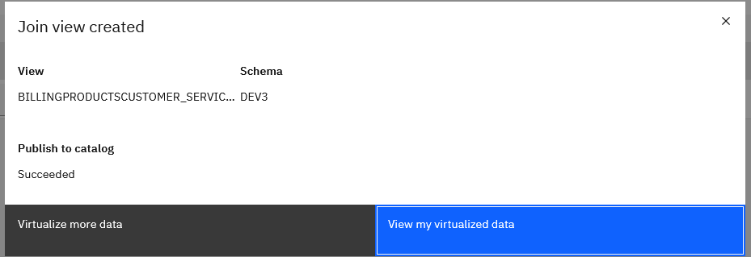

Now you should be able to see your 2 Virtualized tables

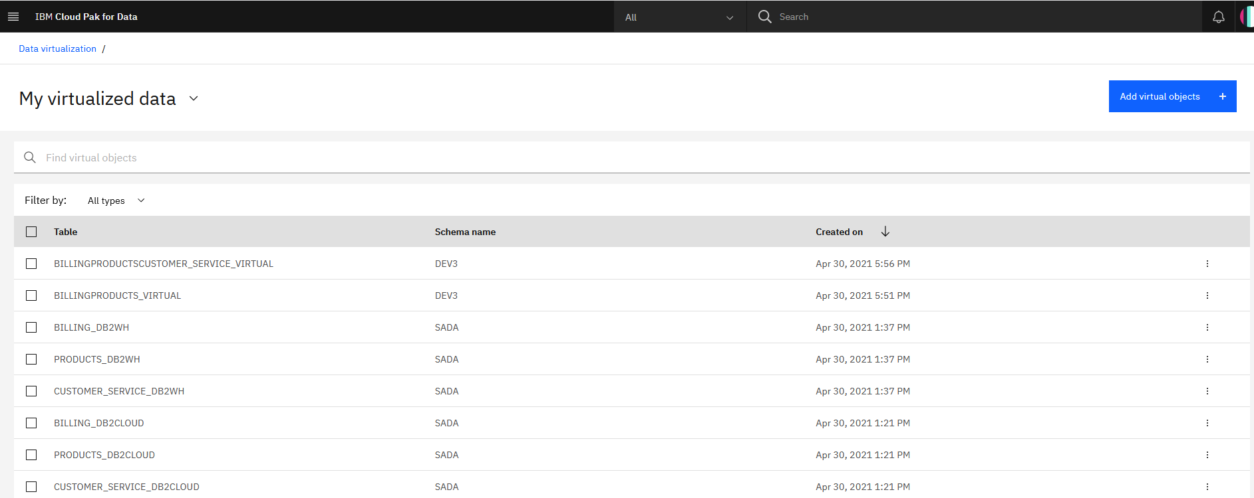

We now have the below virtual tables that we can Publish to the catalog if needed.

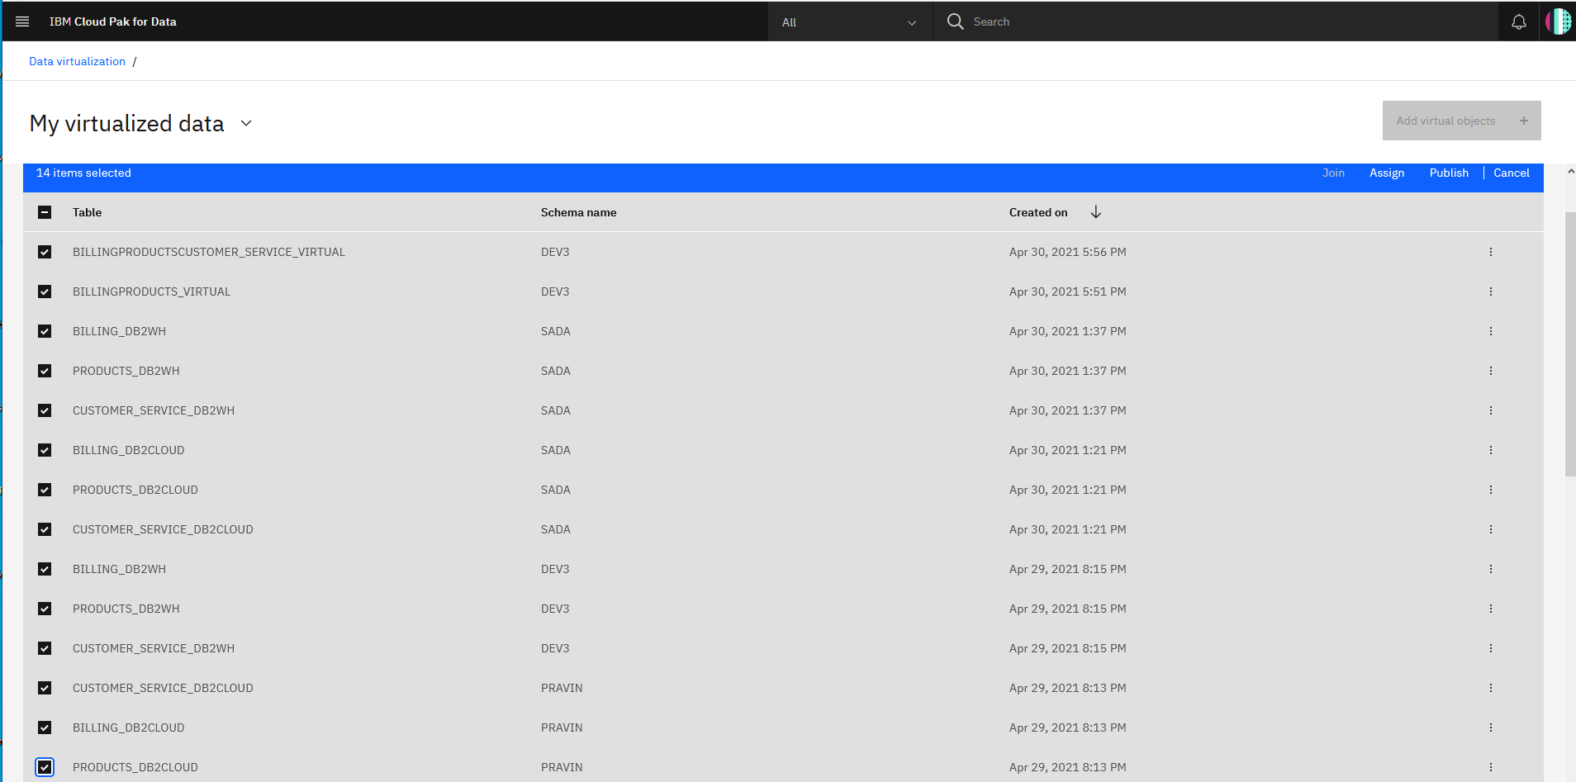

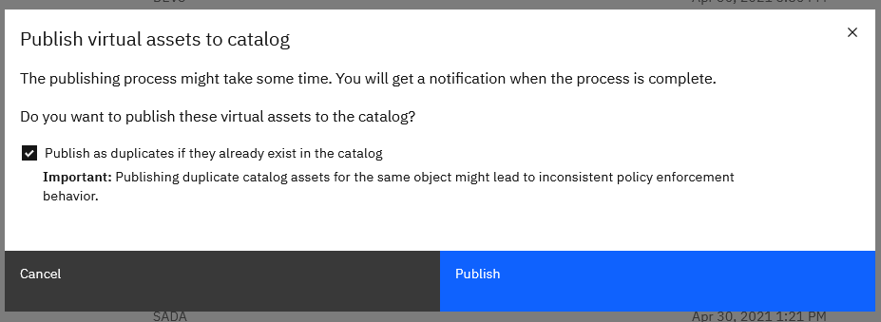



**Grant access to the virtualized data**

For other users to have access to the data you just virtualized, you need to grant it. Follow these steps to make your virtualized data visible to them:

1. Go to **Data Virtualization** from the hamburger (☰) menu. Click on **Menu > My virtualized data**.
2. Click on the virtualized data you’ve created, then click the three vertical dots to the right, and choose **Manage access**

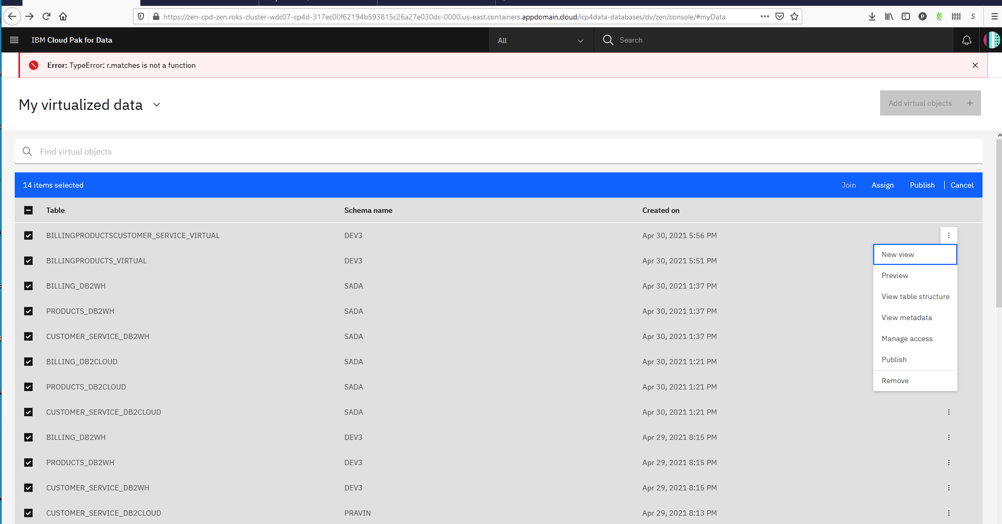

1. Click the **Specific users** radio button, then **Add user +**.

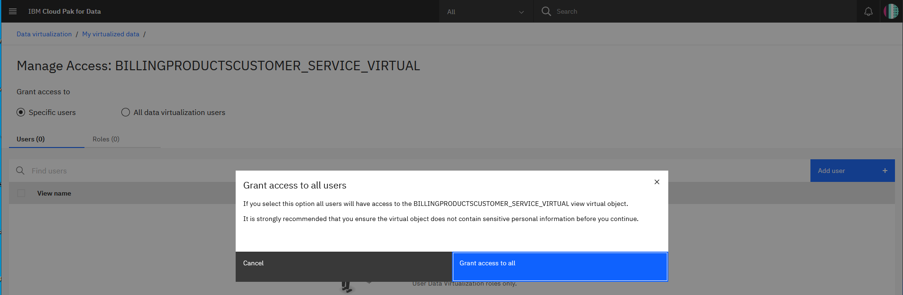

1. Select the users you wish to grant access to and click **Add users or all users**.

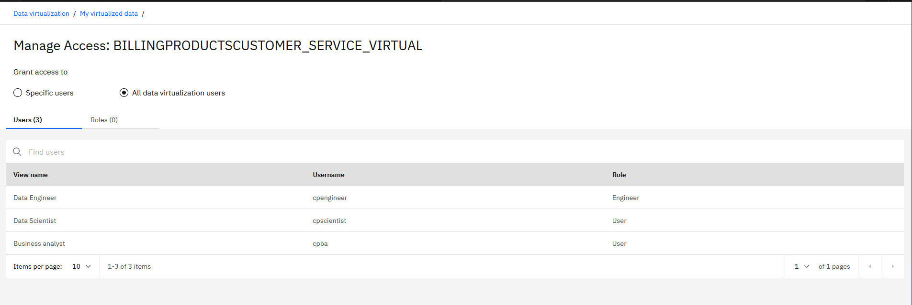

Repeat the above steps for the remaining tables and views.

**Users assign virtualized data.**

Now let’s look at how a user who has access to virtualized data can assign the data to their project — how to add the virtualized data as asset to a project.

### Assign the data to your project.

1. From the hamburger (☰) menu, click on **Collect > Data Virtualization**. You will be brought to the My virtualized data section. Here you should see the data you can access (or that the administrator has assigned to you).
2. Select the checkbox next to our original tables (BILLING, PRODUCTS, CUSTOMERS) and the joined tables (BILLINGPRODUCTS, BILLINGPRODUCTSCUSTOMERS), and click the **Assign** button to import them into your project.

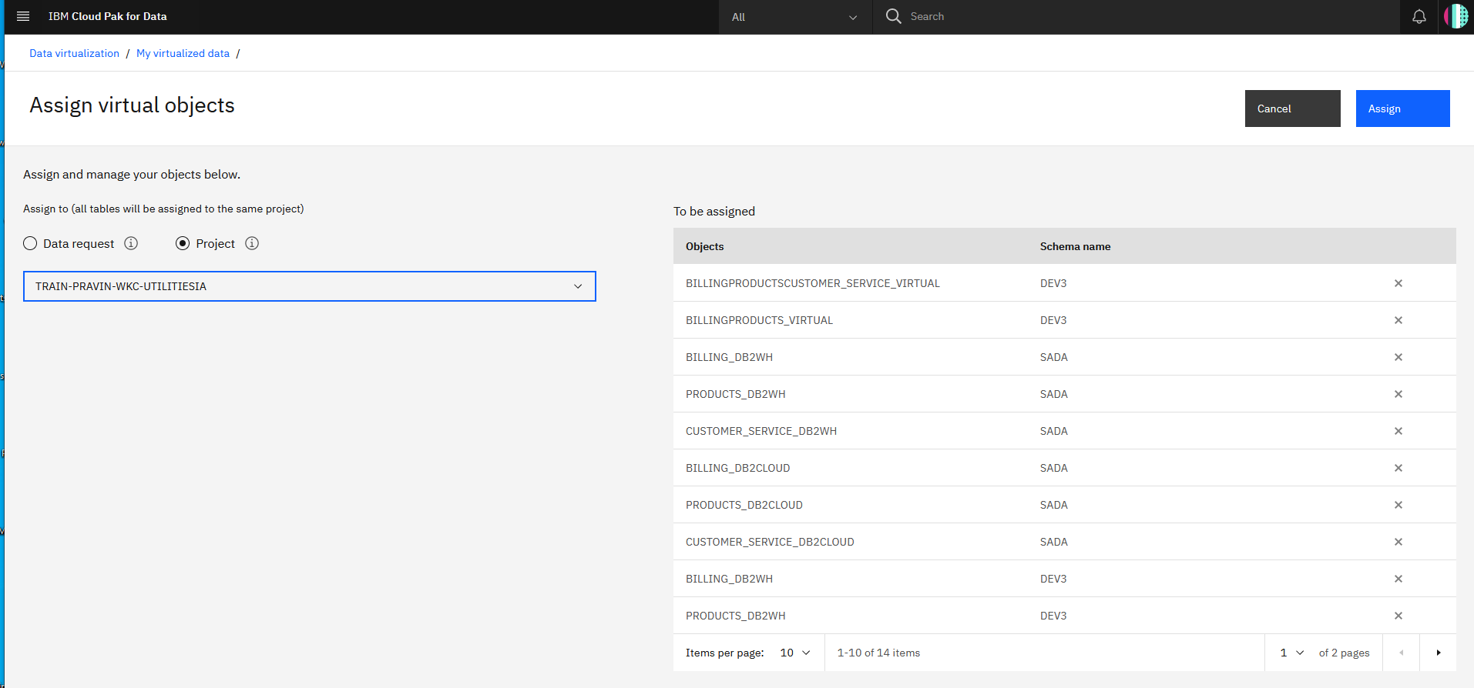

1. On the Assign virtual objects screen, choose the project to assign the data. If there is a **Submit to catalog** checkbox on the top right, uncheck it and click the **Assign** button to add the data to your project.

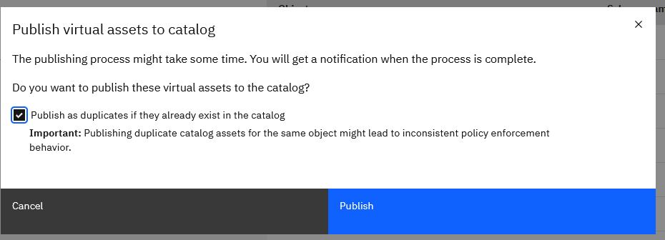

1. In the pop-up panel, you will receive a confirmation that the objects have been assigned to your project. Click the **Go to project** button.

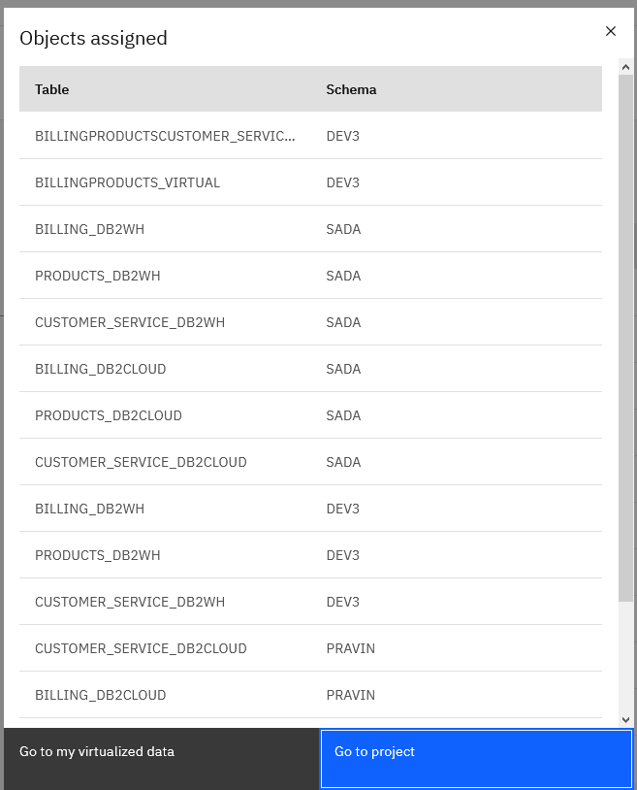

1. Click on **Go to project**. Alternatively, close the model and go to your projects by clicking on the hamburger (☰) menu, then choosing **Projects**.

On the project page, clicking on the **Assets** tab will show the virtualized tables and joined tables that are now in your project.

