Amaznon Prime EDA Report

# Sentiments By Title

Lorem Ipsum is simply dummy text of the printing and typesetting industry. Lorem Ipsum has been the industry’s standard dummy text ever since the 1500s, when an unknown printer took a galley of type and scrambled it to make a type specimen book.

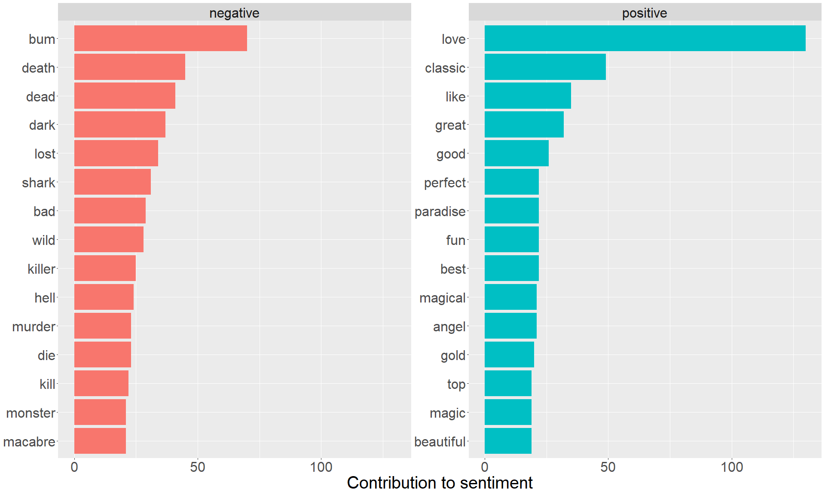

# Sentiment By Description

Lorem Ipsum is simply dummy text of the printing and typesetting industry. Lorem Ipsum has been the industry’s standard dummy text ever since the 1500s, when an unknown printer took a galley of type and scrambled it to make a type specimen book.

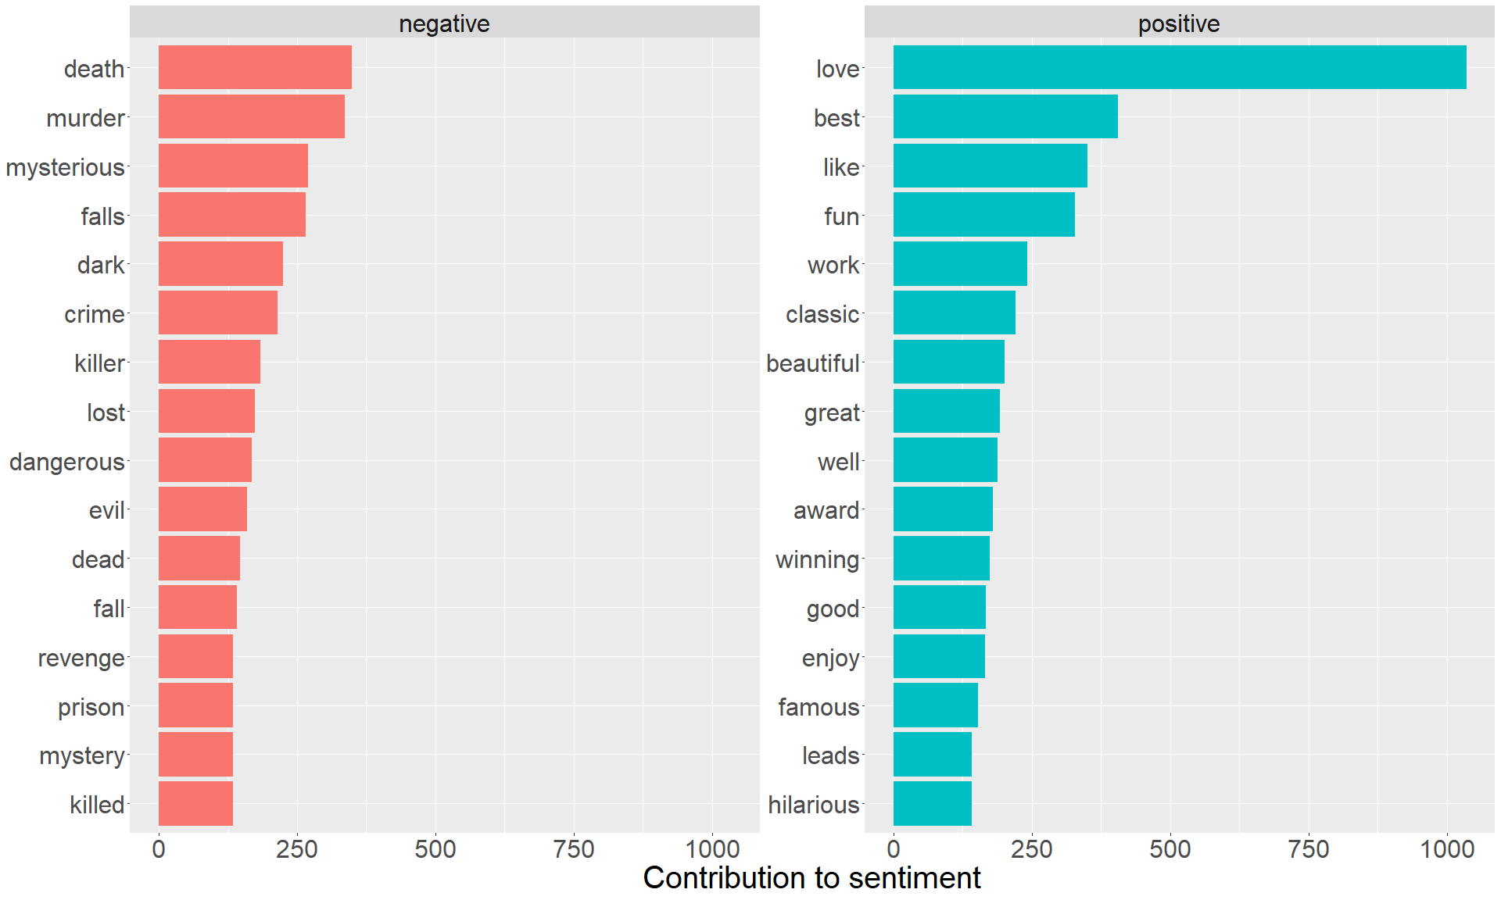

# Top 5 Countries With Highest Content

Lorem Ipsum is simply dummy text of the printing and typesetting industry. Lorem Ipsum has been the industry’s standard dummy text ever since the 1500s, when an unknown printer took a galley of type and scrambled it to make a type specimen book.

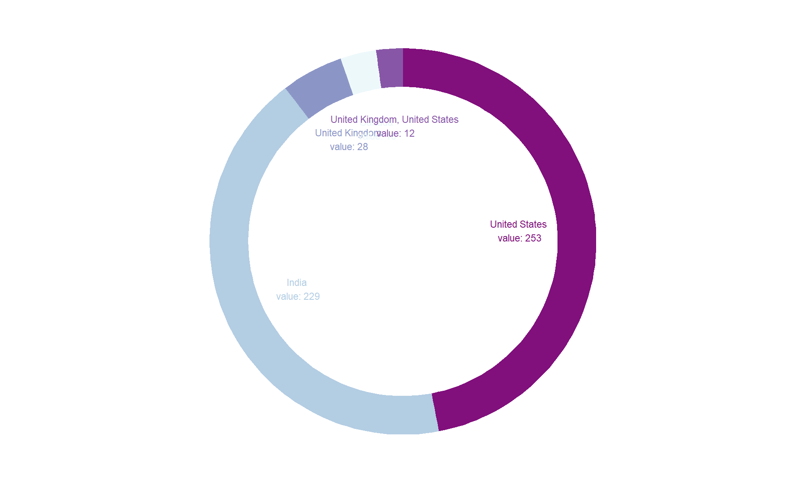

# Least 5 Countries With Highest Content

Lorem Ipsum is simply dummy text of the printing and typesetting industry. Lorem Ipsum has been the industry’s standard dummy text ever since the 1500s, when an unknown printer took a galley of type and scrambled it to make a type specimen book.

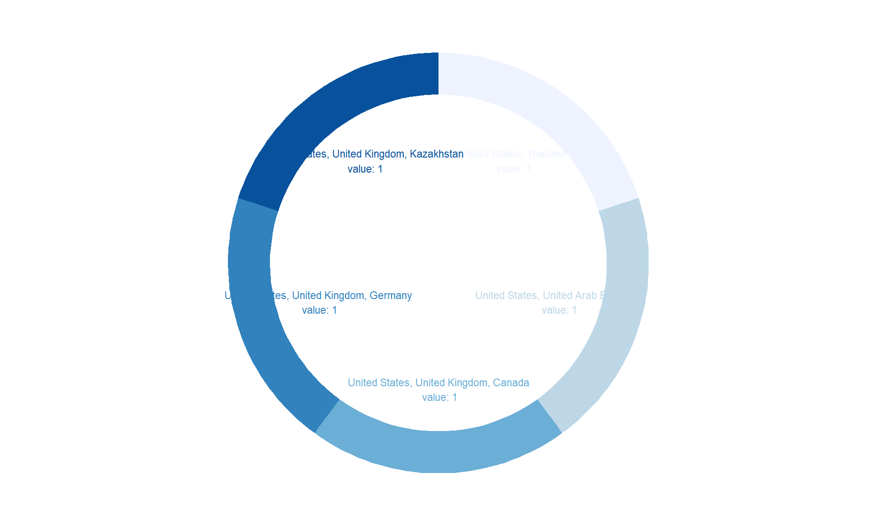

# 5 Frequency of Generes

Lorem Ipsum is simply dummy text of the printing and typesetting industry. Lorem Ipsum has been the industry’s standard dummy text ever since the 1500s, when an unknown printer took a galley of type and scrambled it to make a type specimen book.

|  |  |  |
| --- | --- | --- |
| Type | Genere | Frequency |
| Movie | Drama | 870 |
| Movie | Comedy | 442 |
| Movie | Drama, Suspense | 349 |
| Movie | Comedy, Drama | 338 |
| Movie | Documentary | 300 |
| Movie | Action, Drama | 277 |
| TV Show | TV Shows | 263 |
| Movie | Horror | 253 |
| Movie | Kids | 226 |
| Movie | Action | 216 |
| Movie | Arts, Entertainment, and Culture, Comedy, Special Interest | 215 |
| Movie | Horror, Suspense | 194 |
| Movie | Documentary, Special Interest | 182 |
| Movie | Suspense | 181 |
| Movie | Animation, Kids | 180 |
| TV Show | Animation, Kids | 176 |
| Movie | Drama, Romance | 167 |
| Movie | Action, Suspense | 136 |
| Movie | Action, Drama, Suspense | 129 |
| TV Show | Drama | 116 |

# Wordcloud by Description

Lorem Ipsum is simply dummy text of the printing and typesetting industry. Lorem Ipsum has been the industry’s standard dummy text ever since the 1500s, when an unknown printer took a galley of type and scrambled it to make a type specimen book.

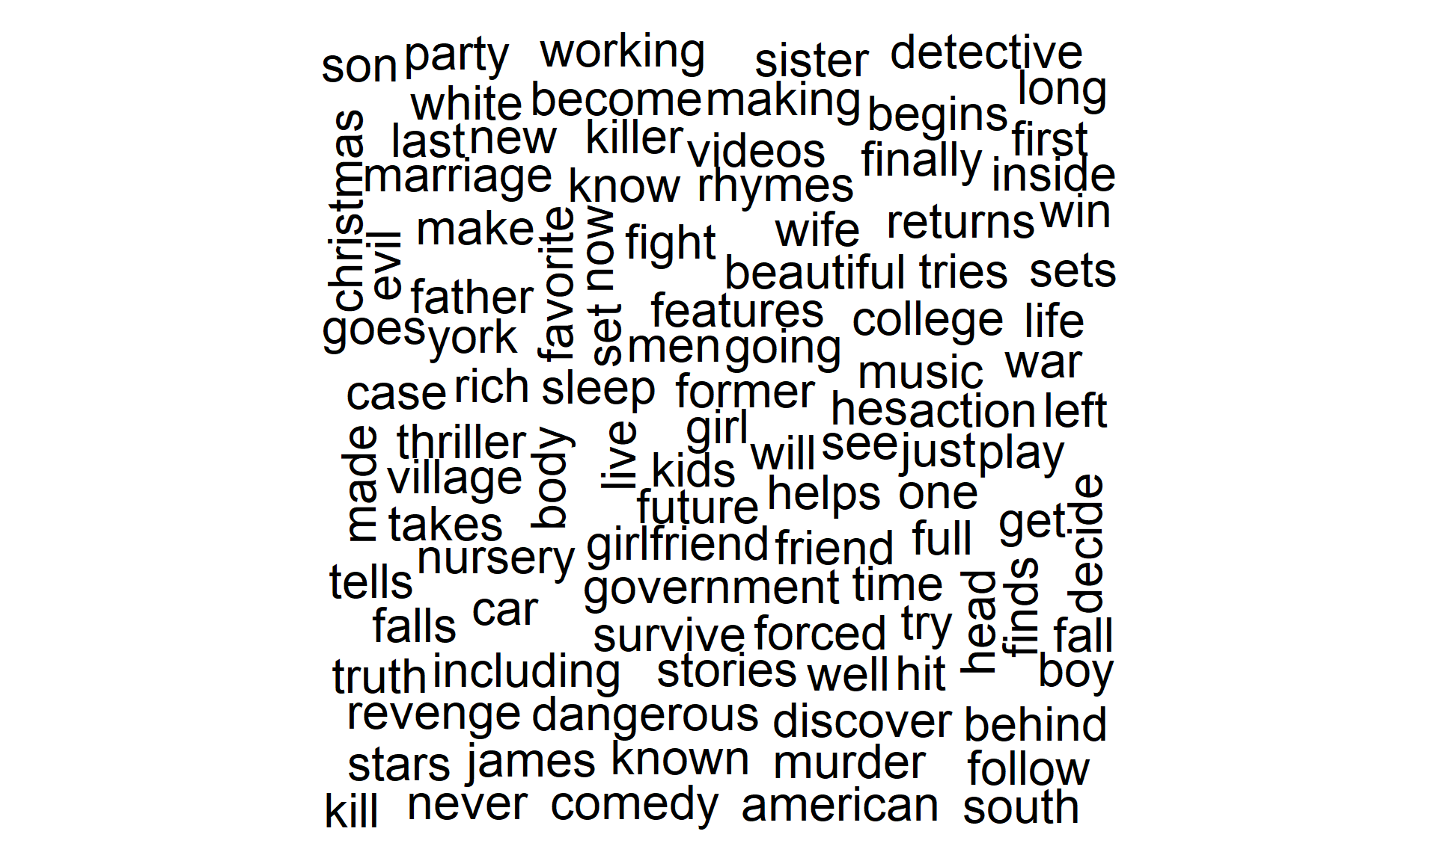

# Wordcloud by Title

Lorem Ipsum is simply dummy text of the printing and typesetting industry. Lorem Ipsum has been the industry’s standard dummy text ever since the 1500s, when an unknown printer took a galley of type and scrambled it to make a type specimen book.

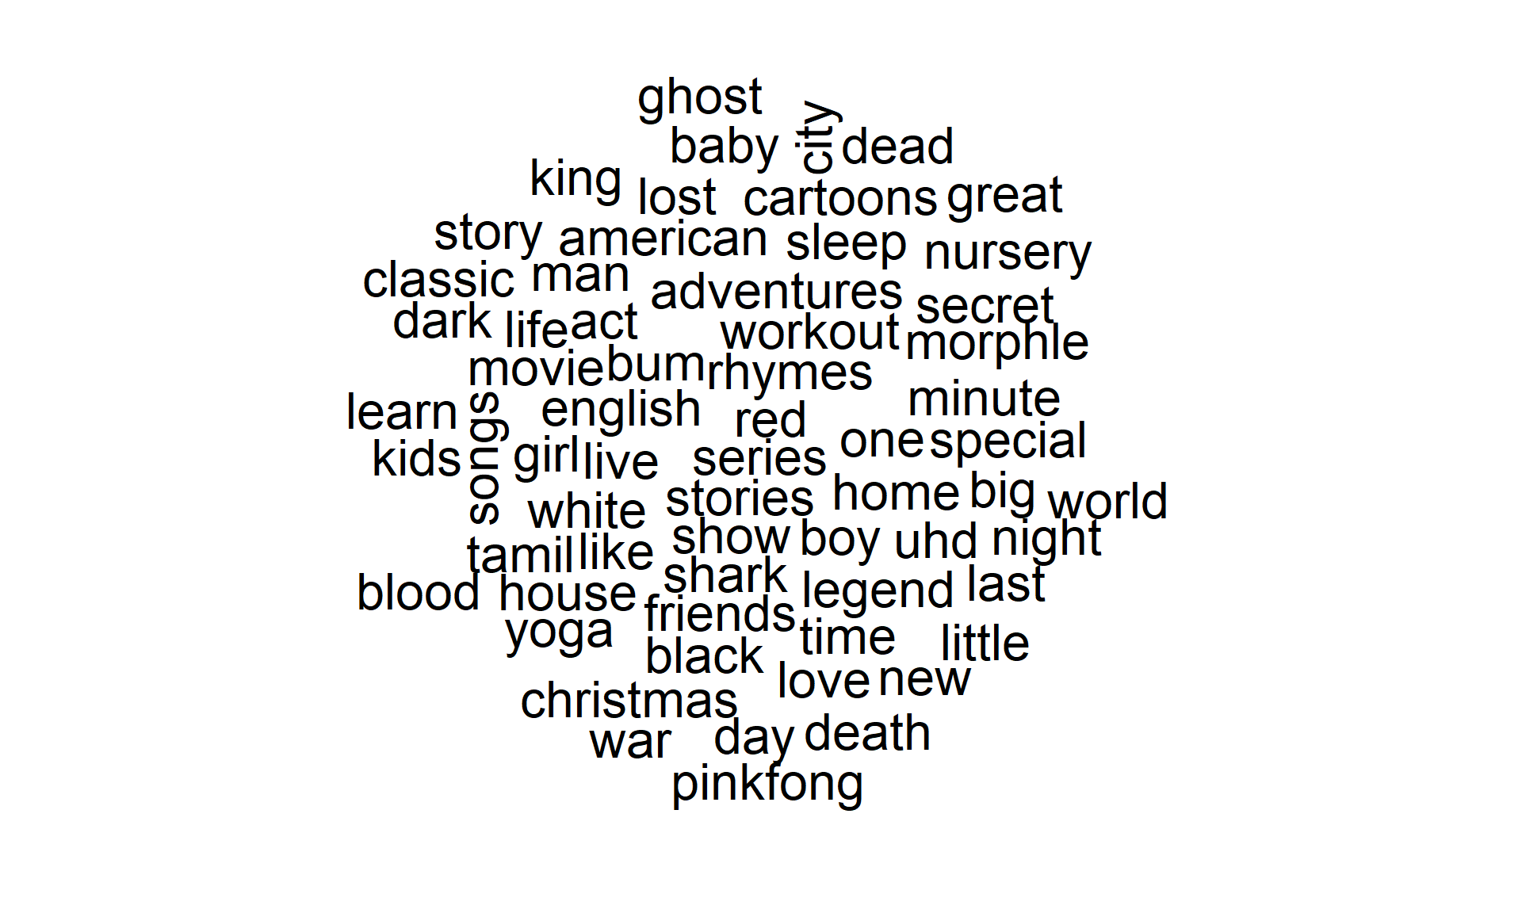

# Positive Words Freq by Description

Lorem Ipsum is simply dummy text of the printing and typesetting industry. Lorem Ipsum has been the industry’s standard dummy text ever since the 1500s, when an unknown printer took a galley of type and scrambled it to make a type specimen book.

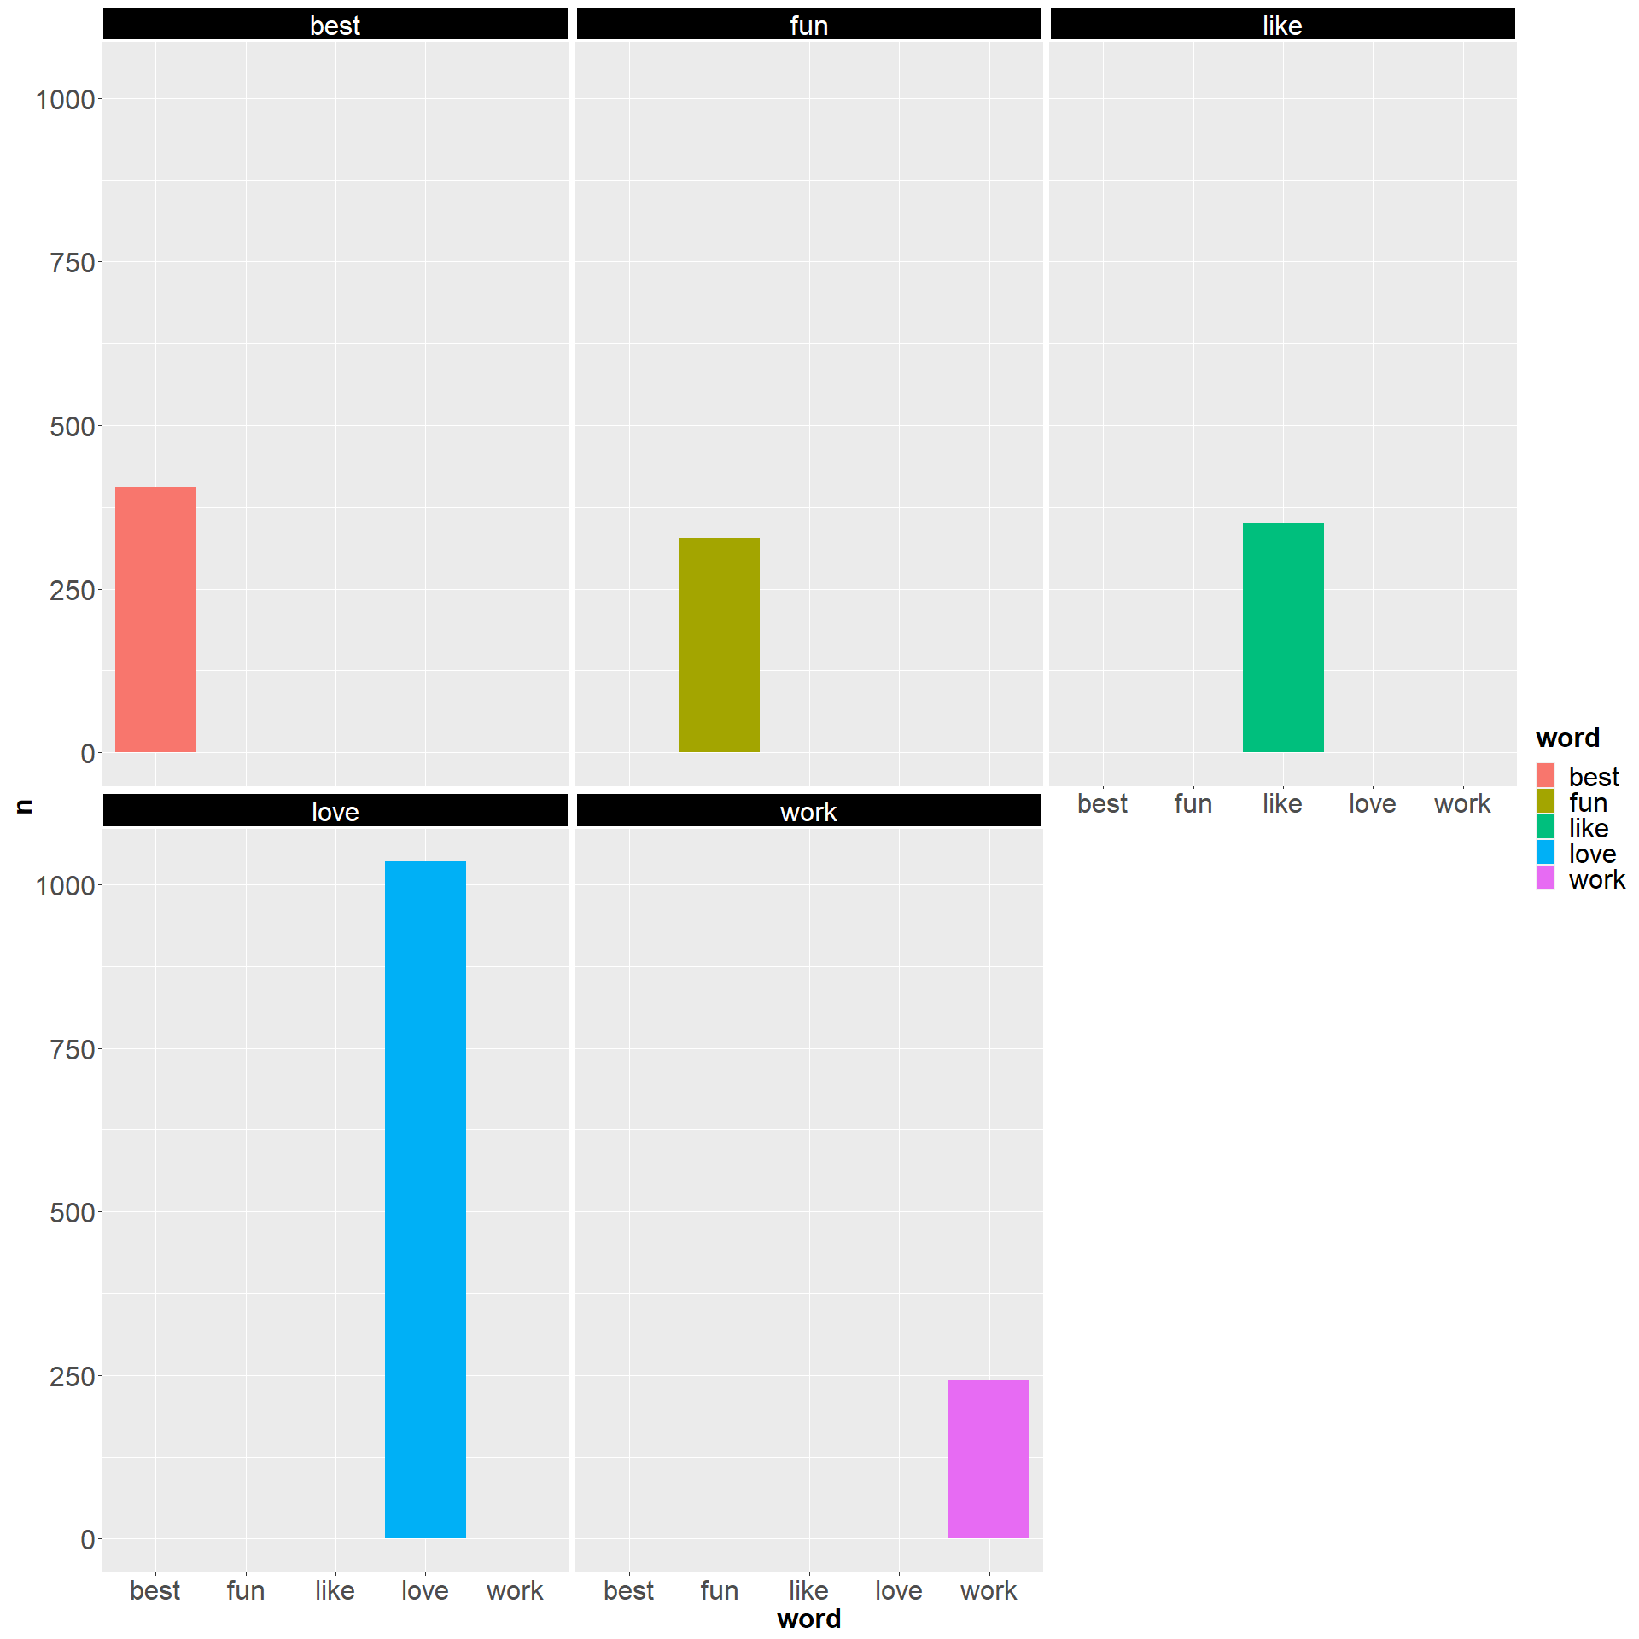

# Negative Words Freq by Description

Lorem Ipsum is simply dummy text of the printing and typesetting industry. Lorem Ipsum has been the industry’s standard dummy text ever since the 1500s, when an unknown printer took a galley of type and scrambled it to make a type specimen book.

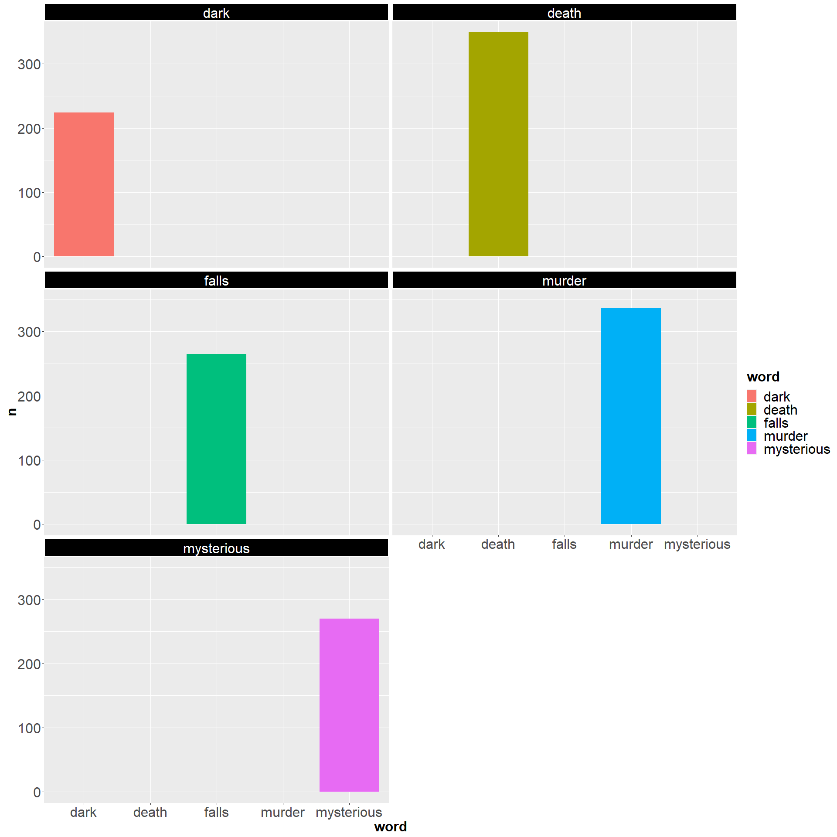

# Positive Words Freq by Title

Lorem Ipsum is simply dummy text of the printing and typesetting industry. Lorem Ipsum has been the industry’s standard dummy text ever since the 1500s, when an unknown printer took a galley of type and scrambled it to make a type specimen book.

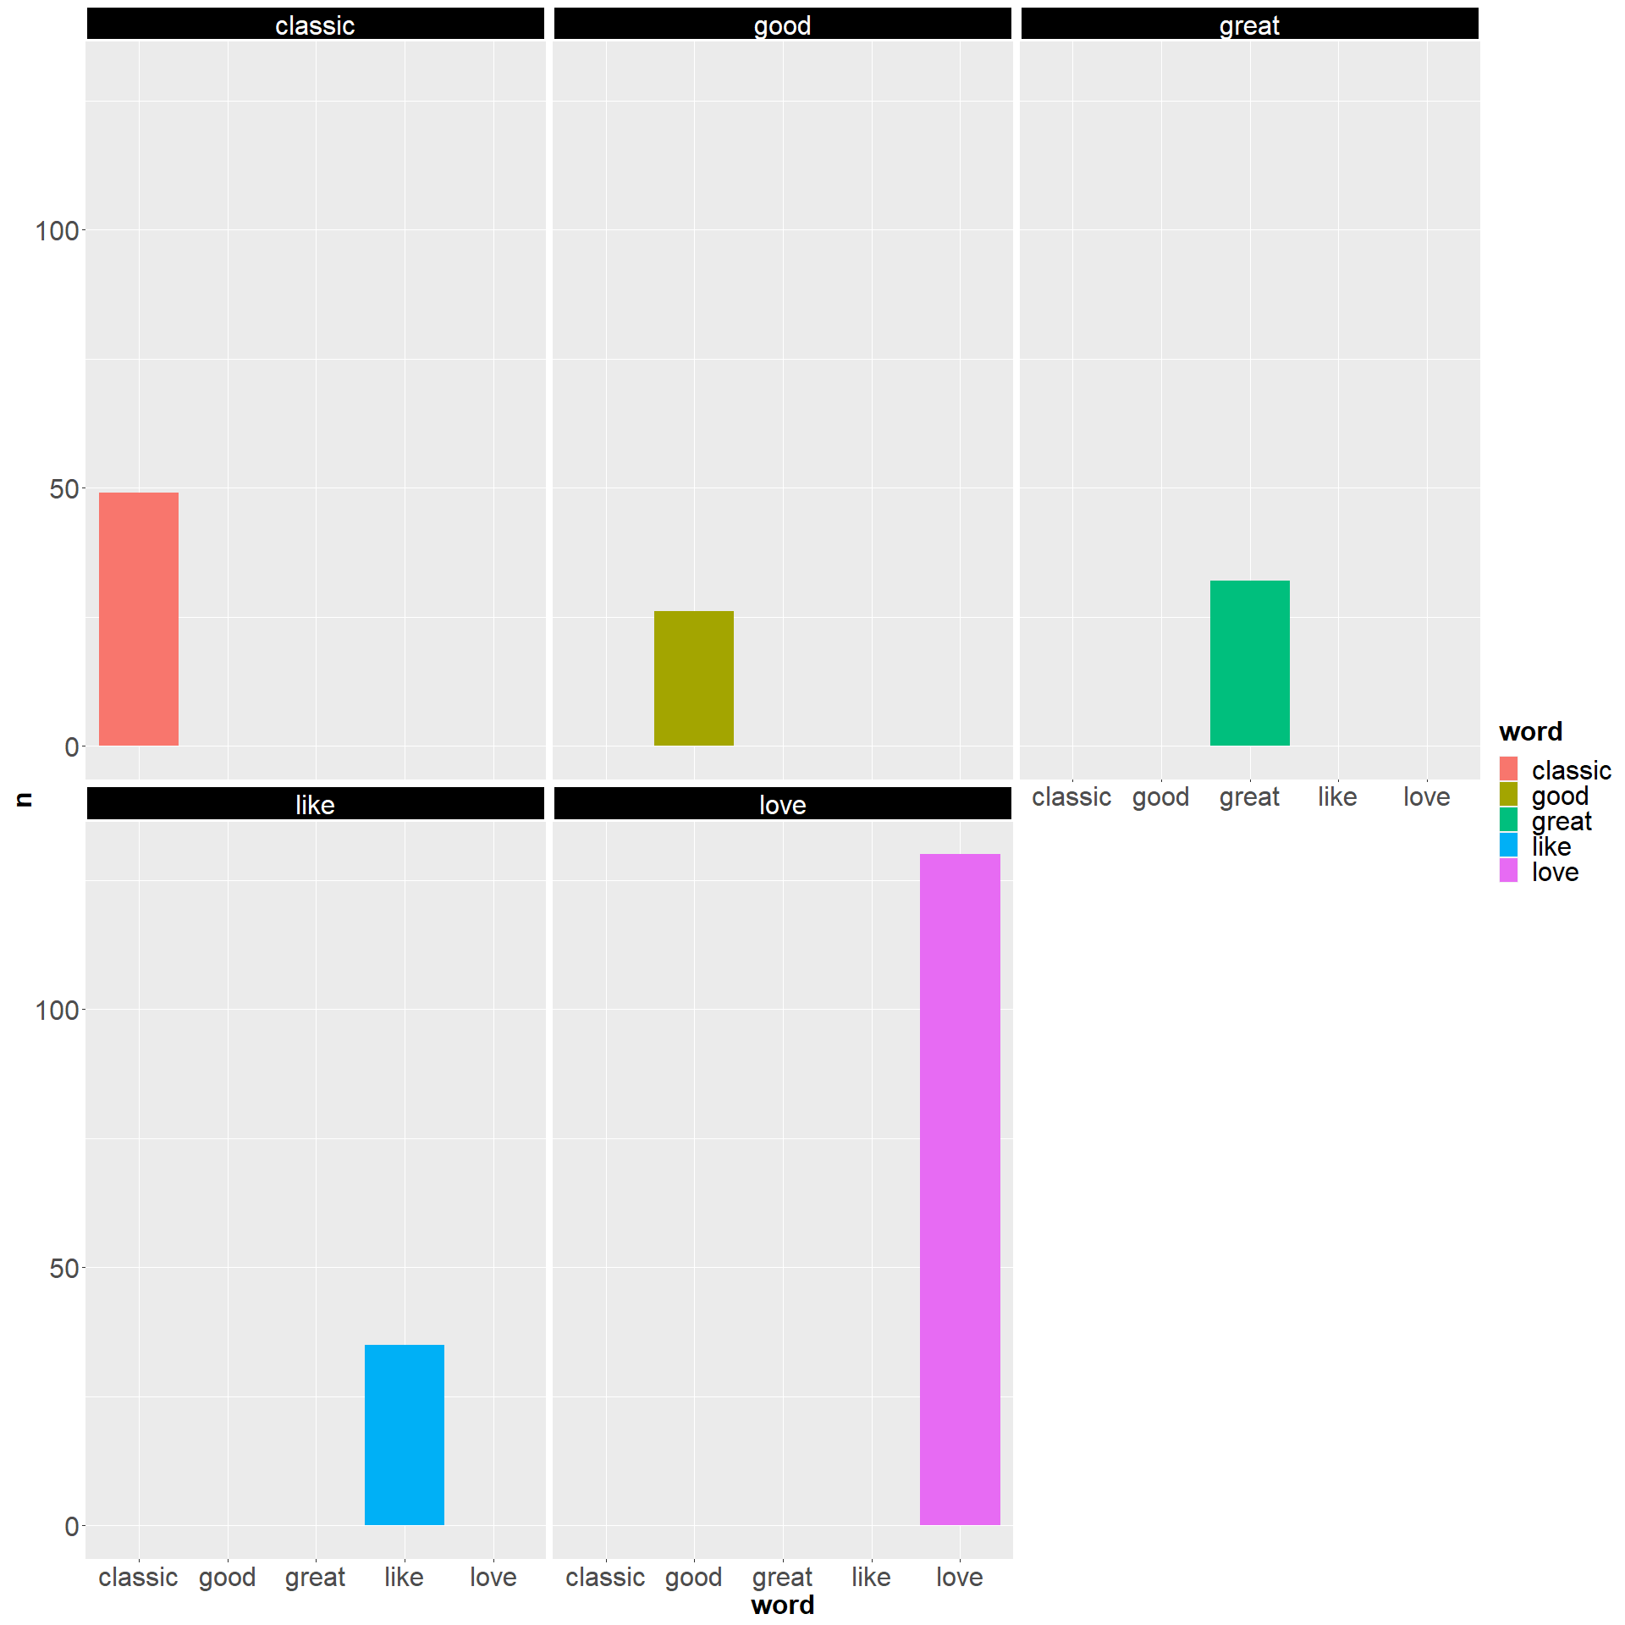

# Negative Words Freq by Title

Lorem Ipsum is simply dummy text of the printing and typesetting industry. Lorem Ipsum has been the industry’s standard dummy text ever since the 1500s, when an unknown printer took a galley of type and scrambled it to make a type specimen book.

