**Statistics: The Science of Decisions Project Rubric**

Answer Q1:

The independent variable is the color of the words.

The dependent variable is the time taken to read the words.

Answer Q2:

The appropriate set of hypothesis is as below

Our Null Hypothesis or Ho = $μi$

There is no difference in the population means for the time taken in reading the words irrespective of the ink of the color used in the words.

Null Hypothesis : Ho = $μi-μc$ <= 0

Our alternate hypothesis or Ha = $μc$

There is difference in the population means for the time taken in reading the words irrespective of the ink of the color used in the words. The time difference is greater for the incongruent (color of the ink is different than what is in word) population means than for the congruent (ink color is same as what is in the word) population means.

Alternate Hypothesis Ha = $μi-μc>0$

We are testing if the response time between the same ink color used for writing the color of the ink and the different color used for writing the color of the ink is significant or not for the population using the sample.

The paired t-test is the appropriate hypothesis to be performed for this.

The reason for the paired t-test for this test is

1.The sample size is less than 30, which is appropriate for the t-test.

2.We do not know the population mean .So we cannot use the Z test.

3.The test is before and after from the same subject which makes it appropriate for the dependent pair t-test.

For all the above reason we chose the paired t test.

Answer Q3:

Soln:

Mean of the differences between incongruent and congruent results:

7.964791667

Sample Standard deviation of the difference between incongruent and congruent results:

4.86

Answer Q4:

This chart shows the graph showing the congruent and incongruent values for all the data points.

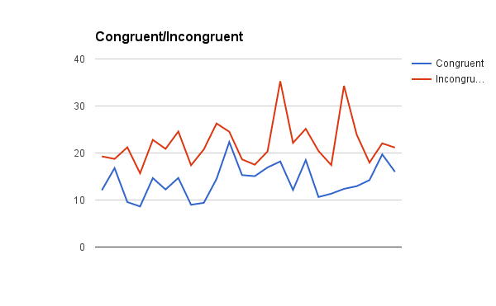

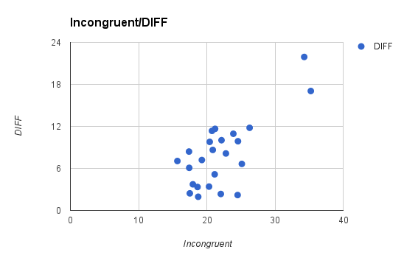

The above chart shows the scatter plot for the difference values between congruent and incongruent values for the incongruent values. The differences is large for the larger incongruent values.

Answer Q5:

My sample size was 5 with 4 Degrees of Freedom.

The results are shown below

Confidence level = 99%

t-statistic value : 3.38

t-critical for 99% for one tailed test(t-0.99) is 2.5.

We reject the null hypothesis that there is no difference between the congruent and incongruent tests because 3.38 > 2.064 and it falls in the critical region.

The experimental task from the stroop test gave the t-stat value of 8.027 which is also > 2.5.

This comes to the conclusion that the results taken by me is same as the experimental tasks.

The results matched my expectation.