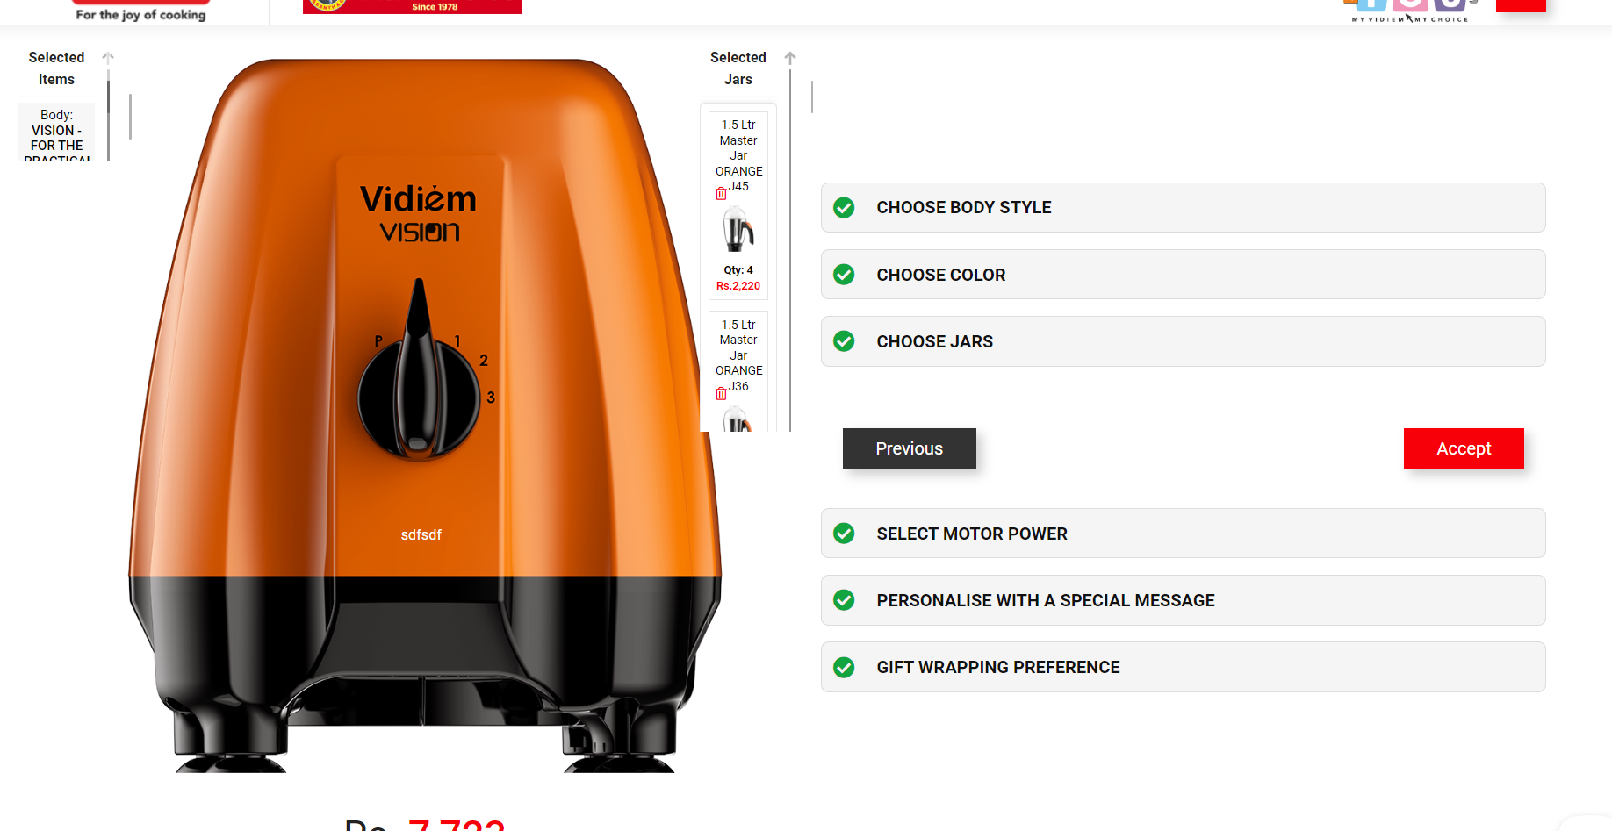

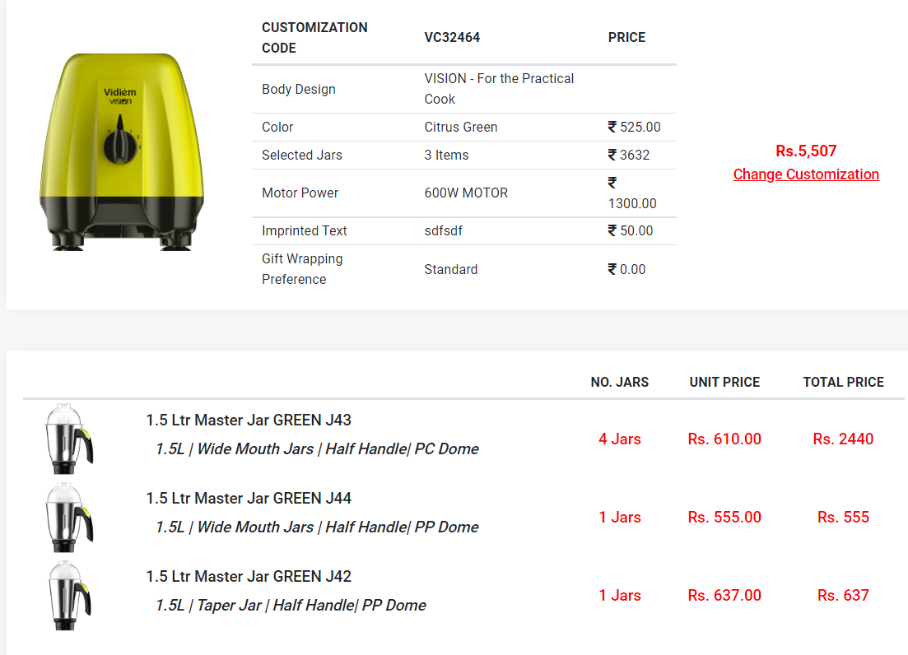

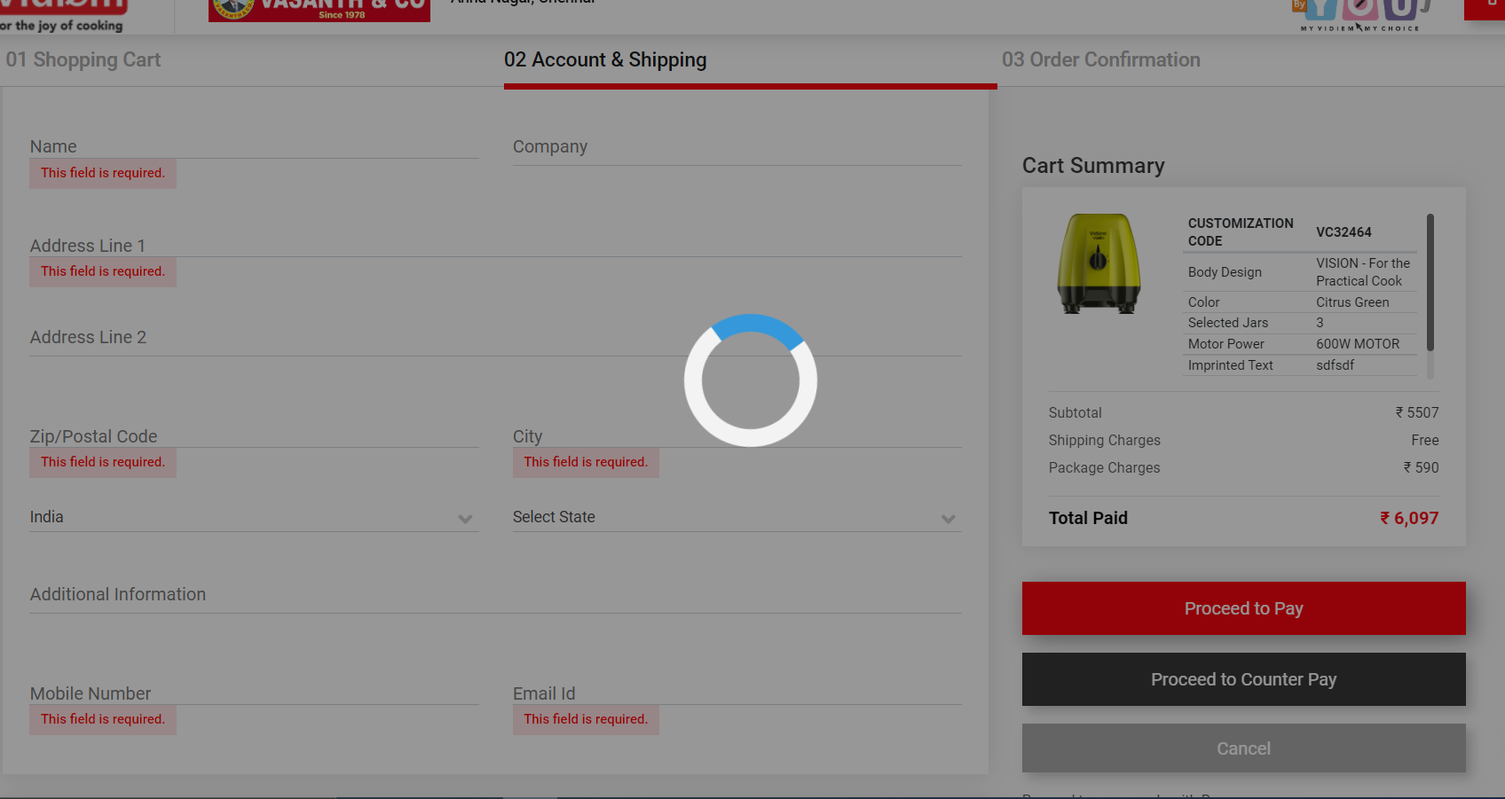

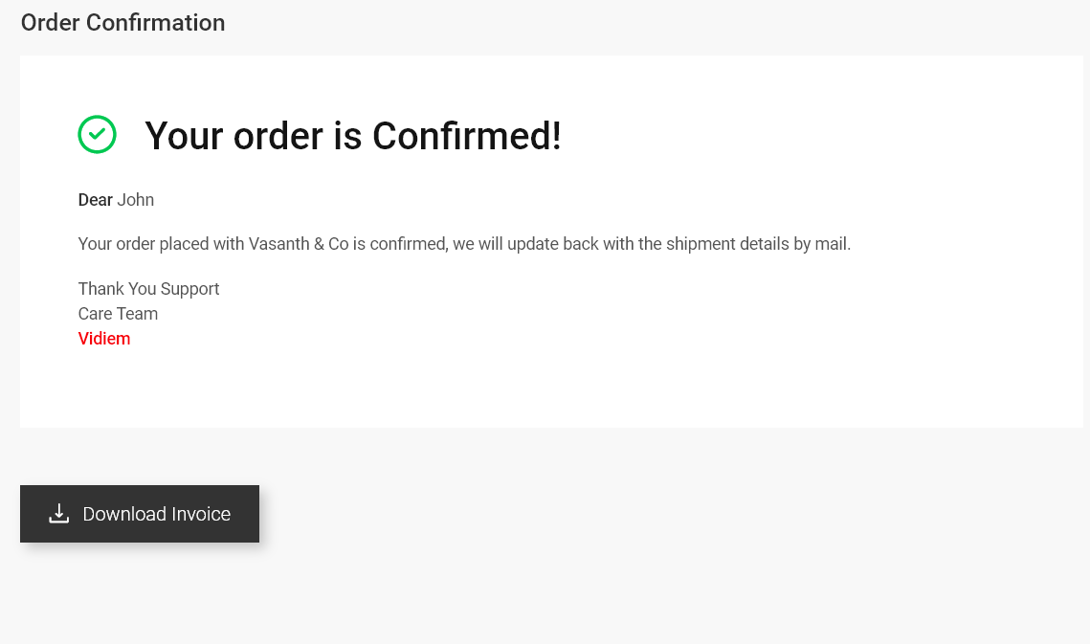

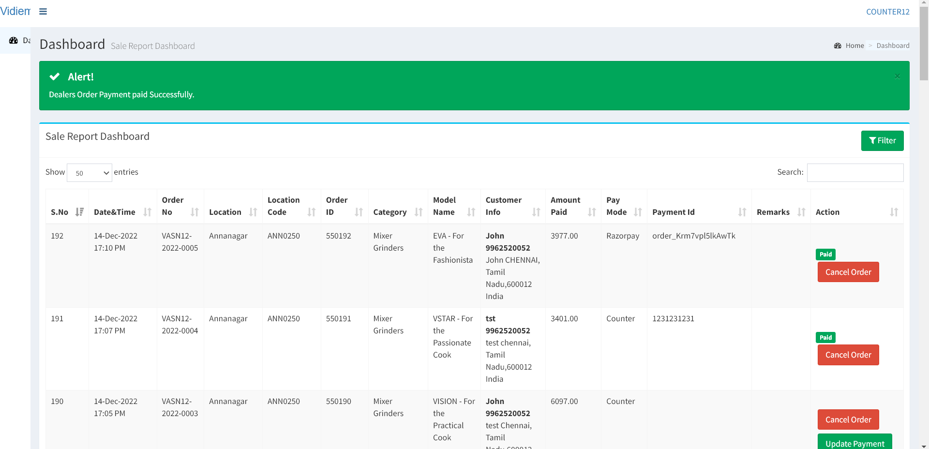

1. Title is missing AFTER CLICKED ONCE
2. [**VASANTH & CO |** VIDIEM BY YOU](http://192.168.0.48:8081/vidiem/dealer-admin)  ORDER MANAGEMENT  
   PLEASE CHANGE THE TITLE AS ABOVE
3. Need to show the Branch Name and Code
4. pLEASE MAKE THE BUTONS IN SAME SIZE
   * 1. Paid
   1. Cancel Order
   2. Update Payment
5. ONCE THE PAYMENT DONE REMOVE CANCEL ORDER BUTTON
6. Enable View option even after payment status updated

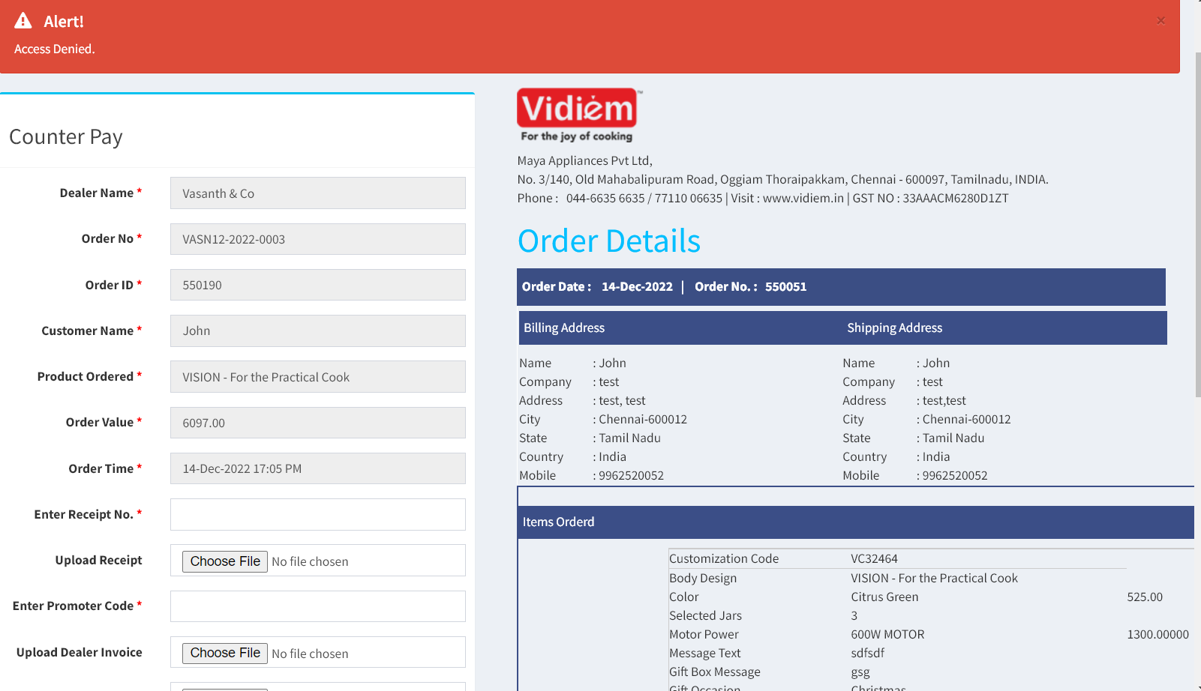

Change title to **Update Counter Payment Information**

**Change Button text cancel order to Cancel & Exit**

**Change button Pay to “Update & Save”**

**Remove the address information below Vidiem Logo**

**Enable the above form even after payment status updated. Need to edit the details after receipt update too**