DPEN022: Enabling Mathematics B
Class Questions Week 5
Week 5A
Key Idea – Definite Integrals of Power of x
1. Evaluate the following definite integrals:
(a) (b) (c)
(d) (e) (f)
(g) (h) (i)

Key Idea – Area under the Curve
For each graph below, find the area of the shaded region.
- (a)
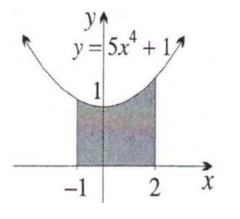

2. (a) Find the area of the region bounded between the curve and the x – axis from to .
(b) Find the area of the region bounded between the curve and the x–axis from to .
(c) Calculate the area of the region bounded by the curve and the
x–axis and the lines and .

Week 5B
Key Idea – Area below the x-axis and Subdividing Regions before Integrating
- For the graph below, find the area of the shaded region.
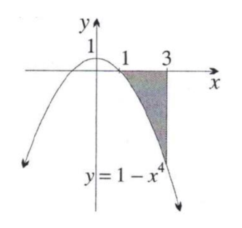

2. Find the area enclosed by the graph of and the x-axis.
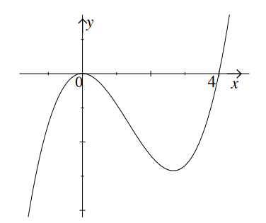

3. Given the function .
(a) Find the x-intercepts of the curve.
(b) Sketch the graph.
(c) Find the area of the region between the curve and the x-axis where the curve is below the x-axis.
4. Find the area of the region bounded between the curve and the x – axis from to x = 3.
5. Find the total area enclosed between the graph of and the x-axis.
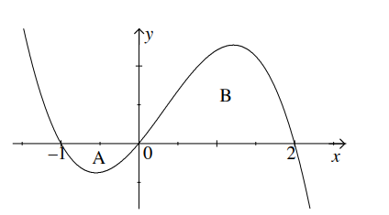

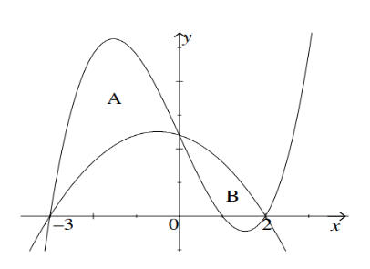
Key Idea – The Area between two Curve.
- Given the graphs of the function y = 6 − x − x² and
y = x³ − 7x + 6 (upper curve).
- Find the points of intersection of the curves.
- Find the total area enclosed between them.

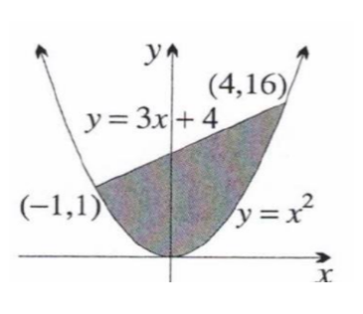
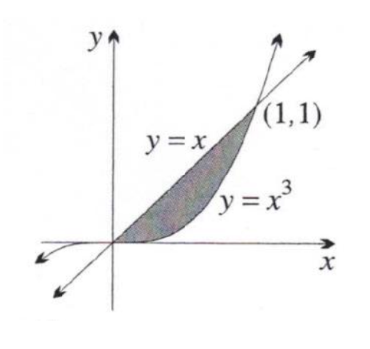
- (a) (b)

- Find the area enclosed by the curves and .
- Find the exact area enclosed between the parabola y = x(x − 2) and the line y = −x + 2
5. Find the area enclosed between the two parabolas y = x² − 4x + 2 and y = 2 − x².

Integration – Exponential Functions
1. Integrate the following:
(a) (b) (c) (d) (e) (f)
(g) (h) (i)
(j) (k) (l)

2. Evaluate the following definite integrals:
(a) (b) (c) (d) (e) (f)
(g) (h)

Week 5C
Key Idea - Integration of Logarithmic Functions
1. Integrate the following:
(a) (b) (c)
(d) (e) (f)
(g) (h) (i)
(j) (k) (l)

2. Evaluate the following definite integrals:
(a) (b) (c)
(d) (e) (f)

Integration – Trigonometric Functions
1. Integrate the following:
(a) (b) (c)
(d) (e) (f)
(g) (h) (i)

2. Evaluate the following definite integrals:
(a) (b) (c)
(d) (e) (f)
(g) (h) (i)

Integration – Mixed
1. Integrate the following:
(a) (b) (c)
(d) (e) (f)
(g) (h)

Week 5D
Key Idea – Simple Substitution
1. Use substitution to integrate the following:
- (b) (c)
(d) (e) (f)
(g) (h) (i) (j)
2. Using substitution to evaluate the following definite integrals:
(a) (b) (c) (d)

