ARCHITECTURE READOUT
Agentforce session traces to Databricks Zerobus
How Salesforce Agentforce session traces reach Unity Catalog Delta tables through a telemetry bridge on EKS, and where AWS Private Link attaches for Suncorp.
Field | Value
Customer | Suncorp
Scope | Centralised AI observability for Salesforce Agentforce on Databricks (AWS)
Lab environment | Salesforce OrgFarm orgfarm918; Databricks FEVM fevm-ot-pdm-semi (us-east-1); AWS account 332745928618, EKS agentforce-otel (ap-southeast-2)
Prepared by | Pravin Varma
Date | 24 October 2026
Status | Draft v0.1 for Suncorp architecture review

1. Purpose
This readout describes how Suncorp lands Salesforce Agentforce session traces in Databricks. It sets out the Salesforce session export API, the Zerobus Ingest OTLP contract, the telemetry bridge that connects them, and the point where AWS Private Link attaches. The test plan for the Private Link phase sits in the companion document suncorp-test-setup.md.

1.1 Key definitions
Session export API is Salesforce's Export Agentforce Session Tracing Data endpoint. A client calls GET with one session id and receives OTLP-shaped JSON for that session.
Zerobus Ingest OTLP is the Databricks managed gateway that accepts OTLP Protobuf over HTTPS and writes Unity Catalog Delta tables.
Telemetry bridge is the poller and OpenTelemetry Collector pair. The poller is the Salesforce client. The Collector is the Zerobus client and runs in the VPC.

2. Background
Suncorp runs customer-facing work on Salesforce Agentforce: LLM reasoning, tool calls, and CRM actions. Platform and risk teams need the same traces in Databricks so they can query conversations, run evaluations, and retain the data with the rest of the lakehouse. Suncorp workspaces use AWS front-end Private Link. The ingest path is Zerobus Ingest OTLP into Delta.
Both products publish the APIs this design uses. This lab wires them together on Databricks and AWS and identifies the network work Suncorp owns for the Private Link phase.

3. Salesforce session tracing
With Agentforce Session Tracing, Einstein Audit, and Agent Platform Tracing enabled, Data 360 stores each session: prompts, tool calls, evaluation spans, metrics, and logs. Salesforce's Export Agentforce Session Tracing Data API returns that payload over REST.
GET /services/data/v66.0/einstein/audit/otel/{session-id}
A client authenticates with OAuth 2.0 through an External Client App, supplies one session id, and receives JSON that follows the OTLP schema (ResourceSpans, plus metrics and logs). Sessions must have started within the prior 72 hours. Throughput follows Connect API rate limits. Salesforce's developer guidance is to POST this JSON to the observability backend you operate.
Data 360 DMOs such as ssot__TelemetryTraceSpan__dlm offer a second read path through SOQL. In OpenTelemetry terms, an exporter POSTs OTLP to a URL you configure. The Salesforce endpoint is a session export GET, so the integration calls Salesforce and receives the payload.

4. Databricks Zerobus Ingest
Zerobus Ingest OTLP is a managed gateway. A client POSTs OTLP to {workspaceId}.zerobus.{region}.cloud.databricks.com with Unity Catalog authorization and the header x-databricks-zerobus-table-name. Zerobus writes Delta tables and stores attributes as VARIANT.
The gateway takes Protobuf (application/x-protobuf). The client initiates every POST. The OTLP interface is a documented front-end Private Link service on TCP 443; MQTT and Kafka-compatible Zerobus APIs follow their own networking model. Databricks OAuth tokens last about 60 minutes, so the client refreshes them.

5. The telemetry bridge
Salesforce holds the session and serves it on GET. Zerobus accepts a Protobuf POST and writes Delta. The telemetry bridge is the client of both APIs. Table 1 sets the two contracts side by side.
 | Salesforce session export API | Databricks Zerobus OTLP
Job | Session system of record | Lakehouse ingest
Call | Integration GETs OTLP JSON | Integration POSTs OTLP Protobuf
Unit | One session id, 72-hour window | Batches of spans, logs, and metrics
Auth | Salesforce OAuth 2.0 External Client App | Databricks service principal OAuth, Unity Catalog authorization

Table 1. The two API contracts the bridge connects.
The bridge discovers finished sessions through ssot__AiAgentSession__dlm, reads each session with the export GET, converts OTLP JSON to OTLP Protobuf, and POSTs to Zerobus with a refreshed service principal token. Where Salesforce sends an empty spanId on evaluation spans, the converter writes a deterministic 8-byte id so the batch is valid OTLP.
The poller implements the Salesforce client and acts as the OTLP exporter for Agentforce. The Collector implements the Zerobus client and is the long-lived push process in the VPC.

6. Architecture
Figure 1 reads left to right. Agentforce writes sessions into Data 360. The poller GETs the session JSON (PULL GET OTel JSON). Inside the AWS VPC, the poller POSTs Protobuf to the OpenTelemetry Collector on EKS Fargate (PUSH Protobuf), and the Collector POSTs to Zerobus (PUSH OTLP Protobuf to Zerobus). Zerobus returns HTTP 200 once the write is durable.
Today the Collector POSTs over public HTTPS to FEVM Zerobus in us-east-1. Phase B keeps the same Collector and Protobuf and points the hostname at a VPC endpoint: front-end or service-direct Private Link on TCP 443 with private DNS. The Salesforce GET uses Salesforce's network path. If that hop must also stay private, Suncorp adds Salesforce Private Connect or an approved egress allowlist as a separate control.
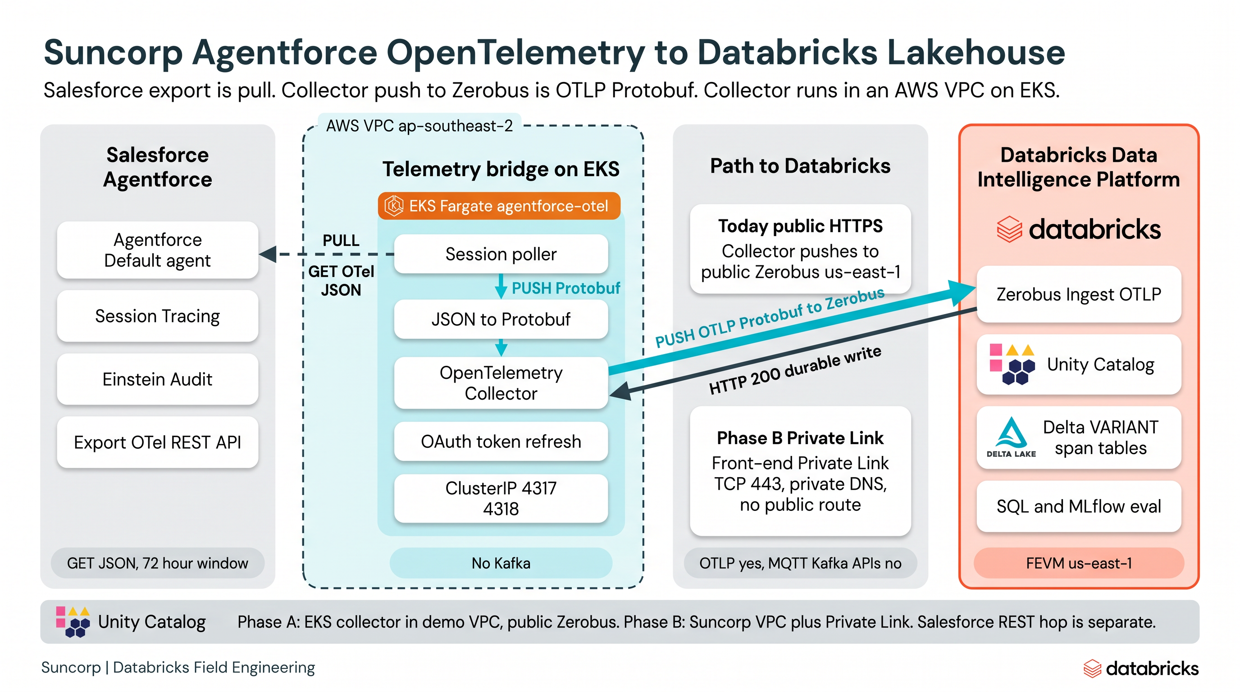
Figure 1. Agentforce session traces to Databricks: session export GET, telemetry bridge on EKS in an AWS VPC, Zerobus OTLP push, and the Phase B Private Link hop.
Component | Where it runs | Role
Agentforce + Data 360 Session Tracing | Salesforce | Runs the agent and stores prompts, tool calls, evaluation spans, metrics, and logs per session.
Session export API | Salesforce | GET /services/data/v66.0/einstein/audit/otel/{session-id} returns OTLP JSON for one session.
Session poller | AWS VPC (laptop in the lab) | Discovers finished sessions, GETs JSON, converts to Protobuf, fills empty spanIds, POSTs to the Collector.
OpenTelemetry Collector | EKS Fargate agentforce-otel | Receives Protobuf on 4317/4318, batches, sets source attributes, refreshes OAuth, POSTs to Zerobus.
Zerobus Ingest OTLP | Databricks workspace region | Accepts Protobuf with x-databricks-zerobus-table-name and writes Delta tables.
Unity Catalog Delta tables | Databricks | agentforce_otel_spans, _logs, _metrics with VARIANT attributes. SQL and MLflow evals read these tables.

Table 2. Components on the data path.

7. What the lab has demonstrated
Phase | Work | Status
A1 | Live Agentforce session 01a16cb0-5079-71ce-a37e-9aee0cb3c332: 8 spans, public Zerobus HTTP 200, rows in Delta. | Done, 24 October 2026
A2 | OpenTelemetry Collector on EKS Fargate in an AWS VPC, POSTing to public Zerobus. | Done, 24 October 2026
B | Same Collector with Private Link: private DNS, VPC endpoint, POST and SQL from the VPC. | Suncorp network build

Table 3. Lab phases and status.
A1 posted Protobuf directly to Zerobus while local Docker was unavailable. A2 runs the Collector in an AWS VPC, which is the pattern Suncorp copies. FEVM fevm-ot-pdm-semi is a public workspace, so A2 uses the public Zerobus hostname. Manifests are in otel-collector/k8s/.

8. Lab and Suncorp production
 | This lab | Suncorp production (Phase B)
Salesforce | OrgFarm DE orgfarm918 | Suncorp Agentforce + Data Cloud
Databricks | Public FEVM fevm-ot-pdm-semi, us-east-1 | Private Link workspace in the same region as the VPC
VPC | Demo VPC with EKS agentforce-otel, ap-southeast-2 | Suncorp VPC; Collector uses the Private Link hostname
Collector | Running on Fargate | Same pattern with private DNS and Private Link
Poller | Laptop with kubectl port-forward | Same VPC as the Collector
Catalog | ot_pdm_semi_catalog.agentforce_otel | Suncorp Unity Catalog names, same DDL
Auth | SP agentforce-zerobus-otel | Suncorp SP with table-level SELECT and MODIFY

Table 4. Lab environment against the Suncorp target.
Phase B checks cover private DNS resolution, VPC endpoint connectivity, an OTLP POST returning HTTP 200, and SQL rows for the test session. The detailed cases sit in suncorp-test-setup.md.

9. Delivery implication
Suncorp reuses the EKS manifests in its own VPC, swaps the workspace id, catalog, and schema, and keeps Protobuf with x-databricks-zerobus-table-name. Suncorp networking provisions the VPC endpoint and private DNS for Zerobus OTLP. The poller moves into the same VPC as the Collector and authenticates to Salesforce through an External Client App. VARIANT columns keep prompt and tool payloads available for MLflow evaluation, and Delta Sharing can return curated aggregates to Data Cloud once traces land in Delta.

