***:OS ASSIGNMENT***

**ASSIGNMENT : 1 TXT**

**Q1)**

**one**

**apple**

**banana**

**cat**

**dog**

**elephant**

**two**

**fish**

**gun**

**horse**

**icecream**

**three**

**jelly**

**kitkat**

**lolipop**

**marshmallow**

**four**

**new**

**oppo**

**vivo**

**china**

**/home -> mkdir EVERYONE**

**chmod 777 EVERYONE**

**Create a file with every user (whoami >> username.txt)**

**oppo -> primary group change -> one**

**vivo -> primary group change -> two**

**jelly,kitkat, lolipop, marshmallow -> add these users to sudo group**

**fish,gun -> add these users to one group as well (secondary group)**

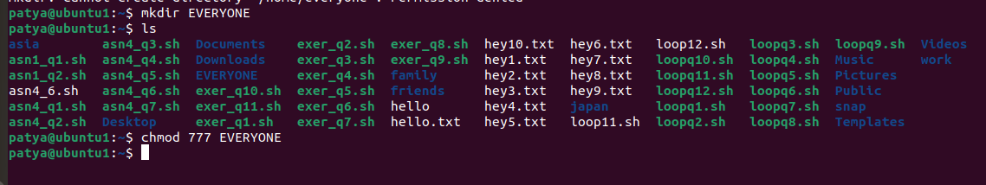

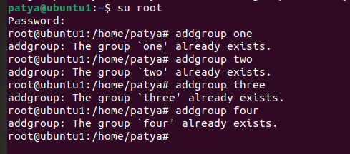

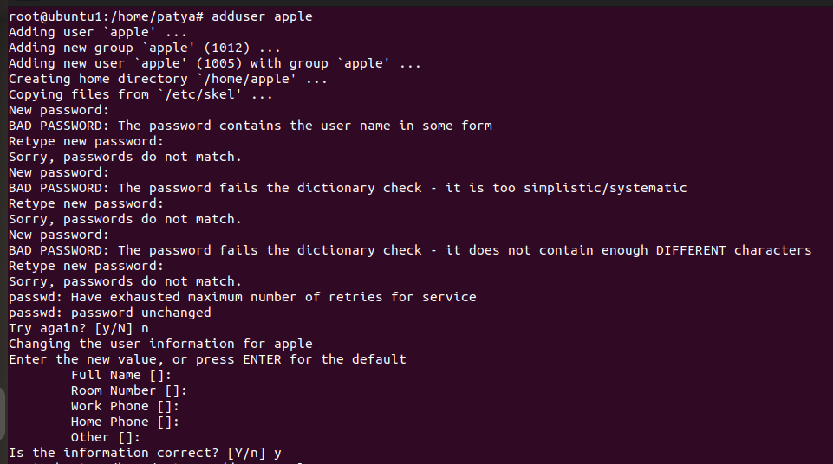

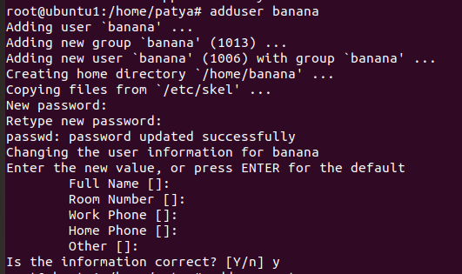

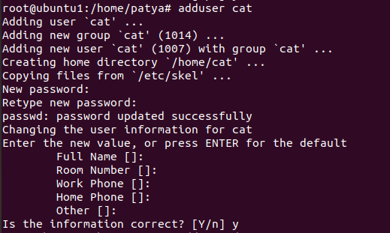

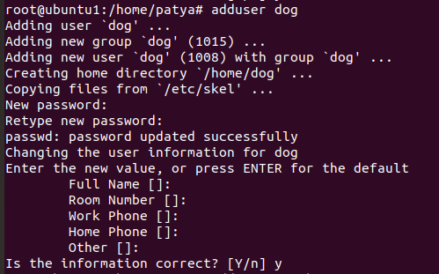

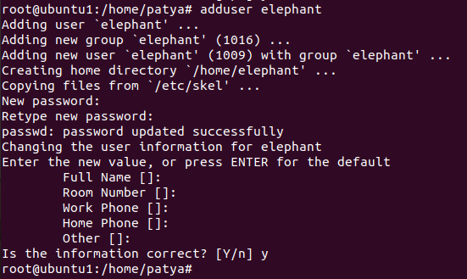

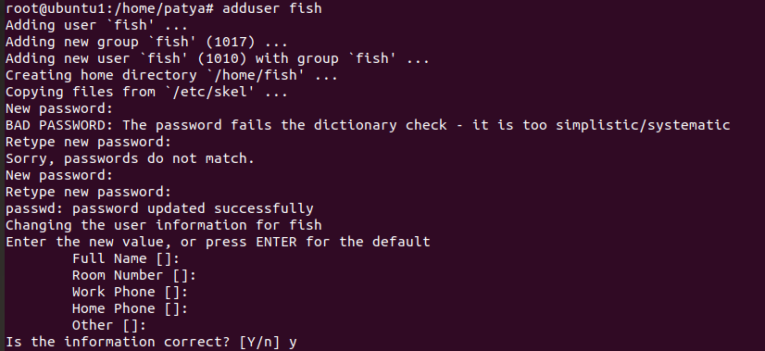

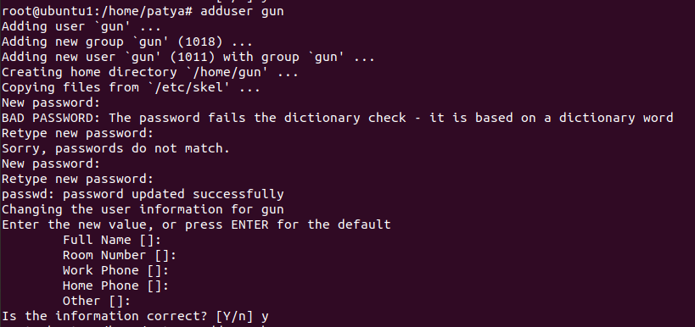

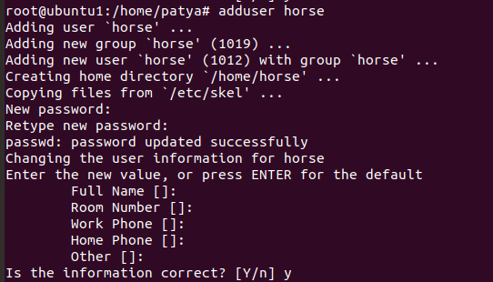

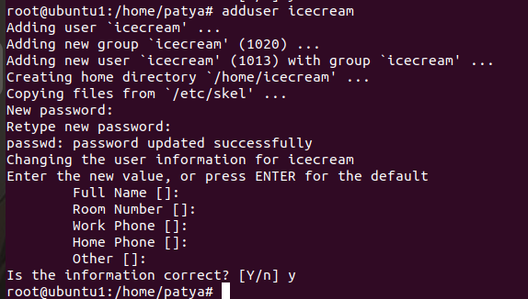

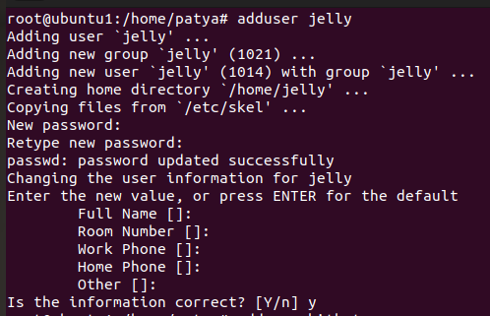

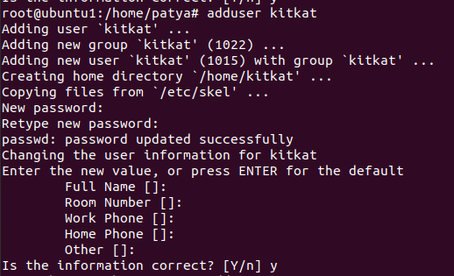

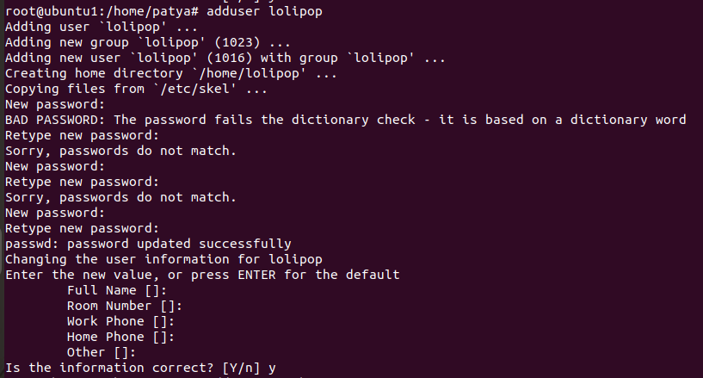

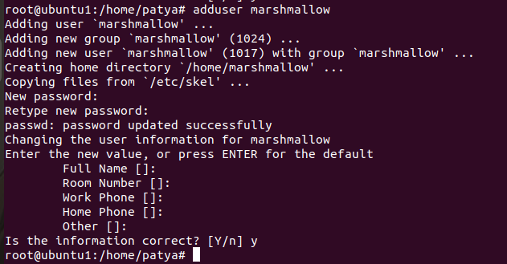

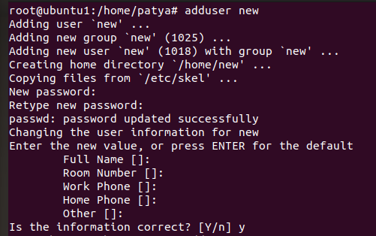

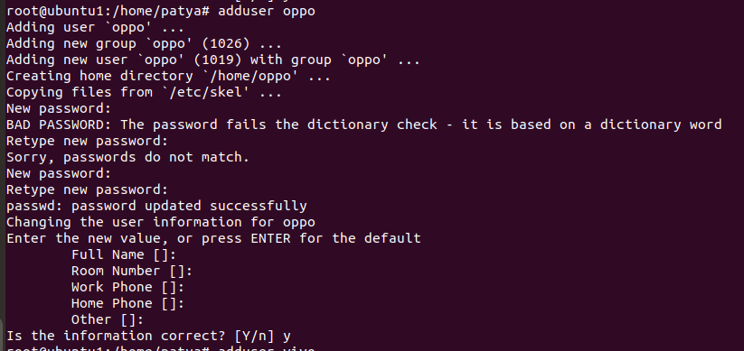

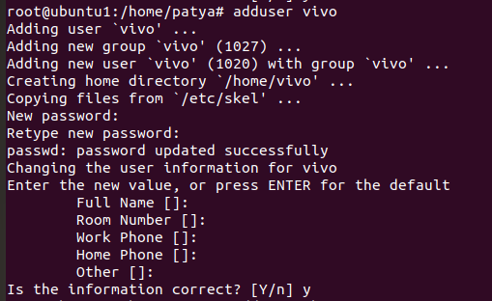

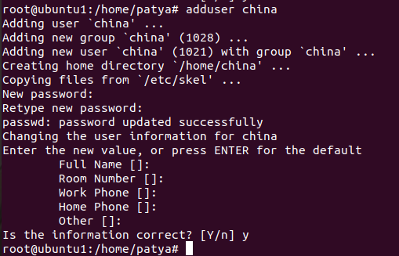

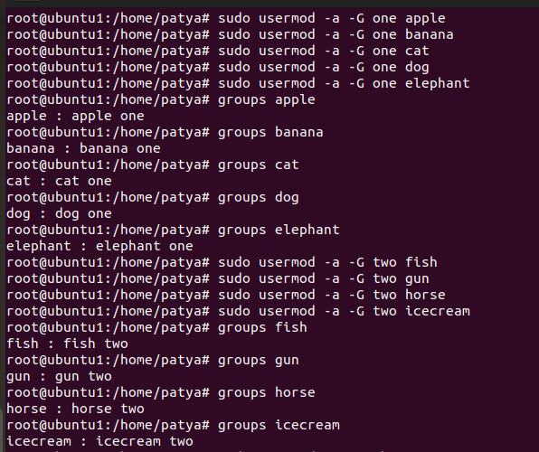

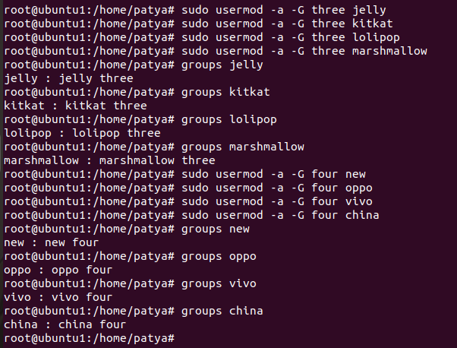

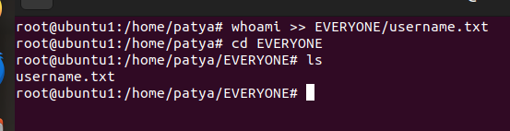

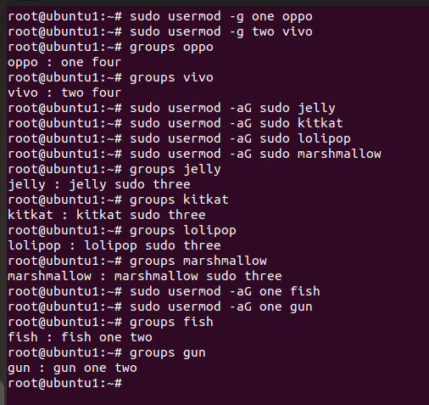

**ASSIGNMENT : 1 DOCS**

**1. In your home directory, create sets of empty practice files**

* **Create 6 files with names of the form songsX.mp3.**
* **Create 6 files with names of the form snapX.jpg.**
* **Create 6 files with names of the form filmX.avi.**

**In each set, replace X with the numbers 1 through 6.**

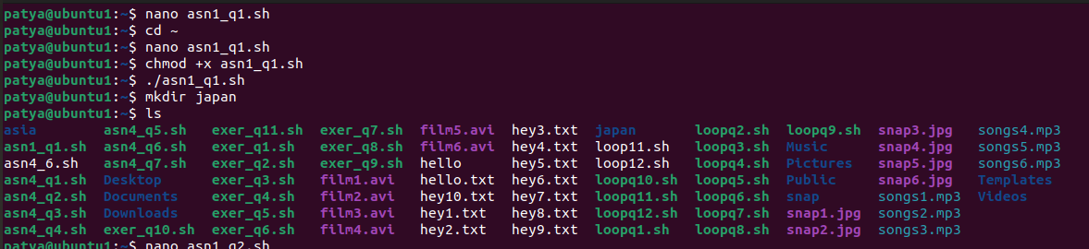

**2. From your home directory,**

* **Move songs file into your Music subdirectory.**
* **Move snap file into your Pictures subdirectory.**
* **Move your movie files into Videos subdirectory**

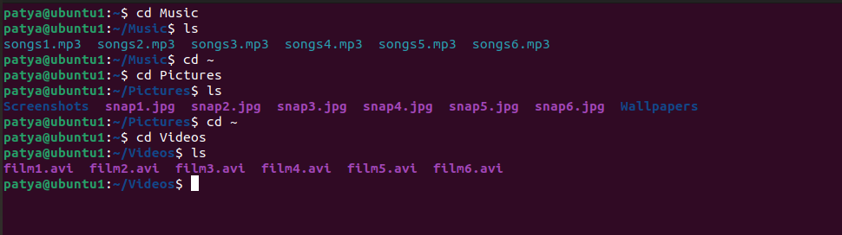

**3. Create 3 subdirectories for organizing your files named friends,family,work**

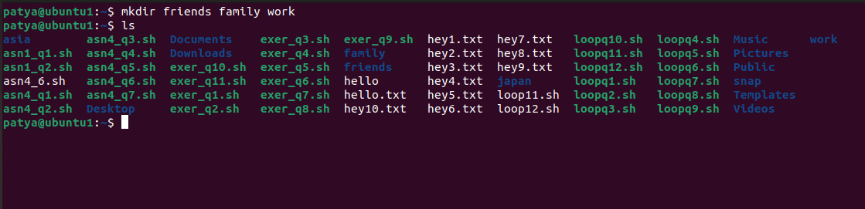

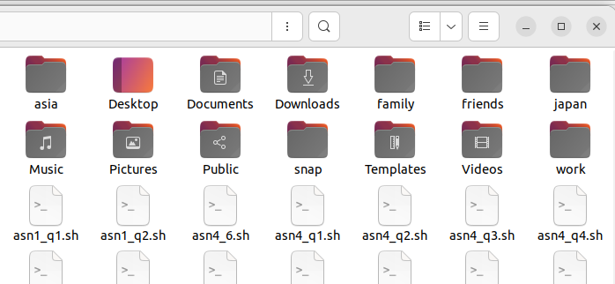

**4. Copy files (all types ) containing numbers 1 and 2 to the friends folder.**

**Copy files (all types) containing numbers 3 and 4 to the family folder.**

**Copy files (all types) containing numbers 5 and 6 to the work folder.**

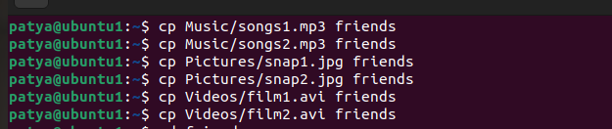

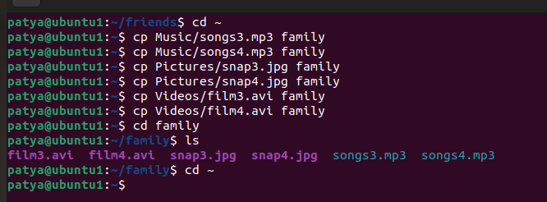

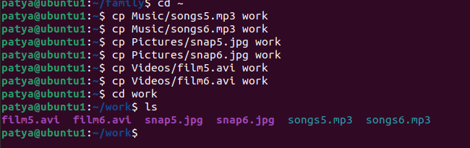

**ASSIGNMENT : 2**

**6. Delete all files in family subdirectory.**

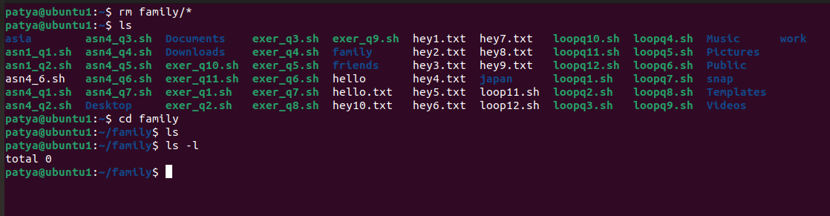

**7. Delete friends subdirectory**

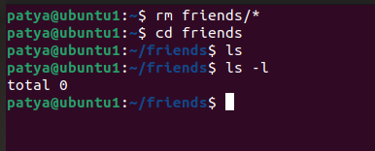

**8. Create user tom , bob , sam , prince**

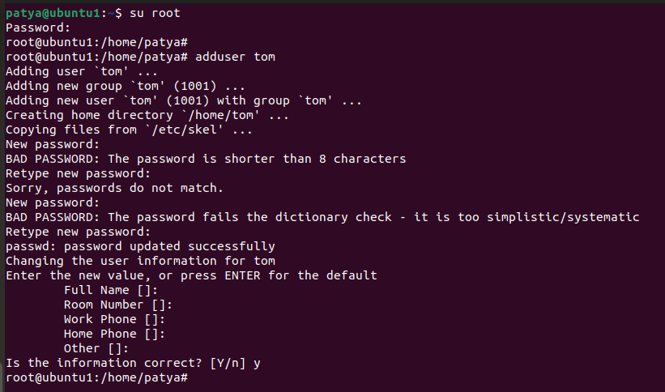

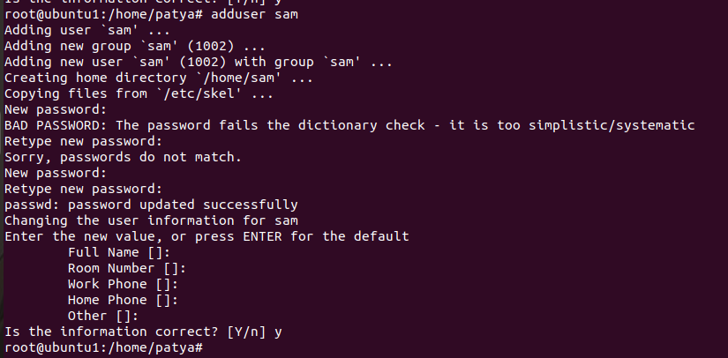

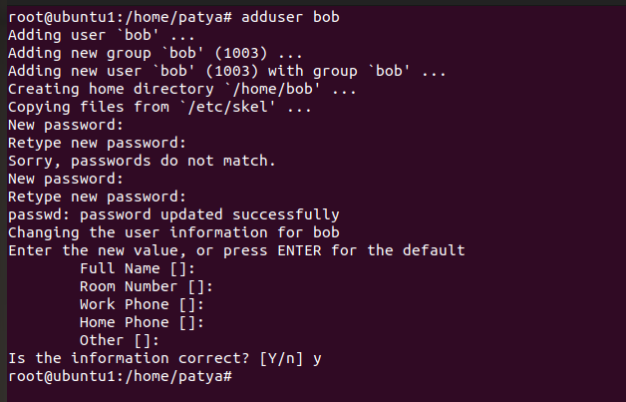

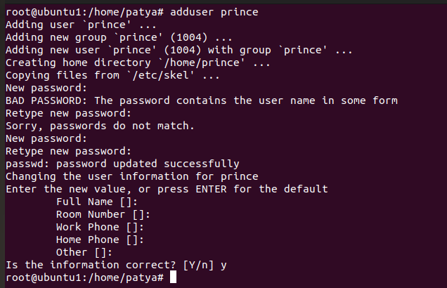

**9. Create Group dac , dbda ,ditiss**

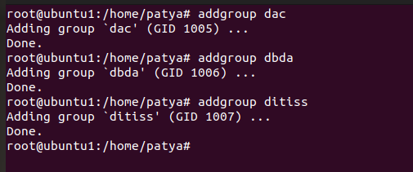

**10. add user**

**Tom in dac**

**Bob in dbda**

**Sam in ditiss**

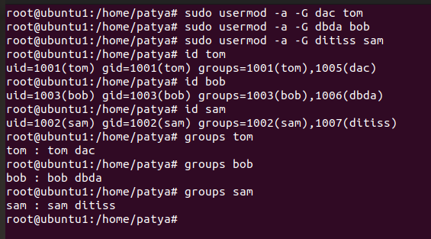

**11. login as prince and create iacsd directory in /tmp and create 4 files in iacsd with name project-1 project-2 upto 4**

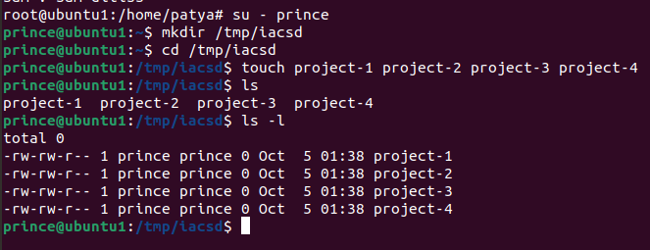

**12. assign permissions to project files as below**

**Project-1 – tom should be owner of this**

**Project-2 – dac should be owner of this**

**Project-3 --- others should not have any permission but tom should have rw access**

**Project-4 – dbda group should have rwx permissions.**

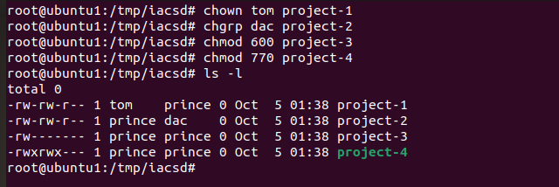

**ASSIGNMENT : 4**

**1) Write a shell script tp print**

* **your are logged in as which user**
* **in which directory you are**
* **and in which terminal you are working**
* **total number of files and directories in current directory**

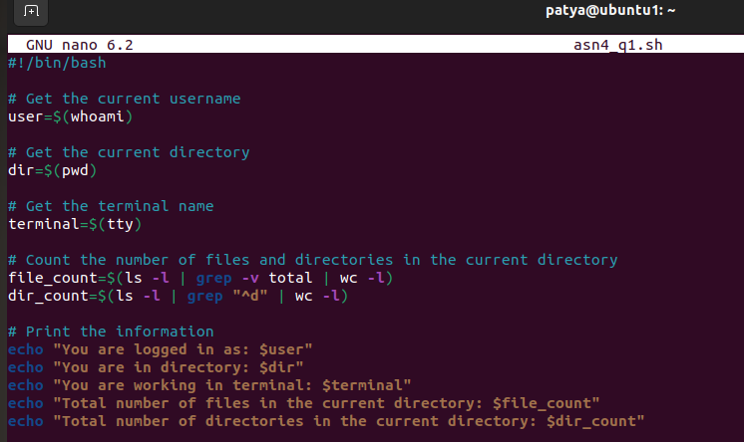

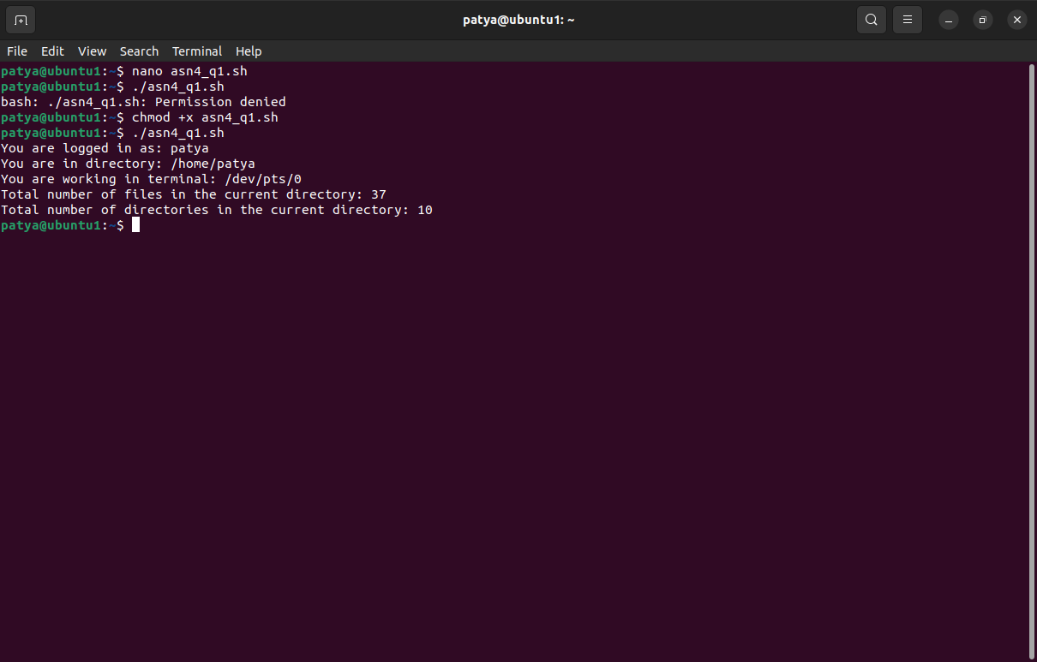

**2).Write a shell script to create a menu driven program for adding, deletion or finding a record in a database. Database should have the field like rollno, name, semester and marks of three subjects. Last option of the menu should be to exit the menu.**

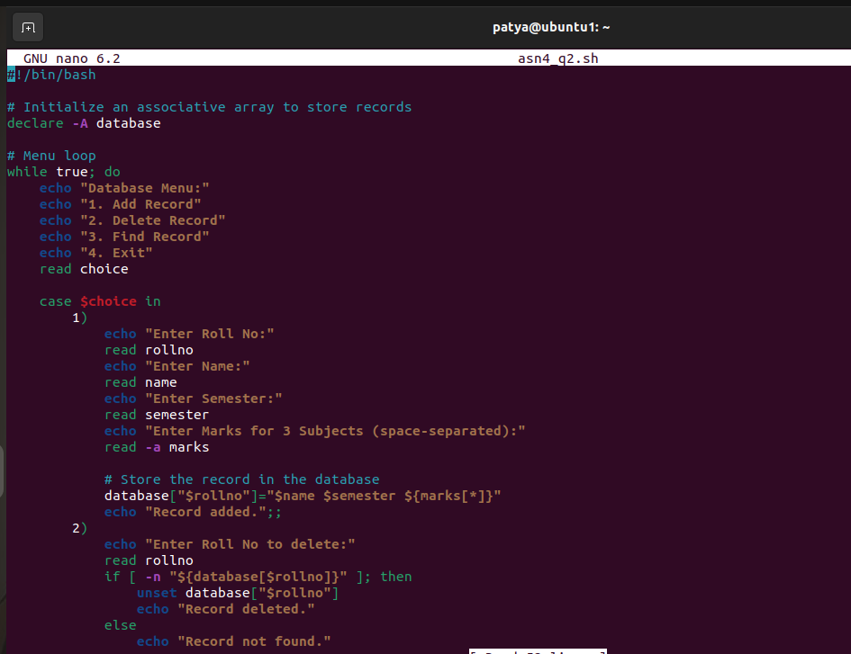

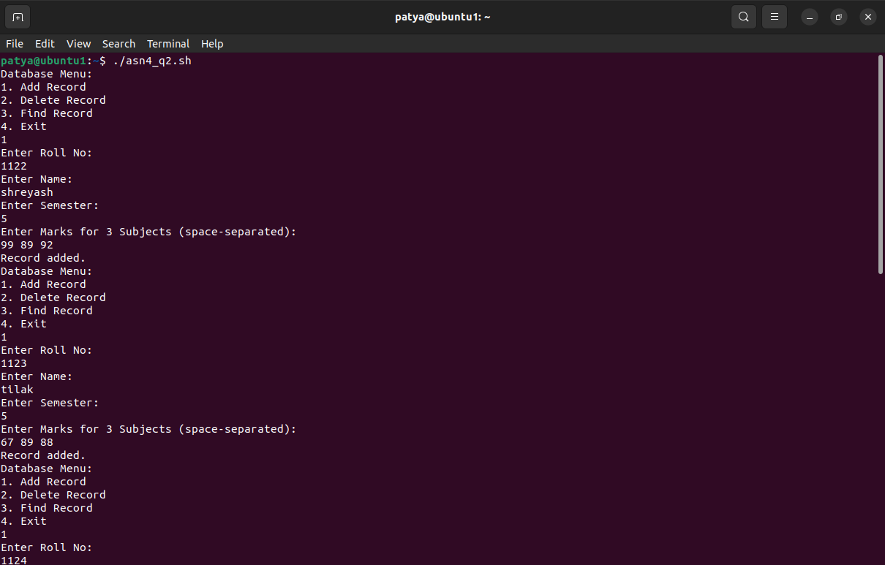

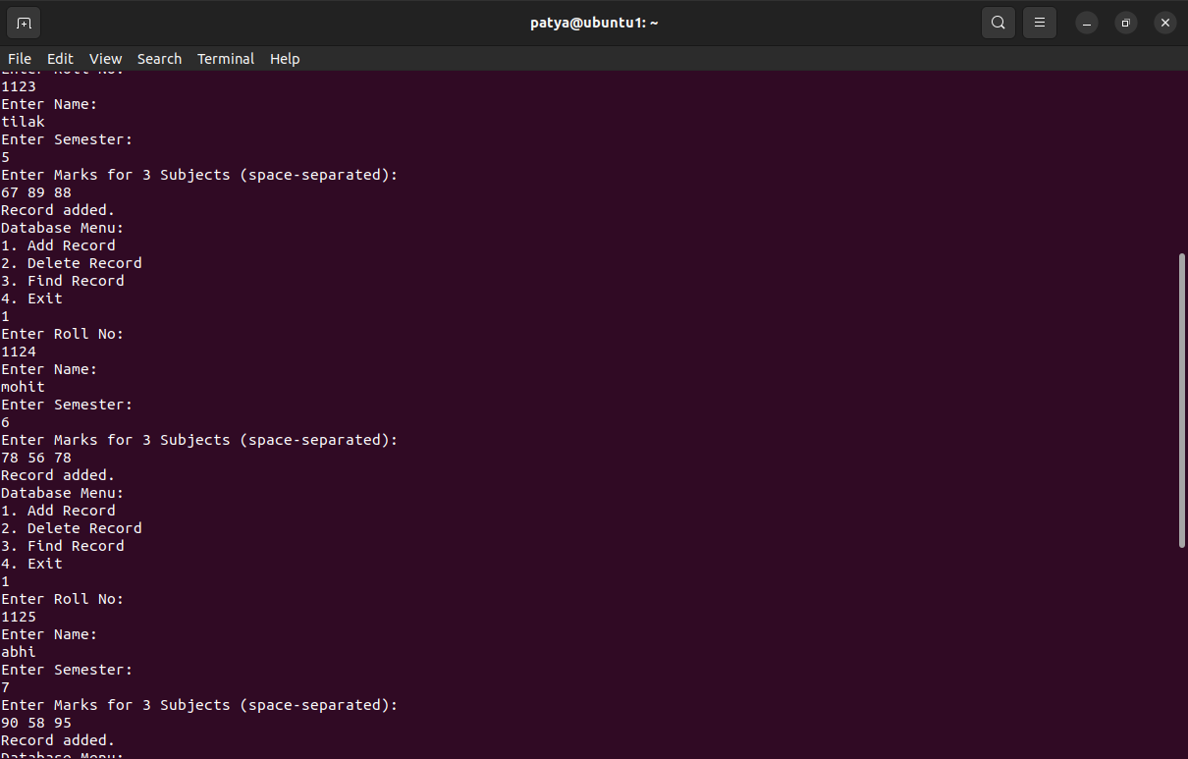

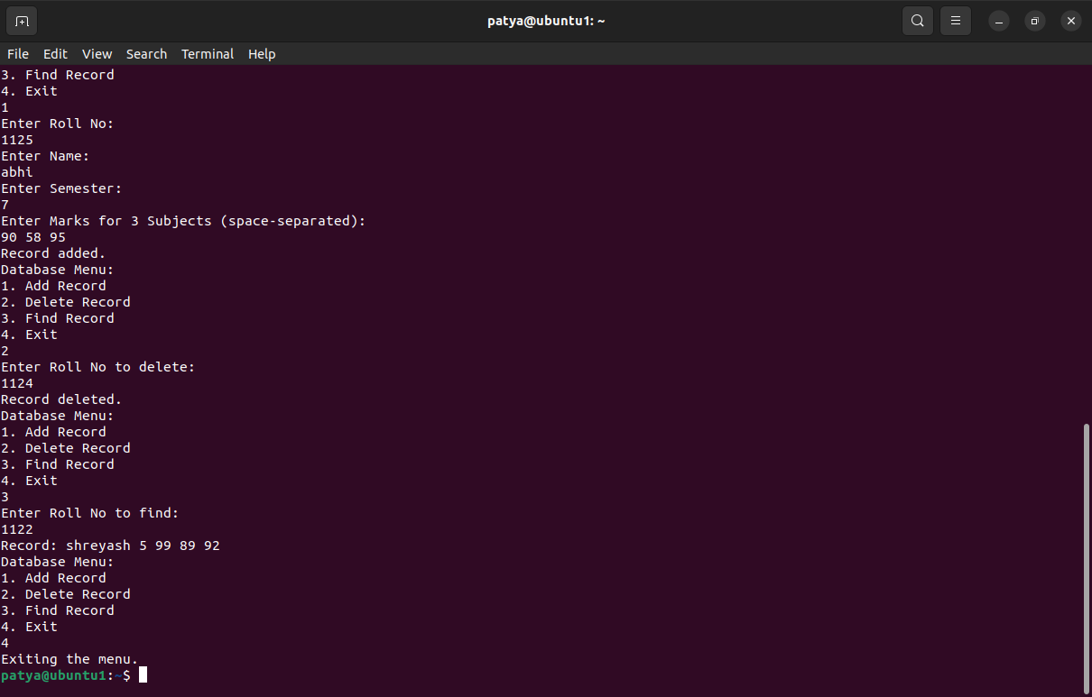

**3) Write a Linux shell script to accept 10 number and tell how many are +tive, -tive and zero.**

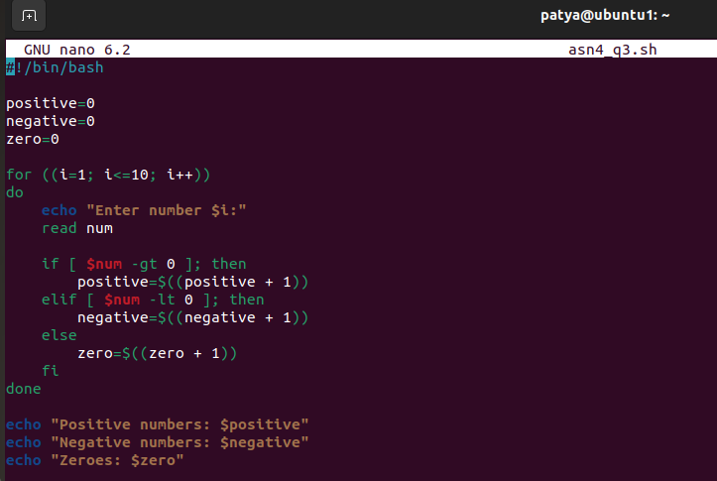

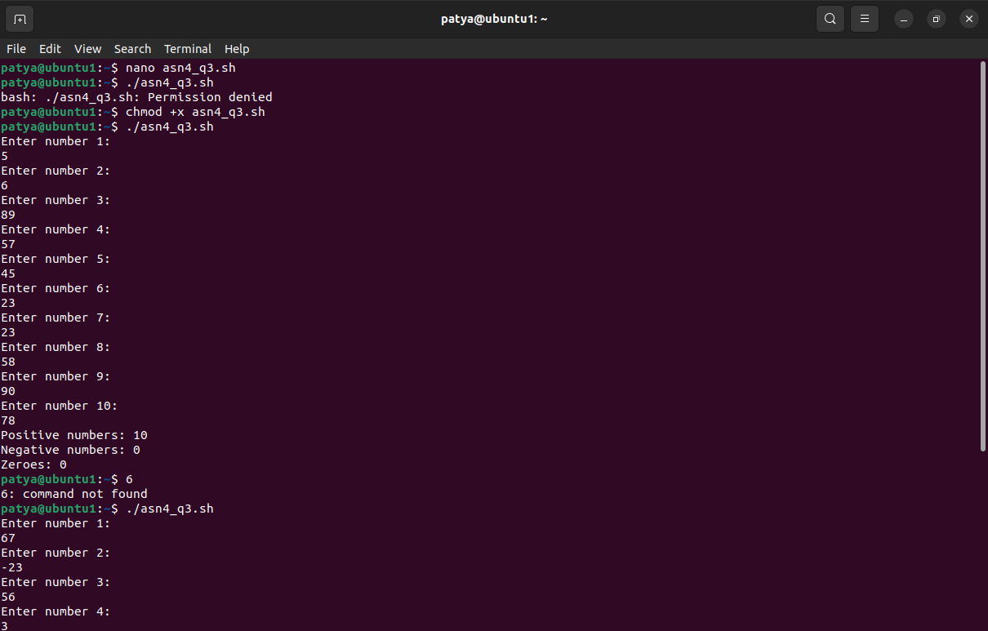

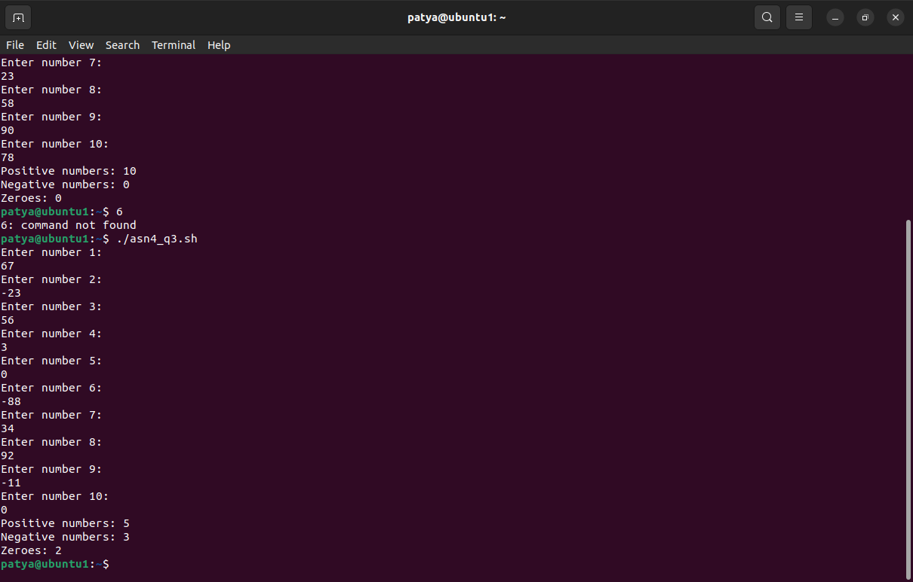

**4) Write a shell script to accept five number and display max and min value.**

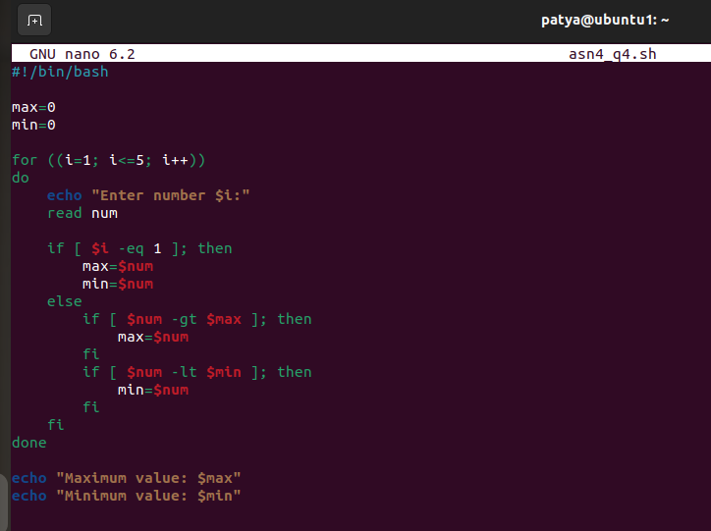

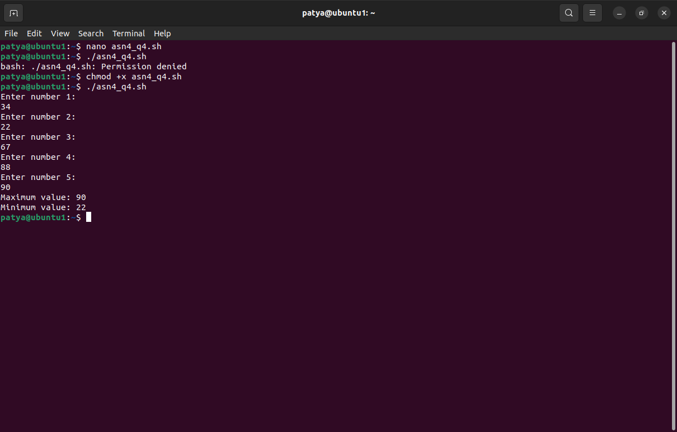

**5) Write a script to find out String is palindrome or not.**

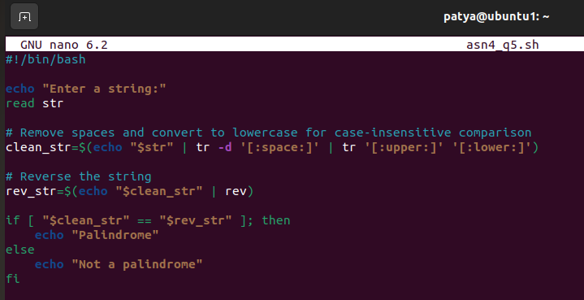

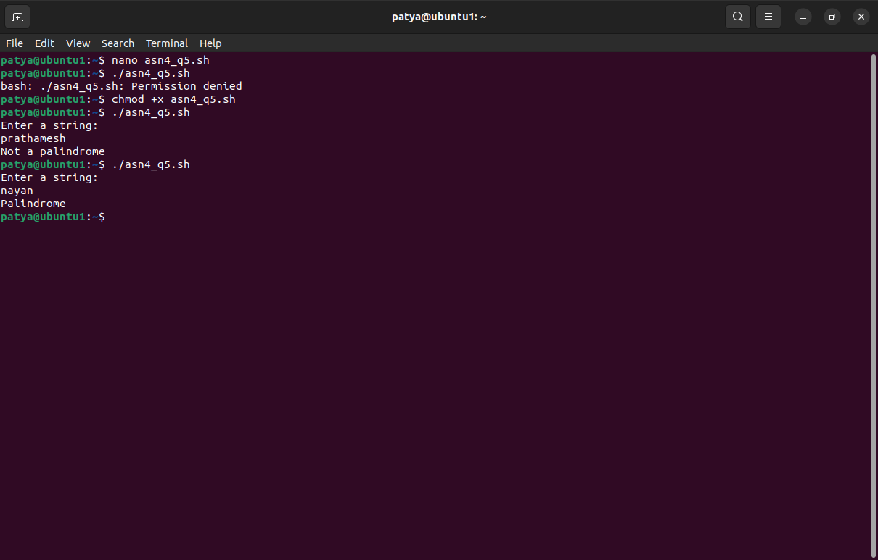

**6) Write a shell script to print given number’s sum of all digits (eg. If number is 123, then it’s sum of all digits will be 1+2+3=6)**

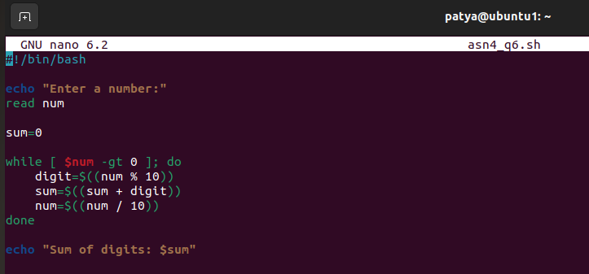

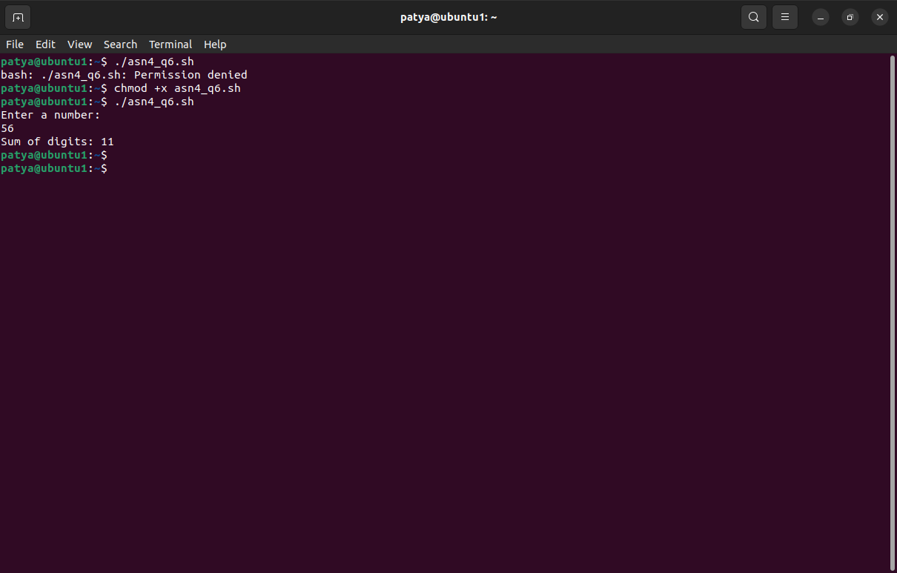

**7) Create a script to**

**Create user , Delete user , Create group , delete Group using case**

**n**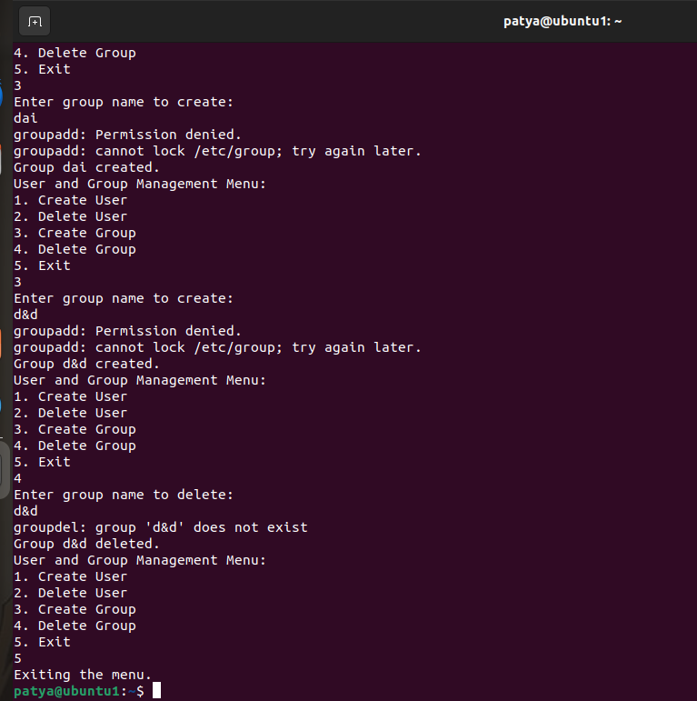

**ASSIGNMENT : EXERCISE**

**1. Write a Shell Script to find maximum between two numbers.**

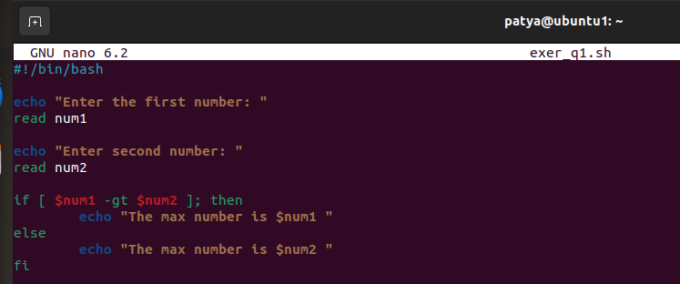

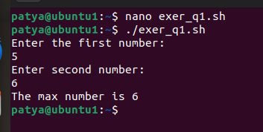

**2. Write a Shell Script to find maximum between three numbers.**

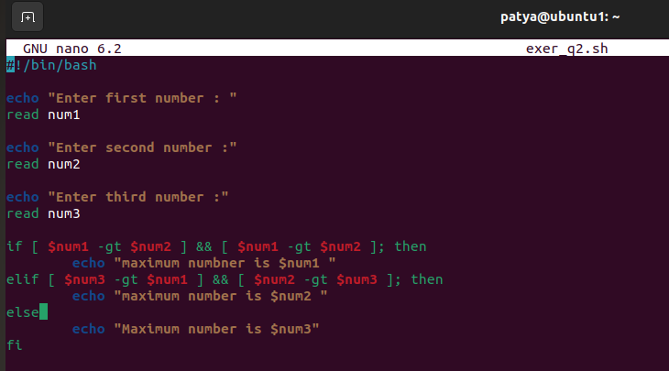

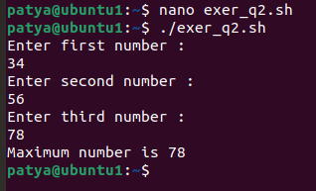

**3. Write a Shell Script to check whether a number is negative, positive or zero.**

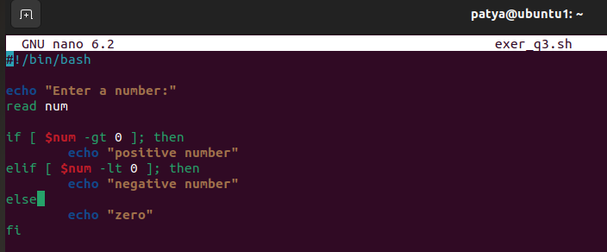

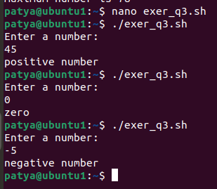

**4. Write a Shell Script to check whether a number is divisible by 5 and 11 or not.**

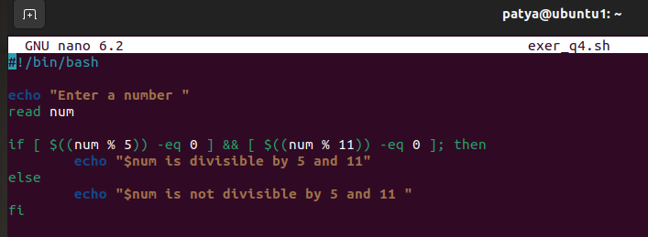

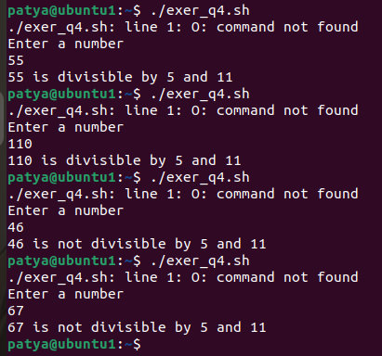

**5. Write a Shell Script to check whether a number is even or odd.**

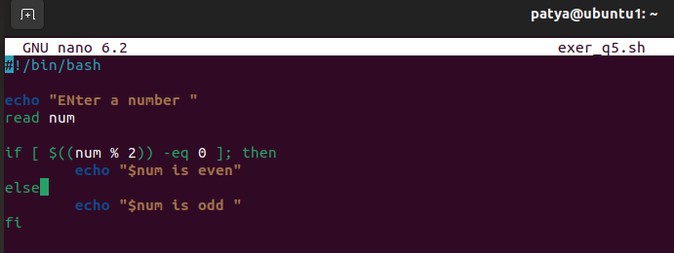

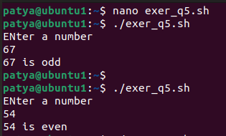

**6. Write a Shell Script to check whether a year is leap year or not.**

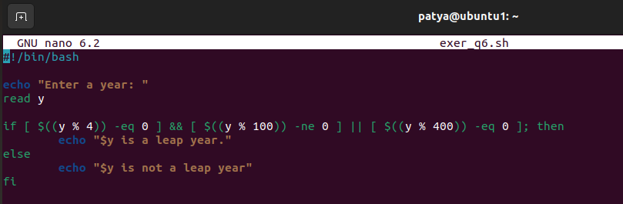

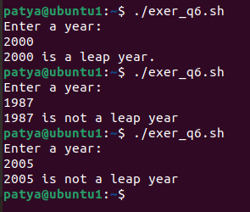

**7. Shell Script to print number between 1 to 10 in character format using switch-case.**

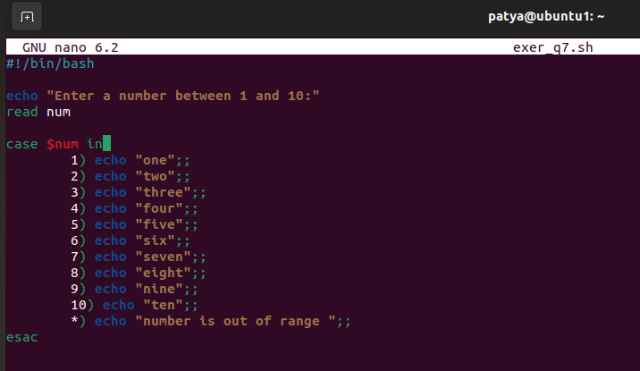

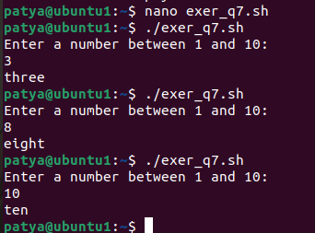

**8. Shell Script to accept id from user to confirm department using switch-case.**

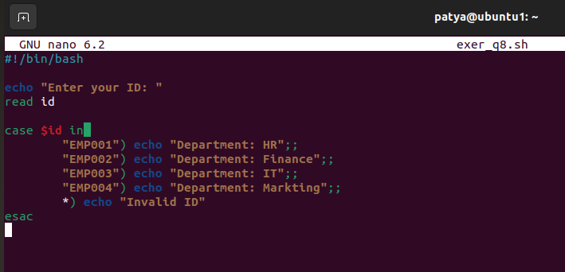

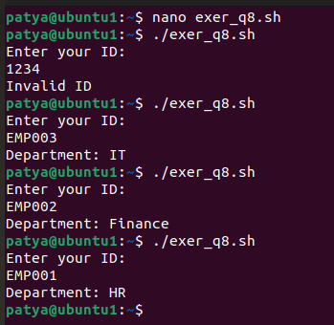

**9. Shell Script to check password is correct or incorrect using switch-case.**

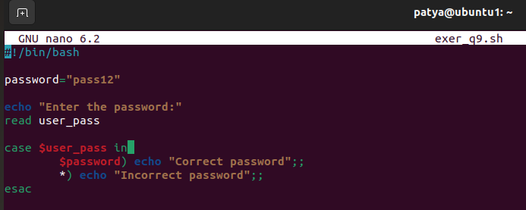

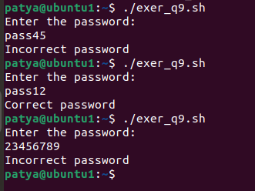

**10. Shell Script to print day of week using switch-case.**

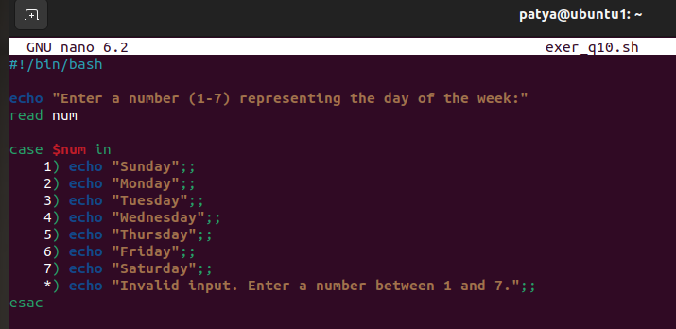

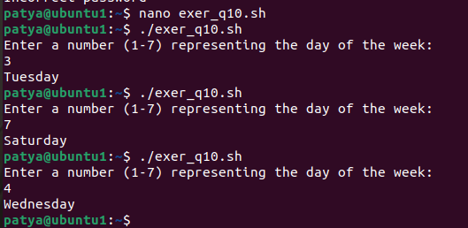

**11. Shell Script to create calculator using switch-case.**

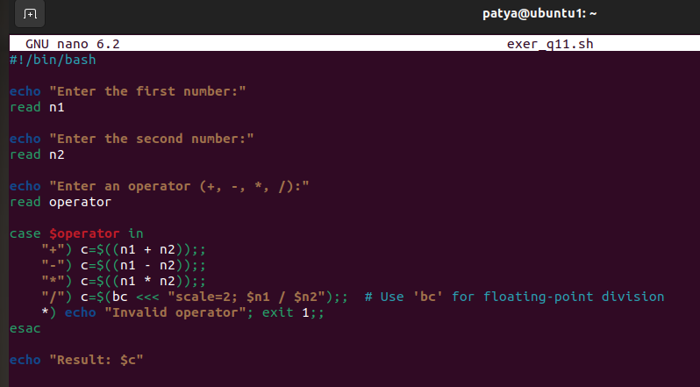

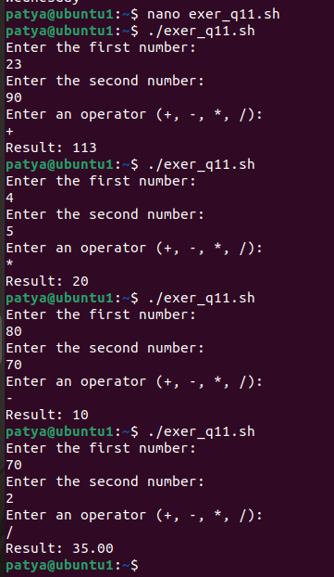

**ASSIGNMENT : LOOP**

**1. Shell Script to display the first 10 natural numbers.**

**Expected Output :**

**1 2 3 4 5 6 7 8 9 10**

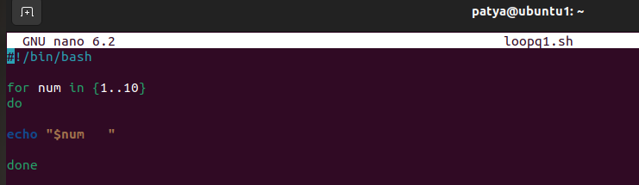

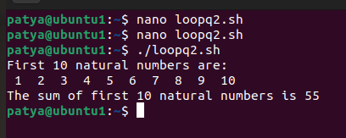

**2. Shell Script to compute the sum of the first 10 natural numbers.**

**Expected Output :**

**The first 10 natural number is :**

**1 2 3 4 5 6 7 8 9 10**

**The Sum is : 55**

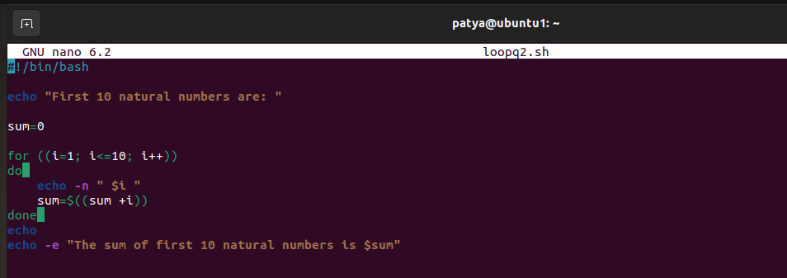



**3. Shell Script to display n terms of natural numbers and their sum.**

**Test Data : 7**

**Expected Output :**

**The first 7 natural number is :**

**1 2 3 4 5 6 7**

**The Sum of Natural Number upto 7 terms : 28**

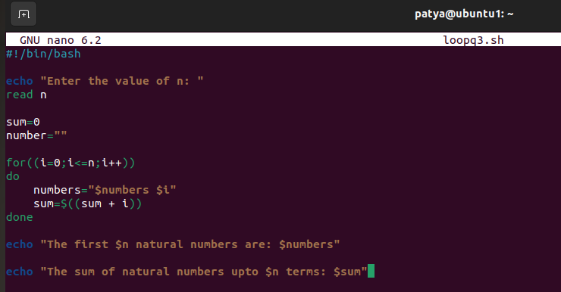

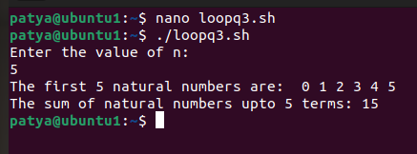

**4. Shell Script to read 10 numbers from the keyboard and find their sum and average.**

**Test Data :**

**Input the 10 numbers :**

**Number-1 :2**

**...**

**Number-10 :2**

**Expected Output :**

**The sum of 10 no is : 55**

**The Average is : 5.500000**

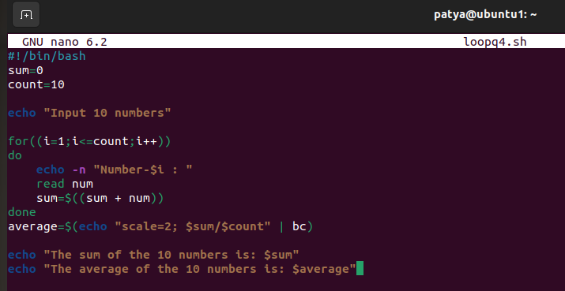

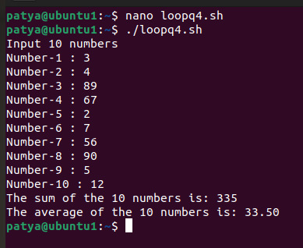

**5. Shell Script to display the cube of the number up to an integer.**

**Test Data :**

**Input number of terms : 5**

**Expected Output :**

**Number is : 1 and cube of the 1 is :1**

**Number is : 2 and cube of the 2 is :8**

**Number is : 3 and cube of the 3 is :27**

**Number is : 4 and cube of the 4 is :64**

**Number is : 5 and cube of the 5 is :125**



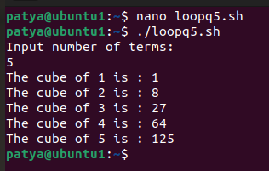

**6. Shell Script to display the multiplication table for a given integer.**

**Test Data :**

**Input the number (Table to be calculated) : 15**

**Expected Output :**

**15 X 1 = 15**

**...**

**...**

**15 X 10 = 150**

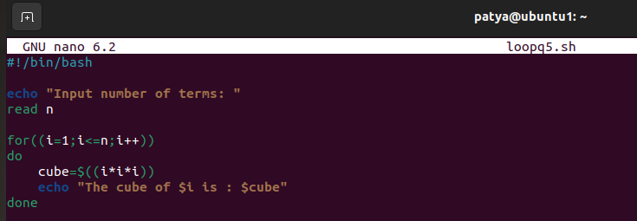

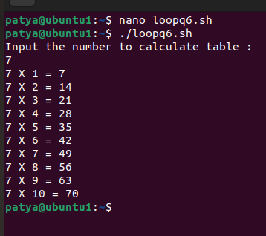

**7. Shell Script to display the multiplier table vertically from 1 to n.**

**Test Data :**

**Input upto the table number starting from 1 : 8**

**Expected Output :**

**Multiplication table from 1 to 8**

**1x1 = 1, 2x1 = 2, 3x1 = 3, 4x1 = 4, 5x1 = 5, 6x1 = 6, 7x1 = 7, 8x1 = 8**

**...**

**1x10 = 10, 2x10 = 20, 3x10 = 30, 4x10 = 40, 5x10 = 50, 6x10 = 60, 7x10 = 70, 8x10 = 80**

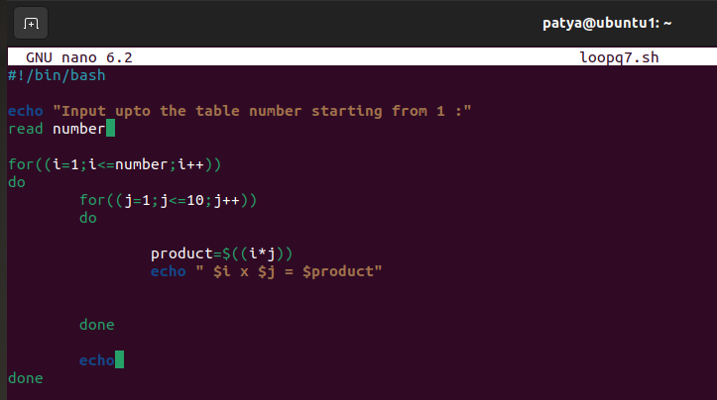

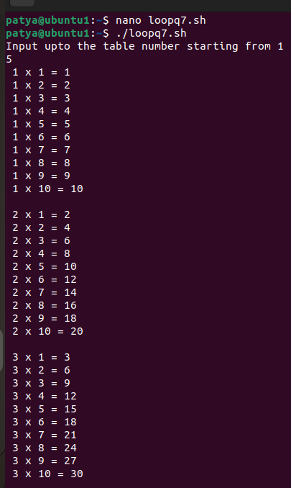

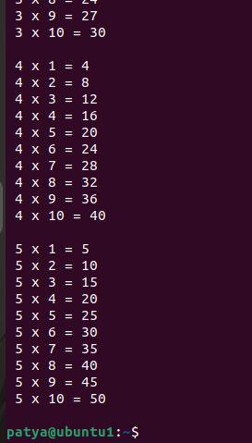

**8. Shell Script to display the n terms of odd natural numbers and their sum.**

**Test Data**

**Input number of terms : 10**

**Expected Output :**

**The odd numbers are :1 3 5 7 9 11 13 15 17 19**

**The Sum of odd Natural Number upto 10 terms : 100**



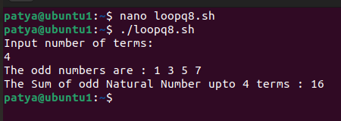

**9. Shell Script to display a pattern like a right angle triangle using an asterisk.**

**The pattern like :**

**\***

**\*\***

**\*\*\***

**\*\*\*\***

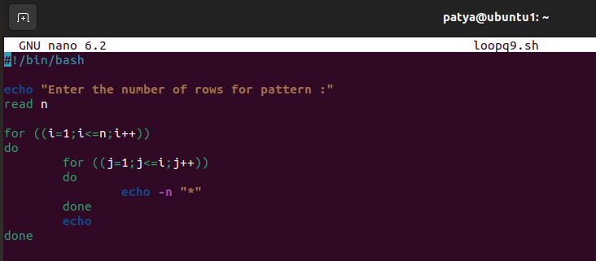

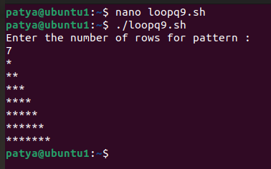

**10. Shell Script to display a pattern like a right angle triangle with a number.**

**The pattern like :**

**1**

**12**

**123**

**1234**

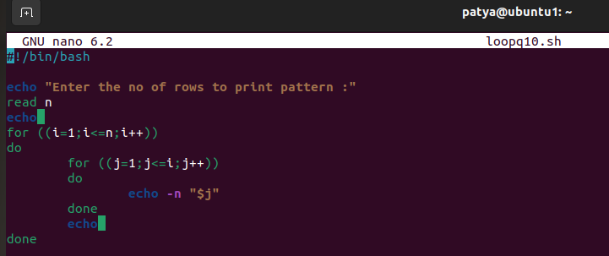

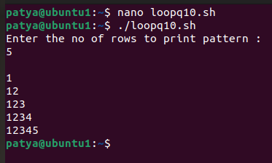

**11. Shell Script to make such a pattern like a right angle triangle with a number which will repeat a number in a row.**

**The pattern like :**

**1**

**22**

**333**

**4444**

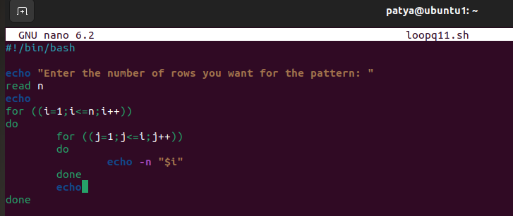

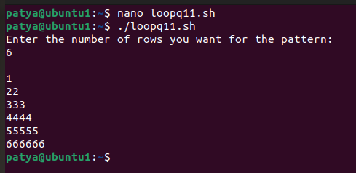

**12. Shell Script to make such a pattern like a right angle triangle with the number increased by 1.**

**The pattern like :**

**1**

**2 3**

**4 5 6**

**7 8 9 10**

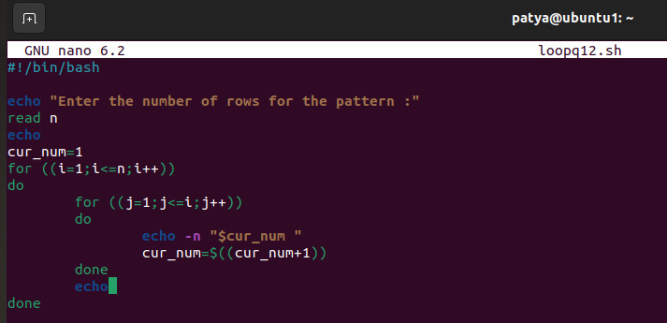

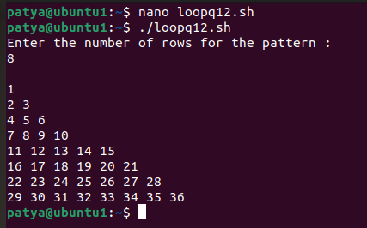

#!/bin/bash

# Function to display the menu

show_menu() {

echo "1. List files"

echo "2. Create a file"

echo "3. Delete a file"

echo "4. Exit"

}

# Function to list files

list_files() {

ls -l

}

# Function to create a file

create_file() {

echo -n "Enter file name: "

read file_name

touch $file_name

echo "File created successfully!"

}

# Function to delete a file

delete_file() {

echo -n "Enter file name to delete: "

read file_name

rm -i $file_name

echo "File deleted successfully!"

}

# Menu loop

while true

do

show_menu

echo -n "Enter your choice: "

read choice

case $choice in

1) list_files ;;

2) create_file ;;

3) delete_file ;;

4) exit ;;

*) echo "Invalid choice. Please try again." ;;

esac

echo

done