- Color code not matching

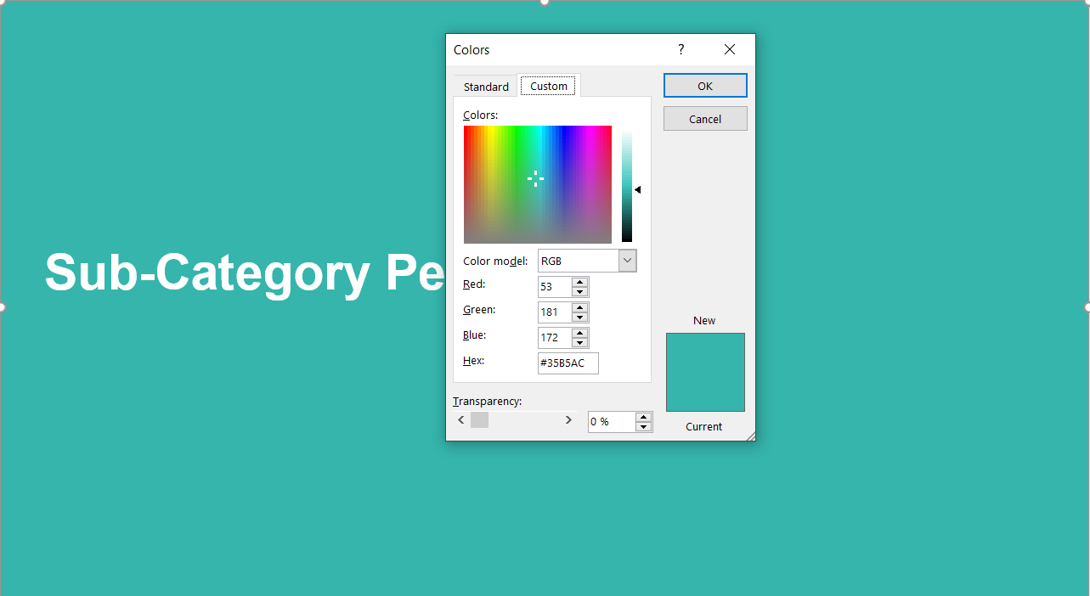

Expected : #61C1BC

2) Text size and layout should be like mentioned in highlights.

Expected :
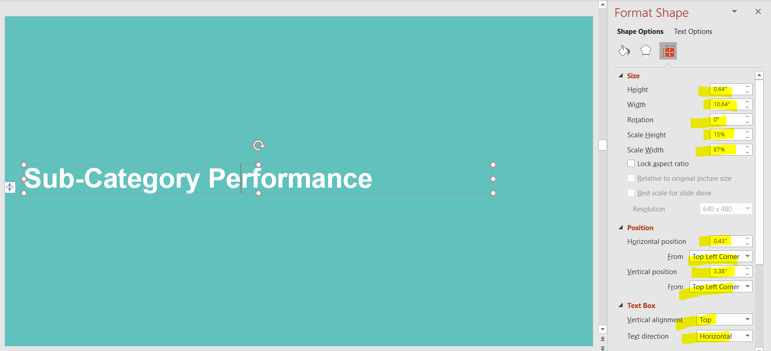

- Highlited text should be size 28 and same layouts should be there.

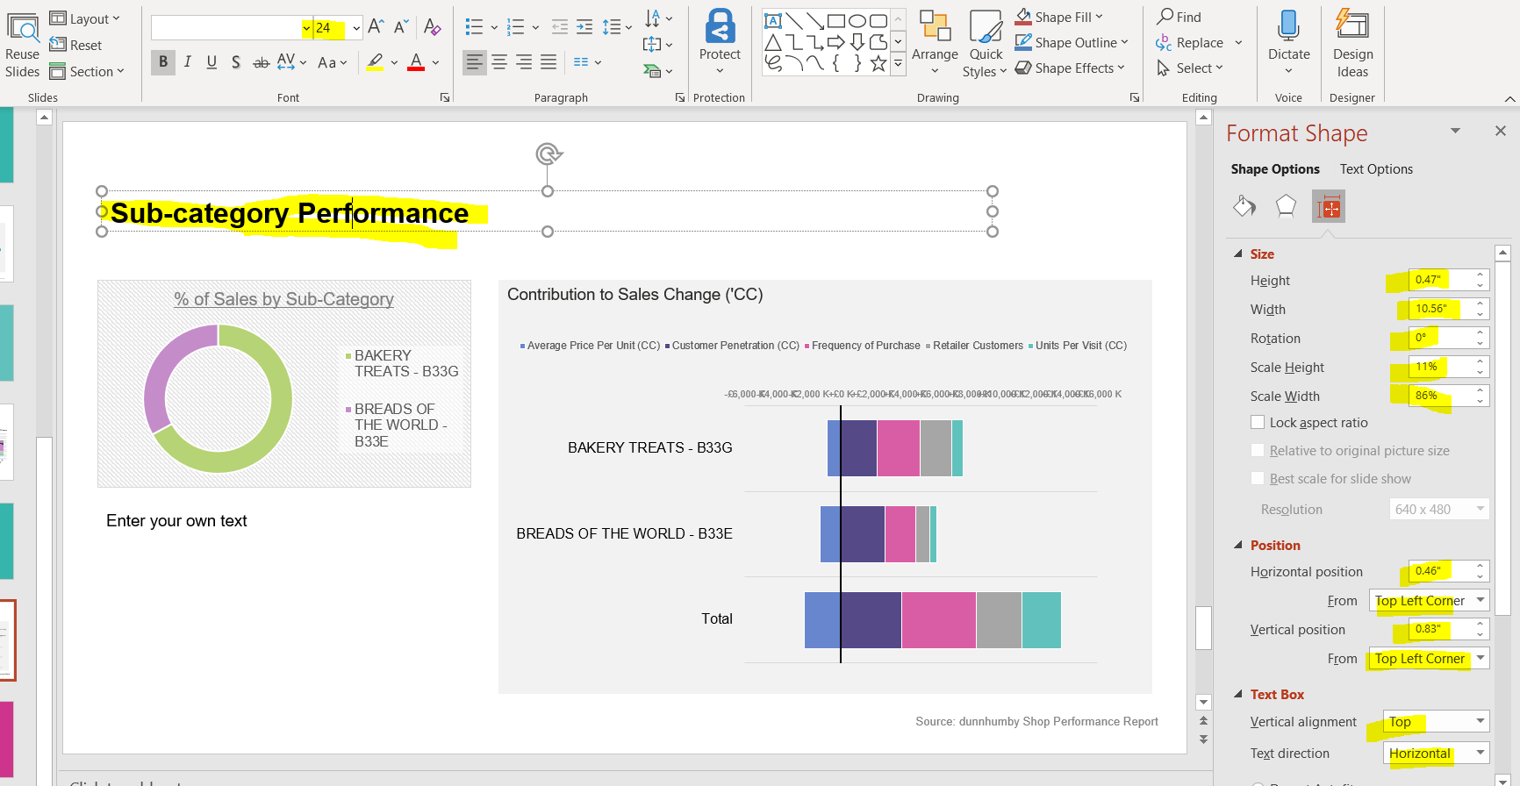

Expected :
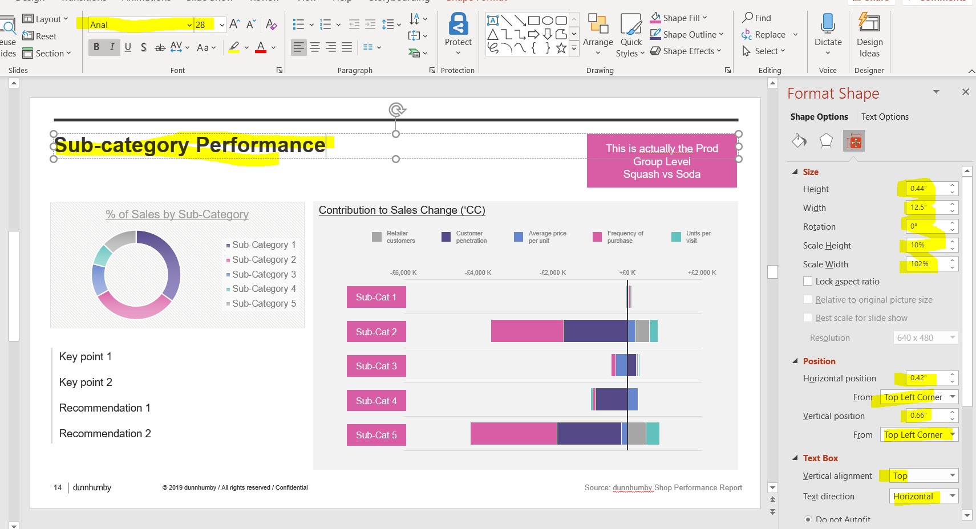

4)Chart Layouts not matching

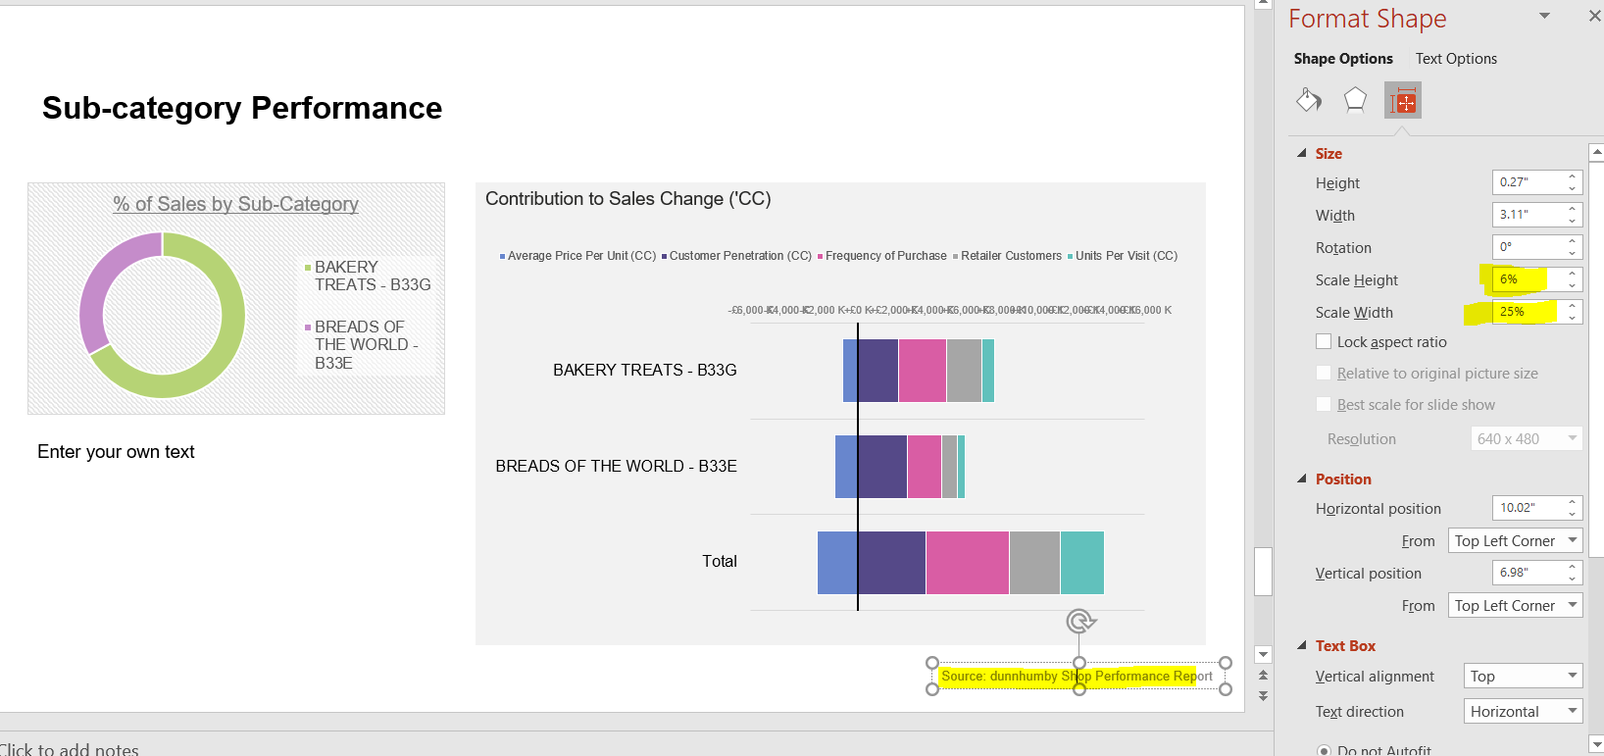

Expected :
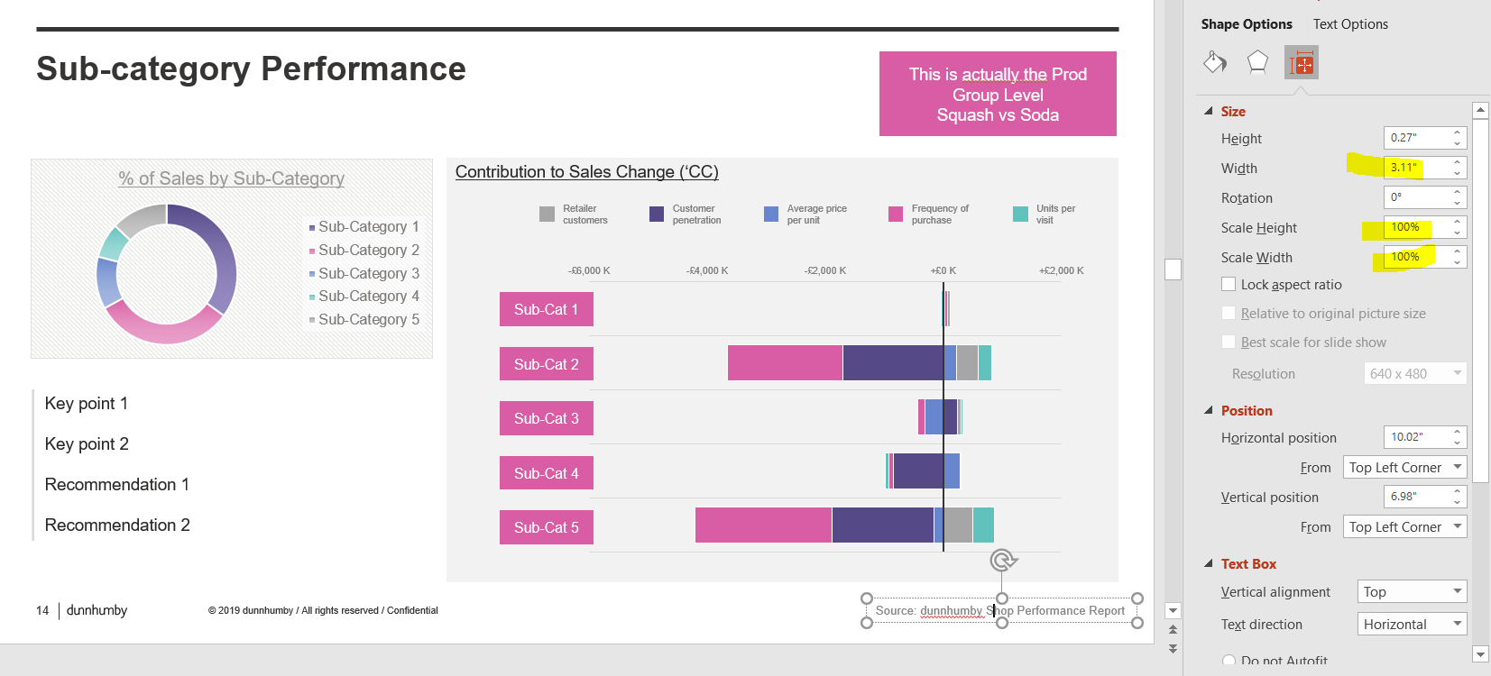

5) The difference should be of 1M but in chart it is 2 M .

Expected :
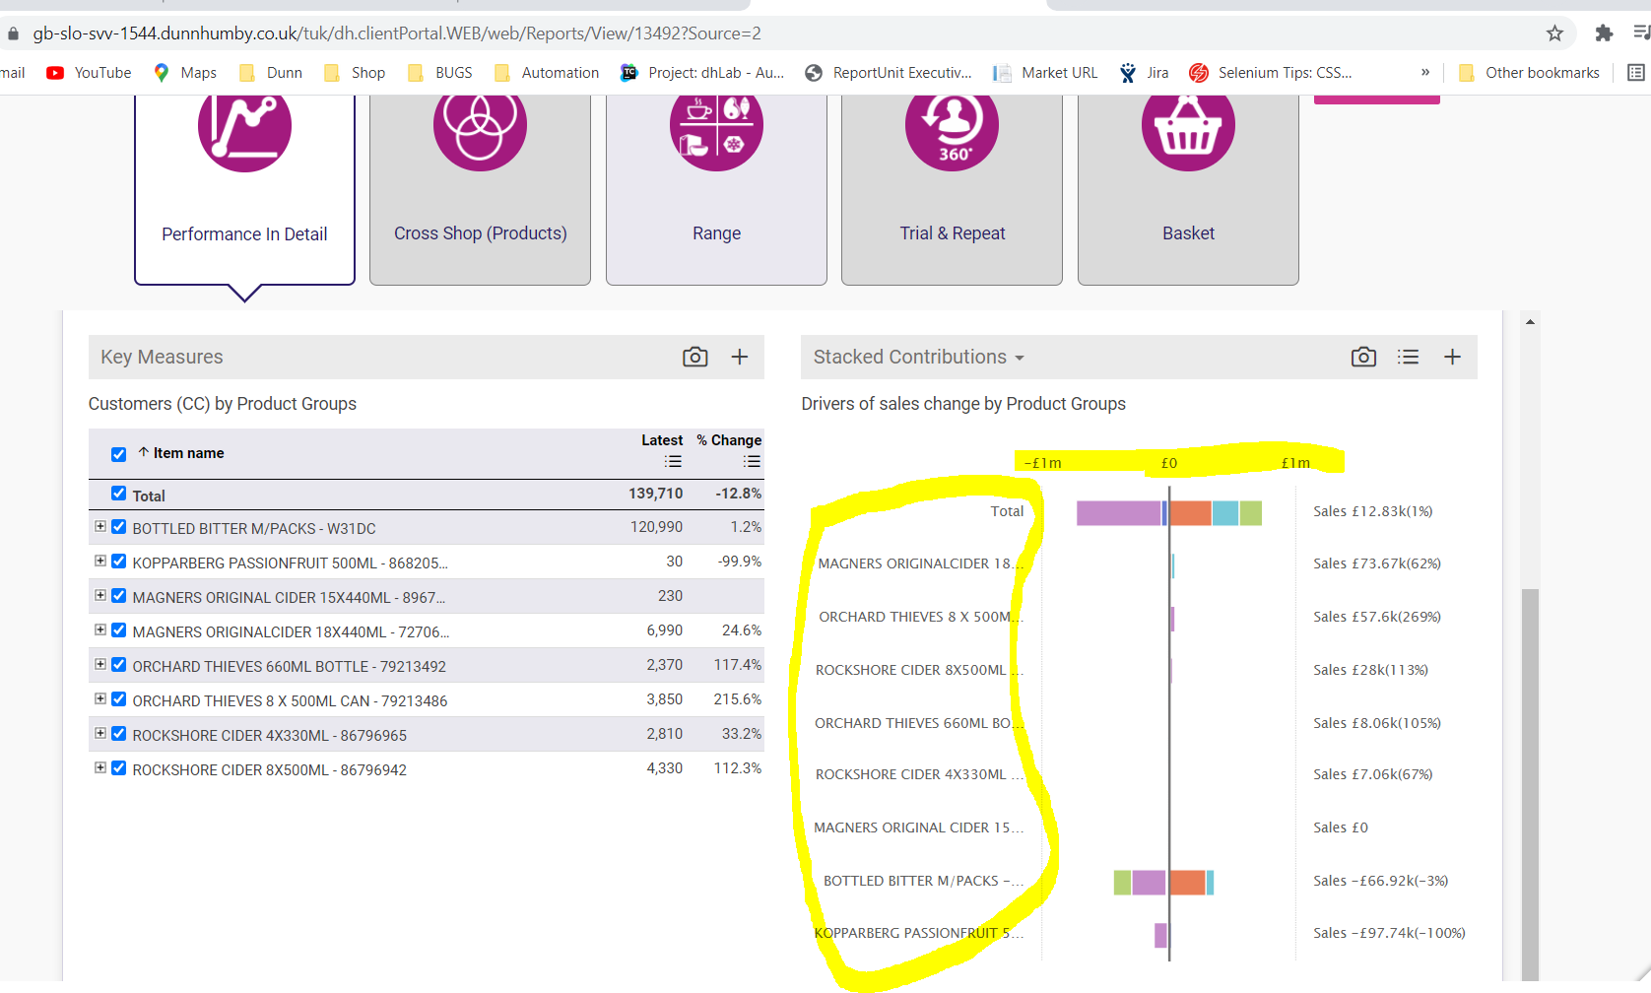

6) LEGION order should match with online report

Expected :
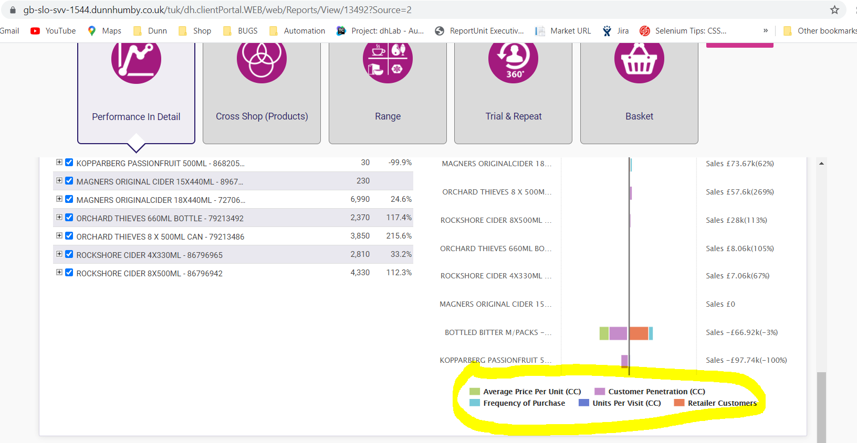

7) Color should be strictly of dunnhumby colors

Expected :
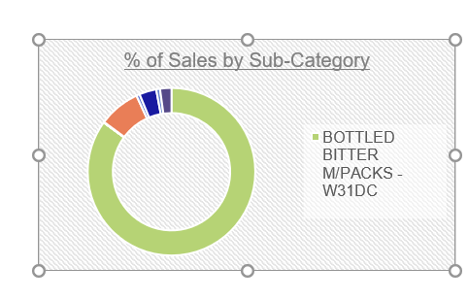

8) % value missing also tag is appearing in first row first column
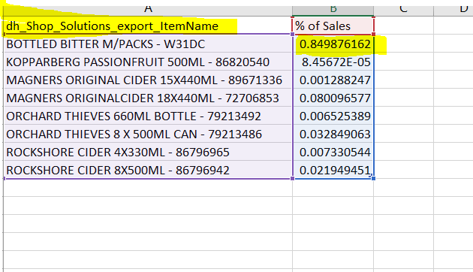

Expected :

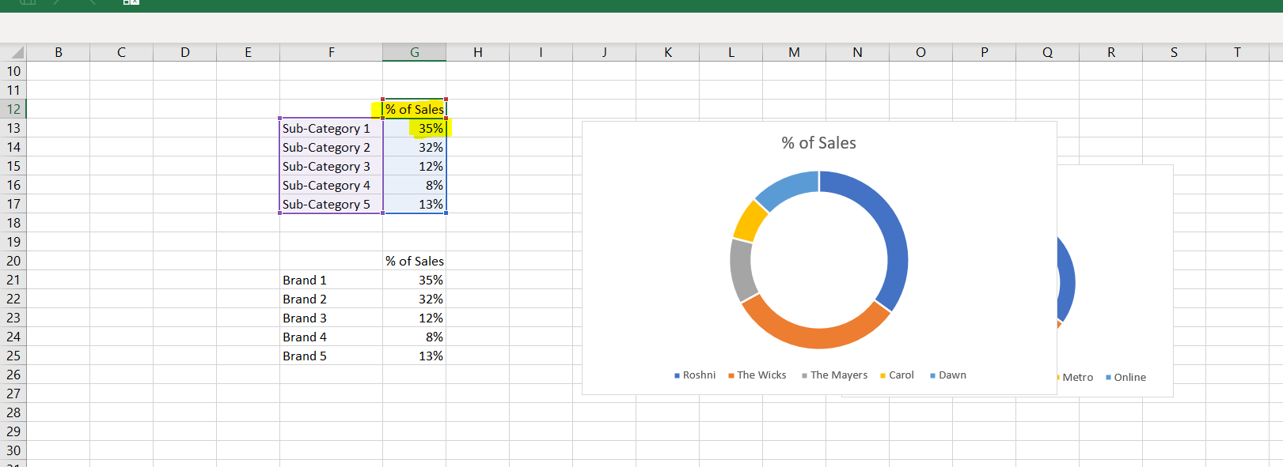

9) Currency symbol is missing also tag is appearing in first row first column
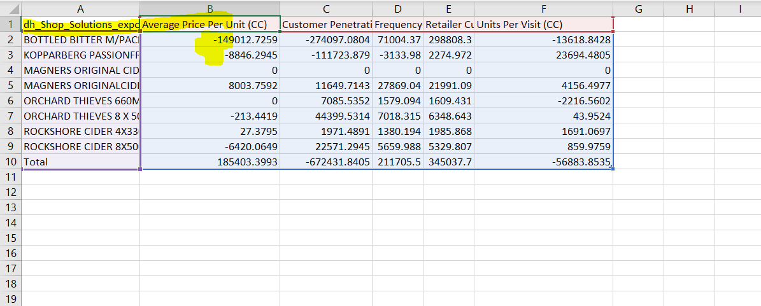

Expected :

