1)The color code and format is mis-matching

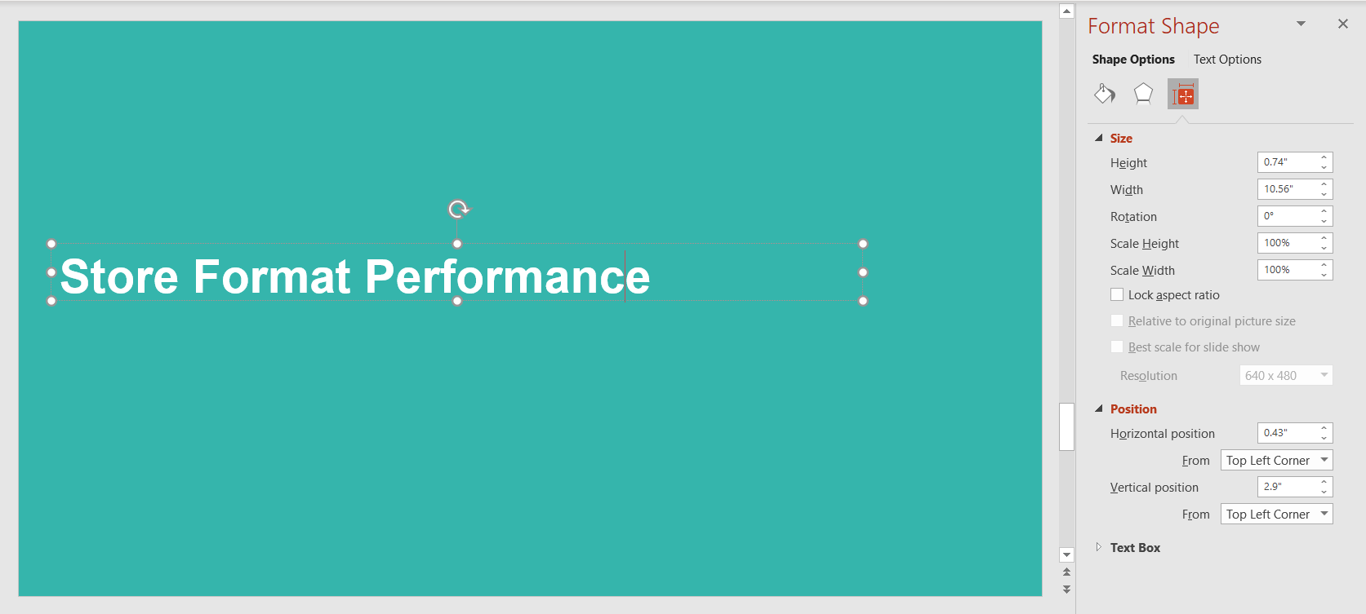

Expected :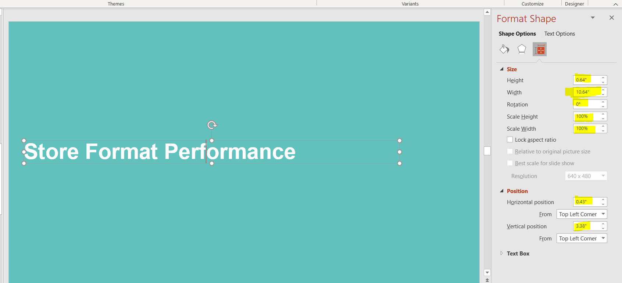

2) Actual : #35B5AC

Expected : #61C1BC

3)Text size should be 28 ans also chart layout is not equal.

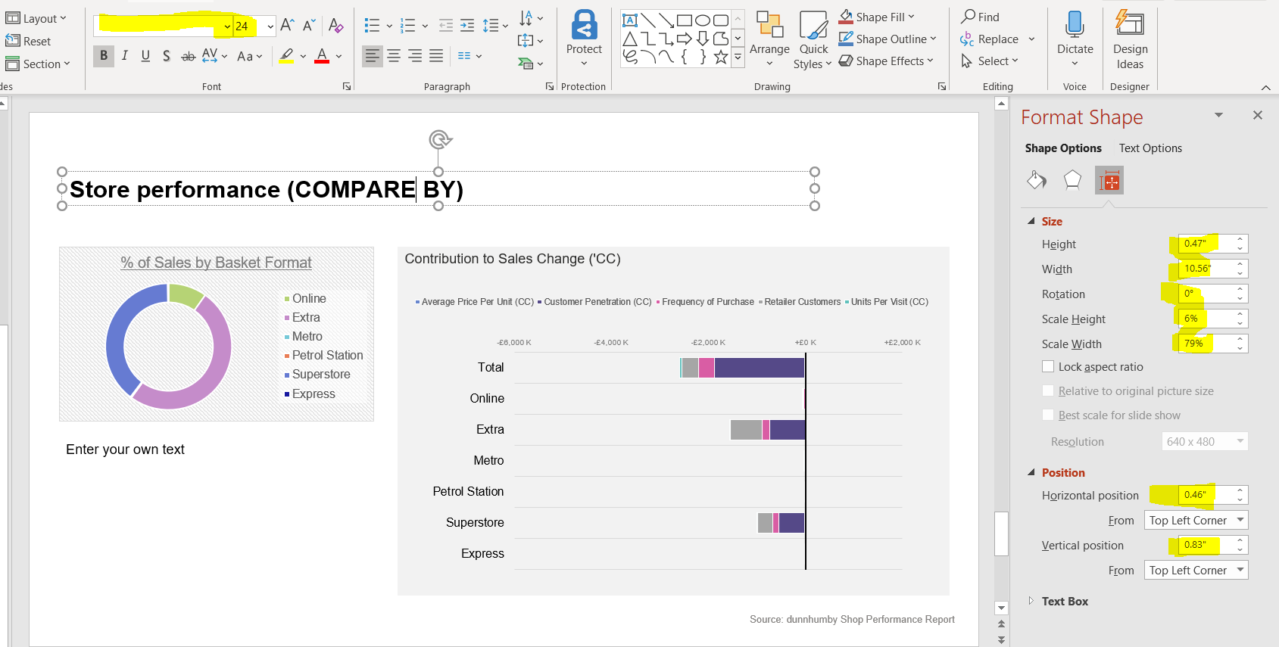

Expected :

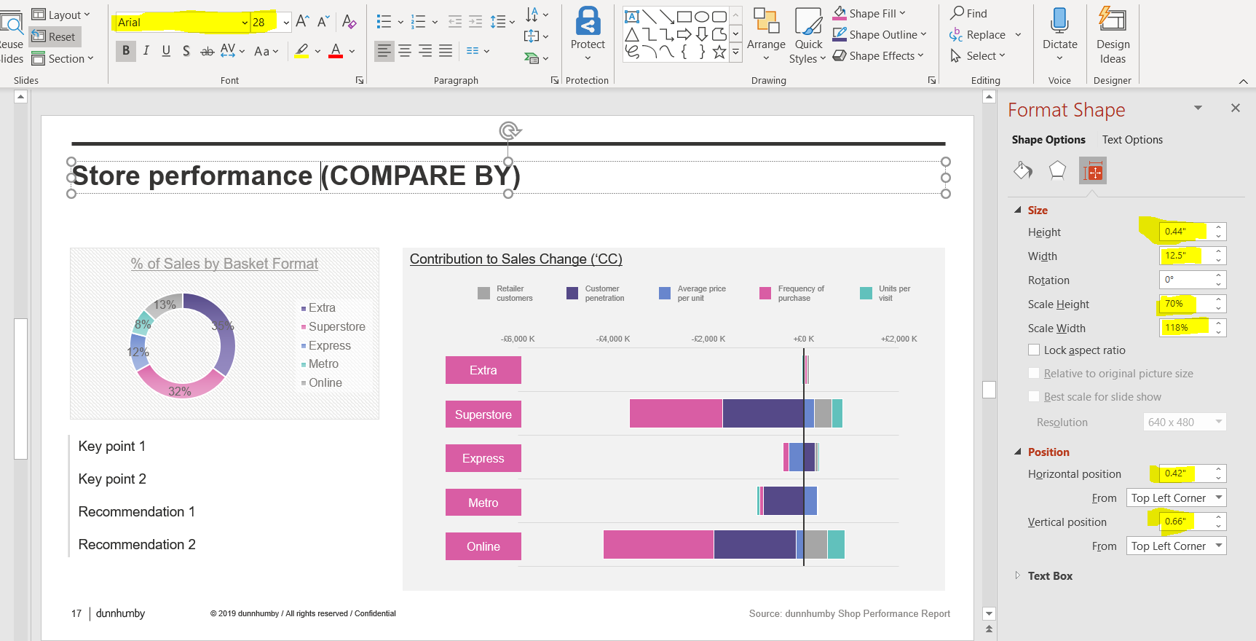

4) Value and % like 12 % is missing

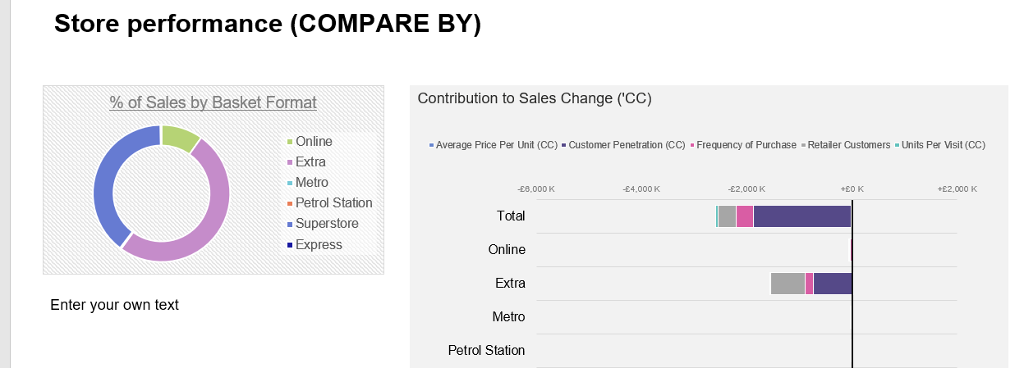

Expected :

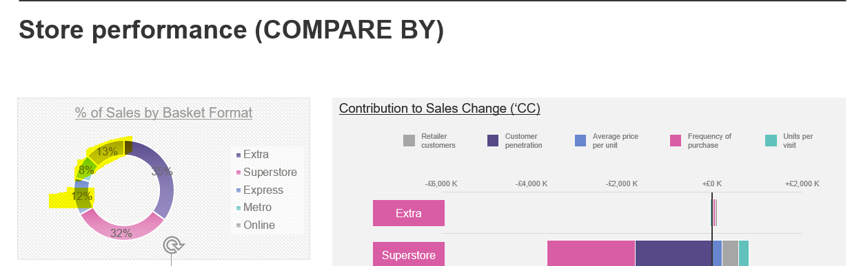

5) Currency symbol is missing also tag is appearing in first row first column

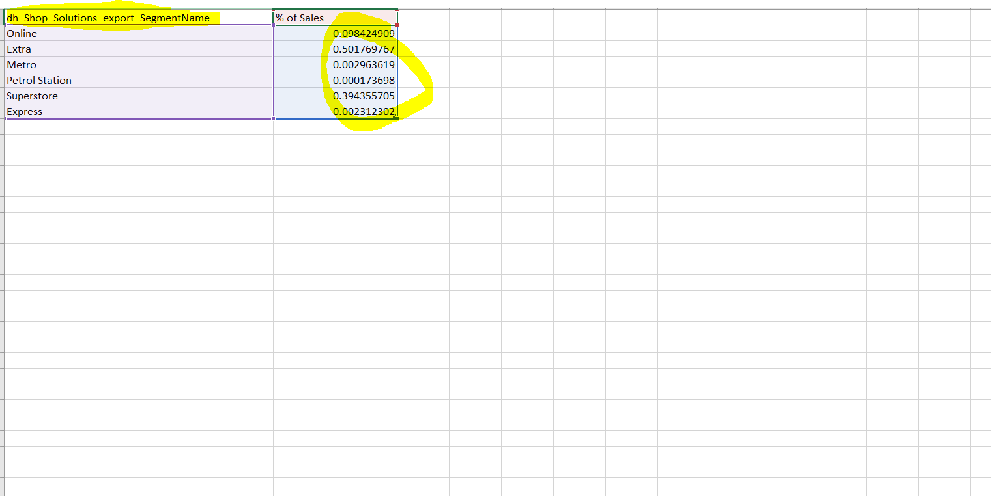

Expected :
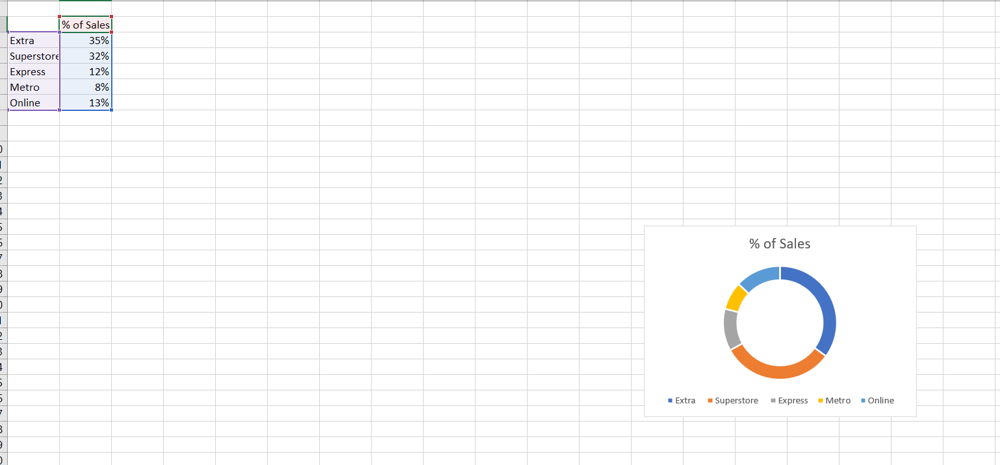

6) Underline is missing in below highted text.

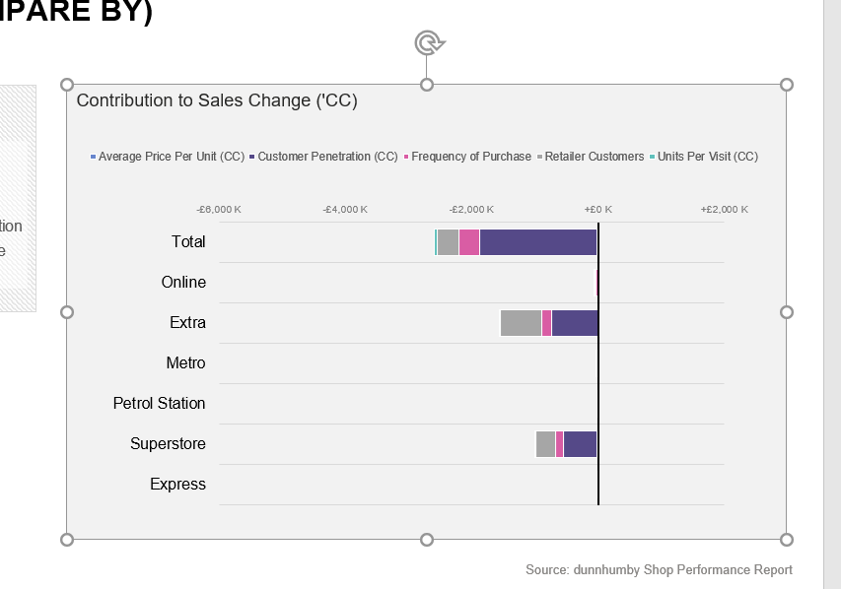

Expected :
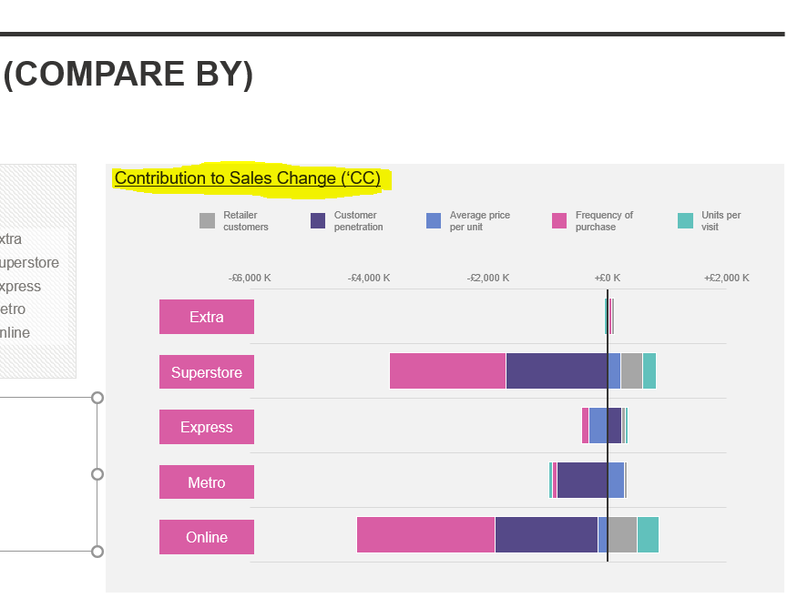

7) LEGION text not in order as per the PPT/Online

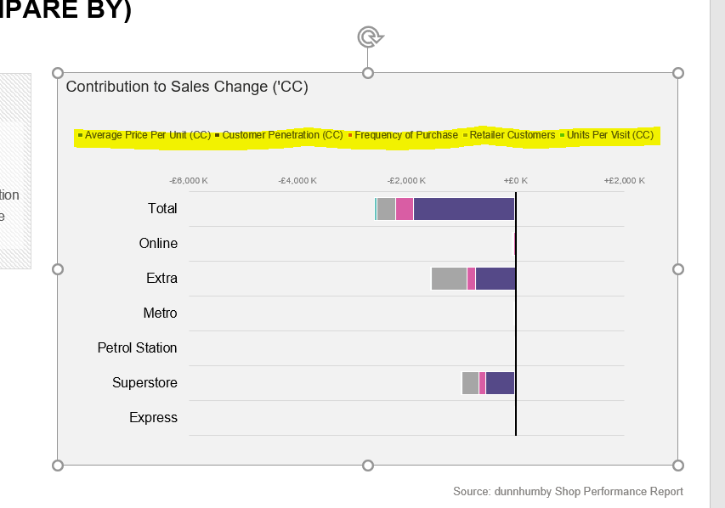

Expected :
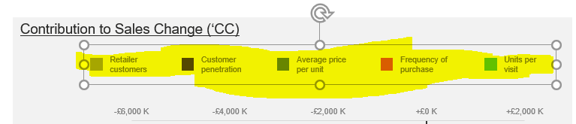

8) Currency symbol is missing also tag is appearing in first row first column

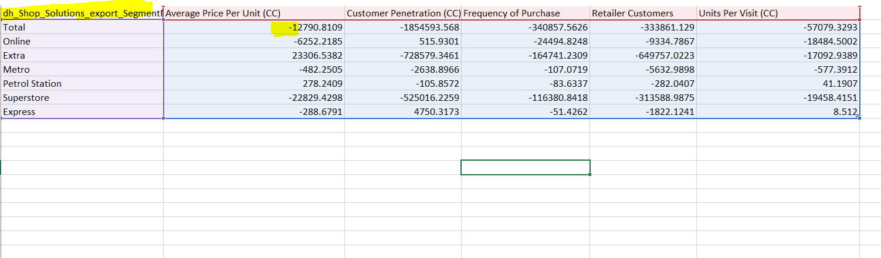
Expected: 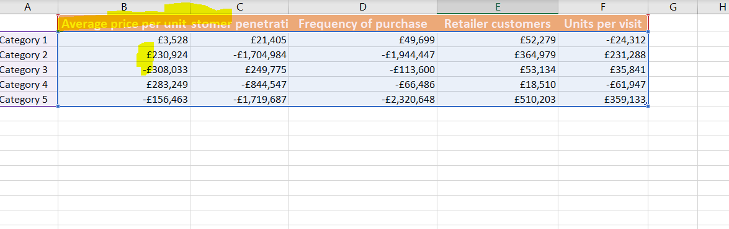

9) Need to discuss if we need any color for the highlited text or leave it as it is.

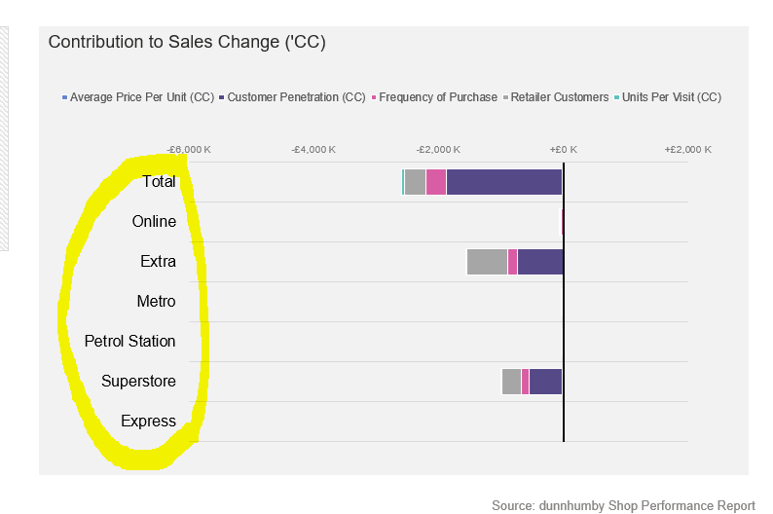

Expected :
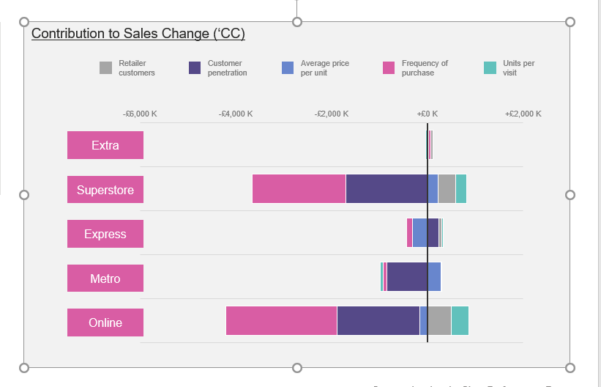

10) Chart has to be in only dunnhumby color

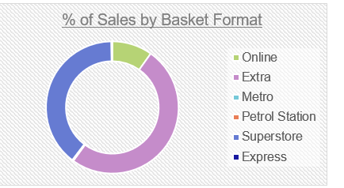

Expected : Dunnhumby colors

11)LEGIONS should match with Online report

Expected :
