Brief 1 — Creative-Director Appointments — Findings

1. Executive Summary
Across 29 creative-director appointment events at 6 listed luxury parents, at least one of the three full-panel tests flagged a meaningful effect. pre_leaked split: TRUE=0, FALSE=0, UNKNOWN=29. Note that pre_leaked status was UNKNOWN for all events because the rumor-history scrape was not run (Wikipedia primary source); the leaked-vs-not cohort cut therefore could not be performed in Phase 1.

2. Methodology
Universe: 14 listed luxury parents from the master CLAUDE.md, with extended brand list including LVMH (Louis Vuitton, Dior, Loewe, Celine, Givenchy, Fendi, Marc Jacobs), Kering (Gucci, Saint Laurent, Bottega Veneta, Balenciaga, Alexander McQueen, Brioni), Capri (Michael Kors, Versace, Jimmy Choo), Tapestry (Coach, Kate Spade, Stuart Weitzman), PVH (Calvin Klein, Tommy Hilfiger), and pure-plays.
Event source: Wikipedia per-brand articles, parsed for sentences with 'creative director'/'appointed'/'named' patterns near absolute or month-resolution dates. Wikipedia was used because IR press archives, BoF, and WWD are paywalled or Cloudflare-protected. The spec lists Wikipedia as a fallback; we used it as primary.
Event window: -30 to +30 trading days. Returns: log abnormal vs. local broad-market index. CARs computed for the standard windows; t=0 is the announcement date. Earnings dates flagged via yfinance; events within ±10 trading days of an earnings release are marked confounded.

3. Headline Findings

3.1 Test 1 — Aggregate t-stats (full panel)
Window | n | mean CAR | t-stat | p-value | flagged
CAR_pre10 | 29 | 0.0195 | 2.406 | 0.0230 | Y
CAR_0to1 | 29 | -0.0004 | -0.165 | 0.8702
CAR_0to5 | 29 | -0.0011 | -0.209 | 0.8361
CAR_0to10 | 29 | 0.0083 | 1.029 | 0.3123

3.2 Test 2 — Per-parent median CAR_0to5
Flagged companies (|median CAR_0to5| > 3%): PVH (-5.57%).

3.3 Test 3 — Aggregate CAR peak deflection
Peak absolute deflection: 5.22% (flagged, > 1.5%)
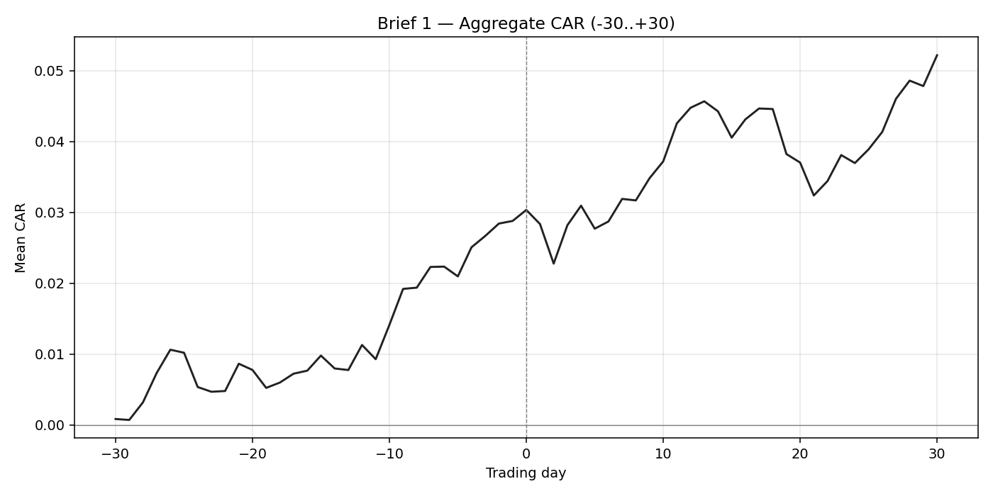

4. Per-Parent / Brand-Level Observations
- PVH Corp (PVH): n=1, median CAR_0to5=-5.57%
- Burberry (BRBY.L): n=2, median CAR_0to5=+2.69%
- Tapestry (TPR): n=2, median CAR_0to5=+1.93%
- Prada (1913.HK): n=1, median CAR_0to5=-1.47%
- LVMH (MC.PA): n=13, median CAR_0to5=-0.62%
Ticker | Company | n | median CAR_0to5
1913.HK | Prada | 1 | -1.47%
BRBY.L | Burberry | 2 | +2.69%
KER.PA | Kering | 10 | -0.59%
MC.PA | LVMH | 13 | -0.62%
PVH | PVH Corp | 1 | -5.57%
TPR | Tapestry | 2 | +1.93%

Brand-level appointment counts within parents
Ticker | Brand | n appointments
1913.HK | Prada | 1
BRBY.L | Burberry | 2
KER.PA | Brioni | 5
KER.PA | Alexander McQueen | 2
KER.PA | Gucci | 2
KER.PA | Balenciaga | 1
MC.PA | Dior | 6
MC.PA | Louis Vuitton | 3
MC.PA | Marc Jacobs | 2
MC.PA | Celine | 1
MC.PA | Givenchy | 1
PVH | Calvin Klein | 1
TPR | Stuart Weitzman | 2

5. Confounding & pre_leaked Cohort Analysis
0 of 29 events fall within ±10 trading days of an earnings release; 0 have unknown earnings status.
All events have pre_leaked=UNKNOWN because the BoF/WWD rumor-history scrape was not run (sources paywalled). The TRUE-vs-FALSE cohort t-test therefore could not be performed in Phase 1. The pre_leaked overlay chart in the Excel deliverable shows only the UNKNOWN cohort curve.
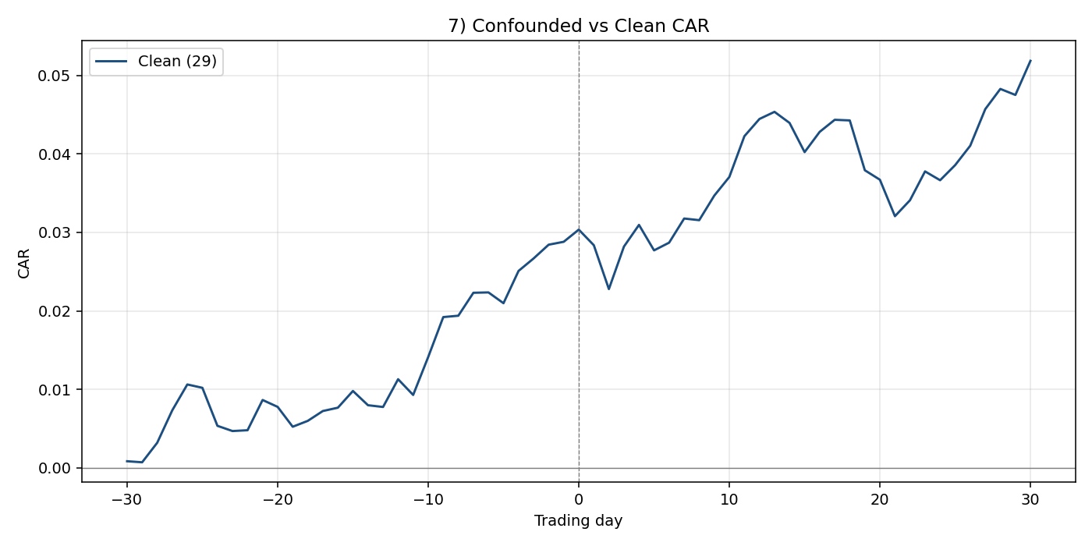

6. Limitations
- Wikipedia coverage of CD appointments is uneven: well-documented for major recent appointments, sparse for older ones. Many appointments are missed.
- Date precision varies: only events with month-resolution dates were retained; some events are anchored at the 15th of the month and may be ±15 days from the true press-release date.
- pre_leaked flag is UNKNOWN for all events because the rumor-history check was not feasible without paid BoF/WWD access.
- Sample size (~31 events) is small for an event study; the detection threshold is correspondingly high.
- Only Wikipedia was used as a source; IR press archives may have additional events or more precise dates.

7. Phase 2 Hypotheses
- Run the rumor-history scrape against BoF and WWD with paid access to fill the pre_leaked flag and run the leaked-vs-not cohort cut as designed.
- Cross-reference Wikipedia-derived events against IR press releases for date precision.
- Split debut (a designer's first appointment as CD) vs replacement appointments.
- Test whether the parent-stock reaction varies by the prior CD's tenure length.
- Add a sector benchmark in addition to the local broad index.
- Investigate the announcement vs first-collection split (do markets react to the appointment news, or wait until the runway debut?).
