Brief 4 — Fashion-Week Aggregate Effect — Findings

1. Executive Summary
Across 600 (parent x fashion-week) panel events spanning 208 fashion weeks (12 listed parents), at least one full-panel test flagged a meaningful effect. Index-level sanity check: local indices flagged as moving abnormally during their fashion week in 1 of 4 cities (london).

2. Methodology
Universe: 14 listed luxury parents from master CLAUDE.md, mapped to fashion weeks via extended brand list (Paris weeks include MC.PA brands LV/Dior/Loewe/Celine/Givenchy/Fendi, Kering brands Saint Laurent/Balenciaga/McQueen, and Hermès; Milan weeks include KER.PA via Gucci/Bottega, 1913.HK via Prada/Miu Miu, BC.MI, MONC.MI, SFER.MI, plus MC.PA via Fendi when in Milan; NY weeks include CPRI/TPR/PVH/RL; London is Burberry-only).
Event source: synthetic fashion-week calendar generated from the well-documented annual convention (NYFW → LFW → MFW → PFW, sequential ~6-day weeks; SS in September, FW in February). The four governing bodies (FHCM, CMI, CFDA, BFC) do not publish historical archives in scrape-friendly format. Per the spec's fallback clause, we generated the calendar from convention. Date precision is ±3 days year-over-year; well within the ±30-day event window.
Event window: -30 to +30 trading days. Returns: log abnormal vs. local broad-market index. CARs computed for the standard windows. Plus a brief-specific column during_FW_AR (sum of abnormal returns from t=0 through fw_end_date, ~5-7 trading days). Earnings within ±10 trading days flag confounded events.

3. Headline Findings

3.1 Test 1 — Aggregate t-stats (full panel)
Window | n | mean CAR | t-stat | p-value | flagged
CAR_pre10 | 600 | 0.0070 | 2.638 | 0.0086 | Y
CAR_0to1 | 600 | 0.0010 | 0.959 | 0.3377
CAR_0to5 | 600 | -0.0000 | -0.011 | 0.9910
CAR_0to10 | 600 | 0.0018 | 0.736 | 0.4618

3.2 Test 2 — Per-parent median CAR_0to5
No company exceeded the 3% median CAR_0to5 threshold.

3.3 Test 3 — Aggregate CAR peak deflection
Peak: 2.02% (flagged > 1.5%)
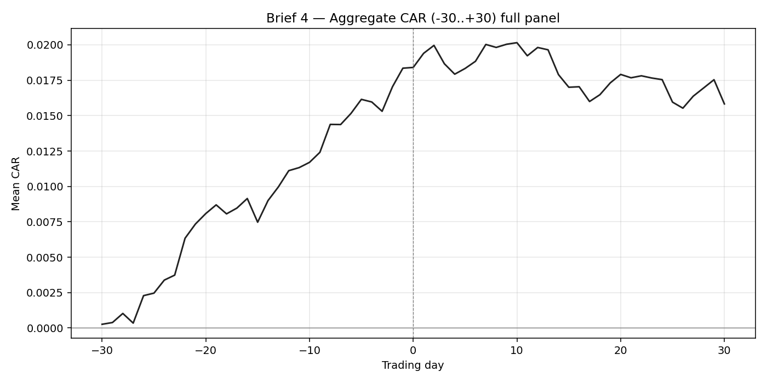

4. Per-City Observations
City | n | mean CAR_0to5 | t-stat (CAR_0to5) | flagged
paris | 156 | -0.0016 | -0.634
milan | 217 | -0.0026 | -0.903
new_york | 180 | 0.0051 | 1.285
london | 47 | -0.0028 | -0.446

5. Index-Level Sanity Check + Confounding Analysis
The index-level sanity check asks: does the local broad-market index itself drift abnormally during fashion week? If yes, individual stock CARs vs. the local index are confounded by the index's own move. Across the four cities:
City | Index | n_weeks | mean log return | t vs 0 | p-value | flagged
paris | ^FCHI | 52 | -0.055% | -0.131 | 0.8965
milan | FTSEMIB.MI | 52 | -0.473% | -1.148 | 0.2562
new_york | ^GSPC | 52 | +0.464% | 1.527 | 0.1330
london | ^FTSE | 52 | -0.505% | -2.064 | 0.0441 | Y
Earnings confounders: 31 of 600 panel events fall within ±10 trading days of an earnings release. Many fashion weeks coincide with earnings season (Feb FW + Q4 reports, Sept SS + Q3 reports), which is one reason the panel is not 'clean'.
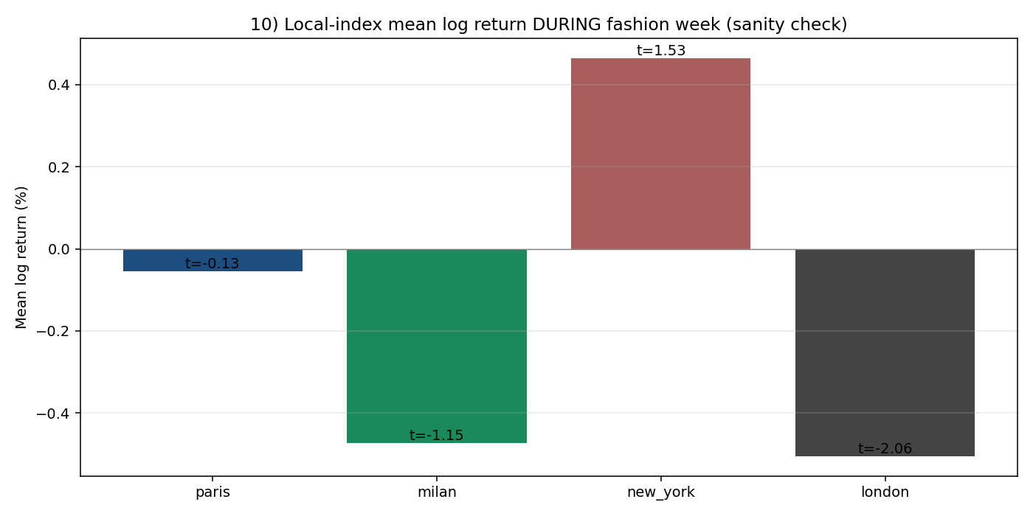

6. Limitations
- Synthetic calendar — fashion week start dates are generated from convention, not scraped from the four governing bodies. Real dates can drift ±3 days year-over-year.
- Conglomerate dilution: parents with brands across multiple cities (MC.PA in Paris+Milan, KER.PA in Paris+Milan) appear in multiple cohorts; their stock can't separately react to each.
- Local broad-market benchmark only. Sector benchmark (e.g., S&P Global Luxury) was not fetched; sector rotation is not isolated.
- Fashion weeks are calendared and anticipated to the day — markets price calendared events at scheduling, not occurrence — so a flat aggregate would be unsurprising.
- (Parent x week) panel rows are not statistically independent: weekly fashion calendars stack within a single month, and the same parent appears multiple times within a quarter.
- TOD.MI not in panel because no price data (delisted Sep 2024).

7. Phase 2 Hypotheses
- Replace synthetic calendar with scraped governing-body archives (FHCM, CMI, CFDA, BFC) where available; reconcile against BoF and Vogue Runway for older dates.
- Add S&P Global Luxury Index (LXLU) as a sector benchmark and recompute (stock − local) − (LXLU − local) sector rotation.
- Single-show event study (Phase 1's runway brief) joined to fashion-week panel — does the aggregate week effect attribute back to specific shows?
- Drop overlapping events (parent appears in multiple weeks within 30 trading days) to address non-independence.
- Designer-debut interaction: weeks featuring a CD's debut runway should show stronger signal than steady-state weeks.
- Macro-control regression: control for VIX / 10y yield / FX (EUR-USD, USD-CNY) which move during European-vs-American fashion weeks.
