Fashion Show Event Study — Phase 1 Findings

1. Executive Summary
Phase 1 analyzed 675 runway events across 13 listed fashion companies, 2000-2025. None of the three Phase 1 tests flagged a statistically meaningful effect. Test 1 (aggregate t-stat across 4 windows) showed no significant aggregate effect. Test 2 (median brand-level effect, |·|>3%) flagged 0 of 13 companies. Test 3 (visual peak deflection) measured 1.12% peak (below 1.5% threshold).

2. Methodology
Universe of 15 publicly-listed fashion houses across France (LVMH, Kering, Hermes), the US (Capri Holdings, Tapestry, Coach Inc legacy, PVH, Ralph Lauren), the UK (Burberry), Hong Kong (Prada), Italy (Brunello Cucinelli, Moncler, Salvatore Ferragamo, Tod's), and Germany (Hugo Boss). Events are SS and FW main women's ready-to-wear runway shows scraped from Vogue Runway 2000-2025. Couture, cruise/resort, pre-fall, and menswear shows are excluded.
Event window is -30..+30 trading days around the first trading day on or after the show date. Abnormal returns are computed daily as stock log return minus local-index log return; CARs are the cumulative sum of abnormal returns over the specified subwindows. Earnings dates within 10 trading days flag confounded events but do not exclude them.

3. Headline Findings

3.1 Test 1 — Aggregate t-stats
Window | n | mean CAR | t-stat | p-value | flagged
CAR_pre10 | 675 | 0.0020 | 0.851 | 0.3951
CAR_0to1 | 675 | 0.0005 | 0.449 | 0.6538
CAR_0to5 | 675 | -0.0006 | -0.343 | 0.7317
CAR_0to10 | 675 | -0.0021 | -0.869 | 0.3850

3.2 Test 2 — Median brand-level effects
No company exceeded the 3% median CAR_0to5 threshold.

3.3 Test 3 — Aggregate CAR curve
Peak absolute deflection of the mean CAR curve over the -30..+30 window: 1.12% (below 1.5% threshold).
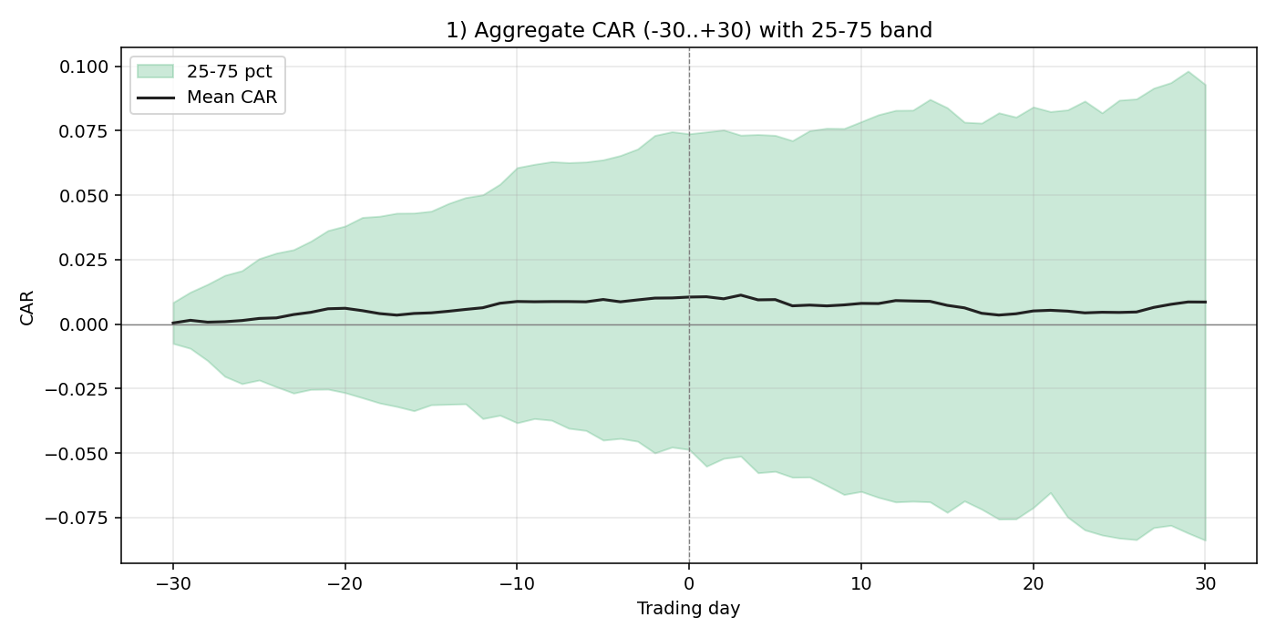

4. Per-Company Observations
Strongest signals (largest |median CAR_0to5|):
- Hugo Boss (BOSS.DE): n=21, median CAR_0to5=-0.98%
- Tapestry (TPR): n=23, median CAR_0to5=+0.97%
- Prada (1913.HK): n=70, median CAR_0to5=+0.96%
- Brunello Cucinelli (BC.MI): n=22, median CAR_0to5=-0.78%
- Hermes (RMS.PA): n=44, median CAR_0to5=+0.73%
Ticker | Company | n | median CAR_0to5
1913.HK | Prada | 70 | +0.96%
BC.MI | Brunello Cucinelli | 22 | -0.78%
BOSS.DE | Hugo Boss | 21 | -0.98%
BRBY.L | Burberry | 45 | +0.14%
CPRI | Capri Holdings | 40 | +0.69%
KER.PA | Kering | 145 | +0.05%
MC.PA | LVMH | 102 | +0.38%
MONC.MI | Moncler | 10 | +0.41%
PVH | PVH Corp | 76 | -0.15%
RL | Ralph Lauren | 49 | -0.41%
RMS.PA | Hermes | 44 | +0.73%
SFER.MI | Salvatore Ferragamo | 28 | +0.72%
TPR | Tapestry | 23 | +0.97%

5. Confounding Analysis
Of 675 events, 28 fall within 10 trading days of an earnings release (flagged confounded), 647 are clean, and 0 have unknown earnings status. The chart below compares mean CAR curves for confounded vs clean subsets; if the runway signal survives the earnings filter, the curves should track.
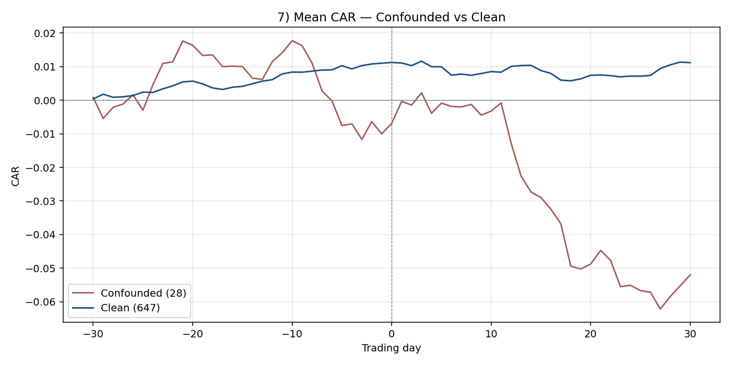

6. Limitations
- Vogue Runway coverage is sparse for several brands pre-2003 and varies by brand throughout the period.
- Conglomerate tickers (LVMH, Kering, PVH, CPRI, TPR) capture the parent's full portfolio, not the runway brand alone — attribution dilution is unavoidable in Phase 1.
- Benchmark is the local broad-market index only. No sector or luxury-specific benchmark.
- Earnings dates from yfinance are best-effort; some tickers return no data and are flagged confounder_unknown.
- Phase 1 measures whether shows move stocks; it does not investigate the mechanism (sentiment, sales, leadership signal).
- Hugo Boss, Moncler, and Brunello Cucinelli have notably thin Vogue Runway coverage, lowering their event counts.

7. Phase 2 Hypotheses
- Designer-change cohort: do CARs differ markedly around shows immediately following a creative-director appointment?
- Star-debut effect: isolate first-show-by-new-designer events vs steady-state shows.
- Social-media era cut: split sample at 2014 (Instagram-runway era) and compare.
- SS vs FW asymmetry: investigate whether one season's signal dominates and why (calendar, retail cycle).
- Pure-play vs conglomerate sensitivity: deeper test on dilution hypothesis.
- Cross-tabs by company size, market cap, and country exchange microstructure.

