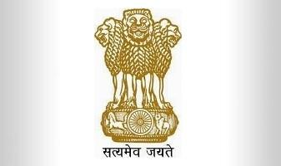 | भारत सरकार  दूरसंचार विभाग  दूरसंचार अभियांत्रिकी केंद्र  Government of India  Department of Telecommunications  Telecommunication Engineering Centre  K.L. Bhawan, Janpath, New Delhi- 110001 | 

No. 6-5/2022-6GT/TEC Date:22nd April, 2022

Meeting Notice
Subject: First meeting of National Working Group (NWG)-12 corresponding to ITU-T Study Group-12 regarding “Performance, Quality of Service (QoS), Quality of Experience (QoE) and end to end service” scheduled on April 25, 2022 at 15:00 – 18:00 hrs.
Telecommunication Engineering Centre (TEC) is pleased to announce the constitution of National Working Groups (NWG-12) corresponding to International Telecommunication Union (ITU-T) Study Group-12. ITU-SG12 is responsible for Recommendations on Performance, Quality of Service (QoS) and Quality of Experience (QoE) for the full spectrum of terminals, networks, services and applications, ranging from speech over fixed circuit-based networks to multimedia applications over networks that are mobile and packet based. Included in this scope are the operational aspects of performance, QoS and QoE; the end-to-end quality aspects of interoperability and the development of multimedia quality assessment methodologies, both subjective and objective.
- The objective of the NWG-12 is to contribute to ITU-T SG 12 standardization. Members are requested to examine the current study questions and choose Questions of their preference out of the Questions listed under ITU-T SG-12 (as Annexure-II) and provide contributions/inputs to the undersigned on e-mail: ‘dir6gt.tec-dot@gov.in’ with a copy to ‘ddg6gt.tec-dot@gov.in’ for discussion during the meeting.
- The first meeting of NWG-12 is scheduled to be held on April 25, 2022 at 03:00 PM (online). Please register for the following meeting link please;
https://www.airmeet.com/e/30dd6120-c14d-11ec-bf7b-2de33343d5e7
Encl: List of NWG members as Annexure-I and ITU-T Doc no.TS22-SG-C-0001 as Annexure-II.

To: Director (6G Technologies)
1. All Stakeholders through email and TEC portal.
Copy for kind information to:
- Member (Services)/ Member (Technology)/ DG (Telecom) DoT, New Delhi.
- Sr. DDG & Head TEC.

