 | INTERNATIONAL TELECOMMUNICATION UNION  TELECOMMUNICATION  STANDARDIZATION SECTOR  STUDY PERIOD 2022-2024 |  | SG13-C 0157
 |  |  | STUDY GROUP 13
 |  |  | Original: English
Question(s): |  | 2/13 |  | Geneva, 04 – 15 Jul 2022
CONTRIBUTION
Source: |  | Ministry of Communications, India
Title: |  | Proposal to initiatea new work item on “Architectural framework for NGN evolution for IMT-2030 by extending SDN paradigm to the Network control plane”
Contact: |  | Rashmi Kamran  Indian Institute of Technology Bombay  India |  |  | Tel: +91 9920122898  E-mail: rashmi.kamran@iitb.ac.in
Contact: |  | Pranav Jha  Indian Institute of Technology Bombay  India |  |  | Tel: +91 9818017469  E-mail: pranavjha@ee.iitb.ac.in
Contact: |  | Shwetha Kiran  Indian Institute of Technology Bombay  India |  |  | Tel: +91 9619739635  E-mail: shwethak@iitb.ac.in
Contact: |  | Ranjana Sivaram  Telecom Engineering Centre (TEC)  India |  |  | Tel: +91 9868136990  E-mail: ranjana.sivaram@gov.in
Contact: |  | Jyoti Roat  Telecom Engineering Centre (TEC)  India |  |  | Tel: +91 9468697726  E-mail: jroat.91@gov.in
Contact: |  | AbhayShanker Verma  Telecom Engineering Centre (TEC)  India |  |  | Tel: + 91 9999554900  E-mail: as.verma@gov.in
Keywords: |  | Architecture; NGN; SDN; network control plane

Abstract: | This contribution proposes to initiate a new work item on “Architectural framework for NGN evolution for IMT-2030 by extending SDN paradigm to the Network control plane”

- Introduction

Next generation network (NGN) for IMT-2030 needs to support enormous data traffic along with diversified use cases. To meet such future requirements, the architecture has to be more scalable, modular and flexible. Existing mobile network architecture, 5th generation system (5GS) for IMT-2020[ITU-R M.2150-1, ITU-T Y.3102, ITU-T Y.3104] has employed a separation between the control plane (transport control functions) and the user plane functionality (transport functions) in line with NGN [ITU-T Y.2012]. The control plane network functions (same as transport control functions in NGN) in the 5GS(both Access Network (AN) and Core Network (CN)) are responsible for controlling the user plane functions (or network resources at transport functions),which essentially translates into establishment, modification or deletion of data sessions over the user plane functions (transport functions). In addition to controlling the user plane functions, the control plane network functions are also responsible for exchange of signaling messages with end user (User Equipment (UEs)). UE-specific signalling includes information exchange related to its (UE) initial access such as registration, authentication, access control, connection management and other services such as session and mobility management. Though currently tightly coupled within the control plane of the existing IMT-2020 5GS, these two categories of functionalities “signaling control” and “user plane control”can be thought of as logically separate functionalities. Once separated, they may interact via a standardized interface and decoupling them can result in a modular, scalable and flexible NGN architecture for IMT-2030.

Next, we analyse the architecture of IMT-2020 5GS[ITU-R M.2150-1, ITU-T Y.3102, ITU-T Y.3104] from the perspective of “Framework of Software-Defined Networking (SDN)” given in ITU-T Y.3300. The user plane functionality in IMT-2020 5GS is akin to the “Resource layer” as defined in ITU-T Y.3300 since it essentially handles data transport and processing function like the resource layer. The subset of “control plane” functionality in IMT-20205GS that deals with “user plane control” is similar to the "SDN control layer” functionality as defined in ITU-T Y.3300. It controls the user plane functions, establishes/modifies/deletes data sessions over user plane functions, i.e., essentially controls the network resources. However, as highlighted earlier the “control plane functionality" in IMT-2020 5GS also includes the functionality of signalling exchange with UEs, which may not fit into the SDN control layer and rather be a part of the "Application (or service) layer” as per the SDN framework [ITU-T Y.3300].

This proposal aims to explore an evolved NGN architecture with improved alignment to SDN principles by decoupling the “user plane control functionality” from the “signaling control functionality”. Further, by treating UE-associated signaling as a service, the proposal aims to arrive at a service-driven architecture for the next generation networks for IMT-2030, where all services are handled in a uniform manner, be it built-in services such as authentication or user mobility or external services such as media streaming or IP Multimedia Subsystem (IMS) services. Future work as part of this work item may include proposals for further elaboration of the architecture. It may also include assessment of the impact of the proposed architecture on the procedures and protocols, modularity of the system, and also on the capability of the system to handle diverse use cases and huge data volume in future.

- Gap Analysis

Although the existing 5G system for IMT-2020 [ITU-R M.2150-1,ITU-T Y.3102, ITU-T Y.3104] and NGN architecture [ITU-T Y.2012] have been designed to incorporate control and user plane separation. There is scope for further evolution in the network architecture in the following directions.

- Alignment with SDN principles

In a standard SDN based architecture[ITU-T Y.3300], an SDN controller (control layer functions) controls the behaviour of network resources or in other words configures the user (data) plane to enable data transfer through the user plane functions. The control layer functions are not responsible for direct communication with network users (UEs) to provide services to them and also to gather service-related requirements from UEs. Functions handling the signaling exchange with UEs and providing services to them are typically part of the application/service layer. These application layer functions provide services to UEs, such as authenticate UEs, and also help the SDN control layer configure the user plane to support appropriate service-aware behaviour. While SDN technology has been utilized in the existing IMT-2020 networks through separation of control plane and user plane, the tight coupling of “user plane control” and “signaling exchange (with UEs)” functionalities is not very well aligned with the SDN principles.

Existing NGN architecture [ITU-T Y.2012] also does not distinguish between these two categories of tasks and both are included as part of the "transport control functions”. Hence, there is scope for improved alignment with SDN principles by decoupling these two categories of functionalities and separating them via a standardized interface.

- Complexity of protocols

In the existing IMT-2020 networks, control plane functions need to exchange signaling messages with end users (UEs). The path for this UE - control plane communication passes through the user plane (transport functions). The control plane functions also need to control user plane functions using a resource control interface[ITU-T Y.3300].For both types of communication, (UE - control plane communication and user plane – control plane communication) the control plane functions use the resource control protocols in the existing IMT-2020 networks. It increases the complexity of the resource control protocols. Separation of the two types of functionalities will result in the simplification of resource control protocols as it will no longer be required to carry the signaling messages and will need to support only resource control messages.

- Slice/service specific signaling requirements

NGN architecture for IMT-2030 should have provision for different signaling overheads for different slices/services to support diversified use cases, which is missing currently in the IMT-2020 networks. Such requirements can be supported with ease through deployment of slice specific signaling service functions, once the signaling handling functionality is separated from the control plane functionality and independently deployed as signaling service functions in the network.The communication between these signaling service functions and the UEs takes place via data paths passing through the user plane. These slice specific signaling service functions can support slice specific signaling needs.

- Dynamic deployment of signalling service functions

Separation of handling of signaling from the control plane functionality brings additional flexibility to deployment of signaling service functions. The signalling service functions may be deployed at run-time to take care of dynamically changing signaling overhead requirements.

- Uniform service delivery mechanism

In the existing IMT-2020systems, services are provided to users (UEs) by using application functions (AF/AS) via data sessions established through the user plane. Example of such services may be IMS, media streaming or multicast/broadcast services. In addition to these external (application based) services, there are some intrinsic (built-in) services offered by the existing IMT-2020 systems such as authentication and access control, connectivity to data networks, mobility support. These services are not always apparent to the end-user, but they form an essential part of the system. The application/servicefunctions are typically decoupled from the transport stratum and the control plane therein (transport control functions). While they access the control plane functions over a standardized interface to enable service delivery via transport functions, the delivery of built-in services is tightly integrated within the control plane of the transport stratum. Based on this insight, we ask the following questions: Is it possible to support the built-in services in a similar manner to the external application-based services in NGN architecture? i.e., can all types of services be supported in a uniform manner? Is a tight integration between “built-in” services and the “control plane” functionality in the IMT-2020 network desirable? It appears that uniform delivery mechanism for all types of services (built-in as well as application-based services) may bring simplicity to the network architecture.

- Problem Statement:

This contribution, proposing a new work item, aims to explore an evolved architecture forIMT-2030 NGN, with decoupled signaling handling and the user plane control functionality. It proposes to treat signaling as a user service(data) and intends to utilize separate application functions, separate from the control plane, to handle exchange of signaling messages with UEs.
Following tasks would be undertaken as part of this work item:

- Analysethe architecture options to separate the signaling exchange functionality from the control plane functionality in the NGN for IMT-2030.
- Analyse the feasibility of treating the signaling message exchange with UEs as a user service (data), i.e., if the signaling messages can be treated in a manner similar to user data transfer and if this approach to signaling exchange is feasible.
- Identify the benefits of the proposed approach both in terms of quantitative and qualitative performance parameters such as flexibility, modularity, scalability, resource efficiency.
- Study the impact of the proposed approach on other services offered by the network such as “network slicing”.

- Benefits:

- Enhanced modularity

The proposal is likely to result in enhanced modularity for the IMT-2030 network with decoupling of signaling handling functionality from the control plane functionality. The two categories of functions shall be separated bya standardized interface.

- Simplification of information flow

Currently, the exchange of signaling messages between UE and network functions utilizes multiple mechanisms. For example, the Non-Access Stratum (NAS) messages are encapsulated within Radio Resource Control (RRC) messages over the radio interface, within AN-CN signalling messages between access network and core,and further exchanged via service interface between the Network Access Control Function (NACF) and the Session Management Function (SMF) in the core [ITU-T Y.3102].However, if UE signalling is handled by dedicated signalling service functions, then the signaling messages may simply be carried by user plane functions in the path, i.e., the signaling service functions and the UEs can exchange signaling messages via bearers established through the user plane functions in the network. This may simplify the signaling information flow in the network considerably.

- Improved alignment with SDN principles

In an SDN-based network architecture, an SDN controller which acts typically as a network control function, performs data flow management to enable transfer of data through the network, i.e., through the user plane functions. However, the controller is typically not responsible for signaling exchange with end users (UEs) to authorize initial access and collect service-specific requirements. This is the job of the application or service functions in SDN based networks, which may interact with users to authorise their access, collect the requirements from them and provide the information to the control plane to configure the data (user) plane appropriately. By separating the UE signaling exchange from the control plane functionality and considering it as a user service (as part of service stratum), the NGN architecture can become better aligned with SDN paradigm.

- Enable easy deployment of use case-specific variants of UE signaling protocols and associated state machines

If the functions (or components) responsible for signaling exchange with UEs are cleanly separated from the user plane control functionality,it will be easier to deploy use case specific signaling protocols and state machines.

- Flexible function placement and chaining for signaling service

Different signaling service functions such as RRC signaling server, Non-Access Stratum (NAS)signaling server, Authentication signaling server can be placed and chained together flexibly to serve UEs with different signaling requirements. Such a deployment may allow deployment of slice/use case specific “signaling servers” with ease and in different locations (edge or core) in the network, if needed.

- Reducedsignaling overhead
There can be different signaling overheads in different scenarios such as for different network slices and for UEs with different mobility management needs. Decoupled control plane using signaling as a service can minimize signaling overhead and optimize access for different use cases.Similarly, if there is a need to support different signaling latencies for different use cases, that may also be supported quite easily with flexible placement of signaling service functions.

- Simpler protocols
With decoupling of “User plane control” functionality from “signaling” handling, some of the protocols may become simpler, for example, same protocol is used for UE context management, interface management of base station data plane and also for RRC message transfer to UEs. With the proposed decoupling of functionality, this protocol can be simplified and would not need to support RRC message transfer as that can be handled separately between the RRC signalling service functions and the user plane functions.

- Proposal

Service Delivery Architecture: Disaggregating built-in services from User plane control
To decouple the “Signaling handling functionality”from the “user plane control functionality”, we propose to separate UE signaling from the user plane control (as shown in Figure 1(a)) and to handle UE signalling via an application function (service function). UE signalling messages can be treated as another form of data flowing through the network.

One set of functionalities for the network control plane involves controlling and managing user-plane entities, i.e., management of data sessions (data paths) in the user plane which can be decoupled as user plane control functions. The other set of functionalities, responsible for either directly providing or enabling the built-in services, can be a part of the signaling service functions. These signaling service functions may exchange signaling messages with UEs to provide direct services such as authentication service. These functions are other than those included as part of user plane control functions. However, the enabling of certain services may also require interaction between these two categories of functions. For example, in order to provide the data session connectivity service to a UE, signaling service functions may communicate with a UE to collect the requirements for the data session and request the user plane control functions to setup the data session through the user plane functions. As in another example, such interactions may be required to support the mobility service, say, when a UE is moving from one base station to another base station. In this case, the signaling service functions, using the RRC functionality, may interact with the mobile UE to collect the measurement reports and provide to the user plane control function for further processing (establishment of data session on the target base station along with teardown of data session on the source base station).

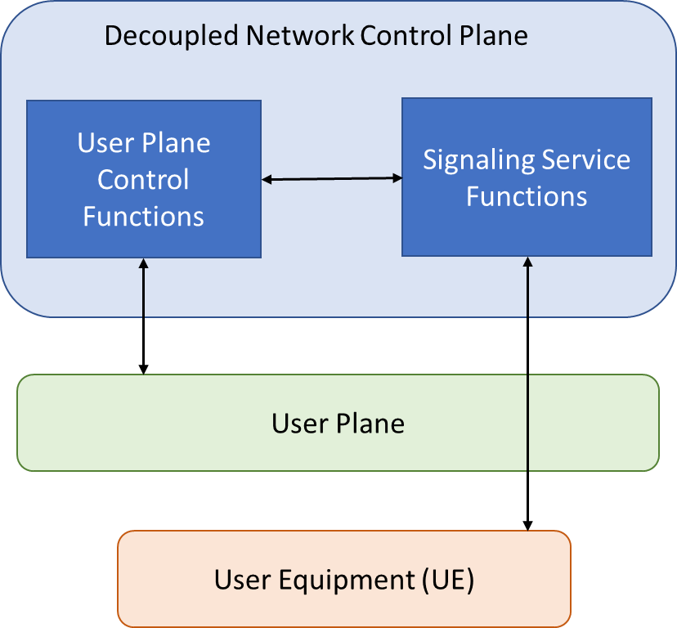
(a)

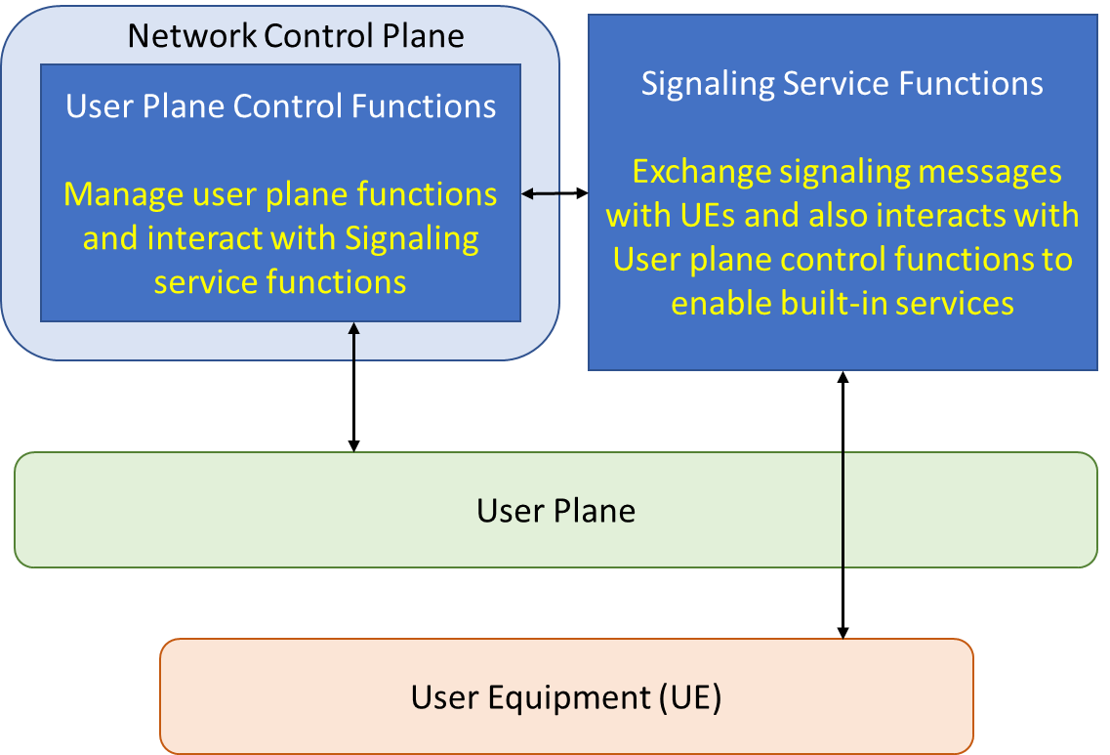
(b)

Figure 1: (a) Decoupling of user plane control functions and Signaling service functions. (b) Decoupled built-in service delivery architecture.

We propose new signalling service functions (Application Functions (AF)) to handle exchange of signaling messages with UEs. These signaling handlers (AF) are not part of the network control plane (SDN control layer) and communicate with the network control plane via standardized application-control interface. The network control plane (modified) shall contain only the user plane control functionality as shown in Figure 1(b). These signaling service (application) functions shall support certain services such as user authentication directly via exchange of signaling messages with UEs and also enable other services such as data transfer or user mobility by collecting relevant information (requirements) from UEs through signaling exchange and providing the information to the control plane to be used further for configuration of user plane functions in order to support the appropriate service-aware behaviour.
Apparently, once decoupled, these signaling service functions can also be treated like external application-based services. Similar to the Application service-based architecture for service delivery, the signaling related to a built-in service can be exchanged with a UE over a data path (i.e., a signaling path) by signalling service functions. The user plane control functions interact only with signalingservice functions (and not with a UE directly) and establish the required data path for a service, e.g., data session connectivity service or mobility etc.
This contribution proposes initiation of a new work item under the Q2/13 on “Architectural framework for NGN evolution by extending SDN paradigm in Network control plane”. A preliminary draft recommendation outlining the scope and the concept of an architectural framework along with procedural and performance aspects is annexed (Annexure-I).

_______________________

Annexure- I

Draft Recommendation ITU-T Y.xxxx:

Architectural framework for NGN evolution by extending SDN paradigm in Network control plane
Summary
Keywords
<Mandatory>
Introduction
<Optional – This clause should appear only if it contains information different from that in Scope and Summary>
The tasks performed by control plane functions within the network can be classified into tasks related to, i)handling signaling message exchange with User Equipment (UE) (Signaling control and management) and ii) those pertaining to control and management of User plane functions in the network. Control plane functions such as Network access control function and Session management function communicate with UEs using Non-Access Stratum (NAS) signaling and collect service (e.g., for establishment of data session) related requirements from them. At the same time, they are also responsible for network control tasks, such as establishment and modification of data sessions over the user plane functions in the core. Similarly, the control plane function in the access network exchanges signaling messages with UEs via Radio Resource Control (RRC) protocol and it also controls user plane functions in the access network. Note that the existing architecture does not distinguish between these two categories of tasks and considers both to be part of the control plane functionality. However, these are independent functionalities and can be decoupled from one another. On the basis of this concept, we present an architecture framework in this proposal along with basic procedures and performance evaluation.

1 Scope
The recommendation includes:
- Architecture to separate the UE-specific signaling exchange functionality from the user plane control functionality for NGN architecture based on the SDN paradigm and network service model;
- Information flow for services such as initial access, session establishment and registration; and
- Performance evaluation of the proposed architectural framework in terms of scalability and other parameters

2 References
The following ITU-T Recommendations and other references contain provisions, which, through reference in this text, constitute provisions of this Recommendation. At the time of publication, the editions indicated were valid. All Recommendations and other references are subject to revision; users of this Recommendation are therefore encouraged to investigate the possibility of applying the most recent edition of the Recommendations and other references listed below. A list of the currently valid ITU-T Recommendations is regularly published. The reference to a document within this Recommendation does not give it, as a stand-alone document, the status of a Recommendation.
[ITU-T X.yyy] Recommendation ITU-T X.yyy (date), Title.

3 Definitions
<Check in the ITU-T terms and definitions database at www.itu.int/go/terminology-database whether the term has already been defined in another Recommendation. It would be more consistent to refer to such a definition rather than to redefine the term>

3.1 Terms defined elsewhere
<Normally, terms defined elsewhere will simply refer to the defining document. In certain cases, it may be desirable to quote the definition to allow for a stand-alone document>
This Recommendation uses the following terms defined elsewhere:
3.1.1 <Term 1> [Reference]: <optional quoted definition>.
3.1.2 <Term 2> [Reference]: <optional quoted definition>.

3.2 Terms defined in this Recommendation
This Recommendation defines the following terms:
3.2.1 <Term 3>: <definition>.

4 Abbreviations and acronyms
This Recommendation uses the following abbreviations and acronyms:
<abbr> <expansion>
<Include all abbreviations and acronyms used in this Recommendation>

5 Conventions
In this Recommendation, requirements are classified as follows:
• The keywords "is required to" or “are required to” indicate a requirement/ requirement, which must be strictly followed and from which no deviation is permitted if conformance to this document is to be claimed;
• The keywords "is recommended" indicate a requirement, which is recommended but which is not absolutely required. Thus, such requirements need not be present to claim conformance; and
• The keywords "optionally" or "may" indicate an optional requirement which is permissible, without implying any sense of being recommended. These terms are not intended to imply that the vendor's implementation must provide the option; it means the vendor may optionally provide the feature and still claim conformance with the specification.

6 Concept of service-based architecture
To understand the concept of service-based architecture, let’s review how an application service is served in the network. Application service interacts with the network via standardized interfaces, both with the control plane as well as the user plane as shown in Figure 6x. For example, for content delivery, Application service provider sends the data to the user plane to be forwarded to the end-users (UEs). In addition, it also interacts with the network control plane via the separate interface for the establishment of the data session through the network to be used for data delivery. An important point to note here is that the Application Function (AF) may also need to interact with the UEs before setting up the data sessions. This signaling message exchange between the UE and AF provides the requirements to the AF for the data session to be established later (via network) to deliver the service to UEs. Here, the initial signaling exchange between the UE and AF also takes place over a data session established earlier, similar to the delivery of content via data session later. AF itself cannot set up the data session through the user plane of the network but requests the control plane through a standardized interface to set up the session through the user plane. A similar flow is applicable for different kind of external application-basedservices.

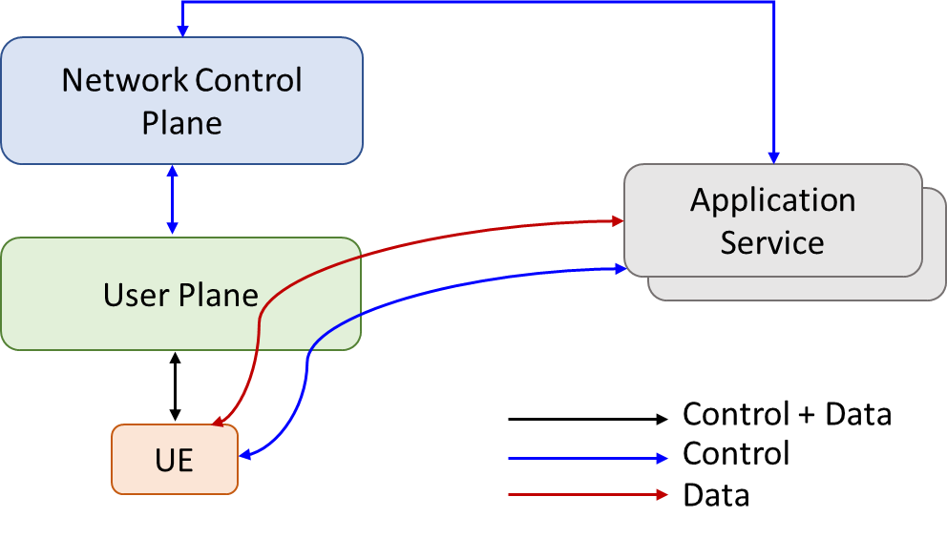
Figure 6x: Interfaces between an external application service provider and network (control plane and user plane).

As the application provider is decoupled from the network and accesses it via standardized interfaces to support the service delivery, the delivery of built-in services also can be handled in the same way. Based on this concept, we introduce a generalized SDN based network service model(shown in Figure 6y) for employing signaling functions as built-in service functions. The facilitation of a service to a UE may involve twosteps a) the collection of service requirements and b) the establishment of a path for service access. Interestingly, even collecting service-related requirements from a user may need establishment of a path through the network. In this recursive view, the user plane control functions (SDN Controller(s)) enable communication between a UE and a group of service functions. These service functions may trigger the user plane control functions using a separate module, called a ‘Service Orchestrator’ to enable additional services for the UE through establishment of supplementary data paths. Service Orchestrators, shown in Figure 6y, are responsible for orchestration of a service.

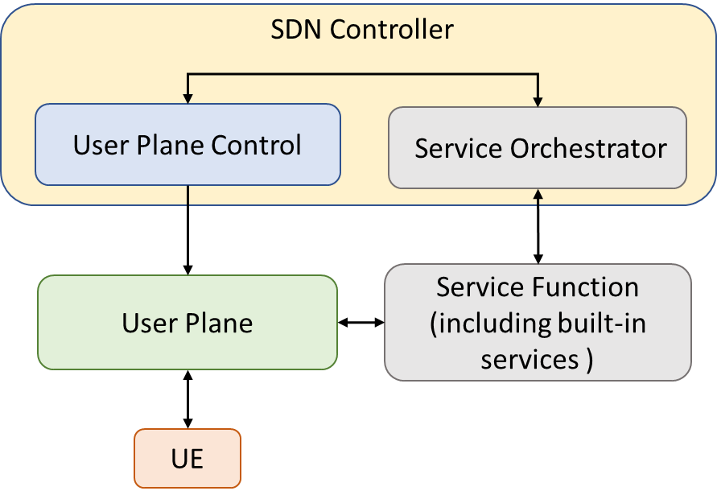

Figure 6y: Network service model based on SDN.

7 Functional Architecture
We propose to separate signalling control from the user plane control and further to treat UE-specific signaling as an Application Function (Service Function + Service Orchestrator). There are two approaches to implement this proposed concept in the functional architecture. In the first approach (as shown in Figure 7x), there are separate signaling service functions for Access network and Core network placed at Access network and Core network respectively. These two interact with each other through a new interface. Besides new interfaces need to be designed between user plane control and signaling service functions of Access network and Core network.
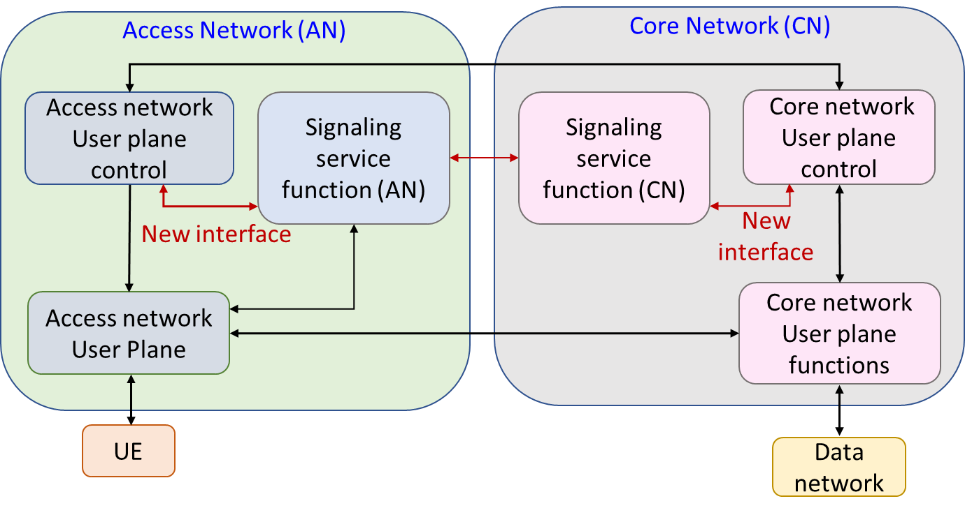
Figure 7x: Approach 1: Separate signaling service functions for Access network and Core network.

In the second approach as shown in Figure 7y, signalling service functions (for Core network and Access network) have been combined and placed together. This implementation can be useful in certain cases based on deployment scenarios
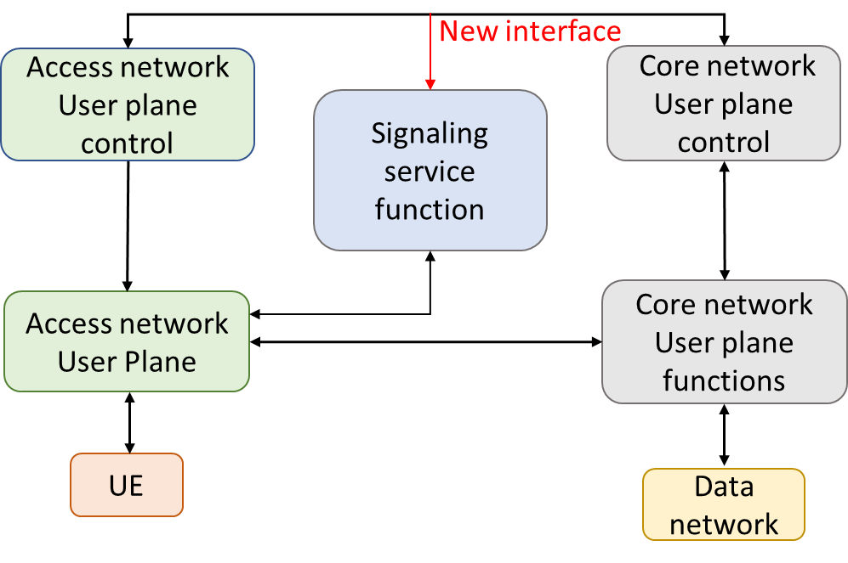
Figure 7y: Approach 2: Combined signaling service function for Access network and Core network.
These proposed functional architectures provide improved segregation of functionality in the network control plane. Signaling functions can be thought of as an application function in SDN architecture (Service Functions and Service Orchestrators). The tasks of these functions include collection of UE requirements (e.g., authenticate and authorize a UE), requirement for a data session through NAS messages, sending request to user plane control functions to setup data path through the network, and confirming back to the UE that the requirement has been met etc. Whereas user plane control functions act as the SDN Controller and sets up the data path through the network. The proposal is better aligned with SDN Principles and can serve various functionalities of the network in simplified and modular manner that is to be in explored further sections.

8 Information flows

<TBD>

9 Performance evaluation
<TBD>

10 Impact on handling of various services
<TBD>

A.1 Justification for proposed draft new Recommendation Y.xxx

Question: | 2/13 | Proposed new ITU-T Recommendation | Geneva, 04 July – 15 July 2022
Reference and title: | ITU-T Y.xxx " Architectural framework for NGN evolution for IMT-2030 by extending SDN paradigm to the Network control plane "
Base text: | Cn |  | Timing: | 202x-yy
Editor(s): | Rashmi Kamran, IIT Bombay (India), +91 9920122898, rashmi.kamran@iitb.ac.in  Pranav Jha, IIT Bombay (India), +91 9818017469, pranavjha@ee.iitb.ac.in  Shwetha Kiran, IIT Bombay (India), +91 9619739635, shwethak@iitb.ac.in  Ranjana Sivaram, Telecom Engineering Centre (TEC)  India, ranjana.sivaram@gov.in  Jyoti Roat, Telecom Engineering Centre (TEC)  India, jroat.91@gov.in  AbhayShanker Verma, Telecom Engineering Centre (TEC)  India, as.verma@gov.in |  | Approval process:
Scope (defines the intent or object of the Recommendation and the aspects covered, thereby indicating the limits of its applicability):
This document presents:
- An architecture to separate UE-specific signaling exchange functionality from the user plane control functionality for NGN architecture based on the SDN paradigm and the network services model;
- Information flow for UE services such as initial access, session establishment and registration; and
- Performance evaluation of the proposed architectural framework in terms of scalability and other parameters

Summary (provides a brief overview of the purpose and contents of the Recommendation, thus permitting readers to judge its usefulness for their work):
The tasks performed by control plane functions within the network can be classified into tasks such as: i) handling signaling message exchange with User Equipment (UE) (signaling control and management) and ii) those pertaining to control and management of user plane functions in the network. Control plane functions such as Network access control function and Session management function communicate with UEs using Non-Access Stratum (NAS) signaling and collect service (e.g., for establishment of data session) related requirements from them. At the same time, they are also responsible for network control tasks, such as establishment and modification of data sessions over the user plane functions in the core. Similarly, the control plane function in the access network exchanges signaling messages with UEs via Radio Resource Control (RRC) protocol and it also controls user plane functions in the access network. Note that the existing architecture does not distinguish between these two categories of tasks and considers both to be part of the control plane functionality. However, these are independent functionalities and can be decoupled from one another. On the basis of this concept, we propose an architecture framework along with basic procedures and performance evaluation.

Relations to ITU-T Recommendations or to other standards (approved or under development):

- Relationship with ITU-T Y.3300
This Recommendation provides a framework of Software-Defined Networking (SDN), in which control layer controls the behaviour of data transport and processing functions in the resource layer. However, the functionality of signaling exchange with end-users (UEs) is handled by the application/service layer. The proposed concept of decoupling UE signaling exchange from user plane control is an extension of the SDN framework in evolved NGN architecture which makes NGN architecture more aligned with the SDN principle.
- Relationship with ITU-T Y.2012
This Recommendation describes the functional requirements and architecture of the next generation network (NGN). This Recommendation covers functional entities (FEs) of the NGN and information flows across reference points of these functional entities. Existing NGN architecture in this recommendation does not distinguish between control of user plane (transport functions) and signaling exchange (with end-users or UEs) tasks and both of these are included as part of the "transport control functions”. Our proposal is an extension of the existing architecture to achieve improved alignment with SDN principles by decoupling these two categories of functionalities and separating them via a standardized interface. The proposal intends to treat the functionality of signalling exchange with end-users as a service.
- Relationship with ITU-T Y.3104
This Recommendation describes the architecture of IMT-2020 network from a functional perspective along with procedures for basic network services to be provided to end-users. It contains procedures for registration, connection management, session management and handover management. We aim to simplify these procedures by employing further decoupling of signalling exchange tasks with user plane control and also by enhancing modularity in the system by applying the proposed decoupling concept.
- Relationship with ITU-T Y.3101
This Recommendation describes requirements of the IMT-2020 network for overall non-radio aspects of the IMT-2020 network from both the service and network operation points of view. Our proposal is an effort to meet some of the requirements as highlighted in ITU-T Y.3101 such as “9.7 Efficient signaling” via alignment with principles provided in this recommendation. We anticipate that the requirements such as these are likely to find a place in beyond IMT-2020 network as well.
- Relationship with ITU-T Y.3102
This Recommendation describes the framework for overall non-radio aspects and key features of the IMT-2020 network along with architectural design considerations. It also includes detailing of basic network services such as registration management, connection management, session management, user plane management and handover management. These functionalities are handled by control plane. The framework provided in this recommendation supports clear separation of control plane and user plane. However, UE-network signaling exchange and user plane control functionalities are tightly coupled with each other and decoupling of these two categories of tasks have not been discussed in this recommendation.

Liaisons with other study groups or with other standards bodies:
ITU-T SG 11
Supporting members that are committing to contributing actively to the work item:
India (Republic of)

_______________________

