 | INTERNATIONAL TELECOMMUNICATION UNION  TELECOMMUNICATION  STANDARDIZATION SECTOR  STUDY PERIOD 2022-2024 |  |  |  | SG13-C0161
 |  |  |  |  | STUDY GROUP 13
 |  |  |  |  | Original: English
Question(s): |  |  | 20/13 |  | Geneva, 4-15 July 2022
CONTRIBUTION
Source: |  |  | Ministry of Communications, India
Title: |  |  | Draft new Recommendation Y.ML-IMT2020-SANDBOX “Architectural framework for Machine Learning Sandbox in future networks including IMT-2020”
Purpose: |  |  | Proposal
Contact: |  |  | Abhay Shanker Verma  Telecom Engineering Centre (TEC)  India | Tel: + 91 9999554900  E-mail: as.verma@gov.in
Contact: |  |  | Vijay Kumar Roy  Telecom Engineering Centre (TEC)  India | Tel: +91 7011000101  E-mail: vk.roy@gov.in
Contact: |  |  | Ranjana Sivaram  Telecom Engineering Centre (TEC)  India | Tel: +91 9868136990  E-mail: ranjana.sivaram@gov.in
Contact: |  |  | Vishnu Ram O.V.  Independent Consultant  India | Tel: +91 9844178052  E-mail: vishnu.n@ieee.org
Keywords: |  | Architecture; Requirements; Sandbox; Simulator
Abstract: |  | This contribution proposes modifications to thenew draft Recommendation Y.ML-IMT2020-SANDBOX “Architectural framework for Machine Learning Sandbox in future networks including IMT-2020”based on the changes agreed in Q20/13 e-meeting, 26-28 April 2022

Work plan for completion of this draft Recommendation (target for consent: July 2022 SG13 meeting)
- Confirmation (and completion for one of them) of all newly added definitions
- Review of clause 8.3(all sub-clauses)
- Resolution of all remaining Editor’s notes and highlights
- Final technical and editorial checking (e.g., consistency, more compact and shorter paragraphs, spelling of each acronym at the first time of its occurrence, NOTEs numberingand clauses renumbering -including cross-referencing- where needed) including Authors’ guidelines.

Proposal
This contribution proposes modifications/updates toSG13-TD4/WP1 of 2022-2024 study period and according to changes agreed in Q20/13 e-meeting, 26-28 April 2022.

Annexure-I

Draft new Recommendation ITU-T Y.ML-IMT2020-SANDBOX

Architectural framework for ML sandbox in future networks

including IMT-2020

Summary
This Recommendation provides anarchitectural framework formachine learning sandbox in future networks including IMT-2020. More precisely,it describes requirements and highlevel architecture for ML sandbox in future networks including IMT-2020.
Keywords
Future networks, machine learning, model, IMT-2020, sandbox.

Table of Contents
Architectural framework for ML Sandbox in future networks 3
including IMT-2020 3
Architectural framework for ML Sandbox in future networks 5
including IMT-2020 5
1. Scope 5
2. References 5
3. Definitions 5
3.1 Terms defined elsewhere 5
3.2 Terms defined in this document 6
4. Abbreviations and acronyms 7
5. Introduction 7
6. Requirements 8
6.1 Simulated ML underlay requirements 8
6.2 Operational requirements 9
6.3 Communication requirements 10
6.4 Metadata requirements 11
7. High-level architecture of the ML Sandbox 12
7.1 Components of the ML Sandbox 14
7.1.1 Simulated ML underlay networks 15
7.1.1.1 Simulated NF-s and AF-s 15
7.1.1.2 Model evaluation plug-ins 15
7.1.2 Simulation Manager 15
7.1.2.1 Simulation designer 15
7.1.2.2 Simulation composer 16
7.1.2.3 Monitoring agent 16
7.1.2.4 Simulation post-processor 16
7.1.3 Evaluation ML pipeline 16
7.1.4 Data handling 16
7.1.5 Inference engine 17
7.1.9 17
7.2 Sequence Diagrams 17
7.2.1 Capability discovery/negotiation for third-party simulation components 17
7.2.2 Monitor health 19
7.2.3 Validate input/output data 20
7.2.4 MLFO-triggered operations 20
7.2.5 Sandbox asynchronous messages 23
7.3 APIs 24
7.3.1 Capability discovery/negotiation request API 24
7.3.2 Monitor health reporting API 25
7.3.3 Input/Output validation reporting API 26
7.3.4 MLFO-triggered operations API 26
7.3.5 Sandbox asynchronous messages API 27

Draft new Recommendation ITU-T Y.ML-IMT2020-SANDBOX

Architectural framework for ML sandbox in future networks

including IMT-2020

1. Scope
This Recommendation providesan architecturalframework for the ML sandbox in the context of integrating machine learning in future networks including IMT-2020.ThisRecommendation provides requirementsand highlevelarchitecture of ML Sandbox. Architectural components along with corresponding reference points and APIs are specified.

2. References
The following ITU-T Recommendations and other references contain provisions which, through reference in this text, constitute provisions of this Recommendation. At the time of publication, the editions indicated were valid. All Recommendations and other references are subject to revision; users of this Recommendation are therefore encouraged to investigate the possibility of applying the most recent edition of the Recommendations and other references listed below. A list of the currently valid ITU-T Recommendations is regularly published. The reference to a document within this Recommendation does not give it, as a stand-alone document, the status of a Recommendation.
[ITU-T Y.3172] ITU-T Recommendation “Architectural framework for machine learning in future networks including IMT-2020”
[ITU-T Y.3173] ITU-T Recommendation “Framework for evaluating intelligence levels of future networks including IMT-2020”
[ITU-T Y.3174] ITU-T Recommendation “Framework for data handling to enable machine learning in future networks including IMT-2020”

[ITU-T Y.3176] ITU-T Y.3176“Machine learning marketplace integration in future networks including IMT-2020”
[ITU-T Y.3179] ITU-T RecommendationY.3179 “Architectural framework for machine learning model serving in future networks including IMT-2020”

3. Definitions

3.1Terms defined elsewhere

This Recommendation uses the following terms defined elsewhere:
3.1.1 machine learning model [ITU-T Y.3172]: model created by applying machine learning techniques to data to learn from.
3.1.2 machine learning pipeline [ITU-T Y.3172]:a set of logical nodes, each with specificfunctionalities, that can be combined to form a machine learning application in a telecommunicationnetwork.
3.1.3 machine learning sandbox [ITU-T Y.3172]: an environment in which machine learning modelscan be trained, tested and their effects on the network evaluated.
3.1.4 machine learning function orchestrator [ITU-T Y.3172]: A logical node with functionalities that manage and orchestrate the nodes in a machine learning pipeline.
3.1.5 machine learning marketplace [ITU-T Y.3176]: a component which provides capabilities facilitating the exchange and delivery of machine learning models among multiple parties. NOTE 1 – Examples of parties include suppliers and users of ML models. Capabilities provided to users of ML models include functionalities to find, learn about, deploy (or download) and use ML models. Capabilities provided to suppliers of ML models (e.g. data scientist) include functionalities to share (on-board, upload), describe (learn about) and market their ML models.
NOTE 2 – A network operator may use a machine learning marketplace deployed internally and/or externally to the network operator’s administrative domains. Internal and external marketplaces differ only in the deployment perspective. A marketplace which is internal to a network operator may act as an external marketplace to another network operator and vice versa.

3.1.7 machine learning model metadata [ITU-T Y.3176]: information which describes the characteristics of a machine learning model.
NOTE – Machine learning (ML) model metadata include, but is not limited to, name of the ML model, ML model’s author, version of the ML model, license information of the ML model, description of the data inputs and outputs of the ML model and runtime environment of the ML model.
3.1.8 network intelligence level [ITU-T Y.3173]:Level of application of automation capabilities including those enabled by the integration of artificial intelligence techniques in the network.
3.1.9 ML model serving [ITU-T Y.3179]: A process of preparing and deploying machine learning models in different deployment environments to enable the application of model inference to machine learning underlay networks.

3.2Terms defined in this document

3.2.2 evaluation ML pipeline: chaining of pipeline nodes and simulated NFs with served ML models whose goal is to evaluate a particular ML use case.
3.2.3 simulation component metadata: data describing the characteristics of a particular simulation component.
NOTE–Examples of simulation component metadata are capabilities of simulated NFs, configurable parameters, performance indicators and monitored parameters, interfaces.
3.2.4 simulation environment metadata: data describing the characteristics of a particular simulation environment.
NOTE 1 – Simulation environment metadata can contain information such as installation/execution requirements, simulation component metadata,performance indicators, connections, maturity indicators (alpha/beta versions), etc.
NOTE 2 – Examples offormat for representing simulation environment metadatacan be JSON [b-JSON], CSV [b-CSV], or XML [b-XML].

3.2.5 simulation profile: a list of parameters and their values which describe the ML use case to be trained, evaluated, or tested at the ML sandbox.
NOTE – The list of parameters and their values may be derived from ML intent [ITU-T Y.3172]and simulation environment metadata.

4. Abbreviations and acronyms
This Recommendation uses the following abbreviations and acronyms:
AF Application Function
AI Artificial Intelligence
AP Access Point
API Application Programming Interface
DBr Data Broker
DH Data handling
DM Data Model
KPI Key Performance Indicator
ML Machine Learning
MLFO Machine Learning Function Orchestrator
NF Network Function
OAM Operation Administration and Maintenance
RL Reinforcement Learning
SL Supervised Learning
UL Unsupervised Learning

5. Conventions
In this Recommendation:
The keywords "is required to" indicate a requirement which must be strictly followed and from which no deviation is permitted, if conformance to this Recommendation is to be claimed.
The keywords "is recommended" indicate a requirement which is recommended but which is not absolutely required. Thus, this requirement need not be present to claim conformance.
The keywords "can optionally" indicate an optional requirement which is permissible, without implying any sense of being recommended. This term is not intended to imply that the vendor's implementation must provide the option, and the feature can be optionally enabled by the network operator/service provider. Rather, it means the vendor may optionally provide the feature and still claim conformance with this Recommendation.

6. Introduction
The integration of AI/ML has been identified as one of the key features of future networks. However, network operators have the challenge of maintaining the operational performance and associated key performance indicators during or after this integration. In addition, the introduction of machine learning (ML) techniques to IMT-2020networksmay raise concerns regarding transparency, reliability, and availability of ML methods, techniques and data.
Studying the tradeoffs, advantages and disadvantages while integrating various ML mechanisms is important to understand the impact on the network. For example, reducing the generalization error is the main concern on applying any kind of supervised learning (SL) approach, which can be high even if the test error is kept low (this phenomenon is commonly known as overfitting). Similarly, unsupervised learning aims to find patterns from data without any guidance (unlabelled data) and hence lacks validation. On the other hand, RL is based on the learning-by-experience paradigm.RL has been shown to be of great utility for single-agent approaches in controlled scenarios, however notable adverse effects can appear as a result of the competition raised by multiple systems sharing the same resources (e.g., while providing heterogeneous services usingcommon network resources).
Thus, all kinds of learning can lead to unexpected and/or undesired behaviour of live network. Even if the performance of networking systems can be improved by ML techniques in the long-term, it is safe to assume that the system will unavoidably experience certain performance degradation during a transitory regime.In some situations, this degradation to KPIs may be unacceptable for network operators, especially for demanding requirements of certain network-oriented applications such as ultra-reliable low-latency communication (uRLLC) applications. In other cases, the network may change quickly and may not reach a stable, long-term regime that is entailed to optimize the network’s performance.
NOTE- The transitory regime precedes the stability phase of an ML model when applied to a network. Performance degradation can result from potential delays in serving models in the network, or from trying suboptimal configurations during exploration periods in online learning.
Given the instability that ML methods can generate to networking systems (especially the ones based on exploration-exploitation), the sandbox subsystem[ITU-T Y.3172] emerges as a promising solution for training, testing and evaluating the performance of ML models before being deployed in live environments. The ML sandbox is an isolated environment in which machine learning modelscan be evaluated.The ML sandboxis therefore meant to reproduce the behaviour/operation of live networking systems, thus improving the robustness and resilience of future ML-enabled networking systems. ML sandboxincludes a managedtest network (e.g., a testbed) or a software-based environment (e.g. using a simulator/emulator), including simulators, emulators, and models. In this regard, network simulators can be particularly useful to overcome the limitations of limited training data sets and laboratory-based testbeds. Simulators can be used to frame cases that have not been noticed before (i.e., anomalies), which would contribute to enabling failure prediction, anomaly detection, and self-healing.
Through the management subsystem, network operators can managethe ML Sandbox and thereby address the challenges posed by ML-driven solutions for networks. The interfaces between the MLFOand the ML sandbox allow the manageability of the simulation, the execution of test cases, andthe evaluation of ML models.

7. Requirements
The requirements forthe ML sandbox’s architectural framework are divided into the following broad categories:
- Simulated ML underlay requirements
- Operational requirements
- Communication requirements
- Metadata requirements

7.1 Simulated ML underlay requirements

REQ-ML-SANDBOX-001:The ML sandbox is required to simulate heterogeneous sources of data (SRCs) and sinks (SINK) of ML output.
NOTE – SRCs and SINKs simulated in the ML Sandbox include those within the IMT-2020 network as well as application functionalities hosted in network slices. Examples of application functionalities hosted in network slices are V2X applications, Industry 4.0 applications, emergency applications.
REQ-ML-SANDBOX-002:The ML sandbox is required to support the dynamic instantiation of new simulated SRCs and/or SINK nodes.
NOTE- Instantiation of new simulated SRCs and SINK nodes is managed by MLFO.
REQ-ML-SANDBOX-003:The ML sandbox is required to consider policy inputs from the operatorwhile configuring the simulated ML underlay networks.
NOTE x - Examples of policy inputs are those related to conflict resolution and resource management.
REQ-ML-SANDBOX-004:The ML sandbox is required to enable coordinated time synchronization of operations executed in ML Sandbox as required by the specific use case.
NOTE x– The time synchronization may be coordinated by the MLFO by controlling the sequence of operations executed in the ML sandbox.The sequence of operations triggered by the MLFO may be according to the synchronisation requirements of the specific use case. Example of sequence of operations triggered by the MLFO is, generation of data by RAN specific simulator which is input into corresponding ML model as SRC, followed by analysis in the ML model, and finally application of ML inference into specific simulators for SINK.
REQ-ML-SANDBOX-005: The ML sandbox is recommended to consider the quality of data needed for ML models (training or testing) while generating the simulated data.
NOTEx - Quality of data depends on the use case requirements. The requirements on the quality are input in the Intent. Examples are alignment and similarity with live network, including UE capabilities, granularity of reported UE measurements, frequency of channel measurements, accuracy of measured parameters, etc.
REQ-ML-SANDBOX-006:The ML sandbox is recommended to support demand mapping [ITU-T Y.3173] for configuring and updating the simulated ML underlay networks.
NOTE 4 – Demand mapping is achieved by continuous, run-time, matching of the Intent with the configuration options provided by the simulated ML underlay network. The configuration of the simulated ML underlay networks may be continuously adjusted based on demand mapping.
NOTE 5 – Demand mapping may beimplemented through the analysis of data patterns and ML pipeline output and corresponding optimization of simulated ML underlay networks.
REQ-ML-SANDBOX-007:The ML sandbox is required to provide sanity checks to assess the correct operation of the simulated ML underlay networks.

7.2 Operational requirements

REQ-ML-SANDBOX-008:The ML sandbox is required to support multiple evaluation ML pipelines, which may be chained and interfaced with simulators from different levels of the network.
NOTE 1 – Network levels are defined in [ITU-T Y.3172].
REQ-ML-SANDBOX-009:The ML sandbox is required to support the monitoring and evaluation of ML pipelines and simulation components according to specifications in the ML intent.
NOTE 2 – Examples may include threshold-based asynchronous notifications from the ML sandbox (to the MLFO), post-processing of ML output, metering, security threat analysis, etc.
REQ-ML-SANDBOX-010:The ML sandbox is required to support testing and evaluation of multiple ML pipelines at the same time, including aggregated impacts on the network due to them.
NOTE 3 – For example, different ML pipelines may use different type of models (e.g., based on reinforcement learning (RL) and supervised learning (SL)). The type of modelmay be decided by the MLFO based on the use case. Simultaneous evaluation of the different ML pipelines may be triggered for addressing a ML use case. The outputs of these ML pipelinesmay becompared to make an optimal decision.
REQ-ML-SANDBOX-011:The ML sandbox is required to support training and testing ML models that combine simulated and real data from the network.
NOTE 4 –The choice of data to be used is managed by the MLFO[ITU-T Y.3172].
NOTE 5 – The combination of simulated and real data may also include augmented data.
REQ-ML-SANDBOX-012:The ML sandbox is required to support dynamic resource management for ML pipeline nodes instantiated in the ML sandbox.
NOTE 6 –The instances of ML pipeline nodesin the ML sandbox (e.g., simulated SRC node) may need resource management mechanisms like dynamic resource allocation. The ML sandbox may usevarious request handling mechanisms like load balancing towards ML pipeline nodes (e.g., ML model) in the ML sandbox.
REQ-ML-SANDBOX-013: The ML sandbox is required to enable granular evaluation of ML test cases.
NOTE 7 –In case of batch jobs (combined test cases) which are triggered by the ML sandbox, isolation of problems found in the evaluation stage need granular information on the specific test case which failed. The ML sandbox is needed to enable such granular evaluation.
REQ-ML-SANDBOX-014: The ML sandbox is required to support monitoring and evaluating network intelligence level.
NOTE 8 – See [ITU-T Y.3173] for monitoring and evaluating network intelligence level.
REQ-ML-SANDBOX-015:The ML sandbox is required to support testing techniques to enhance the robustness of the ML pipelines.
NOTE 9 – Examples of testing techniques include Generative Adversarial Networks (GANs)[refXXX] for testing ML models, data generation techniques for ensuring quality and augmentation of simulated data, simulation of failure scenarios or rare scenarios for ML model training.
REQ-ML-SANDBOX-016: The ML sandboxis required to produce output of simulations, tests, and evaluations in machine-readable format.

7.3Communication requirements

REQ-ML-SANDBOX-017:The ML sandbox is required to support data handling reference points towards technology-specific simulated ML underlay networks.
NOTE 1 – Data handling reference points are defined in [ITU-T Y.3174].
REQ-ML-SANDBOX-018:The ML sandbox is required to support the transfer of trained models across the different ML pipelines in the sandbox as well as to other subsystems in the ML overlay.

NOTE 2 - Application and reuse of trained models from the ML sandbox for many use cases are examples of scenarios where transfer of trained models across different ML pipelines in the ML sandbox is required. Transfer and deployment of trained models in live network to enable specific use cases is an example of scenario which requires transfer of trained models from the ML sandbox to other ML overlays.

REQ-ML-SANDBOX-019:The ML sandbox is required to support the transfer of data for training or testing models across different ML pipelines in the Sandbox as well as to other ML overlays.

REQ-ML-SANDBOX-020:The ML sandbox is required to support interfaces with ML marketplaces to transfer ML models.
NOTE 2 – See reference point 13 in [ITU-T Y.3176] for the interface between ML marketplaces and the ML sandbox. This interface serves both in the downlink (e.g., download models) and the uplink (e.g., update models).
REQ-ML-SANDBOX-021: The ML sandboxis required to support data handling mechanisms including metadata store, communication interfaces with data models (DM) and ML underlay networks, and data storage.
NOTE 3 – See [ITU-T Y.3174] for data handling mechanisms.

7.4 Metadata requirements

REQ-ML-SANDBOX-022:The ML sandbox is recommended to reuse the ML metadata store acrossdifferent ML underlay network to allow interworking between evaluation ML pipelines and simulated ML underlay networks.
NOTE 1 – API-gis stored in the management subsystem to allow the training, testing, and evaluation of MLmodels in the simulated ML pipeline [ITU-T Y.3174].
NOTE 2 – DM and corresponding API-s used in the simulated ML underlay network are stored in the management subsystem to allow the interworking between the data broker (DBr) and the simulated NFs [ITU-T Y.3174].
REQ-ML-SANDBOX-023:The ML sandbox is recommended to derive the simulation profile from ML intent inputs from the MLFO along with the simulation environment metadata and use it to configure and update the simulated ML underlay networks.
NOTE3 –Simulation profile may include a list of parameters and their values which describe the ML use case to be trained, evaluated, or tested at the ML sandbox.The MLFO can provide ML intent inputsofflineor runtime, based on triggers.
NOTE 4- Simulation environment metadata describes the parameters of each simulator. This is provided by the simulation designer.
REQ-ML-SANDBOX-024:The ML sandbox is recommended to use ML model metadata from the ML Marketplace to adjust the simulated ML underlay networksand the evaluation scenarios.
NOTE 5 – For instance,the limitations of algorithms in terms of the amount of data (e.g., unsupervised learning) should be input as the amount of data to be generated (e.g., the number of access points (AP) to be simulated, total simulation time, minimum number of events, etc.).
REQ-ML-SANDBOX-025:The ML sandbox is required to support simulation environment metadata.
NOTE 6 – Simulation environment metadata can be provided to the serving frameworkfor considering the deployment environment while creating aninferenceengine (see clause 8.1.3in [ITU-T Y.3179]).
NOTE 7 – Simulation environment metadata includes the data models used by simulated NFs and APIs to access these data.
NOTE 8 – Simulation environment metadata can be used by the data handling (DH) to select the type of storage of data (REQ-ML-DH-011 in [ITU-T Y.3174]).
REQ-ML-SANDBOX-024: The ML sandbox is recommended to support isolation between different instances of evaluation ML pipelines (instantiated for different ML underlay networks).
NOTE 9 – Examples of reasons for isolation aresecurity, data privacy reasons and support for slicing, etc.

8. High-level architecture
Editor’s note: it is needed to clarify the architecture sub components which satisfy the requirements in clause 7 (Specifically for Requirements 006- demand mapping and Requirement 004-Ttime synchronisation related).
8.1 ML sandbox within the high-level ML architecture

Tosimulate ML underlay networks, the MLsandbox includes simulated NFs, application functions (AF), and ML pipeline(s) whose elements are managed by the Machine Learning Function Orchestrator (MLFO) [ITU-T Y.3172]. The ML Sandbox is particularly useful to address dynamic networking systems since it allows validating the effect of ML-based optimizations before being deployed in production environments. Besides, because of the potential limitations of data coming from live networks (insufficient amount, privacy issue, etc.), the ML Sandbox can be used to generate synthetic data as a complement for a given training procedure.

Figure 1provides the high-level architecture showingthe main involved componentsand the ML sandbox.

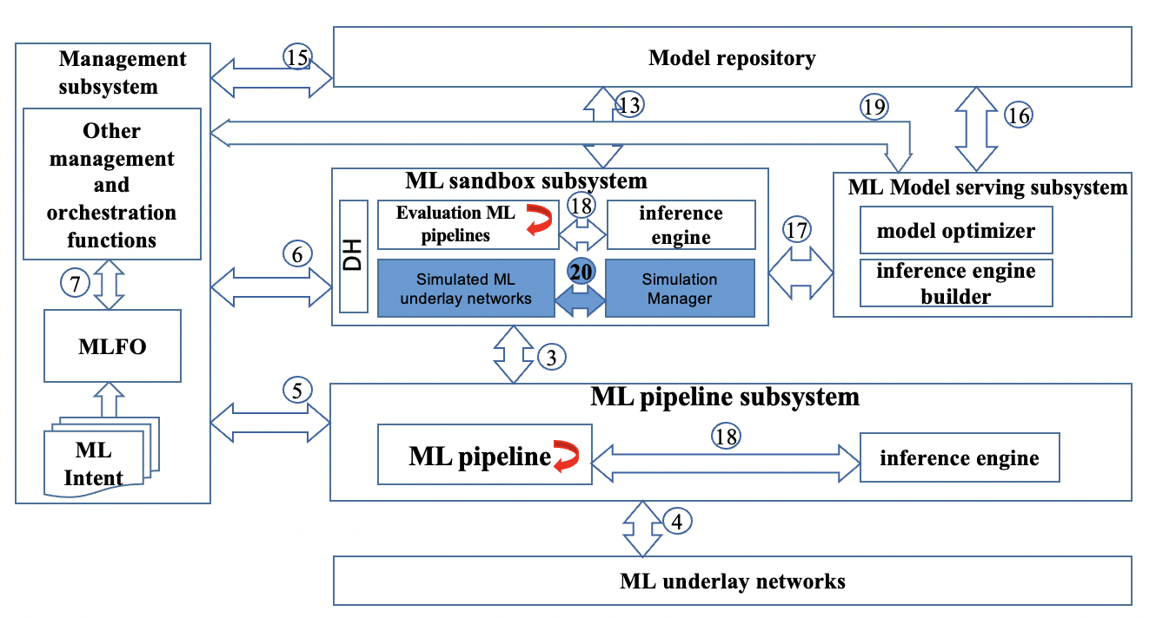
Figure 1:ML sandbox within the high-level ML architecture
Editor’s note: summary description of figure 1 is needed here. To be completed.
Editor’s note: detailed description of reference points should be considered for a following clause after current clause 8.1 or directly enhancing current clause 8.1.

See clause 8.2 for further details regarding the ML sandbox architectural components shown in Figure 1.
The reference points shown in Figure 1 are as follows:

Reference points 1 and 2, act as internal reference points within the ML sandbox subsystem,between the simulated ML underlay networks and the evaluation ML pipeline, are used unmodified as defined in [ITU-T Y.3172], for training and update of ML models at the ML Sandbox subsystem.
Editor’s note – to add reference point 1 and 2 in the figure.
Reference point 3 is the reference point between ML Sandbox and ML pipeline subsystems [ITU-T Y.3172]. Itallows the ML pipelines to interface with the ML Sandbox subsystem for training and update of ML models. It is used only as a Model management interface as described in [ITU-T Y.3179].
Reference point 4, as defined in [ITU-T Y.3174], is the interface between the ML pipeline and the ML underlay network.Itis used for transfer of data between the ML underlay network and the (evaluation) ML pipeline instantiated in the ML Sandbox (See Clause XX in [ITU-T Y.3174]). Data from the ML underlay networks and/or the simulated ML underlay networks may be used to train the ML models in the ML Sandbox subsystem.
Reference point 5, as defined in [ITU-T Y.3172], is the interface between the Management subsystem and the ML pipeline subsystem.
Reference point 6is used for the management subsystem to manage the models applied to the ML Sandbox [ [ITU-T Y.3172], including monitoring and evaluating network intelligence levels [ITU-T Y.3173].Reference point 6 has two parts:
- Reference point 6.1 [ITU-T Y.3174] is the interface between the management subsystem and the simulated ML underlay network to orchestrate and manage simulated ML underlay networks.
- Reference point 6.2 interfaces the management subsystem with the evaluation ML pipeline to orchestrate and manage evaluation ML pipeline.

NOTE x - Data from the ML underlay networks and/or the simulated ML underlay networks may be used to train ML models in the ML Sandbox subsystem.
[Editor Note: 6.2 is new, there is no reference for 6.2 in Y.3176 or Y.3179, cross check the role of 6.2 in this doc as per the sequence diagrams below.]
Reference point 7is the interface between MLFO and other management and orchestration functions of Management subsystem, used unmodified as defined in [ITU-T Y.3172].
Reference point 13 is the interface between ML marketplace and the ML Sandbox subsystem, used unmodified as defined in [ITU-T Y.3176].
Reference point 15 is the interface between the management subsystem and the ML marketplace, used unmodified as defined in [ITU-T Y.3176].

Reference point 16is the interface between ML model serving subsystem and model repository, used unmodified as defined in [ITU-T Y.3179].
Reference point 17is the interface between ML sandbox subsystem and ML model serving subsystem, used unmodified as defined in [ITU-T Y.3179].
Reference point 18is the interface betweenevaluation ML pipeline and the inference engine, used from[ITU-T Y.3179].
Note: The evaluation ML pipeline referred here is same as ML pipeline in ML sandbox subsystem in [ITU-T Y.3179].
Reference point 19is the interface between the management subsystem and the ML model serving subsystem, used unmodified as defined in [ITU-T Y.3179].
Reference point 20is the interface betweenthe simulated ML underlay networks and the simulation manager used for managing the simulated ML underlay networks See Clause 7.1 for more details.
–

8.2Components of the ML Sandbox
The ML Sandbox contains thecomponents defined in the following sub-clauses.The high-level architecture of the ML Sandbox subsystem is illustrated inFigure 2.
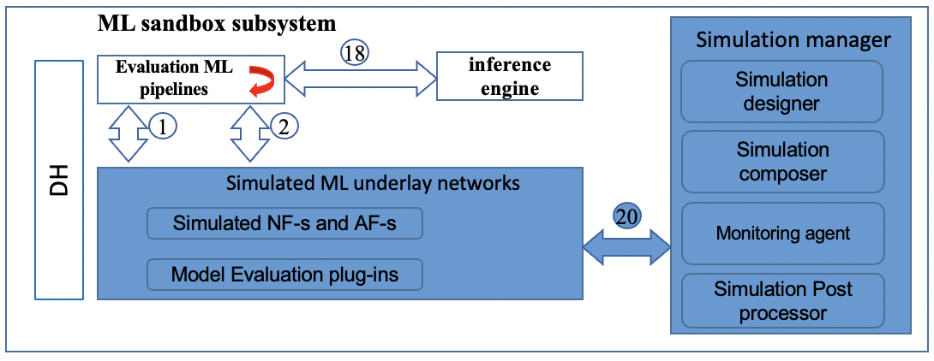
Figure 2: High-level architecture of the ML Sandbox components within the ML architecture.

Editor’s note: to align the description of this clause with the updated figure 2

8.1.1 Simulated ML underlay networks
Simulated ML underlay networks componentis reused from [ITU-T Y.3172]. As explained in [ITU-T Y.3172], ML sandbox can use data generated from simulated ML underlay networks(obtained via Reference Points 1 and 2), and/or live networks(obtained via Reference Point 3),for training or testing of ML Models.
In this document, two sub components of Simulated ML underlay networks are introduced, Simulated NF-s and AF-s, and Model evaluation plug-ins.
NOTE x–Example of a Simulated NF is athird-party simulation tool such as ns-3 [TBD].

8.1.1.1 Simulated NF-s and AF-s
As explained in [ITU-T Y.3174], simulated NF-s and AF-s provide SRC and SINK functionality. In this document, these SRC and SINK are used for training and testing of the evaluation ML pipelines.

8.1.1.2Model evaluation plug-ins
Model evaluation plug-insare responsible for evaluating the performance of ML models as per the requirements defined in the use case. The plug-ins interact with the simulated NF-s and AF-s using technology-agnostic interfaces, which would enable interacting with heterogenous third-party applications such as network simulators and collect ML Model evaluation parameters.
NOTE – Examples of ML model KPIs are model accuracy, recall and precision. Other parameters evaluated could be inference latency and memory footprint. These parameters are to be specified in the use case description (ML Intent).

8.1.2 Simulation Manager
The simulation manager manages the simulated ML underlay networks, specifically consisting of the following subcomponents - Simulation designer, Simulation composer, Monitoring agent, Simulation post-processor.

8.1.2.1Simulation designer
Based on the input from MLFO regarding the simulation requirements for the use case, the simulation designer prepares the set of simulation resources, that compose the simulated ML underlay, corresponding to the ML use case.
NOTE – The information to designsimulated ML underlays can come from the use case (ML Intent) or data gathered by the live ML underlay.
NOTE x- Example-1: In a traffic steering use case, ML models may be applied to predictively manage the resource allocation in the network. Simulation designer arrives at the simulation needs for this use case which may include data generation and simulated resource management mechanisms and corresponding parameters and configurations.
NOTE x- Example-2: As a result of network dynamics, some path-loss parameters used by the ML Sandbox subsystem may vary over time. To address this issue, the MLFO keeps track of those changes and provides feedback to the Simulation designer to update the necessary simulation parameters.

8.1.2.2 Simulation composer
The simulation composeruses the design from the Simulation designer, identifies the specific simulation components to use for the use case. It takes as input the configurations and KPIs as specified in the use case. Simulation composer then deploys, installs and instantiates the simulated ML underlay components (NF-s, AF-s, and model evaluation plug-ins) to be used for simulating different types of network underlays and evaluating various types of ML models.
NOTE 1 – Based on the specified role and requirements of the simulation (derived from use cases), the simulation composermay indicate the best simulation tool (e.g. specific implementation of RAN simulator).

8.1.2.3Monitoring agent
Monitoring agent monitors and evaluates the simulations in the ML Sandbox.
In addition to the use case specific parameters obtained from MLFO, the following five dimensions are considered [ITU-T Y.3173]: demand mapping, data collection, analysis, decision, and action implementation.
Monitoring of data collection, action implementation and analysis is done by the monitoring agent(see clause 8.3 [ITU-T Y.3173]).

8.1.2.4 Simulation post-processor
Simulation post-processor provides an interfacewherebydata from simulated ML underlays are post-processed and presented in a standard-compliant manner to the MLFO, which performs model evaluations and/or (re)training. This step is critical to handle heterogeneous sources of information.
NOTE – for instance, once the handler gets the raw logs generated by a simulator (e.g., a CSV file), the post-processor extracts the information to be used by the MLFO.

8.1.3Evaluation ML pipeline
Evaluation ML pipeline is used for model evaluation in the ML sandbox environment as described in [ITU-T Y.3172].
NOTE – The evaluation ML pipeline is similar to live ML pipeline except that it uses simulated ML underlay network instead of live ML underlay network. For example, both evaluation ML pipeline and live ML pipeline uses reference point 4 and reference point 5 and reference 6.2 (as discussed above).

8.1.4 Data handling
Data handling (DH) provides functionality for storage of data models and data for simulated ML underlay networks, used unmodified as defined in [ITU-T Y.3174].Components of DH as defined in [ITU-T Y.3174] are instantiated in the ML Sandbox subsystem. Reference points 1 and 2 are reused from ITU-T Y.3172 and ITU-T Y.3174 between evaluation ML pipelines and Simulated ML underlay networks.
NOTE x- DH is shown here for completeness. The role and interactions with DH remains the same as defined in Y.3174, with the only difference of evaluation ML pipelines, which is treated in this document.

8.1.5Inference engine
The inference engine provides ML model inference capability for ML pipeline(s), used unmodified as defined in[ITU-T Y.3179].

8.2Sequence Diagrams

8.2.1 Capability discovery/negotiation for third-party simulation components
Simulation components provided by third parties can be used to perform use-case specific simulations in ML Sandbox. This procedure enables discovery ofsuch simulation components stored inthird party repositories. The sequence diagram is shown in Figure 3.
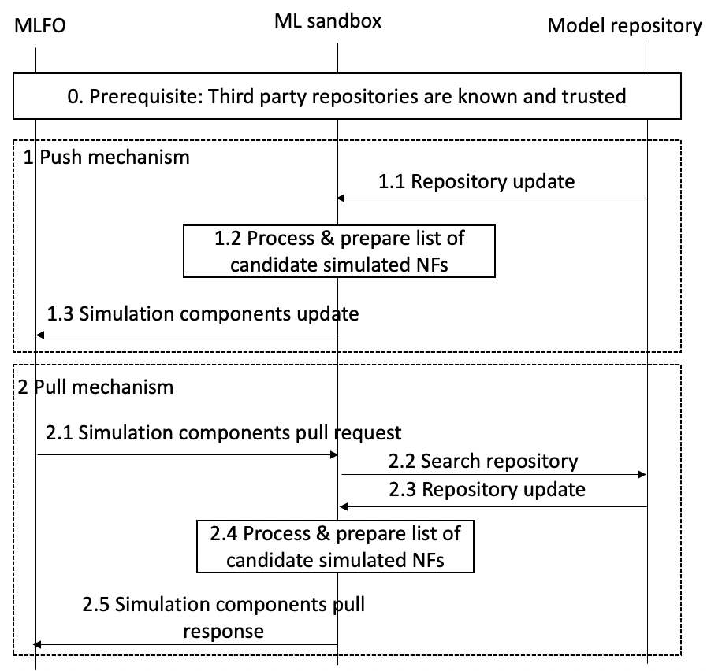
Figure 3: Sequence diagram of Capability discovery/negotiation for third-party simulation components
(Editor’s note: Step 1.3, 2.1 and 2.5 should be satisfied by ref point 6- to be checked.
Similarly, to be checked for other reference points and steps.

Prerequisite: MLFO knows the list of 3rd party repositories, offline configured, trusted, secure channels. Simulation components in the repositoriesare described using simulation environment metadata.
Two methods are considered according to the type of notification. The steps in the figure 3 are explained below.
1. Push mechanism
This includes the following steps as shown in figure 3
1.1 Third party simulator repositories push their simulation components to the ML Sandbox. These are to be evaluated in the ML Sandbox in combination with the Model evaluation plug-ins. Further component updatescan also be pushedto the ML Sandbox as and when a third party simulation repository(e.g.ns-3) releases specificfeatures(e.g. MIMO support).
  - Information from the push message is processed to preparean updated list of candidate simulated NFs for evaluation in the ML Sandbox.
1.3 The corresponding updatedsimulation components arepublished to trusted MLFOs.
2 Pull mechanism
This includes the following steps as shown in figure 3:
2.1 MLFO queries the ML Sandbox for simulation capabilities based on simulation environment metadata.
2.2 The ML Sandboxsendsthe query to trusted third-party simulation component repositories.
2.3 Repositories respond with a list of simulation components matching the query.
2.4 Information from the response message is processed to prepare an updated list of candidate simulated NFs for evaluation in the ML Sandbox.
2.5 The corresponding updatedsimulation components are published to trusted MLFOs.

Based on the use case requirement and the result of push or pull mechanism, MLFO arrives atcandidate simulation environments (list of NFs, simulation components, corresponding configurations, connections, data handling adaptors). From the candidate simulation environments provided by MLFO, operator selects an optimal configuration and deploys it in the ML Sandbox.
In addition, data handling and other underlay changes are also applied based on the selected configuration.
NOTE 1 – Simulation resources in the repositories are described using simulation environment metadata.
NOTE 2 – Example ofthird party simulated NF is ns-3,used to simulate a specific deployment of IEEE 802.11ac WLANs.
NOTE 3 – Based on the use case requirements, the list of potential NFs is decided. NFs can have associated information (as part of simulation environment metadata) such as “running time”, “billing aspects”, “accuracy”, etc.

8.2.2Health monitoring
Health monitoring is meant toensure the proper behaviour of the simulation components in the ML Sandbox. The sequence diagram is shown in Figure 4.
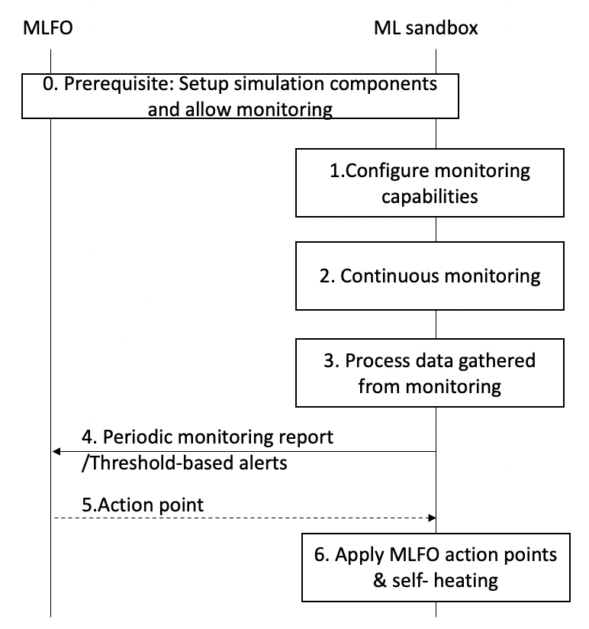
Figure 4:Health monitoring
[Prerequisite] Simulation components have been setup andthe ML intentallows for monitoring simulation components.
- ML Sandbox sets up the resources for monitoring of simulation components through the Simulation designer.
- Monitoring is carried out based on continuous flow of data generated by simulation components, including simulation data (SRC & SINK nodes), regression tests, reporting from simulation modules, etc.
- Data gathered from monitoring is processed and delivered in the form of reports.
- Periodic reports are generated and sent to the MLFO, according to ML intent specification. Alternatively, threshold-based alerts can be activated when undesired events occur, which are also reported to MLFO.
- MLFO may take action after processing periodic reports or threshold-based alerts (covered in “Manage simulated ML underlay”) and optionally send action points to ML Sandbox.
- ML Sandbox applies action points (if any) suggested by MLFO and/or self-healing actions.

8.2.3 Validate input/output data
In this scenario, input data and simulated output data is validated. This includes checking of feasibility of training models, accuracy of generated data, etc. For instance, testing techniquessuch as equivalence partitioning or centroid positioning can be applied to validate the diversity and the quality of the data generated by simulators.
NOTE- E.g.it is necessary to validate the synthetic data generated byGANs.
The sequence diagram is shown in Figure 5.
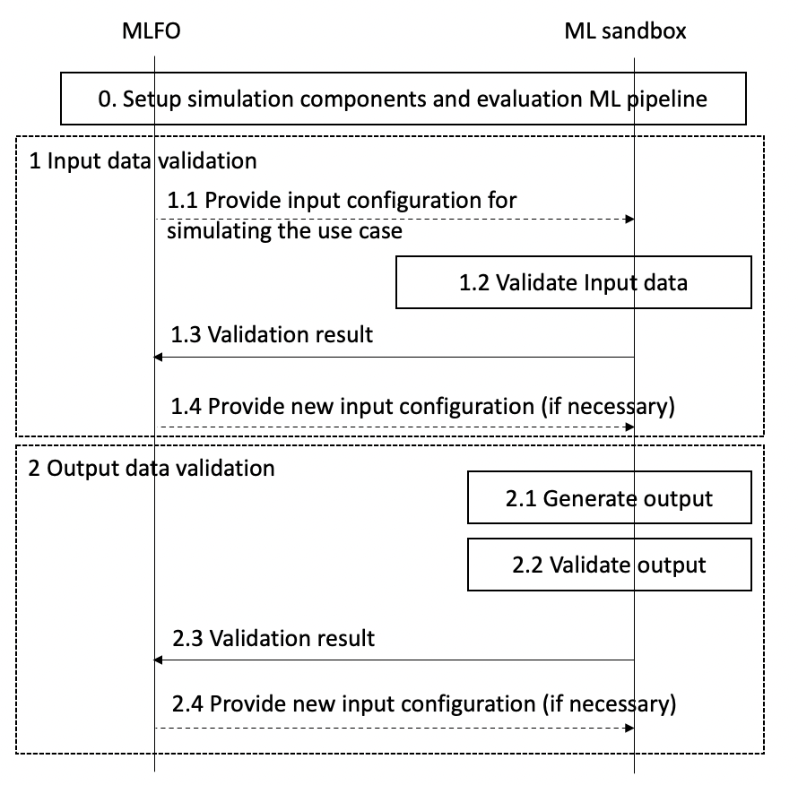
Figure 5:Sequence diagram of Validate input/output data
[Prerequisite] Simulation components and evaluation ML pipeline have been setup.
For input data:
1.1ML Sandbox receives input configuration from the MLFO to configure input data generation from the simulation environment.
1.2 Input data generation is validated by the simulation designer.
1.3 A response with the validation result is provided to MLFO.
1.4 MLFO may provide updated inputs to configure the simulation environment.
For simulated output data:
2.1ML Sandbox receives output data from the ML use case (training data set, trained ML model, evaluation of ML model).
2.2 Output data is validated by the simulation post-processor.
2.3 The result of the validation is sent to MLFO
2.4 MLFO may provide updated inputs to configure the simulation environment.

8.2.4MLFO-triggered operations
The MLFO-triggered operations are generally defined in Figure 6.
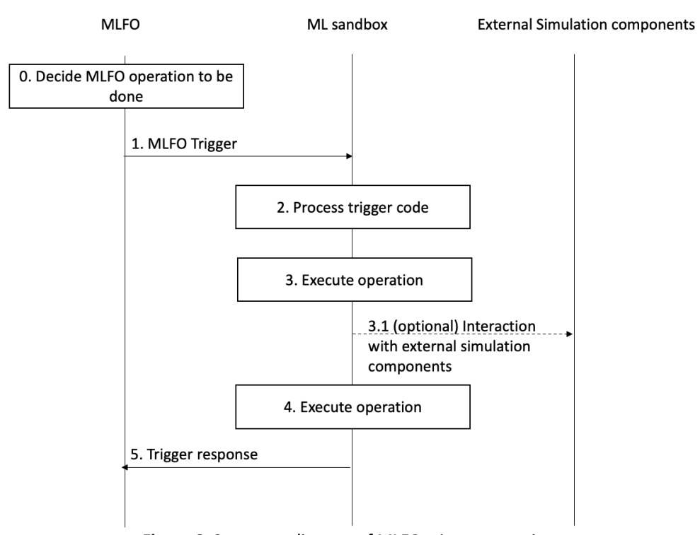
Figure 6: Sequence diagram of MLFO-trigger operations
The set of MLFO-triggered operations are as follows:
- Setup environment for ML use case:
[Prerequisite] capability discovery is done (see Clause 8.2.1).
- The MLFO sends a request to the ML Sandbox to setup the environment for the ML use case in the sandbox. This request contains the selected candidate simulation environment, as a result of the procedure in Clause 8.2.1.
- ML Sandbox (Simulation designer) prepares the environment:
  - This step canoptionally include download and install of simulation components.
  - Data handling for the simulated ML underlay includes integration with brokers and data storage units [ITU-T Y.3174]. A plugin to interact with third party applications can also be employed for the setup.
- A response is provided by ML Sandbox to the MLFO.
NOTE 1 – Environment setup may use the policies from MLFO and demand mapping (e.g.ML intentmay require isolation of resources). The ML underlay may also be configured based on the use case specification and based on features extracted from the live ML underlay to be simulated.
NOTE 2 – Setting up the evaluation ML pipeline may include the download of ML models from marketplaces [ITU-T Y.3176] and ML model serving[ITU-T Y.3179]to create evaluation ML pipelines.
NOTE 3 – environment setup may include the installation of third-party applications or setting up interfaces, establish connections via sockets, etc.
- Validate environment for ML use case:
[Prerequisite] Setup environment for ML use case is done (see Clause 6.2.2).
- MLFO requests to run sanity tests on a specific simulation environment for the ML use case.
- Simulation designer selects and executes the test suite (interaction with 3rd party applications can be done through the evaluation plugin).
- The output of the test suite is processed and output to MLFO.
NOTE – for instance, installing a third-party simulation tool may output a set of traces (or logs) indicating the result of installing submodules. This information should be post-processed to assess that the final installation procedure was successfully accomplished regarding the use case requirement. Example: if the installation of the LTE module failed, but the use case was meant for Wi-Fi (which module was successfully installed), then the result of the installation is satisfactory.
- The MLFO decides whether the validation results are acceptable or not (may include some basic tests and KPIs).
- Manage simulated ML underlay:
- The MLFO sends a trigger for modifying/updating the simulated ML underlay. Information on changes is included in the updated ML profile.
- The Simulation driver configures the simulated ML underlay accordingly (e.g., adapt configuration parameters, specify desired output…). Besides, there is an information exchange between the live and simulated ML underlays (mimic purposes).
- The ML Sandbox responds to the trigger with the information related to changes done in the simulated ML underlay (OK/NOK, changelog, etc.).
NOTE – Example:as a result of network dynamics, some path-loss parameters used by the ML Sandbox subsystem may vary over time. To address this issue, the MLFO keeps track of those changes and provides feedback to the Simulation designerto update the necessary simulation parameters.
- Evaluate output of ML model:
[Pre-requisite]The environment has been setup in the Sandbox for the ML use case.
- The MLFO sends a request to the Simulation composer in the ML sandbox to run the simulated ML underlay.
- The Simulation composer uses the “evaluator plugin” to input the output of the ML model. The plugin can also be used to interact with the 3rd party application (i.e., translate commands from the MLFO to simulator-oriented instructions).
- Evaluate the output of an ML model: the evaluation platform provides a report, which is processed by the post-processor.
- The processed report is sent back to the MLFO. The report can also include synthetic data for training.
NOTE 1 – the information extracted from the simulated ML underlay needs to be post-processed according to the desired output specified in the use case and the characteristics of the simulated ML underlay. The evaluation result can be an OK/NOK message, a percentage of reliability, a set of KPIs gather from the evaluation procedure, etc.
NOTE 2 – post-processing for third-party simulation tools may include the conversion of raw data into meaningful information (e.g., average or deviation on KPIs).
- ML model training:
[Requirement] ML model is served and evaluation blocks are ready.
- MLFO sends a trigger for training an ML model at the sandbox.
- Model training is performed at the simulated ML underlay through the Simulator composer.
- The trained ML model is post-processed (e.g.,compressed, pruned) according to the use case and the policies and capabilities (time constraints, link capacity for exchanging information, storage capabilities, etc.).
- The trained model is included in the response sent to the MLFO.
Table 1: Definition of MLFO-triggered operation codes (MLFO Trigger Types)
MLFO Trigger Type | Parameters | Time sync / dependencies | Description
SANDBOX-TRIGGER-001 | Request type, ML profile | Time sync = yes (evaluation blocks) | Request to prepare the simulation environment (both simulated ML underlay and evaluation ML pipeline) to train, test, and evaluate ML models in the ML sandbox.
SANDBOX-TRIGGER-002 | Request type, validation type, acceptance criteria | Time sync = yes (sanity checklist, test suite, etc.) | Request to validate (sanity check) the deployed simulation environment. Used by the MLFO to determine whether to take action to fix potential deployment issues, proceed with ML model evaluation in the sandbox, etc.
SANDBOX-TRIGGER-003 | Request type, update type, updated ML profile | Time sync = yes (updated simulation components) | Request to modify/update the simulated ML underlay according to updates in policies, changes in the live ML underlay, potential failures of previous simulated functions, etc.
SANDBOX-TRIGGER-004 | Request type, ML profile, ML model output | Time sync = yes (evaluation results) | Request to evaluate the impact of the output of an ML model in the simulated ML underlay, so that some insights can be provided before applying that output on the live ML underlay.
SANDBOX-TRIGGER-005 | Request type, ML profile | Time sync = no | Request to train an ML model in the ML sandbox.

8.2.5Sandbox asynchronous messages
ML Sandbox asynchronous messages are generally defined in Figure 7.
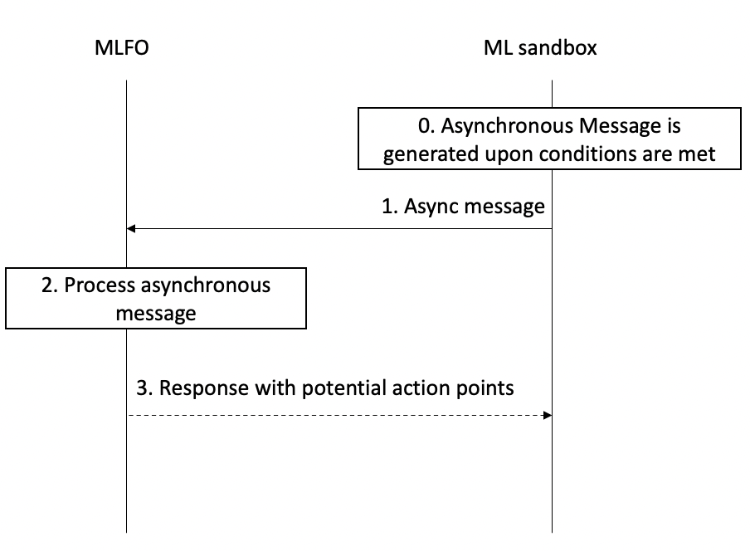
Figure 7: Sequence diagram of Sandbox asynchronous messages
[Requirement] Asynchronous messages are generated upon certain conditions are met, which are specific to the different types of events.
- Upon meeting the trigger conditions, ML Sandbox sends an asynchronous message to MLFO.
- The message is processed and potential action points are defined.
- MLFO sends a response to ML Sandbox.
The set of Sandbox asynchronous messages are defined in Table 2.
Table 2: Definition of ML Sandbox asynchronous message codes
Code | Parameters | Conditions | Description
SANDBOX-ASYNC-001 | Status code / Error code / detailed report (conditional) | Threshold-based alert is fired / miss-behavior is detected/ keep-alive message | Report the health status of the simulation components
SANDBOX-ASYNC-002 | Update type / changelog / additional information on implications of update | Updated on simulation components is notified/discovered to/by the ML Sandbox | Report an update on security, accounting, licensing requirements of simulation components
SANDBOX-ASYNC-003 | Alert type / forecasted results / additional information on potential failure points | Threshold-based alert based on trend analysis (e.g., service at risk) | Proactive behavior trendidentification of simulation componentsand sandbox resources
SANDBOX-ASYNC-004 | Report type / Updated simulation component metadata | Change on simulation component is noticed | Report an update on simulation component metadata
SANDBOX-ASYNC-005 | Report type / Updated level of intelligence of simulation components | Change on the intelligence level of a simulation component | Report the simulation environment intelligence level

8.3 APIs

8.3.1 Capability discovery/negotiation request API
API Description: discover third-party simulation components that can be used to perform use-case-specific simulations in the ML sandbox. List of updated capabilities to be used by MLFO to find candidate simulation environments for the ML use case.
Request (pull mechanism): MLFO → ML sandbox subsystem
Information element | Type | Mandatory/Optional  /Conditional | Description
Request ID | Integer | Mandatory | Identifier of the request, indicating “capability discover/negotiation”
ML profile | Json | Mandatory | Includes metadata defining policies, requirements, constraints, etc.
Response (or push method): ML sandbox subsystem → MLFO
Information element | Type | Mandatory/Optional  /Conditional | Description
List of simulation components | Json | Mandatory | Updated capability list of the available simulation components
Simulation environment metadata | Json | Mandatory | Metadata can contain information such as installation/execution requirements, capabilities of simulated NFs, performance indicators, configurable parameters, maturity (alpha/beta), etc.
NOTE 1 – as an example of 3rd party NF, ns-3 can be selected to simulate a specific deployment of IEEE 802.11ac WLANs.
NOTE 2 – based on the use case requirements, the list of potential NFs is narrowed. For instance, NFs can have associated information (via simulation environment metadata) such as “running time”, “billing aspects”, “accuracy”, etc.

8.3.2 Monitor health reporting API
API Description:report the health status of the simulation components, so that the MLFO can consider taking healing actions.
Request (periodical or responsive):ML sandbox subsystem → MLFO
Information element | Type | Mandatory/Optional  /Conditional | Description
Notification ID | Integer | Mandatory | Identifier of the request, indicating “monitoring report”
Health status | Integer | Mandatory | Code indicating the current status of the simulation components (Green, Yellow, Orange, Red)
Severity | Integer | Optional | Code indicating the severity of the potential anomalies identified (Critical, Major, Minor, Normal, or Clear)
Monitoring logs | String list | Optional | Raw data resulting from monitoring
Alerts | Key-value pairs | Optional | Threshold-based alerts
Suggested action points | String list | Optional | List of suggested action points to fix the potential reported issues
NOTE – Monitoring is carried out based on continuous flow of data generated by simulation components, including simulation data (SRC & SINK nodes), regression tests, reporting from simulation modules, etc.

8.3.3 Input/Output validation reporting API
API Description:this API is used to report the status of input/output data used/generated at/by the ML Sandbox. This information can be used by the MLFO to generate new data sets,re-train ML models with different configurations, update simulation components, etc.
Requests:ML sandbox subsystem → MLFO
Information element | Type | Mandatory/Optional  /Conditional | Description
Notification ID | Integer | Mandatory | Identifier of the request, indicating “input/output validation result”
Validation type | Integer | Mandatory | Indicates the type of validation performed (e.g., input data to configure simulation parameters or output training data validity)
Result of validation | Integer | Mandatory | “Success” or “fail”
Warnings | String list | Optional | Detailed information regarding potential issues or misbehaviors observed from the current input/output data
Error details | String list | Conditional | Detailed information regarding the errors thrown during the validation procedure
NOTE 1 – validate input data (check that demand mapping can be fulfilled at the simulated ML underlay) and simulation output data (feasibility of trained models, accuracy of generated data, etc.). For instance, testing techniques such as equivalence partitioning or centroid positioning can be applied to validate the diversity and the quality of the data generated by simulators (e.g., as for validating the synthetic data generated byGANs).

8.3.4 MLFO-triggered operations API
API Description:this API is used for the MLFO-triggered operations defined in Clause 7.2.5.
Request (pull mechanism): MLFO → ML sandbox subsystem
Information element | Type | Mandatory/Optional  /Conditional | Description
Message ID | Integer | Mandatory | Identifier of the message, indicating “ML-triggered operation”
Operation code | Integer | Mandatory | Code of the operation to be performed
Policies & Requirements | Json | Conditional | Metadata including policies, requirements.
Simulation environment metadata | Json | Conditional | Includes simulation configuration, available resources, time constraints, etc.
Response (or push method): ML sandbox subsystem → MLFO
Information element | Type | Mandatory/Optional  /Conditional | Description
Message ID | Integer | Mandatory | Identifier of the message, indicating “ML-triggered operation”
Response code | Integer | Mandatory | Code of the operation response (OK, Bad request, Error, etc.)
Response data | (variable) | Conditional | Depending on the request type, different response data types can be provided (e.g., training data set, trained ML model, validated ML model).

8.3.5 Sandbox asynchronous messages API
API Description:this API is used for the Sandbox asynchronous messages defined in Clause 7.2.6.
Request: ML sandbox subsystem → MLFO
Information element | Type | Mandatory/Optional  /Conditional | Description
Message ID | Integer | Mandatory | Identifier of the message, indicating “Sandbox asynchronous message”
Message code | Integer | Mandatory | Code of the asynchronous message type
Additional information | String list | Conditional | Additional information related to the message type

9 Security considerations
This Recommendation describesan architecturalframework for the ML sandbox in the context of integrating machine learning in future networks including IMT-2020: therefore, general network security requirements and mechanisms in IP-based networks should be applied [ITU-T Y.2701] [ITU-T Y.3101].
It is required to prevent from unauthorized access to, and data leaking from, an ML Sandbox, whether or not there is a malicious intention, with implementation of mechanisms regarding authentication and authorization, external attack protection, etc.

Bibliography

[b-JSON] IETF RFC 8259 (2017), The JavaScript Object Notation (JSON) Data Interchange Format (JSON)
[b-CSV] IETF RFC 4180 (2005), Common Format and MIME Type for Comma-Separated Values (CSV) Files
[b-XML] W3C Recommendation (2008), Extensible Markup Language (XML) 1.0 (Fifth Edition)
[b-ITU-T Y.Sup55] ITU-T Supplement ITU-T Y.3170-series “Machine learning in future networks including IMT-2020: use cases”

___________________

