 | INTERNATIONAL TELECOMMUNICATION UNION  TELECOMMUNICATION  STANDARDIZATION SECTOR  STUDY PERIOD 2022-2024 |  | SG13-C0165
 |  |  | STUDY GROUP 13
 |  |  | English only
Question(s): |  | 16/13 |  | Geneva, 4-15 July 2022
CONTRIBUTION
Source: |  | Telecommunication Engineering Centre (TEC), Ministry of Communications, India
Title: |  | Proposal for initiating a new work item on “Trust Registry for Devices and Applications: requirements, architectural framework”
Purpose: |  | Proposal
Contact: |  | Abhay Shanker Verma  TEC, DOT  India |  |  | Tel: +91 11 2332 9333  Fax: +91 11 23329367  E-mail: as.verma@gov.in
Contact: |  | Ravinder Kumar  TEC, DOT  India |  |  | Tel:  Fax:  E-mail: dirm2.tec@gov.in
Contact: |  | RanjanaSivaram  TEC, DOT  India |  |  | Tel: +91 98681 36990  Fax: +91 11 2332 9367  E-mail: ranjana.sivaram@gov.in
Contact: |  | Dayanand Kumar  TEC, DOT  India |  |  | Tel:  E-mail: dayanand.31@gov.in
Contact: |  | SharadArora  Independent Expert  India |  |  | Tel: +91 92121 09999  Fax:  E-mail: sharadsan@gmail.com

Keywords: | Trust Registry; Devices and Applications
Abstract: | This contribution proposes initiating a new work item on “Trust Registry for Devices and Applications: requirements, architectural framework”

- Introduction
The role of the network infrastructure is becoming essential to meet the security needs of customers for all types of connected devices and applications, including those not provided by the network operator. Having a registry of trusted devices and applications is a meaningful way, and a prerequisite for creating an environment of trust. Connectivity is an essential aspect for the connected devices and applications, and the network identities present a viable and practical option for identification and management of the trustworthiness of connected devices and applications. The fact that connected devices and applications are online creates the opportunity for trust registries to address the matter of trust in real time. It enables a proposition that a registry could establish, allow, deny and/or alert the user or application provider regarding the trustworthiness of the connected devices and applications in real time. The concept of the trust framework described above ismost effective when customers all over the world can be assured of its benefit, regardless of where the connected devices and applications are produced or used. For this to happen, the registries, networks, service providers, certification agencies, connected devices and applications must all adhere to some common agreed functions and mechanisms for registration, assertion, revocation and response to a question regarding the trustworthiness of the connected devices and applications, first at the start but also throughout the lifecycle. This contribution aims to develop a draft recommendation containing such requirements, architectures, functions and mechanisms, which when implemented by trusted network infrastructures, trust registries, service providers, connected devices and applications will enable the presentation of trustworthiness of connected devices and applications throughout their lifecycle, in a sustainable and orderly manner, which can be extensible to become a global trust infrastructure.

- Gap Analysis

The digital and connected world is aware of many trust repositories, and some of these come very close to hosting the requirements of the trust described in the above section. Examples of these are:

- The global GSM Equipment Identity Register (EIR)
The GSM EIR is indeed a global repository with properly defined hierarchy and interfaces for EIR to CEIR communication and information sharing. The issue is that the EIR only works for the GSM technology and is not capable of ubiquitous access, the nature of which is required to support all types of connected devices and applications. It also lacks a mechanism for mutual authentication between the device and the EIR. It does not support any encryption/ decryption mechanism for the interrogation of devices. It also does not identify trusted applications.

- Certification Authority (CAs)
The CA infrastructure (Public Key Infrastructures (PKI – X.509) is globally inter-operable; however, it only knows how to issue certificates and expose the revocation status. It does not have any means for recognizing different manufacturers, different type of devices and services and does not have the technical means for the management and interrogation of devices and applications. This is dealt under Q11/17 “Generic technologies (such as Directory, PKI, Formal languages, Object Identifiers) to support secure applications” which also deals with Directory services (X.500 series), Secure communication (X.510), Object Identifiers and their Registration Authorities etc. In the proposed work item, network based identities will be reused for trust and the focus is on defining the methods and interfaces for registration and sharing of the real time status of certification/ verification of trusted devices and applications.

- The Domain Name System (DNS)
The DNS is a look up for internet resources. Whilst it has a global footprint, has the capability to acknowledge many registrars, identify the owner of the internet resource and manages the lifecycle of the internet assets, it lacks the ability to maintain identities other than as IP addresses, and does not have the mechanisms identifying different types of assets (thousands of types of Devices and Applications) the methods for their interrogation and maintenance of their trustworthiness

- Problem Statement:
The rapid expansion of new and evolving ecosystems of devices and applications that are enabling advanced services by interconnecting physical and virtual things, require improvements in trust infrastructure for identification, authentication and authorization amongst the unrelated and diverse set of entities within the ecosystem including users, service providers, devices, networks and applications.

If the ICT layer interfaces and related processes are standardized over a wide range of network technologies, the new standardized infrastructure can be used for an open yet secured access and interactions between devices and applications in distributed ecosystems.
However, there is no common definition or understanding regarding how the trusted network infrastructures and trust registries should interconnect and interface with each other to share attributes of trustworthiness of connected devices and applications between each other in real time such as to create a trusted ecosystem that users can benefit from.

- Use Cases:
- Public service vehicles are identified using the globally unique root of trust identifier (e.g. IccID) embedded in the vehicle’s telematics control unit and interrogated by the trust repository by the use of the network identifier (e.g. MSISDN). The repository of connected devices (in this example, a connected vehicle) is thus identified and secured using the globally unique network based root(s) of trust. The registration enables the establishment and verification of the genuineness of the connected device in real time, using tamper resistant roots of trust anchored in the network;
- People are routinely identified by the mobile numbers when using financial transactions. However, there is no explicit mechanism for the financial community to establish in real time, the veracity of the network identifier (e.g. the mobile number in this example); and
- Connected devices are manufactured in one country and exported for use in several other markets. A trust infrastructure is required to ensure a real time look up facility, that is based on a tamper resistant root of trust, which works across networks and across borders, that can easily establish to a user/ beneficiary of the connected device whether the device and its applications are still trust worthy (without any compromise).
This contribution proposing a new work item aims to define the methods and interfaces for:
- registration of connected devices and applications with trust registries using the identifiers provided within trusted network infrastructures;
- the real time sharing of the status of certification/ verification amongst the network operators (including the OTT, IoT network providers), trust repositories and the beneficiary users; and
- the development of a globally inter-operable repository of trusted devices and applications using a hierarchical system of trust repositories.
It proposes to define technical aspects relevant to the trust frameworks, and does not intend to cover any of the following:
- the administrative aspects for hosting and running the trust registries; and
- The national and international agreements required between connected device and application providers, trust registries and network operators.

- Proposal
Regulators and security agencies are seized with the importance of creating regulations and policies for certification of smart devices and applications. A globally inter-operable hierarchy and architecture of device and application registries is required for proper information and protection of the user community. Registration and revocation mechanisms are required for identification of trusted and un-trusted devices and applications, and sharing of the information between registrars, manufacturers and service providers, beneficiary ecosystem. Accordingly, a new work item is proposed to be initiated under SG-13, Q16, WP-3, which aims to define the requirements that must be fulfilled by a such registry that, when supported by the member states, the industry and the beneficiaries, will create an environment for sustainable and orderly proliferation of secure devices and applications.
This contribution proposes initiation of a new work item under the Q16/13 on “Trust Registry for Devices and Applications: requirements, architectural framework”. A preliminary draft recommendation outlining the scope, summary and concept of a hierarchical architectureis annexed (Annexure-I).

Annexure- I

Draft Recommendation ITU-T Y.xxxx:

Trust Registry for Devices and Applications: requirements, architectural framework

Summary
The world is witnessing a massive proliferation of connected devices and services that affect every day of life. The security threats from this vast, distributed and often unregulated emerging ecosystem of providers of devices and applications are also clear to the world. Regulators and security agencies across the world are seized with the importance of creating regulations, policies, architectures, operating procedures and industry best practices to create a trusted environment. This recommendation defines the requirements that must be fulfilled by a trust registry that, when supported by the member states, the industry and the beneficiaries, is likely to create an environment for sustainable and orderly proliferation of secure devices and applications.
A hierarchical structure of registrars and a mechanism for the registration and lifecycle management of devices and applications is recommended, with the objective that the reliability of a device or an application can be verified at any point in time.
A mechanism has been outlined by which member states can set up a registry, and, the ecosystem of service providers, operators, device manufacturers and providers of applications can register their genuine/ trusted devices and applications, to the registry. Methods of provisioning the information, from one registrar to another, to create a globally inter-operable security infrastructure and enable the management of vulnerabilities are also defined in this recommendation.
Keywords
<Mandatory>
Introduction
<Optional – This clause should appear only if it contains information different from that in Scope and Summary>

1 Scope
The recommendation includes:
- Requirements for a registrar for registration, certification and revocation of devices and applications enabling trustworthy networking and services;
- Requirements for root(s) of trust to enable identification and authentication of devices and applications at a trust registry;
- Interfaces, protocols and data flows for the registration, certification and revocation of trusted devices and applications; and
- National and international hierarchy and interfaces between trust registries of devices and applications.

2 References
The following ITU-T Recommendations and other references contain provisions, which, through reference in this text, constitute provisions of this Recommendation. At the time of publication, the editions indicated were valid. All Recommendations and other references are subject to revision; users of this Recommendation are therefore encouraged to investigate the possibility of applying the most recent edition of the Recommendations and other references listed below. A list of the currently valid ITU-T Recommendations is regularly published. The reference to a document within this Recommendation does not give it, as a stand-alone document, the status of a Recommendation.
[ITU-T X.yyy] Recommendation ITU-T X.yyy (date), Title.

3 Definitions
<Check in the ITU-T terms and definitions database at www.itu.int/go/terminology-database whether the term has already been defined in another Recommendation. It would be more consistent to refer to such a definition rather than to redefine the term>

3.1 Terms defined elsewhere
<Normally, terms defined elsewhere will simply refer to the defining document. In certain cases, it may be desirable to quote the definition to allow for a stand-alone document>
This Recommendation uses the following terms defined elsewhere:
3.1.1 <Term 1> [Reference]: <optional quoted definition>.
3.1.2 <Term 2> [Reference]: <optional quoted definition>.

3.2 Terms defined in this Recommendation
This Recommendation defines the following terms:
3.2.1 <Term 3>: <definition>.

4 Abbreviations and acronyms
This Recommendation uses the following abbreviations and acronyms:
<abbr> <expansion>
<Include all abbreviations and acronyms used in this Recommendation>

5 Conventions
In this Recommendation, requirements are classified as follows:
• The keywords "is required to" or “are required to” indicate a requirement/ requirements, which must be strictly followed and from which no deviation is permitted if conformance to this document is to be claimed;
• The keywords "is recommended" indicate a requirement, which is recommended but which is not absolutely required. Thus, such requirements need not be present to claim conformance; and
• The keywords "optionally" or "may" indicate an optional requirement which is permissible, without implying any sense of being recommended. These terms are not intended to imply that the vendor's implementation must provide the option; it means the vendor may optionally provide the feature and still claim conformance with the specification.

6 Concept of hierarchical Trust Registry Architecture

The concept of a hierarchical Trust Registry architecturemay as below:
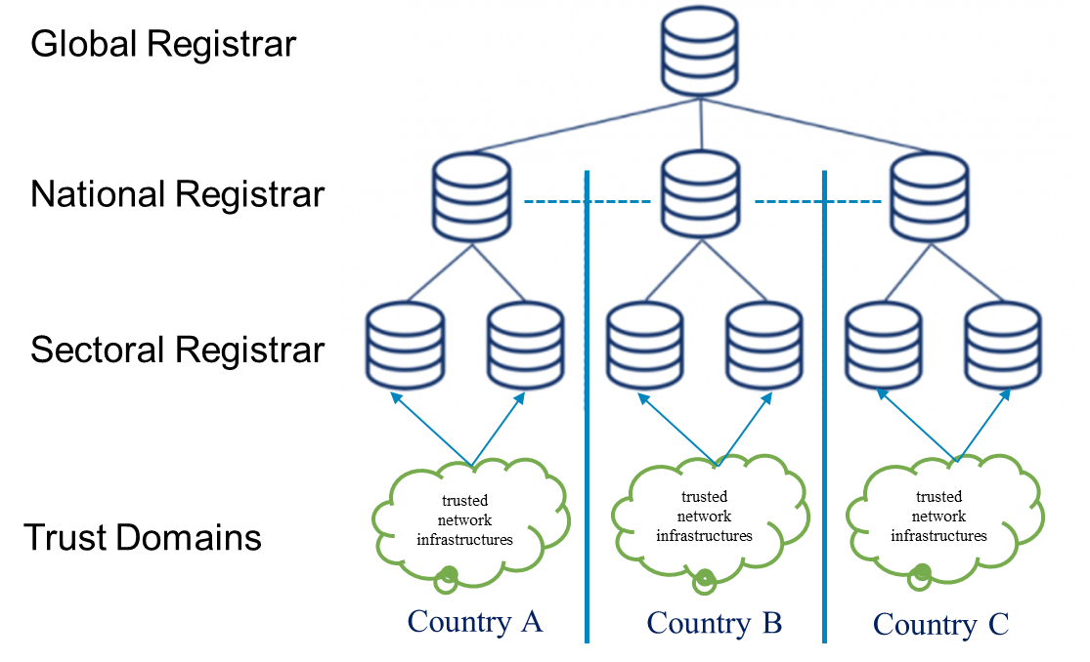
Figure 1: Concept of a Hierarchical Trust Registry Architecture

Note: This is an indicative diagram to propose the concept. There can be several models in which the Sectoral, National and Global registrars may interact bilaterally.

7 Requirements
<TBD>
Requirements for a registrar for registration
Requirements for certification and revocation of connected devices with root of trust based on network elements and trusted applications enabling trustworthy networking and services;
Requirements for root(s) of trust to enable identification and authentication of devices and applications at a trust registry;
Interfaces, protocols and data flows for the registration, certification and revocation of trusted devices and applications; and
National and international hierarchy and interfaces between trust registries of devices and applications.

8 Pre-requisites
<TBD>

9 Reference Model
<TBD>

10 Functional Architecture
<TBD>

11 Capabilities and reference points
<TBD>

12 Information Workflows
<TBD>

Annex A
<Annex Title>
(This annex forms an integral part of this Recommendation.)
<Body of annex A>
Appendix I
Identity and security is a critical requirement for all types of Devices and Apps
(This appendix does not form an integral part of this Recommendation.)

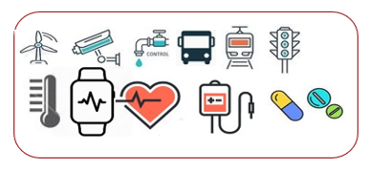

Device Security Classes
Use Case Classification and Compliance
Registration & Certification

Applications

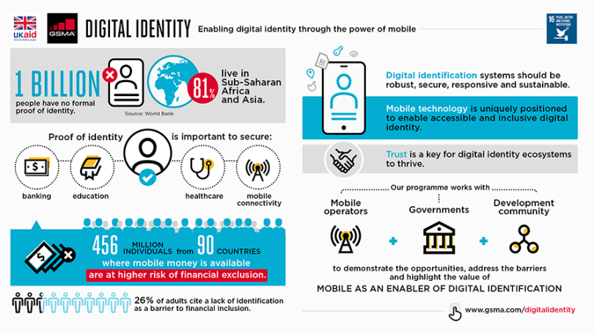
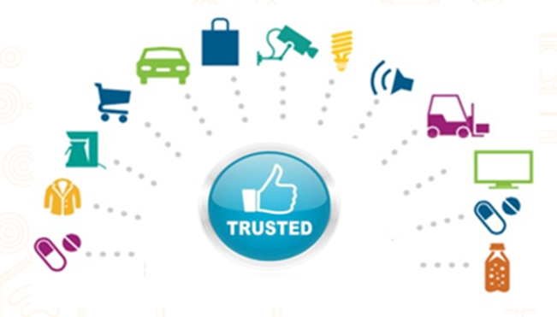

Smart Devices
Mobile Devices

Appendix II
New Age devices and applications need added security

Device Security Classes
Registration & Certification
Use Case Classification and Compliance

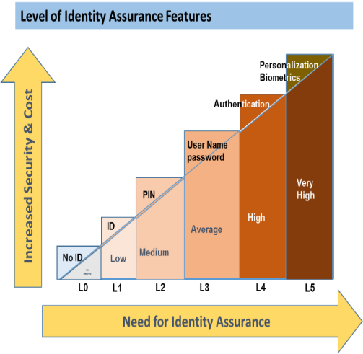
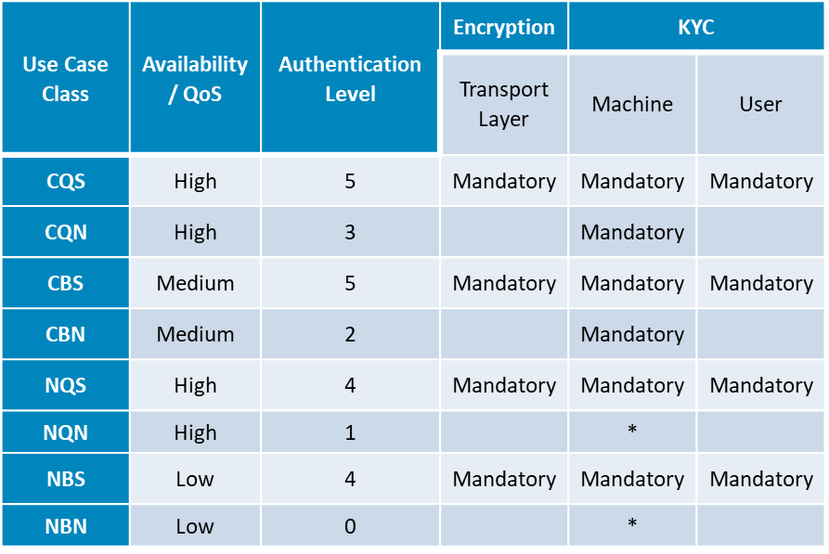
Trust Framework
- Keys and Certificates
- Trusted Service Provider
- Authenticated Devices
- Certified Applications

Root of trust
Security by Design: Unique global tamper resistant identity as root of trust, certification, digital trust, registration and compliance
Authentication

Requirements for Security by design and End to End Security are stated by national and international bodies

Bibliography
[b-ITU-T X.yyy] Recommendation ITU-T X.yyy (date), Title.

