 | INTERNATIONAL TELECOMMUNICATION UNION  TELECOMMUNICATION  STANDARDIZATION SECTOR  STUDY PERIOD 2022-2024 |  | SG16-C344-R1
 |  |  | STUDY GROUP 16
 |  |  | Original: English
Question(s): |  | 5/16 |  | Geneva, 10-21 July 2023
CONTRIBUTION
Source: |  | Ministry of Communications, India
Title: |  | F.AI-SF: Proposed modifications
Contact: |  | Rajmohan Meena  Department of Telecommunications, Ministry of Communications,  India |  |  | Tel: +91 9013135530  E-mail: adgn3.tec@gov.in

Abstract: | This contribution attempts to provide an updated draft text for draft new recommendation ITU-T F.AI-SF "Requirements for smart factory based on artificial intelligence" (New), as found hereinafter. The reference text is found in SG16-TD48/WP3 (2022-10).
NOTE – Editorial adjustments performed by TSB.

Draft new Recommendation ITU-T F.AI-SF
Requirements for smart factory based on artificial intelligence

Summary
[Mandatory part]

Keyword
requirements, use cases, artificial intelligence, smart factory, multimedia, data XXX

1 Scope
This Recommendation specifies high-level architecture, use cases and requirements for smart factory based on artificial intelligence.
This draft Recommendation covers the followings:
- Requirements for smart factory based on artificial intelligence.
- High-level architecture of smart factory based on artificial intelligence.
- Use cases for smart factory based on artificial intelligence.

2 References
The following ITU-T Recommendations and other references contain provisions, which, through reference in this text, constitute provisions of this Recommendation. At the time of publication, the editions indicated were valid. All Recommendations and other references are subject to revision; users of this Recommendation are therefore encouraged to investigate the possibility of applying the most recent edition of the Recommendations and other references listed below. A list of the currently valid ITU-T Recommendations is regularly published.
The reference to a document within this Recommendation does not give it, as a stand-alone document, the status of a Recommendation.
[TBD]

3 Definitions

3.1 Terms defined elsewhere
This Recommendation uses the following terms defined elsewhere:
3.1.1 application [ITU-T Y.2091]: A structured set of capabilities, which provide value-added functionality supported by one or more services, which may be supported by an API interface.
[TBD]

3.2 Terms defined in this Recommendation
This Recommendation defines the following terms:
[TBD]

4 Abbreviations and acronyms
This Recommendation uses the following abbreviations and acronyms:
AI | Artificial intelligence
[TBD]

5 Conventions
In this Recommendation:
- The keywords "shall" indicate a requirement which must be strictly followed and from which no deviation is permitted if conformance to this document is to be claimed.
- The keywords "should" indicate an optional requirement which is permissible. This term is not intended to imply that the vendor's implementation must provide the option, and the feature can be optionally enabled by the vendor. Rather, it means the vendor may optionally provide the feature and still claim conformance with the specification.

6 Overview
Smart factory is the key path to promote the deep integration of digital economy and real economy. This has become a common choice for the world's major economies to promote high-quality economic development. As the key technology, artificial intelligence technology is continuously integrated with smart factory. It is gradually changing the existing industrial form and business model, and has become a key technology to promote industrial upgrading.
Figure 1 shows artificial intelligence scenarios in smart factory.
Figure 1 – Artificial intelligence scenarios in smart factory
Artificial intelligence technology can be applied to 5 major scenarios of smart factory, such as asset predictive maintenance scenario, assembly line management scenario, workshop management scenario, management decision scenario and manufacturing process optimization scenario.

6.1 AI enabled multimedia applications in asset predictive maintenance
Predictive maintenance is a strategy that entails continuous monitoring of equipment's state under normal working conditions and predicting remaining useful life. During the running of machine and equipment, operating data, vibration data, and noise will be generated, and appearance changes may occur. AI technologies such as computer vision, voice analysis, and data analysis technology can be used to process and analyse multimedia data (e.g., audio, video/image, text) collected from the equipment by sensors and cameras. Through the AI technology, it is possible to predict the time of occurrence of machine failures, to avoid unplanned production stoppages and consequent delays..
AI-enabled systems provide:
- Big data capturing and processing (including audio, video etc);
- Anomalies or detection of equipment inefficiencies (e.g., computer vision);
- Unplanned equipment downtime prevention;
- Fixing malfunctions in individual components (which is economical than replacing an entire machine).

6.2 AI enabled multimedia applications in assembly line management
Product defects detection and object sorting are the typical applications of AI technology in assembly lines. For defect detection applications, it can quickly identify subtle defects on the product surface using computer vision technology. And for object sorting applications, the robots can automatically identify various materials, shapes and determine the best grasping point using computer vision technology.

6.3 AI enabled multimedia applications in workshop management
AI enabled video surveillance applications are applied to workshop management. Through computer vision technology, it can analyse the working status of workers to standardize the work process and identify potential safety hazards.
AI helps improve the end product's overall product quality and performance. ML algorithms process images and automatically validate an item's quality. Defect detection, enhanced with computer vision, uses high-resolution cameras to scan every production angle.
Workplace safety is also a target for AI in manufacturing. For instance, detecting toxic gas emissions on the fly or other anomalies prevents workspace hazards and ensures factory safety.

6.4 AI enabled multimedia applications in management decision
AI technology can be used to assist factory managers in the decision-making process. It makes the process clearer, faster, transparent and more data-driven. By collecting financial data, production and productivity data, scanned copy of contract and logistics data etc., OCR (Optical Character Recognition), natural language processing and knowledge graph technology can be used to process and analyse multi-format text and provide decision-making support for the subsequent operation of the factory.

6.5 AI enabled multimedia applications in manufacturing process optimization
AI technology can be used to optimize process and parameters to improve efficiency and reduce energy consumption. Through natural language processing technology, an expert system based on text knowledge and experience can be constructed to assist staff in parameter optimization and process configuration.

6.6 AI enabled multimedia applications in Quality Assurance & Inspection:
AI technology can be used for quality assurance in manufacturing to maintain consistent quality levels. QA in manufacturing has great potential for applying AI-based computer vision systems , which uses high-resolution cameras to monitor every aspect of the production process to automate inspection throughout the entire production process. Human vision has its obvious cons such as fatigue and inconsistency, but with computer vision inspection, QA becomes more reliable and precise. Another AI-based system is AR overlays, which compare the actual assembly parts with those provided by suppliers to spot any quality deviations. AR can also help with remote training and support so that technicians from any location can connect with those at a facility and guide them.

7 Requirements

7.1 Data collection/transmission requirements
Data is the foundation of AI for model training and model execution in smart factory. AI requires a large amount of data to support AI models and AI applications. The data include data collected from various equipment on the industrial workshop site as well as enterprise application data collected from business application areas. In order to meet various AI-based data collection and transmission in smart factories, the following requirements should be supported:
- It is required to support the connection with the OT (Operation Technology) network to realize the data collection in the industrial field, and support the OT network protocol (such as Profinet, Modbus, OPC DA/UA, etc.)
- According to business requirements, it is required to support the connection with the enterprise IT system to realize the collection of enterprise operation data.
- Data collection and transmission is required to support the collection and transmission of multiple data formats, including time-series stream data, video stream data, picture data, text data, etc.
- Data collection and transmission have different performance requirements according to different scenarios:
- In the model training scenario, due to the non-real-time of model training, it is recommended to use non-real-time mode for data collection and transmission, and the delay of data collection and transmission can be relatively higher, such as the second level.
- In the model inference scenario, in the case of highly real-time (such as automatic control), data collection and transmission are recommended to be completed in milliseconds level or less; while in non-real-time situations (such as predictive maintenance, intelligent business processes), the data collection and transmission delay can be higher, such as the second level.

7.2 Networks requirements
The network of the smart factory includes the IT network connecting the management information system and the OT network connecting the field control and monitoring system. In order to realize data transmission, flow and intelligent production, IP and wireless have become the trend of factory data transmission network. In order to meet the needs of a smart factory network, the following requirements should be supported:
- It is required to support Ethernet network to support data transmission between IT systems in the factory and video stream data transmission;
- It is recommended to support dedicated industrial Ethernet or PON (Passive Optical Network) network to support the transmission of industrial equipment data in the factory;
- It is optional support dedicated industrial wireless network and WLAN (wireless local area network) to support the transmission of on-site industrial equipment data in the factory;
- It is optional support IMT-2020, LTE and other wide-area wireless networks to support the transmission of on-site industrial equipment data in the factory.

7.3 Data processing requirements
Since the data sources and data formats collected in the factory are different, the collected data needs to be pre-processed to meet the requirements of AI model training and model inference. The following requirements should be supported:
- It is required to support the verification of the type, scope, consistency of the data to ensure the quality of the data;
- It is required to support the conversion of data format, encoding to ensure the consistency of data types;
- It is required to support data alignment, including semantic level alignment and time alignment, etc.
- It is required to support the treatment of missing data and abnormal data;
- In the case of supervised machine learning, labelling the data according to known labels is required to be supported so that the model can learn from the dataset during model training;
- The steps and methods of data processing is required to be consistent between the model training and inference phases to ensure data consistency during model training and inference.

7.4 Model training requirements
Based on the data collected in the factory, AI models are trained through different algorithms and applied to corresponding smart factory applications. The following requirements should be supported:
- It is required to support multiple machine learning algorithms/models and deep learning frameworks.
- It is required to support massive computing resources for model training.
- It is required to the selection of appropriate algorithms or models (such as deep learning models, machine learning algorithms, knowledge graphs, time series data models, etc.) according to different application scenarios and data types (such as video/picture, natural language, time series data, etc.)
- It is recommended to support iterative update of the AI model based on continuously collected data to meet the update of application requirements.
7.5 Model deployment requirements
After the models are trained and tested on the cloud server, it needs to be deployed to the inference servers or edge servers/terminals. The following requirements should be supported:
- For latency-sensitive applications, the AI models are recommended to be deployed on the edge servers or terminals, while for latency-insensitive applications, the AI models are recommended to be deployed on the cloud servers.
- It is recommended to support the adaptation of the AI models for different hardware/software environments. Especially for the edge servers or terminals, due to the limitation of computing power, in order to ensure the performance of model inference, the models are recommended to be trimmed/distilled, and the size of the models can be reduced on the premise of the accuracy.
- It is required to support the upgrade, addition and deletion of AI models.

7.6 Model inference requirements
Compared with AI model training, the AI model inference process does not require a large amount of data, but in different scenarios in a smart factory, there are different requirements for AI model inference. The following requirements should be supported:
- In order to meet low-latency applications such as defect detection and industrial robot control, it is recommended that the AI model inference time in these scenarios be as low as milliseconds.
- AI model inference is required to support the batch mode inference and the real-time mode inference. In the batch mode inference, the AI model will be called regularly or on demand, such as text data and process optimization scenarios; in the real-time mode inference, the AI model will be triggered by the real-time streaming data, such as video streaming data and time series data etc.

7.7 AI enabled applications requirements
The AI enabled applications in smart factories involve multiple application scenarios such as asset predictive maintenance, assembly line management etc. And the AI technologies involved also include machine vision, NLP, knowledge graphs, big data and others. Meanwhile, it is also necessary to determine the deployment method of the AI model algorithm according to different application characteristics. The following requirements should be supported:
- The AI enabled applications is required to train and integrate appropriate AI model/algorithms according to the characteristics of each application.
- The AI enabled applications is required to choose the appropriate AI model/algorithm deployment mode according to the requirements of each application, including cloud server deployment mode, edge server/terminal deployment mode, or hybrid deployment mode.

7.8 Security and privacy requirements
For AI systems in smart factories, the security of the AI system itself must be considered, including data security, communication network security, and AI model training and running security. In addition, the security of interworking between IT and OT systems in the factory also needs to be considered. The following requirements for security should be supported:
- It is required to support and ensure the security of the entire AI application life cycle, including data collection, data transmission, data storage, AI model training, AI model deployment and AI model running.
- It is required to support and ensure the trustworthiness of data sources in the process of data collection, to verify the data, and to avoid data from unknown sources.
- It is required to support technologies such as identity authentication, data encryption, integrity verification, and data flow control to ensure the security of communication and connection processes.
- It is required to ensure the security of the basic computing facilities and basic software environment of the AI model/algorithm running environment, especially the security of edge servers and terminals.
- It is required to ensure the robustness of the AI model/algorithm to prevent data poisoning and adversarial sample attacks.
- It is recommended to support the security isolation between the OT domain and the IT domain to prevent security attacks on the OT network from the IT network.
Data privacy regulates how personal data should be handled, what types of actions are permitted on that data, and who is authorized to carry out these actions. The AI enabled applications in smart factories is required to obey the data privacy laws of different regions in the world.

7.9 Reliability requirements
[TBD]

8 Functional architecture

8.1 High level reference framework
Figure 2 presents the high-layer framework for AI enabled multimedia in smart factory.
Figure 2 – High-layer framework for AI enabled multimedia in smart factory
The high-layer framework for AI enabled multimedia in smart factory covers three blocks: AI cloud server, edge equipment, and enterprise IT systems. A general description of these three blocks is presented below.
The AI cloud server can train and deploy AI models through data collection and processing to realize AI applications in smart factories. The AI cloud server covers three layers: Applications, services and networks.
- AI enabled applications: AI enabled applications are the AI based software to realize the targets of smart factory. These applications may include failure prediction, security video surveillance, decision-making support and process optimization etc.
- AI Services: AI services are the basic functional modules for supporting the AI applications. The services include basic services such as data processing, model training/deployment, security, and AI services such as NLP (natural language processing), CV (computer vision), OCR, KG (knowledge graph), ML (machine learning) algorithms.
- Networks: Networks are the communication networks for data exchange between edge equipment, enterprise IT systems and AI cloud server. The networks include wireless wide area network, wireless short-range communication networks and wired networks.
The edge equipment are the computing resources such as terminals or servers deployed on the workshop site. The edge computing mainly completes the collection and transmission of AI-related multimedia data, and completes model inference for delay-sensitive applications such as product defects detection and object sorting etc.
The enterprise IT systems are the CRM, MES, ERP and other systems within the enterprise, which can provide data to AI cloud server to support the AI applications such as decision-making support and process optimization etc.

[TBD]

Appendix I
Examples of smart factory based on artificial intelligence
(This appendix does not form an integral part of this Recommendation.)

I.1 Use cases

I.1.1 Use cases for asset predictive maintenance
Predictive maintenance technology is based on equipment operating data collected by sensors, such as noise, vibration, temperature, pressure, etc. Analyse and predict possible failure points through artificial intelligence technology, and give corresponding maintenance suggestions. The management personnel can deal with the risky equipment in advance according to the suggestions, so as to avoid the risk of failure.
Predictive maintenance technology can provide:
1. Reduce unplanned breakdown, increase overall equipment efficiency (OEE), ensure continuous production, and increase output
2. Reduce maintenance frequency, reduce maintenance cost, shorten maintenance time, improve operation and maintenance efficiency
3. Reduce replacement parts, make full use of existing equipment, extend equipment service life, and increase return on investment
Some factories combine smart sensors and machine learning algorithms to use data sources other than sensors such as sensor data, weather data, and maintenance logs to build equipment operation models, reduce machine maintenance costs, reduce actual failures, and optimize maintenance plans on asset life cycle.
In the figureI.1, a pressure sensor is acquiring the actual pressure value of the robotic arm and sending the data to the system. The system can use AI algorithms to analyse the data and determine the degree of wear of related components, and prompts to replace the components when necessary.
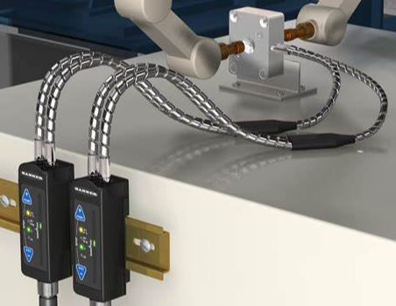
Figure I.1 – Example of asset predictive maintenance
Based on machine learning technology, an energy supplier can use hardware information from cables, real-time performance measurement and weather data to detect and predict grid outages, and proactively identify the possibility of grid defects.

I.1.2 Use cases for assembly line management
[TBD]
The application of artificial intelligence technology in the assembly line can realize defect detection and object sorting, and improve the efficiency of the assembly line.
In defect detection scenarios, deep learning technology can be used to detect smaller and more complex product defects under frequent environmental changes and improve detection efficiency. Through the combination with 3D microscope, it can identify defects in milliseconds, support high-speed applications and increase throughput, solve complex defect detection and positioning problems that cannot be solved by traditional methods, and greatly improve detection efficiency.
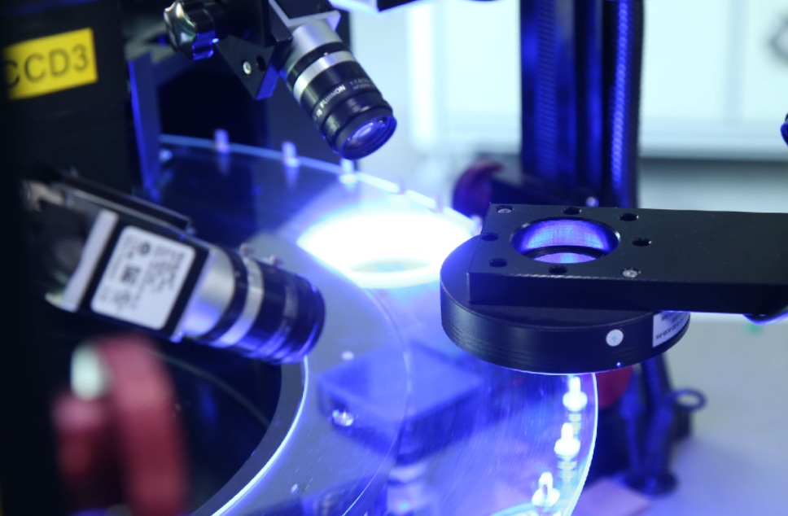
Figure I.2 – Example of defect detection
In the scenarios of irregular object sorting, deep learning is used to construct feature models of complex objects to realize autonomous learning and greatly improve sorting efficiency. By combining with a 3D vision camera, the robot can automatically identify various materials, shapes and even overlapping objects, and determine the best grasping point.
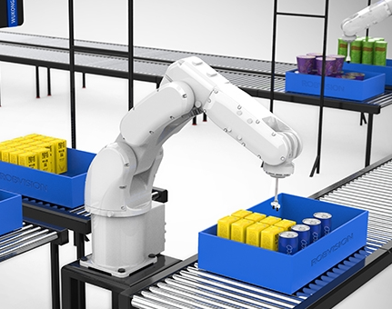
Figure I.3 – Example of irregular object sorting

I.1.3 Use cases for workshop management
In the scenarios of factory management, it is necessary to monitor the working status of workers in the factory to standardize the work process of workers and identify potential safety hazards.
The factory can use cameras to capture the operating behaviour of the employees on the production line, and use artificial intelligence technology to calculate and analyse to determine whether the worker's process is up to standard, thereby improving the quality of the product.
The factory can use cameras to capture the behaviour and status of workers. When certain unsafe factors occur, such as when the workers are too close to a large machine, or when the safety accessories are not properly worn, it can notify the system and remind the workers to handle crises before occur, and effectively reducing the probability of accidents in the work environment.
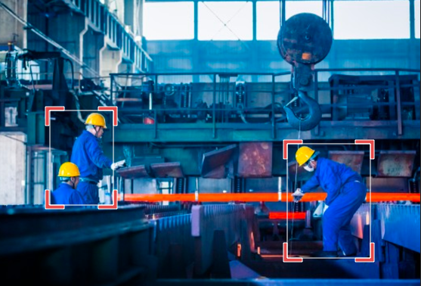
Figure I.4 – Example of workshop management
[TBD]

I.1.4 Use cases for management decision
In the supply chain risk management scenario, companies build a factory's supply chain knowledge graph by gathering information resources such as product knowledge, logistics knowledge, procurement knowledge, manufacturing knowledge, traffic information, and trade information etc. to realize supply chain risk management and parts selection.
In the financing risk management and control scenario, companies can rely on the knowledge graph to correlate multiple objects and realize the prediction and control of financial risks. Companies can break information isolated islands based on knowledge graphs, establish high-dimensional network of relationships between self-employed, partners, competitors and other objects, and realize the risk identification of unforeseen events in the financing process.
For example, a manufacturer builds a supply chain knowledge graph by gathering information resources such as academic papers, online encyclopaedias, open-source knowledge bases, meteorological information, media information, product knowledge, logistics knowledge, procurement knowledge, manufacturing knowledge, traffic information, and trade information, and through corporate semantics network realizes supply chain risk management and parts selection.
Neural networks can be put to use in supply chain management to analyse customer-seller audio and video communications and to plan and adjust lead-time. Machine learning is in general important to optimize the decision-making process in the flow of goods and services alongside supply chain management.
[TBD]

I.1.5 Use cases for manufacturing process optimization
The companies can use manual methods to analyse equipment operation, process parameters and other data and find the optimal parameters, which can greatly improve operating efficiency, reduce energy consumption, and improve manufacturing quality.
In the scheduling and production management scenario, companies can generate scheduling instructions through an expert system, dynamically perform scheduling processing, and perform manufacturing capacity planning, inventory management, and other management tasks related to the manufacturing process.
For example, a manufacturer uses intelligent algorithms to optimize the design of the production line during the manufacturing process of aero engines, assists in the formulation and optimization of the production planning process, and increase productivity through intelligent manufacturing technology.

I.1.6 Use Cases for Cyber Security:

Being connected to cloud or the internet, the risk of cyberattacks are key concern for the manufacturers, as even a small shutdown of the assembly line can prove them costly. The threats will continue to grow exponentially with the continuous increase in use of IoT devices. Smart factories are particularly susceptible to cyberattacks.
AI based cybersecurity systems and risk detection mechanisms can help secure production facilities and mitigate threats. Using AI, manufacturers can spot attacks across cloud services and IoT devices and interrupt them in seconds, with surgical precision. The system can also alert the concerned teams to act immediately to prevent any further damage. Using sandboxing, code signing and other such security measures can help combat cyber threats to IIoT technologies.
Key steps to follow: perform an initial cybersecurity assessment of the factory; build awareness of smart-factory cyber threats; identify risk ownership for cyberattacks in smart factories; establish a framework that monitors and facilitates smart-factory cybersecurity; embed cybersecurity practices tailored to the smart-factory environment; establish strong governance structures with rigorous oversight measures

_______________________

