 | INTERNATIONAL TELECOMMUNICATION UNION  TELECOMMUNICATION  STANDARDIZATION SECTOR  STUDY PERIOD 2022-2024 |  | SG16-C345-R1
 |  |  | STUDY GROUP 16
 |  |  | Original: English
Question(s): |  | 5/16 |  | Geneva, 10-21 July 2023
CONTRIBUTION
Source: |  | Ministry of Communications, India
Title: |  | F.DBDA: Proposed modifications
Contact: |  | Rajmohan Meena  Department of Telecommunications, Ministry of Communications,  India |  |  | Tel: +91 9013135530  E-mail: adgn3.tec@gov.in

Abstract: | This contribution attempts to provide an updated draft text for draft new recommendation ITU-T F.DBDA "Technical requirements and evaluation methods of AI-based driver behaviour detection application" as found hereinafter. The reference text is SG16-TD46/WP3 (2022-10).
NOTE – Editorial adjustments performed by TSB.

Draft New Recommendation ITU-T F.DBDA
Technical requirements and evaluation methods of AI-based driver behaviour detection application
Summary
This recommendation provides technical requirements and evaluation methods for AI-based driver behaviour detection application. It is submitted for discussion and approval at Q5/16 meeting.
Keywords
Artificial intelligence; Driver Behaviour Detection; Machine learning; Deep learning
Introduction
Driver behaviour and driving style detection is one of the most important parts of vehicle driving safety assistant system. It includes understand, detect, identify, predict driving styles and behaviours and corrective decisions/ measures. It helps effectively prevent overall safety risks caused by human beings and reduce the occurrence of serious accidents significantly. However, how to realize a mature driver behaviour detection application has drawn public attention.
The connections between the driver, the car, and the environment needs to be investigated to fully understand driver behaviour. Therefore, three contexts have to be considered: Driver context such as driver pose, status, facial expression, and distraction; Car context like speed, acceleration, and orientation; Environmental context like traffic conditions and weather conditions etc.
This proposal aims to provide general framework, requirements and evaluation methods for driver behaviour detection applications using AI/ ML, embedded sensors etc. and to help companies and industries boost the development of driver behaviour detection multimedia application.

1 Scope
The proposal focuses on the technical requirements and evaluation methods of AI-based driver behaviour detection application, including:
- Framework for driver behaviour detection application based on AI multimedia application
- Functions required in each module
- Requirements and evaluation methods for AI-based driver behaviour detection application

2 References
The following ITU-T Recommendations and other references contain provisions which, through reference in this text, constitute provisions of this Recommendation. At the time of publication, the editions indicated were valid. All Recommendations and other references are subject to revision; users of this Recommendation are therefore encouraged to investigate the possibility of applying the most recent edition of the Recommendations and other references listed below. A list of the currently valid ITU-T Recommendations is regularly published. The reference to a document within this Recommendation does not give it, as a stand-alone document, the status of a Recommendation.
[ITU-T X.yyy] Recommendation ITU-T X.yyy (date), Title.
<TBD>

3 Definitions

3.1 Terms defined elsewhere
This Recommendation uses the following terms defined elsewhere:
3.1.1 machine learning [ITU-T Y.3172]: Processes that enable computational systems to understand data and gain knowledge from it without necessarily being explicitly programmed.
3.1.2 deep learning [ITU-T F.748.12]: A representation learning method, used to model high-level abstractions in data through the use of model architectures, which are composed of multiple nonlinear transformations.
<TBD>

3.2 Terms defined in this Recommendation
This Recommendation defines the following terms:
<TBD>

4 Abbreviations and acronyms
This Recommendation uses the following abbreviations and acronyms:
CPU | Central Processing Unit
GPU | Graphics Processing Unit
NPU | Neural Network Processing Unit
<TBD>

5 Conventions
<TBD>

6 Technical requirements and evaluation methods of AI-based driver behaviour detection application
The proposal mainly covers the overall framework for driver behaviour detection application and the basic functions of each module, including data input module, data preprocessing module and computation and decision module.The driver behaviour detection application contains various kind of AI-based multimedia tasks, including human pose estimation, object detection and speech recognition, which all take multimedia data as input and apply application generated by deep learning technologies to multimedia to generate new outcomes. The driver behaviour prediction result is the comprehensive output of multiple models.
In data input module, the application takes multimedia data such as images, video and audio as input. The data is cleaned and processed and features like human limb and body are extracted by AI technologies like in data preprocessing module. In computation and decision module, different kinds of AI models(YOLO ((You Only Look Once), AlexNet) are used to deal with multimedia data from video, image and audio. AI-based multimedia applications like human pose estimation, object detection, image classification and speech recognition are included in the module.

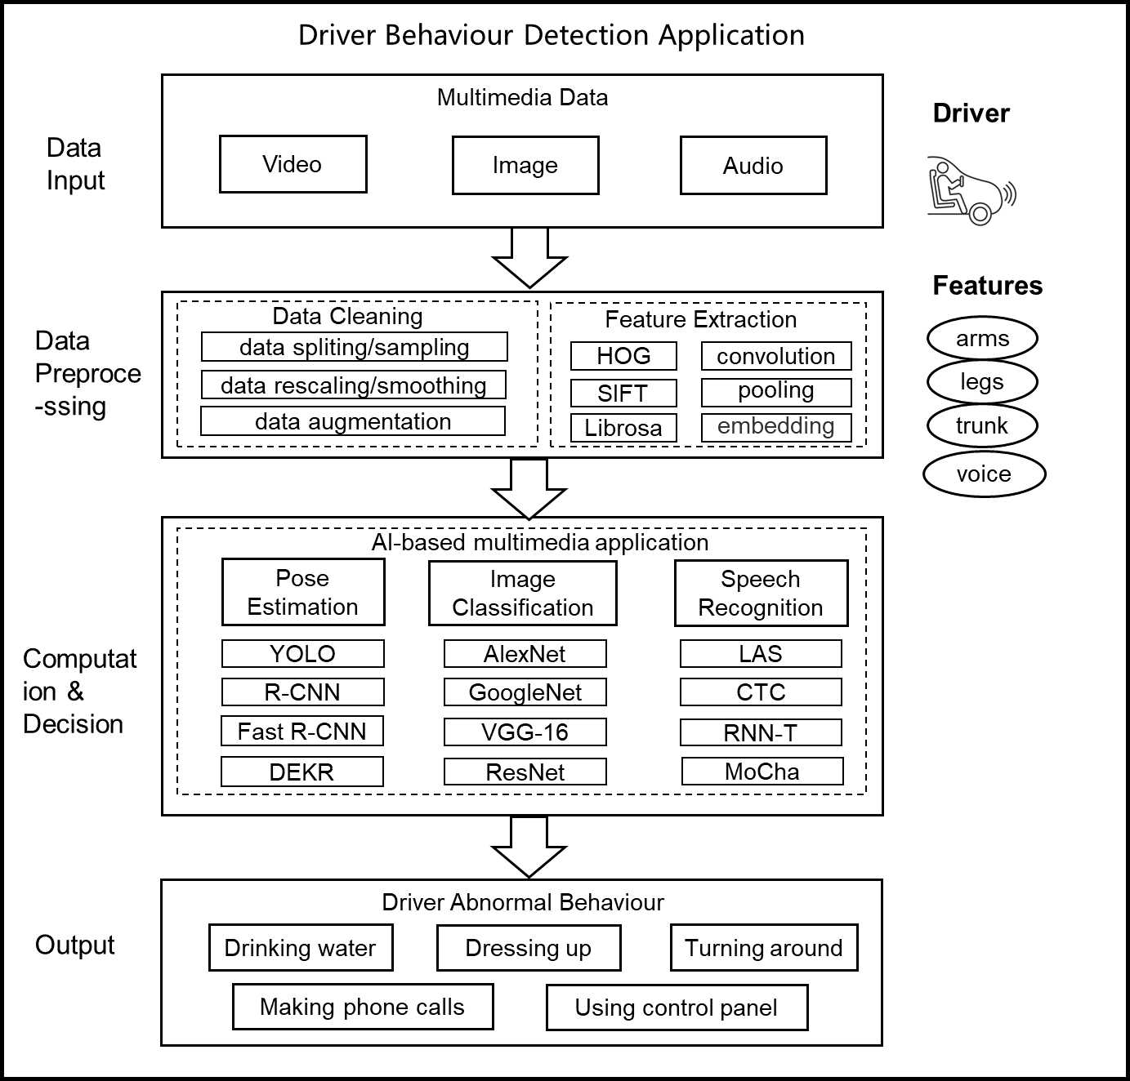
Figure 6.1 – Framework for AI-based Driver Behaviour Detection Application

6.1 Framework for driver behaviour detection application
<TBD>

6.2 Functions of each module
<TBD>

6.2.1 Data input
Editor Notes:
1) Driver behaviour detection application takes video, images and audio as input and concentrates on data about human voice and human limb, including arms, legs, trunk, eye movement, facial expression, head position and overall body language. A few essential abnormal behaviours of drivers like smoking, eating, drinking etc. also needed to be considered for detection. AI-based multimedia applications like human pose estimation, object detection and speech recognition are included in the application. The data which are not related to AI tasks mentioned before will be blurred and be anonymized. No user identification data will be collected and used.
2) The application will not store or transmit data.
<TBD>

6.2.2 Data preprocessing
<TBD> Pre-processing the input data/frames before passing them into the AI model is essential to ensure reliable, effective and accurate results. Data being prepared which reduces the adversarial impact of background and illumination changes (as it can often be the case in real driving conditions) so that only directly relevant data can be achieved for analysis.

6.2.3 Computation and decision
<TBD>

6.3 Technical requirements and evaluation methods of AI-based driver behaviour detection application

6.3.1 Technical requirements
<TBD>

6.3.2 Evaluation methods
<TBD>

Bibliography
<TBD>
_______________

