 |  | INTERNATIONAL TELECOMMUNICATION UNION  TELECOMMUNICATION  STANDARDIZATION SECTOR  STUDY PERIOD 2022-2024 |  |  | SG2-C049
 |  |  |  |  | STUDY GROUP 2
 |  |  |  |  | Original: English
Question(s): |  |  | 1/2 |  |  | Geneva, 16-20 May 2022
CONTRIBUTION
Source: |  |  | Ministry of Communications (India)
Title: |  |  | Proposed new work item on "Tamper proof IoT device’s Identity life cycle Management"
 | Contact: |  |  | Rajeev Kumar Tyagi  Deputy Director General (FN),  Telecom Engineering Centre,  Department of Telecommunications  Ministry of Communications,  Government of India,,  New Delhi. |  |  | Phone :+919582577030  E-mail: ddgn.tec@gov.in
 | Contact: |  |  | Pranav SINGH  Standards and Specification Expert  IDEMIA, NOIDA,  India |  |  | Phone : +91 9582817930  E-mail : pranav.singh2@idemia.com

Abstract: | Generic usage of IoT device is to collect data via IoT platform, which manages the endpoint devices (IoT). The discussion is about secure on boarding of IoT device and defining their unique identity, which is other than the supply chain identity. The ideais, not to expose the device identity. It is only known to its respective platform and the device OS. This tamper proof Identity would be stored in Secure element/ UICC/eUICC.

Tamper proof IoT device’s Identity life cycle Management

Question: | 1/2 | Proposed new ITU-T :Technical report | 16-20 May’ 2022
Reference and title: | Tamper proof IoT device Identity life cycle Management
Base text: |  |  | Timing: | 2022-2024
Editor(s): |  |  | Approval process:
Purpose and scope
IoT device identity life cycle management scope to secure IoT devices, only and only if responsible to its platform, where it was on boarded. This technical idea provides the next level of security of device in form tamper proof Identity, over the TLS end_to_end encryption and authentication
Summary:
IoT Industry has the challenges for the security of devices, to get unauthorised access, very first step to steal the device identity and then further device credentials. Weak OS and loosely coupled unsecure software assets in the devices are targeted for attack. This is also a fact that most IoT devices are having native OS, which is in general vulnerable.

The idea is not to compromise the security by considering a slave microcontroller (in form of SE/ UICC/eUICC), in which one can store the device identity and its respective keys and credentials concerning to the platform.

How it will work
Creating root of trust, in the devices using security solution with unique combination of HW and SW. The SE/UICC/eUICC used as root of trust. IoT security platform inject the secure credential ITU X.509 certificates.
X. 509 digital certificate is a certificate-based authentication security framework that can be used for providing secure transaction processing and private information. This could be used for handling the security and identity in IoT devices, managed from its related platform form where it is on boarded.
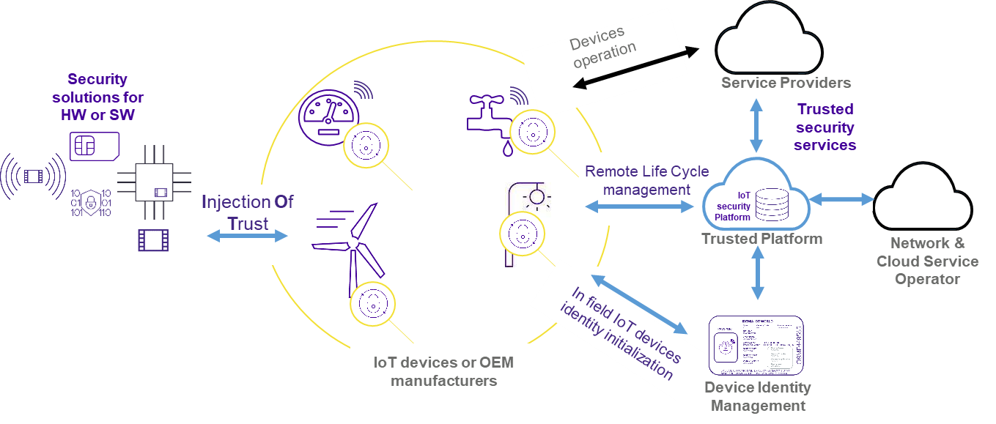
Standard reference: GSMA IoT Security guidance CLP.13
Cyber Security for Consumer IoT (ETSI 103 645)

X.509 based authentication (Digital Certificate based authentication): Data security is one of the most necessary aspects of every modern data platform. The process of verifying that a user is called authentication. A digital certificate is a digital document that includes the public key related to an individual, organization, or a IoT device. Certificates are issued by CA - certificate authorities. They have documented policies for determining owner identity and distributing certificates.
X.509 digital certificate-based authentication is a standard-based security framework that is used to secure private information and transaction processing. A certificate-based authentication uses public-key cryptography or self-sign on the digital certificate to authenticate a user. The server then confirms the validity of the digital signature and if the certificate has been issued by a trusted certificate authority or not.

An X.509 certificate contains the following information
- Version: It demonstrates which X.509 version applies to the certificate
- Unique Identity: While creating the certificate, the identity creating it must assign a serial number that differentiates it from other certificates.
- Algorithm information: This is the algorithm used by the issuer to sign the digital certificate.
- Issuer’s unique name: The name of the entity issuing the certificate. (usually a certificate authority including the platform associated to the IoT device)
Unique ID creation and storing – an Idea.
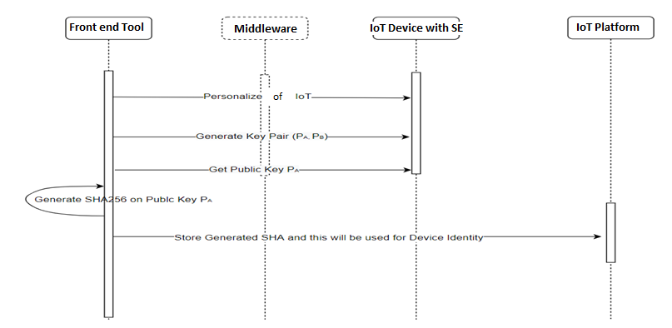
Above is an idea flow, how to generate an unique identity in device and further burn to IoT device SE/UICC/eUICC. below are the steps creating the unique Identity
- The tool will personalise the IoT device to generate the Key pairs say ( P_{a} and P_{b})
- Get public key P_{a} from IoT device SE/UICC/eUICC.
- Generate SHA256 on Public Key P_{a}
- Store SHA to server and IoT device as a Unique Identity.

Relations to ITU-T Recommendations or other documents (approved or under development):
Liaisons with other study groups or with other standards bodies:
Supporting members that are committing to contributing actively to the work item:
__________________

