 | INTERNATIONAL TELECOMMUNICATION UNION  TELECOMMUNICATION  STANDARDIZATION SECTOR  STUDY PERIOD 2022-2024 |  | SG2–C053
 |  |  | STUDY GROUP 2
 |  |  | Original: English
Question(s): |  | 3/2 | Geneva, 16-20 May 2022
CONTRIBUTION
Source: |  | Ministry of Communications, India
Title: |  | Proposed revised baseline text for E.370: "Service principles when public circuit-switched international telecommunication networks interwork with IP-based networks"
Contact | Tejpal Singh, Director  Dept. of Telecom, Ministry of Communication, India | Tel: +91-9818885790  E-mail: tejpal.singh70@gov.in

Abstract: | This contribution proposes modifications to the baseline text SG2-TD1096 titled “Service principles when public circuit-switched international telecommunication networks interwork with IP-based networks”
- Introduction
Modifications to ITU-T E.370 “Service principles when public circuit-switched international telecommunication networks interwork with IP-based networks” was discussed in the ITU-T SG2 virtual meeting from 27 May to 5 June 2020. The revised baseline text is given in SG2-TD1096.
- Proposal
This contribution proposes modifications/ updates to the baseline text SG2-TD1096 with reference to compliance to E.164 and National Numbering Plan(NNP) while interconnecting PSTN/PLMN with IP-based networks. The updated draft work item in track change mode is annexed (Annexure-I) for consideration.

Annexure-I

Draft Recommendation ITU-T E.370
Service principles when public circuit-switched international telecommunication networks interwork/interconnect/terminate with IP-based networks//OTTs
1 Introduction
There is an increased availability of Internet Protocol (IP)-based networks on an international and a national basis. Users of these IP-based networks may expect to be able to be connected with users of public, circuit-switched, international telecommunications networks if such interconnection is offered as a feature. In order to ensure that the needs of both IP-based network users and circuit-switched, international telecommunication network users are met, principles of interworking between IP-based networks and the circuitswitched, international telecommunication networks are presented in this Recommendation.
In addition, consumers use IP-based networks to access a wide variety of OTTs that do not interconnect to public, circuit-switched, international telecommunications networks. Users do not expect to be connected with users of public, circuit-switched, international telecommunications networks when using these OTTs. This Recommendation does not apply to OTTs that do not interwork/interconnect/terminate topublic, circuit-switched, international telecommunications networks. The Recommendation does not state that IP-based OTTs should interconnect with public, circuit-switched, international telecommunications networks or that Member States should compel them to do so.
2 Scope
This Recommendation defines the principles applicable to IP-based networks and OTTs that interwork/interconnect/terminate with the ITU-defined, circuit-switched, international telecommunication networks (for example, the PSTN, ISDN and PLMN) for the purposes of providing international telecommunications services.
3 References
The following ITU-T Recommendations and other references contain provisions which, through reference in this text, constitute provisions of this Recommendation. At the time of publication, the editions indicated were valid. All Recommendations and other references are subject to revision; users of this Recommendation are therefore encouraged to investigate the possibility of applying the most recent edition of the Recommendations and other references listed below. A list of the currently valid ITU-T Recommendations is regularly published.
– ITU-T E.105 (1992), International telephone service.
– ITU-T E.106 (2000), Description of aninternational emergency preference scheme (IEPS).
– ITU-T E.164 (1997), The international public telecommunication numbering plan.
– ITU-T H.323 (2000), Packet-based multimedia communications systems.
- PP 18
4 Definitions
This Recommendation defines the following term:
IP-based network: a network in which the Internet Protocol is used as the ISO layer 3 protocol (OSI Reference Model).

5 Abbreviations
This Recommendation uses the following abbreviations:
OTT Over the Top
DTMF Dual Tone Multi-Frequency
IP Internet Protocol
ISDN Integrated Services Digital Network
ISO International Organization for Standardization
ITU International Telecommunication Union
ITU-T International Telecommunication Union – Telecommunication Standardization Sector
IWF Interworking Facility
OSI Open Systems Interconnection
PLMN Public Land Mobile Network
PSTN Public Switched Telephone Network
ROA Recognized Operating Agency
SIP Session Initiation Protocol
CLI Caller line identification
QoS Quality of services
QoE Quality of experience
OI origin identification
6 General principles of interconnection
6.1 In general, the interconnection of an IP-based network to an existing international telecommunication network should not impose any requirement for additional functionality in the international telecommunication network, nor any restriction in the normal operation of the international telecommunication network. Any added functionality should be provided in the IPbased network, unless otherwise agreed between the operators of the IP-based and international telecommunication networks. The international telecommunication network should not have to be specially engineered to compensate for possible performance variation of services supported by the IP-based network interconnected to it in order to match the performance of similar services fully supported by the international telecommunication network.
6.2 The interconnection arrangements could be formalized by an agreement between the operators of the two networks. The agreement could cover the following areas:
– network topology;
– interface specifications, including signalling systems;
– provisioning procedures;
– operations and maintenance procedures;
– performance monitoring (quality of service, grade of service, traffic measurement, etc.);
– growth management (forecasts, network planning, etc.);
– charging and accounting arrangements.
- Provision of CLI
- QoS and QoE
Interconnection arrangements should enable calls to be set up:
a) which originate on an IP-based networkand terminate on PSTN/ISDN/PLMN networks;
b) which originate at terminals on PSTN/ISDN/PLMN networks and terminate on an IP-based network; and
c) which allow for backward and forward call clearing.
The detection of a non-recoverable failure of any of the critical resources involved in the call shall initiate the clearing of the call.
User services, which make use of end-to-end bidirectional and unidirectional DTMF signalling, should be supported, e.g. voicemail applications, conference bridge applications, etc.
An inability to complete the call within the PSTN/ISDN/PLMN network should be detected and communicated to the calling party (e.g. busy tone).
The ability for in band audio tones and announcements to be received by the caller should be supported (e.g. special information tones, referral messages, etc.).
In order to preserve existing PSTN/ISDN/PLMN service features the following should be supported:
a) presentation of a number in ITU-T E.164 format identifying the Calling Party for Calling Line Identification Presentation;
b) transport of calling line identification;
c) transport of calling line identification restriction;
d) malicious call tracing;
e) emergency calling;
f) International Emergency Preference Scheme (see ITU-T E.106);
g) E.164 number portability.
7 Services
The services, including any supplementary services, offered by IP-based networks (voice, data, etc.) when interworking with the international telecommunication networks to provide public correspondence services should be similar to those provided on international telecommunication networks and work on an end-to-end basis unless otherwise agreed. For example, when interworking with users on the PSTN, ITU-T E.105 defines the requirements of the International Telephone Service. While it is recognized that the manner in which the services, including any supplementary services, are presented to users on an IP-based network may be different from the way in which those services are presented to users of the PSTN, ISDN and PLMN; the basic functions, as defined in the appropriate ITU-T Recommendation, should still operate across the various networks.
[Should be modified to cove the interconnection]
8 Service scenarios

8.1 General cases
A number of scenarios may be deployed to reflect particular configurations of networks, namely:
Scenario 1: communication between IP-based network//OTTs users and International Telecommunication Network users, in which the call set-up is originated by the IP network user.
Scenario 2: communication between IP-based network/OTTs users and International Telecommunication Network users, in which the call set-up is originated by the International Telecommunication Network user.
Scenario 3: communication between International Telecommunication Network users, using IPbased networksOTTsfor the connection/trunking between the involved users.
Scenario 4: communication between IP-based network//OTTs, using International Telecommunication Networks for the connection/trunking between the involved users.
In principle the interworking between the IP-based network/OTTs, and the international telecommunication network can be at any level in the international telecommunication network hierarchy, e.g. local exchange, transit exchange, international exchange.
Align the otherscenarios with scenario 2

8.2 Call from IP-based network/OTTs to international telecommunication networks (Scenario 1)
In this configuration, the call is established within the IP-based network/OTTs towards the international telecommunication networks (see Figure 1). Any added functionality to enable interworking should be provided in the IP-based network, unless otherwise agreed between the operators of the IP-based and international telecommunication networks.

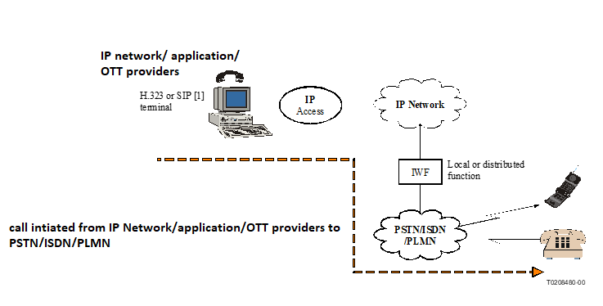
Figure 1/E.370 − Call from IP network/OTTs user to the international
telecommunication network
−Using only one graph for 8.2

8.3 Call from international telecommunication networks to IP-basednetwork/OTTs(Scenario 2)
In this configuration, a call is established from the international telecommunication networks towards the IP-based Network/OTTss user (see Figure 2). Any added functionality to enable interworking should be provided in the IP-based network/OTTs, unless otherwise agreed between the operators of the IP-basedapplication and international telecommunication networks.

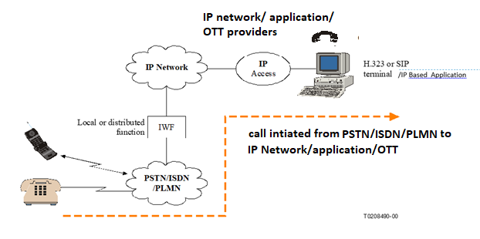Figure 2/E.370 − Call from international telecommunication networks
to an IP-based network/OTTs

8.4 Interconnection of international telecommunication networks using IP-based/ network (Scenario 3)
In this case, the IP-based network is provided by a separate entity (e.g. ROA) from the international telecommunication network (see Figure 3). It does not cover the case where IP technology is integrated within the international telecommunication network of a single service provider.
The traffic, technical, economical, and administrative advantages/disadvantages should be considered before such interconnection is proposed by network operators.
Any added functionality to enable interworking should be provided in the IP-basednetwork, unless otherwise agreed between the operators of the IP-based and international telecommunication networks.
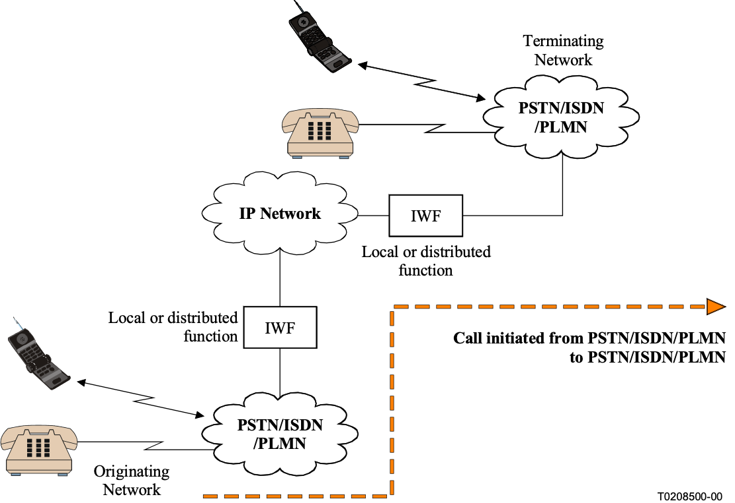
Figure 3/E.370 − Call from international telecommunication network to another international telecommunication network via an IP-based network

8.5 Interconnection of IP-based networks/OTTs using International Telecommunication Networks (Scenario 4)
In this case, the IP-based network is provided by a separate entity (e.g. ROA) from the international telecommunication network (see Figure 4). It does not cover the case where IP technology is integrated within the international telecommunication network of a single service provider.
Any added functionality to enable interworking should be provided in the IP-based network, unless otherwise agreed between the operators of the IP-based and international telecommunication networks.

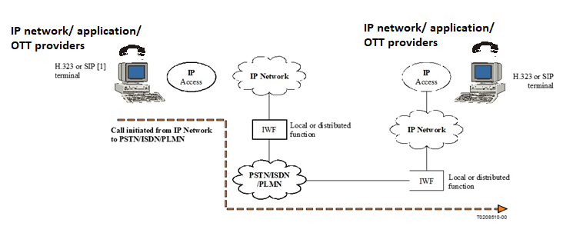
Figure 4/E.370 − Call from an IP-based network/OTTs user to another IP-based network/OTTs
via an international telecommunication network
9 Operation
9.1 Wheninterworking/interconnecting/terminatingbetween IP-based networks/OTTs and international telecommunication networks the operational procedures for services should, wherever possible, be the same as for those on the international telecommunication networks. The same tones, announcements, service codes and signals,etc., used in the international telecommunication services should be recognized and where appropriate returned by the IP-based network/OTTs. For interworking between IP-based networks/OTTs and international telecommunication networks, User-to-Network signalling (where a user on one network is accessing functionality supplied on the other network), Network-to-Network signalling, and User-to-User signalling must be consistently interpreted across the various networks. The latter case is particularly important when users must interact with interactive voice response systems.
Add text cover the new topics of the recommendation and CLI proposal should be mentioned in 9.1 and remove it from 9.2
- 9.2 For users on the international telecommunication networks to reach users on IP-based networks/OTTs, the IP-based networkOTTsshould be
- Addressable using the national numbering plan
- Applicable to the international telecommunication recommendation(i.e. ITU-T E.164)
- The recipient should be able to identify the number of the calling party

Note : the CLI provisioning should be in both directions
- [

- ]

[] 9.5 There should be mechanisms in place to cater for the needs of any call recording, billing and international accounting and lawful interception functions that might be required. For example, an answer supervisory signal should be returned by the terminating network when an incoming call is established.
9.3 Compliance to E.164 and National Numbering Plan(NNP) : In order to ensure valid CLI presentation by IP-based networks/OTTs, regulators and telecom operators may enforce compliance to E.164 standard and NNP while providing interconnection with PSTN/PLMN or ISDN.

10 Quality of service
[When international telecommunication networks interwork with IP-based networks/applications/OTT providers, the QoS/QoEexperienced by the users should, maintainthe same as the acceptable level of QoS/QoE on PSTN/PLMN networks.]

Note : call for contribution in this topicCheck ISDN and modify
.¹
AppendiX i
Bibliography
[1] HANDLEY (M.), SCHULZRINNE (H.), SCHOOLER (E.), and ROSENBERG (J.): SIP: session initiation protocol, Request for Comments2543, Internet Engineering Task Force 1999.
[2] ITU-T G.109 (1999), Definition of categories of speech transmission quality.

_____________________

¹ Categories of speech quality are defined in ITU-T G.109 [2].

