 | INTERNATIONAL TELECOMMUNICATION UNION  TELECOMMUNICATION  STANDARDIZATION SECTOR  STUDY PERIOD 2022-2024 |  | T22-SG09-C-0079
 |  |  | STUDY GROUP 9
 |  |  | Original: English
Question(s): |  | 6/9 | Bangalore, 09-18 May 2023
CONTRIBUTION

Source: |  | Ministry of Communications, India
Title: |  | Proposed draft revision of ITU-T Recommendation J.298(03/2019) “Requirements and technical specifications of a cable TV hybrid set-top box compatible with terrestrial and satellite TV transport”
Contact: |  | Meenakshi Singhvi,  Ministry of Communications  India | Tel: +91-9426302816  E-mail: meenakshi.singhvi@prasarbharati@gov.in
Contact: |  | Rajiv Khattar  India | Tel: +91-9821040126  E-mail: rajivkhattar@gmail.com
Contact: |  | Paritosh Saha  India | Tel: +91-9899456795  E-mail: paritosh.saha@disney.com
Contact: |  | Ramesh D Sampath  India | Tel: -  E-mail: dsramesh@exaltocomtech.com
Abstract: |  | This contribution contains the proposed revised draft, placed as Annex, of the ITU Recommendation ITU-T J.298 “Requirements and technical specifications of a cable TV hybrid set-top box compatible with terrestrial and satellite TV transport” published in the year 2019.

_______________________

 |  | International Telecommunication Union
 |  | ITU-T | J.298
 |  | TELECOMMUNICATION  STANDARDIZATION SECTOR  OF ITU |  | (03/2019)
SERIES J: CABLE NETWORKS AND TRANSMISSION OF TELEVISION, SOUND PROGRAMME AND OTHER MULTIMEDIA SIGNALS
Cable set-top box

 | Requirements and technical specifications of a cable TV hybrid set-top box compatible with terrestrial and satellite TV transport
 | Recommendation ITU-T J.298


Recommendation ITU-T J.298
Requirements and technical specifications of a cable TV hybrid set-top box compatible with terrestrial and satellite TV transport

Summary
Recommendation ITU-T J.298 describes the requirements and technical specifications of a cable TV hybrid set-top box compatible with terrestrial and satellite TV transport. The main purpose of the Recommendation is to specify minimum and basic requirements for a hybrid set-top box (STB), which meets the requirements of developing countries and regions. The hybrid set-top box has full functionalities for traditional cable broadcasting services based on Recommendation ITU-T J.83, at the same time, satellite or a terrestrial broadcast receiving functions will also be implemented so that the STB is able to receive satellite or terrestrial broadcasting services. The basic functionalities for IP-based interactive video services are also required so that the STB be able to support the latest Internet protocol (IP) interactive services together with legacy cable and satellite/terrestrial services.

History
Edition | Recommendation | Approval | Study Group | Unique ID*
1.0 | ITU-T J.298 | 2019-03-22 | 9 | 11.1002/1000/13834

Keywords
Set-top box, television transport.

FOREWORD
The International Telecommunication Union (ITU) is the United Nations specialized agency in the field of telecommunications, information and communication technologies (ICTs). The ITU Telecommunication Standardization Sector (ITU-T) is a permanent organ of ITU. ITU-T is responsible for studying technical, operating and tariff questions and issuing Recommendations on them with a view to standardizing telecommunications on a worldwide basis.
The World Telecommunication Standardization Assembly (WTSA), which meets every four years, establishes the topics for study by the ITU-T study groups which, in turn, produce Recommendations on these topics.
The approval of ITU-T Recommendations is covered by the procedure laid down in WTSA Resolution 1.
In some areas of information technology which fall within ITU-T's purview, the necessary standards are prepared on a collaborative basis with ISO and IEC.

NOTE
In this Recommendation, the expression "Administration" is used for conciseness to indicate both a telecommunication administration and a recognized operating agency.
Compliance with this Recommendation is voluntary. However, the Recommendation may contain certain mandatory provisions (to ensure, e.g., interoperability or applicability) and compliance with the Recommendation is achieved when all of these mandatory provisions are met. The words "shall" or some other obligatory language such as "must" and the negative equivalents are used to express requirements. The use of such words does not suggest that compliance with the Recommendation is required of any party.

INTELLECTUAL PROPERTY RIGHTS
ITU draws attention to the possibility that the practice or implementation of this Recommendation may involve the use of a claimed Intellectual Property Right. ITU takes no position concerning the evidence, validity or applicability of claimed Intellectual Property Rights, whether asserted by ITU members or others outside of the Recommendation development process.
As of the date of approval of this Recommendation, ITU had not received notice of intellectual property, protected by patents, which may be required to implement this Recommendation. However, implementers are cautioned that this may not represent the latest information and are therefore strongly urged to consult the TSB patent database at http://www.itu.int/ITU-T/ipr/.

© ITU 2019
All rights reserved. No part of this publication may be reproduced, by any means whatsoever, without the prior written permission of ITU.
Table of Contents
Page
1 Scope 1
2 References 1
3 Definitions 2
3.1 Terms defined elsewhere 2
3.2 Terms defined in this Recommendation 3
4 Abbreviations and acronyms 3
5 Conventions 6
6 Overview 6
6.1 Overview of hybrid video system 6
6.2 The hybrid STB software architecture 8
6.3 The hybrid STB categories 9
7 Requirements 9
7.1 SOC platform and compatibility 10
7.2 AV decoders 10
7.3 Connectivity 10
7.4 Broadcasting service 11
7.5 Channel search 12
7.6 Channel management 12
7.7 Channel play 12
7.8 EPG 13
7.9 Subtitles 13
7.10 Programme record and playback 13
7.11 Multi-media player 13
7.12 IP streaming and service 13
7.13 Browser 13
7.14 Security 13
7.15 System management 14
7.16 Maintenance 14
8 Technical specifications 15
8.1 Minimum system 15
8.2 Decoder 15
8.3 Hardware interface 16
8.4 Power supply 18
8.5 Software functions 18
8.6 Security 20
8.7 OSD 21
8.8 System upgrade 21
Page
8.9 RCU 22
Bibliography 23

Recommendation ITU-T J.298
Requirements and technical specifications of a cable TV hybrid set-top box compatible with terrestrial and satellite TV transport

1 Scope
This Recommendation describes the requirements and specifications for a hybrid cable set-top box (STB) compatible with terrestrial and satellite TV transport to be used in developing countries and regions. By combining a mix-mode transmission platform with IP network, the STB can offer new interactive services to cable, satellite and terrestrial TV customers and operators.

2 References
The following ITU-T Recommendations and other references contain provisions which, through reference in this text, constitute provisions of this Recommendation. At the time of publication, the editions indicated were valid. All Recommendations and other references are subject to revision; users of this Recommendation are therefore encouraged to investigate the possibility of applying the most recent edition of the Recommendations and other references listed below. A list of the currently valid ITU-T Recommendations is regularly published. The reference to a document within this Recommendation does not give it, as a stand-alone document, the status of a Recommendation.
[ITU-T J.83] Recommendation ITU-T J.83 (2007), Digital multi-programme systems for television, sound and data services for cable distribution.
[ITU-T H.262] Recommendation ITU-T H.262 (2012), Information technology – Generic coding of moving pictures and associated audio information: Video.
[ITU-T H.264] Recommendation ITU-T H.264 (2017), Advanced video coding for generic audiovisual services.
ISO/IEC 14496-10:2012, Information technology – Coding of audio-visual objects – Part 10: Advanced Video Coding
[ITU-T H.265] Recommendation ITU-T H.265 (2018), High efficiency video coding.
[ITU-R BT.1700] Recommendation ITU-R BT.1700 (2005), Characteristics of composite video signals for conventional analogue television systems.
[ETSI EN 300 421] ETSI EN V1.1.2 (1997), Framing structure, channel coding and modulation for 11/12 GHz satellite services.
[ETSI EN 300 468] ETSI EN 300 468 V1.3.1 (1997), Specification for Service Information (SI) in DVB systems.
[ETSI EN 300 744] ETSI EN 300 744 V1.4.1 (2000), Digital Video Broadcasting (DVB); Framing structure, channel coding and modulation for digital terrestrial television.
[ETSI EN 302 307-1] ETSI EN 302 307-1 V1.4.1 (2014), Digital Video Broadcasting (DVB); Second generation framing structure, channel coding and modulation systems for Broadcasting, Interactive Services, News Gathering and other broadband satellite applications; Part 1 (DVB-S2).
[ETSI EN 302 755] ETSI EN 302 755 V1.4.1 (2015), Digital Video Broadcasting (DVB); Frame structure channel coding and modulation for a second generation digital terrestrial television broadcasting system (DVB-T2).
[ETSI TS 100 289] ETSI TS 100 289 V1.2.1 (2014), Digital Video Broadcasting (DVB); Support for use of the DVB Scrambling Algorithm version 3 within digital broadcasting systems.
[ETSI TS 101 154] ETSI TS 101 154 V2.2.1 (2016), Digital Video Broadcasting (DVB); Specification for the use of Video and Audio Coding in Broadcasting Applications based on the MPEG-2 Transport Stream.
[ETSI TS 102 006] ETSI TS 102 006 V1.4.1 (2015), Digital Video Broadcasting (DVB); Specification for System Software Update (SSU) in DVB Systems.
[ETSI TS 102 366] ETSI TS 102 366 V1.2.1 (2008), Digital Audio Compression (AC-3, Enhanced AC-3) Standard.
[IEC 11172-3] IEC 11172-3:1993, Information technology – Coding of moving pictures and associated audio for digital storage media at up to about 1,5 Mbit/s – Part 3: Audio.
[IEC 60603-14] IEC 60603-14:1998, Connectors for frequencies below 3 MHz for use with printed boards – Part 14: Detail specification for circular connectors for low-frequency audio and video applications such as audio, video and audio-visual equipment.
[ISO/IEC 7816-1, 2, 3] ISO/IEC 7816-1, 2, 3 (2011), Identification cards – Integrated circuit cards: Parts 1, 2, 3.
[ISO/IEC 13818-3] ISO/IEC 13818-3:1995, Information technology – Generic coding of moving pictures and associated audio information – Part 3: Audio.
[ISO/IEC 14496-3] ISO/IEC 14496-3:2009, Information technology – Coding of audio-visual objects – Part 3: Audio.
[ISO/IEC 60958-1] ISO/IEC 60958-1:2004, Digital audio interface – Part 1: General.
[ARIB STD-B21] ARIB STD-B21, Receiver for Digital Broadcasting (Desirable Specifications).
[ARIB STD-B24] ARIB STD-B24, Data Coding and Transmission Specification for Digital Broadcasting.
[ARIB STD-B31] ARIB STD-B31, Transmission System for Digital Terrestrial Television Broadcasting.
[TR-069 Amd.5] Broadband Forum, 2013, CPE WAN Management Protocol, Amendment 5.
[TR-106 Amd.5] Broadband Forum, 2010, Data Model Template for TR-069-Enabled Devices, Amendment 5.
[TR-135 Amd.1] Broadband Forum, 2010, Data Model for a TR-069 Enabled STB, Amendment 1.

3 Definitions

3.1 Terms defined elsewhere
This Recommendation uses the following terms defined elsewhere:
3.1.1 conditional access system [b-ITU-T X.1193]: A component of a service and content protection system, the purpose of which is to prevent unauthorized (unentitled) access to a service or to content.
3.1.2 cable television [b-ITU-T J.142]: Communications systems distributes broadcast and non-broadcast signals, as well as a multiplicity of satellite signals originating programming and other signals by means of coaxial cable and/or optical fibre.
3.1.3 electronic programme guide [b-ITU-T J.90]: A structured multimedia database, intended to provide information on programmes to be broadcast or cablecast.
3.1.4 Hypertext transfer protocol (HTTP) [b-IETF RFC 2616]: An application-layer protocol used to transmit data over the World-Wide Web.
3.1.5 network [b-ITU-T J.94]: A collection of MPEG-2 or improved codec’s Transport Stream (TS) multiplexes transmitted on a single delivery system, e.g., all digital channels on a specific cable system/satellite delivery platform/Terrestrial Delivery platform.
3.1.6 service information (SI) [b-ITU-T J.94]: Digital data describing the delivery system, content, and scheduling/timing of broadcast data streams etc. It includes MPEG-2 Programme Specific Information (PSI) together with independently defined extensions.
3.1.7 user interface [b-ITU-T F.902]: Software and hardware components through which a user can interact with a system.
3.1.8 video on demand (VOD) [b-ITU-T Y.1910]: A service in which the end user can, on demand, select and view video content and where the end user can control the temporal order in which the video content is viewed (e.g., the ability to start the viewing, pause, fast forward, rewind, etc.).
3.1.9 JavaScript [b-ITU-T J.296]: JavaScript is a scripting language for a Web browser. JavaScript is an implementation of the ECMAScript language standard and is primarily used in the form of client-side JavaScript, implemented as part of a Web browser in order to provide enhanced-user interfaces and dynamic websites.
3.1.10 subtitle [b-ITU-T J.296]: A service of superimposing related text on a TV video broadcast.
3.1.11 transport stream (TS) [b-ITU-T J.296]: The transport stream defined by the MPEG-2 system standard (in digital terrestrial television broadcasting, one TS is assigned to a master transmitter).

3.2 Terms defined in this Recommendation
This Recommendation defines the following term:
3.2.1 hybrid STB: A hybrid set-top box (STB) is a STB that uses multiple methods of receiving transmission signals with video and audio content.
NOTE – For the purposes of this Recommendation, the dual streams will be IP based via the Internet protocols and cable, satellite and terrestrial television, based on the ITU-T J.83, DVB-S/S2, DVB-T/T2 or ISDB-T/Tb standards.

4 Abbreviations and acronyms
This Recommendation uses the following abbreviations and acronyms:
AES Advanced Encryption Standard
API Application Program Interface
ATIS Alliance for Telecommunications Industry Solutions
AVC Advance Video Coding (also known as H.264)
BAT Bouquet Association Table
BGA Ball Grid Array
CAS Conditional Access System
CGMS Copy Generation Management System
CWMP CPE WAN Management Protocol
CPE Customer Premise Equipment
CPU Central Processing Unit
CSA Common Scrambling Algorithm
DC Direct Current
DDR Double Data Rate
DHCP Dynamic Host Configuration Protocol
DiSEqC Digital Satellite Equipment Control
DMA Direct Memory Access
DMIPS Dhrystone Million Instructions per Second
DRM Digital Rights Management
DTCP Digital Transmission Content Protection
EIT Event Information Table
EPG Electronic Programme Guide
FCC Fast Channel Change
FEC Forward Error Correction
FHD Full High Definition
GPU Graphics Processing Unit
HD High Definition
HDCP High Definition Content Protection
HDD Hard Disk Drive
HDMI High-Definition Multimedia Interface
HDR High Dynamic Range
HEVC High Efficiency Video Coding (also known as H.265)
HFC Hybrid Fibre/Coax
HLS HTTP Live Streaming
HTML Hypertext Mark-up Language
HTTP Hyper Text Transport Protocol
ICMP Internet Control Messages Protocol
IGMP Internet Group Management Protocol
IP Internet Protocol
IPTV Internet Protocol Television
IPv4 Internet Protocol Version 4
IPv6 Internet Protocol Version 6
LAN Local Area Network
LCN Logical Channel Number
LED Light Emitting Diode
LNB Low Noise Block
OS Operating System
OSD On Screen Display
OTA Over the Air
OTT Over The Top
PCM Pulse Code Modulation
PID Packet Identifier
PIN Personal Identification Number
PIP Picture in Picture
PPV Pay Per View
PSU Power Supply Unit
PVR Personal Video Recorder
QoS Quality of Service
RAM Random Access Memory
RCU Remote Control Unit
RF Radio Frequency
ROM Read Only Memory
RTCP RTP Control Protocol
RTP Real-Time Protocol
RTSP Real Time Streaming Protocol
SDK Software Development Kit
SDP Service Delivery Platform
SDR Standard Dynamic Range
SID Service Identifier
SNMP Simple Network Management Protocol
SNS Social Network Service
SOC System on a Chip
SSL Secure Sockets Layer
SSU System Software Update
STB Set-Top Box
TCP Transmission Control Protocol
TDES Triple Data Encryption Standard
TDT Time Date Table
TOT Time of Transmission
TP Transponder
UDP User Datagram Protocol
UHD Ultra High Definition
UI User Interface
UPnP Universal Plug and Play
URI User Right Information
USB Universal Serial Bus
VOD Video on Demand
WAN Wide Area Network

5 Conventions
In this Recommendation:
The phrase "is required to" indicates a requirement which must be strictly followed and from which no deviation is permitted if conformity with this document is to be claimed.
The phrase "is recommended" indicates a requirement which is recommended but which is not absolutely required. Thus this requirement needs not be present to claim conformity.
The phrase "is prohibited from" indicates a requirement which must be strictly followed and from which no deviation is permitted if conformity with this document is to be claimed.
The phrase "can optionally" indicates an optional requirement which is permissible, without implying any sense of being recommended. This term is not intended to imply that the vendor's implementation must provide the option and the feature can be optionally enabled by the network operator/service provider. Rather, it means the vendor may optionally provide the feature and still claim conformity with this Recommendation.
In the body of this document and its annexes, the words shall, shall not, should, and may sometimes appear, in which case they are to be interpreted, respectively, as is required to, is prohibited from, is recommended, and can optionally. The appearance of such phrases or keywords in an appendix or in material explicitly marked as informative are to be interpreted as having no normative intent.

6 Overview

6.1 Overview of hybrid video system
The overall outline of a content distribution system for a hybrid STB is shown in Figure 6-1, basically it contains following parts:
• Content
• Service head-end
• Cable, terrestrial and satellite broadcast path
• Over the top (OTT) and Internet protocol television (IPTV) head-end
• IP network
• Hybrid STB device
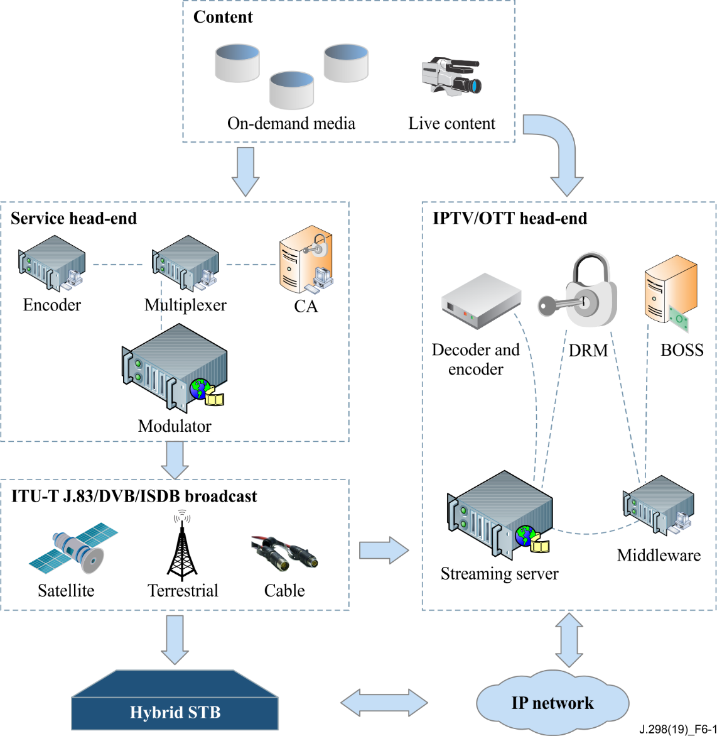
Figure 6-1 – Hybrid STB video system overview
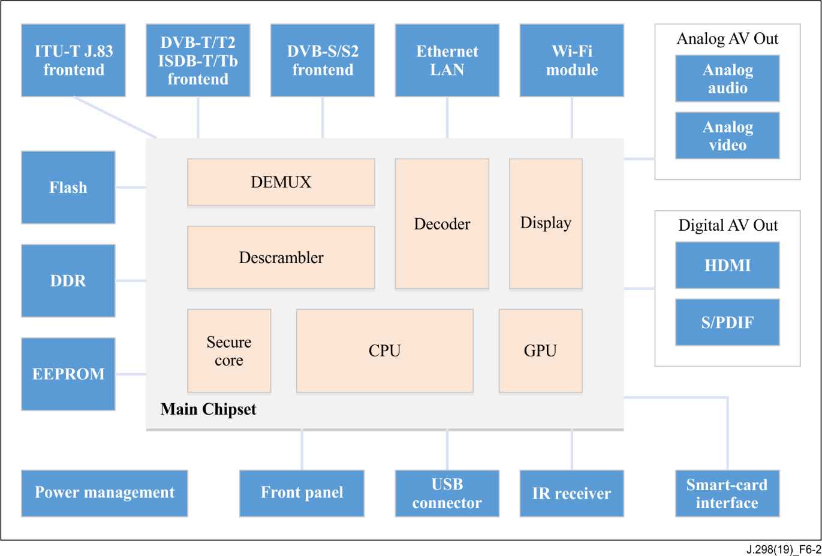
Figure 6-2 – The hybrid STB hardware block diagram
The basic hardware diagram for the hybrid STB is shown in Figure 6-2, which contains the following modules:
• Main chipset, the core module of the STB, contains the central processing unit (CPU), graphics processing unit (GPU), audio and video decoder and all the relevant processors
• Memory, which contains double data rate (DDR) for software execution and Flash for storage
• Frontend which includes at least one of ITU-T J.83, DVB-T/T2, DVB-S/S2 and ISDB-T/Tb
• Power module
• Ethernet interface
• USB interface
• Wi-Fi module
• Audio and video output interface
• Conditional access system (CAS) smart card interface
• Keyboard interface

6.2 The hybrid STB software architecture
Figure 6-3 shows the basic software architecture for the hybrid STB which contains the following modules:
• Hardware on which the software executes
• Software development kit (SDK) platform which includes board configuration, low level driver, operating system and driver interface
• Porting layer, which is the porting interface for all the driver and OS operation, will be called by high-level applications
• Applications
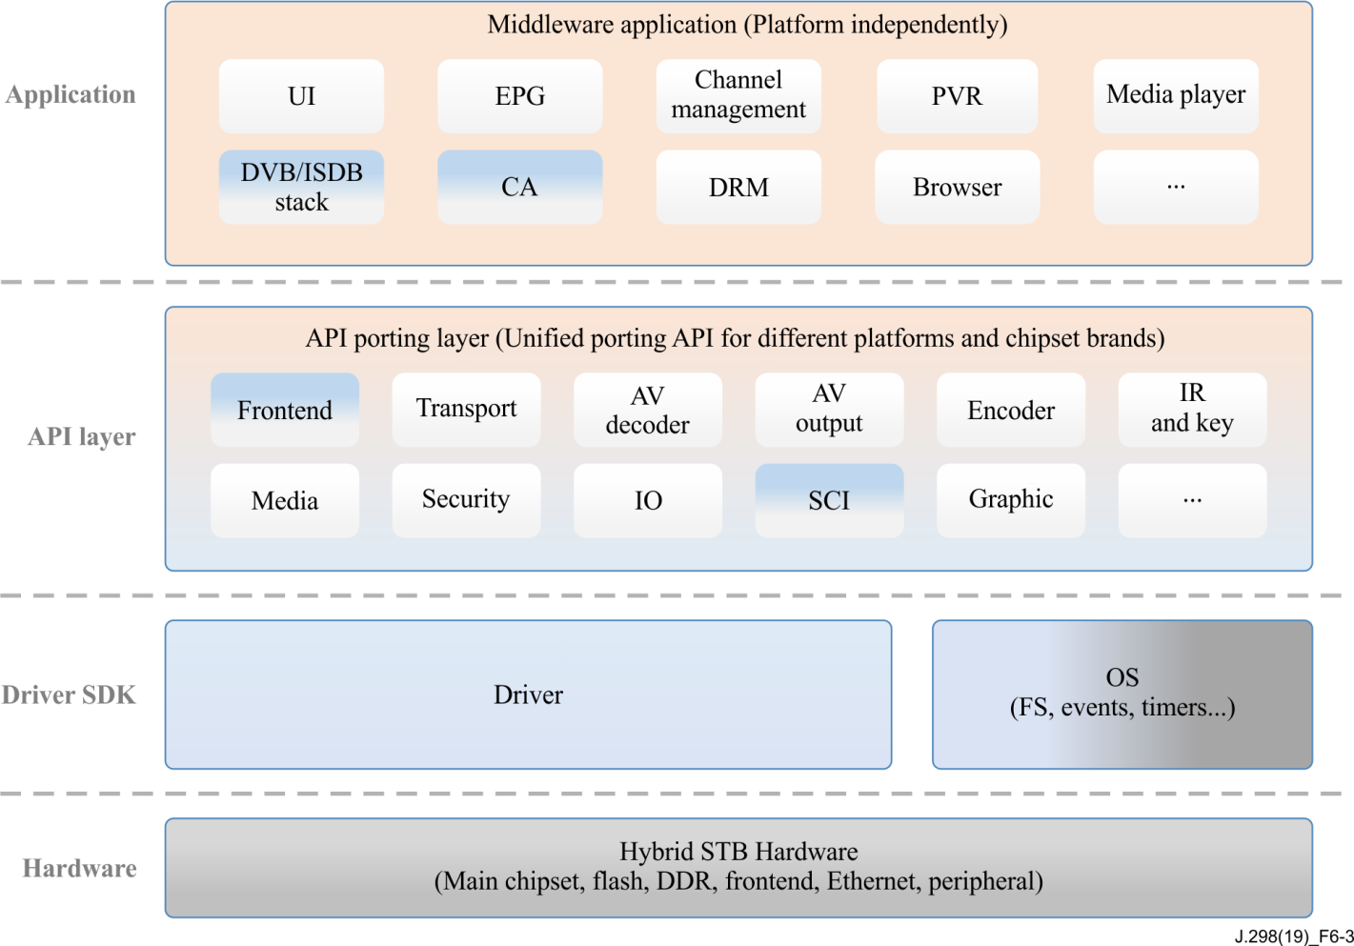
Figure 6-3 – The hybrid STB software architecture

6.3 The hybrid STB categories
To adapt to requirements from different regions and operators, it is recommended to design the hybrid STB taking a modular approach such that different combinations can be supported with configuration changes as opposed to full re-design. For instance, DVB-T/T2 may be required in some regions while DVB-S/S2 or ISDB-T/Tb are required in other regions, therefore, the following combination patterns are recommended.
• IP + ITU-T J.83 + DVB-T/T2
• IP + ITU-T J.83 + DVB-S/S2
• IP + DVB-T/T2
• IP + DVB-S/S2
• IP + ITU-T J.83
• IP + ITU-T J.83+ISDB-T/Tb
• IP + ISDB-T/Tb
• IP + DVB-T/T2 + DVB-S/S2

7 Requirements
The hybrid STB is required to receive and playback AV programmes via cable, satellite/terrestrial and IP transport. Programmes that are protected by conditional access system (CAS) and digital rights management (DRM) systems shall be descrambled or decrypted by integrating CAS and DRM solutions from qualified CAS and DRM solution vendors.

7.1 SOC platform and compatibility
The hybrid STB is required to be independent of any specific type of CPU architecture. Multi-tasking is required to be supported by the CPU.
Embedded GPU hardware is recommended for supporting Direct-FB or Open-GL.
The selected system on a chip (SOC) platform is required to be certified by a CAS vendor.

7.2 AV decoders
The hybrid STB is required to support following video compression formats.
• H.262/MPEG2, H.264/MPEG4/AVC, and H.265/HEVC video compressions.
The Hybrid STB is recommended to support new codecs such as VP9, and AV1
• FHD video resolutions
The Hybrid STB is recommended to support new codecs such as VP9, AV1
The hybrid STB is recommended to support following audio compression formats.
• MPEG-1 and MPEG-2 audio compression
• MPEG4 AAC and AAC Plus
• AC-3, Dolby Digital and Dolby Digital Plus
The decoder is required to switch between aspect ratio of 4:3 and 16:9 and do suitable conversion in case of receiving an anamorphic video.
At least simultaneous dual video decoding is recommended for picture in picture (PIP) or fast channel change (FCC) application.

7.3 Connectivity

7.3.1 Frontend
The hybrid STB is required to integrate at least one tuner and demodulator for reception of ITU-T J.83, DVB-T, DVB-S or ISDB-T signals.
1) ITU-T J.83
In case ITU-T J.83 frontend is applied in the hybrid STB, an input radio frequency (RF) connector is required and one RF loop-out connector can be applied optionally.
2) DVB-T/T2
In case DVB-T/T2 frontend is applied in the hybrid STB, the following requirements are required:
• At least one tuner and demodulator for reception of signals from terrestrial TV transmitters, with one RF input connector
• RF loop-out connector can be applied optionally
3) ISDB-T/Tb
In case ISDB-T/Tb frontend is applied in the hybrid STB, an input RF connector is required and one RF loop-out connector can be applied optionally
4) DVB-S/S2
In case DVB-S/S2 frontend is applied in the hybrid STB, the following requirements are required:
• At least one tuner and demodulator for reception of signals from satellite TV transmitters, with one RF input connector
• A low noise block (LNB) power supply is required for the RF input connector
RF loop-out connector can be applied optionally
A second RF input connector is recommended with a sperate RF route up to the SoC, which can be provided for seamless OTA downloads, etc.

7.3.2 IP
The hybrid STB is required to integrate at least one Ethernet interface of an RJ45 connector, for network streaming and IP applications and /or
one Wi-Fi module for wireless connection.

7.3.3 USB
The hybrid STB is required to install at least one universal serial bus (USB) interface of version 2.0 or higher, for connecting external USB storage.
In addition to one mandatory USB interface, one more USB 2.0 port or above is recommended.

7.3.4 Key button
The necessary key buttons on the front panel are recommended, for instance "Power On/Off", "Up" and "Down" buttons, in case the remote control unit (RCU) is not available the user can still use the STB with basic operations. The front panel should have “Left”, “Right”, “Select” & “Menu” buttons to allow navigation through a UI and selecting the required parameters and also select virtual keyboard characters to enter information. .

7.3.5 IR/RCU
The hybrid STB is required to integrate an infrared receiver for STB operation via RCU. RCU is required to have buttons for selection of Input source i.e. to select IP, Satellite, Terrestrial or cable. RCU is recommended to have dedicated buttons to invoke Closed Captioning / Teletext / Subtitles, Audio language selection & one button to enable voice guided menu. The RCU is recommended to have Braille buttons also.

7.3.6 Video output
The hybrid STB is required to have at least one high-definition multimedia interface (HDMI) interface for transmitting HD, UHD with HDR/SDR video output.
For better compatibility with legacy television, an analogue video output interface is recommended, it can be applied as one of the following forms:
• Standard RCA connector for composite video signal
• 3.5 mm jack connector for composite video signal

7.3.7 Audio output
Digital audio is required to be transmitted via HDMI output interface.
For better compatibility with legacy television, an analogue audio output interface is recommended, it can be applied as one of the following forms:
• Standard RCA connector as stereo (L and R) analogue audio signal
• 3.5 mm jack connector for stereo analogue audio signal. Generally, it can be applied by sharing the same ear jack for analogue video signal as proposed in clause 7.3.6
The hybrid STB can optionally have digital audio output interface as coaxial or optical S/PDIF form.

7.3.8 Power supply
It is required that the power supply comply with the regional low power management standards, for example Energy Star in the US and EU code of conduct, the power supply can be an internal integrated module or an external power adaptor. The external power adaptor is recommended, with external power adaptor, the DC power connector is required.

7.4 Broadcasting service
The hybrid STB is required to be able to receive broadcast content of hybrid services, including the following standards:
• ITU-T J.83, DVB-T/T2, ISDB-T/Tb, DVB-S/S2
• OTT or IPTV

7.5 Channel search
The hybrid STB is required to provide a channel searching procedure over the whole available frontend types and its frequency range. The following requirements are required as minimum:
• Support to detect all available source signals: ITU-T J.83, DVB-T/S or ISDB-T/Tb and IP
• Support automatic and manual channel search
• The progress of channel searching procedure is required to be present on and on screen display (OSD) menu, with received programme information and current frequency being displayed
• Search all available tracks for each channel (subtitles, multi-language audios, etc.)
• User can abort the searching process anytime during automatic or manual channel search
In case of DVB-T or ISDB-T/Tb frontend is applied in the hybrid STB, power supply on antenna and its configuration menu is required.
In case of DVB-S/S2 frontend is applied in the hybrid STB, the following requirements are required during channel search process:
• Support power supply for LNB and satellite switcher
• Support automatic search and detection of connected satellite networks through DiSEqC switcher. DVB-S/S2 shall be automatically detected
• The hybrid STB is available for user to set up the satellite dish LNB configuration
• The hybrid STB will connect to the selected LNB and acquire the signal from the selected satellite automatically

7.6 Channel management
The hybrid STB is required to build a list of all received channels and support a logical channel number (LCN) mechanism, in case there is no LCN descriptor in services sections of transport stream, the hybrid STB is required to sort and numerate programmes according to service ID. The channels come from different signals (cable/satellite/terrestrial and IP) are required to be combined.
The hybrid STB is required to support building a favourite channel list by the user, at least 8 groups are required to support the favourite list.
The hybrid STB is required to provide an appropriate method and OSD menu to the user for managing the channel list, including the following actions on channels in the channel list:
• Sort and filter
• Add to favourite list
• Hide/Unhide
• Lock
The services being broadcasted by head-end of operators may be changed over time. To ensure that the user is always able to access the up-to-date service being broadcasted, the hybrid STB is required to detect and reflect to the user any change with minimal user involvement.

7.7 Channel play
The hybrid STB is required to play all the received programmes smoothly (without mosaic or frame freezing), with the following features:
• The hybrid STB is required to display the last channel viewed when it is turned on from main-power or from standby
• Support to select and play channels with channel number or in sequence (channel up and channel down)
• Support to select audio language in case multi-language audio is available in the current channel
• Support to select subtitles language in case multi-language subtitle is available in the current channel

7.8 EPG
The hybrid STB is required to support a view of information about shows on programmes, parallel timetable of shows and detailed description of shows. The electronic programme guide (EPG) shall be implemented in accordance with SI standard [ETSI EN 300 468].
The hybrid STB is required to provide displaying EPG based on event information table (EIT) service information, for today, tomorrow and the next 7 days (including current day).

7.9 Subtitles
The hybrid STB is required to support decoding and viewing of subtitles and teletext.

7.10 Programme record and playback
The hybrid STB is recommended to support native programme record and playback features based on external USB storage, with the following functions:
• The user is able to record content from the broadcast to the USB storage
• The user is able to trick play when an external storage device is connected
• Support immediate recording, scheduled recording and simultaneous playback and recording
• Support to display the storage status in settings menu. (Memory usage, format option, etc.)
• The recorded content shall be re-encrypted by hardware advanced encryption standard (AES) engine with chipset unique root key, to make sure the content can be played on the current STB only.

7.11 Multi-media player
The hybrid STB is required to support a multi-media player for playing local (via external USB storage) and cloud (via IP) media content.

7.12 IP streaming and service
The hybrid STB is required to support at least one type of http adaptive streaming protocol, such as HLS, MPEG-DASH, Smooth Streaming, etc., the exact selection will be defined by the operators and broadcasters. The hybrid STB is recommended to support both multicast network technologies for IPTV and unicast network technologies for OTT and support switching from multicast to unicast when necessary and allowed if security parameters are complied with.

7.13 Browser
The hybrid STB is required to integrate a browser which complies with the following specification:
• HTML5 profile compatible
• Support for JavaScript

7.14 Security
The hybrid STB is required to comply to all the security requirements of CAS vendor, at least the following features required to be applied:
• Embedded advanced security CAS which will be defined by CAS vendors and operators
• Embedded DRM client system for incoming and outgoing streams which will be defined by operator and content broadcaster
• Contain a secure bootloader that shall be stored in write protected flash area, secure boot process with signature verification shall be applied during boot up process, only the signed software can be executed
- Secure pairing of the STB with the VC or a unique UA number for cardless STBs
• Support high definition content protection (HDCP) copy protection on HDMI output of the latest version
• Support CGMS-A copy protection on analogue video output of the latest version.
• All content recorded to the USB storage shall be encrypted with a unique chipset root key
• Parental control shall be enabled with viewer age ratings and classifications
- Secure Wi-fi connection for Wi-fi enabled STB and Wi-fi should connect only to the authorized networks / URL to ensure it is not used for accessing CAS security keys from and external unauthorized illegitimate source
- Allow access to only those apps which are approved by the distribution platform and content provider.
- Should be enabled in such a way that content cannot be viewed using any VPN connections also.
- The STBs are recommended to enable Forensic Watermarking which is unique per STB at all times when output is available.
- The STBs are required to display visible & unique finger printing per STB when triggered from the Headend to enable identify the STB.

7.15 System management

7.15.1 First time installation
The hybrid STB is required to provide a procedure for the user to setup the STB system configuration during first power up. The following items are recommended to be included in the setup menu:
• OSD language
• Time zone
• Aspect ratio
• Resolution
• Home TP/frequency (This is recommended to be preloaded by the operator for ease of consumer. or should be through software OTA downloads)
• Network setting

7.15.2 System standby
The hybrid STB is required to support power standby function for better user experience and power efficiency. At least one type of the following standby mode is required:
• Active standby mode is required, in this mode, most parts of the hybrid STB are still working normally and the STB can be woken up to normal viewing mode in 3 seconds.
• Passive standby mode is recommended, in this mode, most parts of the hybrid STB are powered down, the power consumption is much lower, while the wake-up time is similar with normal power up process.

7.16 Maintenance

7.16.1 Software upgrade
The hybrid STB is required to provide a software download mechanism for upgrading software modules.
The hybrid STB is required to support at least one of the following upgrade methods:
• OTA
• IP
•

7.16.2 Remote management and diagnostic
The hybrid STB is recommended to support CPE WAN management protocol (CWMP) according to Amendment 5 of [TR-069 Amd.5], it is also recommended to support [TR-106 Amd.5] and [TR-135 Amd.1] data models for troubleshooting and collecting the information of QoS/QoE statistics.

8 Technical specifications
This clause defines the technical specification for the implementation of the hybrid STB. All the items in this specification are required to be included but not limited for the specific hybrid STB implementation.

8.1 Minimum system

8.1.1 CPU
The CPU performance of the hybrid STB is required to be more than 2000DMIPS for execution of the applications, for sufficient computing power and a smooth user experience. The selection of CPU architecture is not limited and could be defined by the operators and the STB vendors.

8.1.2 GPU
The hybrid STB is recommended to implement 3D graphic accelerator supporting OpenGL ES2.0 or above.

8.1.3 Memory
For the supporting web browser and IP related features, the following memory capacity of the hybrid STB is required:
• Flash: 128 Mbytes as minimum
• DDR: 512 Mbytes as minimum

8.2 Decoder

8.2.1 Audio
The hybrid STB is required to support the following mainstream audio codecs:
• PCM audio is required
• MPEG-1 Layer I/II [IEC 11172-3]
• MPEG-2 Audio [ISO/IEC 13818-3]
• MPEG4 AAC-HE v2 Level 2 as specified in [ISO/IEC 14496-3]
• MPEG4 AAC-HE v2 Level 4 as specified in [ETSI TS 101 154], section 6.4
• Dolby Digital, Dolby Digital Plus and Dolby Atmos is recommended.
• AC-3 [ETSI TS 102 366] is recommended
• Manual lip-sync delay is recommended up to 400 ms
Multichannel audio formats, before transferring to analogue audio output, is required to be converted to stereo format (down mix) and the hybrid STB is recommended to support down mix digital audio output as below for better compatibility:
• Dolby Digital down mix to stereo for HDMI and S/PDIF
• Dolby Digital Plus down mix to stereo for HDMI and S/PDIF
• Dolby Digital Plus conversion to Dolby Digital for pass through S/PDIF
- STB is recommended to Passthrough of all audio formats to allow connectivity and decode with Home Theatre systems
The hybrid STB is required to support following output mode for digital audio
• PCM (should be switched ON by default)
• RAW bit-stream
The following audio output modes are required:
• Mono
• Dual mono
• Stereo

8.2.2 Video
The hybrid STB is required to support the following mainstream video codecs:
• MPEG-2: MP@ML, MP@HL
• MPEG-4 or H.264 or AVC: MP@L3, MP@L4.1, HiP@L4.1
• H.265 or HEVC: Main@L5.1, Main 10@L5.1 (or higher)
The Hybrid STB is recommended to support
- VP9
- AV1

The hybrid STB is required to support down scale UHD to HD video to SD display for analogue video output and HRD to SDR
The following video resolutions are required to be supported by the hybrid STB:
• 1080p
• 1080i
• 720p
• 576p
• 576i
The hybrid STB is recommended to support 1440p, 2160p
The following aspect ratios are required to be supported:
• 4:3 with centre cut (cropped) 16:9
• 4:3 with letterboxed 16:9
• 16:9 with pillar boxed 4:3
• 16:9 with zoomed 4:3
• Zoom
- Stretched to fit TV size

8.2.3 Picture
The hybrid STB is required to support the following mainstream picture compression formats:
• BMP
• GIF
• GIF w/ Animation
• JPEG up to 8M pixels

8.3 Hardware interface

8.3.1 ITU-T J.83 frontend
In case ITU-T J.83 frontend is integrated, the hybrid STB is required to integrate cable frontend in accordance with ITU-T J.83 and apply the following specifications as well.
• Integrate an input IEC female connector in accordance with [b-IEC 61169-2] the characteristic impedance is 75 Ω
• The minimum frequency bandwidth on input from 50 MHz to 862 MHz
• Receive incoming RF signal whose level is in accordance with the defined bandwidth of signal level according to [b-IEC EN 60728-1]

8.3.2 DVB-T/T2 frontend
In case DVB-T/T2 frontend is integrated, the hybrid STB is required to follow the specifications defined in [ETSI EN 300 744] and [ETSI EN 302 755] and apply following specifications as well:
• Integrate an input IEC female connector in accordance with [b-IEC 61169-2], the characteristic impedance is 75 Ω
• Frequency range from 174 MHz to 862 MHz
• Support at least −47dBm of input signal
• Support 5V@100 mA as maximum DC power to an external antenna with amplifier. The DC power shall be protected against short circuit and there shall be an alternative in the menu system to turn the DC power supply on and off

8.3.3 ISDB-T/Tb frontend
In case ISDB-T/Tb frontend is integrated, the hybrid STB is required to follow the specifications defined in [ARIB STD-B21], [ARIB STD-B31] and [b-ITU-R BT.1306-7], and apply following specifications as well:
• Integrate an input IEC female connector in accordance with [b-IEC 61169-2], the characteristic impedance is 75 Ω
• Frequency range from 174 MHz to 862 MHz
• Support 5V@100 mA as maximum DC power to an external antenna with amplifier. The DC power shall be protected against short circuit and there shall be an alternative in the menu system to turn the DC power supply on and off

8.3.4 DVB-S/S2 frontend
In case DVB-S/S2 frontend is integrated, the hybrid STB is required to follow the specifications defined in [ETSI EN 300 421] and [ETSI EN 302 307-1] and apply the following specifications as well:
• Integrate an input IEC F-Type connector in accordance with IEC 169-24 female, the characteristic impedance is 75 Ω
• Frequency range from 950 MHz to 2150 MHz as minimum
• Signal level from −25 dBm to −65 dBm
The hybrid STB is required to support LNB control and protection with the following specifications:
• DC power for vertical (13V) and horizontal (18V), capable of maximum 350 mA
• Short circuit and over temperature protection
• Remote shutdown via SOC
• DiSEqC 2.0 or higher
• Uni-cable
• 22 kHz Tone

8.3.5 HDMI
The hybrid STB is required to integrate a HDMI connector for digital video and audio output, it shall be compliant with the following specifications:
• Type-A (female)
• HDMI version 1.4a or above
• HDCP version 1.4 or above
The HDMI ports are required to be enabled with Content Copy Protection mechanisms of the latest versions for all resolution outputs.
HDMI CEC feature can be optionally applied in the hybrid STB.

8.3.6 S/PDIF
The hybrid STB can optionally integrate an S/PDIF interface (either an optical or coaxial connector) for digital audio output, it shall be compliant with [ISO/IEC 60958-1].

8.3.7 RCA
The hybrid STB is recommended to integrate an RCA connector for stereo audio and composite video output. The analog output is required to be enabled with Content Copy Protection mechanisms such as CGMS-A

8.3.8 Ear jack
The hybrid STB can optionally integrate an ear jack connector for stereo audio and composite video output.

8.3.9 USB
The hybrid STB is required to integrate at least one USB connector with the following specifications:
• USB Type A connector, version 2.0 or above
• 5V@500 mA power supply as minimum
• Comply with Universal Serial Bus Specification v2.0 or above

8.3.10 Ethernet
The hybrid STB is required to integrate an Ethernet network interface with the following specifications:
• RJ 45 connector
• IEEE 802.3 10/100Mbase-T
• IPv4 (mandatory) and IPv6 (recommended)
- The port is required to be configurable only by the operator through a secure connection similar to OTA

8.3.11 Wi-Fi
The hybrid STB is recommended to integrate Wi-Fi network interface with the following specifications:
• Compliant with IEEE 802.11 a/b/g/n standard as minimum
• Single band (2.4 GHz) Wi-Fi module as client mode
The port is required to be configurable only by the operator through a secure connection similar to OTA

8.3.12 Front panel
The hybrid STB is recommended to integrate a front panel with the following specifications:
• Front panel buttons: Power On/Off, Up, Down, Left, Right, Select, Back/Exit
• IR receiver
• Led light to indicate power status

8.4 Power supply
The hybrid STB is recommended to work with an external AC/DC power supply unit (PSU) adaptor, connected with a DC jack interface. The hybrid STB and PSU adaptor is required to comply with the following specifications:
• Input voltage: AC 100V to 240V as minimum range
• AC frequency: 50/60 Hz

8.5 Software functions

8.5.1 Channel list
The capability of the channel list is required to support following specifications:
• At least 3000 TV and radio services from cable/satellite/ terrestrial and IP frontend
• At least 8 groups for favourite channel lists
The operations on channel list are recommended to have the SORT, FIND functions. The SORT is to sort channels in alphabetic order or FTA/scrambled.

8.5.2 Dynamic update
The hybrid STB is required to support dynamic update as follows:
• Changes in PSI/SI will be applied automatically
• All changes will be applied in hidden mode without any action from user

8.5.3 Subtitles
The hybrid STB is required to support subtitles with the following specifications:
• [ITU-T J.83] Annex A (DVB-C) subtitle in accordance with [b-ETSI EN 300 743], including characters from code table ISO/IEC 8859-2
• [ITU-T J.83] Annex C subtitle in accordance with [ARIB STD-B24].
• Teletext in accordance with [b-ETSI EN 300 706]
• Closed captions in accordance with CEA-608, CEA-708 and [ARIB STD-B24]
• Selection of substile languages and turning on/off of subtitles

8.5.4 Multiple languages
The hybrid STB is required to support multiple languages as specified below:
• Support multi-language for OSD menu, audio track and subtitles
• The language setting shall be used to define the default audio track and subtitle language
• Support minimum 2 multi-language tracks

8.5.5 PVR and TimeShift
The hybrid STB is recommended to support personal video recorder (PVR) and TimeShift features, the following mechanism is required as minimum in case PVR and TimesShift are supported.
• Recorded content will be stored as encrypted transport stream
• Recording one channel while watching the other channels on the same carrier
• The recorded content should include the channel name and programme title if available
• The recorded content could be renamed, locked and deleted
• While in playback, the user is able to select any of multi audio and subtitle streams if they are present in the recorded content.
The hybrid STB is required to support the following specification of trick mode:
• Fast forward/ backward
• Slow forward/ backward
• Pause and resume

8.5.6 Media player
The hybrid STB is recommended to implement a media player for playing both local and cloud media content with the following specifications.
In case the media player is applied in the hybrid STB, the following features are required to be implemented:
• Play content from USB external storage devices
• Play content from IP network interface
• Media formats at least: AVI, MKV, MP4, TS
• Video codecs at least: MPEG-2, MPEG-4 part 2 (ASP, Xvid), MPEG-4 part 10 (AVC/H.264, x264)
- Recommended to support HEVC or H.265, AV1 and VP9
• Audio codecs at least: MP2, AAC
• Image formats at least: BMP, TIFF, PNG, JPEG

8.5.7 Network
The hybrid STB is required to integrate a LAN interface, a Wi-Fi interface is recommended to be integrated.
The hybrid STB is required to support Internet protocol as specified below:
• IPv4, IPv6 (optional)
• IGMP v1, v2 and v3
• ICMP
• UDP, TCP, RTP, RTSP/RTCP, HTTP, SSL2.0/3.0
• DHCP

8.5.8 IP streaming
The hybrid STB is required to support IP streaming as specified below:
• Unicast for OTT
• Multicast for IPTV
The hybrid STB is required to support at least one of the following dynamic adaptive streaming standards:
• MPEG-DASH
• HLS
• Smooth Streaming

8.6 Security

8.6.1 General
The hybrid STB is required to implement the following general security specifications:
• Memory to memory encryption and random access memory (RAM) scrambling is required
• AES-128 encryption and a triple data encryption standard (TDES) algorithm is required
• The main chipset of the hybrid STB is required to provide a unique hardware root key
• The algorithm of software signature and verification is required to support RSA 2048-bit keys

8.6.2 CA
The hybrid STB is recommended to implement a CAS function by fully complying with the detailed specification of the selected CAS vendor. For an encryption algorithm, the following basic standard is required:
• Encryption algorithm DVB-CSA-2/3, AES 128 (ATIS 0800006)
• DVB-CSA2 is required and should be implemented in hardware on the chipset
• DVB-CSA3 which defined in [ETSI TS 100 289] is recommended and should be implemented in hardware on the chipset

8.6.3 DRM
At least one of the digital rights management (DRM) standards is required for content protection of IP streaming, the detailed selection of DRM will be decided by the operator and the broadcaster.

8.6.4 Output protection
The hybrid STB is required to support output protection as follows:
• HDCP v1.4 or above for HDMI digital video and audio transmission
• CGMS-A for analogue video output protection, with CEA-608, CEA-805 standard

8.6.5 Parental control
The hybrid STB is required to provide a PIN-controlled parental control feature to perform the following functions:
• Setting age and PIN for viewing single events
• Activating or deactivating PIN checking
• The STB shall exercise parental control at event level if there is an event information table (EIT) associated with it.

8.7 OSD

8.7.1 User interface
The hybrid STB is required to support an OSD user interface to the following specifications:
• Support resolution at least 720p
• Include system setting, installation, info bar, channel list, EPG
• Include CAS configuration menu
• Support view of system messages and CAS messages

8.7.2 EPG
The hybrid STB is required to support the EPG application based on DVB-SI according to [ETSI EN 300 468], and is required to support the following features:
• Support UTF-8 character encoding
• Decode full EIT information with capability to display 7 days EPG information

8.7.3 Information bar
The hybrid STB is required to implement the information bar as defined in the following specification:
• Showing channel name
• Showing now and next event details with time
• Showing multi audio, icon to indicate the presence of subtitle and teletext, video resolution

8.7.4 CA menu
The hybrid STB is required to implement a CA service menu for presenting the current CAS status and subscriber information, the detailed specification is required to comply with the requirement of the selected CAS vendor.

8.8 System upgrade
The hybrid STB is recommended to implement over the air (OTA) system software update (DVB SSU) from transport stream (TS) in accordance with [ETSI TS 102 006] and other relevant documents.

8.9 RCU
The hybrid STB is required to have one remote control unit, the minimum required keys are listed below:
• Alphanumerical keys
• Navigation (up, down, left, right)
• Power
• Menu, EPG, OK, Back, Exit, Colour keys

Bibliography

[b-ITU-T F.902] Recommendation ITU-T F.902 (1995), Interactive services design guidelines.
[b-ITU-T H.262] Recommendation ITU-T H.262 (2012)|ISO/IEC 13818-2:2013, Information technology – Generic coding of moving pictures and associated audio information – Part 2: Video.
[b-ITU-T J.90] Recommendation ITU-T J.90 (2000), Electronic programme guides for delivery by digital cable television and similar methods – Reference operating scenario and requirements.
[b-ITU-T J.94] Recommendation ITU-T J.94 (2016), Service information for digital broadcasting in cable television systems.
[b-ITU-T J.142] Recommendation ITU-T J.142 (2000), Methods for the measurement of parameters in the transmission of digital cable television signals.
[b-ITU-T J.205] Recommendation ITU-T J.205 (2012), Requirements for an application control framework using integrated broadcast and broadband digital television.
[b-ITU-T J.290] Recommendation ITU-T J.290 (2006), Next generation set-top box core architecture.
[ITU-T J.295] Recommendation ITU-T J.295 (2012), Functional requirements for a hybrid cable set-top box.
[ITU-T J.296] Recommendation ITU-T J.296 (2012), Specifications for a hybrid cable set-top box.
[b-ITU-T J.297] Recommendation ITU-T J.297 (11/2016), Requirements and functional specification of cable set top box for 4K ultra high definition television.
[b-ITU-T X.1193] Recommendation ITU-T X.1193 (2011), Key management framework for secure internet protocol television (IPTV) services.
[b-ITU-T Y.1910] Recommendation ITU-T Y.1910 (2008), IPTV functional architecture.
[b-ITU-R BT.1306-7] Recommendation ITU-R BT.1306-7 (2015), Error-correction, data framing, modulation and emission methods for digital terrestrial television broadcasting.
[b-ETSI EN 300 429] ETSI EN 300 429 (1998), Digital Video Broadcasting (DVB) – Framing structure, channel coding and modulation for cable systems.
[b-ETSI EN 300 706] ETSI EN 300 706 (2003), Enhanced Teletext specification.
[b-ETSI EN 300 743] ETSI EN 300 743 (2006), Digital Video Broadcasting (DVB) – Subtitling systems.
[b-ETSI EN 302 307-2] ETSI EN 302 307-2 V1.1.1 (2005), Digital Video Broadcasting (DVB); Second generation framing structure, channel coding and modulation systems for Broadcasting, Interactive Services, News Gathering and other broadband satellite applications; Part 2: DVB-S2 Extensions (DVB-S2X).
[b-ETSI TS 101 162] ETSI TS 101 162 (2009), Digital Video Broadcasting (DVB) – Allocation of Service Information (SI) and Data Broadcasting Codes for Digital Video Broadcasting (DVB) systems.
[b-ETSI TS 101 211] ETSI TS 101 211 (2012), Digital Video Broadcasting (DVB) – Guidelines on implementation and usage of Service Information (SI).
[b-ETSI TS 102 154] ETSI TS 102 154 (2004), Digital Video Broadcasting (DVB) –Implementation guidelines for the use of Video and Audio Coding in Contribution and Primary Distribution Applications based on the MPEG-2 Transport Stream.
[b-IEC 60065] IEC 60065:2014, Audio, video and similar electronic apparatus – Safety requirements.
[b-IEC 60950-1] IEC 60950-1:2005, Information technology equipment – Safety – Part 1: General requirements.
[b-IEC 61169-2] IEC 61169-2:2007, Radio-frequency connectors - Part 2: Sectional specification - Radio frequency coaxial connectors of type 9,52.
[b-IEC 60958-3] IEC 60958-3:2003, Digital audio interface – Part 3: Consumer application.
[b-IEC 60068-2] IEC 60068-2, Electronic Equipment and Product Standards: Part-2.
[b-IEC 62360] IEC 62360:2008, Baseline specifications of satellite and terrestrial receivers for ISDB (Integrated Service Digital Broadcasting).
[b-IEC EN 60728-1] IEC 60728-1 ed 4.0 (2007), Cable networks for television signals, sound signals and interactive services.
[b-IETF RFC 2616] IETF RFC 2616 (1999), Hypertext Transfer Protocol – HTTP/1.1.
[b-CEA-608-E] Consumer Electronics Association 608-E-2008 (R2014) (ANSI), Line 21 Data Services.
[b-CEA-708-E] Consumer Electronics Association 708-E-2013 (ANSI), Digital Television (DTV) Closed Captioning.

SERIES OF ITU-T RECOMMENDATIONS
Series A | Organization of the work of ITU-T
Series D | Tariff and accounting principles and international telecommunication/ICT economic and policy issues
Series E | Overall network operation, telephone service, service operation and human factors
Series F | Non-telephone telecommunication services
Series G | Transmission systems and media, digital systems and networks
Series H | Audiovisual and multimedia systems
Series I | Integrated services digital network
Series J | Cable networks and transmission of television, sound programme and other multimedia signals
Series K | Protection against interference
Series L | Environment and ICTs, climate change, e-waste, energy efficiency; construction, installation and protection of cables and other elements of outside plant
Series M | Telecommunication management, including TMN and network maintenance
Series N | Maintenance: international sound programme and television transmission circuits
Series O | Specifications of measuring equipment
Series P | Telephone transmission quality, telephone installations, local line networks
Series Q | Switching and signalling, and associated measurements and tests
Series R | Telegraph transmission
Series S | Telegraph services terminal equipment
Series T | Terminals for telematic services
Series U | Telegraph switching
Series V | Data communication over the telephone network
Series X | Data networks, open system communications and security
Series Y | Global information infrastructure, Internet protocol aspects, next-generation networks, Internet of Things and smart cities
Series Z | Languages and general software aspects for telecommunication systems

* To access the Recommendation, type the URL http://handle.itu.int/ in the address field of your web browser, followed by the Recommendation's unique ID. For example, http://handle.itu.int/11.1002/1000/11830-en.

