Radiocommunication Study Groups | 
Received: Date 20xx  Subject: Agenda item 1.1 (WRC-23) | Document XX/-E
 | Date 20xx
 | Original: English
India (Republic of)
Supporting material for working document and for the draft CPM text for WRC-23 agenda item 1.1

Introduction
WP5D studies shows various pfd limits for protection of Aero Mobile Station (AMS) and Maritime Mobile Station (MMS).
(i) Study 1 considered the maximum antenna gain, i.e. the antenna of the AMS and MMS points towards IMT. Result of studies for Ssipborne station shows pfd range from -111.57 to - 139.57 (dB(W/(m². MHz))) and for airborne station it shows pfd range from -105.57 to -130.07 (dB(W/(m². MHz))).
(ii) Study 2 considered the scenario where an airborne station at 22 km communicates with ships at a farther distance and is not applicable when the receiver is at a larger distance, communicating with airborne or shipborne transmitters with no or limited antenna discrimination in the direction of IMT. Study 2 result for shipborne station shows pfd range from -99.54 to -112.57 (dB(W/(m². MHz))) and for airborne station it shows pfd range from -102.38 to -114.57 (dB(W/(m². MHz))).
From these studies, it was noted that pfd values are dependent on antenna gain.
Discussion
Since the communication is only possible above external noise, this proposal is to compare WP5D studies outcome pfd values with that of pdf values derived from external noise with variation in receiver antenna gain.
Various external noise has been given in Recommendation ITU-R P.372-16 (Radio noise) in frequency upto 100 GHz. As per Figure 3 of Recommendation ITU-R P.372-16 (Radio noise), there are two levels of external noise at 4800 MHz due to elevation angle of antenna.
- -148 (dB(W/MHz)) approximately, due to sky noise at zero degree elevation, and
- -164 (dB(W/MHz)) approximately, due to cosmic noise.
So, the external noise varies between -148 (dB(W/MHz)) and -164 (dB(W/MHz)) on frequency 4800 MHz depending upon the elevation angle of antenna, see Figure a, below.
Pfd values from external noise have been derived using following formula from chapter 4 of Spectrum handbook.
$s(dB(W/{m^{2}))=p(dB\left(W\right)- a_{e}(dB\left(m^{2}\right))}$ ,
$$a_{e}{(dB(m}^{2}))=38.55+g-20log⁡(f/{MHz})$$
where:
s power flux density $dB(W/{m^{2})}$
p received power $(dB\left(W\right)$
$a_{e}$effective area ${(dB(m}^{2})$
g gain dB

Using the above formula, pfd values calculated for various receiver antenna gain. Figure b is plotted taking two approximated values of external noise i.e -148 (dB(W/MHz)) and -164 (dB(W/MHz)) at the frequency 4800 MHz. Graph shows two lines of pfd values, which decreases when receiver antenna gain increases.

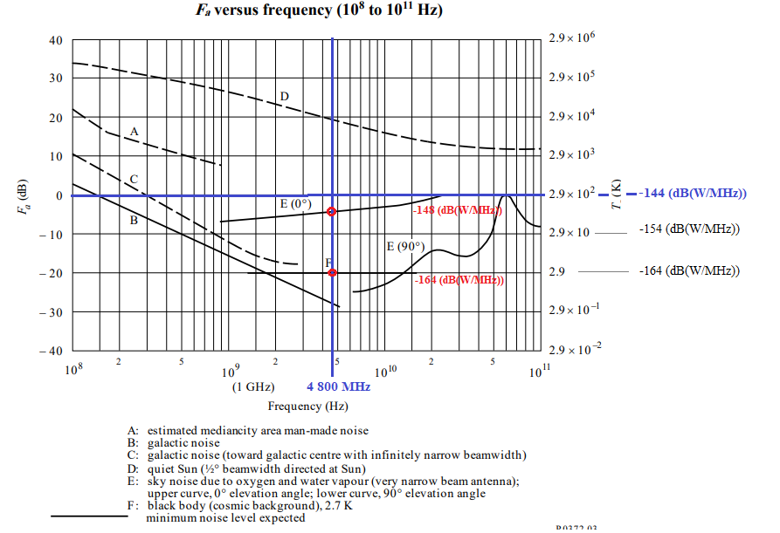
Figure a
Figure b

Proposal
This contribution is to inform about Recommendation ITU-R P.372 (Radio noise) and to consider it as an additional supporting material for incorporating in WP5D studies. WP5D studies has carried out studies with maximum antenna gain for shipborn station, 31 dBi, and for sirborn station,19 dBi.
Considering that
- the variation in the receiver antenna gain is ( 0 dBi to 19 dBi ) and (0 dBi to 31 dBi ) for AMS & MMS, respectively; and
- the external noise approximated to -148 (dB(W/ MHz)) at 4800 MHz at zero degree antenna elevation as per ITU-R Rec. P372,
the calculated variation of pfd values, given the external noise at 4800 MHz in Recommendation ITU-R P.372 (Radio noise), ranges from -113 to -132 dB(W/m². MHz), and from -113 to -144 dB(W/m². MHz) for AMS and MMS, respectively

-------------------------------------------------------------------------------------------------

