 | INTERNATIONAL TELECOMMUNICATION UNION  TELECOMMUNICATION  STANDARDIZATION SECTOR  STUDY PERIOD 2017-2020 |  | SG5-
 |  |  | STUDY GROUP 5
 |  |  | Original: English
Question(s): |  | 12/5 |  | Sophia Antipolis, 13-23 June, 2023
CONTRIBUTION
Source: |  | India
Title: |  | New work item for the creation of a Supplement to Recommendation ITU-T L.1700 on the subject of Low-cost sustainable telecommunication for rural communications in developing countries enabling SIP based voice calling on Wi-Fi.
Purpose: |  | Proposal
Contact: |  | Sandeep Agarwal  CDOT  Department of Telecommunications  India |  |  | Tel: +91-80-2511-9850  E-mail: sandeepa@cdot.in;
Contact: |  | Neha Upadhyay  Telecommunication Engineering Centre  Department of Telecommunications  India |  |  | Tel: +91 11 23323107  E-mail: neha.upadhyay86@gov.in
Keywords: |  | New work item, Low-cost, sustainable telecommunication, rural communication, Wi-Fi, SIP
Abstract: |  | This contribution seeks to propose creation of a new Work Item under Question 9/5 for formulation of a new Supplement to Recommendation ITU-T L.1700 on the subject of Low-cost sustainable telecommunication for rural communications in developing countries enabling SIP based voice calling on Wi-Fi

1. Introduction
Access to communication and ICT infrastructure in rural areas of most developing countries is still a challenge. The inadequacy of crucial infrastructure like electricity in rural and remote areas present a significant problem. Deployment of telecommunication solutions which are low-cost and low maintenance and can be deployed easily is an inevitability in such cases. Wi-Fi network infrastructure, configured to provide traditional telecom services like voice calling, being an overall low cost solution can prove to be a viable solution in such cases to provide low cost sustainable telecommunication.

2. Proposal
This contribution proposes a new Work Item under Question 9/5 for formulation of a new Supplement to Recommendation ITU-T L.1700. The A.1 form is annexed with this document as Annexe I. A suggested base text for the proposed study is also enclosed as Annexe II with the contribution.

ANNEXE I
A.1 justification for proposed draft new Supplement with ITU-T Recommendation L.1700

Question: | 9/5 | Climate change and assessment of information and communication technology (ICT) in the framework of the Sustainable Development Goals (SDGs)​ | Geneva, Switzerland, 13 May – 22 May 2019
Reference and title: | Supplement describing a low cost sustainable telecommunication solution in rural and remote areas using Wi-Fi for conventional telecom services like voice calling.
Base text: | Annex II  Base text for the proposed Supplement describing a low cost sustainable telecommunication solution in rural and remote areas using Wi-Fi for conventional telecom services like voice calling |  | Timing: | Study Period 2017-2020
Editor(s): | Neha Upadhyay  Tel: +91 11 23323107  E-mail: neha.upadhyay86@gov.in  Harshit Modi  E-mail: harshit.modi@gov.in  Bhoomika Gaur  E-mail: bhoomika.gaur@gov.in |  | Approval process: | Agreement
Scope
The scope of this work item is to describe a low cost sustainable telecommunication solution in rural and remote areas using Wi-Fi for conventional telecom services like voice calling.
Summary
The supplement provides description of low cost sustainable telecommunication solution using Wi-Fi network infrastructure in rural and remote areas where crucial infrastructure like electricity etc. pose a major concern in deployment and sustenance of telecom infrastructure.
Relations to ITU-T Recommendations or to other standards (approved or under development):
NIL
Liaisons with other study groups or with other standards bodies:
ITU-D
Supporting members that are committing to contributing actively to the work item:
_________________

ANNEXE II
Base text for the proposed Supplement describing a low cost sustainable telecommunication solution in rural and remote areas using Wi-Fi for conventional telecom services like voice calling

Scope
This aims at identifying a low-cost sustainable solution based on Wi-Fi network which can provide conventional telecommunication services like voice calling to other cellular as well as fixed line phones. This solution also utilises renewable sources of energy, and cost efficient backhaul in areas where optical fiber penetration is low or not present at all.

Introduction
This solution proposes use of Wi-Fi network to facilitate SIP based calling to other mobile or landline networks through the core network of a conventional mobile network service provider. The Wi-Fi Access Point (AP) used in this solution is a multi-radio platform. The same AP is used to provide Hotspot connectivity at 2.4 GHz as well as P2P/P2MP
(Point to Point/ Point to Multi Point) configuration at 5 GHz by using suitable antennas.
Wi-Fi access network at a location is provided by Wi-Fi equipment in Hotspot, P2P & P2MP configuration. The user devices use SIP client to generate VoIP call over Wi-Fi network which is directed to the Telecom Service Provider VoIP core and terminated at mobile/landline networks through respective gateways and vice-versa.

System Architecture
A typical system architecture for this solution is as below
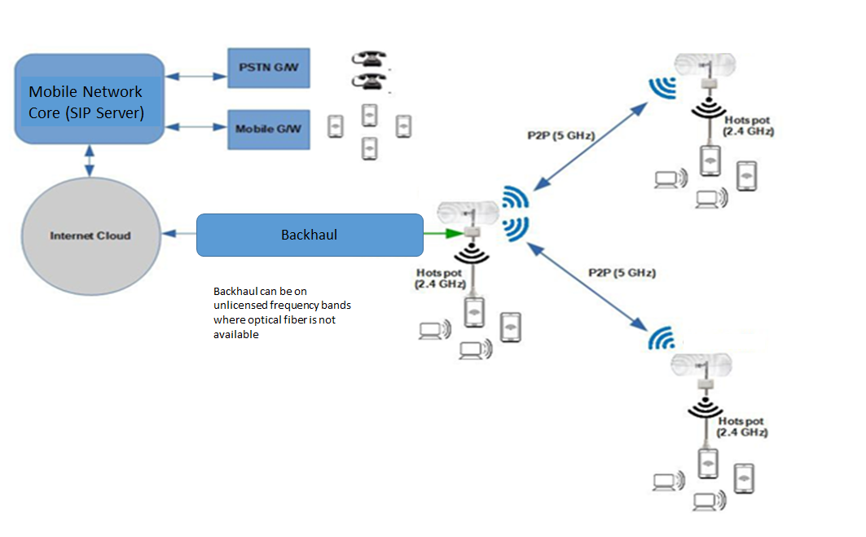

Network components in the solution
A typical deployment of this solution has the following network components:

Sr. No. | Equipment | Details
 | Wi-Fi Access Points | Frequency of operation: 2.4 GHz, 5 GHz  Mode of operation: P2P, P2MP and Hotspot configuration  Technology: IEEE 802.11a/b/g/n/ac
 | Antennas | Sector and long range antenna for access as well as P2P/P2MP links
 | SIP client | Software for placing calls to mobile/landline networks through Wi-Fi network
 | Power supply | Solar panels and cells (Conventional power supply wherever available can be used)
 | Backhaul connectivity | Can be based on  - Backhaul using P2P or P2MP configuration in unlicensed bands of 5 GHz or 2.4 GHz of Wi-Fi APs using long range antenna  - Optical fiber wherever available  - Conventional microwave backhaul wherever available
 | Element Management System | To manage and configure the Wi-Fi AP and other related network devices at remote locations
 | Core network of Mobile Service provider | Mobile core network with SIP server or VoIP enabling core network components.

Overview of the solution
The solution aims to provide Wi-Fi coverage in rural and remote areas where coverage by other conventional sources is limited or not present at all. A brief overview of the system is as below:

- Wi-Fi Access Point (APs) deployment and Wi-Fi Coverage Provision
The Wi-Fi APs will be deployed at different locations in a region where coverage has to be provided. The Wi-Fi AP can be used with sector antennas instead of omnidirectional antennas to extend the coverage. One of the sectors of the Wi-Fi AP can be used to extend P2P link to backhaul. The necessary AAA (Authentication, Authorization & Accounting) provisions are made to ensure necessary AAA functionalities. FCAPS functionality for service provisioning for users and network equipment management is also deployed.
- SIP client based voice calling over Wi-Fi to mobile and landline networks
SIP based calling through Wi-Fi network can enable make or receive calls to and from mobile and landline networks. The call is routed through the SIP server installed in the core network of the anchor service provider (Mobile or fixed line service provider). The service provider will authenticate the user and provide him with a unique calling number (based on the relevant numbering scheme employed in the network) which will be entered in the SIP client to facilitate calling to other mobile or fixed line networks. Whenever, user will make a call through the SIP client, the called party will be displayed this number allocated to the user. The called party will receive the call as normal mobile or fixed-line telephone call and no SIP client or any other VoIP client needs to be installed at the user device of the called party. This facility will enable the users to make conventional calls using Wi-Fi in rural and remote areas where coverage of mobile or landline networks is limited or not present at all. This will also curb the capacity planning issues of the mobile network service providers in certain areas as the traffic in this case is being offloaded over the Wi-Fi network.

Different communication scenarios of the solution
The different communication scenarios of the solution include the following:
Scenario A  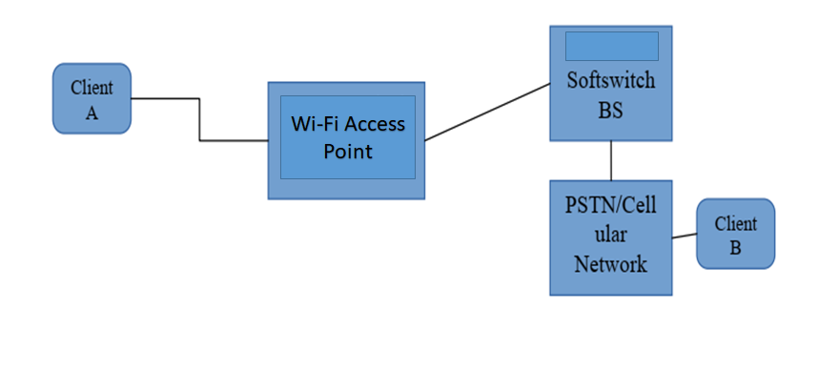 | Scenario B  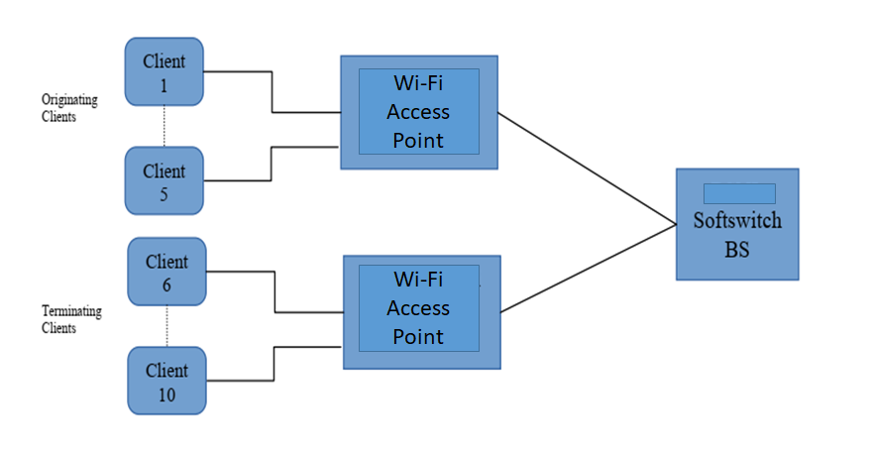

Features of the solution
- Low cost: The solution offers conventional services like voice calling apart from data services over Wi-Fi network which reduces the charges of licensed spectrum for providing access, mobile network equipment charges, backhaul spectrum charges etc. This will also curb the capacity planning issues of the mobile network service providers in certain areas as the traffic in this case is being offloaded over the Wi-Fi network

- Solar based power supply: The whole Wi-Fi AP system with sector based coverage and backhaul on a Wi-Fi link as well can be powered by Solar based power supply which not only provides sustainability but also reduces the dependence of the network on conventional grid power supply thereby aiding in increasing the reliability of the solution in rural and remote areas.

- Easy deployment & management: Wi-Fi networks are easily deployable due to their low degree of complexity as compared to other conventional telecommunication networks.

- User authentication: The user authentication for use of SIP client based calling can be facilitated by the anchor service provider. Different anchor service providers can provide services in different or same areas.

Summary & Conclusion
The solution proposed here offers a low cost and sustainable way of extending coverage in rural areas through Wi-Fi deployment and provide conventional services like voice calling (using SIP client) alongwith the data services.

REFERENCES
- http://www.dot.gov.in/
- http://www.tec.gov.in
- https://www.cdot.in
_________________

