 | INTERNATIONAL TELECOMMUNICATION UNION  TELECOMMUNICATION  STANDARDIZATION SECTOR  STUDY PERIOD 2022-2024 |  |  | SG5-xxxxx-xx
 |  |  |  | STUDY GROUP 5
 |  |  |  | Original: English
Question(s): |  | 11/5 |  | Sophia Antiopolis, 13-23 June 2023
TD
Source: |  | Editors
Title: |  | Updated draft Recommendation ITU-T L.NZ solutions "Best practices to achieve Net Zero with information and communication technologies"
Contact: |  | Sujit Kumar  Telecommunication Engineering Centre,  Ministry of Communications  India | Tel: +919430038723  Email: sujit.kumar88@gov.in
Contact: |  | Avadhesh Singh  Telecommunication Engineering Centre,  Ministry of Communications  India | Tel: +917011207136  Email: avadhesh.singh48@gov.in
Abstract: |  | In this contribution, the updated draft Recommendation ITU-T L.NZ solutions "Best practices to achieve Net Zero with information and communication technologies has been improved and enriched with content to bridge the gap which includes addition of new section on Agriculture Sector as well as on Practices example for Agriculture sector and detailing under heading of Practice example for Industry (ICT sector)."
Please see below.

Draft new Recommendation ITU-T L. NZ solutions
Best practices to achieve net zero with information and communication technologies
Summary

Keywords
Net Zero, ICT, best practice

Table of Contents
1 Scope 4
2 References 4
3 Definitions 4
3.1 Terms defined elsewhere 4
3.2 Terms defined in this Recommendation 4
4 Abbreviations and acronyms 4
5 Introduction to best practices for net zero by information and communication technology 5
5.1 Role of best practices 5
5.2 Value of practices 5
6 Electric sector 5
7 Industry 6
8 Building 7
9 Transport 8
10. Agriculture Sector: - 9
Annex A : Practices Example……………………………………………………………………….11

Draft new Recommendation ITU-T L. NZ solutions
Best practices to achieve net zero with information and communication technologies

1 Scope
This Recommendation specifies best practices aimed at net zero development of every industry by information and communication technology.
The proposed best practices cover:
- Electricity sector
- Industry
- Building
- Transport
- Agriculture Sector

2 References
The following ITU-T Recommendations and other references contain provisions which, through reference in this text, constitute provisions of this Recommendation. At the time of publication, the editions indicated were valid. All Recommendations and other references are subject to revision; users of this Recommendation are therefore encouraged to investigate the possibility of applying the most recent edition of the Recommendations and other references listed below. A list of the currently valid ITU-T Recommendations is regularly published. The reference to a document within this Recommendation does not give it, as a stand-alone document, the status of a Recommendation.

3 Definitions
<Check in the ITU-T terms and definitions database at www.itu.int/go/terminology-database whether the term has already been defined in another Recommendation. It would be more consistent to refer to such a definition rather than to redefine the term>

3.1 Terms defined elsewhere
<Normally terms defined elsewhere will simply refer to the defining document. In certain cases, it may be desirable to quote the definition to allow for a stand-alone document>
This Recommendation uses the following terms defined elsewhere:
3.1.1 net zero:

3.2 Terms defined in this Recommendation
This Recommendation defines the following terms:

4 Abbreviations and acronyms
This Recommendation uses the following abbreviations and acronyms:
ICT information and communication technology
GHG greenhouse gas

5 Introduction to best practices for net zero by information and communication technology
As the world try to limit the rise in global temperatures by curbing emissions of greenhouse gases (GHG), so more and more countries have proposed net zero targets like China, USA, EU, Japan and others. Information and communication technology can effectively enable many industries to achieve lower carbon operation through more refined and intelligent management and operation means.
This Recommendation describes best practices for net zero of high emission industries by information and communication technology.
Best practices have been identified and divided into four clauses to cover the different high emission industries, including the electricity sector, industry, building and transport.

5.1 Role of best practices
This Recommendation is provided as a comprehensive guide to assist enterprise in identifying and implementing measures to improve energy efficiency、reduce energy consumption and carbon emissions of some high emission industries.
The full list of best practices that are specified in this Recommendation can be of practical help for those who are pursuing low-carbon development.

5.2 Value of practices
Each practice has not been assigned a qualitative value to indicate the level of benefit to be expected from an action and the relative priorities that should be applied to it.
When there is a choice of practices, a preference should be given to the one having the least impact on the environment.

6 Electric sector
The carbon emissions brought by the electric sector occupy a large proportion of the total global emissions, it will be difficult to achieve net zero emissions. Information and communication technology can bring positive effects on carbon reduction in many ways.
No. | Practices | Description
1 | Increase the proportion of clean energy | In view of the volatility problem of wind energy, solar energy and other clean energy power generation, various power generation data are analyzed and processed through ICT, and the clean energy power generation is improved through fine, systematic and intelligent management. For example:  1) Quantitative analysis and evaluation of the impact of high-proportion distributed generation access on AC/DC power distribution system;  2) Acceptance capacity calculation technology (bearing capacity) of AC/DC power distribution system for renewable energy;  3) AC/DC power distribution system operation situation awareness technology;  4) Coordinated planning and operation technology of AC/DC power distribution system for the elastic lifting.
2 | Improving power generation efficiency of traditional power plants | With the help of ICT, the construction of ‘virtual power plant’ and ‘smart power plant’ can achieve intelligent monitoring, operation and management, the optimal operation mode of the power plant is determined to reduce energy consumption per unit capacity by big data analysis, digital modeling, automatic fitting, digital twin and other methods. The emission data of the production process are monitored and analyzed, and the high emission links are intelligently controlled and optimized to realize the carbon reduction of the traditional coal-fired / gas power plant.
3 | Reducing power loss by digital twin power grid | The power loss of transmission and distribution network is an energy waste that cannot be ignored. The digital twin power grid compresses the grid response time from minute level (5-7 min) to millisecond level (300ms), and performs intelligent deduction and precise electronic scheduling to effectively reduce transmission loss.
4 | Coordinated operation mechanism on ‘source-network-load-storage’ | Though ICT, coordinated operation mechanism on ‘source-network-load-storage’ can be built to maximize the overall power efficiency with data perception, transmission and processing as the core.
ICT empowerment the electric sector present four-tier structure of hardware device、technology, platform, and application, as shown in the Fig 1. Through ICTs such as big data, artificial intelligence, cloud computing, 5G, edge computing, and blockchain, building comprehensive control platform like network interconnection, sensing detection, simulation analysis, information interaction, trusted transactions, and scheduling optimization, and finally the intelligent application of electric sector is realized.
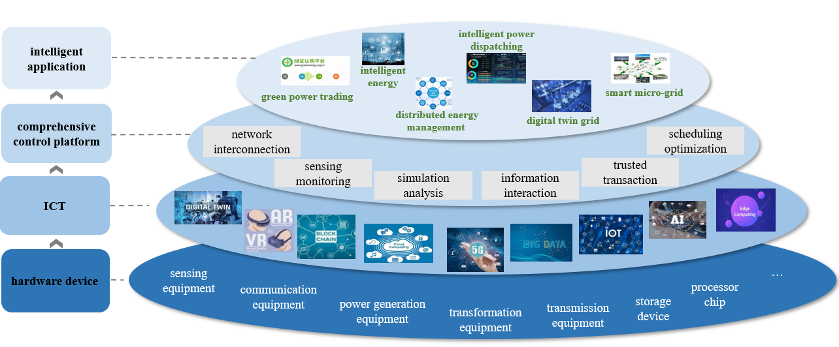
Fig 1. Level map of ICT empowerment electric sector

7 Industry
Industry as the most important material production sector, has surprising energy consumption and carbon emissions. Reducing carbon emissions from various high energy consumption and high emission sectors is very important for net zero emissions, and information and communication technology will play a huge role.
No. | Practices | Description
1 | Reduce production equipment energy consumption | Improving the fine level of production equipment operation though ICT, can help to reduce the energy consumption caused by unreasonable production operation, and improve the amount of work under unit power. Under fixed output, energy consumption and carbon emissions are effectively reduced.  Comprehensive management and control of personnel management and operation management in manufacturing enterprises, combined with advanced technology, reduce excessive operations caused by human factors, and further reduce redundant energy consumption and carbon emissions
2 | Coordinated operation of manufacturing process | Based on the cross-process scheduling optimization, whole process quality management, centralized energy prediction and scheduling optimization, and the carbon footprint analysis and tracking for different processes and products based on LCA (Life Cycle Assessment) model, the efficient collaborative operation of each link of production and manufacturing is realized, and the efficiency of energy and resource utilization is improved from the perspective of overall production.  And based on the industrial Internet platform, it can also realize the collaborative control of multiple bases, carry out the collaborative scheduling of raw fuel and spare parts between different production bases within the group, and improve the efficiency of energy resource utilization from the whole enterprise.
3 | Collaborative operation of industry chain and supply chain | Through industrial-level industrial internet platforms such as e-commerce of industrial products, industrial entities such as production enterprises, processing, transportation and warehousing service providers, and financial service institutions are gathered to create an intelligent ecological circle, reduce transaction costs between enterprises, alleviate vicious competition caused by excessive homogenization of low-end products, effectively resolve overcapacity, thereby reducing carbon emissions caused by excessive production, and simultaneously achieve industrial restructuring.
Carbon footprint management platform building with the help of IoT edge computing and cloud computing of industrial internet, which help industrial enterprises achieve refined and intelligent management of carbon emissions, as shown in the Fig 2.
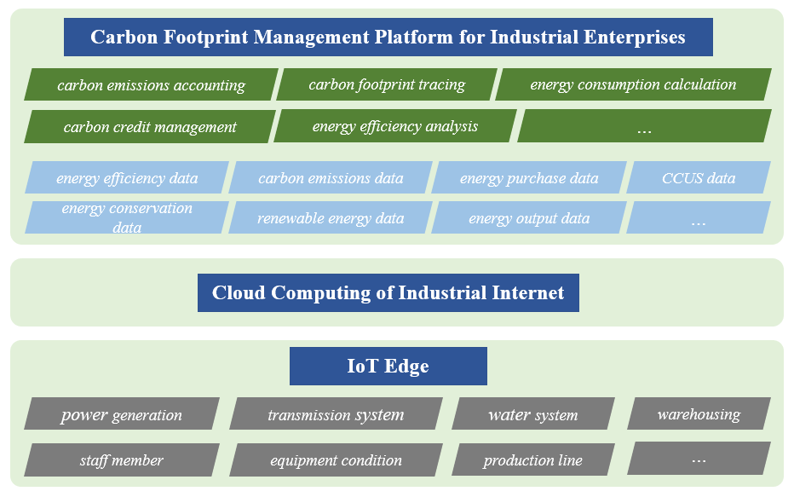
Fig 2. Carbon footprint management platform for industrial enterprises

8 Building
The buildings sector is the terminal source of consumption with the highest carbon emissions, therefore, low-carbon construction and low-carbon operation of buildings will be one of the important measures for emission reduction in the entire society.
No. | Practices | Description
1 | Building automation and control systems | The automatic and control system or platform of the building completed through ICT, intelligently manage air conditioning, heating, lighting, and hot water. The energy efficiency is greatly improved and the building energy consumption is reduced by fine management such as real-time monitoring and accurate deployment.
2 | Building Information modeling (BIM) technology | BIM technology is used to realize the construction information model in visual construction, parametric construction and collaborative construction of various majors. Integrated construction and standardized construction can greatly reduce the energy consumption of building components and various resources.
Through the building and ICT, digital building is realized. Digital building presents a three-tier structure of hardware device, control platform and application service to realize green building and energy conservation of buildings as shown in Fig 3.
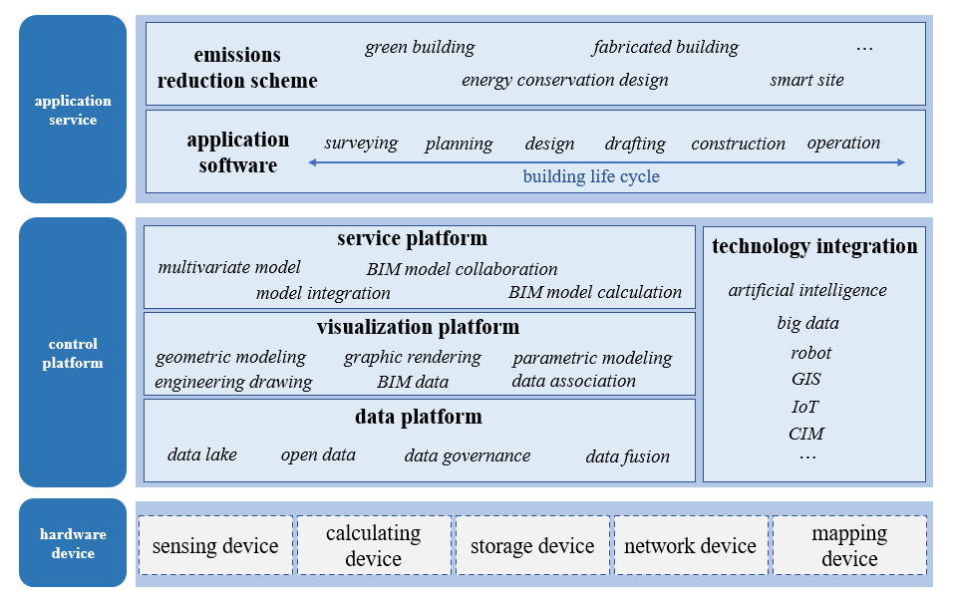
Fig 3. Digital building framework

9 Transport
The carbon emissions of transport mainly come from the burning of fuel in road transportation, waterway transportation and aviation transportation, and the energy source is still dominated by petroleum resources. Tools, road networks and energy constitute a tight and complete traffic ‘carbon chain’, who are interrelated, mutually supportive and mutually constrained. And help the whole chain collaboration through ICT is an efficient method to reduce carbon emissions in the transport.
No. | Practices | Description
1 | Electric vehicles replace fuel vehicles | To a certain extent, ICT has accelerated the substitution of electric vehicles for traditional fuel vehicles, and can greatly reduce carbon emissions with the green transformation of electricity.
2 | Intelligent Internet autonomous driving | Through vehicle autonomous driving and other technologies, intelligent driving scenarios such as green wave traffic guidance, formation driving, and ecological path planning are realized. On the one hand, the overall speed of vehicle flow is improved, the frequency of traffic accidents is reduced, alleviate traffic congestion and reduce energy consumption. On the other hand, make the engine in as many road conditions as possible in the most economical running state, minimize frequent brakes, acceleration and deceleration, to achieve vehicle energy efficiency optimization, reduce unnecessary energy consumption.
3 | Optimizing public transport services | Sharing platform, map navigation, route planning and other technologies help to change the public travel mode. Single person and single car turn to sharing travel, and driving travel turns to public transport. Through various ICT, the digital level of public transport and the public travel experience are improved, the total amount of vehicle operation and the traffic emissions are reduced.
4 | intelligent vehicle infrastructure cooperation | Through the realization of real-time interaction between car and road, on the basis of full time and space dynamic traffic information collection and fusion, vehicle active control and road collaborative management are carried out to fully realize the effective coordination of people-vehicle-road, and ultimately improve traffic efficiency and ensure traffic safety.  Through better detection of vehicle flow and optimization of traffic lights control, road traffic efficiency can be improved by about 10% to achieve the purpose of energy saving and emission reduction.
Through the terminal, network connection, computing and application, can form a traffic network as shown in Fig 4, which will realize intelligent transportation system included the vehicle, road/waterway/aviation and cloud integration.
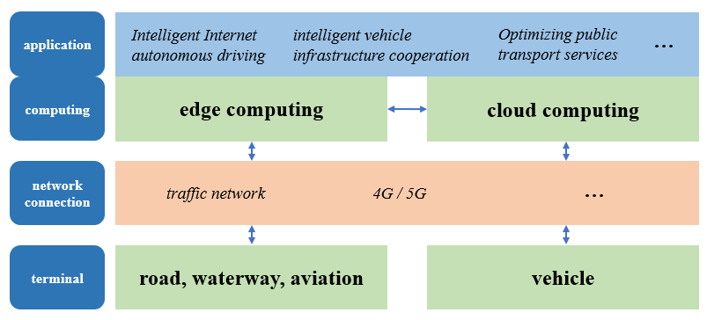
Fig 4. Traffic network framework

10. Agriculture Sector: -
Greenhouse gases from agriculture account for around 11% of total emissions globally, which is roughly equivalent to the entire emissions from transport sector. To cater to the need of burgeoning population, it is estimated that agricultural production will have to be increased by about 70% by 2050. which certainly will increase the GHG emissions from this sector.
In view of this, this sector becomes quite important to target reduction of carbon emission to achieve net zero emission, and certainly Information and Communication Technology has a commendable role to play in this direction:-

No. | Practices | Description
1 | AgInformatics | AgInformatics is a powerful tool that can benefit agriculture in numerous ways, including Precision Agriculture (PA), Precision Livestock Farming (PLF), and Agricultural landscape analysis and planning. PA technologies, such as Variable rate technologies, can help farmers tailor input amounts to the current needs of crops and reduce input use, resulting in positive environmental and economic impacts.  ICT-based decision support systems can also help farmers maximize production efficiency while minimizing production costs and environmental footprint. This includes using smart irrigation systems to reduce water usage and carbon footprint by reducing energy use.  In addition to economic benefits, precision agriculture technologies and practices can also result in lower greenhouse gas emissions, thus mitigating climate change. These technologies can help enhance the carbon sequestration ability of soils, reduce fuel consumption in field operations, and reduce input use, leading to a more sustainable agriculture system.
2 | Food processing, distribution and consumption | ICTs have played a significant role in transforming food systems and improving their sustainability.  Due to the complex and global nature of food supply chains, the use of ICT solutions has effectively consolidated all the components of the supply chain - including farmers, processors, wholesalers, retailers, and consumers - onto a unified platform. This has lead to improved transparency, traceability, and efficiency in the movement of products, information, and finances across the entire food supply chain, from its origin at the farm to the final consumption by the end consumer. Furthermore, ICTs have enabled the development of alternative food production methods such as urban gardening and facilitated the creation of peer food networks to avoid food waste. As such, ICTs represent an important tool for achieving a more sustainable and equitable food system.  By using ICT-enabled techniques such as storage monitoring, factory robotics, digital packaging etc. the efficiency of food processing industry has remarkably improved. ICT has led to reduced consumption, by using novel approaches such as refrigerator monitoring, smart packaging and advisory services on diets
3 | Agrivoltaic | Agrivoltaics, also known as agrophotovoltaics, is a technology that involves the integration of solar panels with agriculture. The use of ICT in agrivoltaics can help optimize the system's performance and improve its sustainability. Some of examples of how ICT can contribute in increasing the efficiency of agrivoltaics are  (i) Monitoring and control: ICT can be used to monitor the performance of the solar panels and the crops, including temperature, humidity, soil moisture, and nutrient levels. This data can be used to optimize the system's performance and improve crop yields.  (ii) Precision agriculture: ICT can be used to implement precision agriculture techniques in agrivoltaics. For example, drones equipped with cameras and sensors can be used to monitor crop health, detect pest infestations, and map the fields.  (iii) Energy management: ICT can be used to manage the energy generated by the solar panels. This includes monitoring the energy output, managing the battery storage, and optimizing the energy use.  (iv) Decision support systems: ICT can be used to develop decision support systems that provide farmers with real-time data and recommendations for managing the agrivoltaic system. For example, the system can provide recommendations on when to water the crops, when to apply fertilizers, and when to harvest.  (v) Data analytics: ICT can be used to analyze the data collected from the agrivoltaic system to identify trends, patterns, and insights. This can help farmers make more informed decisions and improve the system's performance over time.

Annex A
Practices Example
(This annex forms an integral part of this Recommendation.)
Practice example for electricity sector：
Through deep integration of digital technology and physical power grid, a power grid company realizes the construction of digital scenes such as unmanned aerial vehicle patrol of transmission and distribution lines, digital substation, smart distribution room and smart microgrid. Through the large capacity ultrahigh voltage multi-terminal flexible DC transmission technology, the DC power ratio of the power grid is up to 30%, and the clean energy accounts for more than 80% of the annual power supply. Greatly improve the utilization of clean energy power generation.

Practices example for industry：
In view of non-ferrous metal smelting, a smelting company process data management and integration, centralized storage, analysis, modeling in the big data platform, and establish industrial software architecture to support enterprises to achieve business objectives. The detection level is improved to solve the uncertainty in the production process, and the control accuracy is increased by 30%, the power consumption per unit zinc production decreased by about 20%..

Practice example from ICT sector under Industry
- Energy-efficient hardware: The use of energy-efficient hardware is crucial in achieving net-zero emissions. This includes the use of energy-efficient servers, cooling systems, and other ICT equipment. It is essential to ensure that hardware is designed to consume minimal power and that it is properly maintained to reduce energy wastage.

- Indus Tower has put its focus on reducing energy consumption and emissions by moving away from air conditioning and implementing outdoor solutions for their sites. The introduction of Dual Turbine Unit and large-sized micro cooling with HEX-based solutions is a positive step towards achieving sustainability goals. Additionally, the use of solar-based natural free cooling units, large-sized micro cooling cabinets, HEX-based micro cooling units, Free Cooling Unit (FCU), Natural Cooling Unit (NCU), and Precision aircon for critical sites is a commendable effort. Indus Tower's plan to create more concentrated cooling solutions and specific equipment solutions is a smart approach towards efficient energy use. By providing only the required cooling to specific equipment, the company can significantly reduce energy consumption and further reduce emissions. The use of high-efficiency air conditioning for reducing energy consumption at critical sites is also a good strategy. The rollout of precision aircon for higher loads with ultra-sensitive cooling requirements is another great move towards increasing energy efficiency.

- In October 2022, Apple also declared that they will be producing their new phones using completely recycled Earth materials

- Virtualization and cloud computing: Virtualization and cloud computing can help to reduce energy consumption and carbon emissions by consolidating servers and reducing the need for physical infrastructure. Virtualization can enable multiple applications to run on a single physical server, reducing the need for additional hardware.

- Renewable energy: The use of renewable energy such as solar, wind, and hydropower to power ICT infrastructure can help to reduce carbon emissions. ICT companies can partner with renewable energy providers or invest in their renewable energy generation facilities to ensure a clean energy supply.

- Harit Sanchar by Indus Towers: - Indus Towers which is India's largest mobile tower installation company is taking steps towards reducing diesel consumption and emissions at their tower sites. The Harit Sanchar project seems like an innovative solution to replace diesel generators with mobile batteries, which not only reduces emissions but also helps to save costs in the long run. The significant reduction in CO2 emissions of 9,92,038 tonnes during fiscal 2021 is impressive.
Collaborating with renewable energy service companies to power towers with renewable energy is also a great initiative. This not only helps to reduce carbon emissions but also helps to promote the use of clean energy. It's also good to know that Indus Towers is undertaking community power development initiatives in rural areas, which can help to bring clean energy to underserved communities.

- Data center design: The design of data centers can have a significant impact on energy consumption and carbon emissions. Efficient data center design includes the use of efficient cooling systems, optimized airflow, and proper insulation.

- Remote work and video conferencing: The COVID-19 pandemic has shown that remote work and video conferencing can be effective in reducing emissions by eliminating the need for business travel. Companies can encourage remote work and the use of video conferencing to reduce their carbon footprint.

- Circular economy: The adoption of circular economy principles can help to reduce waste and promote sustainability. This includes the refurbishment and reuse of ICT equipment, as well as the recovery of valuable materials from end-of-life products.

- Nokia has adopted circular practices and made progress by setting clearly defined objectives. Their goal is to develop material management to such an extent that by 2030 there will be no need for landfilling. In 2020, Nokia processed 5,870 metric tons of obsolete products out of which 570 metric tons of products were reused. In the same year, Nokia put in motion a policy to improve the use of recycled materials in its products. 54% of the 23,200 metric tons of cast aluminium parts used in Nokia products had recycled materials in them. In 2020, Nokia tried to improve the recycling prospects of plastics. The company has also saved 31,600 tons of CO2 through circular practices in that year.
- Dell, Microsoft, and Google have also joined a new initiative aimed at creating a circular economy for electronics by 2030. This aims to recycle the tech products which often have short life-span

- A recent partnership between BT and Cisco aims to recycle up to 99.9% of network equipment that is ripped out during upgrades. Cisco will process the networking kits to help BT reduce its e-waste

- Telia has reused/ recycled around 70% of its network waste in 2021. Moreover, 20% of its TV set-top boxes and routers were reused. They have also aligned themselves with the goal to achieve zero waste by 2030. Proximus has established a distribution center to refurbish consumer devices including modems, Wi-Fi boosters and smartphones on site. Between 2014-2021 it refurbished around 2.85 million devices, including 845k in 2021 alone.

Practices example for building：
By the BIM system, cloud energy efficiency and energy management platform, a company realize the safety management of building electrical, lighting, HVAC, fire protection, security and workplace data. With the help of digital and big data, it is more intelligent to obtain the status of the whole system and access operational information. By creating modern facilities to improve personnel productivity and optimize building value, it could improve building energy efficiency and reduce energy consumption and cost by 30%.

Practices example for transport：
A bus company has built a customized smart bus based on the internet of vehicles, sorted out the travel big data in specific regions, and excavated the commuting rules of the surrounding residents based on the location big data, so as to screen out the hot destinations and route stations. The customized bus demonstration line based reduces the commuting time from nearly one hour to no more than 30 minutes. Nearly a quarter of the passengers change from driving commuting to travelling by customized bus. In just half a month, more than 700 people change from driving to travelling by bus, equivalent to a one-way reduction of 1.27 tons of carbon dioxide emissions.

Practices example for Agriculture sector:-
There are many types of IoT sensors for agriculture as well as IoT applications in agriculture in general:
1. Monitoring of climate conditions
Probably the most popular smart agriculture gadgets are weather stations, combining various smart farming sensors. Located across the field, they collect various data from the environment and send it to the cloud. The provided measurements can be used to map the climate conditions, choose the appropriate crops, and take the required measures to improve their capacity (i.e. precision farming).
Some examples of such agriculture IoT devices are allMETEO, Smart Elements, and Pycno.
2. Greenhouse automation
Typically, farmers use manual intervention to control the greenhouse environment. The use of IoT sensors enables them to get accurate real-time information on greenhouse conditions such as lighting, temperature, soil condition, and humidity.
In addition to sourcing environmental data, weather stations can automatically adjust the conditions to match the given parameters. Specifically, greenhouse automation systems use a similar principle.
For instance, Farmapp and Growlink are also IoT agriculture products offering such capabilities among others.
3. Crop management
One more type of IoT product in agriculture and another element of precision farming are crop management devices. Just like weather stations, they should be placed in the field to collect data specific to crop farming; from temperature and precipitation to leaf water potential and overall crop health.
Thus, you can monitor your crop growth and any anomalies to effectively prevent any diseases or infestations that can harm your yield. Arable and Semios can serve as good representations of how this use case can be applied in real life.
4. Cattle monitoring and management
Just like crop monitoring, there are IoT agriculture sensors that can be attached to the animals on a farm to monitor their health and log performance. Livestock tracking and monitoring help collect data on stock health, well-being, and physical location.
For example, such sensors can identify sick animals so that farmers can separate them from the herd and avoid contamination. Using drones for real-time cattle tracking also helps farmers reduce staffing expenses. This works similarly to IoT devices for petcare.
For example, SCR by Allflex and Cowlar use smart agriculture sensors (collar tags) to deliver temperature, health, activity, and nutrition insights on each individual cow as well as collective information about the herd.
5. Precision farming
Also known as precision agriculture, precision farming is all about efficiency and making accurate data-driven decisions. It’s also one of the most widespread and effective applications of IoT in agriculture.
By using IoT sensors, farmers can collect a vast array of metrics on every facet of the field microclimate and ecosystem: lighting, temperature, soil condition, humidity, CO2 levels, and pest infections. This data enables farmers to estimate optimal amounts of water, fertilizers, and pesticides that their crops need, reduce expenses, and raise better and healthier crops.
For example, CropX builds IoT soil sensors that measure soil moisture, temperature, and electric conductivity enabling farmers to approach each crop’s unique needs individually. Combined with geospatial data, this technology helps create precise soil maps for each field. Mothive offers similar services, helping farmers reduce waste, improve yields, and increase farm sustainability.
6. Agricultural drones
Perhaps one of the most promising agritech advancements is the use of agricultural drones in smart farming. Also known as UAVs (unmanned aerial vehicles), drones are better equipped than airplanes and satellites to collect agricultural data. Apart from surveillance capabilities, drones can also perform a vast number of tasks that previously required human labor: planting crops, fighting pests and infections, agriculture spraying, crop monitoring, etc.
DroneSeed, for example, builds drones for planting trees in deforested areas. The use of such drones is 6 times more effective than human labor. A Sense Fly agriculture drone eBee SQ uses multispectral image analyses to estimate the health of crops and comes at an affordable price.
7. Predictive analytics for smart farming
Precision agriculture and predictive data analytics go hand in hand. While IoT and smart sensor technology are a goldmine for highly relevant real-time data, the use of data analytics helps farmers make sense of it and come up with important predictions: crop harvesting time, the risks of diseases and infestations, yield volume, etc. Data analytics tools help make farming, which is inherently highly dependent on weather conditions, more manageable, and predictable.
For example, the Crop Performance platform helps farmers access the volume and quality of yields in advance, as well as their vulnerability to unfavorable weather conditions, such as floods and drought. It also enables farmers to optimize the supply of water and nutrients for each crop and even select yield traits to improve quality.
Applied in agriculture, solutions like SoilScout enable farmers to save up to 50% irrigation water, reduce the loss of fertilizers caused by overwatering, and deliver actionable insights regardless of season or weather conditions.
8. End-to-end farm management systems
A more complex approach to IoT products in agriculture can be represented by the so-called farm productivity management systems. They usually include a number of agriculture IoT devices and sensors, installed on the premises as well as a powerful dashboard with analytical capabilities and in-built accounting/reporting features.
This offers remote farm monitoring capabilities and allows you to streamline most of the business operations. Similar solutions are represented by FarmLogs and Cropio.
In addition to the listed IoT agriculture use cases, some prominent opportunities include vehicle tracking (or even automation), storage management, logistics, etc.
9. Robots and autonomous machines
Robotic innovations also offer a promising future in the field of autonomous machines for agricultural purposes. Some farmers already use automated harvesters, tractors, and other machines and vehicles that can operate without a human controlling it. Such robots can complete repetitive, challenging, and labor-intensive tasks.
For instance, modern agrobots include automated tractors that can work on assigned routes, send notifications, start work at planned hours, etc. Such tractors are driverless and cut farmers’ labor costs. Bear Flag Robotics is one company that works on such technology at the moment.
In addition, smart farming also uses robots for planting seeds, weeding, and watering. The given jobs are very demanding and labor-intensive. Yet, robots, such as ones from Eco Robotics, can detect weeds or plant seeds using computer vision and AI technology. These agricultural robots work delicately, drastically reducing harm to the plants and the environment.

