 | INTERNATIONAL TELECOMMUNICATION UNION  TELECOMMUNICATION  STANDARDIZATION SECTOR  STUDY PERIOD 2022-2024 |  | T22-SG15-C128R1
 |  |  | STUDY GROUP 15
 |  |  | Original: English
Question(s): |  | 5/15 |  | Geneva, 19-30 Sep 2022
CONTRIBUTION
Source: |  | Sterlite Technologies Limited (India); Ministry of Communication, India
Title: |  | Proposal for new draft Recommendation L.oehc
Contact: |  | Abdul Kayum  Ministry of Communications  India |  |  | Tel: +91 9868134010  E-mail: ddg6g.tec-dot@gov.in
Contact: |  | Rajmohan Meena  Ministry of Communications  India |  |  | Tel: +91 9013135530  E-mail: adgn3.tec@gov.in
Contact: |  | Sudipta Bhaumik  Sterlite Technologies Ltd.  India |  |  | Tel: +91 9561164116  E-mail: sudipta.bhaumik@stl.tech
Contact: |  | Roshan Kumar  Sterlite Technologies Ltd.  India |  |  | Tel: +91 7042217330  E-mail: roshan.kumar@stl.tech

Abstract: | This contribution proposes to include an application scenario of optical electrical hybrid cable (oehc) with application of “Deployment of Hybrid Cables (Optical and Electrical) and centralised power backup to provide backhaul as well as electrical power for faster rollout of 5G small cells and other similar applications”. The concept can be utilized to connect communication systems like 5G small cells, Wi-Fi hotspots, Digital Billboard, CCTV, Sensor, Public addresses, etc.
Introduction
5G is expected to provide “4A- anytime, anywhere, anyone, anything” connectivity, which will take mobile data speeds to new limits and will support an immense increase in connections. Optical fibre is the key for backhaul connectivity for 5G small cell and other similar applications. The new draft ITU-T Recommendation L.oehc deals with the requirements for Type-II Optical Electrical Hybrid Cables (OEHC) for access point and other terminal equipment where optical fibre can support data transmission and copper pair is used for electrical power delivery. This contribution proposes to include an application scenario “Deployment of Hybrid Cables (Optical and Electrical) and centralised power backup to provide backhaul as well as electrical power for faster rollout of 5G small cells and other similar applications” in new draft Recommendation L.oehc .

Benefits:
- Deployment of Hybrid Cables (Optical and Electrical) maximizes utilization of existing infrastructure to optimize the cost of deployment and maintenance to enable connectivity anytime anywhere.
- Centralized power delivery and power backup system to eliminate the power outage of active devices (like 5G radios) and to minimize the approval and maintenance of the multiple power sources.
- Centralized power delivery system reduces load on the poles as the pole to carry only Radio Unit (RU).
- Provides enhanced safety of telecom assets (mainly centralized) from theft and vandalization.
- Reduces multiple power connections/billing.

Proposal:
The below mentioned application scenario is proposed to be added in the draft new ITU-T Rec. L.oehc

Application Scenario

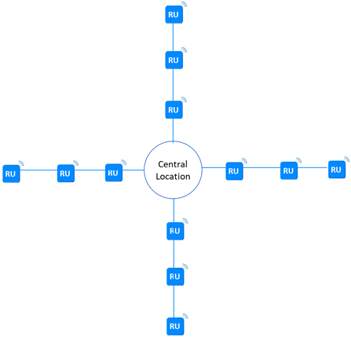

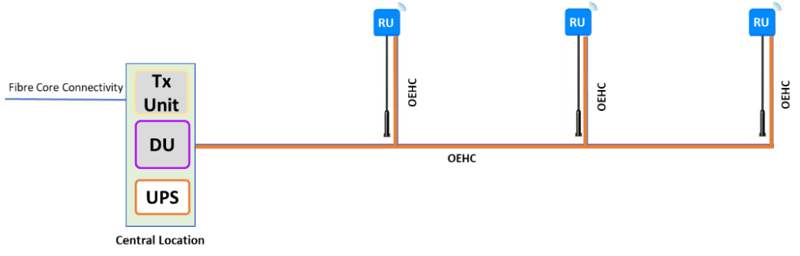
Network Architecture – 5G small cell deployment using OEHC

Deployment of Hybrid Cables (Optical and Electrical) maximizes utilization of existing infrastructure to optimize the cost of deployment and maintenance. The OEHC (Optical Electrical Hybrid Cable) containing optical fiber for data transmission and copper wire for electrical power delivery to the multiple Radio Units (RU) distributed within a distance of 1000-2000 m from the centralized power delivery station as shown in the above figure. The cable can be designed for multiple deployment scenarios to connect multiple termination points. It will help the operator to optimize the cost of deployment and maintenance. Centralized power delivery and power backup system to eliminate the power outage of active terminal devices (like 5G RU). Deployment of Hybrid Cables (Optical and Electrical) can be utilized to connect various communication systems like 5G small cells, Wi-Fi hotspots, Digital Billboard, CCTV, Sensor, Public address systems, etc.

