 | INTERNATIONAL TELECOMMUNICATION UNION  TELECOMMUNICATION  STANDARDIZATION SECTOR  STUDY PERIOD 2022-2024 |  |  | SG15–C137R1
 |  |  |  | STUDY GROUP 15
 |  |  |  | Original: English
Question(s): |  | 7/15 |  | Geneva, 19-30 September 2022
CONTRIBUTION
Source: |  | Sterlite Technologies Limited (India); Department of Telecommunication, Ministry of Communication, India.
Title: |  | Proposal to include new Appendix V to the Draft new Rec. L.ncip “Requirements for passive optical nodes: nodes for customer indoor premises” (May, 2022)
Contact: |  | Ratna Thakur  Ministry of Communications  India |  | Tel: + 91 9463900505  Email: dirt1.tec@gov.in
Contact: |  | Kamla Pargai  Ministry of Communications  India |  | Tel: + 91 9868236169  Email: kamla.pargai@gov.in
Contact: |  | Sudipta Bhaumik  Sterlite Technologies Limited (STL)  India |  | Tel: +91 9868236169  Email: sudipta.bhaumik@stl.tech
Abstract: |  |  | This contribution proposes to include new Appendix V to the latest draft of the new Rec. L.ncip “Requirements for passive optical nodes: nodes for customer indoor premises” (May, 2022). The Appendix V describes the Indian experience of different types Subscriber Premises Boxes for home termination.

Appendix V

Indian experience - Subscriber Premises Box (SPB) for home termination in India
(This appendix does not form an integral part of this Recommendation)

V.1 Introduction
This appendix gives examples of typical Subscriber Premises Box (SPB) for home termination to provide management of optical fibres, cables, and connector/ adapter assemblies for customer indoor premises. The SPB provides facilities for reconfiguration of fibres, network expansion, testing and storing extra length of fibres and pigtails and has provision for cable termination and sealing requirements.

V.2 Subscriber Premises Box (SPB) (Type-I)
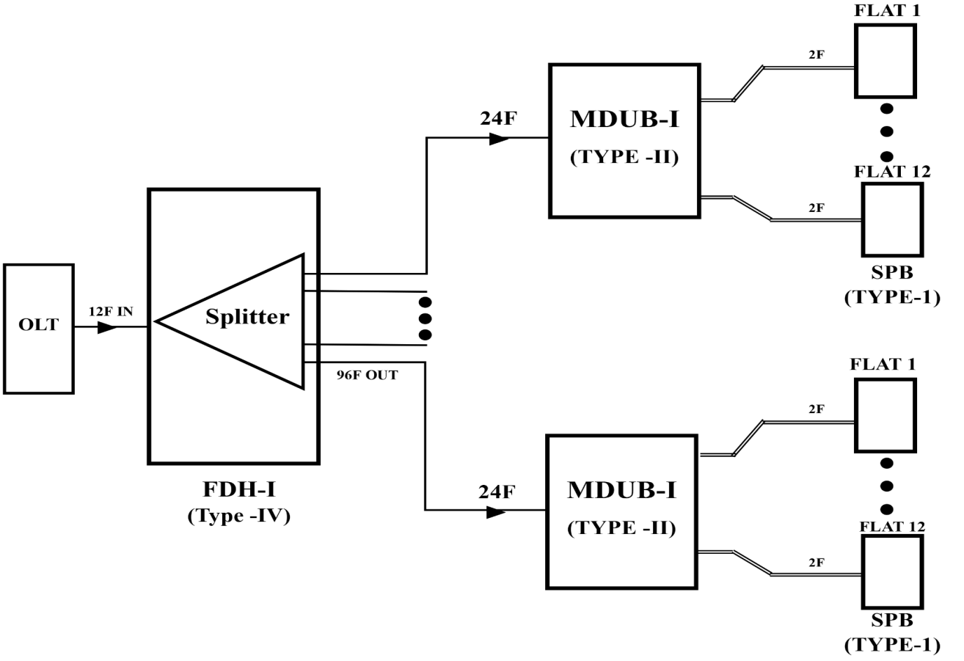
This type of wall mountable box is typically installed in the subscriber’s premises as defined in [b- TEC 87030:2010]. Termination up to four fibres is possible. Termination can be done by fusion splicing or by pre-polished connectors or by pre-connectorized cable. Provision for holding splice and connector adapter is available in the box. Figure V.1 and V.2 show typical examples of distribution on a building floor and on a single residential unit cluster respectively of SPB.

Figure V.1: Typical example of distribution on a building floor
Note:
- In the above diagram, Multi Dwelling Unit Box - Indoor (MDUB-I) shows 12 outgoing cables of 2F. It can be any combination of cables depending on the actual site requirements provided the total number of outgoing fibres does not exceed 24.
- The Fibre Distribution Hub – Indoor (FDH-I) will house splitter modules. It will have 12 incoming fibres and upto 96 outgoing fibres.
- MDUB-I & FDH-I are out of scope of this document.

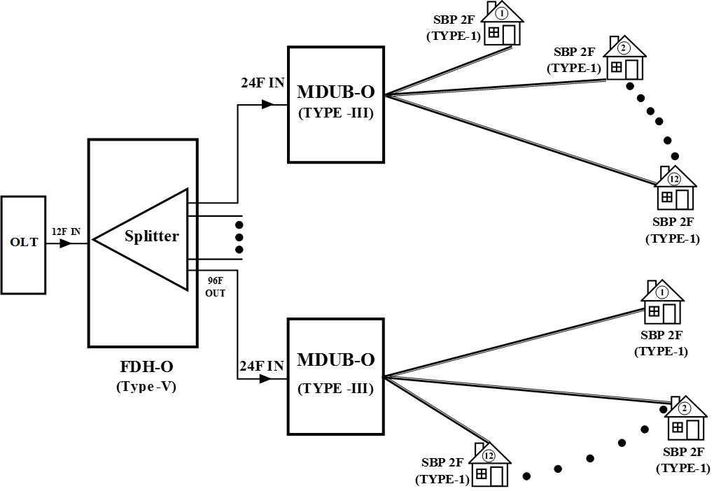
Figure V.2: Typical example of distribution on a single residential unit cluster

Note:
- In the above diagram, Multi Dwelling Unit Box- Outdoor (MDUB – O) shows 12 outgoing cables of 2F. It can be any combination of cables depending on the actual site requirements provided the total number of outgoing fibres does not exceed 24.
- The Fibre Distribution Hub – Outdoor (FDH-O) will house splitter modules. It will have 12 incoming fibres and upto 96 outgoing fibres.
- MDUB-O & FDH-O are out of scope of this document.

V.3 Attributes of SPB

Various attributes of SPB are listed in Table V.1 to specify different types of SPB.

Table V.1 Attributes of SPB

SN | Attributes | Type X
1 | Material of Construction (PC,ABS,PC+ABS)  PC = Polycarbonate  PP = Poly Propylene  ABS = Acrylonitrile Butadiene Styrene | User to specify
2 | IP rating (As per IEC 60529) | IP 30 or better
3 | Installation location | Indoor
4 | Fixture type | User to specify
5 | Length (mm) without entry / exit ports | User to specify
6 | Width (mm) | User to specify
7 | Depth (mm) | User to specify
8 | Minimum thickness of the box body (mm) | User to specify
9 | Color of the box | User to specify
10 | Number of incoming cable | User to specify
11 | Diameter of incoming cable (mm) | User to specify
12 | Fibre count of incoming cable | User to specify
13 | Maximum splice capacity | User to specify
14 | Box security provision | User to specify
15 | Fire Proof (Yes / No) | User to specify
16 | Operating Temperature | -5 to +55 º C
17 | Number of Cable entry port | User to specify
18 | Number of Output Adapter and Type | User to specify
19 | Provision for cable / patch cord storage | User to specify

V.4 Examples of SPB
Based on the location of installation, number of fibres to be spliced and /or connected and other attributes, there are different types of SPB for home termination as mentioned in the examples 1 to 4.

V.4.1 Example 1
This type of SPB is also known as Home Termination Box (HTB) which is a compact fibre wall outlet used in FTTx network for the termination of optical fibre in the customer premises such as residence, offices etc. Its design is ideal for in-premises fibre termination points. It has a provision to secure fibre splicing, storing of extra fibre and housing of single or dual adaptors. The HTB provides mechanical protection and managed fibre control in a format suitable for use inside customer premises.

It has storage space for drop cables of at least 500mm with cable entry from top or from side of the box. It has provision for splicing of drop cable (4F or 2F) to factory terminated pigtails and provision to hold splice protection sleeves. It also has provision for direct termination with field installable connectors. It can accommodate two adaptors for the termination of either Simplex SC/SC-PC/SC-APC or Duplex LC.

The box allows easy fibre access during installation and maintenance. The box maintains the bend radius of the Fibre suitable for [ITU-T G.657] cables. It is a wall mount box made up of aging resistant thermoplastics (PC/ABS) material complying to [b-UL94V-0] flame retardant rating.

It has a snap fit arrangement for the Adaptors for the ease of installation. It has two mounting slots for the Adaptor such that the Adaptors flushes with the surface for IP40 protection. It consists of a base and a cover with press fitment. The rear portion of the base is laminated in order to make the product dust and insect proof.

In Figure V.3 - Example 1 of HTB, (a) to (d) are different drawings for fibre termination techniques.

(a) This type of HTB can accommodate 2 numbers of Simplex SCPC or SCAPC adaptors.
(b) This type of HTB can accommodate 2 adaptors for termination with 4F splicing capacity allowing drop cable spliced to pigtails.
(c) This type of HTB can accommodate 2 adaptors for termination compatible with field installable connectors.
(d) This type of HTB can accommodate 2 SC Simplex adaptors/2 Duplex LC Adapter for termination.

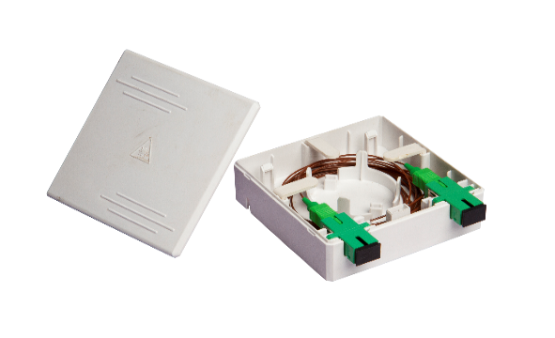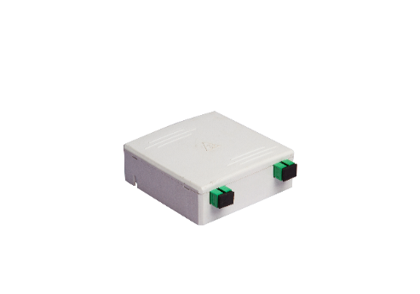

(a)

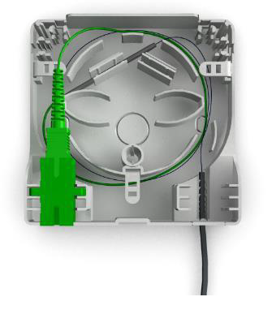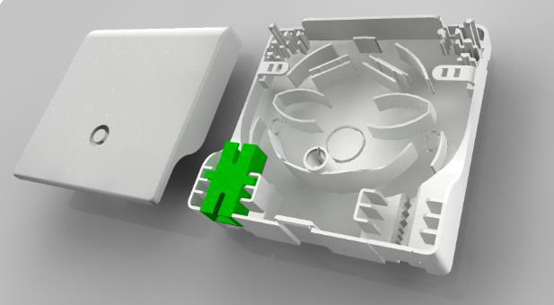

(b)

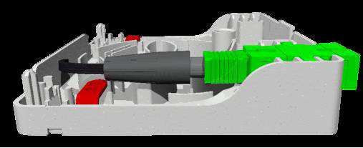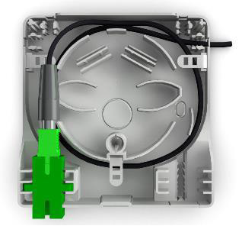

(c)

(d)

Figure V.3 – Example 1 of HTB

V.4.2 Example 2
This type of Home Termination Box (HTB) is a compact termination box used at the customers’ premises such as residence, offices etc. in the FTTx or optical CATV or local area networks. The box has spring shutter cover for laser protection & dust-proof, self-clip design for easy operation, SC or LC shutter adaptor, optional RJ45 connection, provision to store slack, rear and bottom cable entry, integrated heat shrink splice and mechanical splice holder.

Figure V.4 – Example 2 of HTB

V.4.3 Example 3
This type of HTB is suitable for wall mount/pole mount /panel mount installations. The main attributes are ABS housing with mechanical seal, High impact resistance splicing tray & cable spool for fibre & pigtail routing, provision of storing up to 3 meters of 900 micron tight buffered fibre cable, patch or fusion splice field termination standard, and replaceable panel for SC/LC/FC type couplers.

Figure V.5 – Example 3 of HTB

V.4.4 Example 4
This type of HTB is a termination box used at the customers’ premises such as residence, offices etc. in the FTTx or optical CATV or local area networks or point-to-point networks. The IP55 rated box can accommodate 50 meters of drop cable and has provision to accommodate 2 LC adapters and pigtails.

Figure V.6 – Example 4 of HTB
Bibliography

[b- TEC 87030:2010] Standard for Generic Requirements of Fibre Termination and Distribution Box (For FTTH Applications) published by Telecommunications Engineering Centre (Department of Telecommunications), Govt. of India.

