 | INTERNATIONAL TELECOMMUNICATION UNION  TELECOMMUNICATION  STANDARDIZATION SECTOR  STUDY PERIOD 2022-2024 |  |  | SG15-C0367
 |  |  |  | STUDY GROUP 15
 |  |  |  | Original: English
Question(s): |  | 7/15 |  | Geneva, 17-28 April 2023
CONTRIBUTION

Source: |  | Department of Telecommunication, Ministry of Communication, Government of India, New Delhi
Title: |  | Proposal to include new Appendix X to the Draft new Rec. L.250(ex L.90) “Topologies for optical access network”.
Contact: |  | Rakesh Desai  Ministry of Communications  India |  |  | Tel + 919426203403  Email: rakesh.desai@gov.in
Contact: |  | Mudita Chandra  Ministry of Communications  India |  |  | Tel: + 919599924208  Email: mudita.chandra@gov.in
Contact: |  | Vivek Dua  BSNL  India |  |  | Tel + 919417009417  Email: vivek.dua@bsnl.co.in
Contact: |  | Vijay Dixit  Ministry of Communications  India |  |  | Tel + 919425001049  Email: dirt2-tec-dot@gov.in
Keywords: |  |  | L.250, new draft
Abstract: |  |  | This contribution proposes to include new Appendix X to the latest draft new Rec. L.250(ex L.90) “Topologies for optical access network” (April, 2023). The Appendix X describes the Indian experience of optical access network.

Appendix X
Indian Experience
(This appendix does not form an integral part of this Recommendation)

X.1 Introduction
This appendix gives architecture for optical access network through FTTX and is intended as supplementary material to this Recommendation.

X.2 Scope
The traditional technologies, like Digital Subscriber Line (DSL) and cable modem technologies, commonly used for “broadband access”, have access speeds to the order of a megabit per second, with actual rates strongly dependent on distance from the exchange (central office) and quality of copper infrastructure. They cannot fulfill today’s customer demand for bandwidth hungry applications such as high-definition TV, high-speed internet access, video on demand, IPTV, online gaming, distance learning etc.

Fibre to the X(FTTX) is an alternative to the traditional copper loop to provide connectivity by taking fibre closer to the end-user and hence finds its use in Last-mile connectivity. FTTx has many benefits related to speed and capacity and that is the reason legacy copper-based networks are being replaced with Fibre to the X (FTTx).

X.3 FTTX Technology Options
When deciding which architecture to select a provider has many things to consider including the existing outside plant, network location, the cost of deploying the network, subscriber density and the return on investment (ROI). At present different technology options are available for FTTX architecture. The most common implementation of FTTX is through the passive optical network (PON). Gigabit Passive Optical Network (GPON) is a leading standard of Passive Optical Network (PON)

The term ‘Gigabit’ in GPON denotes the maximum speed it provides in Gbps which is typically 2.5 Gbps downstream and 1.25 Gbps upstream, and ‘Passive’ denotes that the optical fiber network does not rely on any electrically-powered equipment in its path. GPON technology is highly energy efficient than a standard copper cable network. This makes it the optical network standard of choice for achieving last-mile connectivity in an efficient and cost-effective manner, as GPON reduces the number of fibre runs in a fibre optic network. The architecture of optical access network deploying GPON is shown in figure X.1

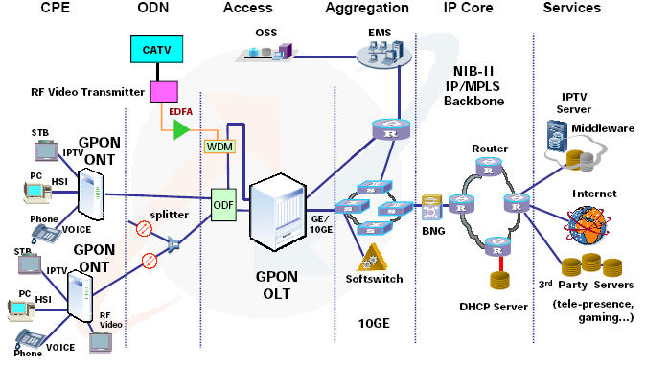
Figure X.1- Optical access network deploying GPON

X.4 Architecture for GPON
A single network typically consists of an optical line terminal (OLT), optical network units (ONU)/optical network terminal (ONT) and Optical Distribution Network (ODN) including Passive Optical Splitter. For G-PON two dedicated wavelengths may be used for downstream and upstream (˞̴̴ 1490nm & 1310nm respectively) and the other one ( 1550nm) may be used for downstream video. A typical GPON architecture is shown in figure X.2.
OLT: The OLT resides in the Central office (CO). The OLT system provides aggregation and switching functionality between the core network (various network interfaces) and PON interfaces. The network interface of the OLT is typically connected to the IP network and backbone of the network operator. Multiple services are provided to the access network through this interface.
ONU/ONT: The access node installed within user premises for network termination is termed as ONT, whereas access node installed at other locations i.e. curb/cabinet/building are known as ONU. The ONU/ONT provides user interfaces (UI) to the customers and uplink interfaces to uplink local traffic toward OLT.
Optical splitter: Distributed or single-staged passive optical splitters/combiners provides connectivity between OLT & multiple ONUs/ONTs through one or two optical fibres. The FTTH network may have two stages of splitting provisioned through Primary splitters and secondary splitters. The Primary splitter shall be placed at the feeder route in ODF. The ODF is to be placed at the plinth/poles as per the execution methodology. The secondary splitter shall be placed inside FAT box. FAT box can be placed on the building shaft/customer wall or pole. Optical splitters are capable of providing m: N splits where m = 1 or 2 and N = 2, 4, 8, 16, 32, 64 and 128. The exact requirement of optical interfaces for 1xN and 2xN splitters is decided based on the optical power budget calculation.
Figure X.2 – GPON architecture

X.5 Optical Distribution Network (ODN) Architecture:
The optical Distribution Network primarily consists of a primary /feeder section (OLT Location to ODF), secondary / distribution network (ODF to FAT ) and last-mile connectivity to customer premises. A typical layout of ODN architecture is shown in figure X.3.
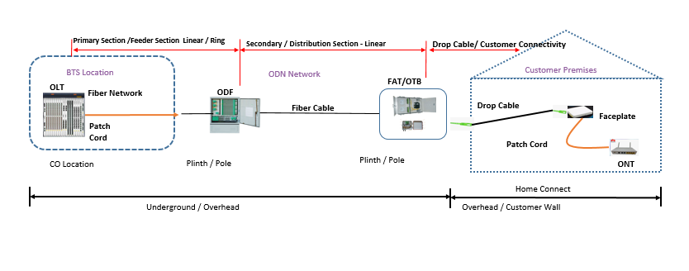
Figure X.3- Layout of Optical Distribution Network (ODN) Architecture

Terms:
- OLT –Optical Line Terminal
- Primary section (Fiber from OLT PON Port to ODF – Primary splitter)
- Primary Splitter
- Secondary section (ODF- Primary splitter to FAT – Secondary splitter)
- Secondary Splitter
- Secondary Splitter to OTB (Optical Termination Box)
- Drop section (OTB to customer premise)
- ONT –Optical Network Terminal.
ODF may also be installed other than OLT location and also may be installed on pillar/pole as per the installation methodology of the network operator. Primary Splitter may be placed at feeder route in ODF. The secondary Splitter shall be placed inside FAT box and FAT box can be further placed on the building shaft /customer Wall or Pole as per the requirement.
Ring Structure till Primary/ Feeder Section:
The ring topology between OLT and ODF section is shown in figure X.4.
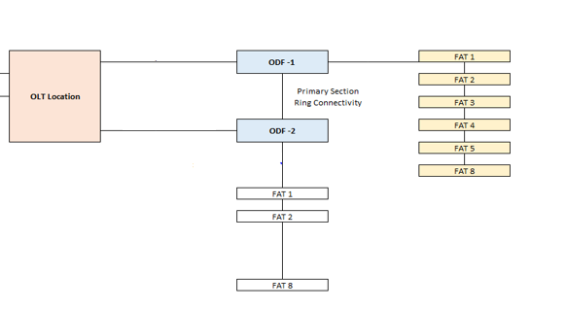
Figure X.4 – Ring structure
The primary splitter installed inside the ODF provides redundancy to the access network in the primary / feeder section. One ODF serves several FATs and connects to the number of secondary splitters.
X.7 FTTX configurations/deployments
Depending on the termination point, the FTTX networks can be described as FTTB (Fiber to building), FTTH (Fiber to home), FTTC (Fiber to curb), etc. As telecommunications providers consider the best method for delivering fiber to their subscribers, they have a variety of FTTx architectures to consider. FTTH, FTTB, and FTTC each have different configurations and characteristics. These FTTX configurations are shown in figure X.5. A typical FTTB connectivity scenario through GPON is shown in figure X.6

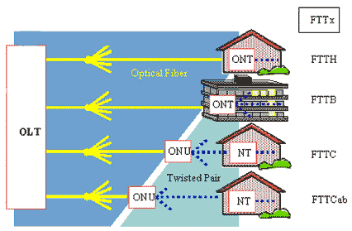
Figure X.5 - FTTX configurations

Figure X.6 - FTTB connectivity scenario through GPON

X.8 Optical wireless Access Network Connectivity
Free Space Optical Communication (FSOC) can effectively bridge the access network connectivity gaps in areas that are difficult to connect through optical fibre cables (like hills, lakes etc.). Some possible scenarios in GPON deploying FSOC links are shown in figures X.7, X.8 and X.9. A combination of these scenarios may also be exercised depending on the requirements and constraints.

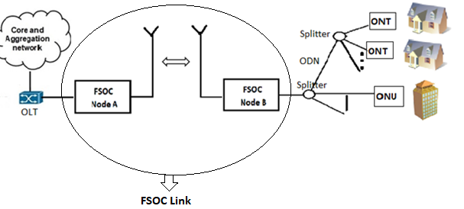
Figure X.7 – FSOC Link in GPON- Scenario 1

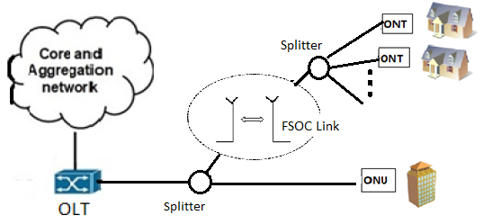
Figure X.8 – FSOC Link in GPON- Scenario 2

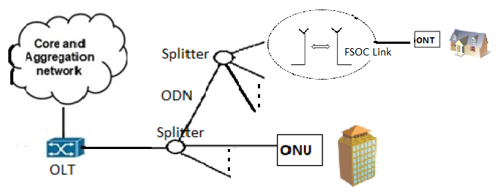
Figure X.9 – FSOC Link in GPON- Scenario 3

X.9 Access Network Connectivity using Radio infrastructure
In scenarios where geographically difficult terrains exist, the access network connectivity to OLT in place of optical fibre, may be established by using radio broadband service. This access network connectivity solution is wireless and is provided by deploying radio infrastructure using an unlicensed spectrum band. Figure X.10 shows the access connectivity solution by deploying Point to Point/Point-to-Multipoint radio network integrated with the core and aggregation networks.

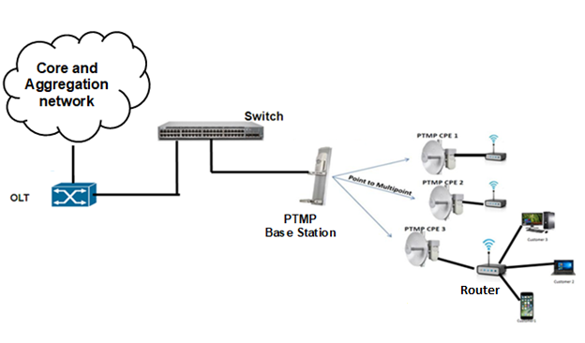
Figure X.10.1 – Point to Multi-Point Connectivity diagram

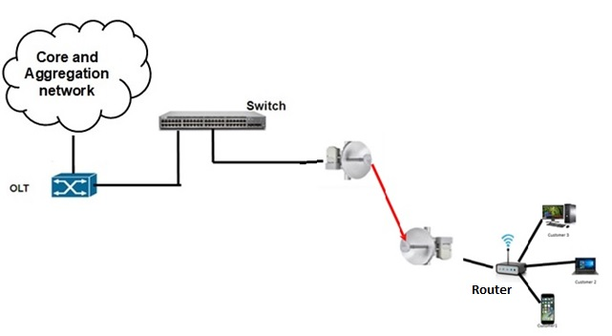
Figure X.10.2 – Point to Point Connectivity diagram

Point-to-Point radio network covers a maximum distance of up to 35 km and has a maximum bandwidth of 1Gbps. Point to Point / Point-to-Multipoint radios use antennas that are more directional and that have higher gain.

*****************************
X.9 Abbreviations
This Appendix uses the following abbreviations:
BNG Broadband Network Gateway
CPE Customer premises equipment
DHCP Dynamic Host Configuration Protocol
EDFA Erbium Doped Fibre Amplifier
FAT Fibre access terminal
IP Internet Protocol
IPTV Internet Protocol Television
JC Joint Closure
MPLS Multi-Protocol Label Switching
ODF Optical Distribution Frame
ODN Optical Distribution Network
OLT Optical Line Terminal
ONT Optical Network Terminal
ONU Optical Network Units
OSS Operations Support Systems
OTB Optical Termination Box
WDM Wavelength Division Multiplexing

