 | INTERNATIONAL TELECOMMUNICATION UNION  TELECOMMUNICATION  STANDARDIZATION SECTOR  STUDY PERIOD 2022-2024 |  |  | SG15-C0369
 |  |  |  | STUDY GROUP 15
 |  |  |  | English only
Question(s): |  | 3/15 |  | Geneva, April 2023
CONTRIBUTION
Source: |  | Ministry of Communication, Government of India, New Delhi
Title: |  | Proposal to include Addendum for use cases to the Draft text for “Technical Paper on the use of ITU-T G.9991 technology for Light Communication (LC)”.
Contact: |  | Rakesh Desai  Ministry of Communications  India |  |  | Tel + 919426203403  Email: rakesh.desai@gov.in
Contact: |  | Mudita Chandra  Ministry of Communications  India |  |  | Tel + 919599924208  Email: mudita.chandra@gov.in
Contact: |  | Hardik Soni  M/s Nav Wireless Technologies Pvt Ltd,  India |  |  | Tel: + 918200667359  Email: hardik.soni@navtechno.in
Contact |  | Deepak Solanki  M/s Research & Development Pvt. Ltd.  India |  |  | Tel +918800968965  Email: deepak@velmenni.com
Keywords: |  |  | G.VLC, new draft
Abstract: |  |  | This contribution proposes to include Addendum for para 6.1.5 of the Draft text for “Technical Paper on the use of ITU-T G.9991 technology for Light Communication (LC)”. The addendum proposes use cases of Li-fi in healthcare and education areas.

Addendum to Chapter 6
VLC Use Cases

6 VLC Use cases

6.1 Use cases

6.1.5 Hospitals

6.1.5.1 Description
In EMC-sensitive installations such as hospital environments/schools, P2P/P2MP links may be provided through LiFi technology based upon (G.VLC) standard. LiFi technology offers wireless connectivity in environments where EMC is not allowed or where RF wireless interferences need to be avoided.

Hospital Isolation Wards LC networking:- Hospitals rely on wireless networks because cables running over a patient's body can cause contamination. Many medical devices, such as infusion pumps, defibrillators, lung ventilators, and anesthesia machines, work on Wi-Fi. However, when doctors use magnetic resonance imaging scanners along with Wi-Fi-based infusion pumps, there is a frequency-overlapping problem. The increasing use of wireless medical devices means that utilizing the radio frequency (RF) spectrum increases, leading to electromagnetic interference (EMI) that can cause potentially hazardous events related to medical equipment operations.

LiFi/VLC network does not release electromagnetic interference and so does not interfere with medical instruments, nor it is interfered with by MRI scanners. Wi-Fi also has security issues in hospital systems, as patient information must be private and secure but accessible to authorized persons. LiFi can combat these limitations of Wi-Fi in health monitoring systems, relieving radio interferences in confined areas and providing high-density wireless data coverage

Li-fi framework in Hospitals:

LiFi is a Visible/In-visible Light Communication system that uses intensity modulation through high-brightness white/infrared LED lights to transmit data wirelessly. The LED lamps can be turned on and off quickly, which allows for data to be transmitted via the light beam. A photodetector receives the transmitted data and decodes it, and parallel data transmission can be achieved using LED arrays to increase the speed of data transmission.
The LiFi system block diagram used in healthcare is shown in figure 6.3 and its use case is shown in figure 6.4. The diagram for the LiFi system showcases a patient monitoring device (multi-para monitor) that utilizes a power line to convert modulated data into electrical signals. With the use of PLC ( Power Line Communications ) technology, multiple monitors can be connected over the power line to transmit data to the LED Driver. The gathered data is processed in the LED lamp, which has a driver capable of transmitting data over LED lights in the form of 1's and 0's. The LED's switching speed is so rapid that it remains undetected by the human eye. The multi-para monitor is linked to a processing unit via various interfaces such as Ethernet, UART, USB, RS 232, or RS 485, to receive the transmitted data.
A LiFi dongle acts as a receiver for the data transmitted by the multi-para monitor. The photo diode of the receiver detects the incoming data, which initially has a low signal strength. However, Op-amp and Comparator circuits are employed to amplify the signal strength. Subsequently, the data is decoded and transformed into a compatible USB protocol. The USB can be plugged directly into the central processing unit for further processing. All the gathered data is transferred by the power line device to the central monitoring unit, which enables doctors to monitor the live status of all multi-para devices with their unique patient IDs.

Block Diagram:

Modulator Processing Data
Power Management
Power Grid
Multi Para

LED Driver
(Encoded Data)
LiFi Tx

Op-Amp & Comparator
Amplification
Photo Diode

PC
(Decoded Data)

LiFi Rx

Figure 6.3 - Li-fi Block Diagram in hospitals

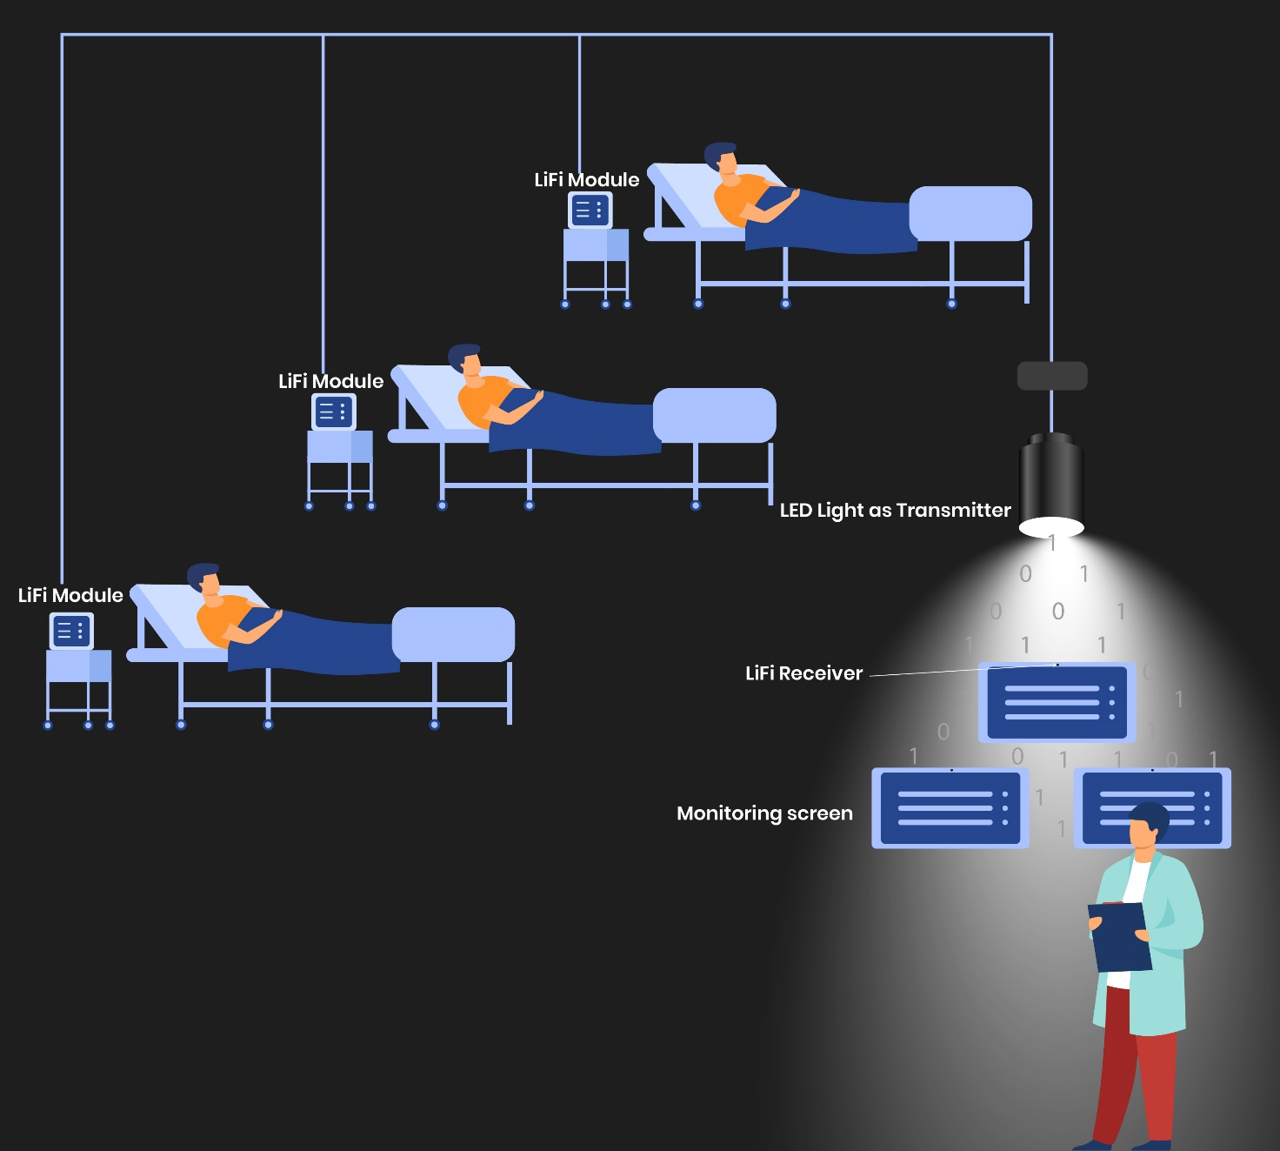

Figure 6.4 - Li-fi deployment in hospitals

6.1.5.2 Main characteristics & constraints
The following clauses describe the main characteristics and constraints of this kind of scenario.

Topology:
The usual topology that can be found in this scenario is P2MP with some nodes connected to the G.9991 DM that illuminates a whole room. Normally, the number of nodes connected to the same DM can be in the order of 10 nodes.

Distances:
Typical distances in this hospital scenario are around 3-4 m with mainly direct visibility.

Target throughput:
Hospital scenarios need throughputs per DM that are defined by the application. A usual target throughput is 100 Mbps/user (aggregated US/DS) leading to an aggregated throughput of 1Gbps at the DM side.
Latency:
Depending on the application being used over the network, the latency requirements may be more or less relaxed. However, a latency of 1-10 ms is acceptable in the majority of the cases. The deterministic MAC of G.9991 allows to maintain a stable latency over the whole session.
Feeder technology:
In the majority of the cases where flexibility and easy installation are the primary factors of decision, the AP may be connected through a powerline connection to the RGW.
A cabled infrastructure (Ethernet, coax) is also possible.

Mobility:
The limited surface covered by this scenario (one room) makes that limited mobility support needed.

6.1.6 School classrooms LC nodes:-

6.1.6.1 Description

LC (LiFi) nodes with high bandwidth are providing faster internet access for video conferences, digital tutorial downloads and online live classes for learning. LC (LiFi) nodes/modules contain ceiling unit as in LED Light Fixture along with Receiver Modules which connects to a device via USB port, both aiming to provide light and connectivity in one device. The system offers a fully networked LiFi solution that act as an access point for ease of use – providing a high level of user experience that is comparable and more secure than existing wireless technologies i.e. Wi-Fi. The merger of illumination with wireless communications claims to provide a measurable reduction in both infrastructure complexity and energy consumption.

The LiFi system block diagram used in schools is shown in figure 6.5 and its use case is shown in figure 6.6. The LiFi transreceivers capable of transmitting and receiving the data are deployed at each node thereby providing the full duplex communication capability.

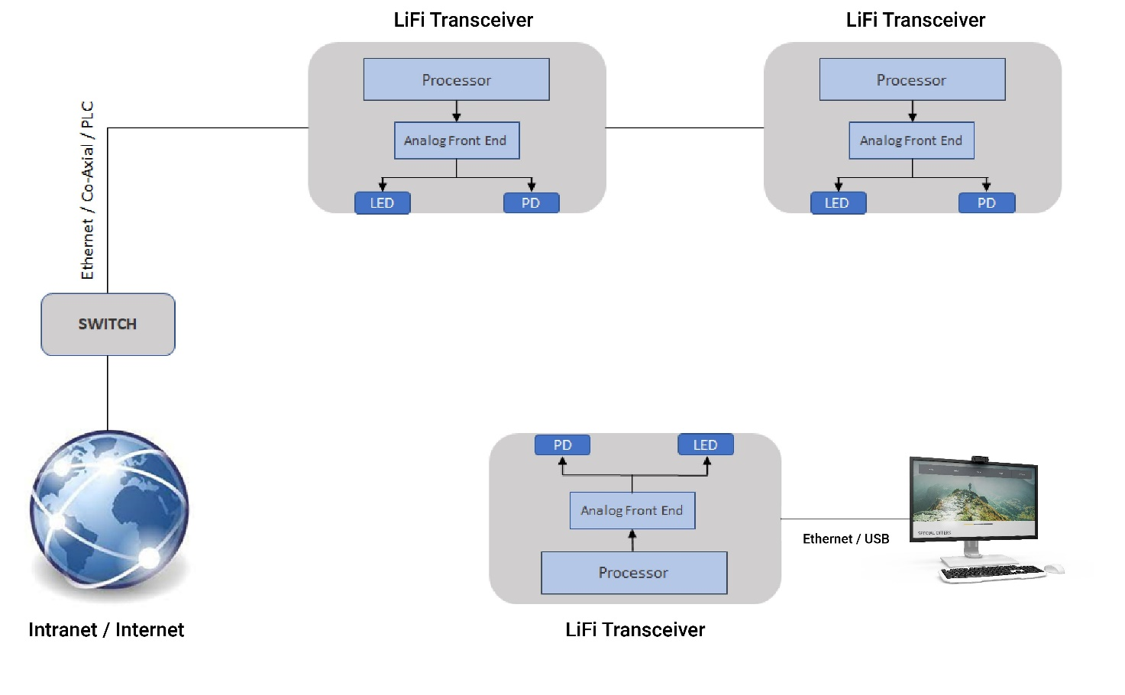
Figure 6.5 - Li-fi framework in Schools

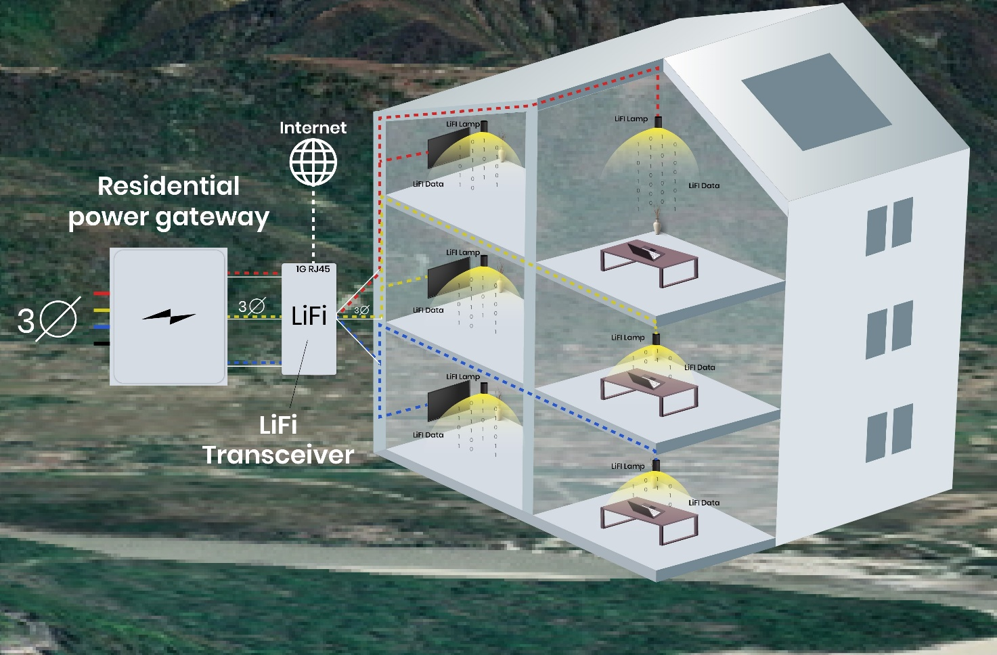

Figure 6.6 - Li-fi deployment in Schools

6.1.6.2 Main characteristics & constraints
The following clauses describe the main characteristics and constraints of this kind of scenario.

Topology:
The usual topology that can be found in this scenario is P2MP with some nodes connected to the G.9991 DM that illuminates a whole room. Normally, the number of nodes connected to the same DM can be in the order of 10 nodes and connects four users per LiFi Access Point. It offers full duplex communication. It supports power over Ethernet (PoE) or Power Line Communications (PLC).
Distances:
Typical distances in this hospital scenario are around 3-4 m with mainly direct visibility.
Target throughput:
School scenarios need throughputs per DM that are defined by the application. A usual target throughput is 100 Mbps/user (aggregated US/DS) leading to an aggregated throughput of 1 Gbps at the DM side.
Latency:
Depending on the application being used over the network, the latency requirements may be more or less relaxed. However, a latency of 1-10 ms is acceptable in the majority of the cases. The deterministic MAC of G.9991 allows to maintain a stable latency over the whole session.
Feeder technology:
In the majority of the cases where flexibility and easy installation are the primary factors of decision, the AP may be connected through a powerline connection to the RGW.
A cabled infrastructure (Ethernet, coax) is also possible.
Mobility:
The limited surface covered by this scenario (one room) makes that limited mobility support needed.

***********************************

