 | INTERNATIONAL TELECOMMUNICATION UNION  TELECOMMUNICATION  STANDARDIZATION SECTOR  STUDY PERIOD 2022-2024 |  | SG17-….
 |  |  | STUDY GROUP 17
 |  |  | Original: English
Question(s): |  | 2/17 |  | Geneva,21 February 2023-03 March 2023
C
Source: |  | India
Title: |  | Proposal for inclusion of text in for X.5Gsec-srocvs: Security Requirements for the Operation of 5G Core Network to Support Vertical Services
Contact: |  | Preetika Singh  Ministry of Communications,  (India ) |  |  | Tel: +011-23319014  Fax: +91-9868137608 E-mail: preetika.singh87@gov.in
Contact: |  | Jyoti Sengar  Ministry of Communications,  (India ) |  |  | Tel: +919997998435 E-mail: jyoti.sengar@gov.in

Abstract: | This proposal will be the new baseline text of X.5Gsec-srocvs after updation of TD628.  The main revisions are as follows:

Recommendation ITU-T X.5Gsec-srocvs
Security Requirements for the Operation of 5G Core Network to Support Vertical Services

Summary
With the development of 5G system, vertical industries have become key scenarios. To support vertical use cases which require ultra reliability and low latency, some of 5G core network’s network functions might be deployed at local sites that are closer to vertical users, while other 5G core network’s network functions still be deployed at central site. Compared to 5G core network deployed as a whole, 5G core network operating in such deployment might face special security threats.
In order to ensure the security of the operation of 5G core network to support vertical services, the specific security threats need to be analysed and relevant security requirements need to be specified.
This recommendation aims to analyse data security threats, network security threats and physical security threats specific to the operation of 5G core network deployed at both central site and local sites to support vertical services, and specify the relevant security requirements.
Keywords
5G core network; vertical service; security requirement

Scope
This draft Recommendation focuses on security requirements for the operation of 5G Core Network deployed at central site and local sites to support vertical services. It analyses the data security threats due to operation and subscription data being transferred between central site and local sites, network security threats due to local sites connecting with central site, physical security threats due to local sites being closer to vertical users, and specify the relevant security requirements to mitigate the security threats.

References
[ITU-T X.1813] Security requirements for the operation of vertical services supporting ultra- reliable and low latency communication (URLLC) in the IMT-2020 private networks
[ITU-T X.5Gsec-netec] Security Capabilities of Network Layer for 5G Edge Computing

Definitions

3.1 Terms defined elsewhere

3.2 Terms defined in this Recommendation

Abbreviations and acronyms
This Recommendation uses the following abbreviations and acronyms:
AMF Access and Mobility Management Function
NEF Network Exposure Function
NF Network Function
SMF Session Management Function
UDM Unified Data Management
UPF User Plane Function

Conventions
This Recommendation uses the following conventions:
The keywords “is required to” indicate a requirement which must be strictly followed and from which no deviation is permitted, if conformance to this Recommendation is to be claimed.
The keywords “is recommended” indicate a requirement which is recommended but which is not absolutely required. Thus, this requirement need not be present to claim conformance.
The keywords “is prohibited from” indicate a requirement which must be strictly followed and from which no deviation is permitted, if conformance to this Recommendation is to be claimed.
The keywords “can optionally” indicate an optional requirement which is permissible, without implying any sense of being recommended. This term is not intended to imply that the vendor’s implementation must provide the option, and the feature can be optionally enabled by the network operator/service provider. Rather, it means the vendor may optionally provide the feature and still claim conformance with the specification.

Deployment scheme
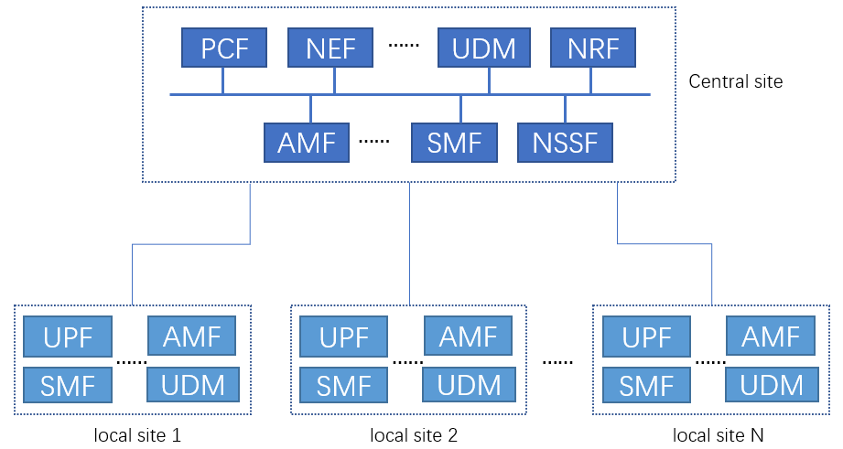
Figure 6-1 Sample deployment of 5G core network to support vertical services
To support vertical services, some of 5G core network’s network functions, like UPF, AMF, SMF, NEF, UDM etc., might be deployed at local sites that are closer to vertical users, while other 5G core network’s network functions still be deployed at central site.
In this deployment, local sites are connected with central sites. And some data will be transferred between central NFs and local NFs. Subscription data like authentication subscription data, access and mobility subscription data, SMF selection subscription data etc. might be transferred between central UDM and local UDM. Operation data like PCC rules, packet flow description, packet detection rules etc. might be transferred between other central NFs and local NFs. Also, subscription data and operation data might be stored in local sites.

Security threats

7.1 Data security threats
AS data would be transferred between central site and local sites，there are some security threats:
- Data might be eavesdropped or tampered by attackers during transfer.
- Without proper dispatch control, data related to one vertical user might be transferred to a local site that serves another vertical user.
- A compromised local NF might post fake data to central NFs, or delete or tamper the data in central NFs.
- Data stored in local NFs might be accessed or tampered by attackers.
- Improper implementation of strong security policy creates the possibility of accessing the data and other resources by unauthorized entities.

7.2 Network security threats
Since local site is connected with central site through signal plane network and management plane network, that might be some security threats.
- Compromised local NFs might scan to find out central NFs’ vulnerabilities and launch further attacks.
- Compromised local NFs might launch DDoS attacks to central sites.

- The availability of system may be compromised by attackers flooding the interface and network assets (AMF, AUSF) resulting in DDoS condition on the signalling plane. (e.g., multiple authentication failure on N1, N2 interface).

One local site might access another local site through central site network. That might also lead to some security threats.
- Compromised NFs at one local site might scan to find out other local site’s NFs’ vulnerabilities and launch further attacks.
- Compromised NFs at one local site might launch DDoS attacks to other local site.

- Lack of adequate mechanisms to filter incoming IP packets on any IP interface according to pre-defined rules make the network device vulnerable to denial-of-service attacks, degradation of services.
- Unrestricted remote login for privileged users expose the network element to increased risk of unauthorized access and manipulation.

Also if there are not mutual authentication with strong security measures between central NFs and local NFs, fake local NF might access central NFs and steal data from central NFs.
If local NFs’ credential is not properly protected, attackers could get the credential and fake local NF to communicate with central site.
…

7.3 Physical security threats
Since local NFs are closer to vertical users, they are more likely to be physically attacked.
- Malicious patches/programs might be installed in local NFs.
- Attackers might control local NFs through local maintenance interfaces.
- Attackers might reset local NFs’ passwords by making them enter recovery mode.
- …

Security requirements
[This chapter specifies security requirements for the operation of 5G core network deployed at both central site and local sites to support vertical services , which include data security requirements to mitigate the threats due to operation and subscription data being transferred between central site and local sites; network security requirements to mitigate the threats due to local sites connecting with central site; physical security requirements to mitigate the threats due to local sites being closer to vertical users.]

8.1 Overview of security requirements analysis
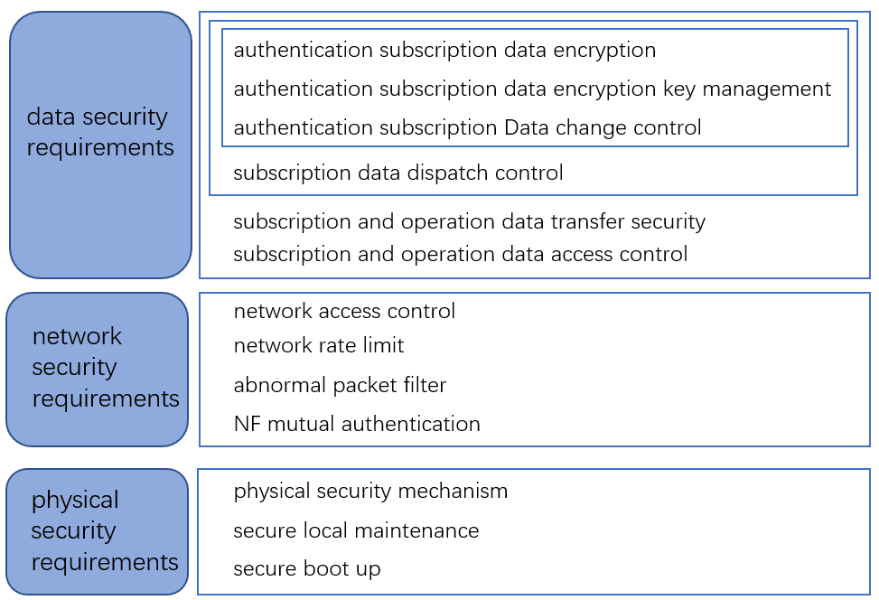
Figure8-1 draft overview of security requirements for the operation of 5G core network deployed at both central site and local sites to support vertical services
Authentication subscription data is the data that is needed for the generation of authentication vectors in the UDM, which may consist of long term key K, sequence number SQN, authentication method used etc. Since authentication subscription data is essential, it requires the protection which include encryption, encryption key management and change control.
Part of subscription data is specific per user, therefore it requires dispatch control.
Both subscription data and operation data needs access control and protection during transfer.

8.2 Data security requirements
The security requirements for authentication subscription data include:
- It is required that Authentication subscription data is encrypted when it is exported out of central UDM.
- It is required that different encryption keys are used to encrypt different local sites’ authentication subscription data.
- It is required that only authorized NFs can change authentication subscription data stored in local UDM.
- It is required that local NFs cannot change authentication subscription data stored in central UDM.
The security requirements for all the subscription data include:
- It is required that subscription data is only be transferred from central site to local sites. Transferring subscription data from local sites to central site should be prohibited.
- It is required that subscription data of one local site cannot be transferred to other local sites.
The security requirements for both subscription data and operation data include:
- It is required that subscription and operation data are integrity protected during transfer.
- It is required that access control is applied to subscription and operation data stored in local sites.
- And the encryption keys should be securely protected.

.
.

8.3 Network security requirements

8.3.1 Network access control
The system shall implement a strong key management system including key generation, key storage, key deletion and cryptographic processing.

8.3.1.1 Access control at signal plane network
There should be access controls between local site and central site, so that local NFs can only access related central NFs. For example, local UPF can access central SMF, but local UPF accessing central AMF should be prohibited.
There should be access controls between local sites, so that local sites serving different vertical users cannot access each other.
All control plane data in transit between hosts should be sent over an encrypted and authenticated channel using non-proprietary protocols.

There shall not be a privilege escalation method in interactive sessions (CLI or GUI) which allow a user to gain administrator/root privileges from another user account without re-authentication.

…

8.3.1.2 Access control at management plane network
There should be access controls at management plane network. So that only OAM (Operation and Management) can access NFs. Local NFs and central NFs cannot access each other through management plane network.
The 5G control plane should be configured in such a way that Network function can only communicate with the NF which they are intended to communicate with.

8.3.2 Network rate limit

The system shall provide security measures to deal with overload situations which may occur as a result of a denial-of-service attack or during periods of increased traffic. In particular, partial or complete impairment of system availability shall be avoided. This can be done through proper rate limits between local site and central site, so that compromised local NFs cannot launch DDoS attacks toward central NFs.

8.3.3 Abnormal packet filter
There should be filtering mechanisms to drop abnormal packets sending from local sites to central site.
Security events shall be logged together with a unique system reference (e.g. host name, IP or MAC address) and the exact time the incident occurred.

8.3.4 NF mutual authentication
Mutual authentication should be performed between local NFs and central NFs.
NFs’ credential should be securely protected.
Strong password policy along with protection against brute force and dictionary attacks should be implemented.
The authorisations for accounts and applications shall be reduced to the minimum required for the tasks they have to perform. Authorisations to a system shall be restricted to a level and access be controlled to a specific user.

8.3.5 Other Security requirements

Unused software components or parts of software which are not needed for operation or functionality of the network product shall not be installed or shall be deleted after installation.

8.4 physical security requirement

8.4.1 physical security mechanism
There should be physical security mechanism to protect local NFs from being stolen, turned off etc.
…

8.4.2 Secure local maintenance
It should be prohibited to recover local NFs’ system password by entering recovery mode.
…

8.4.3 Secure boot up
Local NFs should not boot up from external storage.
…

