 | INTERNATIONAL TELECOMMUNICATION UNION  TELECOMMUNICATION  STANDARDIZATION SECTOR  STUDY PERIOD 2022-2024 |  | SG17-TDxxxx
 |  |  | STUDY GROUP 17
 |  |  | Original: English
Question(s): |  | 7/17 | Geneva, 23 August - 2 September 2022
TD
Source: |  | Editor
Title: |  | First baseline text for X.5Gsec-ss: Security Requirement and guidelines for Software security including OSS in the context of 5G
Contact: |  | Manas Kumar Panda  Ministry of Communications,  (India) | Tel:+91-8249017281  Fax : +91-80- 22481215  E-mail: manas.kumar1@gov.in
Contact:

Abstract:
This TD provides the 1st baseline text for Draft Recommendation ITU-T X.5Gsec-ss, Security Requirement and Guidelines for Software security including OSS in the context of securing 5G. This TD includes
-Range of Software Development Arrangements including OSS
-Security Threats
-Security Requirements to mitigate those threats
-Various security approaches as Security guidelines
Special focus is given in the use of OSS (open-source software) because of growing usage of OSS in 5G in almost every layer like Application, Virtualization, OS etc.

Summary
5G is based on Softwarization of network functions and application, and Virtualization technology (virtual machine or container) which leads to use of softwares more than ever before. Though the joint use of softwarization and virtualization has number of advantages, it introduces more security risks. What concerns more is growing use of open-source software in each & every layer of 5G, be it in application layer, virtualization (OpenSatck, Kubernetes) or OS layer (any version of Linux), as OSS components possess major security risks due to lack of service level agreement for support/patch management unlike proprietary code.
This document introduces the concepts of Open Source Software (OSS) by exploring a variety of deployment scenarios in the context of 5G. It aims to assist the 5G ecosystem to build stronger security resilience by presenting key software security topics through a lens of first, the security threat, and second, the security requirements. This document outlines the security threats associated with use software and OSS components and security requirements to address those threats.
Security is not an outcome; it is a process which requires different approach. This document outlines various approaches such as Secure SDLC, DevSecOPs, Shift left & Zero Trust are described as security guidelines and recommendation.

Keywords:
Open Source Software, SDLC, SBOM

Contents
1. Scope: 4
2. References: 4
3. Definitions 4
4. Abbreviations and acronyms 5
5. Conventions 5
6. Overview: 6
6.1: OSS in 5G Context 6
6.2 Range of Software Development Arrangements 8
7. The Software Security Threat 9
7.1 Insecure Design 9
7.2 Use of Vulnerable and Outdated Components 9
7.3 Software and Data Integrity Failures 10
7.4 Misconfiguration 10
7.5 Coding practices 10
7.6 Cryptographic Failures 10
7.7 Identification and Authentication Failures 11
8. Software Security Requirements 11
8.1 Source code security assurance 11
8.2 Secure Update/Upgrade 11
8.3 No unused/unsupported software 12
8.4 Unnecessary Service & insecure protocol Removal 12
8.5 Secure cryptographic controls 12
8.6 Proper Authentication 12
8.7 Protection of data in store, use and transit 13
8.8 Vulnerability Management 13
8.9 Secure Execution 13
8.10 Code Assessment/ Review 13
9. Software Security Guidelines and Recommendations 14
9.1 Availability of current & updated SBOM: Software Bill of Material 14
9.2 Secure SDLC 14
9.3 “DevSecOps” in place of DevOps 15
9.4 “Shift left” approach 16

1. Scope:
This draft Recommendation provides Security Requirement and Guidelines for software security in the context of securing 5G applications and software including virtualization layer with special focus in securing OSS (open source softwares) as they constitute a major chunk of softwares used in 5G systems & services.
This Recommendation is intended to be used by organizations OEMs/MNOs that would develop and deploy softwares for 5G systems and services. Also, this recommendation can be used by organizations that would assess and evaluate software security in 5G systems.

2. References:
- 3GPP 33.117-14.2.0 V.1.0.0:"Catalogue of General Security Assurance Requirements".
- GSMA Report Mobile Telecommunications Security Landscape 2022
- CISA Top Routinely Exploited Vulnerabilities https://us-cert.cisa.gov/ncas/alerts/aa21-209a
- GSMA white paper on Open Networking & the Security of Open-Source Software Deployment
- OWASP Top 10: https://owasp.org/www-project-top-ten/
- NCCS PGW ITSAR Version 1.0.0.: Indian Telecommunication Security Assurance Requirements (ITSAR) for Packet Data Network Gateway (P-GW/PDN GW)
- NTIA SBOM https://ntia.gov/page/software-bill-materials

3. Definitions
Virtualized Network Functions (VNFs): A VNF is the software implementation of network functions eg AMF which can be composed of one or more VMs or container based implementation.
Software Defined Networking (SDN): SDN is an architecture designed to make a network more flexible and easier to manage. SDN centralizes management by abstracting the control plane (using a centralized controller) from the data forwarding function in the discrete networking devices(switches, access points, routers, and firewalls).
O-RAN: Open RAN
MANO: Network functions virtualization management and orchestration (NFV-MANO)
SCA: Software composition analysis (SCA) is an automated process that identifies the open-source software in a codebase. This analysis is performed to evaluate security, license compliance, and code quality.
SAST: Static application security testing (SAST) is a white box method of testing. It examines the code to find software flaws and weaknesses such as SQL injection and others listed in the OWASP Top 10. SAST requires source code.
DAST: Dynamic application security testing (DAST) is a black box testing method that examines an application as it’s running to find vulnerabilities that an attacker could exploit. DAST requires running application.

4. Abbreviations and acronyms
This Recommendation uses the following abbreviations and acronyms:
NE: Network Equipment
NF: Network Functions
VNF: Virtualized Network Functions
CNF: Cloud-native Network functions
OSS: Open-Source software
SDLC: Software Development Life Cycle
SCA: Software composition analysis
SAST: Static Application Security Testing
DAST: Dynamic Application Security Testing
NFVI: Network Function Virtualization Infrastructure
SAAS: Software as a Service
SDN: Software Defined Networking
RAN: Radio Access Network
O-RAN: Open-Radio Access Network
CVE: Common Vulnerabilities and Exposures
CWE: Common Weakness Enumeration
OWASP: Open Web Application Security Project
SEI: Software Engineering Institute
VM: Virtual Machine
MANO: Management and Network Orchestration
CISA: Cybersecurity and Infrastructure Security Agency
SBOM: Software Bill of Material
NTIA: National Telecommunications and Information Administration
HTTP: Hyper Text Transfer Protocol
VA: Vulnerability Assessment
PT: Penetration Testing
FIPS: Federal Information Processing Standards
NIST: National Institute of Standards and Technology

5. Conventions
This Recommendation applies the following verbal forms for the following expression
1. “Must” or “shall” or “is required to” denotes absolute requirement which must be strictly followed if conformance to this document is to be claimed
2. “Must not” or “shall not” denotes absolute prohibition
3. "Should" indicates a recommendation but which may or may not be followed.

6. Overview:
Software is fundamental to the delivery of mobile communications networks both in proprietary form and increasingly, open source. The telecommunications industry uses software from the open-source community in a range of architectural deployments, including to provide virtualised middleware, as a software component running on virtualised infrastructure or within proprietary code implementation. Malicious software (malware) whether intentional or flawed coding (unintentional) possess a significant risk.

In the advent of 5G, the softwarization has gained a lot more impetus than ever before. Indeed, two novel paradigms i.e., softwarization and virtualization are targeted as two disruptive technologies already adopted in 5G networks to allow flexibility and fast re-configuration of the network & faster delivery of services. The joint use of softwarization and virtualization allows network functions to run in software instead of dedicated hardware and decouples network functions from the underlying hardware platform. From a 5G mobile network point of view, softwarization includes virtualized network functions (VNFs), virtualization middle layer (e.g., OpenStack, Kubernetes), components in software defined networking (SDN) and much discussed O-RAN.

6.1: OSS in 5G Context
The prevalence of OSS in a 5G deployment may be comprehended from the following figure that shows the use of OSS in every layer of 5G stack apart from hardware.
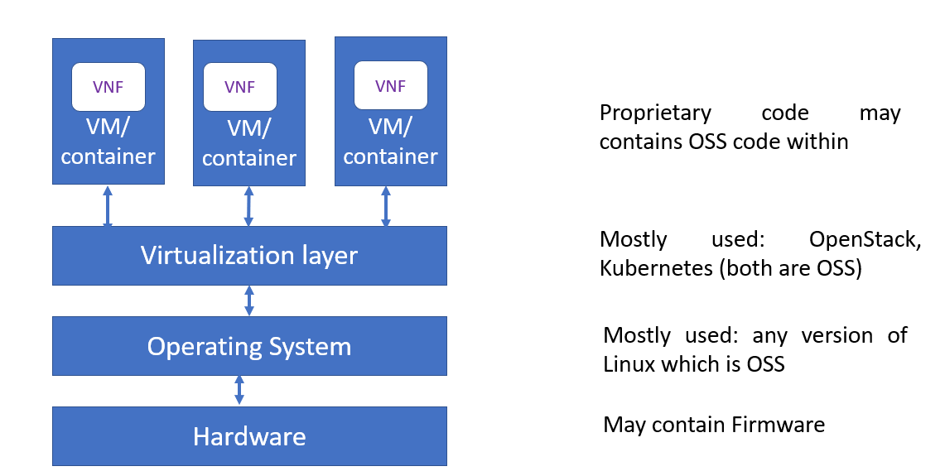

Fig1: Use of OSS in 5G Stack

In context of 5G system and services, the components that are leveraging open-source elements include:

- All distributions of Linux
- OpenStack distributions
- Software Defined Networking controllers
- Management & Network Orchestration
- Near-Real Time RAN Intelligence Controllers
- Virtualisation Hypervisors
- Service Orchestrators
- Ingress controllers
- Software based Load Balancers
- Application components:

There are different deployment arrangements (or use cases scenario) for open-source software as shown below⁴
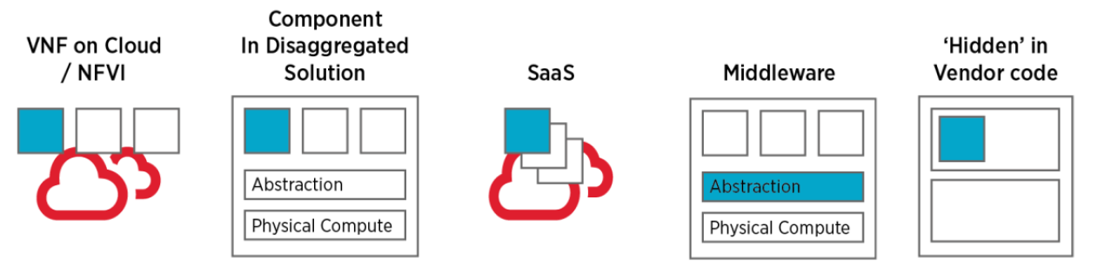
Fig2: Open source software deployment arrangements

- as discrete code such as a Virtual Network Function (VNF) in cloud/NFVI
- as a component within a disaggregated solution or part of vendor proprietary code
- as part of the provision of a wider Software as a Service (SaaS) provision
- as middleware abstraction or virtualisation layer (e.g., OpenStack, Kubernetes)
- re-used within vendor executable code

There are many initiatives driving open architectures and virtualised telecoms infrastructure such as Telecoms Infrastructure Project (TIP), Open-Radio Access Network (O-RAN) Alliance, Linux Networking Foundation, CCNF, Open Networking Forum and many more.

Open Source Software (OSS) has a number of advantages, notably including that source code is accessible and subject to inspection, a wide community of developers can contribute and there is potential to accelerate telco cloud implementation. In contrast, there are various best practice steps that aim to ‘make secure software’ but none of these are mandated in the open-source community whose main focus is functionality. In case of use of OSS, the major security risk is unpatched/unsupported software, not use of open source software or components contrary to proprietary code where service level agreement are in place for support and patch management through the life cycle. Hence special focus is given in this document to secure with OSS components along with the whole software.

6.2 Range of Software Development Arrangements
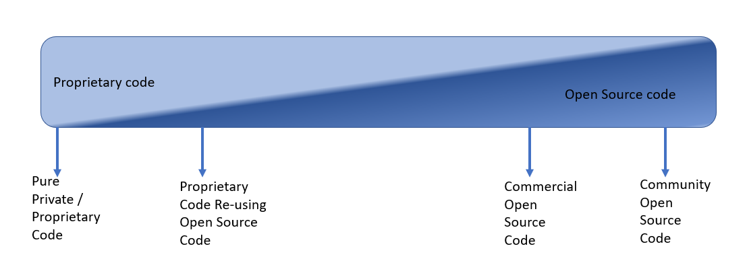Fig3: A Range of Software Development Arrangements²

Open-source code can be noted in a wide range of code development as shown in above figure including complete modules, libraries, utilities and partial code re-use.
For proprietary executable code, the vendor will typically provide all the development resources (coders), and follow their own company-specific software development coding practices (ideally benchmarked to the best in industry) and controlled according to their own configuration management processes, but it is not typically open for inspection from outside of the vendor. Proprietary code developers aim to speed delivery of their products by re-using open source code. In both the scenarios, support for the code is usually provided in a maintenance contract with service level agreements.
For open source developed code, the main focus is typically to deliver the required functionality. Development processes can vary and can be highly distributed by workforce and geographies but open-source code is available for detailed inspection. A major advantage of open source is that the source code is available for detailed inspection unlike vendor-specific executable code. This is also a disadvantage because attackers can equally inspect open source code to assess vulnerabilities.
Community open source code is produced from an open source community and entirely supported from within that community. There is often significant a rapid churn in open source community developments. This can result in a significant number of ‘dead’ or inactive code branches which are unlikely to attract further code development and support.
Commercial open source code is open source code often produced from code developed by the commercial entity and also with other contributors. Commercial open source code is not the same as proprietary – it is often free to download in both source and executable forms. Both commercial and community approaches have advantages; one key differentiator is in the area of support and bug fixes. With a community support arrangement, the software user is dependent on the community to generate the code fix/update to a non-deterministic timescale. Commercial open source can often be backed by a service level agreement to integrate newly developed open source software, update the software with the latest security patches. However, one disadvantages may be that Commercial Packaged open source distributions can include a range of additional components such as installers, linkers and utilities that may ease deployment but may also install unwanted/unneeded packages that increases the security risk. Hence extra security measures are required while dealing with open source code.

7. The Software Security Threat
The threat of poorly written code, or the deliberate insertion of malicious code, that could be used to compromise network operation, data or service features is a major concern. Software vulnerabilities can be observed in a range of code types as illustrated above in Fig 3.
All varieties of code types (private/proprietary code or commercial or community opensource code) contain weaknesses/errors which can lead to vulnerabilities.
Research has found a lack of software validation in network systems deployed in production: e.g., software images not being signed, signatures not being verified during installation and acceptance of software images. Additionally, the integrity and protection of software images are not enforced. Certificate based authentication and integrity protection of images is rarely delivered so it cannot be guaranteed that the software being installed is the same version that was created by the vendor. Finally, reverse engineering of some telco software images undertaken, means it is possible to uncover hardcoded accounts and passwords from the system which can remain used in production systems. Credentials were able to be extracted which may allow an attacker to access and manipulate the images remotely.
A list of the most commonly exploited vulnerabilities was published in a Joint Cybersecurity Advisory³ by the CISA. The document provides details on the top 30 vulnerabilities—primarily Common Vulnerabilities and Exposures (CVEs)—routinely exploited by malicious cyber actors in 2020 and those widely exploited in 2021. The vulnerabilities allowed a range of undesirable actions including arbitrary code execution, arbitrary code reading, path traversal, remote code execution and escalation of privilege.⁴
The Open Web Application Security Project (OWASP) is a non-profit foundation that works to improve the security of software. The OWASP Top 10⁵ is the list of the 10 most critical security concerns for web application or any software. Using the OWASP Top 10 (latest is OWASP Top 10-2021) is perhaps the most effective first step towards changing the software development culture within your organization into one that produces more secure code.

7.1 Insecure Design
Insecure design is a broad category representing different weaknesses, expressed as “missing or ineffective control design”. A secure design can still have implementation defects leading to vulnerabilities that may be exploited. An insecure design cannot be fixed by a perfect implementation as by definition, needed security controls were never created to defend against specific attacks in the design phase itself. One of the factors that contribute to insecure design is the lack of business risk profiling inherent in the software or system being developed, and thus the failure to determine what level of security design is required. Lack of threat modelling, secure design patterns and principles, secure SDLC and reference architectures may cause this design flaw.

7.2 Use of Vulnerable and Outdated Components
Use of software that contains components that are no longer supported by vendor or its third parties including the open-source communities, such as components that have reached end-of-life or end-of-support. This includes the OS, web/application server, database management system (DBMS), applications, APIs and all components, runtime environments, and libraries. Proprietary software may have support through service level agreements however this is a major problem in case of OSS. Often it is very difficult to trace the components and their dependencies when SBOM is either unavailable or not updated. If the software unsupported, or out of date, then it is more likely to have unpatched vulnerabilities which can be easily exploited by the attacker.

7.3 Software and Data Integrity Failures
The product downloads source code or an executable from a remote location and executes the code without sufficiently verifying the origin and integrity of the code. Software images not being signed by the developer, signatures not being verified during updates/upgrade stage. Many applications now include auto-update functionality, where updates are downloaded without sufficient integrity verification. Attackers could potentially upload their own updates to be distributed and run on all installation.
Other such scenario is when updates/upgrades are happening from untrusted sources specially where an application relies upon plugins, libraries, or modules from untrusted sources, repositories, and content delivery networks.

7.4 Misconfiguration
The software/code is vulnerable if
- Missing appropriate security hardening across any part of the application stack or improperly configured permissions on cloud services.
- Unnecessary features are enabled or installed (e.g., unnecessary ports, services, pages, accounts, or privileges).
- Default accounts and their passwords are still enabled and unchanged.
- Error handling reveals stack traces or other overly informative error messages to users.
- For upgraded systems, the latest security features are disabled or not configured securely.
- The security settings in the application servers, application frameworks (e.g., Spring, ASP.NET), libraries, databases, etc., are not set to secure values.

7.5 Coding practices
Every coding language has some inherent vulnerabilities, be it C, C++ or JAVA. One such example in C is use of the strcpy built-in function that does not check buffer lengths and may very well overwrite memory zone contiguous to the intended destination resulting in buffer overflow error. In fact, the whole family of functions are vulnerable: strcpy, strcat and strcmp.
Secure Coding Standards are a roadmap and guide for developers in their efforts to produce secure code during SDLC to make sure that software is free from all known security vulnerabilities.
The SEI CERT Coding Standards are software coding standards developed by the SEI CERT Coordination Centre to improve the reliability and security of software systems. Individual standards are offered for C, C++, Java, Android OS, and Perl for e.g. SEI CERT C Coding Standard for secure coding in C language.

7.6 Cryptographic Failures
- Use of deprecated or legacy hash functions such as MD5 or SHA1.
- If any old or weak or deprecated cryptographic algorithms or protocols still being used. eg use lower key size/length
- Are default crypto keys in use, weak crypto keys generated or re-used, or is proper key management missing
- If any sensitive data transmitted in clear text
Cryptographic Failures often lead to exposure of sensitive data
To cite one example if the password database uses unsalted or simple hashes to store everyone's passwords. A file upload flaw allows an attacker to retrieve the password database. All the unsalted hashes can be exposed with a rainbow table of pre-calculated hashes.

7.7 Identification and Authentication Failures
Confirmation of the user's identity, authentication, and session management is critical to protect against authentication-related attacks. There may be authentication weaknesses if the application or software
- Permits brute force or other automated attacks.
- Permits default, weak or well-known passwords eg "Password1" or "admin/admin".
- Uses plain text, encrypted, or weakly hashed passwords
- Has missing or ineffective multi-factor authentication.
- Exposes session identifier in the URL.
- Reuse session identifier after successful login.

8. Software Security Requirements
This chapter describes the following Software Security Requirements to address the threats discussed in chapter 7.

8.1 Source code security assurance
OEM/Developer shall ensure the following while developing any software
    - Industry standard best practices of secure coding during the entire software development life cycle of the Software, that includes vendor developed code, third party software and open-source code libraries used/embedded in the software. eg SEI CERT C/C++.
    - The software is free from known security vulnerabilities, security weaknesses listed in the CWE database and all the exploitable security vulnerabilities listed in the latest SANS Top 25 and OWASP Top 10. This can be checked using a SAST tool.

8.2 Secure Update/Upgrade
- Software package integrity shall be validated in the installation and update/upgrade stages strictly using the Secure cryptographic controls using Digital Signature method.
- Update/Upgrade is allowed only if code signing certificate is valid and not time expired.
- To this end, NE/NF shall have a list of public keys or certificates of authorised software sources, and uses the keys to verify that the software update/upgrade is originated from only these sources.
- Tampered software shall not be executed or installed if integrity check fails.
- OEM/Developer must sign all Software updates/upgrades/images using his private keys.

8.3 No unused/unsupported software
8.3.1 Software components /packages/functions or parts of software packages which are not needed for operation or functionality of the NF/NE shall not be present e.g., Orphaned software components /packages shall not be present.
A debugging function in software which can be used for troubleshooting shall not be activated during normal operation of the Network product
8.3.2 OEM/Developer to ensure that the NE/NF shall not contain software components that are no longer supported by Vendor or its 3rd Parties including the open source communities, such as components that have reached end-of-life or end-of-support.

8.4 Unnecessary Service & insecure protocol Removal
8.4.1 The Network product shall only run protocol handlers and services which are needed for its operation, and which do not have any known security vulnerabilities.
8.4.2 In particular, by default the following services shall be initially configured to be disabled on the Network product by the vendor(as they are insecure & having known vulnerabilities).
- FTP
- TFTP
- Telnet
- rlogin, RCP, RSH
- HTTP
- SNMPv1 and v2
- SSHv1

8.5 Secure cryptographic controls

8.5.1 Only use secure cryptographic primitives while implementation of crypto controls/crypto functionalities e.g., like encryption, hashing, key exchange etc. Avoid deprecated/legacy cryptographic functions and padding schemes, such as MD5, SHA1. Ensure up-to-date and strong standard algorithms, protocols, and keys are in place and use proper key management.
8.5.2 Secure implementation of Cryptographic algorithms: Cryptographic algorithms embedded in the crypto module of network product are securely implemented in compliance with respective FIPS standards for the specific crypto algorithm e.g., FIPS 197 for AES.

8.6 Proper Authentication

- Enforcing strong password/passphrase with proper complexity.
- Where possible, implement multi-factor authentication to prevent automated credential stuffing, brute force, and stolen credential reuse attacks.
- Store passwords using strong adaptive and salted hashing functions (protection against rainbow attack)
- Predefined or default authentication credentials shall be deleted/permanently disabled.
- Protection against brute force and dictionary attacks such as adding timer delay, CAPTCHA etc.

8.7 Protection of data in store, use and transit
8.7.1 For sensitive data in (persistent or temporary) storage access rights shall be restricted. Files of a system that are needed for the functionality shall be protected against manipulation.
Stored files on the network product should be protected against manipulation by cryptographic methods.
8.7.2 Systems that need access to identification and authentication data in the clear, e.g. in order to perform an authentication. Such systems shall not store this data in the clear, but scramble or encrypt it by implementation-specific means.
Systems that do not need access to sensitive data (e.g., user passwords) in the clear. Such systems shall hash this sensitive data.
8.7.3 The transmission of data with a need of protection shall use industry standard network protocols with sufficient security measures and industry accepted algorithms. In particular, a protocol version without known vulnerabilities or a secure alternative shall be used.

8.8 Vulnerability Management
The purpose of vulnerability scanning is to ensure that there are no known vulnerabilities (or that relevant vulnerabilities are identified and remediation plans in place to mitigate them) on the software/system that can be detected by means of automatic testing tools (VA tool).
Additional considerations here include:
- Scan software image files for known vulnerabilities in repositories before they get deployed into production
- Scan processes and containers in the runtime environment and block vulnerable processes and prevent vulnerable containers from being exposed.
The availability of a current Software Bill of Materials (SBOM) is a key measure in building an effective response to software vulnerabilities and detected CVEs, implementing bug fixes and code enhancements.

8.9 Secure Execution
8.9.1 Application Sandboxing: Use controls to isolate application resources from each other ie apps can't interact with each other and access to other Apps memory and data. The aim of sandboxing is to prevent malicious external programs from interacting with the protected app.
8.9.2 Workload should execute with least privilege access.

8.10 Code Assessment/ Review
8.10.1 The code should be assessed for security vulnerabilities in different phases of SDLC by both SAST & DAST approach. SAST (tools like static source code testing) should be performed early and often against all files containing source code to find software flaws and weaknesses. DAST should be performed on a running application in an environment similar to production to find run-time vulnerabilities. Any vulnerabilities found which is listed in OWASP TOP 10 and/or SANS Top 25 should be addressed immediately in SDLC.
8.10.2 SCA (Software composition analysis) must be performed to identify open-source software/components in codebase to evaluate security, license compliance etc.

9. Software Security Guidelines and Recommendations
Security is not an outcome; it is a process. It requires a different approach in the organization, be it in process, people or technologies. This chapter describes different security approaches in the form of security guidelines and recommendations.

9.1 Availability of current & updated SBOM: Software Bill of Material

Use of open source itself is not risky; unmanaged use of open source is. Not only for effective management but also for effective security response, SBOM is indispensable. The National Telecommunications and Information Administration defines an SBOM as:

“a formal record containing the details and supply chain relationships of various components used in building software An SBOM is effectively a nested inventory: a list of ingredients that make up software components. An SBOM identifies and lists software components, information about those components, and the relationships between them.”
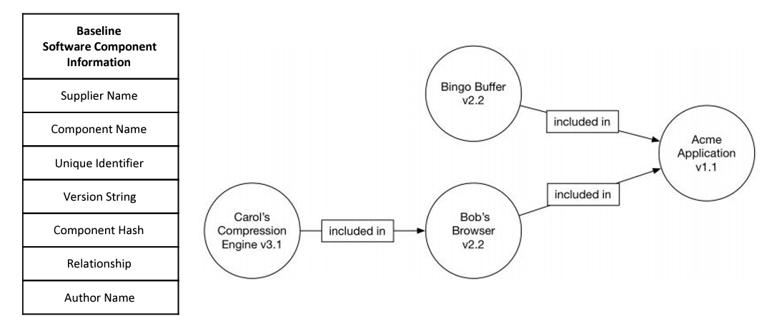

SBOM helps in
- Managing Security Risks Inherent in the Use of Third-party Components (TPC)
- Identify potentially vulnerable components
- The Software Supply Chain
- Monitor components for vulnerabilities & end-of-life
- a blacklist of banned components
- a more targeted security analysis & make code easier to review

Data standards exist today that can capture this SBOM data. These include SPDX, SWID, and CycloneDX. The NTIA SBOM website contains a range of useful information on establishing an SBOM, a report on data formats.

9.2 Secure SDLC

Secure software requires a secure development lifecycle, some form of secure design pattern, paved road methodology, secured component library, security testing & assessment. The SDLC is a well-established framework for organizing application development work from inception to deployment. Over the years, multiple SDLC models have emerged—from waterfall and iterative to, more recently, agile and CI/CD. Each new model has tended to increase the speed and frequency of deployment. No matter which model is being followed, waterfall model or agile, SDLC involves roughly the following stages.
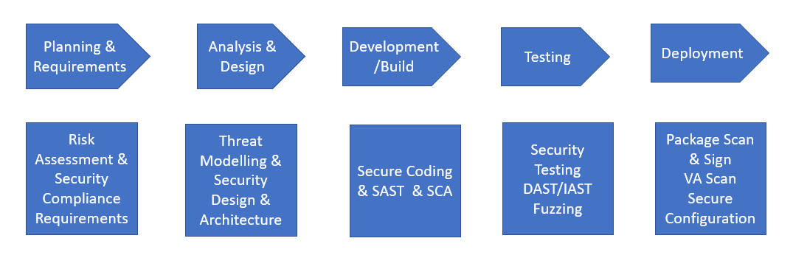
Fig: Stages in SDLC & Security activities in each stages of Secure SDLC

The approach is to follow security in each stage of SDLC rather than at the end/testing phase.
A secure SDLC involves integrating security testing and other activities into an existing development process. Examples include writing security requirements alongside functional requirements and performing an architecture risk analysis & threat modelling during the design phase, practicing secure coding during development & use code scanning tools for static analysis, dynamic analysis, and interactive application security testing during development & testing phase of SDLC. Each Stage of secure SDLC involves many security activities as shown in the above figure.

This is an additional phase ie Maintenance/Support phase. If at all we take that phase into account, the security activities may involve Vulnerability Management, regular VA Scan, Patch Management, Secure update/upgrade, log & incident monitoring, Penetration Testing.

9.3 “DevSecOps” in place of DevOps

Traditionally, there were separate Production (Development) networks and Live (Operations) networks. This allowed a partitioning of technical risk as development code could be tested away from live networks, thus de-risking new deployments, but it delays the deployment.

DevOps - short for development & operations, it is an approach solely focuses on collaboration between these two integral teams in the development process. Here, these two teams work together to develop processes, KPIs and milestones to target collaboratively. In doing so, the operations team can analyse the delivery stages more closely, while assessing continual updates and feedback from the development team. DevOps is important because it enables faster development of new products and easier maintenance of existing deployments. This comes with some additional risk too, in that new code may have bugs that become deployed in the live network.

DevSecOps (short for development, security, and operations) is a development practice that integrates security initiatives at every stage of the software development lifecycle to deliver robust and secure applications. DevSecOps infuses security into the continuous integration and continuous delivery (CI/CD) pipeline by collaboration between Development, Security and Production team.

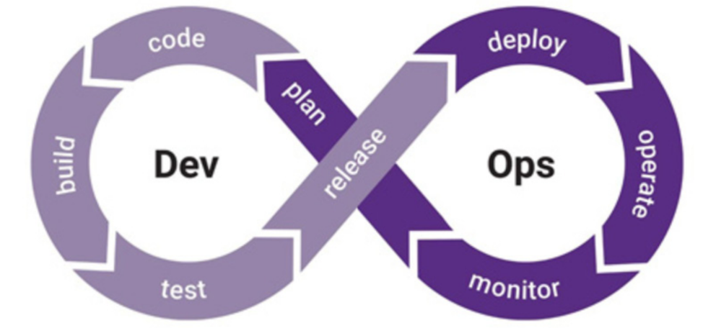

DevSecOps is an iteration of DevOps in the sense that DevSecOps has taken the DevOps model and wrapped security as an additional layer in every stage to the continual development and operations process. Instead of looking at security as an afterthought, DevSecOps pulls in Application Security teams early to fortify the development process from a security and vulnerability mitigation perspective.

9.4 “Shift left” approach

One of the approaches to implement bringing the Security (Sec) part of DevSecOps is the concept of shifting the security review process "left" or earlier in the software development lifecycle.
Most aspects of security can be addressed multiple times within an SDLC, but in general, the earlier in the SDLC that security is addressed, the less effort and cost is ultimately required to achieve the same level of security. This principle, known as shifting left, is critically important regardless of the SDLC model. Shifting left minimizes any technical debt that would require remediating early security flaws late in development or after the software is in production. Shifting left can also result in software with stronger security and resiliency.

This means the operator security team getting involved in the earlier system lifecycle stage such as the design phase, i.e., not leaving security involvement to a late stage when it can be harder to substantively improve security.

Bibliography

<to be added>

