 | INTERNATIONAL TELECOMMUNICATION UNION  TELECOMMUNICATION  STANDARDIZATION SECTOR  STUDY PERIOD 2022-2024 |  | SG17-C….
 |  |  | STUDY GROUP 17
 |  |  | Original: English
Question(s): |  | 2/17 | Geneva ………………2023
C
Source: |  | India
Title: |  | Proposal for new work item : Security Requirement and guidelines for Software security including OSS for secure 5G
Contact: |  | Manas Kumar Panda  Ministry of Communications,  (India) | Tel:+91-8249017281  Fax : +91-80- 22481215  E-mail: manas.kumar1@gov.in
Contact:

Abstract:
This contribution proposes a new work item on Security Requirement and Guidelines for Software security including OSS for secure 5G.
This document introduces the concepts of Open-Source Software (OSS) by exploring a variety of deployment scenarios in the context of 5G as open-source software are being used extensively in every layer of 5G deployments. It aims to assist the 5G ecosystem to build stronger security resilience by presenting key software security topics through a lens of first, the security threat, and second, the security requirements. This document outlines the security threats associated with use software & open-source components and security requirements to address those threats..
The attachments contain the A.1 justification and initial draft for newly proposed work item.

Attachments:
- Annex A: A.1 justification for proposed new draft Recommendation
- Annex B: Background and motivation of proposal for new work item: Security Requirement and Guidelines for Software security including OSS for secure 5G

- Annex C: Draft Recommendation for new work item: Security Requirement and Guidelines for Software security including OSS for secure 5G

Annex A

A.1 Justification for proposed draft new work item: Security Requirement and Guidelines for Software security including OSS for secure 5G"

Question: | Q7/17 | Proposed new ITU-T Recommendation | Geneva 21 February - 3 March 2023
Reference and title: | Security Requirement and Guidelines for Software security including OSS for secure 5G
Base text: | SG17-C |  |  | Timing: | 2024-09
Editor(s): | Manas Kumar Panda, manas.kumar1@gov.in |  |  | Approval process: | AAP
Scope (defines the intent or object of the Recommendation and the aspects covered, thereby indicating the limits of its applicability):
This Recommendation provides recommended software security requirements to address the software security threats in 5G network systems in various layers eg application ie NFV (Network Functions Virtualization), virtualization layer including OpenSatck or Kubernetes for container based & MANO. This Recommendation covers:
- Software Security threats for software used in 5G network systems.
- Recommended security controls/requirements to mitigate the threats
- Prescribed guidelines for a better approach to reduce the surface of vulnerabilities in earlier stages

Summary (provides a brief overview of the purpose and contents of the Recommendation, thus permitting readers to judge its usefulness for their work):
- This document introduces various Open-Source Software (OSS) deployment scenarios in 5G by taking into account the growing use of open-source software in each & every layer of 5G, be it in application layer, virtualization (OpenSatck, Kubernetes) or OS layer (any version of Linux) or MANO, as OSS components possess major security risks due to lack of service level agreement for support/patch management unlike proprietary code.
- It aims to assist the 5G ecosystem to build stronger security resilience by presenting key software security topics through a lens of first, the software security threat, and second, the security requirements. This document outlines the security threats associated with use software and OSS components and security requirements to mitigate those threats.

Relations to ITU-T Recommendations or to other standards (approved or under development):

Liaisons with other study groups or with other standards bodies:
GSMA,

Supporting members that are committing to contributing actively to the work item:

Annex B
- Introduction

5G has enabled the large number of use cases in different operating environment. This has been possible due to the use of cloud and virtualization technologies, allowing for a separation of hardware and software based on open industry standards and usage of open source software.
Despite having the Open-Source Software (OSS) with number of advantages, it can introduce the Security vulnerability in the system.
Any vulnerabilities present either in application software (VNF) or system software i.e OS or virtualization layer possess a major security risk as it has the potential to be leveraged by a threat agent in order to compromise 5G network. In order to ensure the security of 5G network all the softwares including the all-OSS components in each & every layer of 5G should be secured i.e. free from known vulnerabilities and malware.

- Outline of new work item proposal
This contribution proposes to establish a new work item: Security Requirement and Guidelines for Software security including Open Source Software (OSS) for secure 5G. This document introduces the concepts of Open-Source Software (OSS) by exploring a variety of deployment scenarios in the context of 5G. It aims to assist the 5G ecosystem to build stronger security resilience by identifying the security threat, and subsequently the security requirements for addressing those threats.
This document outlines the various security threats associated with use software and OSS components and security requirements to address those threats.
Annex C of this contribution includes a baseline document for this new work item proposal.

- Gap Analysis

1) ITU-T X.1814 (X. 5Gsec-guide): Security guidelines for IMT-2020 communication system
This Recommendation provides security threats to components of IMT-2020 communication system and security capabilities of each component.
- Though it talks about software vulnerabilities, configuration mistakes under section “8.1 Generic threats “and Exploitation of software and hardware vulnerabilities and clearly mention that this type of threat enables a malicious attacker to take advantage of unknown (to the vendor and user) software flaws or known but unpatched flaws to perform an attack, it didn’t mention the security requirements to address software vulnerabilities.
- X.1814 neither address the threat associated with use of OSS in 5G systems nor it provides security requirement/guidelines to address those threats.

2) ITU-T TR.5Gsec-bsf: Guidelines of Built-in Security Framework for the Telecommunications Network
This technical report is about Guidelines of Built-in Security Framework for the Telecommunications Network that includes Network Functions(virtual), Security Capability Function, Security Management Function to implement the securities features. The framework can be applied in the deployment and operation phase, it didn’t address the security concerns before deployment phase like in design and development phases of any software.

Annex C
Summary
5G Technology is based on Softwarization of network functions and application, and Virtualization technology (virtual machine or container) which are primarily a software based technology. 5G technology and related use cases are built primarily using open source software Usage of open-source software in each & every layer of 5G, be it in application layer, virtualization (OpenStack, Kubernetes) or OS layer (any version of Linux), as OSS components may create major security risks due to lack of service level agreement for support/patch management unlike proprietary code.
This document introduces the concepts of Open-Source Software (OSS) by exploring a variety of deployment scenarios in the context of 5G. It aims to assist the 5G ecosystem to build stronger security resilience by presenting key software security topics through a lens of first, the security threat, and second, the security requirements. This document outlines the security threats associated with use software and OSS components and security requirements to address those threats.

Keywords:
Open Source Software, SDLC, TPC, SBOM

Contents
1. Scope: 4
2. References: 4
3. Definitions 4
4. Abbreviations and acronyms 5
5. Conventions 5
6. Overview: 6
6.1 OSS in 5G Context 6
6.2 OSS Advantages & Disadvantages 8
7. The Software Security Threat 9
7.1 Insecure Design 9
7.2 Use of Vulnerable and Outdated Components 9
7.3 Software and Data Integrity Failures 10
7.4 Misconfiguration 10
7.5 Coding practices 10
7.6 Cryptographic Failures 10
7.7 Identification and Authentication Failures 11
8. Software Security Requirements 11
8.1 Source code security assurance 11
8.2 Secure Update/Upgrade 11
8.3 No unused/unsupported software 12
8.4 Unnecessary Service & insecure protocol Removal 12
8.5 Secure cryptographic controls 12
8.6 Proper Authentication 12
8.7 Protection of data in store, use and transit 13
8.8 Vulnerability Management 13
8.9 Secure Execution 13
8.10 Code Assessment/ Review 13
9. Software Security Guidelines and Recommendations 14
9.1 Availability of current & updated SBOM: Software Bill of Material 14
9.2 Secure SDLC 14
9.3 “DevSecOps” in place of DevOps 15
9.4 “Shift left” approach 16

1. Scope:
This draft Recommendation provides Security Requirement and Guidelines for software security in the context of securing 5G software including virtualization layer with special focus in securing OSS (open source softwares) as they constitute a major chunk of softwares used in 5G systems & services.
This Recommendation is intended to be used by organizations OEMs/MNOs that would develop and deploy softwares for 5G systems and services. Also, this recommendation can be used by organizations that would assess and evaluate software security in 5G systems.

2. References:
- 3GPP 33.117-14.2.0 V.1.0.0:"Catalogue of General Security Assurance Requirements".
- GSMA Report Mobile Telecommunications Security Landscape 2022
- CISA Top Routinely Exploited Vulnerabilities https://us-cert.cisa.gov/ncas/alerts/aa21-209a
- GSMA white paper on Open Networking & the Security of Open-Source Software Deployment
- OWASP Top 10: https://owasp.org/www-project-top-ten/
- NCCS PGW ITSAR Version 1.0.0.: Indian Telecommunication Security Assurance Requirements (ITSAR) for Packet Data Network Gateway (P-GW/PDN GW)
- NTIA SBOM https://ntia.gov/page/software-bill-materials

3. Definitions
Network function [ETSI GS NFV 003]: Functional block within a network infrastructure that has well-defined external interfaces and well-defined functional behaviour.
Network functions virtualization (NFV) [ETSI GS NFV 003]: Principle of separating network functions from the hardware they run on by using virtual hardware abstraction.
Virtualized network function (VNF) [ETSI GS NFV 003]: Implementation of an NF that can be deployed on a network function virtualization infrastructure (NFVI). Software Defined Networking (SDN): SDN is an architecture designed to make a network more flexible and easier to manage. SDN centralizes management by abstracting the control plane (using a centralized controller) from the data forwarding function in the discrete networking devices(switches, access points, routers, and firewalls).
O-RAN: Open RAN
MANO: Network functions virtualization management and orchestration (NFV-MANO)
SCA: Software composition analysis (SCA) is an automated process that identifies the open-source software in a codebase. This analysis is performed to evaluate security, license compliance, and code quality.
SAST: Static application security testing (SAST) is a white box method of testing which examines the code to find software flaws and weaknesses such as SQL injection and others listed as per OWASP Top 10 vulnerabilities.
DAST: Dynamic application security testing (DAST) is a black box testing method that examines an application as it’s running to find vulnerabilities that an attacker could exploit.

4. Abbreviations and acronyms
This Recommendation uses the following abbreviations and acronyms:
NE: Network Equipment
NF: Network Functions
VNF: Virtualized Network Functions
CNF: Cloud-native Network functions
OSS: Open-Source software
TPC: Third Party Components
SDLC: Software Development Life Cycle
SCA: Software composition analysis
SAST: Static Application Security Testing
DAST: Dynamic Application Security Testing
NFVI: Network Function Virtualization Infrastructure
SAAS: Software as a Service
SDN: Software Defined Networking
RAN: Radio Access Network
O-RAN: Open-Radio Access Network
CVE: Common Vulnerabilities and Exposures
CWE: Common Weakness Enumeration
OWASP: Open Web Application Security Project
SEI: Software Engineering Institute
VM: Virtual Machine
MANO: Management and Network Orchestration
SBOM: Software Bill of Material
HTTP: Hyper Text Transfer Protocol
VA: Vulnerability Assessment
PT: Penetration Testing
FIPS: Federal Information Processing Standards

5. Conventions
This Recommendation applies the following verbal forms for the following expression
1. “Must” or “shall” or “is required to” denotes absolute requirement which must be strictly followed if conformance to this document is to be claimed
2. “Must not” or “shall not” denotes absolute prohibition
3. "Should" indicates a recommendation but which may or may not be followed.

6. Overview:

The 5G is based on Network Function Virtualization which enables the software to run on multiples hardwares to allow flexibility and fast re-configuration of the network & faster delivery of services. Thereby decoupling network functions from the underlying hardware platform.

Although this concept offers enormous benefits including recued operational costs, efficient utilization of available resources and better management, it enables the usage of Open Source Softwares also for different applications which can create the Security risks.
This proposal focusses on Security risks related to open source softwares (OSS) along with Security approaches which can be followed for improving the security posture.

6.1 OSS in 5G Context
The prevalence of OSS in a 5G deployment may be comprehended from the following figure that shows the use of OSS in every layer of 5G stack apart from hardware.
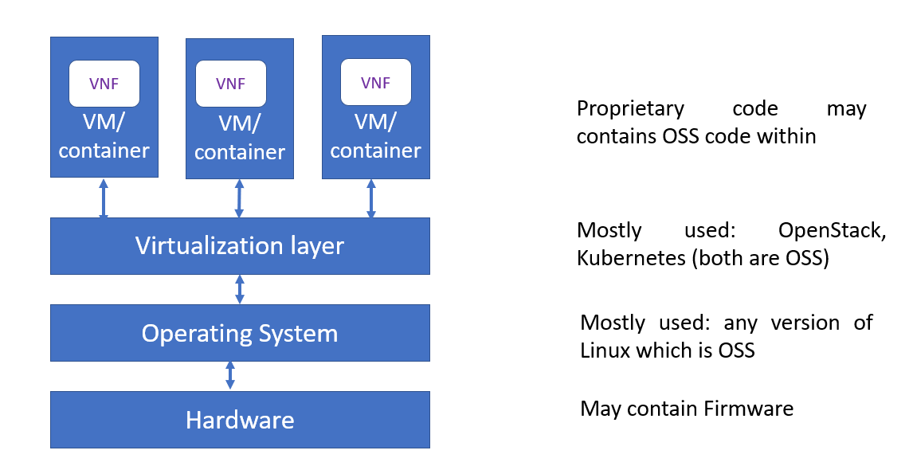

Fig1: Use of OSS in 5G Stack (REF ??)

In context of 5G system and services, the components that are leveraging open-source elements include:

- OpenStack distributions
- Software Defined Networking controllers
- MANO-Management & Network Orchestration
- Virtualisation Hypervisors
- Application components
- ..
- …
- …

There are different deployment arrangements (or use cases scenario) for open-source software as shown below⁴
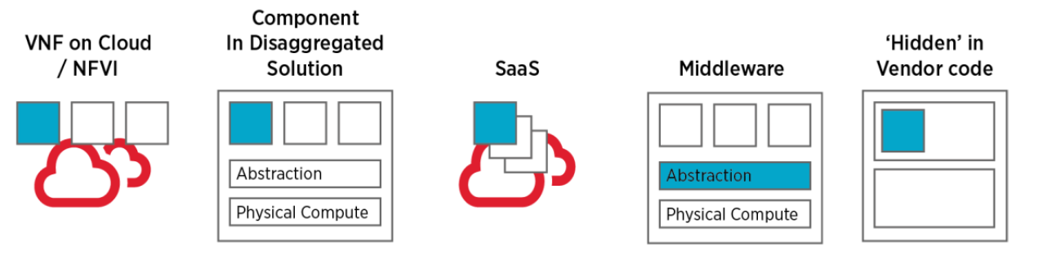
Fig2: Open source software deployment arrangements

- as discrete code such as a Virtual Network Function (VNF) in cloud/NFVI
- as a component within a disaggregated solution or part of vendor proprietary code
- as part of the provision of a wider Software as a Service (SaaS) provision
- as middleware abstraction or virtualisation layer (e.g., OpenStack, Kubernetes)
- re-used within vendor executable code

There are many initiatives driving open architectures and virtualised telecoms infrastructure such as Telecoms Infrastructure Project (TIP), Open-Radio Access Network (O-RAN) Alliance, Linux Networking Foundation, CCNF, Open Networking Forum and many more.

6.2 Open Source Software -Advantages & Disadvantages

Open Source Software (OSS) has a number of advantages, notably including that source code is accessible and subject to inspection, a wide community of developers can contribute and there is potential to accelerate telco cloud implementation. In contrast, there are various best practice steps that aim to ‘make secure software’ but none of these are mandated in the open-source community whose main focus is functionality. In case of use of OSS, the major security risk is unpatched/unsupported software, not use of open source software or components contrary to proprietary code where service level agreement are in place for support and patch management through the life cycle..

7. The Software Security Threat
.
Codes of OSS (private/proprietary code or commercial or community opensource code) may contain weaknesses/errors which can lead to vulnerabilities. Impropercode, or the deliberate insertion of malicious code, that could be used to compromise network operation, data or service features is a major concern. Software vulnerabilities can be observed in a range of code types as illustrated above in Fig 3
The security threats are as below:

.

7.1 Insecure Design
Insecure design is a broad category representing different weaknesses, expressed as “missing or ineffective control design”. A secure design can still have implementation defects leading to vulnerabilities that may be exploited. An insecure design cannot be fixed by a perfect implementation as by definition, needed security controls were never created to defend against specific attacks in the design phase itself.
……
…..

7.2 Use of Vulnerable and Outdated Components
Use of software that contains components that are no longer supported by vendor or its third parties including the open-source communities, such as components that have reached end-of-life or end-of-support. This includes the OS, web/application server, database management system (DBMS), applications, APIs and all components, runtime environments, and libraries. Proprietary software may have support through service level agreements however this is a major problem in case of OSS. Often it is very difficult to trace the components and their dependencies when SBOM is either unavailable or not updated. If the software unsupported, or out of date, then it is more likely to have unpatched vulnerabilities which can be easily exploited by the attacker.

7.3 Software and Data Integrity Failures
….
……
<TBD>

7.4 Misconfiguration
The software/code is vulnerable if
- Missing appropriate security hardening across any part of the application stack or improperly configured permissions on cloud services.
- Unnecessary features are enabled or installed (e.g., unnecessary ports, services, pages, accounts, or privileges).
- ‘…
- ….
- …..
- ……

7.5 Coding practices
Every coding language has some inherent vulnerabilities, be it C, C++ or JAVA. One such example in C is use of the strcpy built-in function that does not check buffer lengths and may very well overwrite memory zone contiguous to the intended destination resulting in buffer overflow error. In fact, the whole family of functions are vulnerable: strcpy, strcat and strcmp.
Secure Coding Standards are a roadmap and guide for developers in their efforts to produce secure code during SDLC to make sure that software is free from all known security vulnerabilities.
…………
…………….

7.6 Cryptographic Failures
- Use of deprecated or legacy hash functions such as MD5 or SHA1.
- If any old or weak or deprecated cryptographic algorithms or protocols still being used. eg use lower key size/length
- ………………..
- ………………..
- ……………………
- ………………….
.

7.7 Identification and Authentication Failures
…….
…….
……..
<TBD>
………

8. Software Security Requirements
This chapter describes the following Software Security Requirements to address the threats discussed in chapter 7.

8.1 Source code security assurance
OEM/Developer shall ensure the following while developing any software
    - Industry standard best practices of secure coding during the entire software development life cycle of the Software, that includes vendor developed code, third party software and open-source code libraries used/embedded in the software.
    - The software is free from known security vulnerabilities, security weaknesses listed in the CWE database and all the exploitable security vulnerabilities listed in the latest SANS Top 25 and OWASP Top 10.

8.2 Secure Update/Upgrade
- Software package integrity shall be validated in the installation and update/upgrade stages strictly using the Secure cryptographic controls using Digital Signature method.
- Update/Upgrade is allowed only if code signing certificate is valid and not time expired.
- To this end, NE/NF shall have a list of public keys or certificates of authorised software sources, and uses the keys to verify that the software update/upgrade is originated from only these sources.
- Tampered software shall not be executed or installed if integrity check fails.
- OEM/Developer must sign all Software updates/upgrades/images using his private keys.

No unused/unsupported software
…..
….

<TBD>

8.4 Unnecessary Service & insecure protocol Removal
…..
….

<TBD>

8.5 Secure cryptographic controls
…..
….

<TBD>

8.6 Proper Authentication
…..
….

<TBD>

8.7 Protection of data in store, use and transit
…..
….

<TBD>

8.8 Vulnerability Management
The purpose of vulnerability scanning is to ensure that there are no known vulnerabilities (or that relevant vulnerabilities are identified and remediation plans in place to mitigate them) on the software/system that can be detected by means of automatic testing tools (VA tool).
…..
….

<TBD>

8.9 Secure Execution
8.9.1 Application Sandboxing: Use controls to isolate application resources from each other ie apps can't interact with each other and access to other Apps memory and data. The aim of sandboxing is to prevent malicious external programs from interacting with the protected app.
………………
……………………
…………………

8.10 Code Assessment/ Review
Code review may be done using different Security Testing Techniques as stated below:
8.10.1 The code should be assessed for security vulnerabilities in different phases of SDLC by both SAST & DAST approach. SAST (Static source code testing) should be performed early and often against all files containing source code to find software flaws and weaknesses. DAST should be performed on a running application in an environment similar to production to find run-time vulnerabilities. Any known listed vulnerabilities found should be addressed immediately during development phase only.
8.10.2 SCA (Software composition analysis) must be performed to identify open-source software/components in codebase to evaluate security, license compliance etc.

9. Software Security Approaches
This chapter describes different security approaches that may be followed.

9.1 Availability of current & updated SBOM: Software Bill of Material

Use of open source itself is not risky; unmanaged use of open source is. Not only for effective management but also for effective security response, SBOM is indispensable. The National Telecommunications and Information Administration defines an SBOM as:

“a formal record containing the details and supply chain relationships of various components used in building software An SBOM is effectively a nested inventory: a list of ingredients that make up software components. An SBOM identifies and lists software components, information about those components, and the relationships between them.”
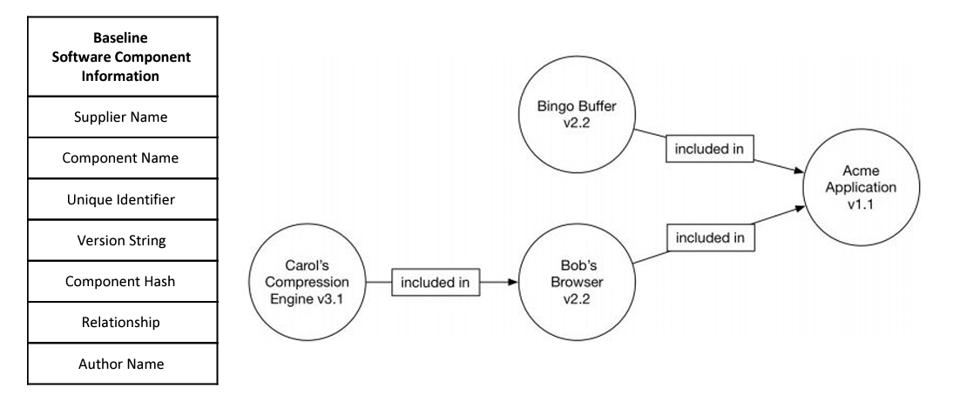

SBOM helps in
- Managing Security Risks Inherent in the Use of Third-party Components (TPC)
- Identify potentially vulnerable components
- The Software Supply Chain
- Monitor components for vulnerabilities & end-of-life
- a blacklist of banned components
- a more targeted security analysis & make code easier to review

Data standards exist today that can capture this SBOM data. These include SPDX, SWID, and CycloneDX. The NTIA SBOM website contains a range of useful information on establishing an SBOM, a report on data formats.

9.2 Secure SDLC

Secure software requires a secure development lifecycle, some form of secure design pattern, paved road methodology, secured component library, security testing & assessment. The SDLC is a well-established framework for organizing application development work from inception to deployment. Over the years, multiple SDLC models have emerged—from waterfall and iterative to, more recently, agile and CI/CD. Each new model has tended to increase the speed and frequency of deployment. No matter which model is being followed, waterfall model or agile, SDLC involves roughly the following stages.
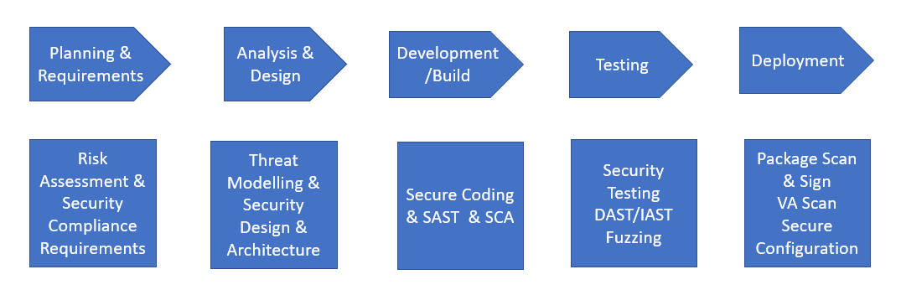
Fig: Stages in SDLC & Security activities in each stages of Secure SDLC

……….
………………
………………..

9.3 “DevSecOps” in place of DevOps

……
……..
<TBD>

9.4 “Shift left” approach

One of the approaches to implement bringing the Security (Sec) part of DevSecOps is the concept of shifting the security review process "left" or earlier in the software development lifecycle.
…….
……..

Bibliography

<to be added>

