 | INTERNATIONAL TELECOMMUNICATION UNION  TELECOMMUNICATION  STANDARDIZATION SECTOR  STUDY PERIOD 2022-2024 |  | SG17-TD980R3
 |  |  | STUDY GROUP 17
 |  |  | Original: English
Question(s): |  | 4/17 |  | Goyang, Korea (Rep. of), 29 August - 8 September 2023
C
Source: |  | Ministry of Communications, India
Title: |  | Proposed revision of SG17-TD980R3 : Security threats of software supply chain
Contact: |  | Jyoti Sengar  Ministry of Communications  India |  |  | Tel.: +91 9997998435  Email: jyoti.sengar@gov.in
Contact: |  | Shekhar Singh  Ministry of Communications  India |  |  | Tel: +91 9899649905  Email: ad.iot-tec@gov.in

Abstract: | It is proposed that the revision of SG17-TD980R3

1. Overview
In recent years there’s been a significant increase in the number of cyber attacks resulting from vulnerabilities within the software supply chain. These attacks can result in devastating, expensive and long-term ramifications for affected organizations, their supply chains and their customers.
To address these threats, there is a need for identifying security threats in the software development life cycle. It also needs to identify all related stakeholders. In addition, it also provides how each stakeholder can use identified security threats in this Recommendation. These threats can be used to develop the controls in the software development life cycle.
This Recommendation can be used by many organizations who need to gain confidence or assurance that controls are in place for vulnerabilities associated with software development life cycle with suppliers.

2. Background & Gap Analysis
There are a few documents in SG17 and other SDOs related to proposed NWI as follows:

2.1 ISO/IEC/IEEE 12207: Systems and software engineering — Software life cycle processes
ISO/IEC 12207 establishes a common framework for software life cycle processes, with well-defined terminology, that can be referenced by the software industry. It contains processes, activities, and tasks that are applicable during the acquisition, supply, development, operation, maintenance or disposal of software systems, products, and services. These life cycle processes are accomplished through the involvement of stakeholders, with the ultimate goal of achieving customer satisfaction.
This Standards applies to the acquisition, supply, development, operation, maintenance, and disposal (whether performed internally or externally to an organization) of software systems, products and services, and the software portion of any system, Software includes the software portion of firmware. Those aspects of system definition needed to provide the context for software products and services are included.
This also provides processes that can be employed for defining, controlling, and improving software life cycle processes within an organization or a project.

2.2 NIST SP 800-161: Cybersecurity Supply Chain Risk Management Practices for Systems and Organizations
ITU NIST SP 800-161 provides guidance to organizations on identifying, assessing, and mitigating cybersecurity risks throughout the supply chain at all levels of their organizations. It also integrates cybersecurity supply chain risk management (C-SCRM) into risk management activities by applying a multilevel, C-SCRM-specific approach, including guidance on the development of C-SCRM strategy implementation plans, C-SCRM policies, C-SCRM plans, and risk assessments for products and services.

2.3 Existing threats taxonomy in “Taxonomy of attacks on open-source software supply chains [b-Ladisa]”
The widespread dependency on open-source software makes it a fruitful target for malicious actors, as demonstrated by recurring attacks. The complexity of today's open-source supply chains results in a significant attack surface, giving attackers numerous opportunities to reach the goal of injecting malicious code into open-source artifacts that is then downloaded and executed by victims.
This work proposes a general taxonomy for attacks on open-source supply chains in Figure 1.
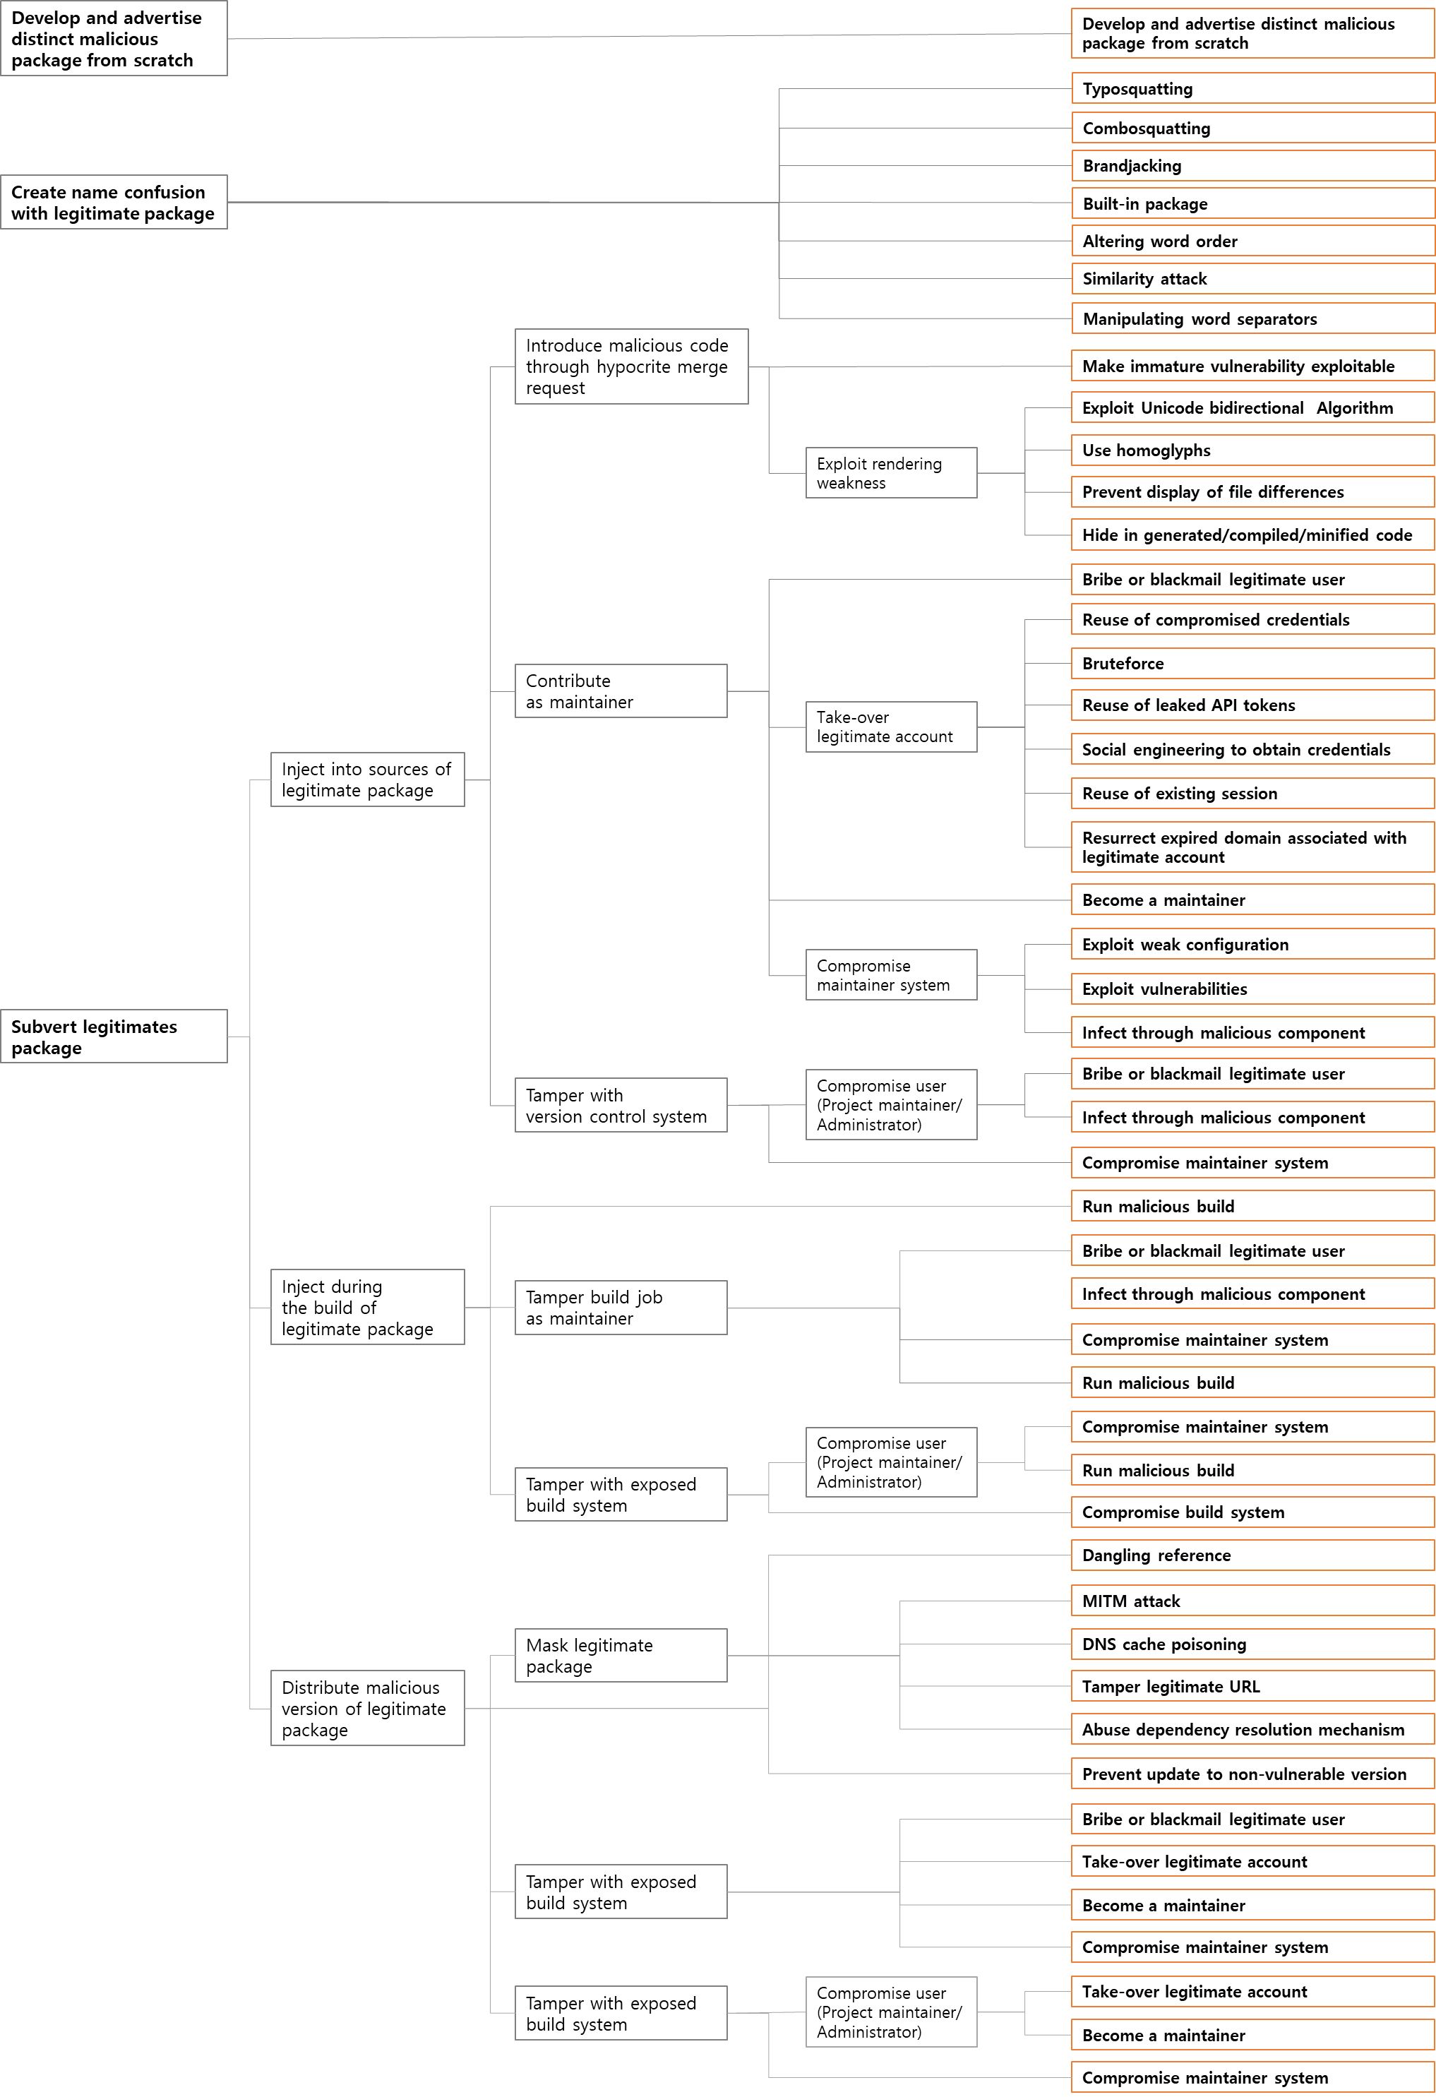
Figure 1 - A general taxonomy for attacks on open-source supply chains

2.4 Current taxonomy of information security threats in software development life cycle
The implementation capabilities of security threats vary depending on the level of attackers' potential. Table 1 provides the level of attacker’s potential and their capabilities [b-Barabanov].

Table 1 - Description of attackers’ capability
Level of attacker potential | Examples of attackers | Capabilities of the attackers
Low | - Persons related to a software developer without authorized access  - Persons engaged by the software developer for software shipping | - Basic IT knowledge or skills: the most common usages of software and development environment, understanding the basic concepts of application manipulation, application of general development environment software, operations with development environment objects.
Medium | Persons related to a software developer with authorized access  - Persons engaged by the software developer for software shipping | - Include all capabilities of low-potential attackers.  - Have authorized access to both higher and lower-level design software documentations or may achieve desired information through permanent or single access to the software development environment.  - Have knowledge on methods and tools to implement security controls in the software development environment.
High | - Competing organizations  - Criminal groups | - Include all capabilities of medium potential attackers.  - Have expertise and knowledge to get information about entire-level software design with no access to the software development environment by keeping under their control of internal or external networks.  - Have knowledge on methods and tools to implement security controls in the software development environment having no access to the software development environment and acting from external networks.

2.5 NIST SP 800-53: Security and Privacy Controls for Information Systems and Organizations
This publication provides a catalog of security and privacy controls for information systems and organizations to protect organizational operations and assets, individuals, other organizations, and the Nation from a diverse set of threats and risks, including hostile attacks, human errors, natural disasters, structural failures, foreign intelligence entities, and privacy risks. The controls address diverse requirements derived from mission and business needs, laws, executive orders, directives, regulations, policies, standards, and guidelines.

2.6 NIST SP 800-53A: Assessing Security and Privacy Controls in Information Systems and Organizations
This publication provides a methodology and set of procedures for conducting assessments of security and privacy controls employed within systems and organizations within an effective risk management framework. The assessment procedures, executed at various phases of the system development life cycle, are consistent with the security and privacy controls in NIST Special Publication 800-53, Revision 5.

2.7 NTIA Software Bill of Materials(SBOM)
An SBOM is a formal, machine-readable inventory of software components and dependencies, information about those components, and their hierarchical relationships. This document is an introduction to the practice of Software Bill of Materials (SBOM), supporting literature, and the pivotal role SBOMs play in providing much-needed transparency: enabling stakeholders to answer questions like “Am I affected?” and “Where am I affected?” when faced with a supply chain concern.

2.8 OCA PACE(Posture Attribute Collection and Evaluation)
Posture Attribute Collection and Evaluation (PACE) is an Open Cybersecurity Alliance (OCA) project. Posture assessment generally consists of understanding, for a given computing resource (or set of computing resources), software load, composition of that software load, patch levels, vulnerability (implied to be software vulnerability), and configuration state. Together, these attributes of a computing resource represent its cybersecurity posture. PACE will leverage and/or contribute to Open Cybersecurity Alliance (OCA) Ontology and OpenC2 for command and control. PACE will be an instantiation of the IETF Security Automation and Continuous Monitoring (SACM) group’s architecture.

2.9 ISO/IEC 27036: Information security for supplier relationships
ISO/IEC 27036 is a multi-part standard that offers guidance on the evaluation and treatment of information risks involved in the acquisition of goods and services from suppliers.

ISO/IEC 27036-1:2021 Cybersecurity — Supplier relationships — Part 1: Overview and concepts | Part 1 introduces all parts of this standard, providing general background information and introducing the key terms and concepts in relation to information security in supplier relationships.
ISO/IEC 27036-2:2022 Cybersecurity — Supplier relationships — Part 2: Requirements | Part 2 specifies fundamental information security requirements pertaining to business relationships between suppliers and acquirers of various products (goods and services)
ISO/IEC 27036-3:2013 - Information technology - Security techniques - Information security for supplier relationships - Part 3: Guidelines for information and communication technology supply chain security | Part 3 provides product and service acquirers and suppliers in the ICT supply chain with guidance on gaining visibility into and managing the information security risks caused by physically dispersed and multi-layered ICT supply chains; responding to risks stemming from the global ICT supply chain to ICT products and services that can have an information security impact on the organizations using these products and services.
ISO/IEC 27036-4:2016 Information technology — Security techniques — Information security for supplier relationships — Part 4: Guidelines for security of cloud services | Part 4 provides cloud service customers and cloud service providers with guidance on information security management for cloud services.
2.10 ISO/IEC 27034: Information technology — Security techniques — Application security (7 parts, most published except for part 4 in DRAFT)
ISO/IEC 27034 offers guidance on information security to those specifying, designing and programming or procuring, implementing and using application systems, in other words business and IT managers, developers and auditors, and ultimately the end-users of ICT. The aim is to ensure that computer applications deliver the desired or necessary level of security in support of the organisation’s Information Security Management System, adequately addressing many ICT security risks.
This provides guidance on specifying, designing/selecting and implementing information security controls through a set of processes integrated throughout an organisation’s Systems Development Life Cycle/s. It is process-oriented.

2.11 ENISA Threat landscape for supply chain attacks
Through a careful survey and analysis, this report maps supply chain attacks based on incidents identified from January 2020 to early July 2021. This report also analyses the similarities between the lifecycle of supply chain attacks and the more well-known attacks by Advanced Persistent Threats (APTs). The core of the report is an analysis of all the reported supply chain incidents to identify their key characteristics and techniques. The analysis answers the questions: what are the most common attack techniques being used in supply chain attacks, what are the main customer assets that attackers are after, and which is the relationship between attacks and assets targeted?
With the rise in attention being paid to supply chain attacks, many other related security incidents were also highlighted as being related to the supply chain, namely they were assumed to be supply chain attacks. We therefore discuss what constitutes a supply chain attack and why many attacks are not really supply chain attacks, showing some cases as examples. This report is described in [[b-ENISA tlsa].

2.5. Gap analysis
Table 2 provides the difference between Recommendation for NWI and other related texts.

Table 2 – Difference between NWI and other texts
Category | NWI | ISO/IEC/IEEE 12207 | NIST SP 800-161 | [b-Ladisa] | NIST SP 800-53 | NIST SP 800-53A | NTIA SBOM | OCA  PACE | ISO/IEC  27036 | ISO/IEC  27034 | ENISA Threat landscape for supply chain attacks
Software development life cycle | Based on SDLC | O | X | X | X | X | X | O | X | X | X
Software supply chain risk management Practices | Using risks management practices | X | O | X | X | X | X | X | O | O | O
Threats in the software development life cycle | O | X | X | O | X | X | X | X | X | X | X
To our best knowledge, there is a clear demarcation between this NWI and existing Recommendation and Standard. This work item will focus on developing all kinds of threats in the open-source and closed-source software based on analysis existing literatures such [b-Ladisa].

2.6 Why Q4 is the right Question to address this NWI?
Q4/17 is responsible for developing standards in cybersecurity and countering spam. We believe this work item should address security threats of software supply chains.
Following Question and Task item are identified in Q4/17 text:
Question-k) What are the necessary security guidelines and best practices for identifying, mitigating and reducing impact of cyber threats, including malware, distributed denial of service and social engineering?
Task -i) Study and develop a technical guidance to support threats management in terms of
identifying source of cyber attackers.

3. Proposal
Based on aforementioned background, this TD proposes that Q4/17 consider establishing this new work item, “Proposal for new work item: Security threats of software supply chain” in the February/March 2023 SG17 meeting.

<TBD>

4. References
[b-ISO/IEC/IEEE 12207] ISO/IEC/IEEE 12207:2017, Systems and software engineering — Software life cycle processes.
[b-NIST SP 800-161] NIST Special Publication 800-161r1(2022), Cybersecurity Supply Chain Risk Management Practices for Systems and Organizations.
https://doi.org/10.6028/NIST.SP.800-161r1
[b-Ladisa] Ladisa, P., Plate, H., Martinez, M. and Barais, O., (2022), Taxonomy of Attacks on Open-Source Software Supply Chain, arXiv preprint arXiv
https ://arxiv.org/pdf/2204.04008
[b-Barabanov] Barabanov, Alexander V., et al. (2018), Current Taxonomy of Information Security Threats in Software Development Life Cycle, IEEE 12th International Conference on Application of Information and Communication Technologies (AICT)
https://ieeexplore.ieee.org/document/8747065
[b-SCSG 1.0] Supply chain security guidance 1.0, NCSC Supply chain security guidance 28 January 2018
https://www.ncsc.gov.uk/collection/supply-chain-security
[b-Venafi] Venafi Weekly Post (Internet), Is Your Software Supply Chain Vulnerable to OSSL Trust Attacks? 30 May 2019 (accessed: 16 January 2023)
https://venafi.com/blog/your-software-supply-chain-vulnerable-ossl-trust-attacks/
[b-Ohm] Ohm, M., Plate, H., Sykosch, A. and Meier, M., (2020), Backstabber’s knife collection: A review of open-source software supply chain attacks, In International Conference on Detection of Intrusions and Malware, and Vulnerability Assessment, Springer, Cham.
https://link.springer.com/chapter/10.1007/978-3-030-52683-2_2

[b-NIST SP 800-53] NIST Special Publication 800-53r5(2020), Security and Privacy Controls for Information Systems and Organizations.
https://doi.org/10.6028/NIST.SP.800-53r5
[b-NIST SP 800-53A] NIST Special Publication 800-53Ar1(2022), Assessing Security and Privacy Controls in Information Systems and Organizations.
https://doi.org/10.6028/NIST.SP.800-53Ar5

[b-NTIA SBOM] NITA Software Bill of Materials(SBOM)
https://ntia.gov/page/software-bill-materials

[b-OCA PACE] OCA PACE, Posture Attribute Collection and Evaluation.
https://github.com/opencybersecurityalliance/PACE

[b-ISO/IEC 27034] ISO/IEC 27034:2011+, Information technology — Security techniques — Application security.

[b-ISO/IEC 27063] ISO/IEC 27036:2013+, Information security for supplier relationships.

[b-ENISA tlsa] ENISA Publication 2021, Threat Landscape for Supply Chain Attacks.
https://www.enisa.europa.eu/publications/threat-landscape-for-supply-chain-attacks

Attachments:
Annex A: Template for A.1 justification for a new work item proposal
Annex B: Draft Recommendation ITU-T X.st-ssc

Annex A
A.1 justification for proposed draft new Recommendation X.st-ssc
Question: | Q4/17 | Proposed new ITU-T Recommendation | Geneva, 21 February – 3 March 2023
Reference and title: | ITU-T X.st-ssc, Proposal for new work item: Security threats of software supply chain
Base text: | Annex B of this document |  | Timing: | 2025 -05
Editor(s): | Heung Youl Youm, Korea (Republic of), hyyoum@sch.ac.kr  Sungchae Park, Korea (Republic of), zoesc.park@sch.ac.kr  Jae Nam Ko (Republic of), freeinlove1127@gmail.com  Da Eun Hyun (Republic of), chlrhekdms0610@sch.ac.kr  Junhyung Park (Republic of), mintdeath@sch.ac.kr |  | Approval process: | TAP
Scope (defines the intent or object of the Recommendation and the aspects covered, thereby indicating the limits of its applicability):
This draft Recommendation identifies security threats to the software supply chain, including open-source and closed-source software. In addition, it provides fundamental principles and supply chain attack examples, and identifies stakeholders related to the development, build and distribution of software and taxonomy of security threats in the software life cycle processes established by ISO/IEC 12207.
It also assigns an index to security threats according to category so that each threat can be referenced by other parts of this Recommendation and other Recommendations.
Summary (provides a brief overview of the purpose and contents of the Recommendation, thus permitting readers to judge its usefulness for their work):
In recent years there’s been a significant increase in the number of cyber attacks resulting from vulnerabilities within the software supply chain including open-source and closed-source software. These attacks can result in devastating, expensive and long-term ramifications for affected organizations, their supply chains and their customers.
To address these threats, there is a need for identifying security threats in the software development life cycle. It also needs to identify all related stakeholders. These threats can be used to develop the controls in the software development life cycle.
This Recommendation can be used by many organizations who need to gain confidence or assurance that controls are in place for vulnerabilities associated with software development life cycle ng with suppliers.
Relations to ITU-T Recommendations or to other standards (approved or under development):

ISO/IEC/IEEE 12207:2017, Systems and software engineering — Software life cycle processes

NIST SP 800-161, Cybersecurity Supply Chain Risk Management Practices for Systems and Organizations

NIST SP 800-53, Security and Privacy Controls for Information Systems and Organizations

NIST SP 800-53A, Assessing Security and Privacy Controls in Information Systems and Organizations
ISO/IEC 27034, Information technology — Security techniques — Application security
ISO/IEC 27036, Information security for supplier relationships.
Liaisons with other study groups or with other standards bodies:
ISO/IEC JTC 1/SC 27, ETSI
Supporting members that are committing to contributing actively to the work item:
Korea (Republic of), Malaysia, Ghana, Luxemburg, ETRI, KISA, Soonchunhyang University

Annex B
Draft Recommendation ITU-T X.st-ssc
Proposal for new work item: Security threats of software supply chain

- Scope
This draft Recommendation identifies security threats to the software supply chain, including open-source and closed-source software. In addition, it provides fundamental principles and supply chain attack examples, and identifies stakeholders related to the development, build and distribution of software and taxonomy of security threats in the software life cycle processes established by ISO/IEC 12207.
It also assigns an index to security threats according to category so that each threat can be referenced by other parts of this Recommendation and other Recommendations.

- References
The following ITU-T Recommendations and other references contain provisions which, through reference in this text, constitute provisions of this Recommendation. At the time of publication, the editions indicated were valid. All Recommendations and other references are subject to revision; users of this Recommendation are therefore encouraged to investigate the possibility of applying the most recent edition of the Recommendations and other references listed below. A list of the currently valid ITU-T Recommendations is regularly published. The reference to a document within this Recommendation does not give it, as a stand-alone document, the status of a Recommendation.

[ISO/IEC/IEEE 12207] ISO/IEC/IEEE 12207:2017, Systems and software engineering — Software life cycle processes.
<Others to be added>

- Definitions
3.1 Terms defined elsewhere
This Recommendation uses the following terms defined elsewhere:

3.1.1 life cycle [b-ISO/IEC/IEEE 12207]: Evolution of a system, product, service, project or other human-made entity from conception through retirement
3.1.2. closed-source: Software in which the source code is not publicly available, and only the organization that created it has the ability to modify and distribute it
3.1.3 open-source: Software whose source code is open and accessible for use by the public
3.1.4 software supply chain
<TBD>

3.2 Terms defined in this Recommendation
This Recommendation defines the following terms:
<Others to be added>

- Abbreviations and acronyms
This Recommendation uses the following abbreviations and acronyms:
OSS Open-source software
VCS Version Control System

<TBD>

- Conventions
This Recommendation uses the following conventions:
The keywords "is required to" indicate a requirement which must be strictly followed and from which no deviation is permitted, if conformance to this Recommendation is to be claimed.
The keywords "is recommended" indicate a requirement which is recommended but which is not absolutely required. Thus, this requirement need not be present to claim conformance. The keywords "is prohibited from" indicate a requirement which must be strictly followed and from which no deviation is permitted, if conformance to this Recommendation is to be claimed. The keywords "can optionally" indicate an optional requirement which is permissible, without implying any sense of being recommended. This term is not intended to imply that the vendor's implementation must provide the option, and the feature can be optionally enabled by the network operator/service provider. Rather, it means the vendor may optionally provide the feature and still claim conformance with the specification.

- Overview
In recent years there’s been a significant increase in the number of cyber-attacks resulting from vulnerabilities within the software supply chain. These attacks can result in devastating, expensive and long-term ramifications for affected organizations, their supply chains and their customers.
To address these threats, there is a need for identifying security threats in the software development life cycle. It also needs to identify all related stakeholders. These threats can be used to develop the controls in the software development life cycle.

6.1 Fundamental principles for software supply chains
This clause describes fundamental principles applicable to software supply chains security to identify effective countermeasures [b- SCSG 1.0].
Figure 1 illustrates the four stages of their principles.

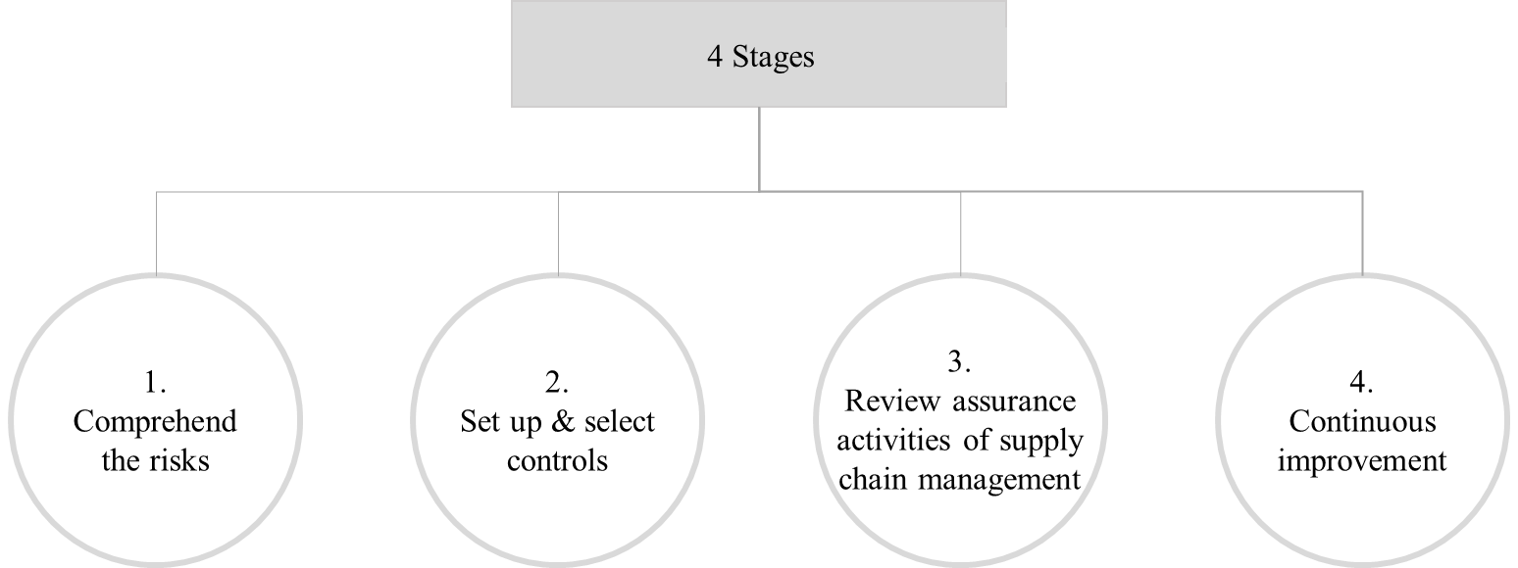
- Comprehend the risk: It is essential to comprehend the risks of software supply chains to identify security controls and mitigations that are appropriate, effective, and responsive. It is necessary to distinguish what needs to be protected and why to be protected, and to understand who the suppliers are by assessing the impact of the risks on the open-source software supply chain.
Figure 1- Four stages of the principles
- Set up and select controls
- Review assurance activities of supply chain management
- Continuous improvement

All stakeholders of software supply chain shall follow the principles described in Figure 1.

<TBD>

6.2 Software supply chain life cycle
The software supply chain life cycle refers to the end-to-end process involved in the development, production, distribution, and maintenance of software products. It encompasses the various stages and activities that occur from the initial planning and design to the retirement or end-of-life phase. Software supply chain life cycle may involve following phases:

- Planning and Requirements:
  - Identify software requirements based on customer needs and market demand.
  - Define the scope, features, and functionalities of the software product.
  - Conduct market research and competitive analysis.
- Design and Development:
  - Design the software architecture, system components, and user interface.
  - Develop the software code, including coding, testing, and debugging.
  - Use software development methodologies such as waterfall, agile, or DevOps.
- Component Acquisition:
  - Identify and acquire third-party software components, libraries, or frameworks.
  - Assess the reliability, security, and licensing aspects of the acquired components.
  - Establish relationships with component suppliers or vendors.
- Quality Assurance and Testing:
  - Perform various types of testing, including unit testing, integration testing, and system testing.
  - Validate the software against requirements and ensure it meets quality standards.
  - Conduct security testing and vulnerability assessments.
- Packaging and Distribution:
  - Package the software for distribution, including creating installation files and documentation.
  - Determine the appropriate distribution channels, such as online platforms, app stores, or physical media.
  - Ensure proper licensing, copyright, and intellectual property protection.
- Deployment and Installation:
  - Deploy the software to production environments or distribute it to end-users.
  - Install the software on users' devices or provide cloud-based deployment options.
  - Configure the software for optimal performance and integration with existing systems.
- Maintenance and Updates:
  - Provide ongoing support and maintenance for the software, including bug fixes and security patches.
  - Release updates and new versions to enhance functionality, improve performance, and address user feedback.
  - Monitor and manage software licenses and compliance.
- Retirement and End-of-Life:
  - Evaluate the need for retiring or phasing out the software based on market conditions, technology advancements, or business decisions.
  - Plan for data migration, archival, or disposal of software and associated data.
  - Communicate with users and provide transition support to alternative solutions, if applicable.

<TBD>

6.3 Stakeholders for open-source software supply chain
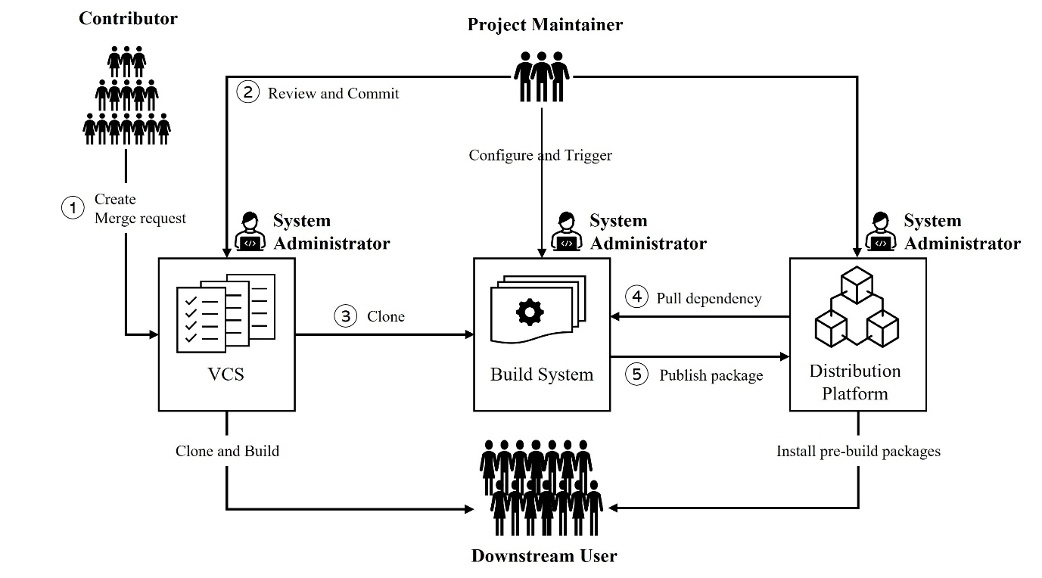
Figure 2 depicts the stakeholders and dataflows related to the open-source software supply chain [b b-Ladisa].
Figure 2 - Stakeholders and data flows related to the open-source software supply chain

There are four stakeholders in open-source software supply chain as follows:
- Contributor: An individual who provides code to OSS projects, with limited access as read-only to the project resources. The contributors typically push their codes to the VCS.
- Project Maintainer: An entity who has privileged access to project resources, e.g., to review and integrate contributors’ merge requests, conﬁgure build systems and trigger build jobs, or deploy ready-made artifacts on package repositories.
- System Administrator: An entity who has the responsibility to conﬁgure, maintain, and operate any of the systems, consisting of members of OSS organizations that operate their own build systems for the projects, or employees of companies running package repositories.
- Downstream User: Entities who consume OSS project outcomes or pre-built packages from distribution platforms. The distribution is typically automated by package managers.

With the roles of each stakeholder, Figure 2 also provides the data flows through the life cycle from its development to distribution in the open-source software supply chain.
It is assumed that project maintainers create an open-source software project and establish its associated systems such as a VCS, a build system and a distribute platform. As the contributor enters the codes into the VCS, the project maintainer will review and commit the codes from the contributor. The code as source code is to be copied and converted into object code in the build system. The build process compiles a project's source code and other resources and produces the software artifacts as their results. These artifacts will be published on distribution platforms to be available to end-users, such as downstream users. Moreover, the artefacts are available to be copied and built by downstream users as developers for their own purposes.
The above stakeholders may be the targets of open-source software supply chain attacks [b- Ohm].
6.4 Stakeholders for closed-source software supply chain
<TBD>
Closed-source software chain can be referred as sequence or flow of events involved in the creation, distribution, and maintenance of closed-source software. The main difference between the open-source software supply chain and the closed-source software supply chain lies in the accessibility and transparency of the software's source code and development process.
Closed-source software is developed by a specific organization or team, with exclusive control over the process and source code, which remains proprietary and inaccessible to the public. Development is conducted internally, with limited access and contributions. Rigorous quality assurance, controlled distribution through compiled binaries, and support provided by the organization are key features.

In a closed-source software supply chain, there are additional stakeholders compared to an open-source supply chain. These stakeholders play specific roles in the development, distribution, and support of closed-source software.
Stakeholders for closed-source software supply chain can vary depending on the specific context and industry. However, here are some common stakeholders that may be involved:
- Software Developers/Companies: The primary stakeholders in a closed-source software supply chain are the developers or companies that create and own the software. They have the authority to determine the distribution, licensing, and pricing of the software.
- Distributors/Resellers: In many cases, closed-source software is distributed through various channels, such as software vendors, resellers, or distributors. These stakeholders play a role in making the software available to end-users by handling marketing, sales, and physical distribution, if applicable.
- End-Users: The individuals or organizations that purchase and use the closed-source software are important stakeholders. They rely on the software to meet their specific needs and expect it to function properly and securely.
- Maintenance and Support Providers: Closed-source software often requires maintenance and support services, either provided directly by the software developers or by third-party service providers. These stakeholders ensure that the software remains up-to-date, resolves issues, and provides assistance to end-users when needed.
- System Integrators: In certain cases, closed-source software is integrated into larger systems or solutions. System integrators are stakeholders who specialize in combining various software components to create comprehensive systems, and they may be involved in customizing and integrating closed-source software for specific projects.
- Regulatory Authorities: Depending on the industry or application domain, regulatory authorities may have a stake in closed-source software. They may set standards, regulations, or compliance requirements that software developers need to adhere to, ensuring safety, privacy, or other legal considerations.
- Quality Assurance and Testing Teams: Stakeholders responsible for quality assurance and testing play a critical role in the closed-source software supply chain. They verify that the software functions as intended, meets quality standards, and does not contain any critical vulnerabilities or bugs.
- Intellectual Property Team: Given the proprietary nature of closed-source software, intellectual property lawyers may be involved to protect the software's copyrights, patents, and trade secrets. They help software developers enforce their legal rights and ensure compliance with intellectual property laws.
- Hardware Manufacturers: In cases where closed-source software is tightly integrated with hardware devices, such as embedded systems or appliances, hardware manufacturers become stakeholders. They work closely with software developers to ensure compatibility, performance, and functionality.
- Third-Party Component Providers: Closed-source software may rely on third-party components, libraries, or frameworks. These third-party providers become stakeholders in the supply chain as their components contribute to the functionality and features of the software.

It's worth noting that the exact stakeholders and their roles may vary depending on the specific software and industry. Additionally, some stakeholders may overlap or have multiple roles in the supply chain.

6.5 Examples of software supply chain attack
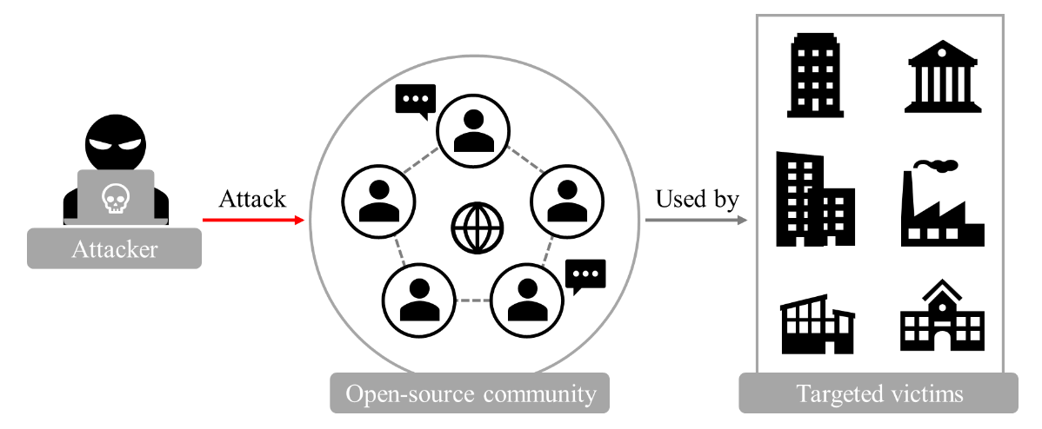
This clause describes some examples of software supply chain attacks. Figure 3 depicts the basic concept of software supply chain attack.
Figure 3 - A concept of software supply chain attacks
In an software supply chain, the attacker uses communities to attack anyone, such as from developers utilizing the software to endpoint users trusting and using the software; rather than simply targeting the community users directly.
The attacks for the software supply chains may differ from traditional attacks where they exploit their software vulnerabilities itself. However, attacks for the software supply chain exploits the trust which the related stakeholders have.
An software community is a group of persons as contributors collaborating on developing, maintaining, extending, and promoting a specific project, or several projects, of the software. [b-Venafi].
Individuals or industries using the software from the software supply chain can be the target of attackers.
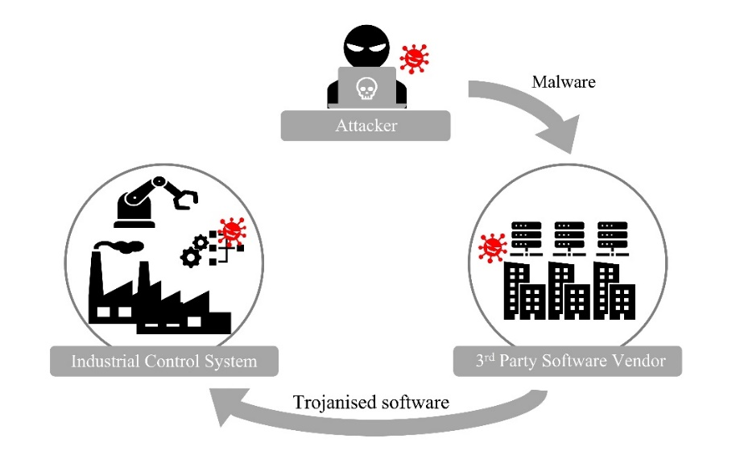
There are several attack examples of software supply chains that may occur. Figure 4 shows one example of software supply chain attacks: the use of third-party software providers[b-SCSG 1.0].
Figure 4 – Attack to the third-party software providers

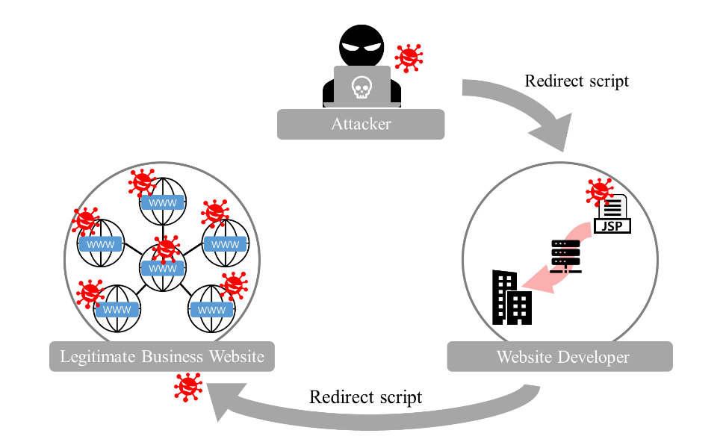
Figure 5 shows an attack example of an attack to the website developers, such as creative or digital agencies, using website builders.
Figure 5 - Attack to the website developers using website builders
<TBD>

Recently many businesses have outsourced their massive data to third-party organizations which aggregate, store, process, and broker the information. Figure 6 shows an example of the software supply chain attack through a third-party data store where networks belonging to the massive data aggregators are considered compromised. As a result, attackers can access the compromised supply chain to any information stored in a third party and perpetrate large-scale cyberattacks.

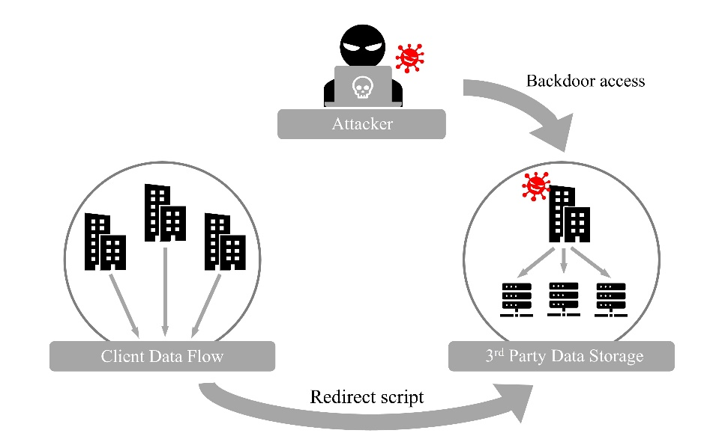
Figure 6 - Attack to third party data stores
<TBD>

6.6 Attacker’s capabilities
There are three types of attackers that are considered in Table 1 [b-Barabanov].

Table 1 – Type of attackers
Level of attacker potential | Examples of attackers | Capabilities of the attackers
Low | - Persons related to a software developer without authorized access  - Persons engaged by the software developer for software shipping | - Basic IT knowledge or skills: the most common usages of software and development environment, understanding the basic concepts of application manipulation, application of general development environment software, operations with development environment objects.
Medium | Persons related to a software developer with authorized access  - Persons engaged by the software developer for software shipping | - Include all capabilities of low-potential attackers.  - Have authorized access to both higher and lower-level design software documentations or may achieve desired information through permanent or single access to the software development environment.  - Have knowledge on methods and tools to implement security controls in the software development environment.
High | - Competing organizations  - Criminal groups | - Include all capabilities of medium potential attackers.  - Have expertise and knowledge to get information about entire-level software design with no access to the software development environment by keeping under their control of internal or external networks.  - Have knowledge on methods and tools to implement security controls in the software development environment having no access to the software development environment and acting from external networks.

- Security threats in the software life cycle processes
Security threats to software life cycle processes are described in clauses 7.1, 7.2 and 7.3. Other Recommendations can refer to a threat with the acronym and number as an index.

7.1 Threats for “Develop and advertise distinct malicious packages from scratch”
It covers the creation of a new open-source software project, which is intended to use this project for spreading malicious code from the beginning or at a later point in time. In addition to creating the new project, the attacker should advertise the project to induce victims to use it [ST-DAP-1].
<TBD>

7.2 Threats for “Create name confusion with legitimate package”
It is to create projects or similar names to legitimate ones, suggest trusted authors, or use common naming patterns to confuse users.

7.2.1 Typosquatting
Should a user enter an incorrect URL address in any event, it may be accessed to the intended URL by attackers, including an alternative website owned by an attacker [ST-CLP-1].

7.2.2 Combosquatting
It is to disguise itself as a real domain by creating a fake domain that users can be mistaken for replacing a word similar to the real domain or another parent domain(.com, .co.kr, .org, etc.) [ST-CLP-2].

7.2.3 Brandjacking
It is to acquire or assume a company's online identity of entities such as a well-known company or person. This threat may attempt to use the reputation of its target or strive to damage its target's reputation for specific purposes [ST-CLP-3].

7.2.4 Built-in package
A built-in package attack is a kind of package impersonation attack. An attacker replicates built-in packages to exploit well-known names, e.g., built-in packages or modules of a programming language, such as a subprocess of Python [ST-CLP-4].

7.2.5 Altering word order
Alerting word order is a deceptive technique that confuses the usage by rearranging the order of words, for example, "test-version-client" to "client-version-test" [ST-CLP-5].

7.2.6 Similarity attack
The Similarity attack uses a misleading similar name or word, such as ‘request’ instead of ‘requests’, to confuse users. This threat does not involve typing mistakes but intentionally is to be manipulated [ST-CLP-6].

<TBD>

7.3 Threats for “Subvert legitimates package”
7.3.1 Make immature vulnerability exploitable
[ST-SLP-1]

7.3.2 Exploit unicode bidirectional algorithm
[ST-SLP-2]

7.3.3 Use homoglyphs
[ST-SLP-3]

7.3.4 Prevent display of file differences
[ST-SLP-4]

7.3.5 Hide in generated/compiled/miniﬁed code
[ST-SLP-5]

7.3.6 Bribe or blackmail legitimate user
[ST-SLP-6]

7.3.7 Reuse of compromised credentials
[ST-SLP-7]

7.3.8 Bruteforce
[ST-SLP-8]

7.3.9 Reuse of leaked API tokens
[ST-SLP-9]

7.3.10 Social engineering to obtain credentials
[ST-SLP-10]

7.3.11 Reuse of existing session
[ST-SLP-11]

7.3.12 Resurrect expired domain associated with legitimate account
[ST-SLP-12]

7.3.13 Become a maintainer
[ST-SLP-13]

7.3.14 Exploit weak conﬁguration
[ST-SLP-14]

7.3.15 Exploit vulnerabilities
[ST-SLP-15]

7.3.16 Infect through malicious component
[ST-SLP-16]

7.3.17 Take-over legitimate account
[ST-SLP-17]

7.3.18 Compromise version control system
[ST-SLP-18]

7.3.19 Compromise maintainer system
[ST-SLP-19]

7.3.20 Compromise build system
[ST-SLP-20]

7.3.21 MITM attack
[ST-SLP-21]

7.3.22 DNS cache poisoning
[ST-SLP-22]

7.3.23 Tamper legitimate URL
[ST-SLP-23]

7.3.24 Abuse dependency resolution mechanism
[ST-SLP-24]

7.3.25 Prevent update to non-vulnerable version
[ST-SLP-25]

7.3.26 Compromise maintainer system
[ST-SLP-26]

7.3.27 Compromise hosting system
[ST-SLP-27]

<TBD>

- How stakeholders can use this Recommendation
Below are some examples of all stakeholders and corresponding usage suggestions:
1) Security threats to the stakeholders: This Recommendation provides non-ambiguous titles and descriptions to the threats to software so that stakeholders share at the same context.

2) Contributor: The security threats, such as ST-DAP-1, ST-CLP-1, ST-CLP-2, ST-SLP-17 shall be fully considered for the design of the general software security framework.
<TBD>

3) Project maintainer: The common security threats, such as ST-DAP-1, ST-CLP-5, ST-SLP-19 shall be fully considered for the design of the general software security framework.
<TBD>

4) System administrator: The security threats, such as ST-CLP-5, ST-SLP-18 shall be fully considered for the design of the general software security framework.
<TBD>

5) Downstream user: The security threats, such as ST-CLP-1, ST-CLP-2, shall be fully considered for the design of the general software security framework.
<TBD>

General security requirements, controls and security framework for software supply chain could be provided based on the identified security threats described in this Recommendation.
<TBD>

Bibliography
[b-ISO/IEC/IEEE 12207] ISO/IEC/IEEE 12207:2017, Systems and software engineering — Software life cycle processes.
[b-NIST SP 800-161] NIST Special Publication 800-161r1(2022), Cybersecurity Supply Chain Risk Management Practices for Systems and Organizations.
https://doi.org/10.6028/NIST.SP.800-161r1
[b-Ladisa] Ladisa, P., Plate, H., Martinez, M. and Barais, O., (2022), Taxonomy of Attacks on Open-Source Software Supply Chain, arXiv preprint arXiv
https://arxiv.org/pdf/2204.04008
[b-Barabanov] Barabanov, Alexander V., et al. (2018), Current Taxonomy of Information Security Threats in Software Development Life Cycle, IEEE 12th International Conference on Application of Information and Communication Technologies (AICT)
https://ieeexplore.ieee.org/document/8747065
[b-SCSG 1.0] Supply chain security guidance 1.0, NCSC Supply chain security guidance 28 January 2018
https://www.ncsc.gov.uk/collection/supply-chain-security
[b-Venafi] Venafi Weekly Post (Internet), Is Your Software Supply Chain Vulnerable to OSSL Trust Attacks? 30 May 2019 (accessed: 16 January 2023)
https://venafi.com/blog/your-software-supply-chain-vulnerable-ossl-trust-attacks/
[b-Ohm] Ohm, M., Plate, H., Sykosch, A. and Meier, M., (2020), Backstabber’s knife collection: A review of open-source software supply chain attacks, In International Conference on Detection of Intrusions and Malware, and Vulnerability Assessment, Springer, Cham.
https://link.springer.com/chapter/10.1007/978-3-030-52683-2_2
[b-NIST SP 800-53] NIST Special Publication 800-53r5(2020), Security and Privacy Controls for Information Systems and Organizations.
https://doi.org/10.6028/NIST.SP.800-53r5
[b-NIST SP 800-53A] NIST Special Publication 800-53Ar1(2022), Assessing Security and Privacy Controls in Information Systems and Organizations.
https://doi.org/10.6028/NIST.SP.800-53Ar5
[b-NTIA SBOM] NITA Software Bill of Materials(SBOM)
https://ntia.gov/page/software-bill-materials
[b-OCA PACE] OCA PACE, Posture Attribute Collection and Evaluation.
https://github.com/opencybersecurityalliance/PACE
[b-ISO/IEC 27034] ISO/IEC 27034:2011+, Information technology — Security techniques — Application security.
[b-ISO/IEC 27063] ISO/IEC 27036:2013+, Information security for supplier relationships.
[b-ENISA tlsa] ENISA Publication 2021, Threat Landscape for Supply Chain Attacks.
https://www.enisa.europa.eu/publications/threat-landscape-for-supply-chain-attacks

Annex A
Summary of security threats in the software life cycle processes
(This annex forms an integral part of this Recommendation.)

Table I.1 provides security threats descriptions according to threat numbers that are categorized.

Category | Acronym and number | Threats
Develop and advertise distinct malicious package from scratch | ST-DAP-1 | Develop and advertise distinct malicious package from scratch
Create name confusion with legitimate package | ST-CLP-1 | Typosquatting
 | ST-CLP-2 | Combosquatting
 | ST-CLP-3 | Brandjacking
 | ST-CLP-4 | Built-in package
 | ST-CLP-5 | Altering word order
 | ST-CLP-6 | Similarity attack
Subvert legitimates package | ST-SLP-1 | Make immature vulnerability exploitable
 | ST-SLP-2 | Exploit unicode bidirectional algorithm
 | ST-SLP-3 | Use homoglyphs
 | ST-SLP-4 | Prevent display of file differences
 | ST-SLP-5 | Hide in enerated/compiled/miniﬁed code
 | ST-SLP-6 | Bribe or blackmail legitimate user
 | ST-SLP-7 | Reuse of compromised credentials
 | ST-SLP-8 | Bruteforce
 | ST-SLP-9 | Reuse of leaked API tokens
 | ST-SLP-10 | Social engineering to obtain credentials
 | ST-SLP-11 | Reuse of existing session
 | ST-SLP-12 | Resurrect expired domain associated with legitimate account
 | ST-SLP-13 | Become a maintainer
 | ST-SLP-14 | Exploit weak conﬁguration
 | ST-SLP-15 | Exploit vulnerabilities
 | ST-SLP-16 | Infect through malicious component
 | ST-SLP-17 | Take-over legitimate account
 | ST-SLP-18 | Compromise version control system
 | ST-SLP-19 | Compromise maintainer system
 | ST-SLP-20 | Compromise build system
 | ST-SLP-21 | MITM attack
 | ST-SLP-22 | DNS cache poisoning
 | ST-SLP-23 | Tamper legitimate URL
 | ST-SLP-24 | Abuse dependency resolution mechanism
 | ST-SLP-25 | Prevent update to non-vulnerable version
 | ST-SLP-26 | Compromise maintainer system
 | ST-SLP-27 | Compromise hosting system

Annex B
Mapping between identified security threats and types of software
(This annex forms an integral part of this Recommendation.)
The Annex B provides mapping between identified security threats in this Recommendation and types of software, i.e., open-source and closed-source. There may be common threats appliable to both types of software.

<TBD>
_______________________

