 | INTERNATIONAL TELECOMMUNICATION UNION  TELECOMMUNICATION  STANDARDIZATION SECTOR  STUDY PERIOD 2022-2024 |  | SG17-TD942R5
 |  |  | STUDY GROUP 17
 |  |  | Original: English
Question(s): |  | 7/17 |  | Goyang, Korea (Rep. of), 29 August - 8 September 2023
C
Source: |  | Ministry of Communications, India
Title: |  | Proposed revision of TD942 ITU-T X.srgsc: “Security requirements and guidelines of application and service for smart city platform”
Contact: |  | Jyoti Sengar  TEC, DoT  India |  |  | Tel.: +91 9997998435  Email: Email jyoti.sengar@gov.in
Contact: |  | Shekhar Singh  TEC, DoT  India |  |  | Tel: +91 9899649905  Email: ad.iot-tec@gov.in
Contact: |  | Namrata Singh  TEC, DoT  India |  |  | Tel: +91 9868137091  Email: namrata.singh51@gov.in

Abstract: | It is proposed that the revision of TD942 ITU-T X.srgsc: “Security requirements and guidelines of application and service for smart city platform”, proposed in this contribution be taken into account for the update of draft proposal X.srgsc at the Goyang, Korea (Rep. of), 29 August - 8 September 2023.

Annexure-1

Draft Recommendation ITU-T X.srgsc
Security requirements and guidelines of application and service for smart city platform

Summary
As a fundamental platform supporting the services and applications of a smart city, smart city platform (SCP) which introduced in ITU-T Y.4201 is designed to provide means for enabling new smart city applications to be rapidly created, deployed, extended and managed. The application and service interacts with smart city platform may bring unexpected security threats. The utilized new technologies and complicated interactions may bring new potential security threats for the application and service of smart city platform.
Accordingly, the security threats and security requirements of application and service for smart city platform need to be analysed to secure the application and service of smart city platform.
This recommendation provides a description of the security threats and requirements for application and service for smart city platform and provides methods for security protection of application and service for smart city platform.

Keywords
security requirements, guidelines, smart city platform
Introduction
<Optional – This clause should appear only if it contains information different from that in Scope and Summary>

Draft Recommendation ITU-T X.srgsc
Security requirements and guidelines of application and service for smart city platform

1 Scope
This draft Recommendation provides security guidelines and requirements of application and service for smart city platform, in particular:
– Analyse the security threats of application and service for smart city platform;
– Analyse the security requirements of application and service for smart city platform;
– Provide methods for security protection of application and service for smart city platform.

2 References
The following ITU-T Recommendations and other references contain provisions which, through reference in this text, constitute provisions of this Recommendation. At the time of publication, the editions indicated were valid. All Recommendations and other references are subject to revision; users of this Recommendation are therefore encouraged to investigate the possibility of applying the most recent edition of the Recommendations and other references listed below. A list of the currently valid ITU-T Recommendations is regularly published. The reference to a document within this Recommendation does not give it, as a stand-alone document, the status of a Recommendation.
[ITU-T Y.4200] Recommendation ITU-T Y.4200 (02/2018), Requirements for the interoperability of smart city platforms.
[ITU-T Y.4201] Recommendation ITU-T Y.4201 (02/2018), High-level requirements and reference framework of smart city platforms.
[ITU-T X.805] Recommendation ITU-T X.805 (10/2003), Security architecture for systems providing end-to-end communications.
[ISO/IEC 27034-1:2011] Information technology — Security techniques — Application security Part 1: Overview and concepts

3 Definitions

3.1 Terms defined elsewhere
This Recommendation uses the following terms defined elsewhere:
3.1.1 city [ITU-T Y.4900]: An urban geographical area with one (or several) local government and
planning authorities.
3.1.2 smart city platform (SCP) [ITU-T Y.4201]: A city platform that offers direct integration of city platforms and systems, or through open interfaces between city platforms and third parties, in order to offer urban operation and services supporting the functioning of city services, as well as efficiency, performance, security and scalability.

3.1.3 Application [ ITU-T Y.2261 ] : A structured set of capabilities, which provide value-added functionality supported by one or more services, which may be supported by an API interface.
3.1.4 Service [[ITU-T Z.100 Sup.1] : A set of functions and facilities offered to a user by a provider.
NOTE – In this definition, the "user" and "provider" may be a pair such as application/application, human/computer, subscriber/organization (operator). The different types of service included in this definition are data transmission service and telecommunications service offered by an operating agency to its customers, and service offered by one layer in a layered protocol to other layers.

3.1.5 internet of Things(IoT) [ITU-T Y.4000] : A global infrastructure for the information society, enabling advanced services by interconnecting (physical and virtual) things based on existing and evolving interoperable information and communication technologies.
NOTE 1 – Through the exploitation of identification, data capture, processing and communication capabilities, the IoT makes full use of things to offer services to all kinds of applications, whilst ensuring that security and privacy requirements are fulfilled.
NOTE 2 – From a broader perspective, the IoT can be perceived as a vision with technological and societal implications.
3.1.6 Threat [ITU-T X.1601] : A potential cause of an unwanted incident, which may result in harm to a system or organization.

3.2 Terms defined in this Recommendation
This Recommendation defines the following terms:
TBD.

4 Abbreviations
SCP Smart City Platform

5 Conventions
TBD.

6 Overview
The services and applications offer advanced solutions for managing urban areas, supporting the emergence of innovative business models, and generating additional value for the city. As a fundamental platform supporting the services and applications of a smart city, smart city platform (SCP) which introduced in ITU-T Y.4201 is designed to provide means for enabling new smart city applications to be rapidly created, deployed, extended and managed. The application and service interacting with smart city platform may bring unexpected security threats. The utilized new technologies and complicated interactions may bring new potential security threats for the application and service of smart city platform.

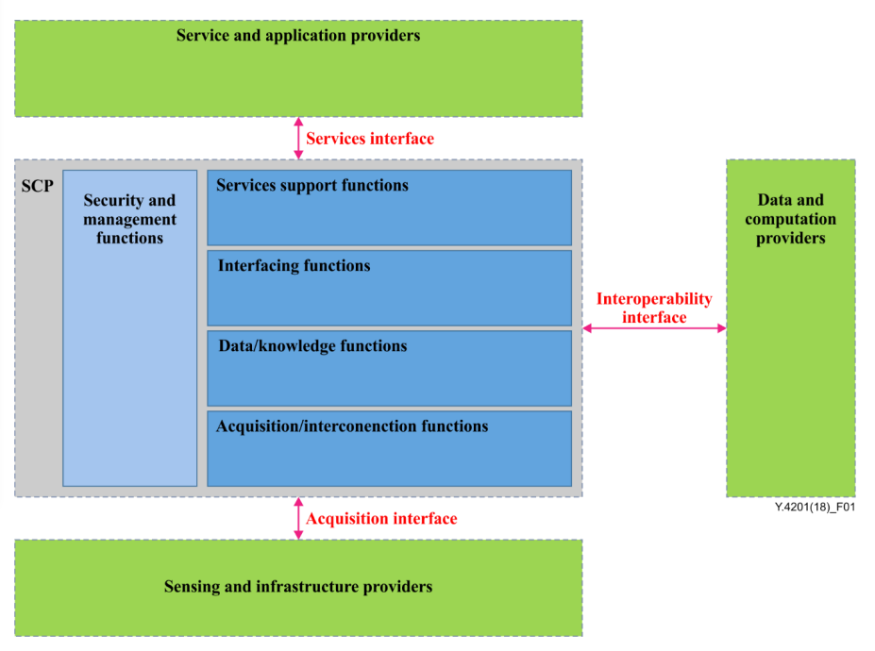

Figure 1 – Overview of an SCP and external systems/platforms [ITU-T Y.4200]

Based on the overview of smart city platform introduced in ITU-T Y.4200, a SCP directly integrates city platforms and systems or through open interfaces between the SCP and external providers to offer application and service. To secure application and service of smart city platform, the security requirements need to consider followings:
- security aspects of application and service of smart city platform
- security aspect of interaction between application and service of smart city platform

7 Security threats of application and service for smart city platform
Editor’s note: This section describes threats of application and service for smart city platform.
- The application and service ecosystem of a smart city platform is exposed to a wide range of security threats. Web attacks, unauthorized access, elevation of privileges, and service vulnerabilities are among the various threats that can compromise the security of applications. [b- ITU-T X.1369]
- Broken Access Control poses a risk by allowing unauthorized users to exploit weaknesses in access restrictions, gaining unauthorized access to sensitive data and performing unauthorized activities.
- Cryptographic Failures can leave the platform vulnerable to data breaches and fraud, as inadequate protection of sensitive information, such as financial data and personally identifiable information (PII), can be exploited by attackers.
- Injection attacks, including SQL injection, present a significant threat where malicious actors can manipulate the system by injecting unauthorized commands or gaining access to unauthorized data.
- Insecure Design is another concern as it encompasses weaknesses arising from neglecting design best practices, leading to potential security flaws in the implementation.
- Security Misconfiguration is a significant threat that arises when security settings, permissions, or access controls are improperly configured, allowing attackers to exploit vulnerabilities.
- The use of Vulnerable and Outdated Components within the application and service ecosystem increases the risk of exploitation as these components may contain known security flaws that can be leveraged by attackers.
- Identification and Authentication Failures can enable unauthorized access and impersonation of legitimate users if weak or improperly implemented mechanisms are present.
- Software and Data Integrity Failures can result in unauthorized access, data manipulation, and compromise of user privacy due to the lack of measures to safeguard against integrity violations.
- Also, Security Logging and Monitoring Failures hinder the detection and mitigation of potential threats by inadequately recording and monitoring activities, making it challenging to identify and respond to security incidents in a timely manner. [b-OWASP]

8 Security requirements of application and service for smart city platform
Editor’s note: This section describes the security requirements of application and service for smart city platform.

- Application security requirements are determined through a comprehensive evaluation of risks and their mitigation. Factors such as application specifications, the environment in which the application operates (including business, regulatory, and technological aspects), critical data involved, and decisions made by the application owner influence these requirements.
- Functional security requirements pertain to the specific security functionalities to be incorporated into the application, while non-functional security requirements focus on the desired security qualities the application should possess. It is important that these controls have been previously defined and approved by the organization at a global level.[b-ISO/IEC 27034-1]
- Application security requirements encompass guidelines, practices, and specifications necessary to protect an application from security threats. Key requirements include strong authentication and authorization mechanisms, input validation and output encoding to prevent attacks, secure communication using protocols like HTTPS/TLS, data encryption for sensitive information, secure configuration management, proper error and exception handling, vulnerability management through testing and patching, secure session management, safe file handling, and regular security testing. These requirements mitigate risks, protect data, maintain user trust, and ensure the application's overall security and reliability.

9 Method for security protection of application and service for smart city platform
Editor’s note: This section provides the method for security protection of application and service for smart city platform.
Bibliography
[b- ITU-T X.1369] Security requirements for IoT service platform
https://www.itu.int/rec/T-REC-X.1369-202201-I
.[b-ISO/IEC 27034-1] Information Technology — Security Techniques — Application Security Part 1 Overview and Concepts
https://www.iso.org/standard/44378.html
[b-OWASP] OWASP Top 10 Application Security Risks
https://owasp.org/Top10/

_______________

